# **ACKNOWLEDGEMENT**

First of all, we would like to express our sincere thanks to the department of Computer Engineering for providing us the opportunity to work on the project named “**Watermark Embedding and Extraction”** to explore our abilities and knowledge in the field of Artificial Intelligence, Image processing and Steganography that we have learned through our semester.

Finally, we would like to thank our supervisor **Er. Bikash chawal** who inspired us to gather different information and conduct proper research on our study of Watermarking.

**Project Team Members:**

1. Aman Mool (740303)

2. Rabin Phaiju (740329)

3. Rodip Duwal (740334)

4. Roshan Dumaru (740335)

# **ABSTRACT**

Now days due to advancement of technology it is difficult to protect creative content and intellectual property. It is very easy to copy and modify digital media resulting in great loss in business. So, the viable solution for this problem is digital watermarking. Digital watermarking is a technique by which we embed copyright mark into digital content which is used to identify the original creator and owner of digital media. It is prominently used for tracing copyright infringements.

We have implemented a robust watermarking technique for the copyright protection based on two famous techniques LSB and 2-level DWT. In the first phase Digital image is introduced as input and for watermarking certain text is embedded as watermark. Our main objective is to embed the text to the image both visibly for image authentication and invisibly as steganography using least significant bit of image in first part where to be compatible within the image for text, the image is converted into byte and that of text operating in bit and back to the byte data. In DWT method a multi-bit watermark is embedded into the low frequency sub-band of a cover image by using alpha blending technique. The insertion and extraction of the watermark in the grayscale cover image is found to be simpler than other transform techniques. The proposed method is compared with the 1-level and 2-level DWT based image watermarking methods by using statistical parameters such as peak-signal-to-noise-ratio and mean square error. The experimental results demonstrate that the watermarks generated with the proposed algorithm are invisible or visible based on the scaling factor and the quality of watermarked image and the recovered image are improved based on it.

*Keywords: Image watermarking, 2-level Discrete Wavelet Transform, Least Significant Bit, alpha blending, wavelet transform, Mean Square Error, Peak Signal to Noise Ratio*

# **LIST OF FIGURES**

|  |  |  |
| --- | --- | --- |
| Fig. No | Title | Page no. |
| 1.1 | Digital Watermarking life-cycle phase | 2 |
| 1.2 | Representation of image as a 2d array of RGB pixels | 6 |
| 3.1 | Working of LSB | 7 |
| 3.2 | 3-Level discrete wavelet decomposition | 8 |
| 3.3 | Basic Block Diagram of watermark system | 10 |
| 3.4 | Basic Block representing embedding and extraction using DWT | 10 |
| 3.6 | Watermark Embedding technique using alpha blending | 11 |
| 3.7 | Watermark extraction technique with alpha blending | 12 |
| 3.8 | Flowchart for Digital watermarking system | 13 |
| 3.9 | Cover Image is divide into 4 sub Band | 15 |
| 4.1 | Histogram of Original Image | 18 |
| 4.2 | Histogram of Watermarked Image | 18 |
| 4.3 | Original Image and Text to be Embedded | 19 |
| 4.4 | Watermarked and recovered image using 2-level DWT for various values of k | 20 |
| 4.8 | Original Image and Text to be Embedded | 23 |
| 4.9 | Watermarked and recovered image using 2-level DWT for various values of k | 23 |
| 4.12 | User Interface | 26 |
| 4.13 | Original Image and text to be embedded | 27 |
| 4.14 | Watermarked Image with text with q=0.98 &k = 0.009 | 27 |
| 4.15 | Extracted Text from the watermarked Image | 28 |
| 4.16 | Original Image and logo to be embedded. | 28 |
| 4.17 | Watermarked Image with Logo embedded with q = 0.98 & k = 0.009 | 29 |
| 4.18 | Extracted Watermarked logo from image | 29 |

# **LIST OF TABLES**

|  |  |  |
| --- | --- | --- |
| Table. No | Title | Page no. |
| 4.5 | Comparison of 1-LEVEL and 2-LEVEL DWT for after-marked image in terms of MSE & PSNR | 20 |
| 4.6 | Comparison of 1-LEVEL and 2-LEVEL DWT for recovered image in terms of MSE & PSNR | 21 |
| 4.7 | Comparison of 1-LEVEL and 2-LEVEL DWT for after-marked image in terms of MSE & PSNR | 22 |
| 4.10 | Comparison of 1-LEVEL and 2-LEVEL DWT for after-marked image of text in terms of MSE & PSNR | 24 |
| 4.11 | Comparison of 1-LEVEL and 2-LEVEL DWT for recovered image of text in terms of MSE & PSNR | 25 |
|  |  |  |
|  |  |  |

# **LIST OF ABBREVIATION**

1. DCT Discrete Cosine Transform
2. DFT Discrete Fourier Transform
3. DWT Discrete Wavelet Transform
4. JPEG Joint Photographic Expert Group
5. LSB Least Significant Bit
6. MSE Mean Square Error
7. PN pseudo-noise
8. PSNR Peak Signal To Noise Ratio

**TABLE OF CONTENTS**

**Title Page No.**

**ACKNOWLEDGEMENT** ii

**ABSTRACT** iii

**LIST OF FIGURES** iv

**LIST OF TABLES** v

**LIST OF ABBREVIATION** vi

**CHAPTER 1** 1

**INTRODUCTION** 1

1.1 Background 1

1.2 Motivation 3

1.3 Statement of Problems 3

1.4 Objectives 3

1.5 Scope & Limitation 3

**CHAPTER 2** 4

**LITERATURE REVIEW** 4

**CHAPTER 3** 6

**METHODOLOGY** 6

3.1 Background 6

3.2 Block Diagram 10

3.3 Flowchart 13

3.4 Algorithm 14

3.5 Tools and Platform 17

**CHAPTER 4** 18

**RESULT AND DISCUSSION** 18

4.1 Overview 18

4.2 Test Analysis 19

4.3 Output Results 26

**CHAPTER 5** 30

**CONCLUSION AND FUTURE RECOMMENDATION** 30

5.1 Conclusion 30

5.2 Future Recommendation 30

**REFERENCES** 31

# **CHAPTER 1**

## **INTRODUCTION**

### **1.1 Background**

Digital media can be copied and modified easily so protecting the copyright of digital media has become an important task. The digital watermark is introduced to solve the problem of copyright. The digital watermarking is a technique of embedding any watermark image into cover image using some known algorithm depending upon the requirement in multimedia data to identify the owner of the document. There are two common methods for watermarking: spatial domain and transform domain. In spatial domain pixels of an image are modified depending upon perceptual analysis of an image. But in transform domain some frequencies are selected and modified from their original values according to certain rules. The transform domain methods are more popular because watermark embedding is more robust in this domain as compared to spatial domain. It also provides more security and imperceptibility.

In digital watermarking, the signal may be text, audio, pictures or video. If the signal is copied, then the information also is carried in the copy. A signal may carry several different watermarks at the same time. The digital watermarking could be done in two ways:

In visible digital watermarking, the information is visible in the picture or video. Typically, the information is text or a logo, which identifies the owner of the media. When a television broadcaster adds its logo to the corner of transmitted video this also is a visible watermark

In Invisible digital watermarking, information is added as digital data to audio, picture or video, but it cannot be perceived. The watermark may be intended for widespread use and thus, is made easy to retrieve or, it may be a form of steganography, where a party communicated a secret message embedded in the digital signal. In either case, as in visible watermarking, the objective is to attach ownership or other descriptive information to the signal in a way that is difficult to remove. It also is possible to use hidden embedded information as a means of convert communication between individuals.

In order for a digital watermarking method to be effective it should be imperceptible, and robust to common image manipulations like compression, filtering, rotation, scaling cropping, and collusion attacks among many other digital signal processing operations. Current digital image watermarking techniques can be grouped into two major classes: Spatial Domain Watermarking and Frequency Domain Watermarking.

Compared to spatial domain techniques, frequency-domain watermarking techniques proved to be more effective with respect to achieving the imperceptibility and robustness requirements of digital watermarking algorithms [5]. Commonly used frequency-domain transforms include the Discrete Wavelet Transform (DWT), the Discrete Cosine Transform (DCT) and Discrete Fourier Transform (DFT). However, DWT has been used in digital image watermarking more frequently due to its excellent spatial localization and multi-resolution characteristics, which are similar to the theoretical models of the human visual system. Further performance improvements in DWT-based digital image watermarking algorithms could be obtained by increasing the level of DWT.

Our aim was to study different watermarking techniques and implement them. In this project we try to implement embedding and extracting of watermarks using the least significant bit and Discrete wavelet transform method for implementing both visible and invisible embedding and to measure the accuracy of extracted watermark. In this project we try to resist our watermark from different types of attack, scalar or geometric. Therefore, the main idea was to implement embedding and extraction of watermark provided by user in concise manner.

**Digital Watermarking Life Cycle Phase**

Generally Digital watermark life cycle phases with embedding, attacking, and detection and retrieval functions

The information to be embedded in a signal is called a digital watermark, although in some contexts the phrase digital watermark means the difference between the watermarked signal and the cover signal. The signal where the watermark is to be embedded is called the host signal. A watermarking system is usually divided into three distinct steps, embedding, attack, and detection. In embedding, an algorithm accepts the host and the data to be embedded and produces a watermark signal.

Then the watermarked digital signal is transmitted or stored, usually transmitted to another person. If this person makes a modification, this is called attack. While the modification may not be malicious the term attack arises from copyright application, where pirates attempt to remove the digital watermark through modification. There are many possible modifications, for example, lossy compression of the data, cropping an image and so on.

Detection is algorithm which is applied to the attacked signal to attempt to extract the watermark from it. If the signal was unmodified during transmission, then the watermark still is present and it may be extracted. In robust digital watermarking application, the extraction algorithm should be able to produce the watermark correctly.

Attacking Function

Embedding Function

Signal

### 

Detecting Function

result

Fig 1.1: Digital Watermarking life-cycle phase

### **1.2 Motivation**

The copyright abuse is the motivating factor in developing new encryption technologies, one such technology is digital watermarking. The focus of this project will detail digital watermarking for digital images applications.

### **1.3 Statement of Problems**

The desire for the availability of information and quick distribution has been a major factor in the development of new technology in the last decade. There is the increased use of digital images across the Internet. It is commonly applied in Internet marketing campaigns and electronic commerce web sites. Due to the growing usage of digital images on the Internet, serious issues have emerged. Counterfeiting, forgery, fraud, and pirating of this content are rising. Virtually anyone with a scanner, frame grabbers, down loader allow them to incorporate copyrighted material into presentations, web designs and Internet marketing campaigns.

### **1.4 Objectives**

To embed and extract watermark from image visibly and invisibly and analysis of scaling factor while using the alpha blending.

### **1.5 Scope & Limitation**

This project is mainly appropriate for protecting intellectual property rights in all kinds of organization and institution. By using this system, owner of any contents can assert their ownership of the content and no one can use it without his/her permission. This system also more appropriate for security point of view. Like duplication of passport and currency can be avoided.

# **CHAPTER 2**

## **LITERATURE REVIEW**

A wavelet-based watermark casting scheme and a blind watermark retrieval technique are investigated in this research. An adaptive watermark casting method is developed to first determine significant wavelet sub bands and then select a couple of significant wavelet coefficients in these sub bands to embed watermarks. A blind watermark retrieval technique that can detect the embedded watermark without the help from the original image is proposed. Experimental results show that the embedded watermark is robust against various signal processing and compression attacks.

Akhil et al. [1] proposed a robust image watermarking technique based on 1-level DWT (Discrete Wavelet Transform). This method embeds invisible watermark into salient features of the original image using alpha blending technique. Experiment result shows that the embedding and extraction of watermark is depend only on the value of alpha. All the results obtained for the recovered images and watermark is identical to the original images.[2]

M.Barni et al. [3] have developed an improved wavelet-based watermarking through pixel-wise masking. It is based on masking watermark according to characteristics of HVS. The watermark is adaptively added to the largest detail bands. The watermark weighing function is calculated as a simple product of data extracted from HVS model. The watermark is detected by correlation. The proposed method is robust to various attacks but this method is complex than other transform technique.

Blossom et al. [4] proposed a DCT based watermarking scheme which provides higher resistance to image processing attacks such as JPEG compression, noise, rotation, translation etc. In this approach, the watermark is embedded in the mid frequency band of the DCT blocks carrying low frequency components and the high frequency sub band components remain unused. Watermark is inserted by adjusting the DCT coefficients of the image and by using the private key. Watermark can then be extracted using the same private key without resorting to the original image. Performance analysis shows that the watermark is robust. [5]

W. Hong et al. [6] proposed a robust digital watermarking scheme for copyright protection of digital images based on sub-sampling. The watermark is a binary image, which is embedded in discrete transform coefficient of the host image and not used in the original image. In this scheme, they had used chaotic map in watermarked image. However, the result of watermark image is good and robust to attack.

Sumedh P. Ingale in his journal of computer science and information technology has discussed about the digital watermarking Algorithm using DWT technique. In this paper based on the requirement of the application the watermark is extracted or detected by detection algorithm to test condition of the data. [7]

Nikita Kashyap and G. R. SINHA also proposed a technique for implementing a robust image watermarking technique for the copyright protection based on 3 level DWT. In this technique a multi bit watermark is embedded into the low frequency sub-band of a cover image by using alpha blending technique. The insertion and extraction of the watermark in the grayscale cover image is found to be simpler than other transform techniques. The proposed method is compared with the 1-level and 2-level DWT based image watermarking methods by using statistical parameters such as peak-signal-to-noise-ratio (PSNR) and mean square error (MSE). The experimental results demonstrate that the watermarks generated with the proposed algorithm are invisible and the quality of watermarked image and the recovered image are improved. [8]

Mistry [9] introduced digital watermarking methods Spatial domain (like LSB) and transform domain (like DCT, DWT) methods. The spatial domain is the normal image space, in which a change in position in image directly projects to a change in position in space. Ex.- Least Significant bit (LSB) method. Transform Domain Method produce high quality watermarked image by first transforming the original image into the frequency domain by the use of Fourier Transform, Discrete Cosine Transform (DCT) or Discrete Wavelet transforms (DWT). Authors found that transform watermarking is comparatively much better than the spatial domain encoding.[10]

Van et al. [11] proposed two LSB techniques. First replaces the LSB of the image with a pseudo-noise (PN) sequence, while the second adds a PN sequence to the LSB of the data. Another LSB data hiding method called Patchwork chooses n pairs (ai ; bi) of the points in an image and increases the brightness of the ai by one unit while simultaneously decreasing the brightness of bi. The problem with this paper is that data is highly sensitive to noise and is easily destroyed. Furthermore, image quality may be degraded by the watermark.

In Previous report created as project in khwopa engineering college, “watermarking using LSB” proposed idea of applying the concept of least significant bits and transforming the grayscale image to embed the text into the image invisibly and also experimented with different attacks possible on the Watermark images. [12]

Most methods found in literature are highly complex and involve multiple execution stages. In this project, we tried to propose a new simple methodology to hide a grayscale image within another grayscale image using LSB and 2- level DWT and the alpha-blending technique for the process of security.

# **CHAPTER 3**

## **METHODOLOGY**

### **3.1 Background**

Digital Watermarking methods have been widely explored in the past few years. This approach is based on providing the authentication and also the data hiding capabilities.

Least significant (LSB) insertion is a common. Simple approach to embedding information in a cover image. The least significant bit (in other words, the 8th bit) of some or all the bytes inside an image is changed to a bit of the text watermark. When using 21-bit image, a bit of each of the red, green, blur color components can be used, since they are each represented by a byte. In other words, one can store 3 bits in each pixel. The utilization of text watermarking invisibly can be seen as the application of steganography. Steganography is the science that involves communication secret data in an appropriate multimedia carrier. E.g., image, audio and video files. It comes under the assumption that if the features are visible the point of attack is evident, thus the goal here is always to conceal the very existence of embedded data. [1]

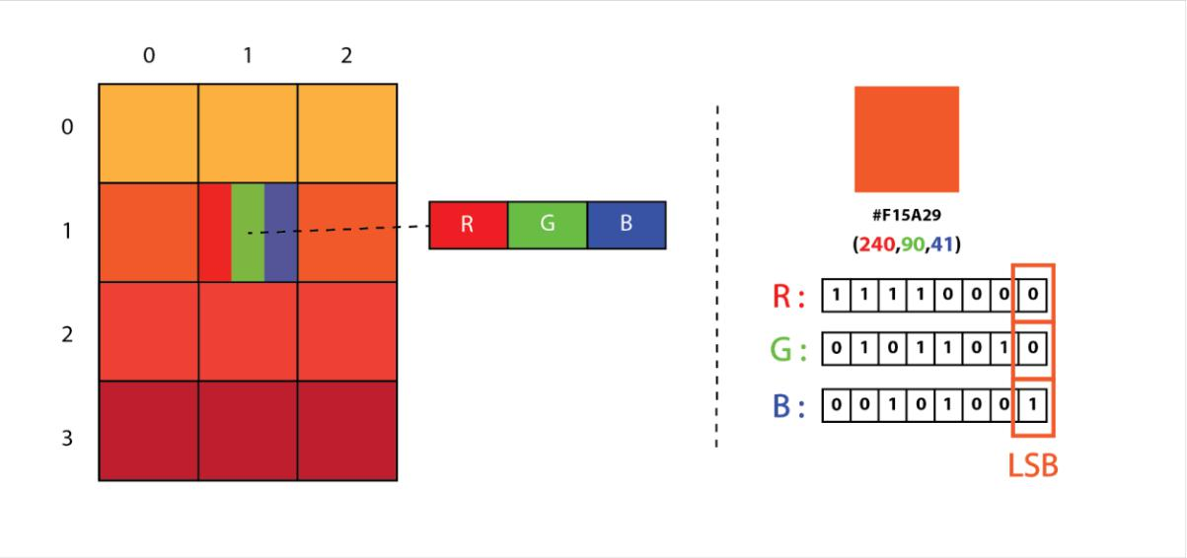**3.1.1.** **LSB Steganography**: LSB steganography is an image steganography technique in which messages are hidden inside an image by replacing each pixel least significant bits with the bits of the message to be hidden.

Fig 3.1: Representation of image as a 2D Array of RGB pixels [9]

To understand better, let’s consider a digital image to be a 2D array of pixels. Each pixel contains values depending on its type and depth. We will consider the most widely used modes RGB (3x8-bit pixels, true-color) and RGBA (4x8-bit pixels, true-color with transparency mask). These values range from 0–255, (8-bit values).

We can convert the message into decimal values and then into binary, by using the ASCII Table. Then, we iterate over the pixel values one by one, after converting them to binary, we replace each least significant bit with that message bits in a sequence.

To decode an encoded image, we simply reverse the process. Collect and store the last bits of each pixel then split them into groups of 8 and convert it back to ASCII characters to get the hidden message.

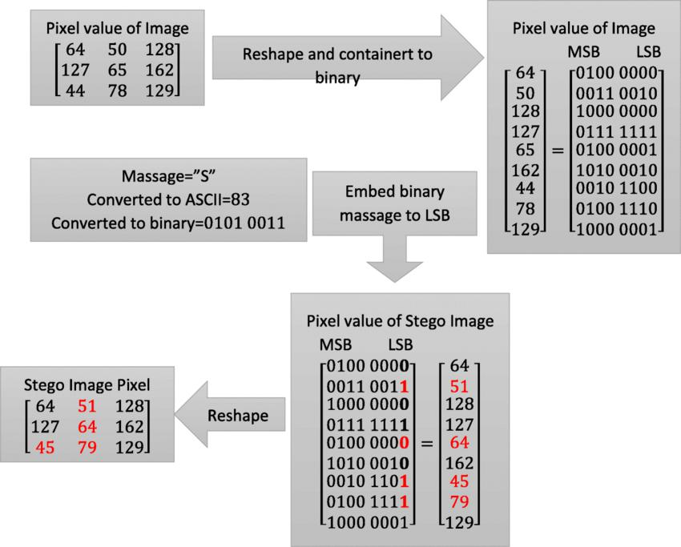Compared to spatial domain techniques, frequency-domain watermarking techniques proved to be more effective with respect to achieving the imperceptibility and robustness requirements of digital watermarking algorithms [8]. Commonly used frequency-domain transforms include the Discrete Wavelet Transform (DWT), the Discrete Cosine Transform (DCT) and Discrete Fourier Transform (DFT). However, DWT has been used in digital image watermarking more frequently due to its excellent spatial localization and multi-resolution characteristics, which are similar to the theoretical models of the human visual system. Further performance improvements in DWT-based digital image watermarking algorithms could be obtained by increasing the level of DWT.

Fig 3.2: Working of LSB [1]

**3.1.2.**  **Discrete Wavelet Transform (DWT)**

Discrete Wavelet transform (DWT) is a mathematical tool for hierarchically decomposing an image [9]. It is useful for processing of non-stationary signals. The transform is based on small waves, called wavelets, of varying frequency and limited duration. Wavelet transform provides both frequency and spatial description of an image. Unlike conventional Fourier transform, temporal information is retained in this transformation process. Wavelets are created by translations and dilations of a fixed function called mother wavelet.

DWT is the multiresolution description of an image the decoding can be processed sequentially from a low resolution to the higher resolution [10]. The DWT splits the signal into high and low frequency parts. The high frequency part contains information about the edge components, while the low frequency part is split again into high and low frequency parts. The high frequency components are usually used for watermarking since the human eye is less sensitive to changes in edges [14].

In two dimensional applications, for each level of decomposition, we first perform the DWT in the vertical direction, followed by the DWT in the horizontal direction. After the first level of decomposition, there are 4 sub-bands: LL1, LH1, HL1, and HH1. For each successive level of decomposition, the LL sub band of the previous level is used as the input. To perform second level decomposition, the DWT is applied to LL1 band which decomposes the LL1 band into the four sub- band

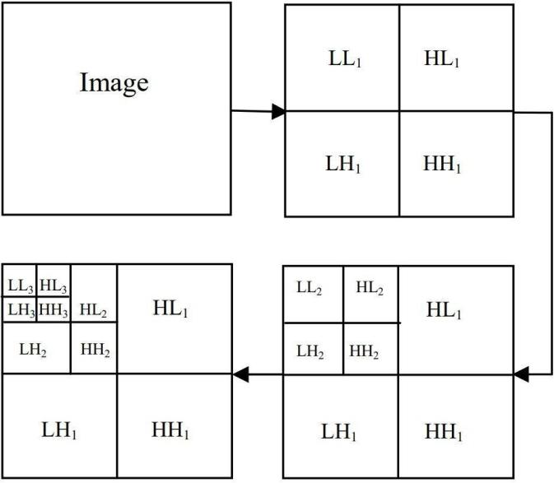To perform third level decomposition, the DWT is applied to LL2 band which decompose this band into the four sub-bands – LL3, LH3, HL3, HH3. This results in 10 sub-bands per component. LH1, HL1, and HH1 contain the highest frequency bands present in the image tile, while LL3 contains the lowest frequency band. The three-level DWT decomposition is shown in Fig below .DWT is currently used in a wide variety of signal processing applications, such as in audio and video compression, removal of noise in audio, and the simulation of wireless antenna distribution [8]. Wavelets have their energy concentrated in time and are well suited for the analysis of transient, time-varying signals. Since most of the real life signals encountered are time varying in nature, the Wavelet Transform suits many applications very well.

Fig 3.3: 3-Level discrete wavelet decomposition [3]

**3.1.3 Noises**

**Gaussian Noise:**

**Gaussian noise**, named after [Carl Friedrich Gauss](https://en.wikipedia.org/wiki/Carl_Friedrich_Gauss), is a term from [signal processing theory](https://en.wikipedia.org/wiki/Signal_processing) denoting a kind of [signal noise](https://en.wikipedia.org/wiki/Noise_(spectral_phenomenon)) that has a [probability density function](https://en.wikipedia.org/wiki/Probability_density_function) (pdf) equal to that of the [normal distribution](https://en.wikipedia.org/wiki/Normal_distribution) (which is also known as the [Gaussian distribution](https://en.wikipedia.org/wiki/Gaussian_distribution)).[[1]](https://en.wikipedia.org/wiki/Gaussian_noise#cite_note-Barbu-1)[[2]](https://en.wikipedia.org/wiki/Gaussian_noise#cite_note-Handbook-2) In other words, the values that the noise can take are Gaussian-distributed.

The probability density function p {\displaystyle p} of a Gaussian random variable z{\displaystyle z} is given by:

………………………………………….………..…(i)

**Salt and pepper noise**

Salt-and-pepper noise, also known as impulse noise, is a form of [noise](https://en.wikipedia.org/wiki/Image_noise) sometimes seen on [digital images](https://en.wikipedia.org/wiki/Digital_image). This noise can be caused by sharp and sudden disturbances in the image signal. It presents itself as sparsely occurring white and black [pixels](https://en.wikipedia.org/wiki/Pixel).

**4.1.4 Test Methods**

**Mean Squared Error (MSE)**

Mean squared error (MSE) measures the amount of error in statistical models. It assesses the average squared difference between the observed and [predicted values](https://statisticsbyjim.com/glossary/fitted-values/). When a model has no error, the MSE equals zero. As model error increases, its value increases. The mean squared error is also known as the mean squared deviation (MSD).

………………(ii)

Where, O represents the matrix data of original image. D represents the matrix data of degraded image. m represents the numbers of rows of pixels and i represents the index of that row of the image. n represents the number of columns of pixels and j represents the index of that column of the image.

**Peak signal to noise ratio (PSNR)**

Peak signal-to-noise ratio (PSNR) is the ratio between the maximum possible power of an image and the power of corrupting noise that affects the quality of its representation. To estimate the PSNR of an image, it is necessary to compare that image to an ideal clean image with the maximum possible power.

………………………..(iii)

### **3.2 Block Diagram**

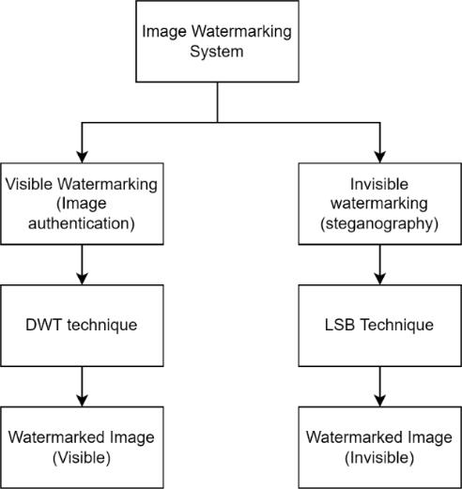The block diagram represents the basic structure of Watermark system. Here the functionality of the watermarking system is categorized to two parts Visible watermarking which is especially applicable for the authentication of the image where the text is embedded in the image using the 3- DWT technique where the user is asked to place the position to place the watermark as well. whereas for the invisible embedding the watermark is embedded as a secret message which is applicable as a steganography. The LSB technique is used where the least significant bit of the image is replaced with the message. For the decoding same technique is used in reverse order.

Fig 3.4: Basic Block Diagram of Watermark system.

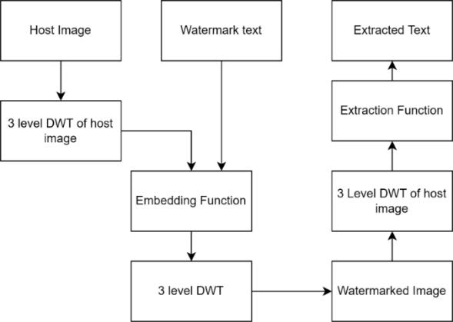

Fig 3.5: Basic Block Diagram representing embedding and extraction using DWT.

**3.2.1 Working of DWT technique**

Based on DWT technique, we propose a new watermarking algorithm for remote multimodal biometric authentication system. The proposed algorithm is divided into two parts, watermark embedding and watermark extraction

**Watermark Embedding**

In this process firstly the gray scale host image is taken and 2-D, 3-level DWT (Discrete Wavelet Transform) is applied to the image which decomposes image into low frequency and high frequency components. In the same manner 2-D, 3-level DWT is also applied to the watermark image which is to be embedded in the host image. The wavelet used here is the wavelets of Daubechies. The technique used here for inserting the watermark is alpha blending [11, 15]. In this technique the decomposed components of the host image and the watermark are multiplied by a scaling factor and are added. Since the watermark embedded in this paper is perceptible in nature or visible, it is embedded in the low frequency approximation component of the host image. According to the formula of the alpha blending the watermarked image is given by bands LL2, LH2, HL2, and HH2.

WMI = k * (LL2) + q * (WM2) ……………..… (iv)

where WMI = low frequency component of watermarked image, LL3 = low frequency component of the original image obtained by 3-level DWT, WM3 = low frequency component of Watermark image, and k, q = Scaling factors for the original image and watermark respectively.

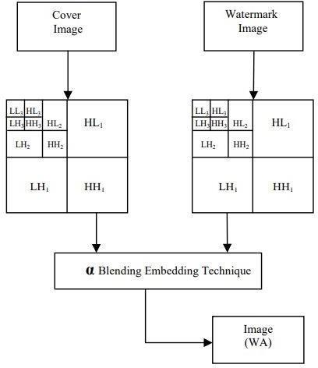After embedding the cover image with watermark image, 3-level Inverse discrete wavelet transform is applied to the watermarked image coefficient to generate the final secure watermarked image. Fig. 2 shows watermark embedding process.

Fig 3.6: watermark embedding technique with alpha blending.

**Watermark Extraction**

In this process firstly 3-level DWT is applied to watermarked image and cover image which decomposed the image in sub-bands. After that the watermark is recovered from the watermarked image by using the formula of the alpha blending. According to the formula of the alpha blending the recovered image is given by

RW = (WMI - k * LL3) …………….….(v)

where RW= Low frequency approximation of Recovered watermark, LL3= Low frequency approximation of the original image, and WMI= Low frequency approximation of watermarked image. After extraction process, 3-level Inverse discrete wavelet transform is applied to the watermark image coefficient to generate the final watermark extracted image. Fig. 3 shows the watermark extraction process.

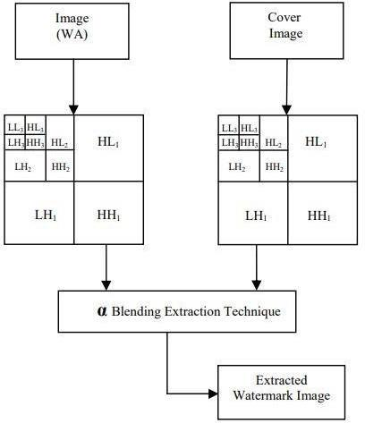

Fig 3.7: watermark extraction technique with alpha blending

### **3.3 Flowchart**

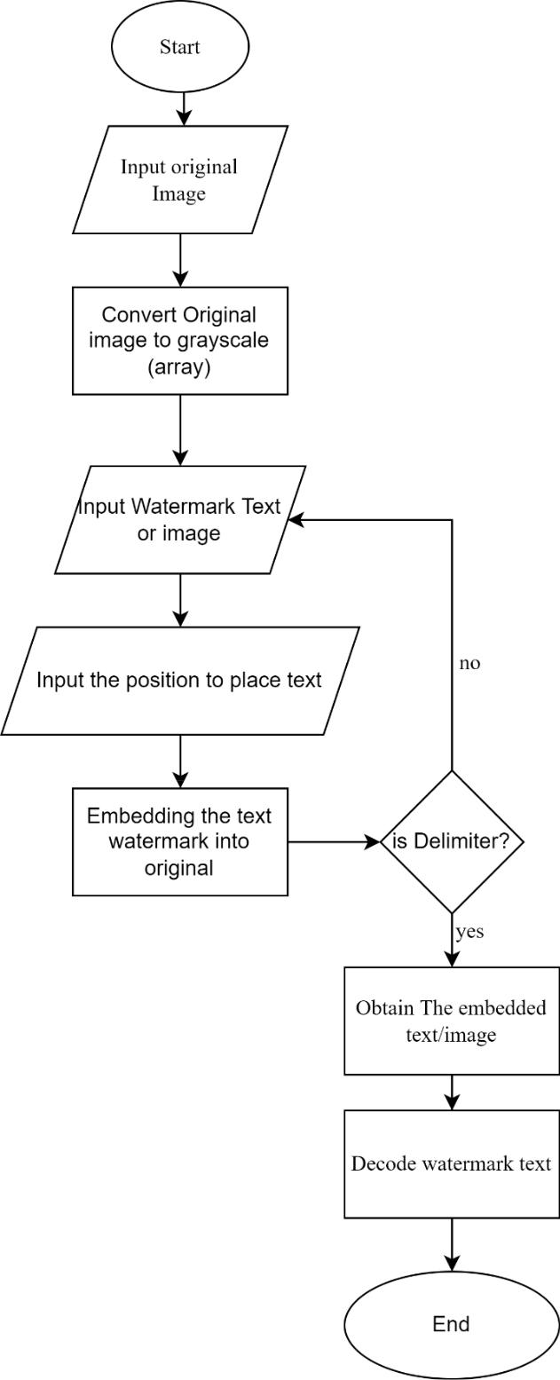

Fig 3.8: Flowchart for Digital Watermarking System

### **3.4 Algorithm**

To accomplish our project, we have performed following series of task in step-by-step format. To accomplish The LSB steganography we implemented following algorithm:

1. Take the original Image
2. Convert the original Image into gray scale
3. Byte conversion of gray scale image
4. Write the certain text to be embedded as watermark in grayscale image.
5. Add the delimiter in the end of the text so that when program decodes it knows when to stop.
6. Check if the total pixel available is sufficient for message. If yes proceed to iterating the pixel one by one and modify least significant bits to bits of text
7. Embedding watermark into grayscale image by using encoding technique
8. Extracting the watermarked text from image using the reverse decoding technique.

**Watermark Embedding Algorithm:**

Step 1: Select two images a. Cover image b. Watermark image to be embedded.

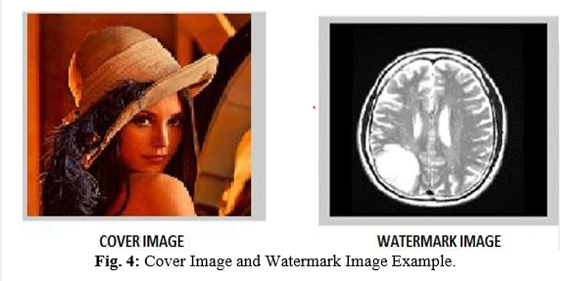

Step 2: Cover Image will be converted into gray scale image as shown in figure below:

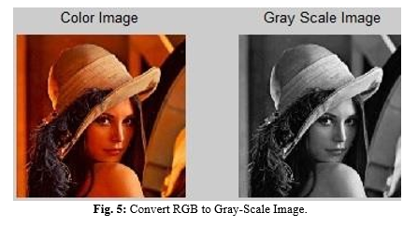

Step 3: We read Both images (Cover image and watermark image) to get the two images

Step 4: Apply DWT (Discrete Wavelet Transform) is applied to the image which decomposes image into low frequency and high frequency components.

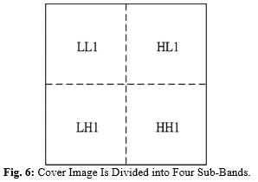Step 5: First Level DWT is performed on the host image to decompose it into four sub bands LL1, HL1, LH1 and HH1 as in figure

Fig 3.9: Cover Image is divide into 4 sub Band

Step 6: The second Level DWT is performed to the LL1 sub band to get four smaller sub bands LL2 , HH2, LH2 and HH2

Step 7: The third level DWT is performed on the LL2 sub band to get four smaller sub bands LL3, HL3, LH3 and HH3.

Step 8: In the same manner DWT is applied to the watermark image which is to be embedded in the host image. The technique used here is alpha blending.

Step 9: The decomposed components of host image and watermark are multiplied by a scaling factor and are added. Since the watermark embedded is visible it is embedded in low frequency approximation component of host image.

The formula is given by:

WMI = k * (LL2) + q * (WM2)………….…………(vi)

Where,

WMI = Low frequency component of watermarked image

LL3 = Low Frequency component of the original image obtained by DWT

WM3 = Low frequency component of Watermark image

K, Q = Scaling factors for the original image and watermark respectively.

Step 10: To Generate the sequence convert the grey-scale watermark image to the vectors consisting of zeros and ones.

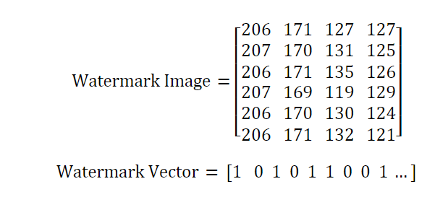

Step 11: Generate the two sequences S1 and S2. S1 is used to embed the watermark bit 0 and s2 sequence is used to embed the watermark bit 1.

Step 12: After the sequences the embedding function is used to add the two sub bands with the embedding formulae with value ‘a’ as in follows:

New LL3 = LL3 + q * wLL3…………………...(vii)

Step 13: Now Inverse DWT is performed using sub bands to get image new LL2. Similarly Inverse to get LL1 and finally to get the watermarked image.

Now we get the watermarked image that can be used for various purposes.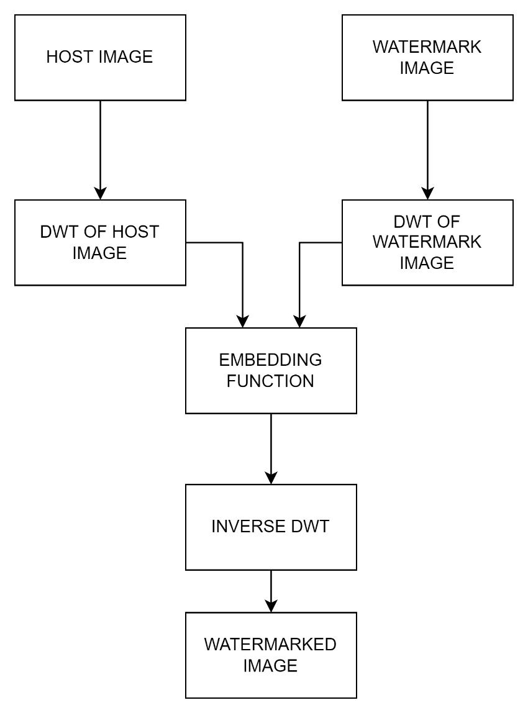

For extraction host image and watermarked text are used:

Step 1: First level DWT is performed on the host image to decompose it into four sub bands LL1, HL1, LH1 and HH1.

Step 2: The second level DWT is performed on the LL1 sub band to get four smaller sub bands LL2, HL2, LH2 and HH2.

Step 3: The third level DWT is performed on the LL2 sub band to get four smaller sub bands LL3, HL3, LH3 and HH3.

Step 4: First level DWT is performed on the watermarked image to decompose it into four sub bands nLL1, nHL1, nLH1 and nHH1.

Step 5: The second level DWT is performed on the LL1 sub band to get four smaller sub bands nLL2, nHL2, nLH2 and nHH2.

Step 6: The third level DWT is performed on the LL2 sub band to get four smaller sub bands n LL3, n HL3, n LH3 and nHH3.

Step7: Then following extracting is performed to get wLL3 with the extraction formulae with same value of 'a' as in embedding

wLL3= new LL3-LL3/ q………….…..(viii)

Step 8: Apply inverse DWT on wLL3 with all other sub bands (LH, HL, HH) equal to zero to get wLL2

Step 9: Repeat step 8 two times each level to get the extracted watermarks.

### **3.5 Tools and Platform**

1. Programming language - Python
2. Visual Studio Code
3. Documentation Tools- Microsoft Word and Microsoft PowerPoint
4. Platform- Window

# **CHAPTER 4**

## **RESULT AND DISCUSSION**

### **4.1 Overview**

To find out whether the watermark image is embedded into the original image or not, it is point of testing to show in what ways watermark can be embedded and extracted from the original image. It is important to extract for authentication.

For the assurance of completion of the project. We go through different experiments. Here in this project, we embedded the text as well as the image using 1-DWT using HAAR method and the histogram of resulting and original image is as below:

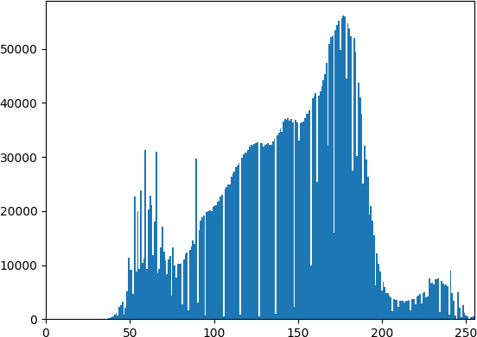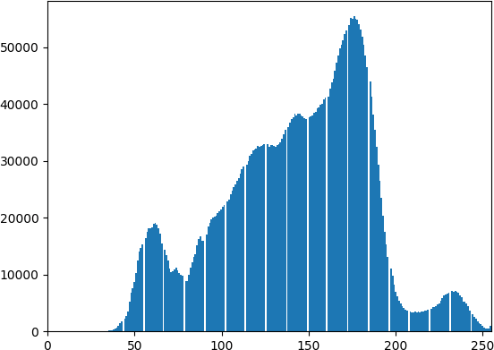

Fig 4.1: histogram of original image Fig 4.2: histogram of watermarked image

Fig 5.1: histogram of original image

The histogram of original image and the watermarked image is somehow very much similar to each other. Therefore, after the encoding of the text or image into the original image it doesn’t distort the original image.

### **4.2 Test Analysis**

We compared proposed 2-level 2-D DWT to the DWT technique. For both the technique we have used gray scale image Lena as original image and trek man image as the watermark. Both the image is of equal size of 512 * 512. The figure below shows the original image and watermark image.

For embedding of watermark in the original image the value of scaling factor k is varied by keeping q constant and best result is obtained for k = 0.98 for 2 level DWT. As the value of k is decreased further to 0.2 the watermarked image becomes darker and finally becomes invisible. The figure below shows the watermarked image using DWT for different value of k.

For the process of recovering the watermark from the watermarked image the value of k is kept constant at 0.009 and q is varied for 1.5 to 0.6. For the higher values of q the watermark becomes almost invisible and as the value of q is reduced best result is obtained and if q is further reduced the recovered watermark becomes darker and PSNR decreases. Below contain the recovered image using 3-level discrete wavelet transform with different value of q.

For Test analysis we take original image and watermark to be embedded and perform the test using MSE and PSNR with respect to scaling factor.

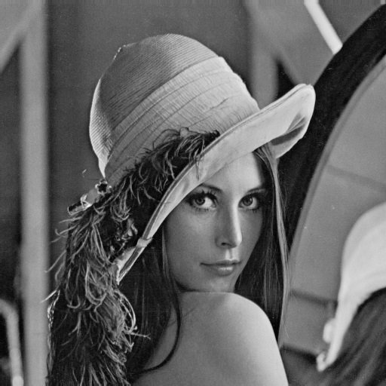

Fig 4.3: Original Image and Watermark Image to be embedded

|  |  |  |  |
| --- | --- | --- | --- |
|  |  |  |  |
| q = 1.5, K = 0.009 | q = .98, K = 0.009 | q = .78, K = 0.009 | q = 0.60, K = 0.009 |

|  |  |  |  |
| --- | --- | --- | --- |
|  |  |  |  |
| K = 1.5, q = 0.009 | K = .98, q = 0.009 | K = .78, q = 0.009 | K = 0.60, q = 0.009 |

Fig 4.4: Watermarked and recovered image using 2-level DWT for various values of k

Table 4.5 Comparison of 1-LEVEL and 2-LEVEL DWT of MSE & PSNR

|  |  |  |  |  |  |  |
| --- | --- | --- | --- | --- | --- | --- |
| q | k | MSE Level 1 | PSNR Level 1 | MSE Level 2 | PSNR Level 2 | Observation |
| 1.5 | 0.009 | 108.6 | 28.02 | 102.97 | 28 |  |
| 1.0 | 0.009 | 105 | 27.92 | 104.97 | 27.9 |  |
| 0.98 | 0.009 | 106 | 27.87 | 106.1 | 27.87 |  |
| 0.95 | 0.009 | 108 | 27.78 | 108.5 | 27.77 |  |
| 0.90 | 0.009 | 106.3 | 27.86 | 106.2 | 27.86 |  |
| 0.85 | 0.009 | 103.2 | 27.99 | 103.04 | 27.96 | Best Result |
| 0.78 | 0.009 | 104.7 | 27.93 | 103.08 | 27.80 |  |
| 0.6 | 0.009 | 108.5 | 27.77 | 109.2 | 27.79 |  |

In this section, we consider 2 different scaling factor MSE and PSNR for determining the best transparency value keeping k constant (i.e. 0.009) and value of q (transparency) ranges from 1.5 to 0.6. Here we consider 2 different level of DWT.

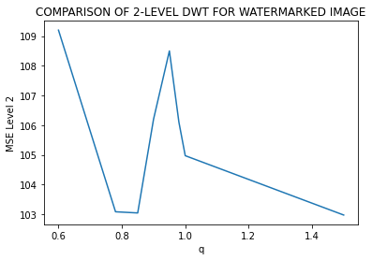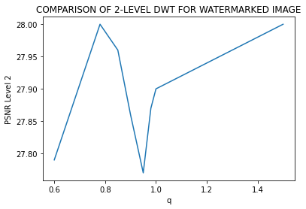

Here, in line graph for 2-LEVEL for watermarked image shows the sharp change in within the range of 0.8 to 1 and according to table Fig 4.2.1 the sharp changes (rise) occur when considering transparency (q) equals to 0.85. Hence suggesting we should keep the transparency around 0.85.

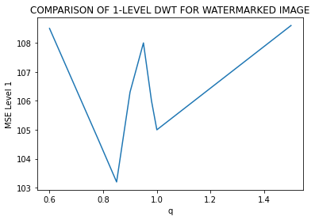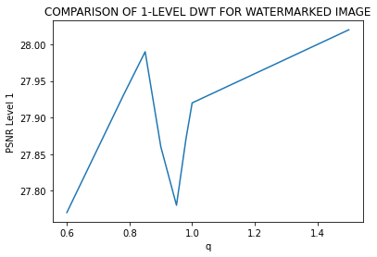

Here, in line graph for 1-LEVEL for watermarked image shows the sharp change in within the range of 0.8 to 1 and according to table Fig 4.2.1 the sharp changes (rise) occur when considering transparency (q) equals to 0.85. Hence suggesting we should keep the transparency around 0.85.

Table 4.6 Comparison of 1-LEVEL and 2-LEVEL DWT for recovered image of MSE & PSNR

|  |  |  |  |  |  |  |
| --- | --- | --- | --- | --- | --- | --- |
| q | k | MSE Level 1 | PSNR Level 1 | MSE Level 2 | PSNR Level 2 | Observation |
| 1.5 | 0.009 | 103.15 | 27.99 | 102.03 | 28.00 |  |
| 1.0 | 0.009 | 47.7 | 31.34 | 63.07 | 30.13 | Best Result |
| 0.98 | 0.009 | 52.08 | 30.89 | 66.53 | 29.90 |  |
| 0.95 | 0.009 | 82.11 | 29.2 | 85.97 | 28.78 |  |
| 0.90 | 0.009 | 94.79 | 28.36 | 99.10 | 28.16 |  |
| 0.85 | 0.009 | 100.3 | 28.11 | 102.64 | 28.017 |  |
| 0.78 | 0.009 | 110.34 | 27.70 | 111.51 | 27.65 |  |
| 0.6 | 0.009 | 103.38 | 27.98 | 105.16 | 27.91 |  |

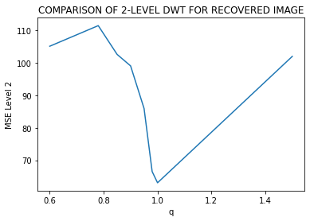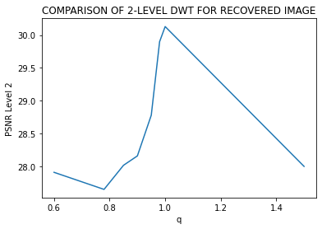

Here, in line graph for 2-LEVEL for recovered image shows the sharp change in within the range of 0.8 to 1.2 and according to table Fig 4.2.2 the sharp changes (rise) occur when considering transparency (q) equals to 1. Hence suggesting we should keep the transparency around 1.

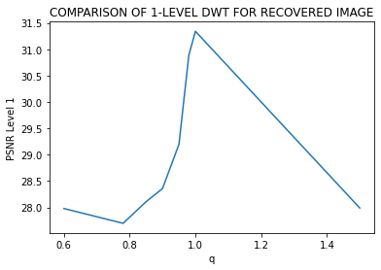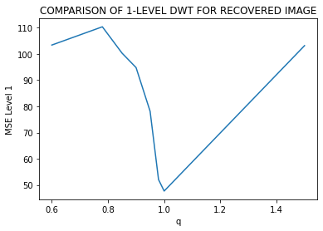

Here, in line graph for 1-LEVEL for recovered image shows the sharp change in within the range of 0.8 to 1.2 and according to table Fig 4.2.2 the sharp changes (rise) occur when considering transparency (q) equals to 1. Hence suggesting we should keep the transparency around 1.

Table 4.7 Comparison of 1-LEVEL and 2-LEVEL DWT with noise with MSE & PSNR

|  |  |  |  |
| --- | --- | --- | --- |
| Gaussian Noise | | | |
| MSE 1 | PSNR 1 | MSE 2 | PSNR 2 |
| 98.59 | 28.19 | 107.33 | 27.82 |
| Salt and Paper Noise | | | |
| MSE 1 | PSNR 1 | MSE 2 | PSNR 2 |
| 102.12 | 28.04 | 104.12 | 27.95 |

Above tabulation (i.e., Fig 4.2.3) shows the calculated value of 2 scaling factor with the use of 2 noise which are gaussian noise and salt and pepper noise with the best result



Fig 4.8: Original Image and Watermark Text to be embedded

|  |  |  |  |
| --- | --- | --- | --- |
|  |  |  |  |
| q= 1.5, K = 0.009 | q = .98, K = 0.009 | q = .78, K = 0.009 | q = 0.60, K = 0.009 |

|  |  |  |  |
| --- | --- | --- | --- |
|  |  |  |  |
| K = 1.5, q = 0.009 | K = .98, q = 0.009 | K = .78, q = 0.009 | K = 0.60, q = 0.009 |

Fig 4.9: Watermarked and recovered image using 2-level DWT for various values of k

Table 4.10 Comparison of 1-LEVEL and 2-LEVEL DWT for of text in terms of MSE & PSNR

|  |  |  |  |  |  |  |
| --- | --- | --- | --- | --- | --- | --- |
| q | k | MSE Level 1 | PSNR Level 1 | MSE Level 2 | PSNR Level 2 | Observation |
| 1.5 | 0.009 | 6.02 | 40.32 | 6.69 | 39.87 |  |
| 1.0 | 0.009 | 5.79 | 40.50 | 6.76 | 39.83 |  |
| 0.98 | 0.009 | 5.81 | 40.48 | 6.71 | 39.85 |  |
| 0.95 | 0.009 | 5.64 | 40.58 | 6.60 | 39.93 | Best Result |
| 0.90 | 0.009 | 6.44 | 40.03 | 7.10 | 39.61 |  |
| 0.85 | 0.009 | 6.18 | 40.21 | 6.98 | 39.68 |  |
| 0.78 | 0.009 | 6.13 | 40.25 | 6.99 | 39.68 |  |
| 0.6 | 0.009 | 6.28 | 40.14 | 6.86 | 39.00 |  |

In this section, we consider 2 different scaling factor MSE and PSNR for determining the best transparency value keeping k constant (i.e. 0.009) and value of q (transparency) ranges from 1.5 to 0.6. Here we consider 2 different level of DWT.

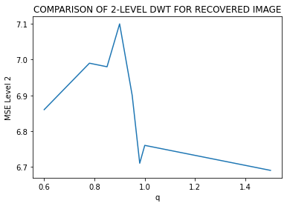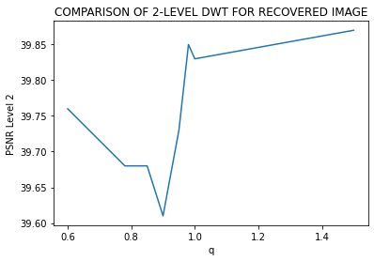

Here, in line graph for 2-LEVEL for watermarked image shows the sharp change in within the range of 0.8 to 1 and according to table Fig 4.2.1 the sharp changes (rise) occur when considering transparency (q) equals to 0.85. Hence suggesting we should keep the transparency around 0.9.

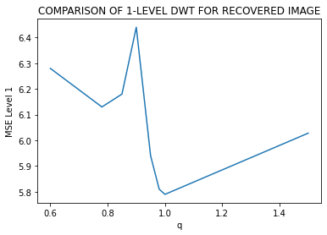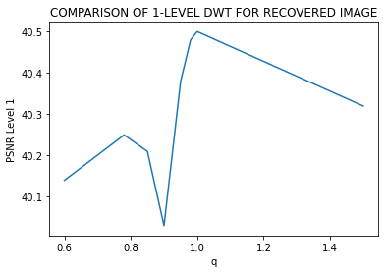

Here, in line graph for 1-LEVEL for watermarked image shows the sharp change in within the range of 0.8 to 1 and according to table Fig 4.2.1 the sharp changes (rise) occur when considering transparency (q) equals to 0.85. Hence suggesting we should keep the transparency around 0.85.

Table 4.11 Comparison of 1-LEVEL and 2-LEVEL DWT for recovered Image

|  |  |  |  |  |  |  |
| --- | --- | --- | --- | --- | --- | --- |
| q | k | MSE Level 1 | PSNR Level 1 | MSE Level 2 | PSNR Level 2 | Observation |
| 1.5 | 0.009 | 24.73 | 34.19 | 23.76 | 34.37 |  |
| 1.0 | 0.009 | 24.90 | 34.16 | 24.28 | 34.27 | Best Result |
| 0.98 | 0.009 | 24.95 | 34.15 | 24.50 | 34.23 |  |
| 0.95 | 0.009 | 24.91 | 34.16 | 24.39 | 34.25 |  |
| 0.90 | 0.009 | 24.95 | 34.15 | 24.69 | 334.20 |  |
| 0.85 | 0.009 | 24.98 | 34.15 | 24.56 | 34.22 |  |
| 0.78 | 0.009 | 24.89 | 34.17 | 24.51 | 34.23 |  |
| 0.6 | 0.009 | 24.44 | 34.24 | 24.14 | 34.30 |  |

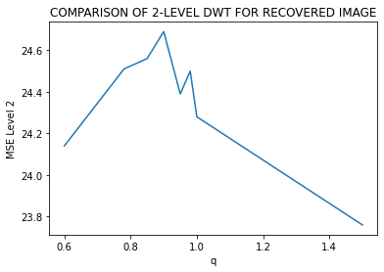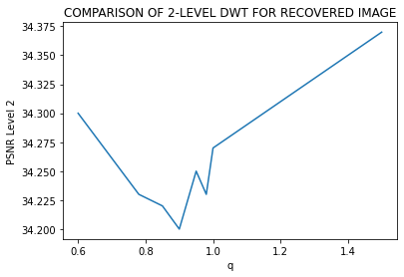

Here, in line graph for 2-LEVEL for recovered image shows the sharp change in within the range of 0.8 to 1.2 and according to table Fig 4.2.2 the sharp changes (rise) occur when considering transparency (q) equals to 1. Hence suggesting we should keep the transparency around 1.

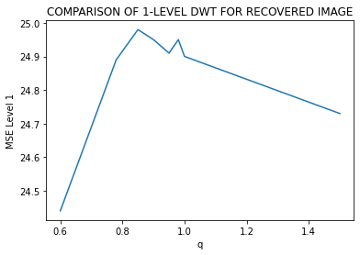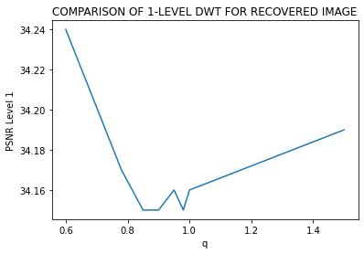

Here, in line graph for 1-LEVEL for recovered image shows the sharp change in within the range of 0.8 to 1.2 and according to table Fig 4.2.2 the sharp changes (rise) occur when considering transparency (q) equals to 1. Hence suggesting we should keep the transparency around 1.

### **4.3 Output Results**

In this project, an image watermarking technique based on a 2-level discrete wavelet transform has been implemented. This technique can embed the invisible watermark into salient features of the image using alpha blending technique. Experiment results shows that the quality of the watermarked image and the recovered watermark are dependent only on the scaling factors k and q whose value ranges from 0.8 to 1 & 0.009 respectively and also indicate that the two level DWT provide better performance than 1-level DWT. All the results obtained for the recovered images and the watermark are identical to the original images.

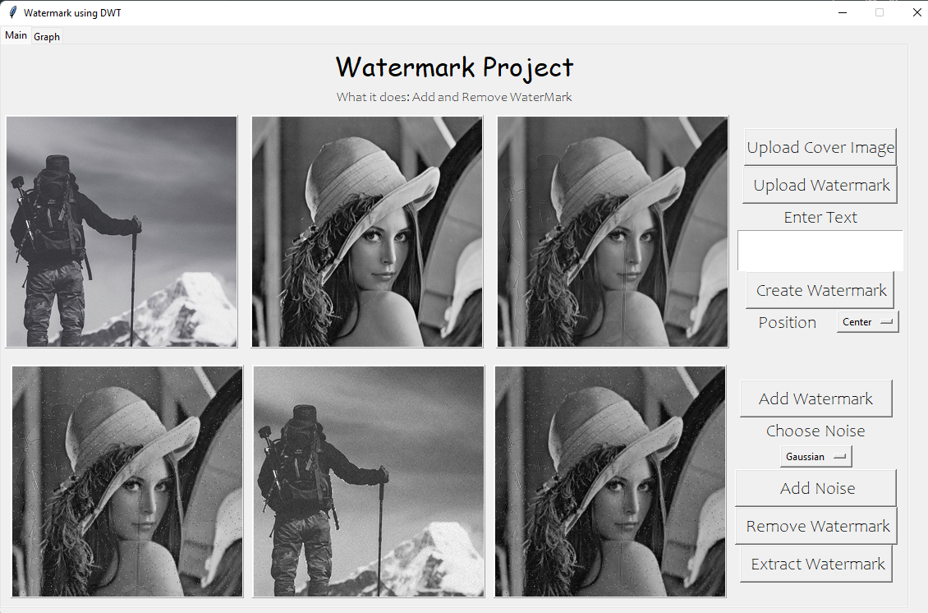

Fig 4.12: User Interface

Above image shows the user interface of our project, Watermark Embedding & Extraction which consists of various feature such as Upload Cover Image, Watermark or insert text as Watermark. Here the UI facilitate users to add watermark in 5 different positions. Here UI also facilitate user to add noise in watermarked image and also allows to remove watermark from cover image and extract watermark.

The resulting output after embedding and extraction of the watermark in the images are shown below:

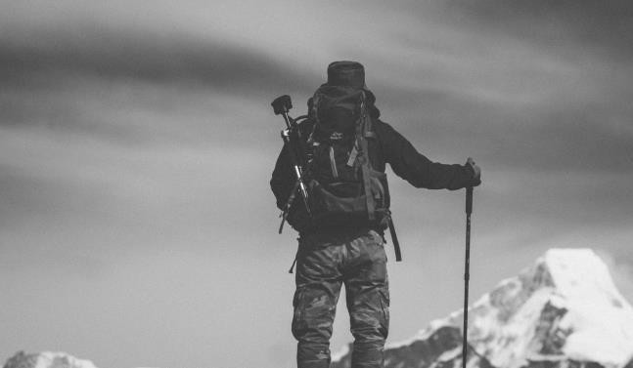

Fig 4.13: Original Image and text to be embedded

Here after the user has added the original image, user is asked to enter the text or the image to be embed as watermark in above example we included the text which is converted to gray scale image to be embedded.



Fig 4.14: Watermarked Image with text with q=0.98 &k = 0.009



Fig 4.15: Extracted Text from the watermarked Image

In the second example we embedded the image instead of text it basically works the same.



Fig 4.16: Original Image and logo to be embedded.

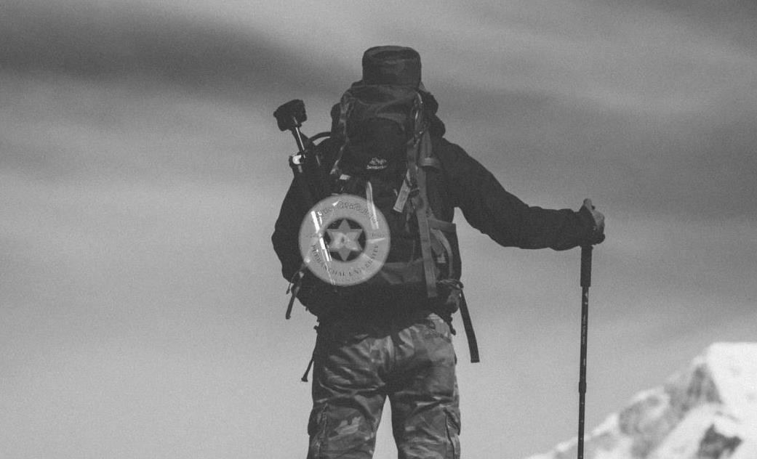

Fig 4.17: Watermarked Image with Logo embedded with q = 0.98 & k = 0.009



Fig 4.18: Extracted Watermarked logo from image

# **CHAPTER 5**

## **CONCLUSION AND FUTURE RECOMMENDATION**

### **5.1 Conclusion**

Digital watermarking technology is an emerging field in computer science, Cryptography, Signal processing and communications. The watermarking research is more exciting as it needs collective concepts from the entire field along with Human psycho-visual analysis, Multimedia and computer graphics. The watermark may be of visible or invisible type and each has got its own application. Visible can be used in the field of authentication of the product whereas the invisible watermark can be used as the steganography in cryptography. We have implemented both visible and invisible text watermark into the image using the DWT as well as LSB in this project work. This technique can embed the invisible watermark into salient features of the image using alpha blending technique. Experiment results shows that the quality of the watermarked image and the recovered watermark are dependent only on the scaling factors k and q and also indicate that the three level DWT provide better performance than 1-level and 2-level DWT. All the results obtained for the recovered images and the watermark are identical to the original images.

So, our project has been towards the better performance for preventing the owners from the copyright and identifies the image of owner’s license information and to track illegal copies.

### **5.2 Future Recommendation**

We can further enhance the performance of this project. And newer models of watermarking could be used. The interface could be improved and watermarking effects on different attacks other than the included noises could be added.

## **REFERENCES**

|  |  |
| --- | --- |
| [1] | Akhil Pratap Shing, Agya Mishra, "Wavelet Based Watermarking on Digital Image," *Indian Journal of computer Science and Engineering,* 2011. |
| [2] | Baisa L. Gunjal, R.R. Manthalkar, "An overview of transform domain robust digital image watermarking algorithms," *Journal of Emerging Trends in Computing and Information Sciences, 2010.* |
| [3] | Barni M, Bartolini F, Piva, "An Improved Wavelet Based Watermarking Through Pixelwise Masking," *IEEE transactions on image processing,* 2011. |
| [4] | Blossom Kaur, Amandeep Kaur, Jasdeep Singh, "Steganographic Approach for hiding Image in DCT Domain," *International Journal of Advances in Engineering & Technology,* 2011. |
| [5] | G. Rosline Nesa Kumari, B. Vijaya Kumar, L. Sumalatha, and Dr V. V. Krishna, "Secure and Robust Digital Watermarking on Grey Level Image," *, International Journal of Advanced Science and Technology,* 2009. |
| [6] | Hang, W. Hong and M., "Robust Digital Watermarking Scheme for Copy Right Protection," *IEEE Trans. Signal Proces,* vol. vo.l2, pp. 1- 8, 2006. |
| [7] | Ingale, Sumedh P ., "Digital Watermarking Algorithm using DWT Technique," *International Journel of Computer Science and Mobile computing,* vol. v, no. 5, pp. 01-09, 2017. |
| [8] | Kashyap, Nikita, "Image Watermarking using 3- Level Discrete Image watermarking Using 3 - Level," *I.J Modern Education and Computer Science,* 2012. |
| [9] | Mistry, Darshana, "Comparison of Digital Watermarking methods," *21st Computer Science Seminar SA1-T1-7, IJCSE,* 2010. |
| [10] | Narang, M. a. S. V., "Digital Watermarking using discrete wavelet transform," *International Journal of Computer Applications,* 2013. |
| [11] | R. G. van Schyndel, A. Z. Tirkel, and C. F. Osborne, "A digital watermark, in Proc," *IEEE Int. Conf. Image Processing (ICIP,* 1994. |
| [12] | Shrestha, N., "Watermarking using LSB," 2012. |

1. A. K. J. S. Blossom Kaur, "Steganographic Approach for hiding Image in DCT Domain," *International Journal of Advances in Engineering & Technology,* 2011.
2. A. M. Akhil Pratap Shing, "Wavelet Based Watermarking on Digital Image," *Indian Journal of computer Science and Engineering,* 2011.
3. D. F. P. Barni M, "An Improved Wavelet Based Watermarking Through Pixelwise Masking," *IEEE transactions on image processing,* 2011.
4. Mistry, "Comparison of Digital Watermarking methods," *21st Computer Science Seminar SA1-T1-7, IJCSE,* 2010.
5. M. a. S. V. Narang, "Digital Watermarking using discrete wavelet transform," *International Journal of Computer Applications,* 2013.
6. M. Hang, "Robust Digital Watermarking Scheme for Copy Right Protection," *IEEE Trans. Signal Proces,* vol. vo.l2, pp. 1- 8, 2006.
7. N. Kashyap, "Image Watermarking using 3- Level Discrete Image watermarking Using 3 - Level," *I.J Modern Education and Computer Science,* 2012.

|  |
| --- |
| 1. N. Shrestha, "Watermarking using LSB," 2012. 2. Rosline Nesa Kumari, " Secure and Robust Digital Watermarking on Grey Level Image," *, International Journal of Advanced Science and Technology,* 2009. 3. R. M. Baisa L. Gunjal, "An overview of transform domain robust digital image watermarking algorithms," *Journal of Emerging Trends in Computing and Information Sciences, 2010.* |
|  | |
| 1. S. P. Ingale, "Digital Watermarking Algorithm using DWT Technique," *International Journel of Computer Science and Mobile computing,* vol. v, no. 5, pp. 01-09, 2017. | |

1. Van Schyndel, " A digital watermark, in Proc," *IEEE Int. Conf. Image Processing (ICIP,* 1994.