**Instructions**

1. Please add below package fron Nauget package
2. jQuery
3. Bootstrap
4. NewtonsoftJson
5. AspNetCore.StaticFiles

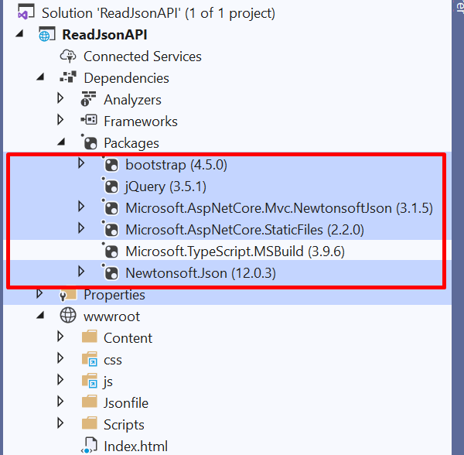

2.Put the Json data file inside wwwroot → Jsonfile folder.

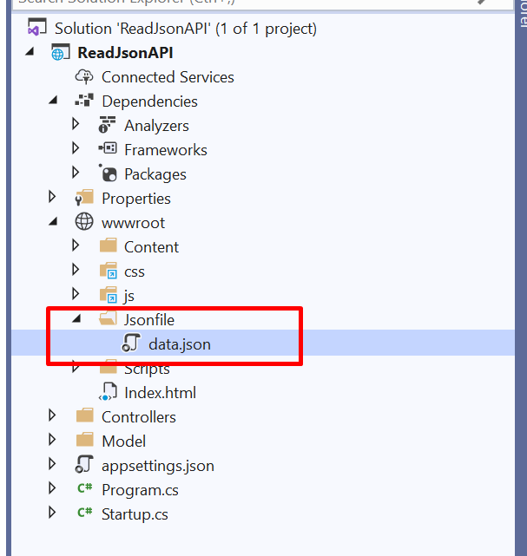

3. Drag and drop that json file inside the controller for file path.

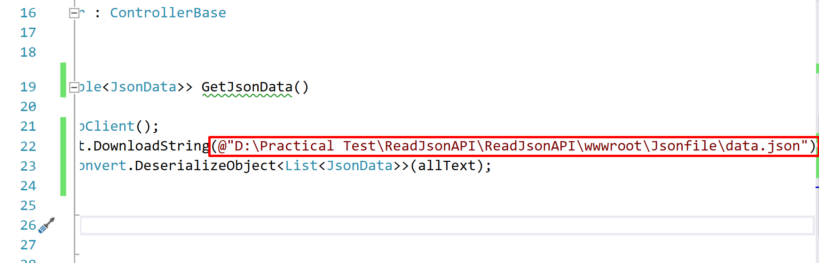

4. Run application for getting result from API

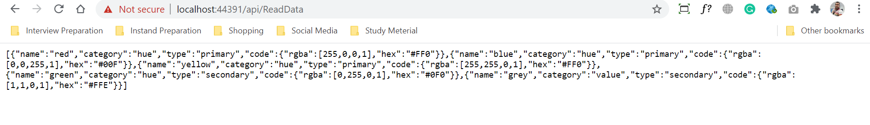

5. Type index.html on URL instead of “api/ReadData”

i.e :- <https://localhost:44391/Index.html>

