Title: Database Design

1.EERM
Task 1: Produce an Extended Entity Relationship Model (EERM – Conceptual Design stage) for the given requirements of the Case Study, using QSEE. [15 Marks]

Include your Assumptions here
- A festival can have many schedules.
- One schedule is for a particular festival.
- A festival takes place in one venue.
- A venue can host only festival at a time.
- An Organizer can organize many festivals.
- Each festival is organized by only one organizer.
- A festival can have many performances.
- Each performance is for only one festival.
- Many bands can perform can a festival
- A band performs in one festival at a time.
- A band can give many performances.
- A performance is given by a band.
- Many bands can perform at a venue.
- A band performs in one venue at a time.
- A venue contains several staffs.
- A staff works at a venue.
- A venue can have many stages.
- A stage is for one venue.
- A venue can have several schedules.
- A supervisor manages the staff.
- An agent can represent many bands.
- A band is represented by a single agent.
- A stage can have many bands performing.
- A band performs at a particular stage.
- One storage space is for only one band.
- A stage can have several equipments.
- Equipment is for one stage at a time.
- A festival can have several working staffs.
- A staff works for a festival.
- Many staff can work in a stage.

1.2 Extended Entity Relationship Diagram (EER Diagram)

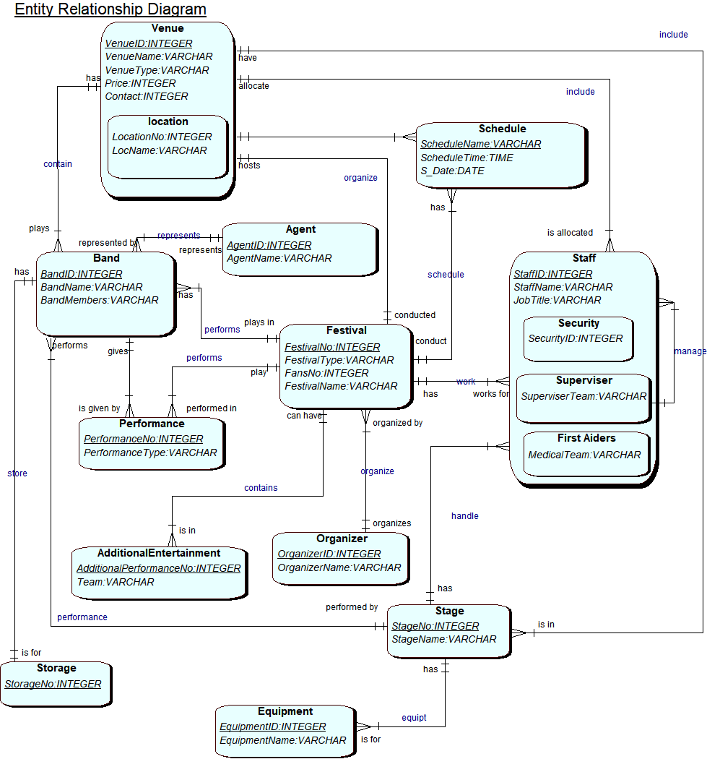

1.3 List your attributes and identifiers here:
Festival (FestivalName, FestivalType)
Band( BandID, BandName, BandMembers)
Venue( VenueID, VenueName, VenueType, Price, Contact )
Agent( AgentID, AgentName)
Schedule(ScheduleName, ScheduleTime, date)
Staff( StaffID, StaffName, JobTitle)
Performance( PerformanceNo, PerformanceType )
Storage( StorageNo )
Organizer( OrganizerID, OrganizerName)
Stage( StageID, StageName)
Equipment( EquipmentID, EquimentName)
Location( LocationNo, LocName)
Security (StaffID , SecurityID)
Superviser (StaffID , SuperviserTeam)
FirstAiders(StaffID, MedicalTeam)

1.4 Include a list of the Validation Questions of your model here:
- Show all the Performance at the Festival.
- Show all Venue Schedule.
- List all Location for the Festival.
- List all the Staff allocated at the Venue.
- List all the Staff working at a Stage.
- List all the Eqipment for the Stage.

1.5 A definition for each entity
- Festival: Record type of festival.
- Band: Record band at the festival
- Venue: Record location
- Agent: record details for its band
- Schedule: record the shedule
- Staff: record all the staff
- Performance: record the type of performance
- Storage: record all the items for the band
- Organizer: record details for the festival
- Stage: record the stage act
- Equipment: record the equipment details
- Location: record the location details for the event
- Security: record details of the security
- Superviser: list the staff being supervised by
- FirstAiders: list the aiders
1.6 Occurrences for each entity...

FestivalName | FestivalType
Leeds Beckett Music Festival | formal
New Year Blast | formal
Dance Mania | Non-formal

BandID | BandName | BandMembers
44 | Alfrojack | 5
55 | Jazzers | 3
44 | Alfrojack | 5

VenueID | VenueName | VenueType | Price | Contact
101 | The big hall | music | $1000 | 0113456
177 | Celebration Point | Entertainment | $500 | 0115674
193 | Leeds Central Hall | Educational | $700 | 0115383

AgentID | AgentName
0699 | Tom Thomas
0645 | Tony Jones
0677 | Ariana Smith

ScheduleName | ScheduleTime | Date
Musical | 5:00pm | 08/11/2017
New Year | 4:00pm | 01/01/2018
Dance | 1:00pm | 22/12/2017

StaffID | StaffName | JobTitle
04567 | Rina Das | Firstaider
08663 | John Wales | Superviser
09674 | Hila Jones | Security

PerformanceNo | PerformanceType
11 | Dance
08 | Musical
22 | Poetry

StorageNo
2234
6678
3456

OrganizerID | OrganizerName
099 | Jack Wills
067 | Harry Jones
056 | Loius Vane

StageID | StageName
101 | Stage1
102 | Stage2
103 | Stage2

EquipmentID | Equipment
1001 | Guitar
1003 | Drumsticks
1021 | Piano

LocationNo | LocName | VenueID
6778 | Sydney | 101
6245 | Melbourne | 123
6899 | Leeds | 193

SecurityID | StaffID | StaffName | JobTitle
7098 | 08663 | Williams | Security Guard
7033 | 08456 | John Brothers | Bouncer
7089 | 08678 | Hinna | Security Guard

StaffID | MedicalTeam | StaffName | JobTitle
07256 | Injury | Katy | Firstaider
02568 | Nurse | Thomas | Firstaider
01346 | Physician | Willy | Firstaider

SuperviserTeam | StaffID | StaffName | JobTitle
Music | 07256 | Taylor | Superviser
Dance | 02568 | Jina | Superviser
Stall | 01346 | Will | Superviser

2.
Task 2: Produce a Relational Data Model (Logical Design stage), defining all the tables including their attributes with primary and foreign keys clearly indicated. [10 Marks]

LIST OF tables and attributes, defining all Primary Keys and any Foreign Keys(s) derived from the EERD

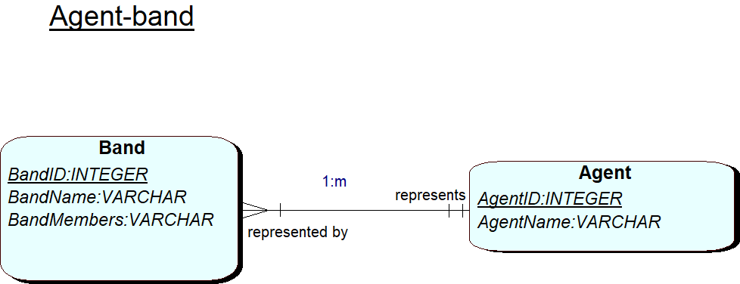
- AGENT (AgentID, AgentName)
BAND (BandID, BandName, BandMembers, AgentID)

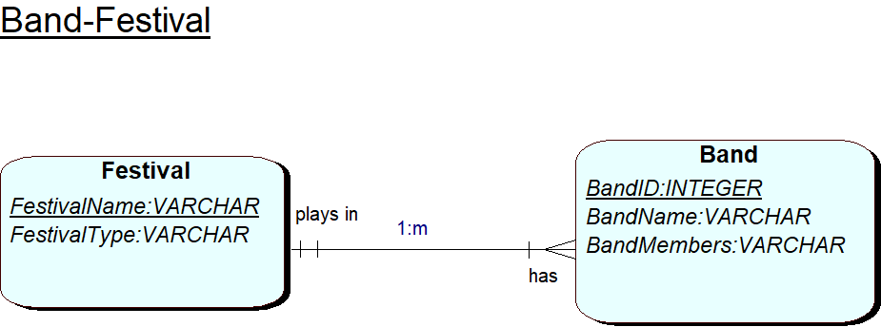
- BAND (BandID, BandName, BandMembers, FestivalName)
FESTIVAL (FestivalName, FestivalType)
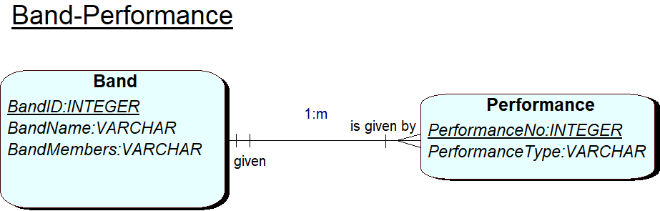
- BAND (BandID, BandName, BandMembers)
PERFORMANCE (PerformanceNo, PerformanceType, BandID)

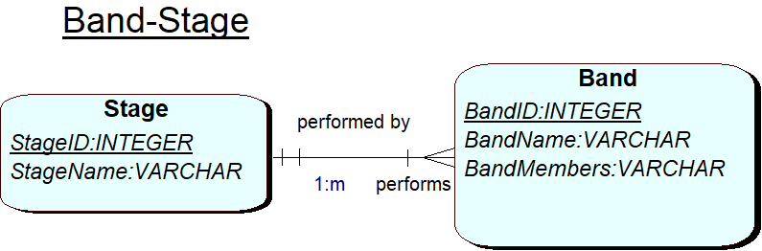
- BAND (BandID, BandName, BandMembers)
STAGE (StageID, StageName)

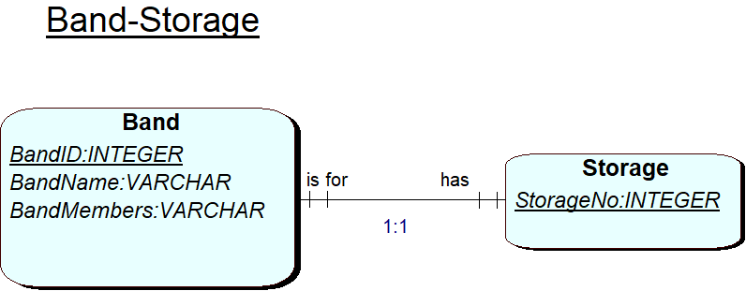
- BAND (BandID, BandName, BandMembers, StorageNo)
STORE (StorageNo, BandID)

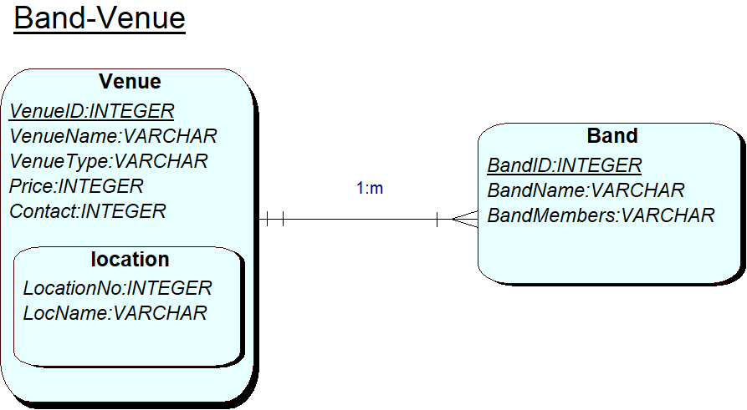

- BAND (BandID, BandName, BandMembers, VenuID)
VENUE (VenueID, VenueName, VenueType, Price, Contact)

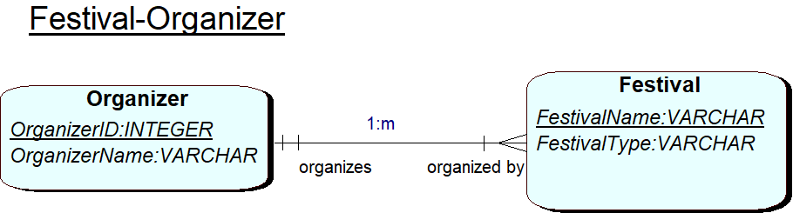
- FESTIVAL (FestivalName, FestivalType, OrganizerID)
ORGANIZER (OrganizerID, OrganizerName)

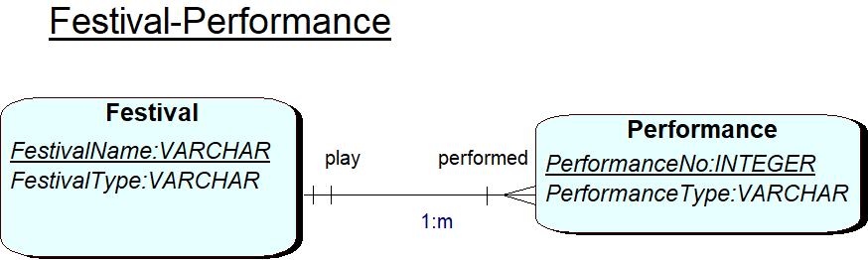
- FESTIVAL (FestivalName, Festival_Type)
PERFORMANCE (PerformanceNo, PerformanceType, FestivalLName)
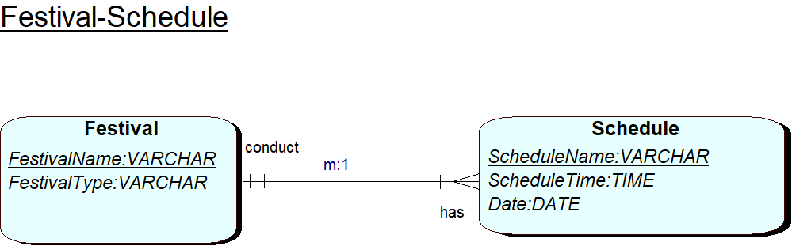
- FESTIVAL (FestivalName, FestivalType, Organizer_ID)
SCHEDULE (ScheduleName, ScheduleTime, Schedule_date, FestivalName)
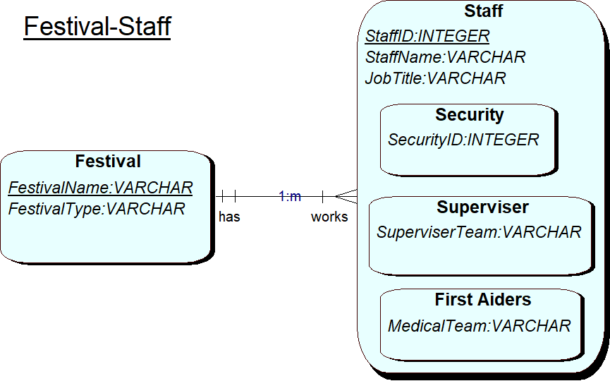
- FESTIVAL (FestivalName, FestivalType)
STAFF (StaffID, StaffName, JobTitle, FestivalName)

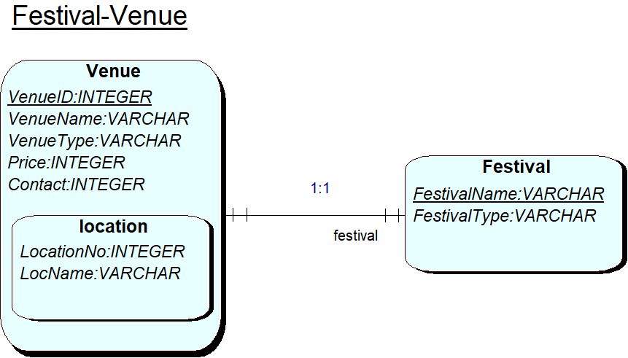
- FESTIVAL (FestivalName, FestivalType, VenueID)
Venue (VenueID, VenueName, VenueType, Price, Contact)

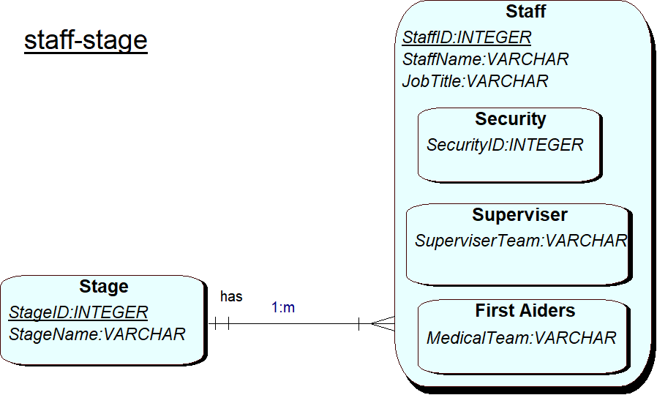
- STAFF (StaffID, StaffName, JobTitle, StageID)
STAGE (StageID, StageName)
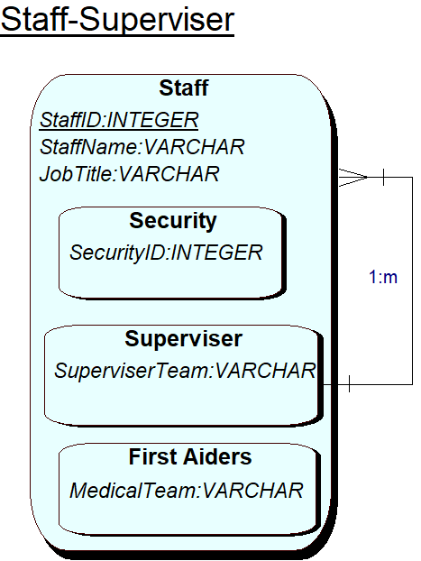
- STAFF (StaffID, StaffName, JobTitle)
SUPERVISER (SuperviserTeam)
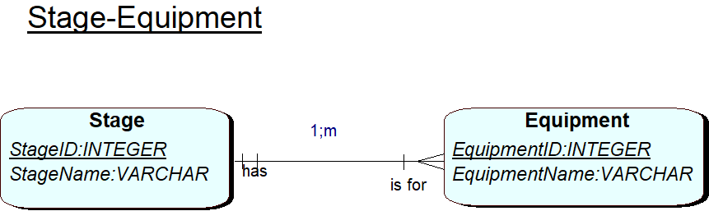
- EQUIPMENT (EquipmentID, EquipmentName, StageID)
STAGE (StageID, StageName)

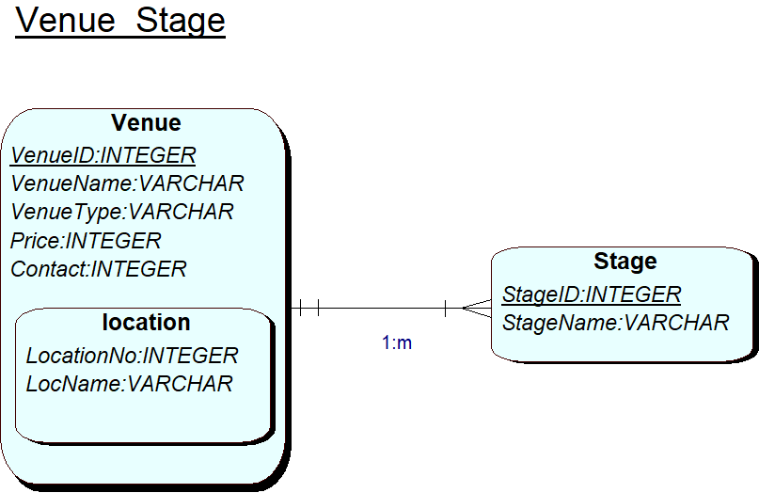

- VENUE (VenueID, VenueName, VenueType, Price, Contacat)
STAGE (StageID, StageName, VenueID)
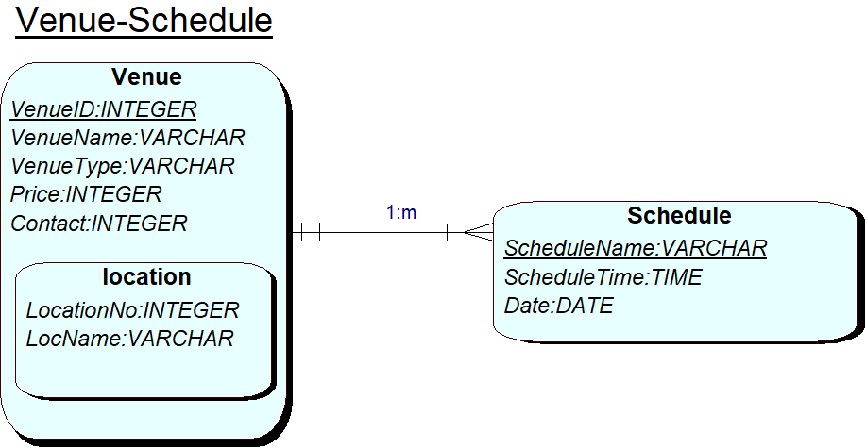
- VENUE (VenueID, VenueName, VenueType, Price, Contacat)
SCHEDULE (ScheduleName, ScheduleTime, Date, VenueID)
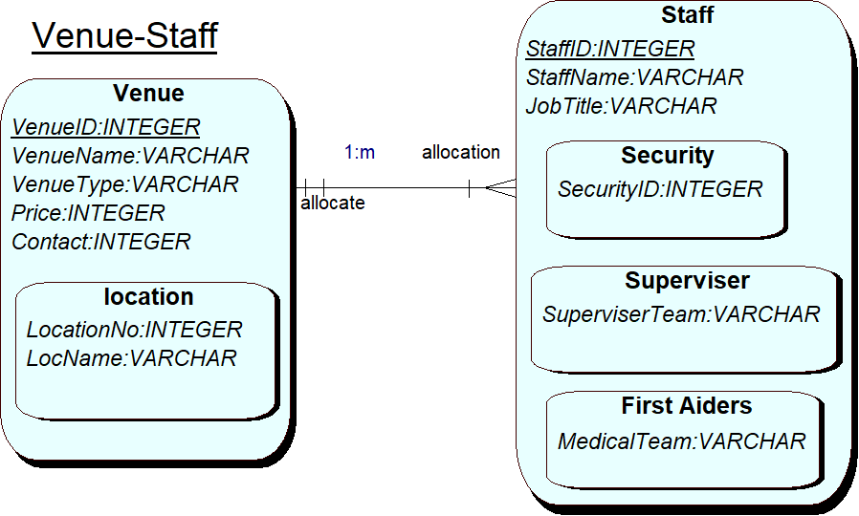

- VENUE (VenueID, VenueName, VenueType, Price, Contacat)
STAFF (StaffID, StaffName, JobTitle, VenueID)

3. COMPOSITE Model – using QSEE.
Task 3: Consider and justify any decomposition or composition of your tables (Physical Design stage). Based on your final decisions produce a final Composite ERD Model using QSEE. [10 Marks]

3.1 Composite Model

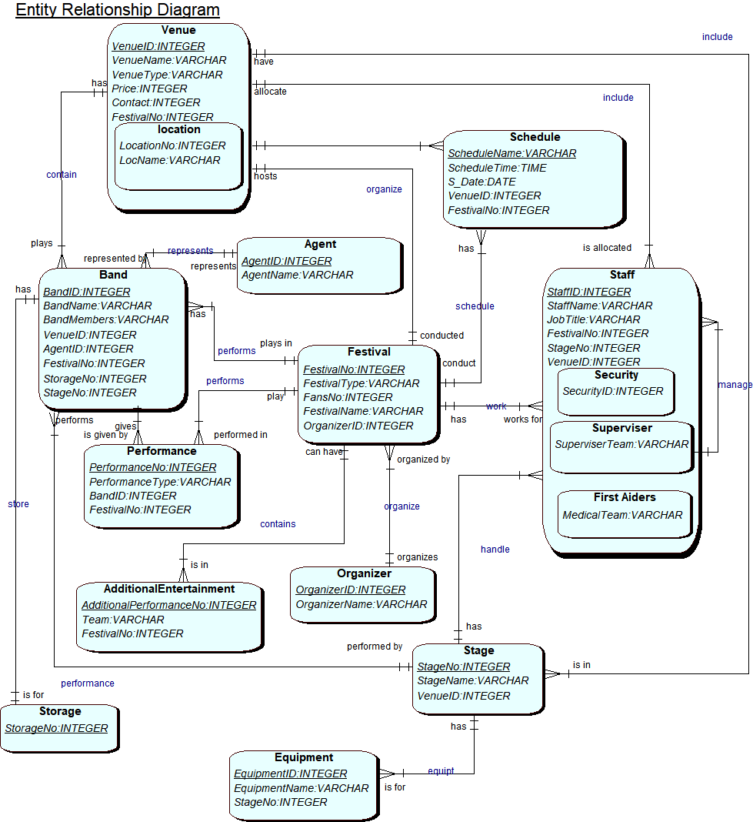

4. Forward Engineering
Task 4: Forward engineer all of your tables, choose a sub-system to create and insert suitable test data. Create a view. Use SQL Scripts Environment for this task.. [15 Marks]

CREATE VIEW LEEDS_FESTIVAL AS
SELECT FESTIVAL.FestivalNo, ORGANIZER.OrganizerID
FROM FESTIVAL, ORGANIZER
WHERE FESTIVAL. FestivalNo=FESTIVAL. OrganizerID;

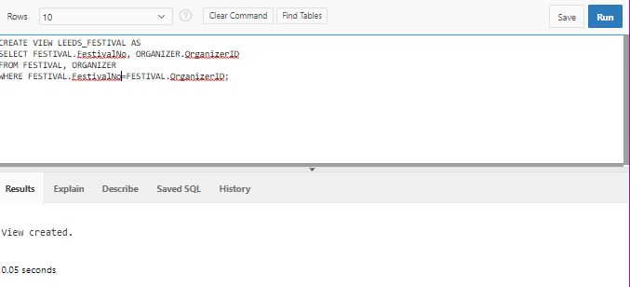

CREATE VIEW LEEDS_FESTIVAL_BAND AS
SELECT BAND.BANDID, AGENT.AGENTID
FROM BAND, AGENT
WHERE BAND.BANDID=BAND.AGENTID;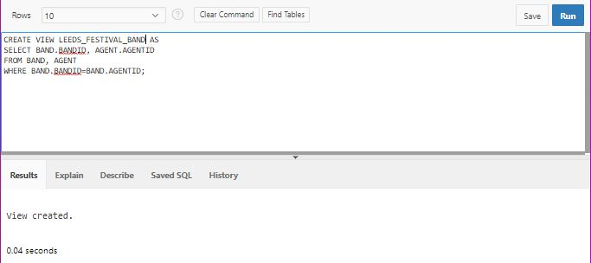

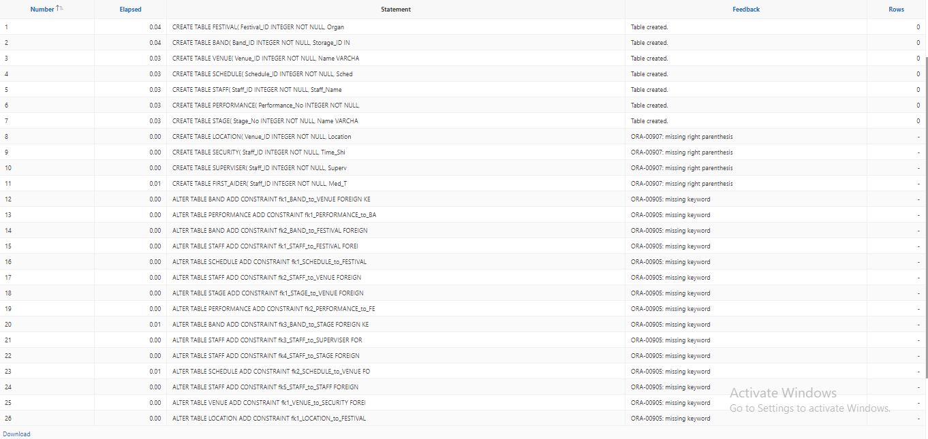

The above image shows the error ORA-00907 : missing right parenthesis when creating a SQL file from QSEE and imported into the ORACLE.
But later on I found out that the Syntax for oracle and mysql is different.
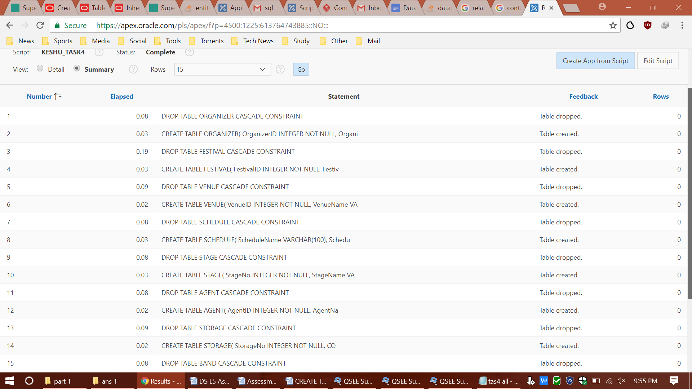
The above image shows the table created without any errors.

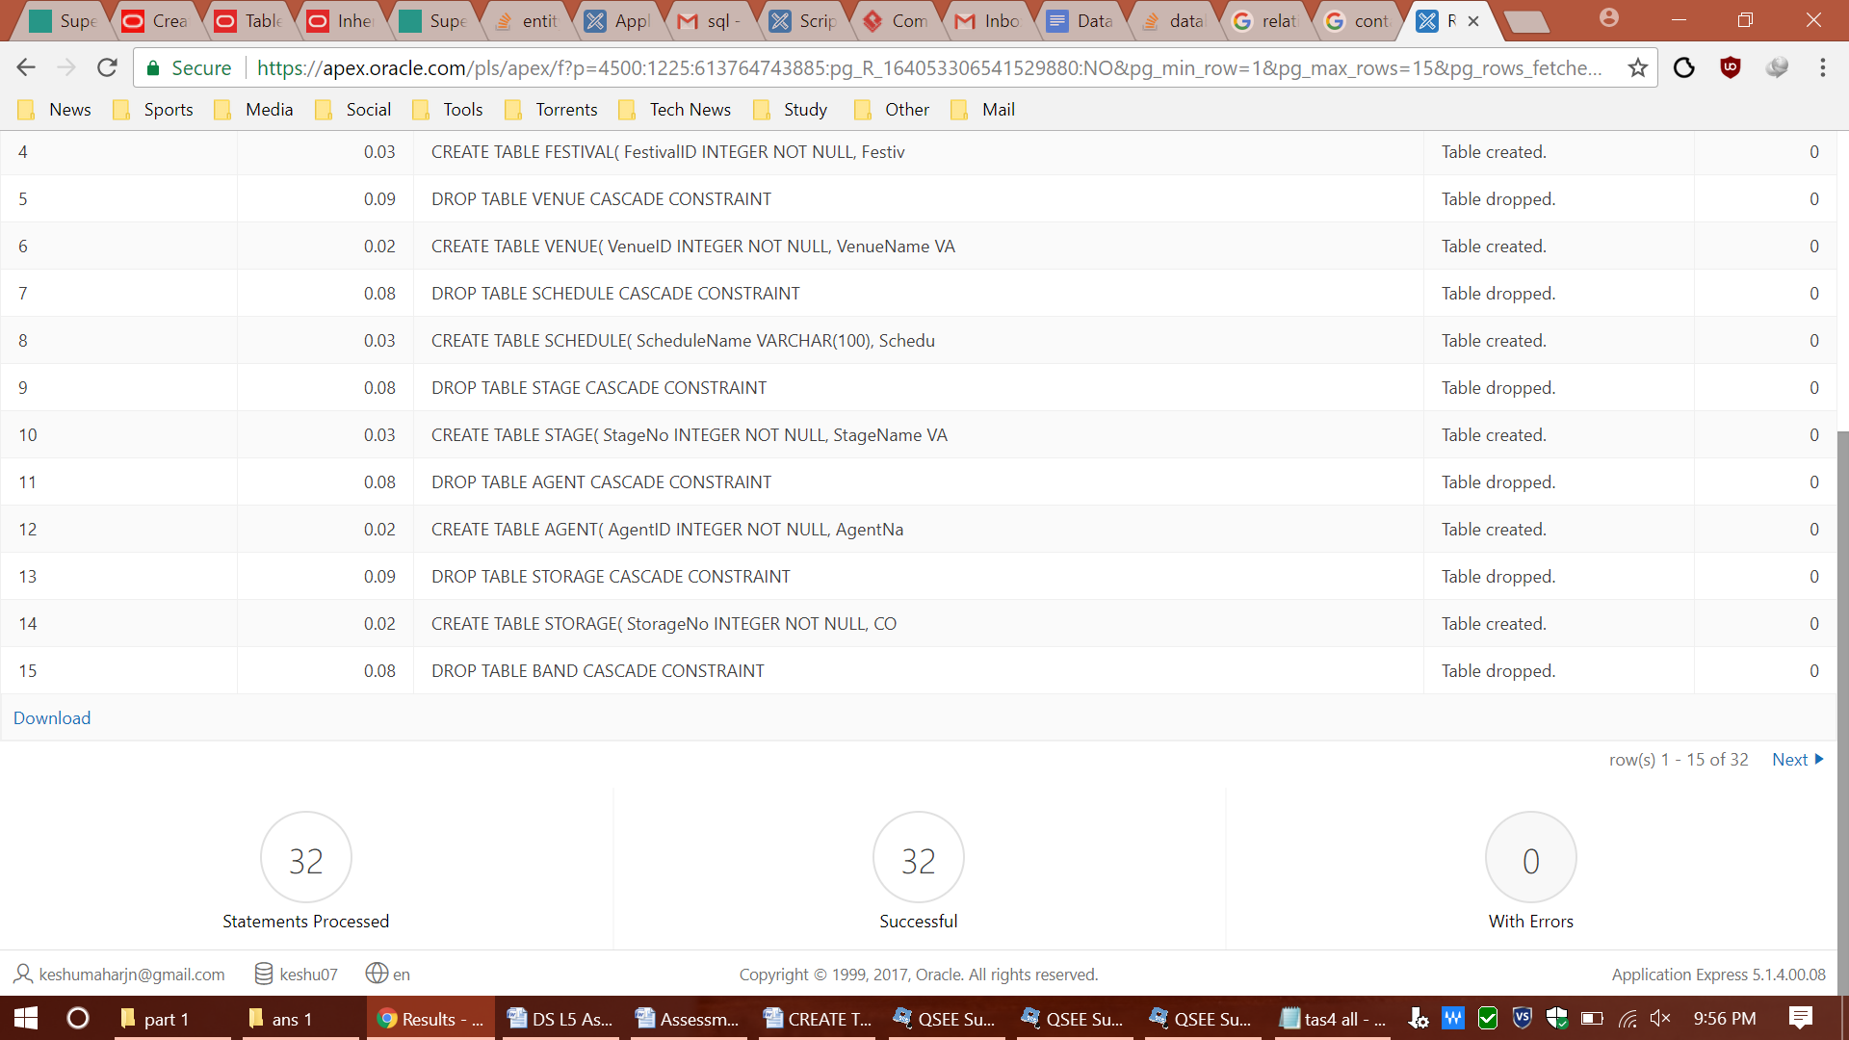

The above image shows the table created without any errors.

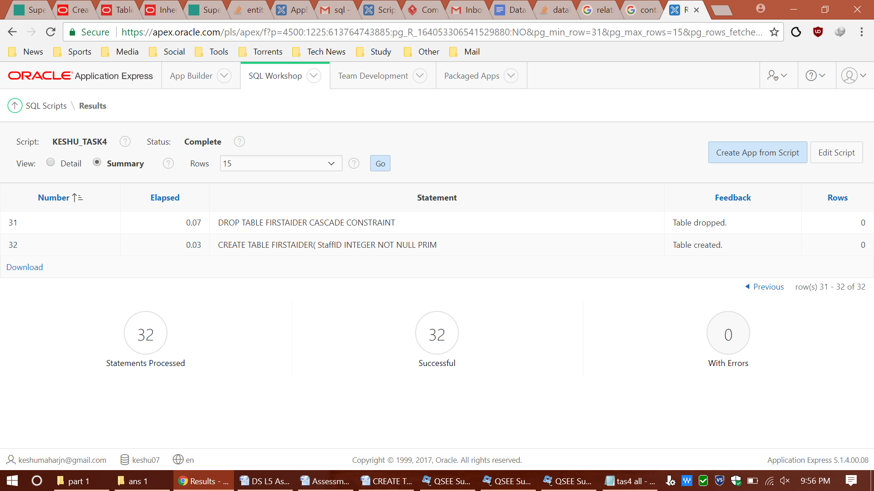

The above image shows all the table being created without any errors

5. Bibliography

- Apex.oracle.com. (2017). Oracle Application Express. [online] Available at: https://apex.oracle.com/en/ [Accessed 30 Dec. 2017].

6. Appendixes
CREATE TABLE FESTIVAL(
Festival_ID INTEGER NOT NULL,
Festival_Name VARCHAR(50),
No_Of_Fans INTEGER,
Festival_Day INTEGER,
Organizer_ID INTEGER NOT NULL,
Organizer_Name VARCHAR(50),
Stall_ID INTEGER NOT NULL,
Stall_Type VARCHAR(50),
-- Specify the PRIMARY KEY constraint for table "FESTIVAL".
-- This indicates which attribute(s) uniquely identify each row of data.
CONSTRAINT pk_FESTIVAL PRIMARY KEY (Festival_ID)
);

-- Create a Database table to represent the "BAND" entity.
CREATE TABLE BAND(
Band_ID INTEGER NOT NULL,
Band_Name VARCHAR(50),
Band_Members VARCHAR(50),
Storage_ID INTEGER NOT NULL,
Agent_ID INTEGER NOT NULL,
Agent_Name VARCHAR(50),
Equipment_No INTEGER NOT NULL,
Equipment_Name VARCHAR(8),
fk1_Venue_ID INTEGER NOT NULL,
fk2_Festival_ID INTEGER NOT NULL,
fk3_Stage_No INTEGER NOT NULL,
-- Specify the PRIMARY KEY constraint for table "BAND".
-- This indicates which attribute(s) uniquely identify each row of data.
CONSTRAINT pk_BAND PRIMARY KEY (Band_ID)
);

-- Create a Database table to represent the "VENUE" entity.
CREATE TABLE VENUE(
Venue_ID INTEGER NOT NULL,
Name VARCHAR(50),
Type VARCHAR(50),
Price INTEGER,
Contact_No INTEGER,
-- Specify the PRIMARY KEY constraint for table "VENUE".
-- This indicates which attribute(s) uniquely identify each row of data.
CONSTRAINT pk_VENUE PRIMARY KEY (Venue_ID)
);

-- Create a Database table to represent the "SCHEDULES" entity.
CREATE TABLE SCHEDULES(
Schedule_ID INTEGER NOT NULL,
Schedule_Name VARCHAR(50),
Schedule_time TIMESTAMP(8),
Schedule_date DATE,
fk1_Festival_ID INTEGER NOT NULL,
fk2_Venue_ID INTEGER NOT NULL,
-- Specify the PRIMARY KEY constraint for table "SCHEDULES".
-- This indicates which attribute(s) uniquely identify each row of data.
CONSTRAINT pk_SCHEDULES PRIMARY KEY (Schedule_ID)
);

-- Create a Database table to represent the "STAFF" entity.
CREATE TABLE STAFF(
Staff_ID INTEGER NOT NULL,
Staff_Name VARCHAR(50),
Staff_Field VARCHAR(50),
fk1_Festival_ID INTEGER NOT NULL,
fk2_Venue_ID INTEGER NOT NULL,
fk3_Staff_ID INTEGER NOT NULL,
fk4_Stage_No INTEGER NOT NULL,
fk5_Staff_ID INTEGER NOT NULL,
-- Specify the PRIMARY KEY constraint for table "STAFF".
-- This indicates which attribute(s) uniquely identify each row of data.
CONSTRAINT pk_STAFF PRIMARY KEY (Staff_ID)
);

-- Create a Database table to represent the "PERFORMANCE" entity.
CREATE TABLE PERFORMANCE(
Performance_No INTEGER NOT NULL,
Performance_Type VARCHAR(50),
fk1_Band_ID INTEGER NOT NULL,
fk2_Festival_ID INTEGER NOT NULL,
-- Specify the PRIMARY KEY constraint for table "PERFORMANCE".
-- This indicates which attribute(s) uniquely identify each row of data.
CONSTRAINT pk_PERFORMANCE PRIMARY KEY (Performance_No)
);

-- Create a Database table to represent the "STAGE" entity.
CREATE TABLE STAGE(
Stage_No INTEGER NOT NULL,
Name VARCHAR(50),
fk1_Venue_ID INTEGER NOT NULL,
-- Specify the PRIMARY KEY constraint for table "STAGE".
-- This indicates which attribute(s) uniquely identify each row of data.
CONSTRAINT pk_STAGE PRIMARY KEY (Stage_No)
);

-- Create a Database table to represent the "LOCATION" entity.
-- This table is representing a sub-type entity, so the primary key will be the same as that
-- defined for table "VENUE" which represents the super-type entity.
CREATE TABLE LOCATION(
Venue_ID INTEGER NOT NULL,
Location_Name VARCHAR(50),
fk1_Festival_ID INTEGER NOT NULL,
-- Specify the PRIMARY KEY constraint for table "LOCATION".
-- This indicates which attribute(s) uniquely identify each row of data.
CONSTRAINT pk_LOCATION PRIMARY KEY (Venue_ID),
-- Specify a FOREIGN KEY constraint to indicate that this table's primary key (Venue_ID)
-- references the super-type table's primary key. In this case the key of table "VENUE"
-- The ON DELETE CASCADE and ON UPDATE CASCADE ensure that if the super-type key data is
-- deleted or updated then the changes will be cascaded down to this sub-type.
-- i.e. if the value of the super-type key is changed the value of this table's key is also changed.
FOREIGN KEY(Venue_ID) REFERENCES VENUE(Venue_ID) ON DELETE CASCADE
);

-- Create a Database table to represent the "GUARD" entity.
-- This table is representing a sub-type entity, so the primary key will be the same as that
-- defined for table "STAFF" which represents the super-type entity.
CREATE TABLE GUARD(
Staff_ID INTEGER NOT NULL,
Time_Shift INTEGER,
fk1_Venue_ID INTEGER NOT NULL,
-- Specify the PRIMARY KEY constraint for table "GUARD".
-- This indicates which attribute(s) uniquely identify each row of data.
CONSTRAINT pk_GUARD PRIMARY KEY (Staff_ID),
-- Specify a FOREIGN KEY constraint to indicate that this table's primary key (Staff_ID)
-- references the super-type table's primary key. In this case the key of table "STAFF"
-- The ON DELETE CASCADE and ON UPDATE CASCADE ensure that if the super-type key data is
-- deleted or updated then the changes will be cascaded down to this sub-type.
-- i.e. if the value of the super-type key is changed the value of this table's key is also changed.
FOREIGN KEY(Staff_ID) REFERENCES STAFF(Staff_ID) ON DELETE CASCADE
);

-- Create a Database table to represent the "SUPERVISER" entity.
-- This table is representing a sub-type entity, so the primary key will be the same as that
-- defined for table "STAFF" which represents the super-type entity.
CREATE TABLE SUPERVISER(
Staff_ID INTEGER NOT NULL,
Superviser_Name VARCHAR(50),
-- Specify the PRIMARY KEY constraint for table "SUPERVISER".
-- This indicates which attribute(s) uniquely identify each row of data.
CONSTRAINT pk_SUPERVISER PRIMARY KEY (Staff_ID),
-- Specify a FOREIGN KEY constraint to indicate that this table's primary key (Staff_ID)
-- references the super-type table's primary key. In this case the key of table "STAFF"
-- The ON DELETE CASCADE and ON UPDATE CASCADE ensure that if the super-type key data is
-- deleted or updated then the changes will be cascaded down to this sub-type.
-- i.e. if the value of the super-type key is changed the value of this table's key is also changed.
FOREIGN KEY(Staff_ID) REFERENCES STAFF(Staff_ID) ON DELETE CASCADE
);

-- Create a Database table to represent the "FIRST AIDER" entity.
-- This table is representing a sub-type entity, so the primary key will be the same as that
-- defined for table "STAFF" which represents the super-type entity.
CREATE TABLE FIRST_AIDER(
Staff_ID INTEGER NOT NULL,
Med_Team VARCHAR(50),
-- Specify the PRIMARY KEY constraint for table "FIRST_AIDER".
-- This indicates which attribute(s) uniquely identify each row of data.
CONSTRAINT pk_FIRST_AIDER PRIMARY KEY (Staff_ID),
-- Specify a FOREIGN KEY constraint to indicate that this table's primary key (Staff_ID)
-- references the super-type table's primary key. In this case the key of table "STAFF"
-- The ON DELETE CASCADE and ON UPDATE CASCADE ensure that if the super-type key data is
-- deleted or updated then the changes will be cascaded down to this sub-type.
-- i.e. if the value of the super-type key is changed the value of this table's key is also changed.
FOREIGN KEY(Staff_ID) REFERENCES STAFF(Staff_ID) ON DELETE CASCADE
);

--------------------------------------------------------------
-- Alter Tables to add fk constraints --

-- Now all the tables have been created the ALTER TABLE command is used to define some additional
-- constraints. These typically constrain values of foreign keys to be associated in some way
-- with the primary keys of related tables. Foreign key constraints can actually be specified
-- when each table is created, but doing so can lead to dependency problems within the script
-- i.e. tables may be referenced before they have been created. This method is therefore safer.

-- Alter table to add new constraints required to implement the "BAND_VENUE" relationship

-- This constraint ensures that the foreign key of table "BAND"
-- correctly references the primary key of table "VENUE"

ALTER TABLE BAND ADD CONSTRAINT fk1_BAND_to_VENUE FOREIGN KEY(fk1_Venue_ID) REFERENCES VENUE(Venue_ID);

-- Alter table to add new constraints required to implement the "preforme" relationship

-- This constraint ensures that the foreign key of table "PERFORMANCE"
-- correctly references the primary key of table "BAND"

ALTER TABLE PERFORMANCE ADD CONSTRAINT fk1_PERFORMANCE_to_BAND FOREIGN KEY(fk1_Band_ID) REFERENCES BAND(Band_ID);

-- Alter table to add new constraints required to implement the "BAND_FESTIVAL" relationship

-- This constraint ensures that the foreign key of table "BAND"
-- correctly references the primary key of table "FESTIVAL"

ALTER TABLE BAND ADD CONSTRAINT fk2_BAND_to_FESTIVAL FOREIGN KEY(fk2_Festival_ID) REFERENCES FESTIVAL(Festival_ID);

-- Alter table to add new constraints required to implement the "work" relationship

-- This constraint ensures that the foreign key of table "STAFF"
-- correctly references the primary key of table "FESTIVAL"

ALTER TABLE STAFF ADD CONSTRAINT fk1_STAFF_to_FESTIVAL FOREIGN KEY(fk1_Festival_ID) REFERENCES FESTIVAL(Festival_ID);

-- Alter table to add new constraints required to implement the "schedule" relationship

-- This constraint ensures that the foreign key of table "SCHEDULES"
-- correctly references the primary key of table "FESTIVAL"

ALTER TABLE SCHEDULES ADD CONSTRAINT fk1_SCHEDULES_to_FESTIVAL FOREIGN KEY(fk1_Festival_ID) REFERENCES FESTIVAL(Festival_ID);

-- Alter table to add new constraints required to implement the "occupies" relationship

-- This constraint ensures that the foreign key of table "STAFF"
-- correctly references the primary key of table "VENUE"

ALTER TABLE STAFF ADD CONSTRAINT fk2_STAFF_to_VENUE FOREIGN KEY(fk2_Venue_ID) REFERENCES VENUE(Venue_ID);

-- Alter table to add new constraints required to implement the "STAGE_VENUE" relationship

-- This constraint ensures that the foreign key of table "STAGE"
-- correctly references the primary key of table "VENUE"

ALTER TABLE STAGE ADD CONSTRAINT fk1_STAGE_to_VENUE FOREIGN KEY(fk1_Venue_ID) REFERENCES VENUE(Venue_ID);

-- Alter table to add new constraints required to implement the "preforme" relationship

-- This constraint ensures that the foreign key of table "PERFORMANCE"
-- correctly references the primary key of table "FESTIVAL"

ALTER TABLE PERFORMANCE ADD CONSTRAINT fk2_PERFORMANCE_to_FESTIVAL FOREIGN KEY(fk2_Festival_ID) REFERENCES FESTIVAL(Festival_ID);

-- Alter table to add new constraints required to implement the "BAND_STAGE" relationship

-- This constraint ensures that the foreign key of table "BAND"
-- correctly references the primary key of table "STAGE"

ALTER TABLE BAND ADD CONSTRAINT fk3_BAND_to_STAGE FOREIGN KEY(fk3_Stage_No) REFERENCES STAGE(Stage_No);

-- Alter table to add new constraints required to implement the "supervise" relationship

-- This constraint ensures that the foreign key of table "STAFF"
-- correctly references the primary key of table "SUPERVISER"

ALTER TABLE STAFF ADD CONSTRAINT fk3_STAFF_to_SUPERVISER FOREIGN KEY(fk3_Staff_ID) REFERENCES SUPERVISER(Staff_ID);

-- Alter table to add new constraints required to implement the "work" relationship

-- This constraint ensures that the foreign key of table "STAFF"
-- correctly references the primary key of table "STAGE"

ALTER TABLE STAFF ADD CONSTRAINT fk4_STAFF_to_STAGE FOREIGN KEY(fk4_Stage_No) REFERENCES STAGE(Stage_No) ;

-- Alter table to add new constraints required to implement the "SCHEDULES_VENUE" relationship

-- This constraint ensures that the foreign key of table "SCHEDULES"
-- correctly references the primary key of table "VENUE"

ALTER TABLE SCHEDULES ADD CONSTRAINT fk2_SCHEDULES_to_VENUE FOREIGN KEY(fk2_Venue_ID) REFERENCES VENUE(Venue_ID);

-- Alter table to add new constraints required to implement the "manage" relationship

-- This constraint ensures that the foreign key of table "STAFF"
-- correctly references the primary key of table "STAFF"

ALTER TABLE STAFF ADD CONSTRAINT fk5_STAFF_to_STAFF FOREIGN KEY(fk5_Staff_ID) REFERENCES STAFF(Staff_ID);

-- Alter table to add new constraints required to implement the "secure" relationship

-- This constraint ensures that the foreign key of table "GUARD"
-- correctly references the primary key of table "VENUE"

ALTER TABLE GUARD ADD CONSTRAINT fk1_GUARD_to_VENUE FOREIGN KEY(fk1_Venue_ID) REFERENCES VENUE(Venue_ID);

-- Alter table to add new constraints required to implement the "consist" relationship

-- This constraint ensures that the foreign key of table "LOCATION"
-- correctly references the primary key of table "FESTIVAL"

ALTER TABLE LOCATION ADD CONSTRAINT fk1_LOCATION_to_FESTIVAL FOREIGN KEY(fk1_Festival_ID) REFERENCES FESTIVAL(Festival_ID);

--------------------------------------------------------------
-- End of DDL file auto-generation
--------------------------------------------------------------

