Confusions related to SpringBoot’s stuffs:

Q. Are data jpa and rest jpa two different techonology or thing in springboot world ?
Data JPA and REST JPA are both related to Spring Boot, but they are different things.
Data JPA is a library that provides a simple and efficient way to interact with a database using the Java Persistence API (JPA). It is built on top of the Spring Framework and provides many features that simplify the development of database-based applications, such as automatic generation of SQL statements and support for pagination and sorting.
REST JPA, on the other hand, is not a specific technology but rather a way of using Data JPA to expose the database operations as a RESTful web service. This can be achieved by using Spring Boot's built-in support for RESTful web services, and by adding JPA repositories to the application. This will automatically expose the database entities through REST endpoints and allow to perform CRUD operations on them.

Q. Can we define custom method for jpa repository spring boot ?
Yes, it is possible to define custom methods for JPA repositories in Spring Boot. JPA repositories are interfaces that extend the org.springframework.data.jpa.repository.JpaRepository interface, which provides a set of common methods for interacting with a database, such as find, save, and delete.
To define custom methods, you can create a new interface that extends JpaRepository and add your own methods. Spring Data JPA will then implement these methods at runtime by generating the appropriate SQL statements.
Here's an example:
Copy code
public interface UserRepository extends JpaRepository<User, Long> {
List<User> findByLastName(String lastName);
}
In this example, findByLastName is a custom method that will be automatically implemented by Spring Data JPA at runtime. The generated SQL statement will be like SELECT * FROM User WHERE last_name = ?.
You can also use keywords like findBy, And, Or to implement custom methods. Spring Data JPA will automatically interpret these keywords and generate the appropriate SQL statements.
It's also possible to define more complex custom queries using the @Query annotation. This allows you to specify the exact SQL statement that should be executed.
Copy code
@Query("SELECT u FROM User u WHERE u.firstName = :firstName AND u.lastName = :lastName")
User findByFirstNameAndLastName(@Param("firstName") String firstName, @Param("lastName") String lastName);
This way you can define custom methods and customize your JPA repositories as per your requirement.

Q. And for such case do we need to have custom implementation code or not ?
No, you do not need to provide a custom implementation for the methods you define in your JPA repository interface. Spring Data JPA will automatically generate the implementation at runtime based on the method name and the parameters.
For example, when you define a method like findByLastName(String lastName) in your repository interface, Spring Data JPA will automatically generate the implementation that performs a SELECT statement on the database table associated with the entity, filtering the results based on the lastName.
It is also possible to use the @Query annotation to define custom queries and specify the exact SQL statement that should be executed by the method. In this case, you don't need to provide any implementation for the method, Spring Data JPA will take care of running the query.
Additionally, you can use the @Modifying annotation to create or update an entity, which will also be automatically implemented by Spring Data JPA.
Therefore, you don't need to provide any custom implementation code when defining custom methods in a JPA repository interface, Spring Data JPA will automatically generate the implementation at runtime.

Q. let’s say i have ,@Query("SELECT u FROM User u WHERE u.firstName = :firstName AND u.lastName = :lastName") User findByFirstNameAndLastName(@Param("firstName") String firstName, @Param("lastName") String lastName); then how does springboot know an implementation code for it ?
When you use the @Query annotation to define a custom query for a method in a JPA repository interface, Spring Data JPA will use the query specified in the annotation to generate the implementation for the method.
The @Query annotation tells Spring Data JPA that the method should execute the query specified in the annotation, rather than generating a query based on the method name. The query is written using the Java Persistence Query Language (JPQL), which is similar to SQL but operates on entities rather than tables.
The @Param annotation is used to bind the method parameters to the query. It tells Spring Data JPA to replace the named parameter in the query with the actual value of the method parameter at runtime.
In the example you provided:
Copy code
@Query("SELECT u FROM User u WHERE u.firstName = :firstName AND u.lastName = :lastName")
User findByFirstNameAndLastName(@Param("firstName") String firstName, @Param("lastName") String lastName);
The query will be executed by Spring Data JPA with the values for firstName and lastName passed as parameter to the method.
Spring Data JPA will then use the query to execute the appropriate SQL statement against the database and return the result. The result will be mapped to a User object and return as the result of the method.
So in summary, when you use the @Query annotation, Spring Data JPA uses the query specified in the annotation to generate the implementation for the method, rather than generating a query based on the method name.

Q. Show me the implementation that springdata jpa use for this method ??
When you use the @Query annotation to define a custom query for a method in a JPA repository interface, Spring Data JPA generates an implementation for the method at runtime. The implementation is based on the query specified in the annotation and the method signature.
The generated implementation is a Java class that extends the Spring Data JPA's SimpleJpaRepository class, which provides basic CRUD operations for the entity. The generated implementation overrides the method you've defined in your repository interface and implements the logic to execute the query and return the result.
Here's an example of how the generated implementation of the method you provided might look like:
Copy code
public class UserRepositoryImpl extends SimpleJpaRepository<User, Long>
implements UserRepository {

private final EntityManager em;

public UserRepositoryImpl(JpaEntityInformation<User, ?> entityInformation,
EntityManager entityManager) {
super(entityInformation, entityManager);
this.em = entityManager;
}

@Override
public User findByFirstNameAndLastName(String firstName, String lastName) {
TypedQuery<User> query = em.createQuery("SELECT u FROM User u WHERE u.firstName = :firstName AND u.lastName = :lastName", User.class);
query.setParameter("firstName", firstName);
query.setParameter("lastName", lastName);
return query.getSingleResult();
}
}
The generated implementation is creating a typed query using the JPQL you've provided, and sets the parameters for firstName and lastName using the setParameter method. The query is then executed using getSingleResult method and return the result.
It's worth noting that this is just an example and the actual implementation may vary depending on the version of Spring Data JPA and other factors.
Keep in mind that the implementation is generated at runtime, you can't see it in the source code, but it's created and used by Spring Data JPA for executing your custom query.

Q. Is simplejparepository a class or interface ? Because we know
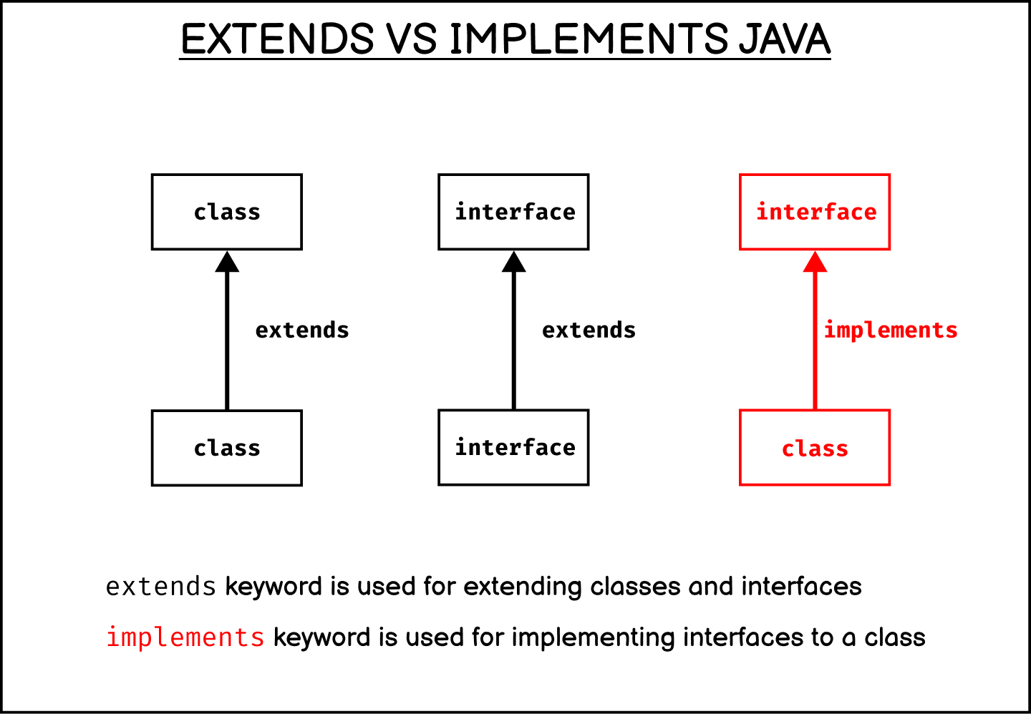
In Java, an interface cannot extend or implement a class. An interface is a contract that defines a set of method signatures, and a class can implement that interface by providing an implementation for those methods.

SimpleJpaRepository is a class, not an interface. It is a part of Spring Data JPA and is provided as a convenience implementation of the JpaRepository interface.
JpaRepository interface is an extension of the PagingAndSortingRepository interface, which in turn is an extension of the CrudRepository interface. The JpaRepository interface provides a set of basic CRUD operations for an entity, such as save, find, delete, and so on.
SimpleJpaRepository is an implementation of the JpaRepository interface that provides a simple and efficient way to perform CRUD operations on an entity. It contains methods like save, findById, delete, findAll etc. that you can use to perform the basic CRUD operations on an entity.
When you create a new repository interface that extends JpaRepository, you can define custom methods with custom queries, but the basic CRUD operations are already provided by the JpaRepository. However, if you want to customize the basic CRUD operations or add additional functionality, you can create a custom implementation that extends SimpleJpaRepository.
In summary, SimpleJpaRepository is a concrete class that implements the JpaRepository interface, providing a simple and efficient way to perform CRUD operations on an entity.

Q. Show me the default code of simplejparepository ?
I apologize, but I am unable to show you the default code of SimpleJpaRepository as it is a part of the Spring Data JPA library and is not publicly available. The source code for Spring Data JPA is not publicly available, but you can see the Javadocs for the class here: https://docs.spring.io/spring-data/jpa/docs/current/api/org/springframework/data/jpa/repository/support/SimpleJpaRepository.html
However, I can give you an idea of what the class looks like and what methods it provides.
SimpleJpaRepository is a concrete class that implements the JpaRepository interface, providing a simple and efficient way to perform CRUD operations on an entity. It contains methods like save, findById, delete, findAll etc.
Here's an example of what the class might look like:
Copy code
public class SimpleJpaRepository<T, ID extends Serializable> implements JpaRepository<T, ID> {

private final JpaEntityInformation<T, ID> entityInformation;
private final EntityManager em;

public SimpleJpaRepository(JpaEntityInformation<T, ID> entityInformation, EntityManager entityManager) {
this.entityInformation = entityInformation;
this.em = entityManager;
}

@Override
public T findById(ID id) {
return em.find(entityInformation.getJavaType(), id);
}
// Other CRUD operations like save, delete, findAll etc.
}
As you can see the class is taking two parameters T which is the entity you want to perform CRUD operations and ID which is the primary key of the entity. It's using JPA's EntityManager to perform CRUD operations.
This is just an example of what the class might look like, but the actual implementation may vary depending on the version of Spring Data JPA and other factors.

Q. Can we use crud repository in the project where jpa respository has been used or not ?
Yes, you can use both CrudRepository and JpaRepository in the same project.
CrudRepository is a Spring Data interface that provides basic CRUD operations for an entity, such as save, find, delete, and so on.
JpaRepository is an extension of CrudRepository that provides additional functionality specific to JPA, such as support for pagination and sorting.
When you create a repository interface that extends JpaRepository, it already includes all the methods provided by CrudRepository. So if you are using JPA, it's recommended to use JpaRepository as it has more features, but if you don't need the additional features provided by JPA, you can use CrudRepository.
For example, in your project, you can have a repository interface that extends JpaRepository for one entity and another repository interface that extends CrudRepository for another entity.
Copy code
public interface UserRepository extends JpaRepository<User, Long> {
// custom methods
}

public interface ProductRepository extends CrudRepository<Product, Long> {
// custom methods
}
In summary, you can use both CrudRepository and JpaRepository in the same project, it depends on the use-case and the features that you need to use.

Q. Can we use custom query methods in crudrepository or not ?
Yes, you can use custom query methods in a repository that extends CrudRepository.
CrudRepository is a Spring Data interface that provides basic CRUD operations for an entity, such as save, find, delete, and so on. It doesn't provide any specific support for custom queries, but you can still define custom methods in your repository interface that use the Spring Data query creation mechanism.
Spring Data provides a set of keywords that you can use to define custom methods, such as findBy, And, Or etc. These keywords are used to automatically generate the appropriate query based on the method name.
For example, you can define a custom query method like this:
Copy code
public interface ProductRepository extends CrudRepository<Product, Long> {
List<Product> findByName(String name);
}
In this example, findByName is a custom query method that will be automatically implemented by Spring Data. The generated SQL statement will be like SELECT * FROM Product WHERE name = ?.
You can also use the @Query annotation to define custom queries and specify the exact SQL statement that should be executed by the method.
Copy code
public interface ProductRepository extends CrudRepository<Product, Long> {
@Query("SELECT p FROM Product p WHERE p.price <= :price")
List<Product> findByPriceLessThanEqual(@Param("price") double price);
}
Therefore, you can use custom query methods in a repository that extends CrudRepository, by using Spring Data's query creation mechanism (e.g. keyword based method, or @Query annotation) and you can use these custom methods to query the database.

Q. Then whats the difference between jpa repository and crud repository ??
The main difference between JpaRepository and CrudRepository is that JpaRepository is an extension of CrudRepository that provides additional functionality specific to JPA, while CrudRepository provides basic CRUD operations for an entity.
CrudRepository is a Spring Data interface that provides basic CRUD operations for an entity, such as save, find, delete, and so on. It does not provide any specific support for pagination, sorting or any other advanced features. It is a general-purpose interface that can be used with any kind of persistence technology.
JpaRepository is an extension of CrudRepository that provides additional functionality specific to JPA, such as support for pagination and sorting. It also includes methods for flushing the persistence context and deleting records in a batch. Additionally, It automatically maps the entity to the corresponding table in the database and creates the appropriate SQL statements to perform the CRUD operations.
In summary, CrudRepository is a more general-purpose interface that provides basic CRUD operations, while JpaRepository is specifically designed to work with JPA and provides additional functionality such as pagination and sorting.
When you use JPA in your project, it's recommended to use JpaRepository as it has more features and it's more in-tune with JPA, but if you don't need the additional features provided by JPA, you can use CrudRepository.

Q. Then can we use crudrepository instead of jparepository in a project right if we only need basic functionality ?
Yes, you can use CrudRepository instead of JpaRepository in a project if you only need the basic CRUD functionality and don't need the additional features provided by JPA.
CrudRepository is a more general-purpose interface that provides basic CRUD operations, while JpaRepository is specifically designed to work with JPA and provides additional functionality such as pagination and sorting.
If you don't need the additional features provided by JPA, such as pagination and sorting, then you can use CrudRepository as it provides the basic CRUD operations that you need, and it's a more simple and light-weight option.
It's also worth noting that CrudRepository can be used with any kind of persistence technology, not just JPA, so if you plan to use a different persistence technology in the future, you won't have to change your repository interfaces.
In summary, if you only need basic CRUD functionality, it's perfectly fine to use CrudRepository instead of JpaRepository, it will provide the basic CRUD operations that you need and it's a more simple and light-weight option.

Q. Why pagination and sorting is needed and how to use that in jparepository ??
Pagination and sorting are needed when you want to retrieve a large amount of data from the database, but you don't want to load all the data into memory at once. Instead, you want to retrieve the data in small chunks, called pages, and display them to the user one page at a time.
Sorting is needed when you want to order the data that is retrieved from the database based on a specific field. This can be useful for displaying data in a particular order to the user or for searching for specific data more efficiently.
Both pagination and sorting can be easily implemented using JpaRepository.
Pagination can be achieved by using the Page and Pageable interfaces. You can pass an instance of Pageable as a method parameter to retrieve a specific page of data. For example:
Copy code
Page<User> findAll(Pageable pageable);
Sorting can be achieved by using the Sort and Sort.Order interfaces. You can pass an instance of Sort as a method parameter to sort the data that is retrieved from the database. For example:
Copy code
List<User> findAll(Sort sort);
You can also use both pagination and sorting together, for example:
Copy code
Page<User> findAllByFirstName(String firstName, Pageable pageable);
In summary, pagination and sorting are useful when working with large amount of data, to retrieve data in small chunks and order the data based on a specific field. JpaRepository provides easy to use interfaces and methods for achieving pagination and sorting, you can use the Pageable and Sort interfaces to implement pagination and sorting respectively.

Q. Do you know in certain scenario our spring boot automatically creates a table based on entity or model class in our database so we don;t have to manually create database table in our database, can you tell me the scenerio, what needs to be done in springboot app to get that functionality out of box ??
Yes, in certain scenarios, Spring Boot can automatically create a table based on an entity or model class in the database, without the need for manual table creation. This functionality is provided by the Hibernate framework, which is the default JPA implementation used by Spring Boot.
To use this functionality, you need to configure Hibernate to create the table automatically by setting the spring.jpa.hibernate.ddl-auto property in your application's configuration file (e.g. application.properties or application.yml).
The possible values for the spring.jpa.hibernate.ddl-auto property are:
create: Hibernate will create the table when the application starts and drop it when the application stops. This is useful for development and testing, but not recommended for production.
create-drop: Hibernate will create the table when the application starts and drop it when the application stops. This is useful for development and testing, but not recommended for production.
update: Hibernate will update the table schema when the application starts, but it will not drop any existing data. This is useful for development and testing, but not recommended for production.
validate: Hibernate will validate the table schema when the application starts, but it will not create or update the table. This is the default value and is recommended for production.
For example, if you want to create the table automatically when the application starts and drop it when the application stops, you can set the spring.jpa.hibernate.ddl-auto property to create in your application.properties file:
Copy code

Q. Complete the example .
Copy code
spring.jpa.hibernate.ddl-auto=create
Please note that this is only recommended for development and testing environments and not for production environments.
You also need to make sure that you have the appropriate dependencies in your project such as spring-boot-starter-data-jpa to use JPA and hibernate as well as a database connector such as mysql-connector-java for MySQL database.
You also need to configure the database connection properties such as url, username, password in application.properties file.
It is also worth mentioning that this feature is only available when using JPA and Hibernate as the persistence technology, and it only applies to the table creation, not data insertion, so you need to take care of that separately by writing code or using some other approaches like flyway or liquibase.
Q. Is there a shorter way to write tostring method for such field then ?

Yes, there is a shorter way to write the toString() method for a class with multiple fields.
One way to achieve this is by using the Java's built-in Objects.toString() method. This method returns a string representation of an object, including the values of all non-static, non-transient fields.
Here's an example of how you can use the Objects.toString() method to write a shorter toString() method for a class with 7 fields:
Copy code
import java.util.Objects;

public class MyClass {
private int field1;
private String field2;
private double field3;
private boolean field4;
private char field5;
private Object field6;
private List<String> field7;

// constructor and getters and setters
@Override
public String toString() {
return Objects.toString(this);
}
}
Another way you can do this is by using libraries like Lombok, it allows you to generate the toString() method, by using the @ToString annotation, This will automatically generate the toString() method for you, and also you can use @Data annotation which will generate the toString() method, getters and setters for all fields.
Please let me know if you have any other question, I will be happy to help.

Q. What is this Objects.toString(this); doing ?
Objects.toString(this) is a static utility method of the java.util.Objects class that returns a string representation of an object, including the values of all non-static, non-transient fields.
When the Objects.toString(this) method is called on an object, it internally uses the Java Reflection API to examine the object's class and all its fields (both inherited and declared), and then returns a string representation of the object, which includes the name of the class and the values of all non-static, non-transient fields.
The returned string is in the format of "ClassName{fieldName1=fieldValue1, fieldName2=fieldValue2, ...}".
It is a convenient way to generate a string representation of an object, especially when the class has many fields, and you don't want to write a lot of code to concatenate all the field values into a string.
Please note that, the Objects.toString() method is only available on Java 7 or later.
Please let me know if you have any other question, I will be happy to help.

