Digital Project:

Rabindra Kharga

Roll: 21204407

Electrical Engg.

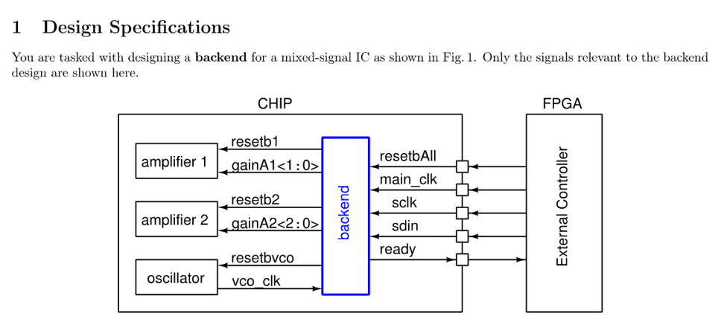

Designing backend of a mixed signal IC using Verilog:

Designing in such a way that backend has to execute startup sequence and provide data to the input of an IC

**Solution:**

**FPGA CODE in Verilog :**

//File Name: FPGA

// Type: Module

// Department : Electrical engineering

// Author: Rabindra Kharga

// Purpose: Module

// Operation : data control

// Date : 10 July 2023

///////////////////////////////////////////////////////////////////////////////

/*FPGA model

* Generates reset signal for the chip

* Sends out progamming bits to the chip

*/

module FPGA_model( i_resetbFPGA,

i_ready,

i_mainclk,

o_resetbAll,

o_sclk,

o_sdout);

//============================================================================

//Parameter declarations

parameter opcode_gainA1 = 1; //range: 0-3. Gain for amplifier 1

parameter opcode_gainA2 = 5; //range: 0-7. Gain for amplifier 2

//FPGA states

parameter sRESET = 0; //Reset all internal variables. Make o_resetbAll=0.

parameter sPROGRAM = 1; //Send programming bits to chip.

parameter sIDLE = 2; //Do nothing.

//===========================================================================

//Input output declarations

input i_resetbFPGA; //resets FPGA

input i_ready; //Alerts FPGA that chip is programmed and ready

input i_mainclk; //Main clock

output reg o_resetbAll; //Reset for the chip

output reg o_sclk; //Serial clock for communication

output reg o_sdout; //Serial data out from FPGA (to chip)

//Internal wire, reg declarations

reg [1:0] FPGAstate; //Holds the state of FPGA

reg [3:0] count; //Used for controlling sclk generation and transmission of serial data

reg mainclkby2, mainclkby4, mainclkby8, mainclkby16; //Low frequency clocks derived from mainclk

//=============================================================

//BEHAVIORAL DESCRIPTION

//=============================================================

// Setting the FPGA state

always @ (posedge(i_mainclk) or negedge(i_resetbFPGA))

begin

if(i_resetbFPGA == 0)

FPGAstate <= sRESET;

else

begin

case(FPGAstate)

sRESET: FPGAstate <= sPROGRAM;

sPROGRAM:

begin

if(count== 10)

FPGAstate <= sIDLE;

else

FPGAstate <= sPROGRAM;

end

sIDLE: FPGAstate <=sIDLE;

default: FPGAstate <= sIDLE;

endcase

end

end

//========================================================

/*resetbALL

* resetbAll=0, when FPGA is reset.

* resetbAll=1 at all other times.

*/

always @(posedge(i_mainclk) or negedge(i_resetbFPGA))

begin

if(i_resetbFPGA == 0)

o_resetbAll <= 0;

else

begin

if(FPGAstate == sRESET)

o_resetbAll <= 0;

else

o_resetbAll <= 1;

end

end

//==========================================================

/* Generation of low frequency clocks from mainclk using divide-by-2 method

*/

always @ (posedge(i_mainclk) or negedge(i_resetbFPGA))

begin

if(i_resetbFPGA == 0)

mainclkby2 <= 0;

else

mainclkby2 <= ~mainclkby2;

end

always @ (posedge(mainclkby2) or negedge(i_resetbFPGA))

begin

if(i_resetbFPGA == 0)

mainclkby4 <= 0;

else

mainclkby4 <= ~mainclkby4;

end

always @(posedge(mainclkby4) or negedge(i_resetbFPGA))

begin

if(i_resetbFPGA == 0)

mainclkby8 <= 0;

else

mainclkby8 <= ~mainclkby8;

end

always @(posedge(mainclkby8) or negedge(i_resetbFPGA))

begin

if(i_resetbFPGA == 0)

mainclkby16 <= 0;

else

mainclkby16 <= ~mainclkby16;

end

//==========================================================

/*count

* used for the generation of sclk and selecting the data to be sent in through sdin

*/

always @(posedge(mainclkby16) or negedge(i_resetbFPGA))

begin

if(i_resetbFPGA == 0)

count <= 0;

else

begin

if(FPGAstate == sPROGRAM)

begin

if(count == 11)

count <= count;

else

count <= count+1;

end

else

count <= count;

end

end

//=========================================================

/*sclk

* sclk is a clock only when the FPGA is programming the chip.

*/

always @ (posedge(mainclkby16) or negedge(i_resetbFPGA))

begin

if(i_resetbFPGA == 0)

o_sclk <= 1;

else

begin

if(FPGAstate == sPROGRAM)

begin

if (count >= 1 && count <= 10)

o_sclk <= ~o_sclk;

else

o_sclk <= 1;

end

else

o_sclk <= 1;

end

end

//=========================================================

/*sdin

*serial data out from FPGA

*/

always @ (negedge(o_sclk) or negedge(i_resetbFPGA))

begin

if(i_resetbFPGA == 0)

o_sdout <= 0;

else

begin

if(FPGAstate == sPROGRAM)

begin

case(count)

4'd2: o_sdout <= opcode_gainA1[0];

4'd4: o_sdout <= opcode_gainA1[1];

4'd6: o_sdout <= opcode_gainA2[0];

4'd8: o_sdout <= opcode_gainA2[1];

4'd10: o_sdout <= opcode_gainA2[2];

default: o_sdout <= o_sdout;

endcase

end

else

o_sdout <= 0;

end

end

//==========================================================

Endmodule

**BACKEND FILE VERILOG CODE:**

//File Name: BACKNED

// Type: Module

// Department : Electrical engineering

// Author: Sagar

//Author's Email ID: guptasagar19965@gmail.com

// Purpose:TEST

// Operation : TEST

// Date : 10 July 2023

// BACKEND DESIGN //

module backend( i_resetbAll,

i_clk,

i_sclk,

i_sdin,

i_vco_clk,

o_ready,

o_resetb1,

o_gainA1,

o_resetb2,

o_gainA2,

o_resetbvco,);

// INPUT OUTPUT REGISTERS DECLARATION //

input i_resetbAll, i_clk, i_sclk, i_sdin, i_vco_clk;

reg [4:0]data;

integer i;

output reg o_ready, o_resetb1, o_resetb2, o_resetbvco;

output reg [1:0] o_gainA1;

output reg [2:0] o_gainA2;

reg [4:0] shiftreg;

reg [4:0] shift2;

reg [2:0] count;

//take serial data from i_sdin and read the data using shift register

always @ ( posedge (i_sclk))

begin

shift2= shiftreg>>1;

shiftreg ={i_sdin, shift2[3:0]};

count<=count+1;

if (count==4)

begin

o_gainA1[0] <= shiftreg[0];

o_gainA1[1] <= shiftreg[1];

o_gainA2[0] <= shiftreg[2];

o_gainA2[1] <= shiftreg[3];

o_gainA2[2] <= shiftreg[4];

end

end

always@(posedge (i_clk) or negedge(i_resetbAll))

begin

if(i_resetbAll) //when i_resetbAll=1, the starup sequence in initiated

begin

for(i=0;i<5;i=i+1) // store data in reg data

begin

@(posedge i_sclk);

data <= {data[4:1],i_sdin};

end

repeat(2) // now we wait for two clock cycles

begin

@(posedge (i_clk) or negedge(i_resetbAll)) ;

end

o_resetbvco <=1; // set o_resetbvco=1

repeat(10) // wait for 10 clock cycles

begin

@(posedge (i_clk) or negedge(i_resetbAll)) ;

end

o_resetb1 <=1;// set o_resetb1=1

o_resetb2<=1;// set o_resetb2=1

repeat(10) // wait for 10 clock cycles

begin

@(posedge (i_clk) or negedge(i_resetbAll)) ;

end

o_ready<=1; // set o_ready=1

end

else // when i_resetbAll=0 all outputs of the backend should be pulled to zero

begin

o_ready <= 0;

o_resetb1 <= 0;

o_resetb2 <= 0;

o_resetbvco <= 0;

o_gainA1[0] <= 0;

o_gainA1[1] <= 0;

o_gainA2[0] <= 0;

o_gainA2[1] <= 0;

o_gainA2[2] <= 0;

shiftreg <=0;

shift2 <= 0;

count <= 0;

data <=0;

end

end

//====================================================================================

Endmodule

**BACKEND TEST BENCH:**

//File Name: Testbanch of FPGA

// Type: Module

// Department : Electrical engineering

// Author: Sagar

//Author's Email ID: guptasagar19965@gmail.com

// Purpose: BACKEND TEST

// Operation : TEST

// Date : 10 July 2023

// Testbanch module for the backend. This is has a module instantiation for

// the FPGA_model and the backend.

`timescale 1ns / 1ps

//==========================================================================

//Change the Verilog filenames approppriately.

`include "FPGA_model.v"

`include "backend.v"

//=========================================================================

module backend_tb();

reg resetbFPGA;

reg main_clk;

wire [1:0]gainA1 ;

wire [2:0]gainA2 ;

wire resetbAll, resetb1, resetb2, resetbvco;

wire vco_clk;

wire sclk, sdin;

wire ready;

//==========================================================================

//FPGA model instantiation

FPGA_model FPGA_obj( .i_resetbFPGA (resetbFPGA),

.i_ready (ready),

.o_resetbAll (resetbAll),

.i_mainclk (main_clk),

.o_sclk (sclk),

.o_sdout (sdin));

// Backend instantiation

backend backend_obj ( .i_resetbAll (resetbAll),

.i_clk (main_clk),

.i_sclk (sclk),

.i_sdin (sdin),

.i_vco_clk (vco_clk),

.o_ready (ready),

.o_resetb1 (resetb1),

.o_gainA1 (gainA1),

.o_resetb2 (resetb2),

.o_gainA2 (gainA2),

.o_resetbvco (resetbvco)

);

//============================================================================

//Test signal generation

initial

begin

resetbFPGA <= 0;

main_clk <= 0;

#1 resetbFPGA <= 1;

end

initial

begin

$dumpfile("Sagar.vcd");

$dumpvars(0,backend_tb);

end

//Generation of main_clk

always #2.5 main_clk <= ~main_clk;

initial

#6000 $finish;

//============================================================================

Endmodule

**SIMULATION OUTPUT:**

