Rabindra Kharga

Analog Project:

Roll:21204407

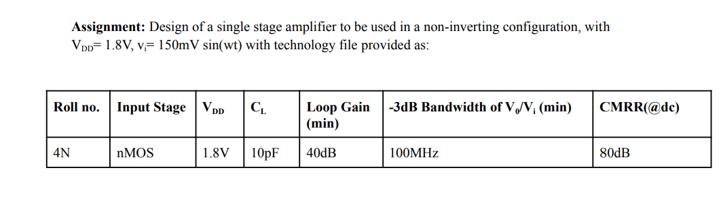

Initially, from the given -3dB bandwidth in the assignment, I calculated transconductance (gm1) which is equal to the unity gain bandwidth (UGB) of open loop system.

To find the gm1 value I started DC biasing of circuit using differential amplifier but with differential amplifier the loop gain of my opamp was less than 40dB and to achieve desired gain I approached to Cascode configuration.

Circuit schematic for the Telescopic Opamp:

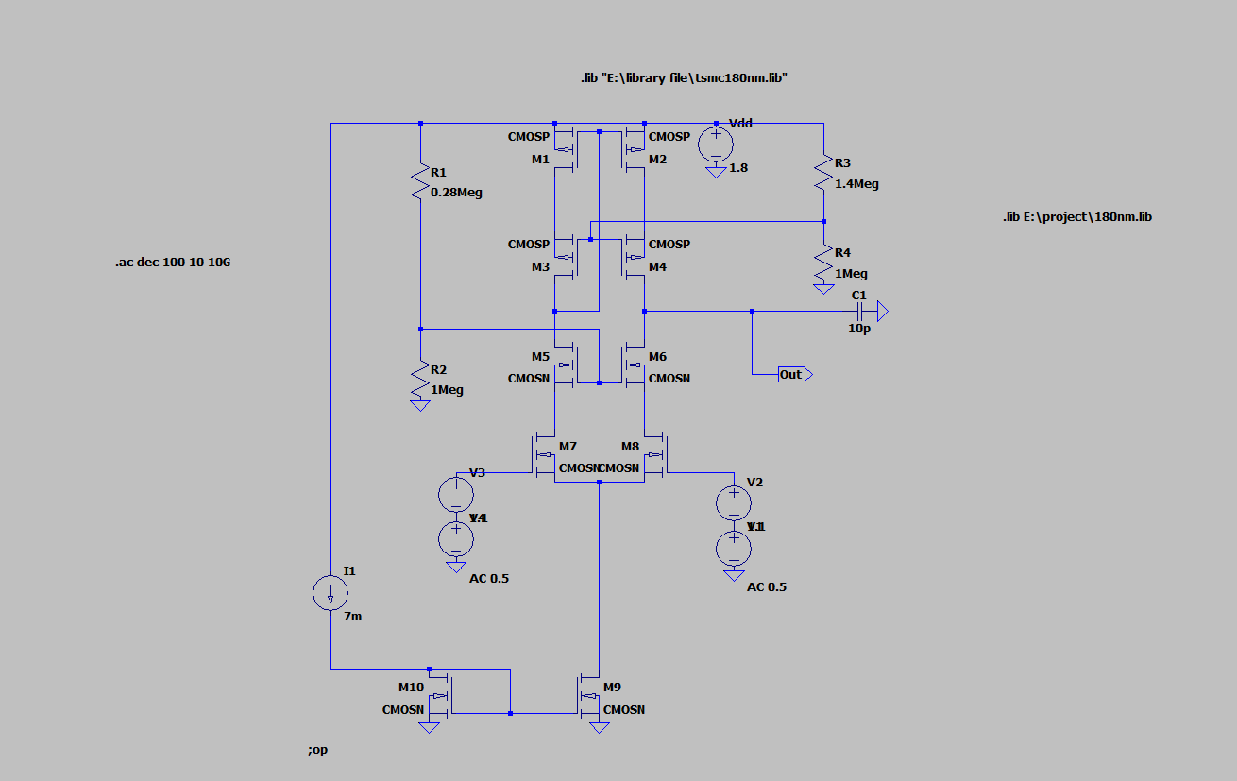

Common mode: open loop gain

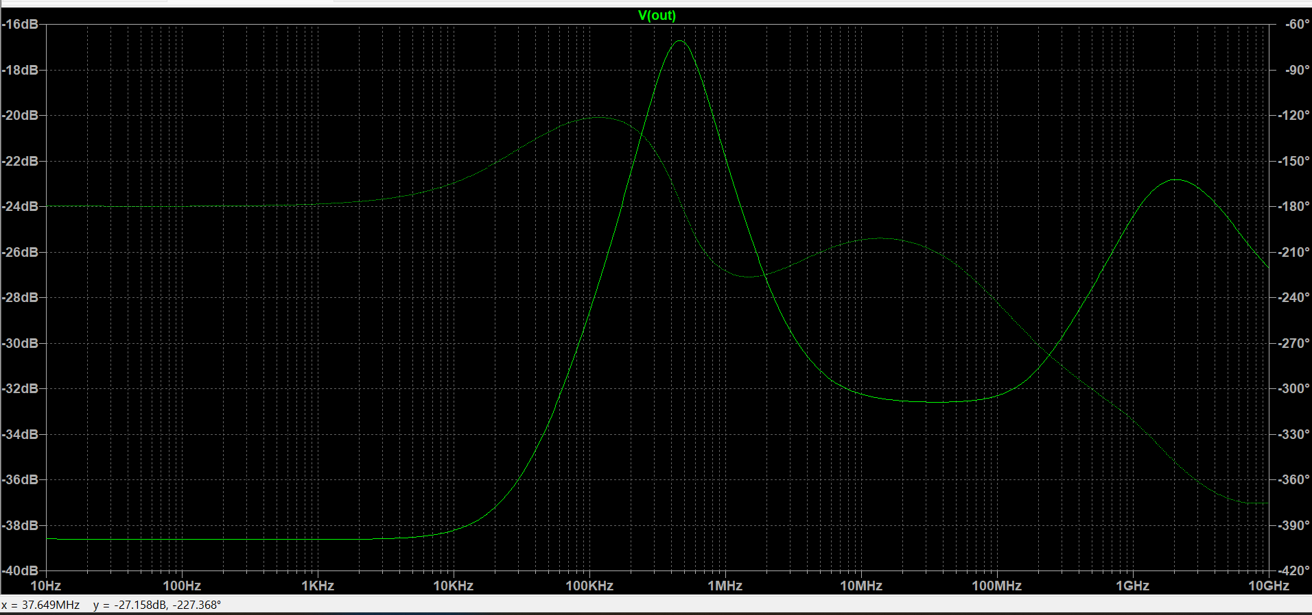

Common mode gain Ac=-38db

Differential open loop gain:

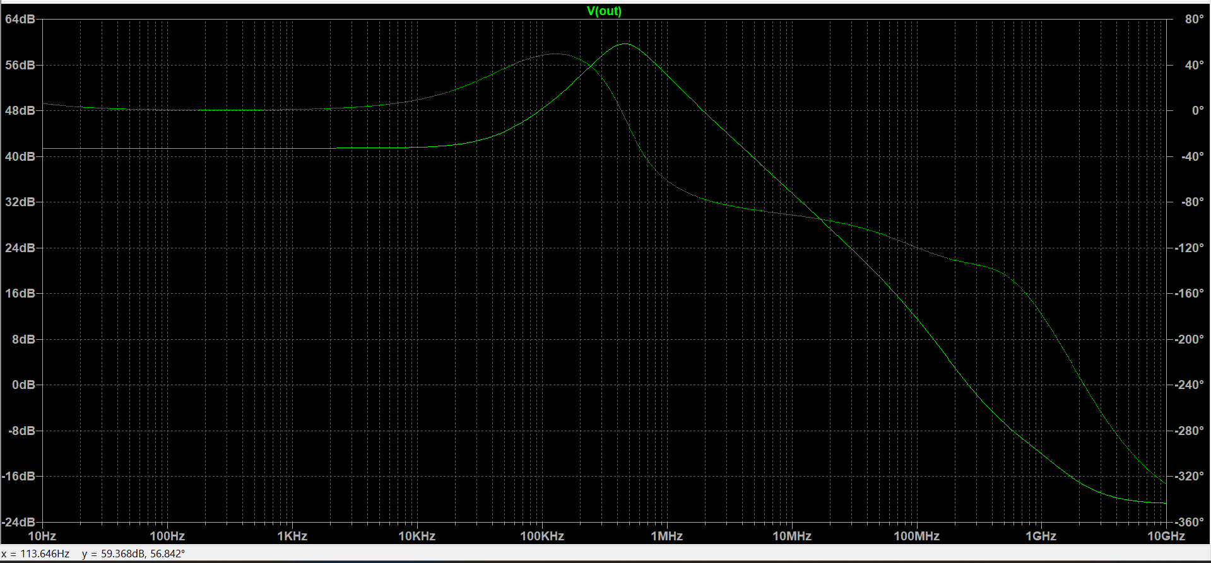

Differential mode gain Ad=42db

CMRR=42-(-38)

=80db

With Inductor Gain Increases:

