**NEPATHYA COLLEGE**

**Tribhuvan University**

**Institute of Science and Technology**



**PNEUMONIA DETECTION SYSTEM**

**A PROJECT REPORT**

**Submitted to:**

**Nepathya College**

**Department of Computer Science and Information Technology**

**Tilottama-2, Rupandehi**

**In partial fulfillment of the requirements for the Bachelor’s Degree in Computer Science and Information Technology (B.Sc.CSIT)**

**Submitted by:**

**Abhishek Adhikari [21959/075]**

**Prabin Poudel [21978/075]**

**Rabin Pokhrel [21984/075]  
  
March, 2023**

**Student Declaration**

We hereby declare that project report entitled “**PNEUMONIA DETECTION SYSTEM**” submitted in partial fulfillment of the requirement for Bachelor's Degree in Computer Science and Information Technology of Tribhuvan University, is our original work and not submitted for the award of any other degree, diploma, fellowship, or any other similar title or prize.

…………………….

Abhishek Adhikari (21959/075)

………………………..

Prabin Poudel(21978/075)

………………………..

Rabin Pokhrel (21984/075)

**Supervisor’s Recommendation**

I hereby recommend that this project prepared under my supervision by Abhishek Adhikari, Prabin Poudel and Rabin Pokhrel entitled “PNEUMONIA DETECTION SYSTEM” in partial fulfillment of the requirements for the degree of B.Sc.in Computer Science and Information Technology be processed for the evaluation.

…………………………………..

Mr. Ananta Pandey

Project Supervisor

Nepathya College

**NEPATHYA COLLEGE**

**Tribhuvan University**



**LETTER OF APPROVAL**

This is to certify that this project prepared by **Ananta Pandey** entitled “**CTB-MAC: Cluster Based TDMA MAC Protocol for Mobile Ad-Hoc Network**” in partial fulfillment of the requirement for Bachelor's Degree in Computer Science and Information Technology of Tribhuvan University has been well studied. In our opinion it is satisfactory in the scope and quality as a project for the required degree.

|  |  |
| --- | --- |
| ……………………………………  Mr. Ananta Pandey  Supervisor, HOD  Nepathya College | …………………………………………..  Mr. Sanjeev Bhandari  Principal  Nepathya College |
| …………………………………………  Mr. Dinesh Neupane Internal Examiner Nepathya College | …………………………………………..  External Examiner  IOST, Tribhuvan University |

## **Acknowledgement**

It is a great pleasure to have the opportunity to extend our heartfelt gratitude to everyone who helped us throughout the course of this project. We are profoundly grateful to our supervisor and Head of Department **Mr. Ananta Pandey**, for his expert guidance, continuous encouragement and ever willingness to spare time from his otherwise busy schedule for the project’s progress reviews. His continuous inspiration has made us complete this project and achieve its target.

We would also like to express our deepest appreciation to **Mr. Sanjeev Bhandari**, Principal, for his constant motivation, support and for providing us with a suitable working environment. We would also like to extend our sincere regards to all the faculty members for their support and encouragement.

At last our special thanks go to all staff members of the BSc. CSIT department who directly and indirectly extended their hands in making this project a success.

## **Abstract**

Pneumonia is a debilitating disease that poses a serious threat to the health of individuals, particularly those with weakened immune systems, such as the elderly, young children, and people with underlying medical conditions. Pneumonia can be caused by various pathogens, including viruses, bacteria, and fungi. An accurate biomedical diagnosis of pneumonia is crucial for effective treatment, which in turn can lead to improved outcomes for patients. However, the diagnosis of pneumonia can be hindered by various factors, including the lack of available experts, tools, and resources. Therefore, there is a pressing need for innovative solutions to address this challenge. One promising approach is the use of machine learning and deep learning algorithms, which can analyze X-ray images to accurately detect the presence of pneumonia.

This project aims to develop a real-time pneumonia detection system using X-ray images. Specifically, the project proposes a Convolutional Neural Network (CNN) system for the detection of pneumonia. The proposed system includes models developed using a range of algorithms from machine learning and deep learning to enable accurate and efficient analysis of X-ray images. Additionally, the project utilizes powerful software packages in Python such as TensorFlow, Seaborn, Keras, Pandas, NumPy, and Gradio to create an application software that recognizes the presence of pneumonia in X-ray images. By leveraging the power of these tools, this project can accurately and efficiently analyze X-ray images to detect pneumonia, which can facilitate earlier and more accurate diagnoses. This, in turn, can lead to improved treatment outcomes, reduced healthcare costs, and a better quality of life for patients.

Overall, this project represents a significant step forward in the development of innovative solutions for the diagnosis and treatment of pneumonia. By combining advanced technology with expert knowledge and resources, we can improve the health outcomes of individuals affected by this disease.

Table of Content

Acknowledgement v

Abstract vi

CHAPTER 1: INTRODUCTION 1

**1.1.** **Introduction** 1

**1.2. Problem Definition** 2

**1.3. Objectives** 2

**1.4. Scope and Limitation** 3

**1.6. Report Organization** 5

CHAPTER 2: BACKGROUND STUDY AND LITERATURE REVIEW 6

**2.1. Background Study** 6

**2.2. Literature Review** 7

CHAPTER 3: SYSTEM ANALYSIS 8

**3.1. System Analysis** 8

**3.1.1. Requirement Analysis** 8

**i.** **Functional Requirements** 8

**ii.** **Non Functional Requirements** 9

**3.1.2. Feasibility Analysis** 10

**3.1.3. Analysis** 12

**i.** **ER Diagram** 12

**ii.** **Data Flow Diagram** 13

CHAPTER 4: SYSTEM DESIGN 14

**4.1. Activity Diagram** 14

**4.2. System Design** 15

**4.2. Algorithm Details** 16

CHAPTER 5: IMPLEMENTATION AND TESTING 17

**5.1.** **Implementation** 17

**5.1.1.** **The Database** 17

**5.1.2 Tools Used** 18

**5.1.2.1 Case tools** 18

**5.1.2.2 Language Used** 18

**5.1.2.3 Database platform** 18

**5.1.3** **Implementation Details of Modules** 18

**5.1.4** **Overview of CNN Architecture** 20

**i.** **Input Layer** 20

**ii.** **Convolutional and Pooling Layer** 20

**iii.** **Fully Connected Layer** 21

**iv.** **Output Layer** 21

**5.2.** **Testing** 22

**5.2.1.** **Test Cases for Unit Testing** 22

**5.3.** **Result Analysis** 24

CHAPTER 6: Conclusion and Future Recommendations 26

**6.1 Conclusion** 26

**6.2 Future Recommendations and Enhancements** 26

References 27

**For information about pneumonia and its situation in Nepal** 27

**For information about related work in this particular domain** 27

**List of Figures**

Figure 1. Development Methodology 4

Figure 2. Report Structure 5

Figure 3. Use case Diagram 9

Figure 4. Gantt chart for scheduling activities 11

Figure 5. Data Modeling using ER Diagram 12

Figure 6. DFD Level 0 13

Figure 7. DFD Level 1 13

Figure 8. Database Structure 17

Figure 9. Architecture of CNN 20

Figure 10. Epoch vs Accuracy while training and testing………………………………..24 Figure 11. Epoch vs Accuracy while training and testing………………………………..24 Figure 12. Confusion Matrix……………………………………………………………..25

**List of Tables**

Table 5.1.2 1. Case Tools 18

Table 5.2. 2. Unit Testing 22

Table 5.2. 3. System Testing 23

**List of Abbreviations:**

CNN - Convolutional Neural Network

GPU - Graphics Processing Unit

Open CV - Open Source Computer Vision Library

PCA - Principal Component Analysis

# **CHAPTER 1: INTRODUCTION**

### **Introduction**

Pneumonia is a form of acute respiratory infection that impacts the lungs, which are composed of alveoli that are small sacs. When healthy people breathe, their lungs should be allowed to fill with air. People who have pneumonia have alveoli that fill with pus and fluid, which makes breathing painful and limits the amount of oxygen that can be absorbed. Pneumonia is the single most important contributor to infant mortality around the world. The diagnosis of pneumonia requires a review of chest radiography (CXR) by a highly qualified specialist, laboratory tests, vital signs, and clinical history, which makes its detection a difficult task. It normally presents as an area of increased opacity within the CXR.

The purpose of this project is to develop a PNEUMONIA DETECTION SYSTEM which can classify an image into two different classes. In addition, the improvement of the validation accuracy compared to the other existing systems as well as to maintain commendable and equal or nearly equal prediction rate for each class will also be addressed.

### **1.2. Problem Definition**

The goal of this project is to develop a pneumonia detection system using machine learning techniques. Pneumonia is a serious respiratory illness that can be fatal if not detected and treated early. Currently, pneumonia is diagnosed by examining chest X-rays and other medical tests, which can be time-consuming and require specialized expertise. Therefore, developing an automated pneumonia detection system that can accurately analyze chest X-rays and quickly identify potential cases of pneumonia would be a valuable tool for healthcare professionals. The system should be able to take in digital 10 chest X-ray images as input, and provide a binary output indicating whether the image is positive or negative for pneumonia. To achieve this, the project will involve building a dataset of chest X-ray images that includes both positive and negative cases of pneumonia, and using machine learning algorithms to train a model that can accurately classify the images. The model should be able to achieve high accuracy, precision, and recall in detecting pneumonia cases, while minimizing false positives and false negatives. Additionally, the system should be designed to be user-friendly and easily accessible for healthcare professionals, with an intuitive user interface that allows for easy uploading and analysis of X-ray images. Finally, the system should be rigorously tested and validated using real-world clinical data to ensure its accuracy and reliability in a clinical setting.

### **1.3. Objectives**

* To develop a dataset of chest X-ray images that includes both positive and negative cases of pneumonia, and ensure the data is of high quality and labeled correctly.
* To train a machine learning model using the dataset to accurately classify chest X-ray images as positive or negative for pneumonia.
* To optimize the machine learning model to achieve high accuracy, precision, and recall in detecting pneumonia cases, while minimizing false positives and false negatives.
* To develop a user-friendly interface that allows healthcare professionals to easily upload and analyze chest X-ray images using the pneumonia detection system.
* To document the development process and methodology, including data collection, preprocessing, model training, and evaluation, to ensure the system is transparent and reproducible.

### **1.4. Scope and Limitation**

The scope of this project is limited to developing a pneumonia detection system using machine learning techniques. The system will be designed to take in digital chest X-ray images as input and provide a binary output indicating whether the image is positive or negative for pneumonia. The project will involve collecting and preprocessing a dataset of chest X-ray images that includes both positive and negative cases of pneumonia, training a machine learning model to accurately classify the images, and developing a user-friendly interface for healthcare professionals to use the system.

**Limitations:**

There are several limitations to the scope of this project:

* The accuracy of the system may be affected by the quality of the chest X-ray images, including issues such as poor image resolution or misalignment.
* The system may not be able to detect pneumonia cases that are atypical or not visible on chest X-ray images.
* The system may not be able to accurately detect pneumonia cases in patients with underlying lung diseases or conditions that affect the appearance of chest X-ray images.
* The system may not be able to differentiate between different types of pneumonia, such as bacterial, viral, or fungal pneumonia.

**1.5. Development Methodology**

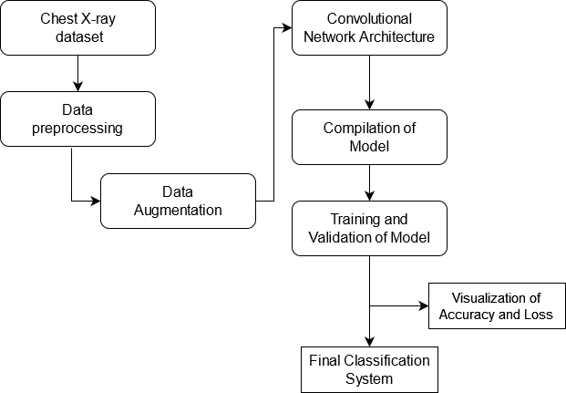

**Figure 1. Development Methodology**

The process begins by inputting a dataset of chest X-ray images, which undergoes preprocessing where preprocessing involves steps like resizing the images to a consistent size , converting them to grayscale, and normalizing their pixel values to a standard range. Additionally, the images may undergo filtering or noise reduction to improve their clarity. After that, the input images undergo data augmentation to improve quality and quantity of the dataset. The images then fed into a convolutional neural network (CNN) architecture, which is trained using Adam optimizer with accuracy as the evaluation metrics. During training, the model learns to identify patterns in the X-ray images that indicate the presence of pneumonia. Once training is complete, the model is evaluated on separate validation dataset to assess its performance. The output of the system includes visualizations of accuracy and loss, as well as the final classification results for each X-ray image. By automating the process of pneumonia detection, this system can improve the efficiency and accuracy of diagnosis, leading to better outcomes for patients.

### **1.6. Report Organization**

The diagram for the report structure is shown below:

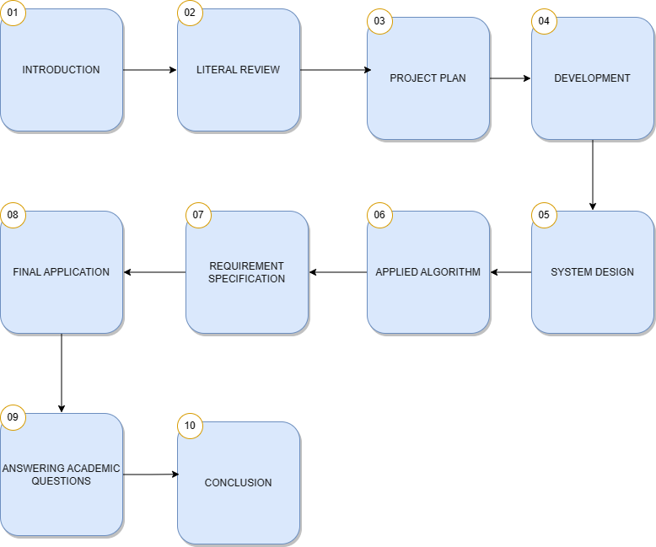

**Figure 2. Report Structure**

# **CHAPTER 2: BACKGROUND STUDY AND LITERATURE REVIEW**

### **2.1. Background Study**

Pneumonia is a respiratory disease that affects millions of people worldwide and is a leading cause of death, particularly among children and the elderly. Early and accurate diagnosis of pneumonia is crucial for effective treatment and improved outcomes. This has led to the development of various pneumonia detection systems that use artificial intelligence and machine learning algorithms to analyze medical images and detect signs of pneumonia. The first step in developing a pneumonia detection system is to gain a thorough understanding of the disease, including its causes, symptoms, and diagnostic methods. This includes understanding the different types of pneumonia, such as bacterial, viral, and fungal pneumonia, and how they manifest on medical images. Researchers must also be familiar with the imaging modalities used to diagnose pneumonia, such as chest X-rays. The development of a pneumonia detection system involves collecting a large dataset of medical images and associated clinical data. The dataset is used to train machine learning algorithms to recognize patterns and features that are indicative of pneumonia. Different machine learning algorithms can be used, such as convolutional neural networks (CNNs), DenseNet. Researchers must also determine the appropriate preprocessing techniques and feature extraction methods to use with the dataset. Validation of the pneumonia detection system involves evaluating its accuracy, sensitivity, and specificity on a separate dataset of medical images. This ensures that the system can accurately diagnose pneumonia and distinguish it from other lung diseases and normal lung tissue. Finally, the system can be integrated into clinical practice to aid physicians in making accurate and timely diagnoses of pneumonia.

### **2.2. Literature Review**

The detection of pneumonia through chest X-rays has been a challenging issue for a considerable time, mainly due to the limited availability of public data. Several conventional machine learning techniques have been extensively explored to address this problem. [4] Sharma et al. and Stephen et al. have designed uncomplicated convolutional neural network (CNN) architectures to classify pneumonic chest X-ray images. They have employed data augmentation to overcome the scarcity of data, resulting in a 90.68% and 93.73% accuracy rate, respectively, on the Kermany dataset. However, data augmentation can only provide a limited amount of new information for the CNNs to learn and may not significantly enhance their performance. In contrast,[5] Rajpukar, Jeremy Irvin, et al. have utilized the DenseNet-121 CNN model for pneumonia classification but obtained only a 76.8% f1-score for classification. They suspected that the lack of patient history was a significant reason for the inferior performance of their deep learning model and the radiologists with whom they compared the performance of their method. Additionally, [9] Zhang et al. have suggested a confidence-aware module for detecting anomalies in lung X-ray images, treating the detection task as a one-class problem to identify only the anomalies. They have achieved an 83.61% AUC score on their dataset. To overcome the data scarcity issue in biomedical image classification tasks, transfer learning has emerged as a frequently employed method. In this approach, the knowledge gained from a vast dataset is used to fine-tune the model on a smaller current dataset. Recently, [6] Rahman et al., [9] Liang et al., [7] Ibrahim et al., and [8] Zubair et al. have employed purely transfer learning techniques, utilizing different CNN models pre-trained on ImageNet data for pneumonia classification.

# **CHAPTER 3: SYSTEM ANALYSIS**

### **3.1. System Analysis**

System analysis is an important step in the development of a pneumonia detection system. It involves breaking down the system into its component parts, analyzing how they interact with each other, and identifying potential areas for improvement. Some of the key components of a pneumonia detection system include: Data collection: The system must be able to collect high-quality medical imaging data, such as chest X-rays or CT scans, from patients who may have pneumonia. Data preprocessing: The collected data must be preprocessed to ensure that it is of high quality and suitable for use in the machine learning algorithms. This may involve tasks such as noise reduction, image segmentation, and normalization. Feature extraction: The system must be able to extract relevant features from the preprocessed data. For example, features such as the presence of opacities or consolidations in chest X-rays may be indicative of pneumonia. Machine learning algorithms: The system must use machine learning algorithms to analyze the extracted features and make a diagnosis of pneumonia. Different algorithms, such as convolutional neural networks or decision trees, may be used for this task. Diagnosis and reporting: The system must be able to accurately diagnose cases of pneumonia and report its findings to healthcare providers in a timely manner.

#### **3.1.1. Requirement Analysis**

##### **Functional Requirements**

1. User should be able to upload the chest X-ray images for Pneumonia detection.
2. System should be able to preprocess the uploaded images for the feature extraction.
3. System should be able to apply CNN to the preprocessed image to detect pneumonia.
4. System should be able to display the detection result to the user.
5. User should be able to view their detection result.

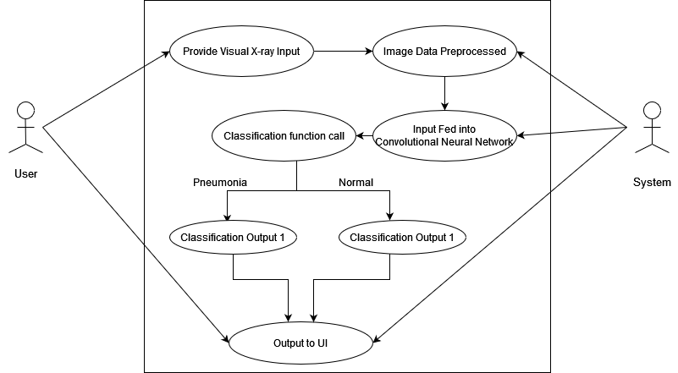

**Figure 3. Use case Diagram**

##### **Non Functional Requirements**

Non-functional requirements for a pneumonia detection system may include:

**Reliability:** The system must be reliable and accurate in detecting pneumonia, with minimal false positives or false negatives.

**Performance**: The system should be able to process a large volume of data and deliver results quickly to ensure timely diagnosis and treatment.

**Usability**: The system should have an intuitive user interface that is easy to use and understand, even for users with limited technical knowledge.

**Accessibility**: The system should be accessible to a wide range of users, including those with disabilities or limited English proficiency.

**Security**: The system must be secure and protect patient data from unauthorized access or breach, in compliance with relevant data protection regulations.

**Scalability**: The system should be able to handle an increasing volume of data and users as the demand grows.

**Interoperability**: The system should be able to integrate with other healthcare systems, such as electronic medical records, to ensure seamless sharing of information.

**Maintainability**: The system should be designed for easy maintenance, with clear documentation and support available to assist users in troubleshooting any issues that arise.

#### **3.1.2. Feasibility Analysis**

1. **Technical**

It is technically feasible as we get the data which are publicly available. We build a CNN model for the classification. The modern-day computer with such computing power is enough to do such things for completion of this project. All the other resources that are required for the development of this system are easily available.

1. **Operational**

The development of this system is operationally feasible because it will have a good user interface with better usability and understandability. The system can be used by any person who cannot afford a radiologist or can’t find one to get help.

1. **Economical**

The development of this system is economically feasible. The only thing that is to be done is making an environment for development with effective supervision. This system will solve the problem of unavailability of radiologists and burden of expensive machines for evaluating x-ray. So, this system is economically feasible.

1. **Schedule**

Assessing the schedule feasibility of a pneumonia detection system depends on several factors, including the project scope, available resources, and project timeline. Generally, developing a pneumonia detection system involves several stages, including data collection, data preprocessing, model selection and development, testing, and deployment. Each of these stages requires a considerable amount of time and effort**.**

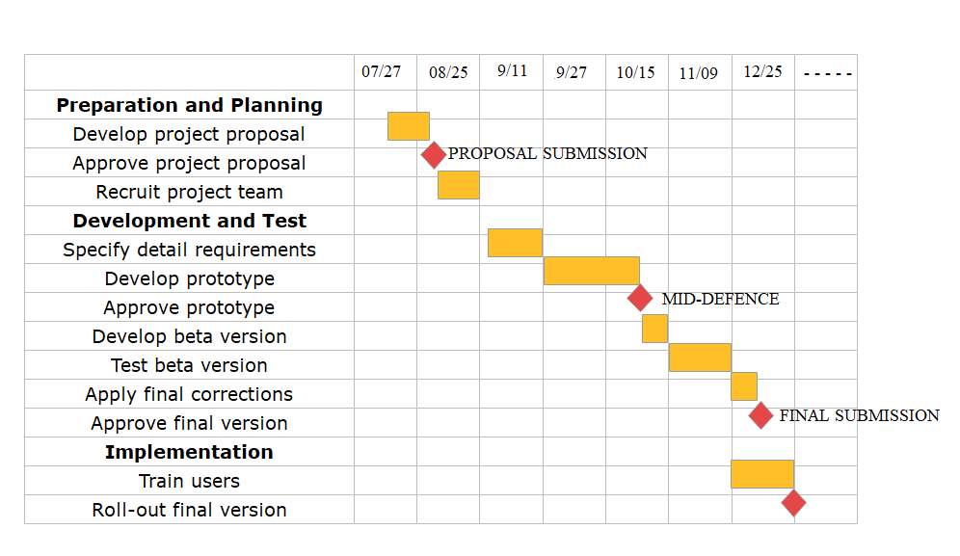

**Figure 4. Gantt chart for scheduling activities**

#### **3.1.3. Analysis**

##### **ER Diagram**

An Entity-Relationship (ER) diagram is a form of data model that graphically depicts the relationships between entities (things) in a system and how they relate to one another. In the case of a pneumonia detection system, we may create an ER diagram to show the various system components and their connections. The data modeling of the ER diagram used in the project is shown in the following figure.

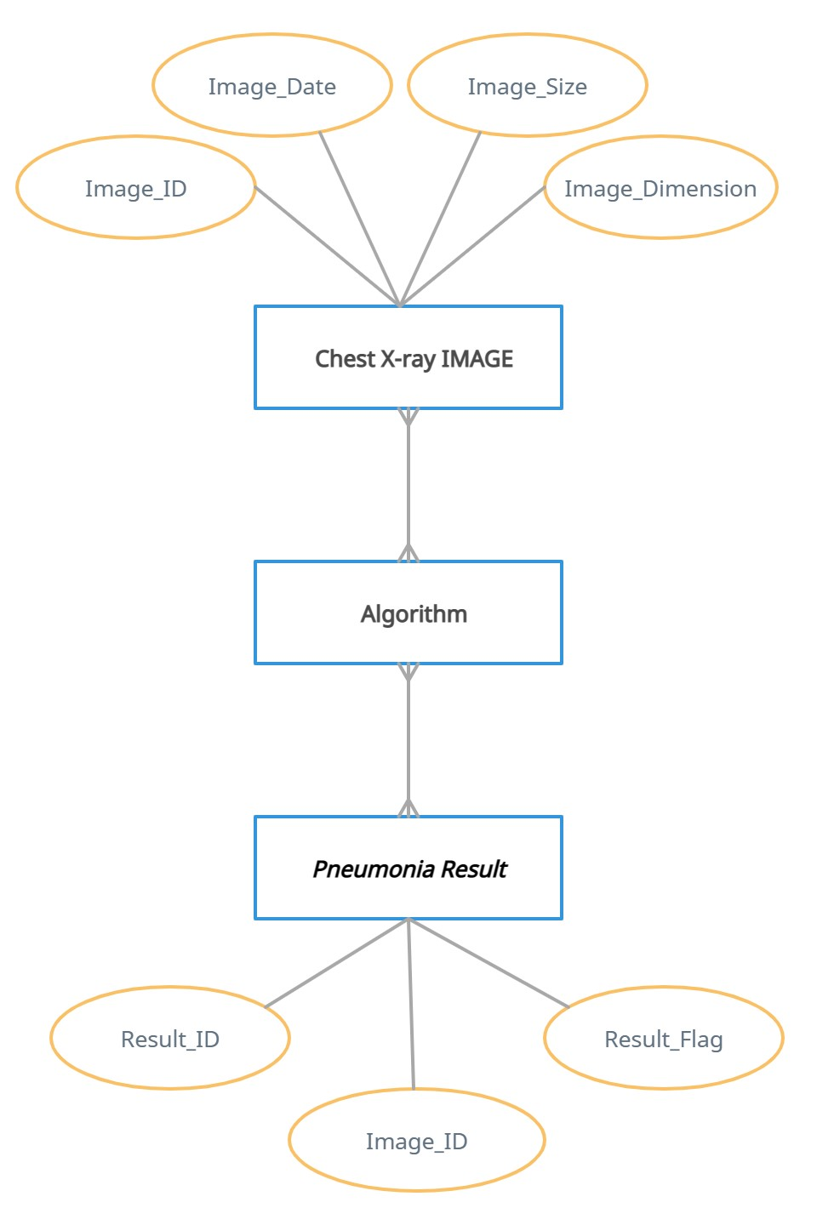

**Figure 5. Data Modeling using ER Diagram**

##### **Data Flow Diagram**

##### 

A data flow diagram (DFD) is a graphical representation of the “flow” of data through an information system, modelling its process aspects. A DFD is often used as a preliminary step to create an overview of the system without going into great detail, which can later be elaborated. DFDs can also be used for the visualization of data processing (structured design). A data flow diagram can dive into progressively more detail by using levels and layers, zeroing in on a particular piece. DFD levels are numbered 0, 1 or 2, and occasionally go to even Level 3 or beyond. The necessary level of detail depends on the scope of what you are trying to accomplish.

**Level 0**

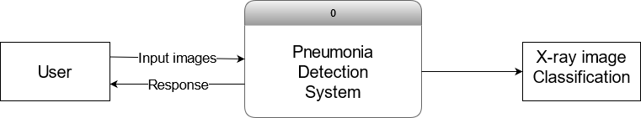

**Figure 6. DFD Level 0**

**Level 1**

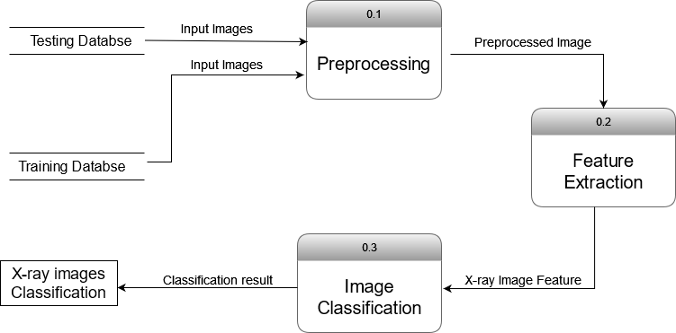

**Figure 7. DFD Level 1**

# **CHAPTER 4: SYSTEM DESIGN**

### **4.1. Activity Diagram**

An activity diagram is a behavioral diagram to depict the behavior of system. It is a visual representation of the flow of activities or actions that occurs in a system/process workflow.

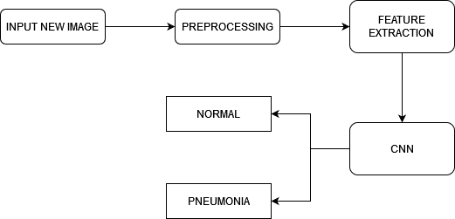

### **4.2. System Design**

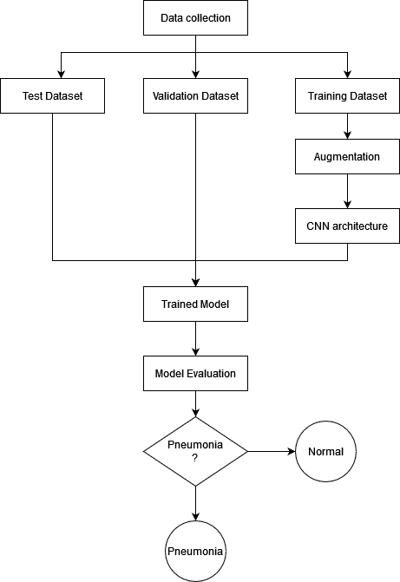

The system design includes several components such as front-end user interface, backend serve and machine learning models. The frontend is responsible for accepting the user input, such as uploading the X-ray images for analysis. These images are passed to the backend server for processing. The backend server is responsible for processing machine learning models used to analyze images and detect the signs of Pneumonia. When the X-ray image is uploaded, the backend server uses models to predict whether the image contains the signs of Pneumonia. Once the predictions are generated, the results are returned to the frontend UI for the user to view.

### **4.2. Algorithm Details**

Step 1: Collection of dataset of chest X-ray images (In this case, the Chest X-ray images from Kaggle has been used)

Step 2: Pre-processing of images

Step 3: Training a CNN model using the pre-processed images.

Step 4: During training, Neural network Forward propagation and backward propagation performed on the pixel values.

Step 5: The model architecture with Convolution2D layers generating feature maps followed by MaxPooling2D layers to reduce the spatial dimensions of the feature maps.

Step 6: The final layer of the model should be a Dense layer with two units, one for each class (pneumonia or normal), followed by Softmax activation function to generate the probabilities of each class.

Step 7: The model is able to predict whether a given chest X-ray image is indicative of pneumonia or not.

# **CHAPTER 5: IMPLEMENTATION AND TESTING**

### **Implementation**

#### **The Database**

The dataset, used for training the model is from a Kaggle which consists of chest X-ray images of patients with pneumonia and normal lungs. A total of 5856 image datasets are available, containing Chest X-ray images of pediatric patients aged one to five years old, collected from Guangzhou Women and Children’s Medical Center in Guangzhou. The datasets are divided into two main categories based on the medical condition: 'NORMAL' for healthy cases and 'PNEUMONIA' for pneumonia cases. To facilitate model development and evaluation, the dataset has been split into three distinct subsets, namely training, testing, and validation sets.

To prepare the dataset for machine learning, the images were preprocessed by resizing them to 150 X 150 pixels and normalizing the pixel values to the range [0, 1].

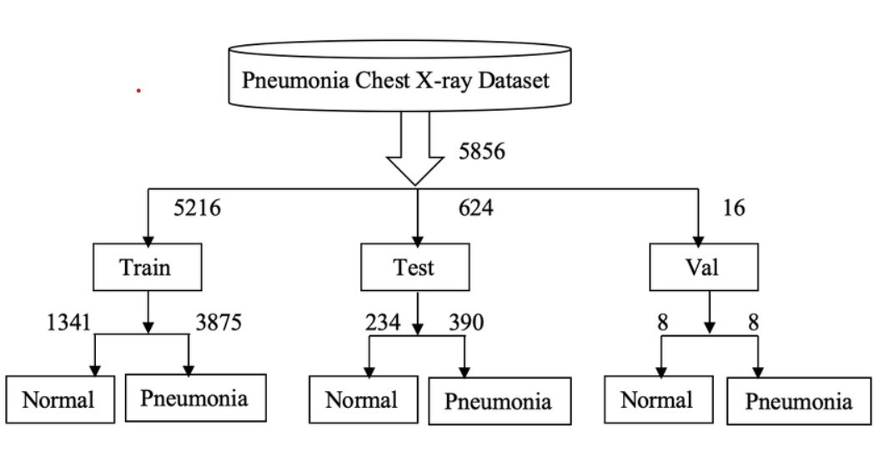

**Figure 8. Database Structure**

#### **5.1.2 Tools Used**

##### **5.1.2.1 Case tools**

**Table 5.1.2 1. Case Tools**

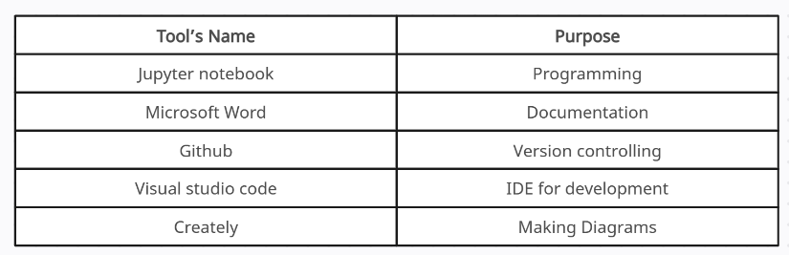

##### **5.1.2.2 Language Used**

* Python

##### **5.1.2.3 Database platform**

* Kaggle

#### **5.1.3** **Implementation Details of Modules**

* **NumPy:** NumPy is an acronym for “Numeric Python” or “Numerical Python”. NumPy is a Python library used for working with arrays of data. It provides a wide range of mathematical functions. Also a tools for performing a complex mathematical operations, like a linear algebra. In this case, NumPy is used for handling and manipulating multidimensional arrays, which are used to represent the images that are analyzed by the CNNs. The input images are first converted into arrays of pixel values, which are then processed by the CNN to detect features that are indicative of Pneumonia.
* **Pandas:** Pandas is a Python library used for data manipulation and analysis. It provides tools for working with the structured data, such as tabular data or time series data, and it includes functions for filtering, merging grouping, and aggregating data. Pandas are commonly used in data science and is a popular tool for data wrangling and cleaning. In this case, Pandas are used to generate summary statistics and visualizations of the data.
* **Keras:** Keras provides a wide range of built-in layers, including dense layers, convolutional layers, recurrent layers and others as well as many activation functions, loss functions and optimization algorithms. These building blocks can be combined in different ways to create a wide variety of deep learning models, such as feedforward networks, CNN, recurrent neural networks and more. In this case, keras are used to build a CNN architecture with pre-built layers and functions that are used to quickly build the models, as well as many activation functions, loss functions, an optimization algorithm.
* **TensorFlow:** TensorFlow is a popular Python library for fast numerical computing created and released by Google. It is a foundation library that can be used to create Deep learning models directly or by using wrapper libraries that simplify the process built on top of TensorFlow. In this case, TensorFlow provides a wide range of tools for optimizing the performance of the CNN, including automatic differentiation and backpropagation, which are essential for training deep learning models. It provides tools for data preprocessing and augmentation which are essential for preparing the image data before it is fed into the CNN.
* **Matplotlib:** Matplotlib is a Python library used for creating static, animated and interactive visualizations in Python. It provides a wide range of plotting functions, from simple line plots to complex 3D visualization. IN this case, matplotlib are used to visualize the filters and feature maps learned by the CNN, which can help to understand how the CNN is detecting Pneumonia in the images. Matplotlib are used to visualize the results such as training and validation accuracy, training and validation loss. Also are used to visualize X-ray images of our datasets.
* **Gradio**: Gradio is a Python module that enables the creation of customizable UI elements for machine learning models and other data science workflows. These UI elements simplify the interaction between non-technical individuals and models by providing an easy-to-use interface. Gradio can be used to build UIs for a variety of applications, including natural language processing pipelines and other data science workflows.

#### **Overview of CNN Architecture**

A typical architecture of a CNN contains an input layer, some convolutional layers, some Fully-connected layers/Dense layers, and an output layer. The architecture of the Convolution Neural Network used in the project is shown in the following figure.

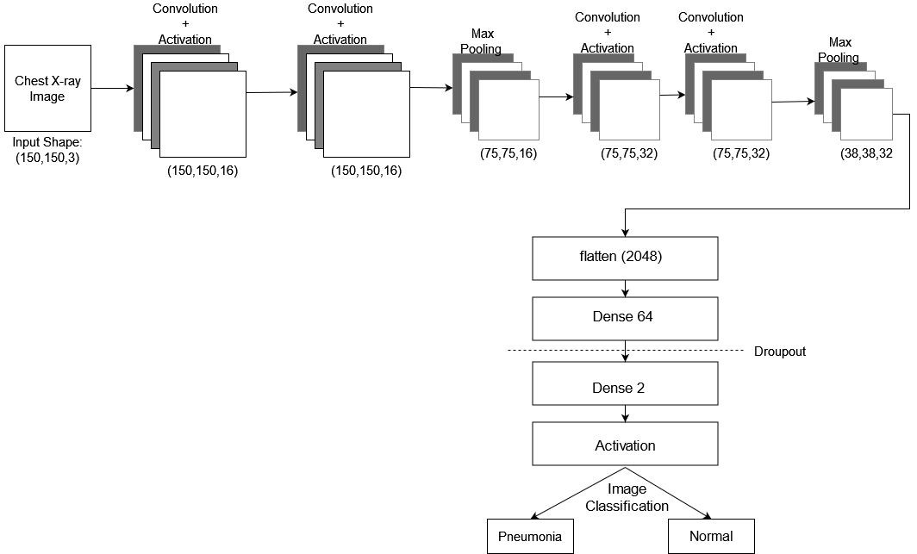

**Figure 9. Architecture of CNN**

##### **Input Layer**

The input layer has predetermined, fixed dimensions, so the image must be preprocessed before it can fed into the layer. Normalized gray scaled images of size 150 X 150 pixels from Kaggle dataset are used for training, validation and testing. In the architecture, the input is an RGB image with size of 150 X 150 pixels. The number of channels in the input image is 3, representing the red, green and blue color channels.

##### **Convolutional and Pooling Layer**

Convolutional layers are the important part of CNN. This layer applies a set of filters to the input images and extract various features, such as edges, corners and textures. In the Model, there are five pairs of convolutional and max pooling layers. Each convolutional layer applies a set of filters to the input image and produces feature maps. The size of the filters in each convolutional layer is (3, 3) or (2, 2) and the number of filters increases with the depth of the network.

After each convolution layer, a max pooling layer is used to down sample the feature maps. The max pooling operation reduces the spatial dimensions of the feature maps while preserving the most important information. In the model, the max pooling layers have a pool size of (2, 2), which means that the feature maps are down sampled by a factor of 2 in each dimension.

##### **Fully Connected Layer**

After the convolutional and pooling layers, the feature maps are flattened into a 1D vector and passed through two fully connected layers. The first fully connected layer has 64 units, and the second layer has 2 units. The first dense layer has a ReLU activation function, which introduces non-linearity in the model. The final dense layers has a softmax activation function, which outputs the probability distribution over two classes.

The dropout layer is used after the first dense layer to reduce overfitting, the dropout randomly drops out some neurons during training, which helps model to generalize better on the unseen data.

##### **Output Layer**

The output layer of this model is a dense layer with 2 neurons, which means that it will output a probability distribution over 2 classes. This is because this model is designed to perform a binary classification task, where it will classify images into two categories (Pneumonia or Normal).

Output of the model will be a vector of length 2, where each elements of the vector represents the probability of the input image belonging to one of the two classes. The two classes are represented by the two neurons in the output layer, with one neuron representing one class and the other neuron representing the other class. The output is computed using the softmax activation function, which ensures that the probabilities sum up to 1.

### **Testing**

#### **Test Cases for Unit Testing**

Unit testing is done to test the functionality of the programs and its blocks.

**Table 5.2. 1. Unit Testing**

|  |  |  |  |
| --- | --- | --- | --- |
| **S.N.** | **Test Cases** | **Expected Result** | **Test Result** |
| 1. | Input an image of pneumonia-infected lung | CNN predicts pneumonia | Pass |
| 2. | Input an image of normal lung | CNN predicts Normal | Pass |
| 3. | Input an image with poor quality or low resolution | CNN may not be able to make accurate prediction | Fail |
| 4. | Input an image that is not a chest X-ray | CNN may not be able to accurately detect pneumonia | Fail |
| 5. | Input images from different sources(e.g. different hospital or machines) | CNN consistently predicts pneumonia across sources | Pass |
| 6. | Input images from different population (e.g. different age or gender groups) | CNN consistently predicts pneumonia across sources | Pass |

* + 1. **Test Cases for Integration Testing**

**Table 5.2. 2. System Testing**

|  |  |  |  |
| --- | --- | --- | --- |
| **S.N.** | **Test Cases** | **Expected Result** | **Test Result** |
| 1. | Test the overall system performance | The system should be able to detect pneumonia with a high level of accuracy | [Success/Failure] |
| 2. | Test the system with different types of chest X-ray images | The system should be able to detect pneumonia accurately inn different types of chest X-ray images, such as those with different orientations, brightness, contrast and resolutions | [Success/Failure] |
| 3. | Test that the machine learning model can successfully classify images passed to it by the UI | The CNN model should be accurately classify the images passed to it by the UI as normal or pneumonia | [Success/Failure] |
| 4. | Test the system with missing or corrupted data | The system should be able to handle missing or corrupted data and provide appropriate error messages to the user | [Success/Failure] |

### **Result Analysis**

We were able to successfully detect normal and infected lungs from X-ray images, and classify them as either healthy or with pneumonia.

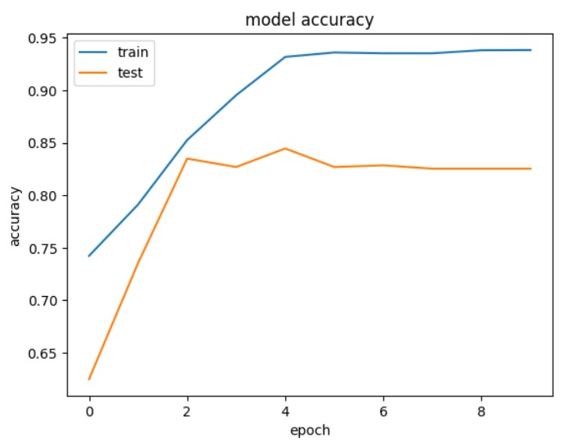

**Figure 10. Epoch vs Accuracy while training and testing**

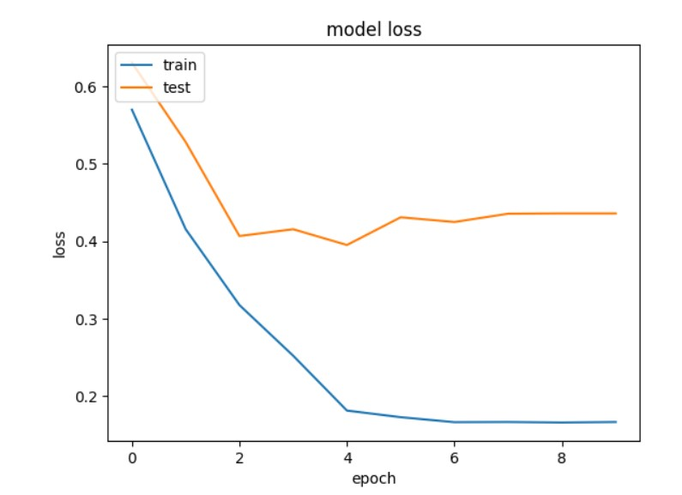

**Figure 11. Epoch vs Loss while training and testing**

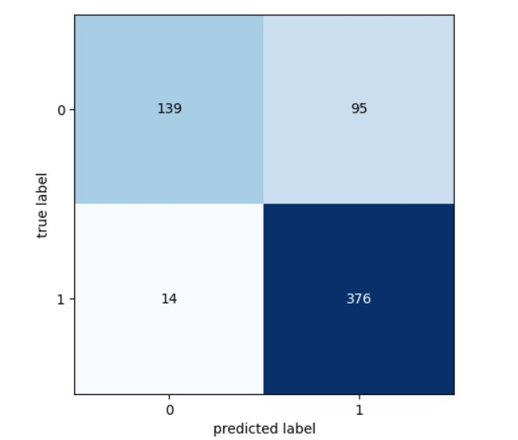

**Figure 12. Confusion Matrix**

Our detection model achieved an accuracy rate of 82.53% and a recall rate of 90.85%. However, since the number of individuals in each class is not equal, we cannot rely solely on accuracy as a metric to assess the model's performance. Recall is considered the most important measure, even more so than accuracy and precision, since minimizing false negatives is crucial. It is much more critical to avoid falsely diagnosing a patient with pneumonia as not having pneumonia than to incorrectly diagnose a healthy individual with pneumonia. This is the main reason why we are developing this model, to help reduce the occurrence of accidental mistakes made by doctors.

# **CHAPTER 6: Conclusion and Future Recommendations**

### **6.1 Conclusion**

Medical image processing technologies have been utilized to develop a novel approach for pneumonia detection. The implementation of this method is expected to enhance the current diagnostic process for pneumonia detection and allow for an expanded range of applications. In particular, the computer-generated results produced by this project can serve as a valuable tool for radiologists and can potentially raise the standard of evaluation for pneumonia detection. For the purpose of training, 89.1% of the images utilized were sourced from the dataset, while 10.7% were reserved for testing. Despite the classification process demonstrating a respectable accuracy rate of 76.89%, there is still room for improvement in this regard, as discussed in the future recommendations and enhancements section of this report.

### **6.2** **Future Recommendations and Enhancements**

* **Dataset Improvement**: In order to improve the accuracy of a pneumonia detection system, it is crucial to have a dataset that is both comprehensive and varied in terms of the X-Ray images included. The quality and quantity of this dataset will significantly impact the overall performance of the system.
* **Deep Learning Architecture and Feature Extraction Improvement**: While the CNN architecture has demonstrated a satisfactory level of performance in detecting pneumonia, there is still potential to enhance the deep learning model. Employing more sophisticated architectures like Transfer Learning could significantly augment the accuracy of the system.
* **User Interface Improvement**: Although the existing system utilizes Gradio for its user interface, there is an opportunity to enhance the interface by integrating it with a web application. This integration would make the interface more accessible and user-friendly to a broader range of users. Additionally, incorporating an authentication system would further improve the usability and security of the web application.

# **References**

### **For information about pneumonia and its situation in Nepal**

[1] Fighting Pneumonia in Nepal, [Fighting pneumonia in Nepal - surveillance, strains and schedules (gavi.org)](https://www.gavi.org/fighting-pneumonia-in-nepal-surveillance#:~:text=Pneumonia%20is%20the%20biggest%20killer,pollution%20also%20aggravate%20respiratory%20infections.)

[2] WHO Pneumonia. World Health Organization. (2019), [https://www.who.int/news- room/fact-sheets/detail/pneumonia](https://www.who.int/news-%20%20room/fact-sheets/detail/pneumonia)

[3] UNICEF Nepal (2020), [More than 23,000 children in Nepal could die in a decade unless world acts on pneumonia, leading agencies warn (unicef.org)](https://www.unicef.org/nepal/press-releases/more-23000-children-nepal-could-die-decade-unless-world-acts-pneumonia-leading)

### **For information about related work in this particular domain**

[4] Stephen O., Sain M., Maduh U. & Jeong D. An efficient deep learning approach to pneumonia classification in healthcare. Journal Of Healthcare Engineering. 2019 (2019) [An Efficient Deep Learning Approach to Pneumonia Classification in Healthcare (hindawi.com)](https://www.hindawi.com/journals/jhe/2019/4180949/)

[5] Pranav Rajpurkar, Jeremy Irvin, Kaylie Zhu, Brandon Yang, Hershel Mehta, Tony Duan, Daisy Ding, Aarti Bagul, Curtis Langlotz, Katie Shpanskaya et al., "Chexnet: Radiologist-level pneumonia detection on chest x-rays with deep learning", 2017, [allintitle: Chexnet: Radiologist-level pneumonia... - Google Scholar](https://scholar.google.com/scholar?as_q=Chexnet%3A+Radiologist-level+pneumonia+detection+on+chest+x-rays+with+deep+learning&as_occt=title&hl=en&as_sdt=0%2C31)

[6] Rahman T., Chowdhury M., Khandakar A., Islam K., Islam K., Mahbub Z., et al. Transfer learning with deep convolutional neural network (CNN) for pneumonia detection using chest X-ray. Applied Sciences. 10, 3233 (2020), [Applied Sciences | Free Full-Text | Transfer Learning with Deep Convolutional Neural Network (CNN) for Pneumonia Detection Using Chest X-ray (mdpi.com)](https://www.mdpi.com/2076-3417/10/9/3233)

[7] Ibrahim A., Ozsoz M., Serte S., Al-Turjman F. & Yakoi P. Pneumonia classification using deep learning from chest X-ray images during COVID-19. Cognitive Computation. pp. 1–13 (2021) pmid:33425044, [Pneumonia Classification Using Deep Learning from Chest X-ray Images During COVID-19 | SpringerLink](https://link.springer.com/article/10.1007/s12559-020-09787-5)

[8] Zubair S. An Efficient Method to Predict Pneumonia from Chest X-Rays Using Deep Learning Approach. The Importance Of Health Informatics In Public Health During A Pandemic. 272 pp. 457 (2020), [Pneumonia detection in chest X-ray images using an ensemble of deep learning models | PLOS ONE](https://journals.plos.org/plosone/article?id=10.1371/journal.pone.0256630)

[9] Liang G. & Zheng L. A transfer learning method with deep residual network for pediatric pneumonia diagnosis. Computer Methods And Programs In Biomedicine. 187 pp. 104964 (2020) pmid:31262537, [A transfer learning method with deep residual network for pediatric pneumonia diagnosis - ScienceDirect](https://www.sciencedirect.com/science/article/abs/pii/S0169260719306017?via%3Dihub)