1. **INTRODUCTION**

A Smart Parking is a modern solution designed to efficiently park and retrieve vehicles with minimal human intervention. These systems typically rely on mechanical and computer-controlled systems, eliminating the need for human drivers to navigate through parking lots. With the increasing demand for parking spaces in urban areas and the challenges posed by limited space, traditional parking methods can no longer keep up with the pace of growth. This prototype provides a highly efficient alternative, utilizing technologies such as sensors, Arduino and UI to maximize space utilization while reducing the time and effort spent by users in finding a parking spot.

As cities grow and populations increase, the demand for parking spaces escalates, leading to a host of challenges. Space Constraints in Urban areas face limited space for parking lots, making it difficult to meet the rising demand. Inefficiency of Traditional Parking makes Manual parking requires vehicles to be driven into narrow spaces, often leading to wasted space and longer search times for available spots. Traffic Congestion in large, congested parking areas, drivers may circle around looking for an available spot, further contributing to urban traffic problems. High Operational Costs of Traditional parking structures require large staff numbers for operations, and maintenance can be costly due to wear and tear on infrastructure. Inefficient use of parking space often leads to increased fuel consumption and pollution as drivers search for parking having an environmental Impact.

Smart Parking addresses few issues with integration of IoT and tech help us resolve the problem of parking anywhere around. This initial prototype is design to analyze the parking space with data availability of slots in the parking area maximize parking space utilization, enabling more vehicles to be parked in a smaller area. Time Efficiency in parking and retrieval of vehicle without the need to search for a spot, reducing wait times and traffic congestion. Minimal staff for operation and have reduced maintenance costs compared to traditional parking garages, offering long-term cost savings and users simply drive to the available space, UI for real time data and convenience.

The goal of the project is to provide a scalable and adaptable framework for performance enhancement, benefiting the technology and automobile industries. Tech and Industries can leverage the system to optimize new areas, improve efficiency, and optimize space. The integration of IoT and mobile application is a forward-looking approach to performance optimization. By offering a holistic and technology-driven solution, this project has the potential to significantly impact how performance is monitored, analyzed, and improved across multiple domains.

1. **SURVEY OF TECHNOLOGY**

*2.1 Software Requirement*

Operating System: Microsoft Windows 10 or higher (64-bit preferred for Visual Studio compatibility and performance).

Integrated Development Environment (IDE): Visual Studio Code, Virtual IoT Environment like Wokwi/Cisco packet tracer

Database and Backend: Android studio/Figma for UI and SQL Database

*2.2 Hardware Requirement*

For Training and Testing

**Processor:** Intel Core i3/AMD Ryzen 3 (minimum) or equivalent intel processor.

Recommended: Intel Core i5/i7 or AMD Ryzen 5

**RAM:** 8 GB minimum.

Recommended: 8 GB or more for optimal performance, especially when running emulators or multiple background processes.

**Storage:** Minimum 100 GB of free space (preferably on an SSD).

For Building and deployment

**Components:** Arduino UNO, IR Sensors, servo motor.

**Language:** Python for , Kotlin(android studio)/Figma in UI Framework.

1. **REQUIREMENT ANALYSIS**

***3.1 Problem Definition***

In modern traffic, managing operations efficiently and effectively remains a significant challenge. The current systems for managing vehicles and growing traffic can be troublesome. These inefficiencies can result in the following issues:

**1. Space Constraints and Limited Availability**

In Urban environments, As the population continues to increase, there is a growing demand for parking spaces, but the physical space to accommodate these vehicles remains restricted. This leads to a shortage of parking spots, particularly in high-demand areas such as commercial districts, residential neighbourhoods, and public transportation hubs.

**2. Inefficiency of Traditional Parking Practices**

Traditional parking requires drivers to navigate through crowded parking lots, often maneuvering in tight spaces to find a spot. This process can be time-consuming and frustrating. Drivers must often spend significant time circling parking lots in search of an available space. In large parking structures, especially during peak hours, this can result in congestion, long waiting times, and even traffic jams within parking lots.

**3. Traffic Congestion and Environmental Impact**

The search for parking is not only an inconvenience for drivers but also contributes to increased traffic congestion. In busy areas, especially in downtown or commercial zones, drivers repeatedly circle the same streets or parking garages in search of an available space. This leads to "cruising" behavior—drivers continuously driving around the block or parking lot, further congesting already crowded streets.

**4. High Cost of Parking Infrastructure and Operations**

Parking lots and garages often need a team of attendants or automated systems to ensure proper operation. Maintaining these structures, including surveillance systems, lighting, signage, and repairs, adds further financial burden to the owners and municipalities. Many cities have to subsidize parking fees, especially in downtown areas, to maintain affordability, creating a financial strain on local governments and taxpayers.

5. Lack of Parking Flexibility

In many cities, parking regulations and availability are rigid and not adapted to the needs of modern urban lifestyles. Parking spaces in urban areas are often allocated based on outdated models of car ownership. For instance, residential parking permits might be limited, and parking spaces may not be distributed equitably, favouring certain areas over others. This lack of flexibility can lead to frustration, as residents or visitors may find it difficult to find parking that suits their needs or preferences.

**6. Safety and Security Concerns**

Parking lots and garages, particularly those located in isolated or poorly lit areas, pose safety risks to both vehicles and individuals. The risk of car theft or break-ins is elevated in certain areas where security is insufficient or poorly monitored. The lack of safety measures, such as surveillance cameras or adequate lighting, increases the vulnerability of parked vehicles and makes these areas uncomfortable for people to navigate, especially at night. In dense, high-traffic areas, parking lots that are poorly managed can lead to chaotic conditions that pose both safety and security challenges.

* 1. ***Requirement Specification***

**3.2.1 Functional Requirements**

The development of a **Smart Parking System** using **Internet of Things, Mobile Application** and a **Database** aims to address the various challenges faced by drivers in locating available parking spaces, reducing traffic congestion, and providing real-time information about parking availability.

**Parking Space Detection and IoT Integration**

IoT Sensors for Parking Space Detection: Each parking space will be equipped with IoT-enabled sensors (e.g., infrared sensors, or magnetic sensors) to detect whether a space is occupied or vacant.

Sensor Communication: Sensors should communicate with a central server or gateway using low-power wide-area networks (LPWAN) such as LoRaWAN or NB-IoT, or Wi-Fi for short-range communication.

Parking Slot Monitoring: The system will monitor parking slots continuously for vacancy status. Each parking spot will send its status (vacant/occupied) to a centralized database or cloud server.

**User Interface (UI) via Mobile App**

App Features:

Real-time Parking Slot Availability: The app should display real-time data about available parking slots where users should be able to search for parking spaces based on their location or input area (e.g., near a shopping centre, residential zone, etc.).

App UI Design:

User-Friendly Interface: Clean, intuitive design with maps showing available slots and user options.

Map View: Interactive map to show parking lot locations, available slots, and real-time updates.

**Database and Cloud Infrastructure**

Database Management: The system requires a centralized database that stores data about parking slots, their availability and user profiles.

Database Design:

Parking Slot Table: Includes slot ID, location, status (vacant/occupied), timestamp, and user reservation information.

User Table: Stores user data (name, email, payment method, history of reserved parking).

Transaction Table: Stores payment details, transaction IDs, payment status, and parking duration.

Cloud Services for Scalability: Use a cloud platform to store real-time data, process parking availability, and scale as needed. Cloud computing also facilitates remote access and data processing.

Real-Time Data Syncing: The app should be synchronized with the central database to reflect real-time parking availability and slot status.

**System Integration and Communication**

Communication Protocol: The sensors in parking spaces will communicate with a central server via a communication protocol. Depending on the technology, this can be either:

LoRaWAN or NB-IoT for long-range, low-power communication, particularly in urban environments with many sensors.

Wi-Fi or Bluetooth for short-range communication, if the sensors are close to a central gateway.

Data Processing: A central server will aggregate data from the sensors and process it to determine the availability of parking spaces in real time. The server will be responsible for:

Data Filtering and Aggregation: Processing sensor data to determine whether a parking spot is available or occupied.

Real-Time Updates: Pushing updates to the mobile app and updating the database accordingly.

User Requests: Handling requests from users regarding parking slot availability and payments.

Security and Privacy: Ensure secure communication between sensors, database, and mobile app through encryption protocols (e.g., SSL/TLS). User data must be stored securely in compliance with data protection regulations (e.g., GDPR, CCPA).

**3.2.2. Non-Functional Requirements**

**Performance**

Real-Time Updates: The system should provide real-time updates with low latency. Parking status updates must be reflected in the mobile app within a few seconds.

Scalability: The system should be able to handle many users and parking spaces without performance degradation, especially in large urban areas.

High Availability: The system should be reliable and available 24/7, with minimal downtime for maintenance or updates.

**Security**

Authentication: Users should be authenticated before accessing the app’s services. This can be achieved through email/password, mobile number, or social media logins.

Data Encryption: All communication between the app, cloud servers, and parking sensors should be encrypted to ensure data privacy and prevent unauthorized access.

**Usability**

Simple Interface: The app’s interface should be designed to be intuitive and simple to use for a wide range of users, including non-tech-savvy individuals.

Multi-Platform Support: The app should be compatible with both Android and iOS platforms.

**Reliability and Fault Tolerance**

Backup and Redundancy: The system should have mechanisms in place for data backup and fault tolerance, ensuring the system operates without interruptions even if a failure occurs.

Sensor Maintenance and Calibration: IoT sensors should be robust and self-maintaining, or equipped with mechanisms to alert administrators when malfunctioning.

* 1. *Feasibility Study*
     1. **Technical Feasibility:**  
        Identify the tools, platforms, and programming languages (wokwi, VS Code, Android Studio/Figma) needed for the system. Database solution for data transformation. Ensure the system can handle larger dataset, better results, and analysis.
     2. **Operational Feasibility:**  
        Determined how the system will align with the requirements. Provide user-friendly training materials, protype models in every phase and sessions to familiarize workflow with the new system.
     3. **Economic Feasibility:**  
        IoT Components, System updates, bug fixes, and support. Ensure the project stays within the financial limits.

**4. PLANNING & SCHEDULING**

**4.1 Planning**

**Phase 1: Project Initiation**

**Define Project Scope**

* + Identify the problem and its solution that can create changing impact.
  + Set goals and success criteria.
  + Assign roles and responsibilities to the project team.

**Phase 2: Requirement Gathering & Analysis**

**System Requirements Specification (SRS)**

* + Gather detailed requirements for all modules (e.g, Arduino Components, Model Selection, Language used, Database, UI Component).
  + Document both functional and non-functional requirements.

**Finalize Technologies and Tools**

* + Select the tech stack (programming languages, database, frameworks).

**Phase 3: System Design**

**High-Level Design**

* + Create architecture diagrams (including data flow diagrams and entity-relationship diagrams).

**Phase 4: Development**

**Back-End Development**

* + Develop core functionalities such as UI integration with virtual model and database connectivity.
  + Set up proper workflow environment where every model works in synchronize.

**Phase 5: Testing & Quality Assurance**

**Unit Testing**

* + Test individual components and modules to ensure each works as expected.

**System Testing**

* + Test the entire system to identify bugs, performance issues, and functionality problems.

**User Acceptance Testing (UAT)**

* + Test the system with real time data and gather feedback.
  + Fix any issues that arise during UAT.

**Phase 6: Implementation & Deployment**

* + Deploy the base model to real time to check its performance, backend and overall working.
  + Verify data integrity and correctness within the system.

**Deployment to Production**

* + Deploy Model to find real time challenges and resolve it.
  + Ensure scalability, security, and backup systems are in place.

**Training & Support**

* + Regular updates and upgrades post deployment.
  + Provide user manuals and guides.

**Phase 7: Maintenance & Support**

**Post-Deployment Support**

* + Address any bugs or issues that arise after the system goes live.

**System Updates & Enhancements**

* + Implement updates and add new features based on feedback and evolving needs.

**5. SYSTEM DESIGN**

The system design for this project focuses on creating a scalable, high-performance architecture that incorporates microservices for flexibility, a robust API gateway for secure communication, and a cloud-based infrastructure to ensure availability, fault tolerance, and seamless scalability to meet growing user demands.

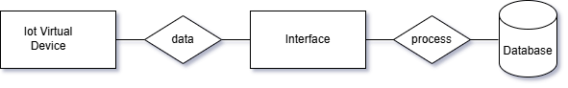

Context level DFD

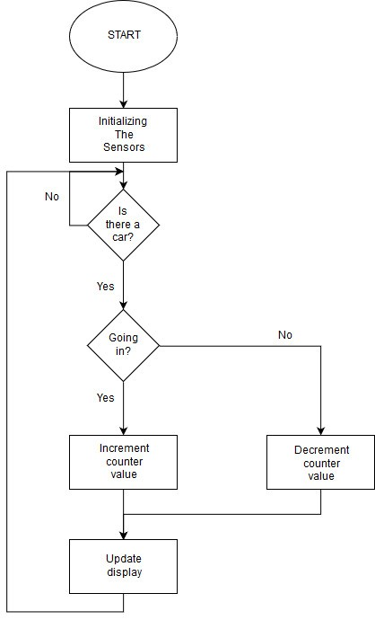

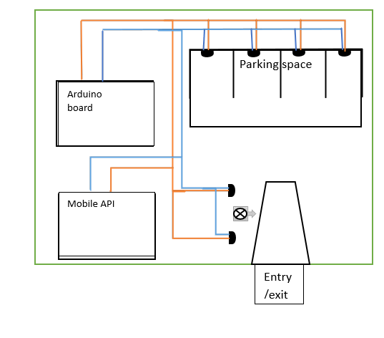

IoT Device

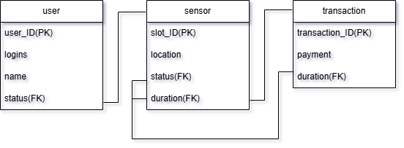

Database