# Lab 2 – APIs

Weather app

Connect to a Weather API of your choice ([OpenWeatherMap](http://openweathermap.org/API), [Forecast.io](https://developer.forecast.io/) are some examples)

Write a web app to show the weather of your current location

Hints:

Get the current location from the browser (HTML5 Geolocation)

Pass the location parameters to the api and get the weather data

Populate the weather data in the html

Use CSS transitions/animations to enhance the look and feel of the app

Example implementation using Bootstrap

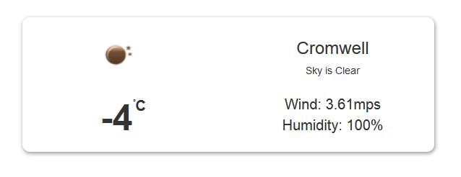

You will be graded on the following;

Formatting and coding style : 10

Objective 1 – Processing API : 10

Objective 2 – Displaying output : 10

Creativity/Coding style : 10

Documentation/Read.me : 10