Задание

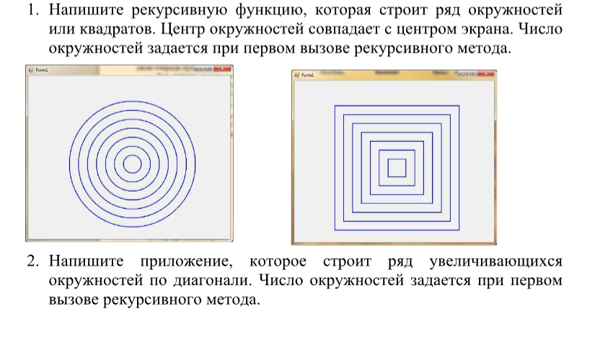

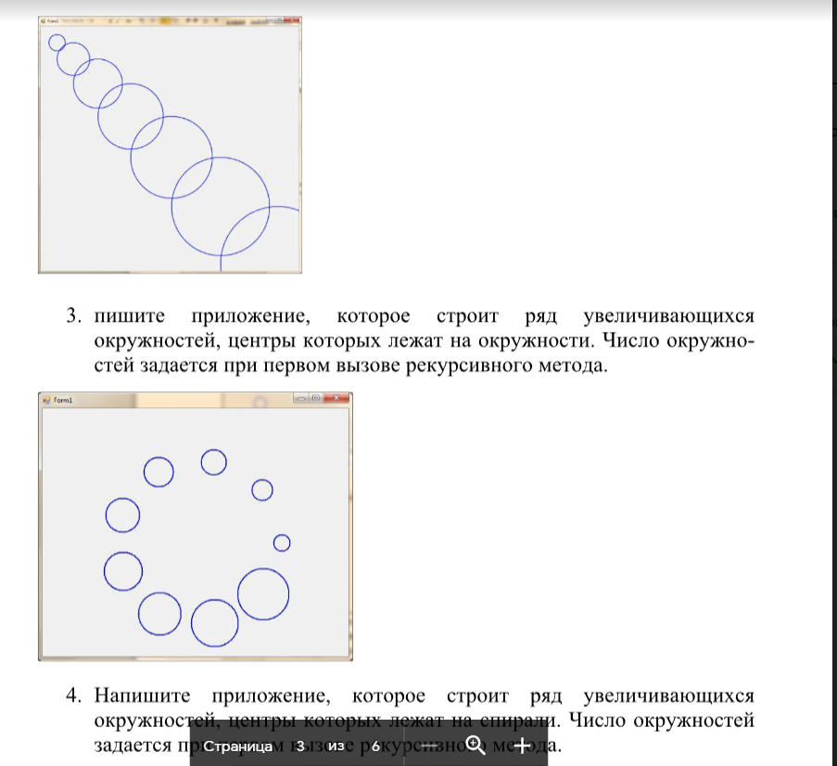

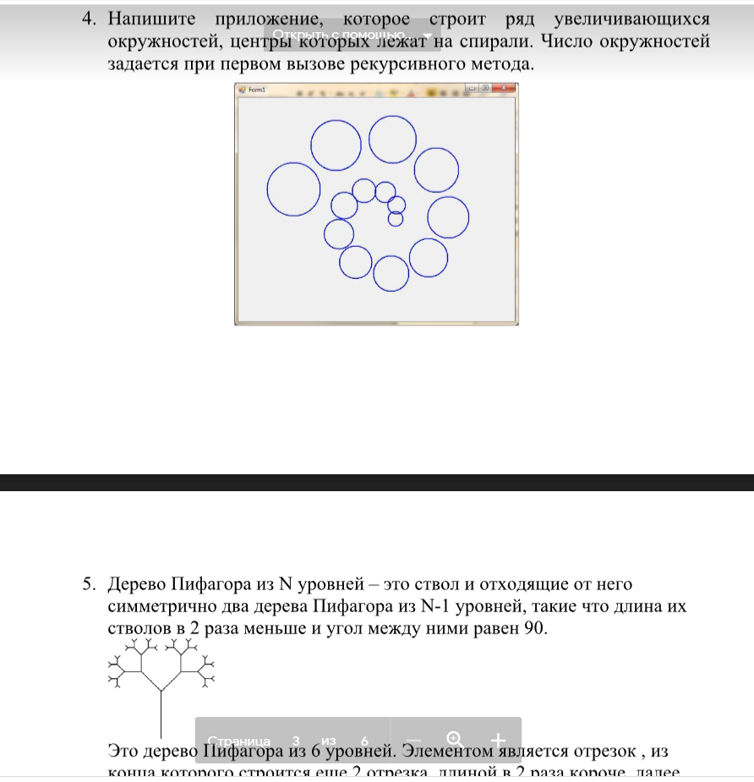

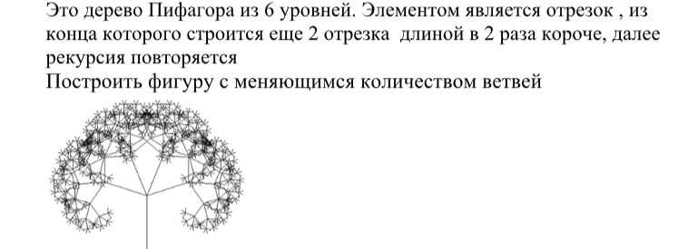

Код программы :

﻿using System;

using System.Drawing;

using System.Windows.Forms;

namespace WindowsFormsApp4

{

public partial class Form1 : Form

{

public Form1()

{

InitializeComponent();

}

void rect(int N, int x0, int y0, int x1)

{

if (N != 0)

{

Graphics g = this.CreateGraphics();

Pen myPen = new Pen(Color.Purple, 3);

g.DrawRectangle(myPen, x0, y0, x1, x1); //myPen, 400, 100, 20, 20

x1 += 30;

N--;

x0 -= 15;

y0 -= 15;

rect(N, x0, y0, x1);

}

}

void krygi(int N, int x0, int y0, int x1, int y1)

{

if (N != 0)

{

Graphics g = this.CreateGraphics();

Pen myPen = new Pen(Color.Purple, 3);

g.DrawEllipse(myPen, x0, y0, x1, y1);

x1 += 20;

y1 += 20;

N--;

x0 = +60;

y0 = -10;

krygi(N, x0, y0, x1, y1);

}

}

void Rectaa(double x1, double y1, double l, double a1)

{

Graphics g = this.CreateGraphics();

Brush brush = new SolidBrush(Color.Black);

Pen myPen = new Pen(brush, 2);

double x2 = Math.Round(x1 + (l * Math.Cos(a1)));

double y2 = Math.Round(y1 - (l * Math.Sin(a1)));

double x3 = Math.Round(x1 + (l * Math.Sqrt(2) * Math.Cos(a1 + Math.PI / 4)));

double y3 = Math.Round(y1 - (l * Math.Sqrt(2) * Math.Sin(a1 + Math.PI / 4)));

double x4 = Math.Round(x1 + (l * Math.Cos(a1 + Math.PI / 2)));

double y4 = Math.Round(y1 - (l * Math.Sin(a1 + Math.PI / 2)));

g.DrawLine(myPen, (int)x1, (int)y1, (int)x2, (int)y2);

g.DrawLine(myPen, (int)x2, (int)y2, (int)x3, (int)y3);

g.DrawLine(myPen, (int)x3, (int)y3, (int)x4, (int)y4);

g.DrawLine(myPen, (int)x4, (int)y4, (int)x1, (int)y1);

}

private void MyDraw2(double x,double y,double l,double a)

{

if (l>4)

{

Rectaa(x, y, l, a);

MyDraw2(x - l * Math.Sin(a), y - l * Math.Cos(a), l / Math.Sqrt(2), a + Math.PI / 4);

MyDraw2(x - l * Math.Sin(a) + l / Math.Sqrt(2) * Math.Cos(a + Math.PI / 4), y - l * Math.Cos(a) - l / Math.Sqrt(2) * Math.Sin(a + Math.PI / 4), l / Math.Sqrt(2), a - Math.PI / 4);

}

}

private void MyDraw(Graphics g, int N, int x, int y)

{

if (N == 0)

return;

else

{

g.DrawRectangle(new Pen(Brushes.Blue, 2),

0, 0, x, y);

x += 50;

y += 50;

N--;

MyDraw(g, N, x, y);

}

}

private void MyDraw1(Graphics g, int N, int x, int y)

{

if (N == 0)

return;

else

{

g.DrawRectangle(new Pen(Brushes.Red, 2), 410, 210, x, y);

x += 10;

y -= 10;

N++;

MyDraw1(g, N, x, y);

}

}

private void Form1_Paint(object sender, PaintEventArgs e)

{

}

private void примерToolStripMenuItem_Click(object sender, EventArgs e)

{

Graphics g = this.CreateGraphics();

MyDraw(g, 7, 50, 50);

}

private void задание1ToolStripMenuItem_Click(object sender, EventArgs e)

{

rect(8, 400, 150, 20);

}

private void задание2ToolStripMenuItem_Click(object sender, EventArgs e)

{

krygi(7, 50, 50, 0, 0);

}

private void задание5ToolStripMenuItem_Click(object sender, EventArgs e)

{

MyDraw2(280, 460, 100, 0);

//Rectaa(280, 460, 100, 0);

}

private void clearToolStripMenuItem_Click(object sender, EventArgs e)

{

Graphics g = this.CreateGraphics();

g.Clear(Color.WhiteSmoke);

g.Dispose();

}

}

}