GotTagged

Pre-Installation Requirements

1. Android device with 2.3 or higher OS
2. Device has to have Internet connectivity at all the time.
3. Device has to have GPS
4. There must be at least one Gmail account signed in
5. Make sure Unknown sources under Settings/Security is checked before proceeding to installation.

Installation

1. Using the Android device download the apk from:

Post-Installation

1. Open gottagged380 app
2. Sign in using one of the Gmail accounts



1. If it’s the first time you are using the email address you will be asked to create a username, else you will see the main menu screen (#4)



1. From here you can create a game by pushing the Create Game (#5) button or join a game (#6) by pushing Join Game

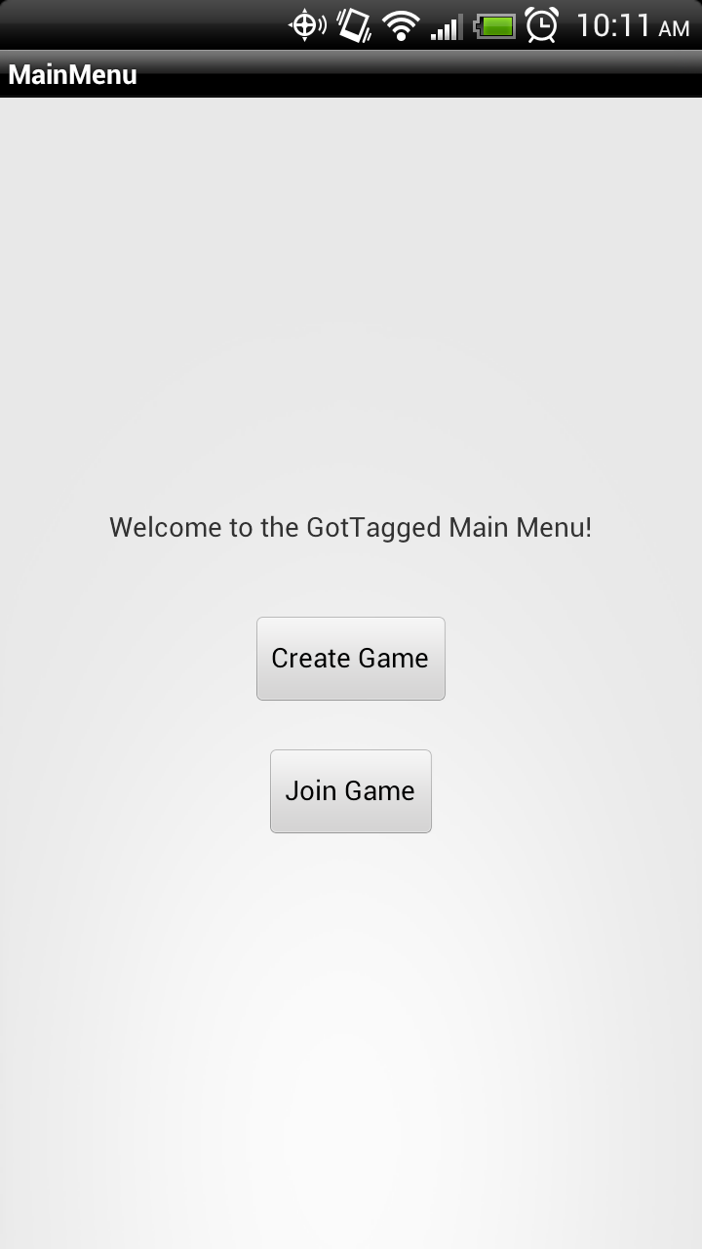

1. Create a game by putting the usernames of other players (up to 3) and push create session button. You will be sent to waiting screen until all the invited users join the game.

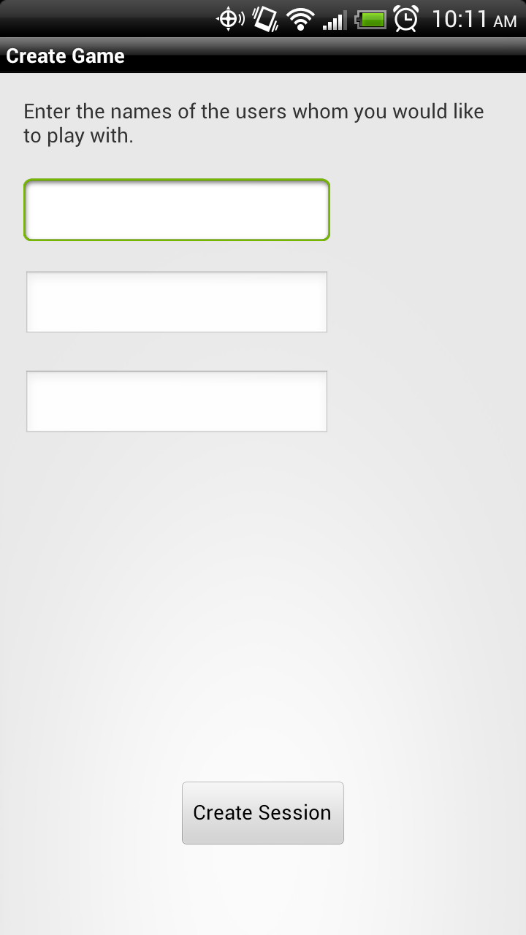

1. Users can join the game by tapping on the name of the creator in the Join Game list. Once user join it will be sent to the waiting screen.



1. After all users have joined the game, They will be sent to the gameplay screen. At this point users can start looking for each other. (Currently the app does not show who the hider is)



1. Once any of the seekers get close enough to the hider , the game will finish. And all other users will see the winner of the game.