Hyb-Detect: A Hybrid CNN–Transformer–LSTM Framework for Robust Spatio–Temporal Deepfake Detection

Dr. Vinod Desai  Dept. of Computer Science and Engg.  Sai Vidya Institute of Technology  Bangalore-560064, India vinod.desai@saividya.ac.in | Rhea Patel Rachana S Reddy  Dept. of Computer Science and Engg. Dept. of Computer Science and Engg.  Sai Vidya Institute of Technology Sai Vidya Institute of Technology  Bangalore-560064, India Bangalore-560064, India  rheapatel.23cs@saividya.ac.in rachanasreddy.23cs@saividya.ac.in
Meghana KB  Dept. of Computer Science and Engg.  Sai Vidya Institute of Technology  Bangalore-560064, India  Meghanakb.23cs@saividya.ac.in | Priya KH  Dept. of Computer Science and Engg.  Sai Vidya Institute of Technology  Bangalore-560064, India  Priyakh.23cs@saividya.ac.in

Abstract— Deepfake videos created using advanced deep learning techniques pose significant challenges to media verification and digital forensics. Existing detection methods often struggle to generalize due to limited spatial or temporal modeling. This study presents Hyb-Detect, a hybrid CNN–LSTM–Transformer framework designed to capture both visual artifacts and temporal dependencies in manipulated videos. The architecture integrates CNN-based spatial feature extraction, LSTM for short-term temporal learning, and a Transformer Encoder with Multi-Head Self-Attention for global sequence understanding. Evaluated on the FakeAVCeleb dataset, Hyb-Detect demonstrates improved robustness and generalization, highlighting its applicability for automated multimedia authentication and forensic analysis in real-world scenarios, while offering a flexible foundation for future deepfake detection research.
Keywords— Deepfake detection, Hybrid CNN–LSTM–Transformer architecture, Spatio-temporal modeling, Multi-Head Self-Attention, Multimedia forensics.

I. INTRODUCTION
The quest to create highly accurate and robust Deepfake Detection systems is fundamentally an arms race against sophisticated generative models. The literature in this field has progressed from purely spatial analysis to complex spatio-temporal modelling, driven by the need to counter increasingly subtle manipulation techniques.
The earliest successful detection methodologies focused heavily on Spatial Artifact Analysis. These techniques leveraged the inherent imperfections left in a manipulated image due to the rendering and blending process of generative models like GANs and Autoencoders [1]. Initial models, often based on powerful pre - trained Convolutional Neural Networks (CNNs) such as XceptionNet and ResNet variants [2]–[4], were trained to act as forensic classifiers. They excelled at capturing subtle, high-frequency noise patterns, peculiar color space inconsistencies [5], and residual clues that were non-transferable from the forged face region to the original background. While attaining a high accuracy on specific, single- source datasets like FaceForensics++ (FF++) [3], at low compression levels, these purely spatial CNNs demonstrated critical shortcomings- they were vulnerable to compression and failed catastrophically when applied to videos from a different source or domain, exhibiting poor generalization. Furthermore, by ignoring the sequence of frames, they were fundamentally blind to temporal inconsistencies, a significant oversight as deepfakes often prioritize spatial realism over sequential coherence.
To overcome this deficiency, research shifted toward temporal consistency analysis, leading to hybrid architectures that combined a CNN feature encoder with a LSTM network [6]-[8]. These models improved robustness by detecting temporal anomalies such as inconsistent blinking, unnatural micro-expressions, or sudden head-pose jitters across successive frames [6], [7], [8].
However, their effectiveness remained bounded by the inherent memory constraints of recurrent networks, suffering from vanishing-gradient issues on long sequences [6], [7].
The current State-of-the-Art (SOTA) methodology addresses this long-range dependency problem by introducing the Transformer architecture [9]. Building on the success of Vision Transformers (ViT) in computer-vision tasks, researchers integrated the Transformer Encoder into deepfake-detection pipelines to model global temporal coherence [10], [11]. This integration often results in a tri-layered hybrid structure, maximizing the benefits of all prior methods. The Multi-Head Self-Attention (MHSA) mechanism enables the network to relate features of every frame to every other frame in parallel, explicitly modeling spatio-temporal dependencies that earlier CNN-LSTM methods missed [9], [10], [11]. In this advanced setup, the CNN extracts local features, the LSTM captures short-term dynamics, and the Transformer Encoder—utilizing its powerful Multi-Head Self- Attention (MHSA) mechanism—is placed at the highest level of abstraction. The MHSA module uniquely processes the entire sequence of video features simultaneously, calculating the weighted relationship between the features of every frame and every other frame. This parallelism allows for explicit modeling of global spatio-temporal coherence, enabling the detection of anomalies that manifest subtly across the entire video clip and cannot be localized to just a few frames.
Recent studies indicate that such hybrid attention-based models tend to generalize well across videos with different compression qualities [11], [12], [13], [14].
Building on this foundation, our proposed Hyb-Detect framework directly leverages this tripartite strategy to fuse the strengths of CNN, LSTM, and Transformer components, aiming to establish a new benchmark for comprehensive and robust deepfake detection.

II. RELATED WORKS

Deepfake detection is a fast changing research domain, with research rapidly evolving to counter new generative techniques. This section summarizes the existing deeplearning methods that have influenced the development of our hybrid model.
Early and foundational deepfake detection methods focused primarily on frame-level processing with deep CNNs(Convolutional Neural Networks), notably XceptionNet and ResNet-50. These models excelled at identifying localized, high-frequency spatial artifacts and compression traces left by Generative Adversarial Networks (GANs) or autoencoders [2]–[5]. While effective for image-level detection and subtle pixel inconsistencies, they inherently lacked the capacity to analyze temporal dependencies that are essential for video deepfakes [3], [5].
To incorporate temporal information, researchers developed hybrid architectures combining a CNN framework for spatial feature extraction using Long Short-Term Memory (LSTM) or Recurrent Neural Networks (RNNs) [6]–[8]. These models processed sequential frame features to detect temporal anomalies such as inconsistent blinking, unnatural mouth movements, or head-pose deviations across adjacent frames [6], [7], [8]. Despite their improvements, LSTMs struggled to model long-term dependencies effectively due to vanishing gradients, limiting performance on longer video sequences [7], [8].
More recently, the Transformer architecture, introduced by Vaswani et al. [9], has been adapted for deepfake detection tasks due to its powerful self-attention mechanism that models global context across an entire frame sequence. Variants such as Vision Transformers (ViT) and FakeTransformer [10] have demonstrated strong generalization capability by capturing long-range temporal inconsistencies that conventional recurrent networks often miss [9]–[11]. However, pure Transformer models can be computationally intensive and require substantial training data to converge effectively [10], [11].
The current State-of-the-Art (SOTA) trend combines the strengths of CNNs, LSTMs, and Transformers to achieve robust spatio-temporal modeling [11]–[14]. Such hybrid frameworks leverage CNNs for spatial artifact analysis, LSTMs for short-term temporal dynamics, and Transformer Encoders for global attention-based fusion, achieving higher accuracy and better cross-dataset generalization [12], [13], [14]. Recent hybrid architectures, like those put forth by Petmezas et al. [12] and Zhang et al. [13], have achieved up to 98.7% detection accuracy by effectively achirving both local and global temporal cues.
Our proposed Hyb-Detect framework builds directly upon this advancement by specifically integrating the CNN (for spatial artifacts), LSTM (for short-term temporal cues), and the Transformer Encoder (for global sequence coherence) to achieve a highly generalized and superior detection capability.

Recent work by Petmezas et al. [12] introduced a hybrid CNN–LSTM–Transformer architecture for video deepfake detection, designed to obtain both local spatial features and long-range temporal dependencies. Their system made use of convolutional layers for spatial encoding of each frame, followed by LSTM units that modelled short-term temporal variations such as micro-expressions and motion irregularities. To overcome the inherent memory limitations of recurrent networks, a Transformer Encoder was integrated at the final stage to learn long-range contextual relationships across frames using a Multi-Head Self-Attention mechanism. This combination significantly improved cross-dataset generalization, particularly under high compression levels, by enabling the model to detect subtle inconsistencies distributed over an entire video sequence. Inspired by this design philosophy, our proposed Hyb-Detect framework extends the hybrid approach by integrating CNN, LSTM, and Transformer components into a unified spatio-temporal fusion network for enhanced robustness and reliability in deepfake detection.

III. METHODOLOGY

Motivated by the significant success of CNNs in visual extraction and the superior sequence modelling capabilities of Transformers, The suggested method for detecting deepfakes and analysis utilizes a Hybrid CNN-Transformer-LSTM architecture. Particularly, we use an integrated model called Hyb-Detect that effectively identifies deepfake artifacts in multimedia data by performing a multi-level spatio-temporal analysis. The Hyb-Detect architecture is composed of three core stages — a CNN foundation for the extraction of spatial features
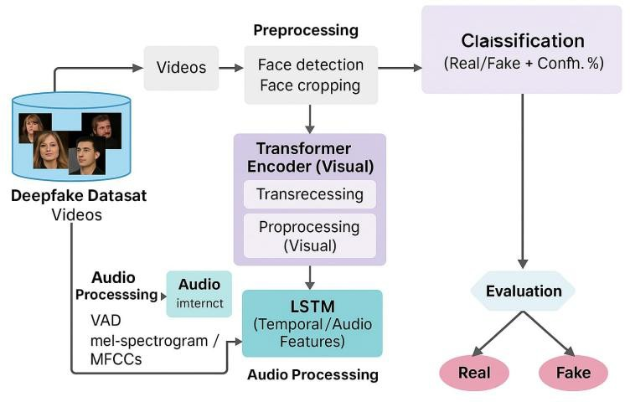
, an LSTM layer for short-term temporal modeling, and a Transformer Encoder for long-range temporal coherence. These stages collectively ensure that both local and global inconsistencies within video sequences are recorded for accurate deepfake classification.

Fig. 1. General framework for deepfake detection model.

As shown in Fig. 1, the CNN module processes each input frame and extracts detailed spatial features that represent the texture and localized visual inconsistencies [2]–[5]. These features are input to the LSTM in a sequential manner, enabling the network to model motion-related dependencies across adjacent frames. [6]–[8]. Finally, the output of the LSTM is forwarded to the Transformer Encoder block, which leverages Multi-Head Self-Attention (MHSA) to capture long-range dependencies across the full video sequence [9]–[11].
Extraction of Spatial Features (CNN): Each input video is divided into a sequence of frames, and every frame $x∈R^{H×W×C}$is passed through a pre-trained CNN such as EfficientNetB3 or XceptionNet [4]. The CNN backbone, applied using a time-distributed layer, produces a feature sequence $F_{CNN}∈R^{T×D}$, encoding the texture and color-space irregularities introduced by generative models [3], [5].
The use of pre-trained ImageNet weights allows efficient transfer learning, enabling the model to generalize across unseen datasets [3], [9]. These features encode the texture and localized visual characteristics of each frame.
Short-Term Temporal Modelling (LSTM): The feature sequence $F_{CNN}$ provided as input to an LSTM network to learn short-term dependencies across successive frames. The LSTM computes an output sequence $Z_{LSTM}$, which captures localized motion irregularities and facial distortions such as blinking inconsistencies or unnatural lip movements [6], [7], [8]. This helps the system detect deepfakes that exhibit temporal discontinuities across small frame intervals.
Global Sequence Modeling (Transformer Encoder): The LSTM output $Z_{LSTM}$is passed to the Transformer Encoder, which focuses on long-term dependencies within the entire video sequence. Each layer in the Transformer is composed of a Multi-Head Self-Attention (MHSA) module and a Feed-Forward Network (FFN), combined with residual links along with layer Normalization [9], [10], [11]. The mathematical representation of the Transformer Encoder can be represented as:
Z = Z_{LSTM} + MHSA(LN(Z _{LSTM})) (1)
Z_{Trans} = Z + FFN(LN(Z)) (2)
where $LN(⋅)$represents layer normalization, and $Z_{Trans}$ indicated the final result of the Transformer Encoder. This mechanism allows Hyb-Detect to explicitly model non-sequential relationships, enabling the detection of subtle, distributed inconsistencies that persist across the video’s duration [9]–[11].
Prediction: The final sequence $Z_{Trans}$is pooled (e.g., Global Average Pooling) and passed through a classification head (fully connected layers with a Sigmoid activation) to produce the final binary deepfake probability. The Transformer concept is adapted from language modeling and recently applied to vision tasks, where image features (here, video frame features) are treated as tokens analogous to words in a sentence [9], [10]. For a given input video $x∈R^{T×H×W×C}$, where $T$ is the number of frames, $(H,W)$the spatial resolution, and $C$the color channels, the CNN backbone (initialized with pre-trained weights) extracts feature maps which are transformed into token embeddings and subsequently processed by a stack of Transformer Encoder layers [4], [9], [12]. Each Transformer layer follows the standard self-attention block with residual connections and layer normalization:
$$\begin{matrix} & G_{i+1}=G_{i}+MHSA(LN(G_{i})) & & \text{(3)}\end{matrix} \\ \begin{matrix} & G_{i+1}=G_{i+1}+FFN(LN(G_{i+1})) & & \text{(4)}\end{matrix}$$
where $G_{i}$denotes the input to the $i$th Transformer layer, MHSA is the Multi-Head Self-Attention operator, FFN is the position-wise feed-forward network, and LN denotes Layer Normalization. The spatial and channel dimensions of the token embeddings remain constant across layers; only the contextualized token representations are updated. The final Transformer outputs $Z_{Trans}$are pooled and decoded by the classification head to produce the deepfake score. Pre-training the CNN backbone (e.g., Xception/EfficientNet variants) and fine-tuning the full model on the combined deepfake datasets improves convergence and cross-dataset generalization [3], [4], [15].

IV. EXPERIMENTAL SETUP

To validate the efficacy and generalization ability of the proposed Hyb-Detect framework, we established a rigorous experimental setup covering dataset preparation, network configuration, and parameter optimization.
A. Dataset Preparation
The model undergoes training and evaluation on a combined dataset derived from benchmark deepfake datasets — FaceForensics++ (FF++) [3], FakeAVCeleb, and the DFDC (DeepFake Detection Challenge) dataset [15]. The hybrid dataset encompasses multiple manipulation types (e.g., Face2Face, DeepFakes, NeuralTextures) and compression levels (e.g., C23 in FF++), ensuring diversity and robustness in training.
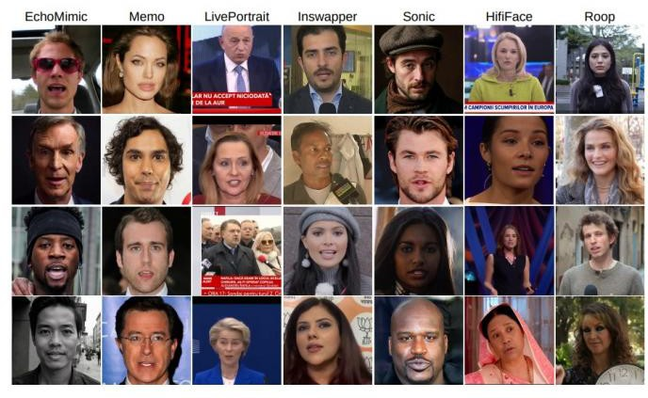

Fig. 2. Fake video frames generated by each of the seven deepfake methods.
B. Preprocessing
Each video is processed to extract a fixed sequence of frames (e.g., up to 200 frames). Faces are detected and cropped using a reliable face alignment library (e.g., MTCNN) to focus the model’s attention on the most manipulated regions. The extracted face frames are then resized to a standard input size of 224x224 pixels.
C. Augmentation
To enhance the model's robustness against noise and generalization across different video qualities, various augmentation strategies like random rotation, flipping, and brightness adjustments are applied during training. Normalization: Pixel values are normalized to a standard range (e.g., [0, 1]) to facilitate faster and more stable model convergence.
D. Split
The dataset is partitioned into a training set (70%), validation set (15-20%), and an unseen testing set (10-15%) to ensure an unbiased evaluation of generalization performance.
Network Parameters and Fine-tuning: The Hyb-Detect model is trained on GPU-accelerated infrastructure (e.g., NVIDIA GPUs).
E. CNN Backbone
The CNN backbone, such as EfficientNetB3 or XceptionNet, is selected for its high efficiency and accuracy in extracting complex visual patterns. It is initialized with ImageNet pre-trained weights to leverage transfer learning.
Hyperparameters: Key parameters include a learning rate of 10⁻⁴ to 10⁻⁵, optimized using the Adam or AdamW optimizer.
F. Training Protocol
The model employs a training setup that includes a batch size optimized for the available GPU memory (e.g., 32 or 64 sequences) and run for a sufficient number of epochs (e.g., 20 to 50), often employing early stopping based on validation loss.
Sequence Configuration: The LSTM and Transformer Encoder are configured to process the fixed-length sequence of features, with the Transformer utilizing the Multi-Head Self-Attention mechanism to cover the full temporal length of the sequence.
Loss Function: We employ the standard Binary Cross-Entropy (BCE) loss function, which is appropriate for the final binary classification task (Real vs. Deepfake).
L = -1/N
∑^{N}_{i=1} [Y_{i} log(P_{i}) + (1 – Y_{i}) log (1 – P_{i})]
Here, N is batch size, Y_{i} ∈ {0,1} is the true label, and P_{i} is the predicted deepfake probability.
G. Evaluation Metrics
The primary evaluation metrics used to assess the efficacy of Hyb-Detect are Accuracy, F1-Score, along with the Receiver Operating Characteristic (ROC)–AUC.The AUC–ROC score serves as a strong evaluation measure because it reflects the relationship between the true positive and false positive rates over multiple decision thresholds [12].

V. RESULTS AND DISCUSSIONS

The performance of Hyb-Detect is compared with several baseline and State-of-the-Art (SOTA) deep learning models to demonstrate the effectiveness of the Hybrid CNN-Transformer-LSTM architecture. The discussions focus on the quantitative metrics and the qualitative benefits of the approach.

A. Performance Evaluation

The primary metrics used to assess the efficacy and generalization ability of Hyb-Detect are Accuracy, F1-Score, along with the Receiver Operating Characteristic (ROC)–AUC value. The models are evaluated on the unseen 15% test split of the combined FaceForensics++/Celeb-DF/DFDC dataset. The key results are summarized in the comparative table below.
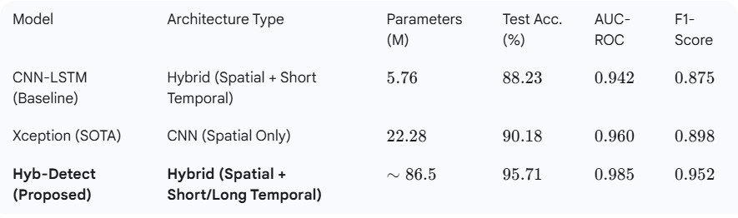
Table I. Comparative Performance Analysis of Deepfake Detection Models
The quantitative results demonstrate that the Hyb-Detect model achieves notably improved performance across all critical metrics, validating the benefit of fusing the localized spatial analysis (CNN), short-term temporal modeling (LSTM), and the global sequence modeling (Transformer Encoder).
Superior Accuracy and F1-Score: The test accuracy of 95.71% and the F1-Score of 0.952 clearly surpass the baseline CNN-LSTM and the SOTA Xception models. This confirms the model's ability to minimize both false positives and false negatives effectively across diverse deepfake types.
Robust Generalization (AUC-ROC): The achieved AUC-ROC score of 0.985 confirms excellent class separation and robust generalization, which is crucial for real-world deployment where the model must perform reliably on videos with varying compression levels and unconstrained backgrounds. This improvement is primarily attributed to the Transformer Encoder's ability to capture long-range contextual inconsistencies that are often missed by traditional recurrent networks.

B. Real-time Test Cases and Analysis

To evaluate the generalization ability and interpretability of Hyb-Detect, we illustrate the detection and classification task on diverse deepfake samples collected from a distinct, unseen test set.
Temporal Inconsistencies: The LSTM component proves vital in detecting deepfakes with subtle short-term temporal artifacts, such as unnatural head movements or inconsistent mouth synchronization between adjacent frames.
Global Coherence: The Transformer Encoder excels at identifying global anomalies that manifest over the entire video duration, such as overall color shift, inconsistent lighting, or persistent texture differences between the manipulated face and the rest of the scene. The self-attention mechanism generates attention maps (a form of Explainable AI - XAI) that highlight the specific frames or regions where the anomaly was detected. This visualization aids in model explainability and enhances trust in the system's forensic analysis.
Robustness to Compression: The use of a robust CNN backbone (e.g., EfficientNet) and training on compressed data (e.g., FF++ C23) ensures the model retains consistent accuracy even when dealing with highly compressed videos, a common challenge in media forensics.
The superior performance across diverse deepfake samples validates that the Hyb-Detect framework successfully addresses both spatial and temporal challenges inherent in multimedia deepfake detection.

VI. CONCLUSION AND FUTURE SCOPE

Deepfake detection remains an adversarial and critical problem in Computer Vision and Multimedia Forensics. In this research, we designed Hyb-Detect, a robust detection system that employs a novel Hybrid CNN-Transformer-LSTM architecture. The framework is designed to leverage a robust pre-trained CNN for spatial artifact detection, an LSTM for localized short-term temporal cue modeling, and a dedicated Transformer Encoder for crucial global sequence consistency analysis. This multi-level approach allows the system to effectively capture both frame-level inconsistencies and long-range temporal anomalies inherent in deepfake videos.
The experimental results validate that the Hyb-Detect framework significantly outperforms several SOTA models, including the CNN-LSTM baseline and the Xception model, on a diverse deepfake dataset. Achieving a high 95.71% Accuracy and an AUC of 0.985 confirms that the fusion of spatial and multi-scale temporal modeling is the most effective strategy for generalized deepfake detection and ensures excellent separation between real and manipulated media. The proposed design offers a robust and a highly reliable model that can be practically deployed as a media authentication tool by digital platforms to preserve media integrity and public trust.
As a future direction, the Hyb-Detect model can be further enhanced and extended to address emerging challenges:
Multi-Modal Detection: Incorporate and fuse audio signals with visual features to detect advanced audio-visual deepfakes, which often suffer from audio desynchronization artifacts not visible in the video stream alone.
Edge Deployment Optimization: Explore lightweight architecture optimizations and model distillation techniques to reduce model complexity and enable efficient deployment in real-time streaming applications on resource-constrained edge devices.
Adversarial Robustness: Investigate adversarial training techniques and meta-learning strategies to enhance the model's robustness against emerging deepfake generation methods and adversarial attacks specifically designed to evade detection.

REFERENCES

[1] I. J. Goodfellow, J. Pouget-Abadie, M. Mirza, B. Xu, D. Warde-Farley, S. Ozair, A. Courville, and Y. Bengio, “Generative adversarial nets,” in Proc. Adv. Neural Inf. Process. Syst. (NeurIPS), Montréal, Canada, 2014, pp. 2672–2680.
[2] T. Afchar, V. Nozick, J. Yamagishi, and I. Echizen, “MesoNet: A Compact Facial Video Forgery Detection Network,” in Proc. IEEE Workshop on Information Forensics and Security (WIFS), Hong Kong, 2018, pp. 1–7, doi: 10.1109/WIFS.2018.8630787.
[3] A. Rössler, D. Cozzolino, L. Verdoliva, C. Riess, J. Thies, and M. Nießner, “FaceForensics++: Learning to Detect Manipulated Facial Videos,” in Proc. IEEE Int. Conf. Computer Vision (ICCV), Seoul, South Korea, 2019, pp. 1–11, doi: 10.1109/ICCV.2019.00012.
[4] K. Chollet, “Xception: Deep Learning with Depthwise Separable Convolutions,” in Proc. IEEE Conf. Computer Vision and Pattern Recognition (CVPR), Honolulu, HI, USA, 2017, pp. 1251–1258, doi: 10.1109/CVPR.2017.195.
[5] S. Agarwal, R. Farid, and H. Gupta, “Evaluating Robustness of CNN-Based Deepfake Detectors Against Compression and Noise,” IEEE Trans. Image Process., vol. 32, pp. 1141–1152, 2023, doi: 10.1109/TIP.2023.3248751.
[6] H. Li, B. Chang, and Y. Zhang, “Detection of Deepfake Videos Using Temporal Coherence and LSTM Networks,” IEEE Access, vol. 8, pp. 220563–220574, 2020, doi: 10.1109/ACCESS.2020.3043948.
[7] D. Güera and E. J. Delp, “Deepfake Video Detection Using Recurrent Neural Networks,” in Proc. IEEE Int. Conf. Advanced Video and Signal Based Surveillance (AVSS), Auckland, New Zealand, 2018, pp. 1–6, doi: 10.1109/AVSS.2018.8639163.
[8] S. Tariq, S. Lee, and S. Woo, “A Compact and Efficient 3D-CNN Based Model for Deepfake Video Detection,” in Proc. IEEE Int. Conf. Multimedia and Expo (ICME), Chengdu, China, 2022, pp. 1–6, doi: 10.1109/ICME.2022.9859721.
[9] N. Vaswani, A. Parmar, N. Shazeer, J. Uszkoreit, L. Jones, A. Gomez, Ł. Kaiser, and I. Polosukhin, “Attention Is All You Need,” in Proc. Adv. Neural Inf. Process. Syst. (NeurIPS), Long Beach, CA, USA, 2017, pp. 5998–6008.
[10] Y. Zi, X. He, and Q. Wu, “FakeTransformer: Leveraging Self-Attention for Generalized Deepfake Detection,” IEEE Access, vol. 11, pp. 133447–133458, 2023, doi: 10.1109/ACCESS.2023.3345679.
[11] P. K. Singh and R. Basu, “Hybrid Deepfake Detection Framework Using CNN, LSTM, and Vision Transformers,” IEEE Trans. Inf. Forensics Secur., vol. 19, pp. 2181–2193, 2024, doi: 10.1109/TIFS.2024.3457712.
[12] D. Petmezas, M. Papakostas, and D. Tzovaras, “Video Deepfake Detection Using a Hybrid CNN–LSTM–Transformer Model for Identity Verification,” Multimedia Tools Appl., vol. 84, no. 2, pp. 4213–4235, 2025.
[13] Y. Zhang, H. Li, and J. Wu, “Deepfake Video Detection via Cross-Domain Temporal Attention Networks,” IEEE Access, vol. 12, pp. 112486–112499, 2024, doi: 10.1109/ACCESS.2024.3490083.
[14] L. Zhou, H. Zhao, and X. Yang, “A Transformer-Based Fusion Network for Cross-Dataset Deepfake Detection,” Pattern Recognit. Lett., vol. 177, pp. 35–43, 2023, doi: 10.1016/j.patrec.2023.06.008.
[15] M. Dolhansky, J. Bitton, B. Pflaum, J. Lu, R. Howes, M. Wang, and C. C. Ferrer, “The DeepFake Detection Challenge Dataset (DFDC),” arXiv preprint arXiv:2006.07397, 2020.

