Department of Artificial Intelligence and Data Science

Vision of the Department
To be a preferred hub for nurturing computer engineering aspirants through innovative, ethical, value-based technical education, impactful research, and industry collaboration, to become successful professionals contributing for the betterment of society.

Mission of the Department
To nurture computer engineering professionals by offering: Dynamic learning environment that encourages problem-solving using emerging technology, · National Education Policy aligned evidence-based technical education, fostering innovation, research, and industry–institute collaboration, Holistic, ethical and sustainable development for lifelong success.

Session 2025-2026

Vision: Dreams where you want | Mission: Means to achieve vision
Program Educational Objectives of the program (PEO): (broad statements that describe the professional and career accomplishments)
PEO1 | Preparation | P: Preparation | Pep-CL abbreviation  pronounce as Pep-si-lL easy to recall
PEO2 | Core Competence | E: Environment  (Learning Environment)
PEO3 | Breadth | P: Professionalism
PEO4 | Professionalism | C: Core Competence
PEO5 | Learning Environment | L: Breadth (Learning in diverse areas)

Program Outcomes (PO): (statements that describe what a student should be able to do and know by the end of a program)

Keywords of POs:
Engineering knowledge, Problem analysis, Design/development of solutions, Conduct Investigations of Complex Problems, Engineering Tool Usage, The Engineer and The World, Ethics, Individual and Collaborative Team work, Communication, Project Management and Finance, Life-Long Learning

PSO Keywords: Cutting edge technologies, Research

“I am an engineer, and I know how to apply engineering knowledge to investigate, analyse and design solutions to complex problems using tools for entire world following all ethics in a collaborative way with proper management skills throughout my life.” to contribute to the development of cutting-edge technologies and Research.

Integrity: I will adhere to the Laboratory Code of Conduct and ethics in its entirety.

Name and Signature of Student and Date
(Signature and Date in Handwritten)

Department of Artificial Intelligence and Data Science

Vision of the Department
To be a preferred hub for nurturing computer engineering aspirants through innovative, ethical, value-based technical education, impactful research, and industry collaboration, to become successful professionals contributing for the betterment of society.

Mission of the Department
To nurture computer engineering professionals by offering: Dynamic learning environment that encourages problem-solving using emerging technology, · National Education Policy aligned evidence-based technical education, fostering innovation, research, and industry–institute collaboration, Holistic, ethical and sustainable development for lifelong success.

Session | 2025-26 (EVEN) |  | Course Name | Advanced Data Structures Lab
Semester | IV |  | Course Code | 23 ADS1404
Roll No | 66 |  | Name of Student | Rachit Rajendra Deogirkar
Practical Number |  | 6
Course Outcome |  | - Understand the fundamental concepts of non -linear data structures  - Implement the real-life application using nonlinear data structures.  - Apply the concept of hashing, disjoint set and union–find techniques with path compression to manage equivalence relations and dynamic groups  - Analyze graph-based problems using traversal, topological sorting, and shortest path algorithms.  - Evaluate the problem requirements and implement an optimal solution using relevant data  structures.

Department of Artificial Intelligence and Data Science

Vision of the Department
To be a preferred hub for nurturing computer engineering aspirants through innovative, ethical, value-based technical education, impactful research, and industry collaboration, to become successful professionals contributing for the betterment of society.

Mission of the Department
To nurture computer engineering professionals by offering: Dynamic learning environment that encourages problem-solving using emerging technology, · National Education Policy aligned evidence-based technical education, fostering innovation, research, and industry–institute collaboration, Holistic, ethical and sustainable development for lifelong success.

Aim | Program based on Hashing:  In a busy city, a parking system is designed to manage available parking spots using a hash table. The system assigns a unique parking spot ID to each vehicle entering the parking lot.  When a vehicle arrives, the system computes a hash value  based on the vehicle’s registration number, and uses this value to assign a parking spot.
Problem Definition | The parking system needs to ensure that when two vehicles hash to the same parking spot (i.e., a collision occurs), a mechanism is in place to handle the collision and assign a new parking spot. Design a parking system that:  - Hashes each vehicle’s registration number to determine an available parking spot.  - Handles hash collisions using open addressing: Using techniques like linear probing to find the next available spot when a collision occurs.  - Resolves collisions efficiently to avoid any vehicle being denied a parking spot.  Returns the parking spot ID for the vehicle after collision resolution.

Department of Artificial Intelligence and Data Science

Vision of the Department
To be a preferred hub for nurturing computer engineering aspirants through innovative, ethical, value-based technical education, impactful research, and industry collaboration, to become successful professionals contributing for the betterment of society.

Mission of the Department
To nurture computer engineering professionals by offering: Dynamic learning environment that encourages problem-solving using emerging technology, · National Education Policy aligned evidence-based technical education, fostering innovation, research, and industry–institute collaboration, Holistic, ethical and sustainable development for lifelong success.

Theory  (100 words) | Hashing is a technique used in data structures to store and retrieve data quickly using a hash function. In a parking management system, hashing can be used to efficiently allocate parking spots to vehicles. When a vehicle enters the parking lot, its registration number is used as input to a hash function, which generates a unique hash value. This value is mapped to an index in a hash table representing available parking spots. The system then assigns that spot to the vehicle. Hashing helps in fast search, insertion, and deletion operations, reducing waiting time and improving parking management efficiency in busy urban environments.
Procedure and Execution  (100 Words) | Algorithm:  - Start  - Create a hash table to represent parking spots.  - Input the vehicle registration number.  - Apply a hash function on the registration number to compute the hash value.  - Calculate the parking spot index using:  index = hash_value % table_size  - Check if the parking spot at that index is empty.  - If empty, assign the parking spot to the vehicle and store its registration number in the hash table.  - If the spot is already occupied, apply a collision handling technique (e.g., linear probing) to find the next available spot.  - Display the assigned parking spot ID.  - Stop.

Department of Artificial Intelligence and Data Science

Vision of the Department
To be a preferred hub for nurturing computer engineering aspirants through innovative, ethical, value-based technical education, impactful research, and industry collaboration, to become successful professionals contributing for the betterment of society.

Mission of the Department
To nurture computer engineering professionals by offering: Dynamic learning environment that encourages problem-solving using emerging technology, · National Education Policy aligned evidence-based technical education, fostering innovation, research, and industry–institute collaboration, Holistic, ethical and sustainable development for lifelong success.

Code:
#include <stdio.h> #include <string.h> #define SIZE 10
char table[SIZE][20];

int hashFunction(char reg[]) { int sum = 0;
for(int i = 0; reg[i] != '\0'; i++) { sum = sum + reg[i];
}
return sum % SIZE;
}
int main() { int i;
char reg[20];
for(i = 0; i < SIZE; i++) { strcpy(table[i], "EMPTY");
}
printf("Enter Vehicle Registration Number: "); scanf("%s", reg);
int index = hashFunction(reg); int start = index;
while(strcmp(table[index], "EMPTY") != 0) { index = (index + 1) % SIZE;
if(index == start) { printf("Parking Full!\n"); return 0;
}
}

strcpy(table[index], reg);

Department of Artificial Intelligence and Data Science

Vision of the Department
To be a preferred hub for nurturing computer engineering aspirants through innovative, ethical, value-based technical education, impactful research, and industry collaboration, to become successful professionals contributing for the betterment of society.

Mission of the Department
To nurture computer engineering professionals by offering: Dynamic learning environment that encourages problem-solving using emerging technology, · National Education Policy aligned evidence-based technical education, fostering innovation, research, and industry–institute collaboration, Holistic, ethical and sustainable development for lifelong success.

printf("Vehicle parked at spot ID: %d\n", index);

printf("\nParking Table:\n"); for(i = 0; i < SIZE; i++) {
printf("Spot %d -> %s\n", i, table[i]);
}

return 0;
}
Output:

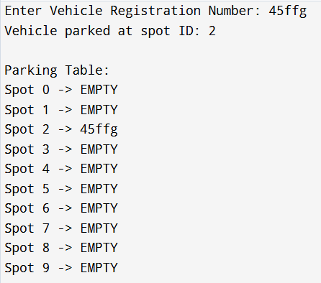

Department of Artificial Intelligence and Data Science

Vision of the Department
To be a preferred hub for nurturing computer engineering aspirants through innovative, ethical, value-based technical education, impactful research, and industry collaboration, to become successful professionals contributing for the betterment of society.

Mission of the Department
To nurture computer engineering professionals by offering: Dynamic learning environment that encourages problem-solving using emerging technology, · National Education Policy aligned evidence-based technical education, fostering innovation, research, and industry–institute collaboration, Holistic, ethical and sustainable development for lifelong success.

Output Analysis | The program simulates a simple parking management system using hashing. When the user enters a vehicle registration number, the hash function calculates a hash value and determines the parking spot index. If the calculated spot is empty, the vehicle is parked there; otherwise, linear probing finds the next available spot. The output displays the assigned parking spot ID and the entire parking table showing occupied and empty spots. This demonstrates how hashing helps in fast allocation and efficient management of parking spaces in the system.
Link of student Github profile where lab assignment has been uploaded | https://github.com/Racchii/ADS-assignments
Conclusion | The hashing-based parking management program demonstrates how data structures can be applied to solve real-world problems efficiently. By using a hash function, vehicle registration numbers are quickly converted into parking spot indices, enabling fast allocation of spaces. Collision handling through linear probing ensures that vehicles can still be parked even when a calculated spot is occupied. This approach reduces search time and improves system performance. Overall, hashing provides a simple and effective method for organizing and managing parking spaces in a busy parking environment.
Plag Report (Similarity index  < 12%) | 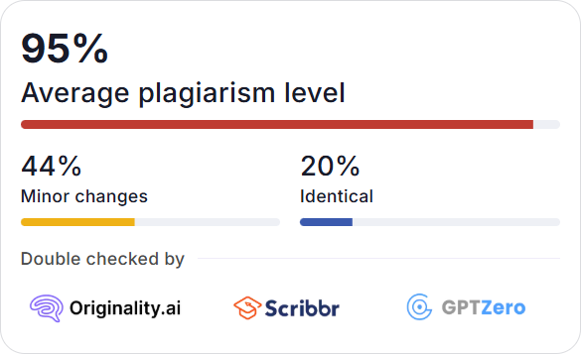

Department of Artificial Intelligence and Data Science

Vision of the Department
To be a preferred hub for nurturing computer engineering aspirants through innovative, ethical, value-based technical education, impactful research, and industry collaboration, to become successful professionals contributing for the betterment of society.

Mission of the Department
To nurture computer engineering professionals by offering: Dynamic learning environment that encourages problem-solving using emerging technology, · National Education Policy aligned evidence-based technical education, fostering innovation, research, and industry–institute collaboration, Holistic, ethical and sustainable development for lifelong success.

Date | 19/01/2026

