Department of Artificial Intelligence and Data Science

Vision of the Department
To be a preferred hub for nurturing computer engineering aspirants through innovative, ethical, value-based technical education, impactful research, and industry collaboration, to become successful professionals contributing for the betterment of society.

Mission of the Department
To nurture computer engineering professionals by offering: Dynamic learning environment that encourages problem-solving using emerging technology, · National Education Policy aligned evidence-based technical education, fostering innovation, research, and industry–institute collaboration, Holistic, ethical and sustainable development for lifelong success.

Session 2025-2026

Vision: To be a well-known centre for pursuing  computer education through innovative pedagogy,  value-based education and industry collaboration | Mission: To establish learning ambience for  ushering in computer engineering professionals in core and multidisciplinary area by developing Problem-solving skills through emerging technologies.
Program Educational Objectives of the program (PEO): (broad statements that describe the professional and career accomplishments)
PEO1 | Preparation | P: Preparation | Pep-CL abbreviation  pronounce as Pep-si-lL easy to recall
PEO2 | Core Competence | E: Environment  (Learning Environment)
PEO3 | Breadth | P: Professionalism
PEO4 | Professionalism | C: Core Competence
PEO5 | Learning Environment | L: Breadth (Learning in diverse areas)

Program Outcomes (PO): (statements that describe what a student should be able to do and know by the end of a program)

Keywords of POs:
Engineering knowledge, Problem analysis, Design/development of solutions, Conduct Investigations of Complex Problems, Engineering Tool Usage, The Engineer and The World, Ethics, Individual and Collaborative Team work, Communication, Project Management and Finance, Life-Long Learning

PSO Keywords: Cutting edge technologies, Research

“I am an engineer, and I know how to apply engineering knowledge to investigate, analyse and design solutions to complex problems using tools for entire world following all ethics in a collaborative way with proper management skills throughout my life.” to contribute to the development of cutting-edge technologies and Research.

Integrity: I will adhere to the Laboratory Code of Conduct and ethics in its entirety.
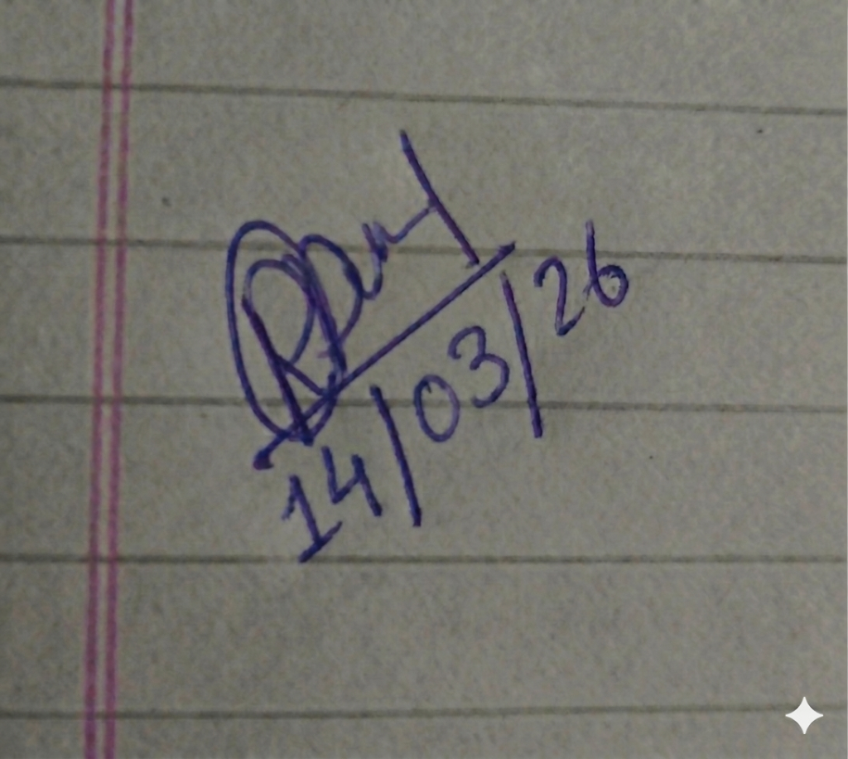

Name and Signature of Student and Date

Department of Artificial Intelligence and Data Science

Vision of the Department
To be a preferred hub for nurturing computer engineering aspirants through innovative, ethical, value-based technical education, impactful research, and industry collaboration, to become successful professionals contributing for the betterment of society.

Mission of the Department
To nurture computer engineering professionals by offering: Dynamic learning environment that encourages problem-solving using emerging technology, · National Education Policy aligned evidence-based technical education, fostering innovation, research, and industry–institute collaboration, Holistic, ethical and sustainable development for lifelong success.

Session | 2025-26 (EVEN) |  | Course Name | Advanced Data Structures Lab
Semester | IV |  | Course Code | 23 ADS1404
Roll No | 66 |  | Name of Student | Rachit R Deogirkar
Practical Number |  | 8
Course Outcome |  | - Understand the fundamental concepts of non -linear data structures  - Implement the real-life application using nonlinear data structures.  - Apply the concept of hashing, disjoint set and union–find techniques with path compression to manage equivalence relations and dynamic groups  - Analyze graph-based problems using traversal, topological sorting, and shortest path algorithms.  - Evaluate the problem requirements and implement an optimal solution using relevant data  structures.

Department of Artificial Intelligence and Data Science

Vision of the Department
To be a preferred hub for nurturing computer engineering aspirants through innovative, ethical, value-based technical education, impactful research, and industry collaboration, to become successful professionals contributing for the betterment of society.

Mission of the Department
To nurture computer engineering professionals by offering: Dynamic learning environment that encourages problem-solving using emerging technology, · National Education Policy aligned evidence-based technical education, fostering innovation, research, and industry–institute collaboration, Holistic, ethical and sustainable development for lifelong success.

Aim | Use disjoint set data structures to represent equivalence relations and implement simple union, smart union, and path compression algorithms to efficiently merge groups and determine group membership.
Problem Definition
Theory | A Disjoint Set Data Structure, also known as Union-Find, is used to manage a collection of non-overlapping sets and efficiently determine whether elements belong to the same group. It is commonly used to represent equivalence relations where elements are grouped based on certain relationships. The structure mainly supports two operations: Find, which identifies the representative of a set, and Union, which merges two sets. Simple union directly connects two sets, while smart union (union by rank or size) attaches the smaller tree under the larger one to keep the structure balanced. Path compression optimizes the Find operation by flattening the tree, making future searches faster and improving overall efficiency.

Department of Artificial Intelligence and Data Science

Vision of the Department
To be a preferred hub for nurturing computer engineering aspirants through innovative, ethical, value-based technical education, impactful research, and industry collaboration, to become successful professionals contributing for the betterment of society.

Mission of the Department
To nurture computer engineering professionals by offering: Dynamic learning environment that encourages problem-solving using emerging technology, · National Education Policy aligned evidence-based technical education, fostering innovation, research, and industry–institute collaboration, Holistic, ethical and sustainable development for lifelong success.

Procedure and Execution  (100 Words) | Algorithm:  - Initialize Set  - Start  - Create an array parent[n] for n elements.  - For each element i, set parent[i] = i (each element is its own set).  - Find Operation  - To find the representative of element x:  - If parent[x] == x, return x.  - Otherwise, recursively find parent[x].  3. Simple Union  7. Find roots of elements x and y.  8. If roots are different, set parent[root_y] = root_x to merge the sets.  4. Smart Union (Union by Rank)  9. Maintain a rank[] array.  10. Attach the tree with smaller rank under the tree with larger rank.  5. Path Compression  11. During Find, update parent[x] to the root to flatten the tree.  6. Stop

Department of Artificial Intelligence and Data Science

Vision of the Department
To be a preferred hub for nurturing computer engineering aspirants through innovative, ethical, value-based technical education, impactful research, and industry collaboration, to become successful professionals contributing for the betterment of society.

Mission of the Department
To nurture computer engineering professionals by offering: Dynamic learning environment that encourages problem-solving using emerging technology, · National Education Policy aligned evidence-based technical education, fostering innovation, research, and industry–institute collaboration, Holistic, ethical and sustainable development for lifelong success.

Code:
#include <stdio.h> #define MAX 50
int parent[MAX], rank[MAX];

void makeSet(int n) { for(int i = 0; i < n; i++) {
parent[i] = i; rank[i] = 0;
}
}
int find(int x) { if(parent[x] != x)
parent[x] = find(parent[x]); return parent[x];
}
void simpleUnion(int x, int y) { int rootX = find(x);
int rootY = find(y);

if(rootX != rootY) parent[rootY] = rootX;
}
void smartUnion(int x, int y) { int rootX = find(x);
int rootY = find(y);

if(rootX == rootY) return;

if(rank[rootX] < rank[rootY]) parent[rootX] = rootY;
else if(rank[rootX] > rank[rootY])

Department of Artificial Intelligence and Data Science

Vision of the Department
To be a preferred hub for nurturing computer engineering aspirants through innovative, ethical, value-based technical education, impactful research, and industry collaboration, to become successful professionals contributing for the betterment of society.

Mission of the Department
To nurture computer engineering professionals by offering: Dynamic learning environment that encourages problem-solving using emerging technology, · National Education Policy aligned evidence-based technical education, fostering innovation, research, and industry–institute collaboration, Holistic, ethical and sustainable development for lifelong success.

parent[rootY] = rootX;
else {
parent[rootY] = rootX; rank[rootX]++;
}
}

int main() {
int n, m, x, y, choice;

printf("Enter number of elements: "); scanf("%d", &n);

makeSet(n);

printf("Enter number of union operations: "); scanf("%d", &m);
printf("Choose Union Method:\n"); printf("1. Simple Union\n");
printf("2. Smart Union (Union by Rank)\n"); printf("Enter choice: ");
scanf("%d", &choice);

for(int i = 0; i < m; i++) {
printf("Enter two elements to union: "); scanf("%d %d", &x, &y);
if(choice == 1) simpleUnion(x, y);
else
smartUnion(x, y);
}
printf("\nSet representative of each element:\n"); for(int i = 0; i < n; i++) {

Department of Artificial Intelligence and Data Science

Vision of the Department
To be a preferred hub for nurturing computer engineering aspirants through innovative, ethical, value-based technical education, impactful research, and industry collaboration, to become successful professionals contributing for the betterment of society.

Mission of the Department
To nurture computer engineering professionals by offering: Dynamic learning environment that encourages problem-solving using emerging technology, · National Education Policy aligned evidence-based technical education, fostering innovation, research, and industry–institute collaboration, Holistic, ethical and sustainable development for lifelong success.

printf("Element %d -> Root %d\n", i, find(i));
}
return 0;
}
Output:

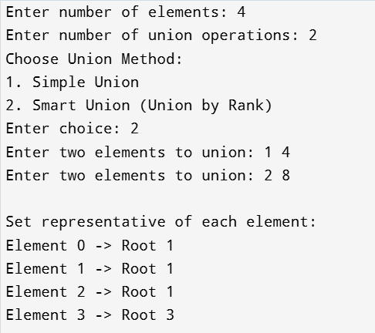

Output Analysis | The program demonstrates the working of the Disjoint Set (Union-Find) data structure. The user first enters the number of  elements and the number of union operations to perform. Based on the chosen method (simple union or smart union), the program merges the specified elements into groups. The find operation with path  compression determines the representative (root) of each element’s set. Finally, the output displays the root of every element, showing which elements belong to the same group. This helps verify how sets are efficiently merged and managed.

Department of Artificial Intelligence and Data Science

Vision of the Department
To be a preferred hub for nurturing computer engineering aspirants through innovative, ethical, value-based technical education, impactful research, and industry collaboration, to become successful professionals contributing for the betterment of society.

Mission of the Department
To nurture computer engineering professionals by offering: Dynamic learning environment that encourages problem-solving using emerging technology, · National Education Policy aligned evidence-based technical education, fostering innovation, research, and industry–institute collaboration, Holistic, ethical and sustainable development for lifelong success.

Link of student Github profile where lab assignment has been uploaded | https://github.com/Racchii/ADS-assignments
Conclusion | The Disjoint Set data structure provides an efficient way to manage and merge groups of elements. Using operations like Find and Union, it helps determine whether elements belong to the same set. The implementation of simple union, smart union (union by rank), and path compression improves the performance by reducing the height of trees and speeding up search operations. This program demonstrates how equivalence relations can be represented and managed effectively. Overall, Disjoint Set is widely used in applications like network connectivity, clustering, and graph algorithms.
Plag Report (Similarity index  < 12%) | 
Date | 14/03/2026

