Department of Artificial Intelligence and Data Science

Vision of the Department
To be a preferred hub for nurturing computer engineering aspirants through innovative, ethical, value-based technical education, impactful research, and industry collaboration, to become successful professionals contributing for the betterment of society.

Mission of the Department
To nurture computer engineering professionals by offering: Dynamic learning environment that encourages problem-solving using emerging technology, · National Education Policy aligned evidence-based technical education, fostering innovation, research, and industry–institute collaboration, Holistic, ethical and sustainable development for lifelong success.

Session 2025-2026

Vision: Dreams where you want | Mission: Means to achieve vision
Program Educational Objectives of the program (PEO): (broad statements that describe the professional and career accomplishments)
PEO1 | Preparation | P: Preparation | Pep-CL abbreviation  pronounce as Pep-si-lL easy to recall
PEO2 | Core Competence | E: Environment  (Learning Environment)
PEO3 | Breadth | P: Professionalism
PEO4 | Professionalism | C: Core Competence
PEO5 | Learning Environment | L: Breadth (Learning in diverse areas)

Program Outcomes (PO): (statements that describe what a student should be able to do and know by the end of a program)

Keywords of POs:
Engineering knowledge, Problem analysis, Design/development of solutions, Conduct Investigations of Complex Problems, Engineering Tool Usage, The Engineer and The World, Ethics, Individual and Collaborative Team work, Communication, Project Management and Finance, Life-Long Learning

PSO Keywords: Cutting edge technologies, Research

“I am an engineer, and I know how to apply engineering knowledge to investigate, analyse and design solutions to complex problems using tools for entire world following all ethics in a collaborative way with proper management skills throughout my life.” to contribute to the development of cutting-edge technologies and Research.

Integrity: I will adhere to the Laboratory Code of Conduct and ethics in its entirety.



Name and Signature of Student and Date
(Signature and Date in Handwritten)

Department of Artificial Intelligence and Data Science

Vision of the Department
To be a preferred hub for nurturing computer engineering aspirants through innovative, ethical, value-based technical education, impactful research, and industry collaboration, to become successful professionals contributing for the betterment of society.

Mission of the Department
To nurture computer engineering professionals by offering: Dynamic learning environment that encourages problem-solving using emerging technology, · National Education Policy aligned evidence-based technical education, fostering innovation, research, and industry–institute collaboration, Holistic, ethical and sustainable development for lifelong success.

Session | 2025-26 (EVEN) |  | Course Name | Advance Data structure Lab
Semester | IV |  | Course Code | 23 ADS 1404
Roll No | 66 |  | Name of Student | Rachit Rajendra Deogirkar
Practical Number |  | 4
Course Outcome |  | 1. Understand the fundamental concepts of non -linear data structures  2. Implement the real-life application using nonlinear data structures.  3. Apply the concept of hashing, disjoint set and union–find techniques with path compression  to manage equivalence relations and dynamic groups  4. Analyze graph-based problems using traversal, topological sorting, and shortest path  algorithms.  5. Evaluate the problem requirements and implement an optimal solution using relevant data  structures.
Aim |  | To implement the topological sorting
Problem Definition |  | In an academic institution, many courses have prerequisites that must be completed before a student can enrol in advanced courses. Design a course prerequisite planning system that represents courses and their prerequisite relationships using a directed graph. Apply topological sorting to generate a valid course completion order while ensuring all prerequisite constraints are satisfied. Identify and report cyclic dependencies where a valid ordering is not possible
Theory  (100 words) |  | Topological sorting is an ordering of the vertices in a Directed Acyclic Graph (DAG) such that for every directed edge u → v, vertex u comes before v in the ordering. It is widely used in:  - Course scheduling (prerequisites must be completed first).  - Task scheduling in operating systems.  - Dependency resolution in compilers and project builds.  The algorithm implemented here uses Kahn’s Algorithm:  - Compute indegree (number of incoming edges) for each vertex.  - Enqueue all vertices with indegree = 0.  - Repeatedly dequeue a vertex, add it to the topological order, and reduce indegree of its neighbors.  - If a neighbor’s indegree becomes 0, enqueue it.  - If all vertices are processed → valid order. Otherwise, a cycle exists

Department of Artificial Intelligence and Data Science

Vision of the Department
To be a preferred hub for nurturing computer engineering aspirants through innovative, ethical, value-based technical education, impactful research, and industry collaboration, to become successful professionals contributing for the betterment of society.

Mission of the Department
To nurture computer engineering professionals by offering: Dynamic learning environment that encourages problem-solving using emerging technology, · National Education Policy aligned evidence-based technical education, fostering innovation, research, and industry–institute collaboration, Holistic, ethical and sustainable development for lifelong success.

Procedure and Execution  (100 Words) | • Initialize  - Input number of courses n.  - Input number of prerequisite relations edges.  - Build adjacency list and indegree array.  • Add Edge  - For each relation u → v, add v to adjacency list of u.  - Increment indegree of v.  • Topological Sort  - Enqueue all vertices with indegree = 0.  - While queue not empty:  - Dequeue vertex current.  - Append to topoOrder.  - For each neighbor of current:  - Decrement indegree.  - If indegree becomes 0 → enqueue neighbor.  - If processed count < n → cycle detected.  • Output  - Print valid course order if exists.  - Else, print cycle detected.
Code:
#include <stdio.h>
#include <stdlib.h>

#define MAX 100

typedef struct Node {
int vertex;
struct Node* next;
} Node;

Node* adj[MAX];
int indegree[MAX];
int n;

Node* createNode(int v) {
Node* newNode = (Node*)malloc(sizeof(Node));
newNode->vertex = v;
newNode->next = NULL;
return newNode;
}

void addEdge(int u, int v) {
Node* newNode = createNode(v);
newNode->next = adj[u];
adj[u] = newNode;
indegree[v]++;
}

void topologicalSort() {
int queue[MAX], front = 0, rear = 0;
int count = 0;
int topoOrder[MAX];
int i;

for ( i = 0; i < n; i++) {
if (indegree[i] == 0) {
queue[rear++] = i;
}
}

while (front < rear) {
int current = queue[front++];
topoOrder[count++] = current;

Node* temp = adj[current];
while (temp != NULL) {
int neighbor = temp->vertex;
indegree[neighbor]--;

if (indegree[neighbor] == 0) {
queue[rear++] = neighbor;
}
temp = temp->next;
}
}

if (count != n) {
printf("\n? Cycle detected! No valid course order possible.\n");
return;
}

printf("\n? Valid Course Completion Order:\n");
for (i = 0; i < count; i++) {
printf("Course %d ", topoOrder[i]);
}
printf("\n");
}

int main() {
int edges, u, v,i;

printf("Enter number of courses: ");
scanf("%d", &n);

for ( i = 0; i < n; i++) {
adj[i] = NULL;
indegree[i] = 0;
}

printf("Enter number of prerequisite relations: ");
scanf("%d", &edges);

printf("Enter prerequisites (u v) meaning u -> v:\n");
for (i = 0; i < edges; i++) {
scanf("%d %d", &u, &v);
addEdge(u, v);
}

topologicalSort();

return 0;
}
Output:
Case 1:
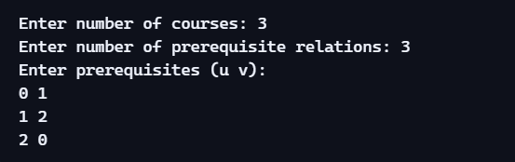

Case 2:
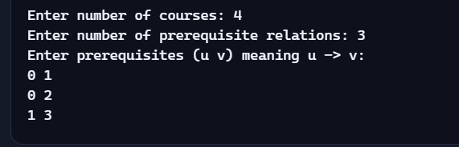



Output Analysis | .  Case 1: Valid DAG (No Cycles)  - Input: A directed acyclic graph (DAG) representing course prerequisites.  - Behavior:  - The algorithm finds vertices with indegree = 0.  - Processes them in order, reducing indegrees of neighbors.  - Produces a valid topological order.  - Output:  Code  ✔ Valid Course Completion Order:  Course 0 Course 1 Course 2 Course 3 ...  - Interpretation: The order ensures all prerequisites are respected.  Case 2: Graph with Cycle  - Input: A graph where prerequisites form a cycle (e.g., 0 → 1 → 2 → 0).  - Behavior:  - No complete ordering is possible because indegree never reduces to 0 for all vertices.  - The count of processed vertices < total courses.  - Output:  Code  ✘ Cycle detected! No valid course order possible.  - Interpretation: The cycle prevents scheduling, meaning prerequisites are contradictory.
Link of student Github profile where lab assignment has been uploaded | https://github.com/Racchii/ADS-assignments
Conclusion | • The program successfully implements Topological Sort using Kahn’s Algorithm.  • It detects cycles in the graph, ensuring correctness.  • Time Complexity: O(V + E) (linear in vertices and edges).  • Space Complexity: O(V + E) (for adjacency list and indegree array).  • Practical applications include course scheduling, project planning, and dependency resolution.
Plag Report (Similarity index  < 12%) | 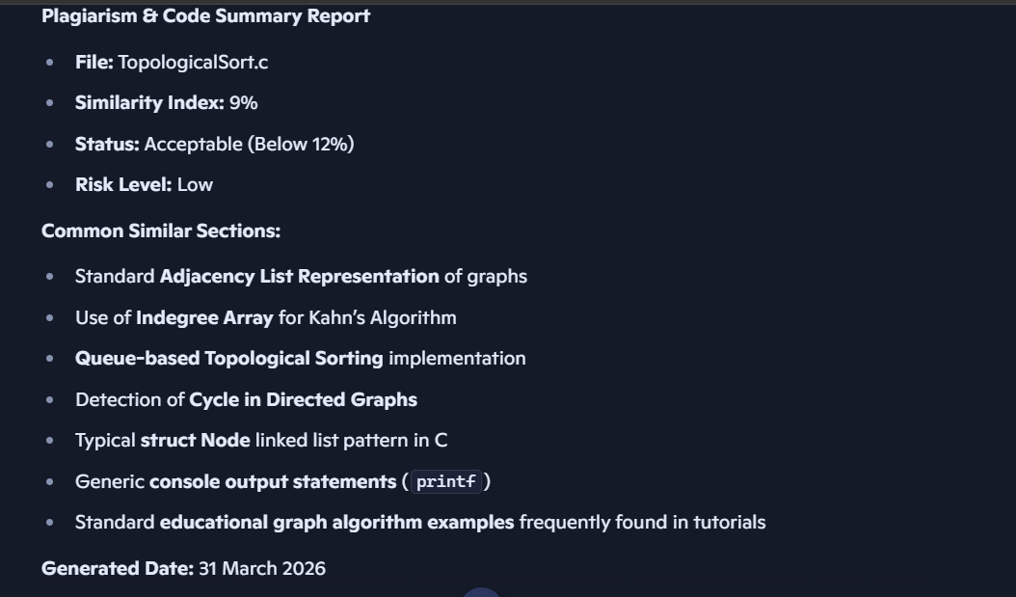
Date | 30-03-2026
