Vision of the Department
To be a preferred hub for nurturing computer engineering aspirants through innovative, ethical, value-based technical education, impactful research, and industry collaboration, to become successful professionals contributing for the betterment of society.

Mission of the Department
To nurture computer engineering professionals by offering: Dynamic learning environment that encourages problem-solving using emerging technology, · National Education Policy aligned evidence-based technical education, fostering innovation, research, and industry–institute collaboration, Holistic, ethical and sustainable development for lifelong success.

Session 2025-2026

Vision: Dreams where you want | Mission: Means to achieve vision

Program Educational Objectives of the program (PEO): (broad statements that describe the professional and career accomplishments)
PEO1 | Preparation | P: Preparation | Pep-CL abbreviation  pronounce as Pep-si-lL easy to recall
PEO2 | Core Competence | E: Environment  (Learning Environment)
PEO3 | Breadth | P: Professionalism
PEO4 | Professionalism | C: Core Competence
PEO5 | Learning  Environment | L: Breadth (Learning in diverse areas)

Program Outcomes (PO): (statements that describe what a student should be able to do and know by the end of a program)
Keywords of POs:
Engineering knowledge, Problem analysis, Design/development of solutions, Conduct Investigations of Complex Problems, Engineering Tool Usage, The Engineer and The World, Ethics, Individual and Collaborative Team work, Communication, Project Management and Finance, Life-Long Learning

PSO Keywords: Cutting edge technologies, Research

“I am an engineer, and I know how to apply engineering knowledge to investigate, analyse and design solutions to complex problems using tools for entire world following all ethics in a collaborative way with proper management skills throughout my life.” to contribute to the development of cutting-edge technologies and Research.

Integrity: I will adhere to the Laboratory Code of Conduct and ethics in its entirety.


Name and Signature of Student and Date
(Signature and Date in Handwritten)

Department of Artificial Intelligence and Data Science

Vision of the Department
To be a preferred hub for nurturing computer engineering aspirants through innovative, ethical, value-based technical education, impactful research, and industry collaboration, to become successful professionals contributing for the betterment of society.

Mission of the Department
To nurture computer engineering professionals by offering: Dynamic learning environment that encourages problem-solving using emerging technology, · National Education Policy aligned evidence-based technical education, fostering innovation, research, and industry–institute collaboration, Holistic, ethical and sustainable development for lifelong success.

Session | 2025-26 (EVEN) | Course Name | Advanced Data Structures Lab
Semester | IV | Course Code | 23 ADS1404
Roll No | 66 | Name of Student | Rachit R Deogirkar

Practical Number | 1
Course Outcome | - Understand the fundamental concepts of non -linear data structures  - Implement the real-life application using nonlinear data structures.  - Apply the concept of hashing, disjoint set and union–find techniques with path compression to manage equivalence relations and dynamic groups  - Analyze graph-based problems using traversal, topological sorting, and shortest path algorithms.  - Evaluate the problem requirements and implement an optimal solution using relevant data structures.
Aim | Program based on tree data structure

Vision of the Department
To be a preferred hub for nurturing computer engineering aspirants through innovative, ethical, value-based technical education, impactful research, and industry collaboration, to become successful professionals contributing for the betterment of society.

Mission of the Department
To nurture computer engineering professionals by offering: Dynamic learning environment that encourages problem-solving using emerging technology, · National Education Policy aligned evidence-based technical education, fostering innovation, research, and industry–institute collaboration, Holistic, ethical and sustainable development for lifelong success.

Problem  Definition | A Library Management System (LMS) manages thousands of books. Each book is identified by a unique Book ID and associated metadata like title, author, etc. The system requires a fast and dynamic method to locate books, add new entries, and remove outdated ones. Design a database indexing system using a Binary Search Tree (BST) to:  i. Store and maintain the Book IDs in sorted order. ii. Efficiently search for books using their Book IDs.  - Support dynamic operations like adding new books or deleting books when they are no longer available.  - Enable retrieval of books within a specific range of IDs for generating reports.
Theory  (100 words) | A Binary Search Tree (BST) is a node-based data structure that organizes elements hierarchically while maintaining a specific ordering rule. Each node contains a key and two child references. For any node, all keys in the left subtree are smaller, and all keys in the right subtree are larger. This arrangement allows efficient searching, insertion, and deletion by following comparisons down the tree. The average time complexity of operations is O(log n), depending on the tree’s height. BSTs are widely used in data storage and retrieval systems. However, if the tree becomes skewed, performance may degrade to O(n).

Department of Artificial Intelligence and Data Science

Vision of the Department
To be a preferred hub for nurturing computer engineering aspirants through innovative, ethical, value-based technical education, impactful research, and industry collaboration, to become successful professionals contributing for the betterment of society.

Mission of the Department
To nurture computer engineering professionals by offering: Dynamic learning environment that encourages problem-solving using emerging technology, · National Education Policy aligned evidence-based technical education, fostering innovation, research, and industry–institute collaboration, Holistic, ethical and sustainable development for lifelong success.

Procedure and  Execution  (100 Words) | Algorithm:  - Insertion (Add Book)  - Create a new node.  - If root is NULL, make it root.  - If ID < root → go left.  - If ID > root → go right.  - Repeat until inserted at correct position.  - Search Book  - Start at root.  - If ID matches → return book.  - If smaller → search left.  - If larger → search right.  - Delete Book  - Locate node.  - No child → delete.  - One child → replace with child.  - Two children → replace with inorder successor, delete successor.  - Range Search (L–R)  - Traverse left if needed.  - Print if ID in range.  - Traverse right if needed.

Code:
#include <stdio.h>
#include <stdlib.h> #include <string.h> struct Book {
int id; char title[50]; char author[50]; struct Book *left, *right;
};
struct Book* createNode(int id, char title[], char author[]) {
struct Book* newNode = (struct Book*)malloc(sizeof(struct Book)); newNode->id = id;
strcpy(newNode->title, title); strcpy(newNode->author, author); newNode->left = newNode->right = NULL; return newNode;
}
struct Book* insert(struct Book* root, int id, char title[], char author[]) { if (root == NULL)
return createNode(id, title, author); if (id < root->id)
root->left = insert(root->left, id, title, author); else if (id > root->id)
root->right = insert(root->right, id, title, author); return root;
}
struct Book* search(struct Book* root, int id) { if (root == NULL || root->id == id) return root; if (id < root->id)
return search(root->left, id); return search(root->right, id);
}
To be a preferred hub for nurturing computer engineering aspirants through innovative, ethical, value-based technical education, impactful research, and industry collaboration, to become successful professionals contributing for the betterment of society.

Mission of the Department
To nurture computer engineering professionals by offering: Dynamic learning environment that encourages problem-solving using emerging technology, · National Education Policy aligned evidence-based technical education, fostering innovation, research, and industry–institute collaboration, Holistic, ethical and sustainable development for lifelong success.
struct Book* findMin(struct Book* root) { while (root->left != NULL) root = root->left; return root;
}
struct Book* deleteNode(struct Book* root, int id) { if (root == NULL) return root; if (id < root->id)
root->left = deleteNode(root->left, id); else if (id > root->id)
root->right = deleteNode(root->right, id); else {
if (root->left == NULL) { struct Book* temp = root->right; free(root); return temp;
}
else if (root->right == NULL) { struct Book* temp = root->left; free(root); return temp;
}
struct Book* temp = findMin(root->right); root->id = temp->id;
strcpy(root->title, temp->title); strcpy(root->author, temp->author);
root->right = deleteNode(root->right, temp->id);
}
return root;
}
void rangeSearch(struct Book* root, int L, int R) { if (root == NULL) return; if (L < root->id)
rangeSearch(root->left, L, R);
To be a preferred hub for nurturing computer engineering aspirants through innovative, ethical, value-based technical education, impactful research, and industry collaboration, to become successful professionals contributing for the betterment of society.

Mission of the Department
To nurture computer engineering professionals by offering: Dynamic learning environment that encourages problem-solving using emerging technology, · National Education Policy aligned evidence-based technical education, fostering innovation, research, and industry–institute collaboration, Holistic, ethical and sustainable development for lifelong success.

if (root->id >= L && root->id <= R)
printf(ID: %d, Title: %s, Author: %s\n", root->id, root->title, root->author); if (R > root->id)
rangeSearch(root->right, L, R);
}
int main() {
struct Book* root = NULL;
root = insert(root, 50, "C Programming", "Dennis Ritchie"); root = insert(root, 30, "Data Structures", "Mark Allen"); root = insert(root, 70, "Algorithms", "CLRS"); root = insert(root, 20, "DBMS", "Korth"); struct Book* found = search(root, 30); if (found != NULL)
printf("Found: %s by %s\n", found->title, found->author); else
printf("Book not found\n");
printf("\nBooks between ID 25 and 65:\n"); rangeSearch(root, 25, 65); root = deleteNode(root, 30); printf("\nAfter Deletion of ID 30:\n"); rangeSearch(root, 20, 70);

return 0;
}

To be a preferred hub for nurturing computer engineering aspirants through innovative, ethical, value-based technical education, impactful research, and industry collaboration, to become successful professionals contributing for the betterment of society.

Mission of the Department
To nurture computer engineering professionals by offering: Dynamic learning environment that encourages problem-solving using emerging technology, · National Education Policy aligned evidence-based technical education, fostering innovation, research, and industry–institute collaboration, Holistic, ethical and sustainable development for lifelong success.

Output:
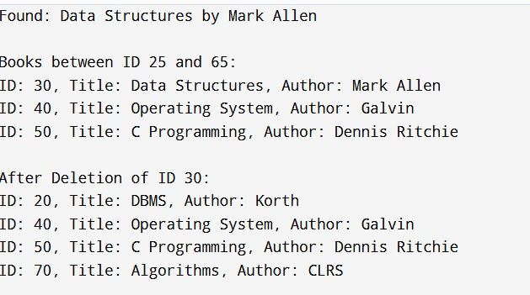
Output Analysis | The output demonstrates that the BST correctly maintains Book IDs in sorted order while supporting efficient operations. Insertion places each book according to BST rules. Searching quickly finds a book by comparing IDs and traversing left or right. Range search prints books within the given limits in sorted order using in-order traversal. During deletion, if a node has two children, it is replaced by its inorder successor to maintain structure. The final output confirms that insertion, search, deletion, and range retrieval all work properly while preserving BST properties.
Link of student Github profile where lab assignment has been uploaded
Conclusion | The Binary Search Tree is an effective indexing method for a Library Management System as it maintains Book IDs in sorted order and supports fast searching, insertion, and deletion. It efficiently handles dynamic updates without reorganizing the entire database. Range queries can also be performed easily using in-order traversal. Thus, BST provides a simple, structured, and efficient solution for managing and retrieving book records in the system.

Department of Artificial Intelligence and Data Science

Vision of the Department
To be a preferred hub for nurturing computer engineering aspirants through innovative, ethical, value-based technical education, impactful research, and industry collaboration, to become successful professionals contributing for the betterment of society.

Mission of the Department
To nurture computer engineering professionals by offering: Dynamic learning environment that encourages problem-solving using emerging technology, · National Education Policy aligned evidence-based technical education, fostering innovation, research, and industry–institute collaboration, Holistic, ethical and sustainable development for lifelong success.

Plag Report  (Similarity index  < 12%) | 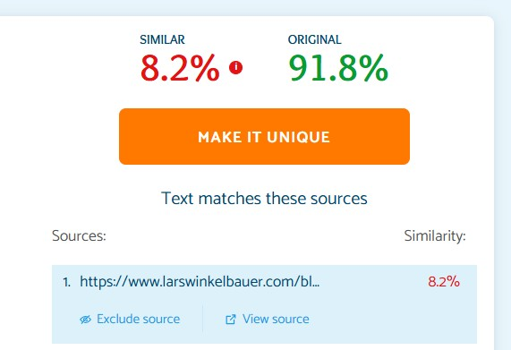
Date | 19/01/2026

