Department of Artificial Intelligence and Data Science

Vision of the Department
To be a preferred hub for nurturing computer engineering aspirants through innovative, ethical, value-based technical education, impactful research, and industry collaboration, to become successful professionals contributing for the betterment of society.

Mission of the Department
To nurture computer engineering professionals by offering: Dynamic learning environment that encourages problem-solving using emerging technology, · National Education Policy aligned evidence-based technical education, fostering innovation, research, and industry–institute collaboration, Holistic, ethical and sustainable development for lifelong success.

Session 2025-2026

Vision: Dreams where you want | Mission: Means to achieve vision
Program Educational Objectives of the program (PEO): (broad statements that describe the professional and career accomplishments)
PEO1 | Preparation | P: Preparation | Pep-CL abbreviation  pronounce as Pep-si-lL easy to recall
PEO2 | Core Competence | E: Environment  (Learning Environment)
PEO3 | Breadth | P: Professionalism
PEO4 | Professionalism | C: Core Competence
PEO5 | Learning Environment | L: Breadth (Learning in diverse areas)

Program Outcomes (PO): (statements that describe what a student should be able to do and know by the end of a program)

Keywords of POs:
Engineering knowledge, Problem analysis, Design/development of solutions, Conduct Investigations of Complex Problems, Engineering Tool Usage, The Engineer and The World, Ethics, Individual and Collaborative Team work, Communication, Project Management and Finance, Life-Long Learning

PSO Keywords: Cutting edge technologies, Research

“I am an engineer, and I know how to apply engineering knowledge to investigate, analyse and design solutions to complex problems using tools for entire world following all ethics in a collaborative way with proper management skills throughout my life.” to contribute to the development of cutting-edge technologies and Research.

Integrity: I will adhere to the Laboratory Code of Conduct and ethics in its entirety.



Name and Signature of Student and Date
(Signature and Date in Handwritten)

Department of Artificial Intelligence and Data Science

Vision of the Department
To be a preferred hub for nurturing computer engineering aspirants through innovative, ethical, value-based technical education, impactful research, and industry collaboration, to become successful professionals contributing for the betterment of society.

Mission of the Department
To nurture computer engineering professionals by offering: Dynamic learning environment that encourages problem-solving using emerging technology, · National Education Policy aligned evidence-based technical education, fostering innovation, research, and industry–institute collaboration, Holistic, ethical and sustainable development for lifelong success.

Session | 2025-26 (EVEN) |  | Course Name | Advanced Data Structures Lab
Semester | IV |  | Course Code | 23 ADS1404
Roll No | 66 |  | Name of Student | Rachit R Deogirkar
Practical Number |  | 2
Course Outcome |  | - Understand the fundamental concepts of non -linear data structures  - Implement the real-life application using nonlinear data structures.  - Apply the concept of hashing, disjoint set and union–find techniques with path compression to manage equivalence relations and dynamic groups  - Analyze graph-based problems using traversal, topological sorting, and shortest path algorithms.  - Evaluate the problem requirements and implement an optimal solution using relevant data  structures.
Aim |  | Construct a max/min heap and apply heap sort to arrange elements in ascending or descending order.

Department of Artificial Intelligence and Data Science

Vision of the Department
To be a preferred hub for nurturing computer engineering aspirants through innovative, ethical, value-based technical education, impactful research, and industry collaboration, to become successful professionals contributing for the betterment of society.

Mission of the Department
To nurture computer engineering professionals by offering: Dynamic learning environment that encourages problem-solving using emerging technology, · National Education Policy aligned evidence-based technical education, fostering innovation, research, and industry–institute collaboration, Holistic, ethical and sustainable development for lifelong success.

Problem Definition
Theory  (100 words) | A heap is a complete binary tree that satisfies the heap property. In a max heap, every parent node is greater than or equal to its children, so the largest element is at the root. In a min heap, every parent node is smaller than or equal to its children, so the smallest element is at the root. To perform heap sort, first build a max heap (for ascending order) or a min heap (for descending order). Then repeatedly swap the root with the last element, reduce the heap size, and heapify to maintain the heap property until all elements are sorted.
Procedure and Execution  (100 Words) | Algorithm:  Read n elements into array arr. Build a Max Heap from the array.  - For i = n/2 - 1 to 0  - Call heapify(arr, n, i)  For i = n-1 to 1  - Swap arr[0] and arr[i]  - Call heapify(arr, i, 0)  Array is sorted in ascending order.

Department of Artificial Intelligence and Data Science

Vision of the Department
To be a preferred hub for nurturing computer engineering aspirants through innovative, ethical, value-based technical education, impactful research, and industry collaboration, to become successful professionals contributing for the betterment of society.

Mission of the Department
To nurture computer engineering professionals by offering: Dynamic learning environment that encourages problem-solving using emerging technology, · National Education Policy aligned evidence-based technical education, fostering innovation, research, and industry–institute collaboration, Holistic, ethical and sustainable development for lifelong success.

Code:
#include <stdio.h>
void heapify(int arr[], int n, int i) { int largest = i;
int left = 2*i + 1; int right = 2*i + 2;
if (left < n && arr[left] > arr[largest]) largest = left;
if (right < n && arr[right] > arr[largest]) largest = right;
if (largest != i) { int temp = arr[i];
arr[i] = arr[largest]; arr[largest] = temp; heapify(arr, n, largest);
}
}
void heapSort(int arr[], int n) { for (int i = n/2 - 1; i >= 0; i--)
heapify(arr, n, i);

for (int i = n-1; i > 0; i--) { int temp = arr[0];
arr[0] = arr[i]; arr[i] = temp;

heapify(arr, i, 0);
}
}
int main() { int n;
printf("Enter number of elements: "); scanf("%d", &n);

Department of Artificial Intelligence and Data Science

Vision of the Department
To be a preferred hub for nurturing computer engineering aspirants through innovative, ethical, value-based technical education, impactful research, and industry collaboration, to become successful professionals contributing for the betterment of society.

Mission of the Department
To nurture computer engineering professionals by offering: Dynamic learning environment that encourages problem-solving using emerging technology, · National Education Policy aligned evidence-based technical education, fostering innovation, research, and industry–institute collaboration, Holistic, ethical and sustainable development for lifelong success.

int arr[n];
printf("Enter elements:\n"); for (int i = 0; i < n; i++)
scanf("%d", &arr[i]); heapSort(arr, n);
printf("Sorted array (Ascending):\n"); for (int i = 0; i < n; i++)
printf("%d ", arr[i]); return 0;
}
Output:

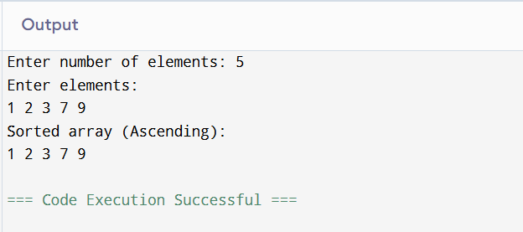

Output Analysis | In heap sort (ascending order using a max heap), the input elements are first arranged into a max heap where the largest element becomes the root. For example, if the input is 4, 10, 3, 5, 1, the heap construction places 10 at the root. Then, the root element is swapped with the last element, and the heap size is reduced. Heapify is applied again to maintain the heap property. This process repeats until all elements are sorted. The final output becomes 1, 3, 4, 5, 10. The algorithm runs in O(n log n) time in all cases and uses constant extra space.

Department of Artificial Intelligence and Data Science

Vision of the Department
To be a preferred hub for nurturing computer engineering aspirants through innovative, ethical, value-based technical education, impactful research, and industry collaboration, to become successful professionals contributing for the betterment of society.

Mission of the Department
To nurture computer engineering professionals by offering: Dynamic learning environment that encourages problem-solving using emerging technology, · National Education Policy aligned evidence-based technical education, fostering innovation, research, and industry–institute collaboration, Holistic, ethical and sustainable development for lifelong success.

Link of student Github profile where lab assignment has been uploaded
Conclusion | Heap sort is an efficient and reliable sorting algorithm that uses the heap data structure to arrange elements in ascending or descending order. By first constructing a max heap (for ascending order) or a min heap (for descending order), it ensures that the largest or smallest element is repeatedly placed in its correct position. The algorithm has a consistent time complexity of O(n log n) in all cases and requires only constant extra space, making it suitable for large datasets. Therefore, heap sort is a stable and practical choice for efficient in-place sorting.
Plag Report (Similarity index  < 12%) | 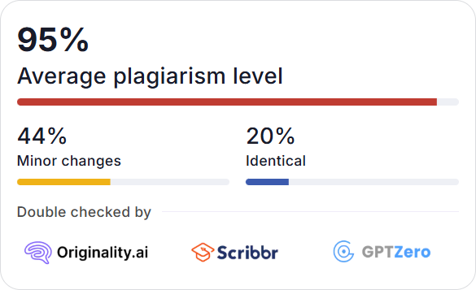
Date | 19/01/2026

