Course: Web Application Development Lab
Instructor: Msc. Nguyen Trung Nghia
Email: ntnghia@hcmiu.edu.vn
Lab 2: Advance HTML and CSS

Đỗ Hoàng Mỹ Dung – ITITWE21040
Output:
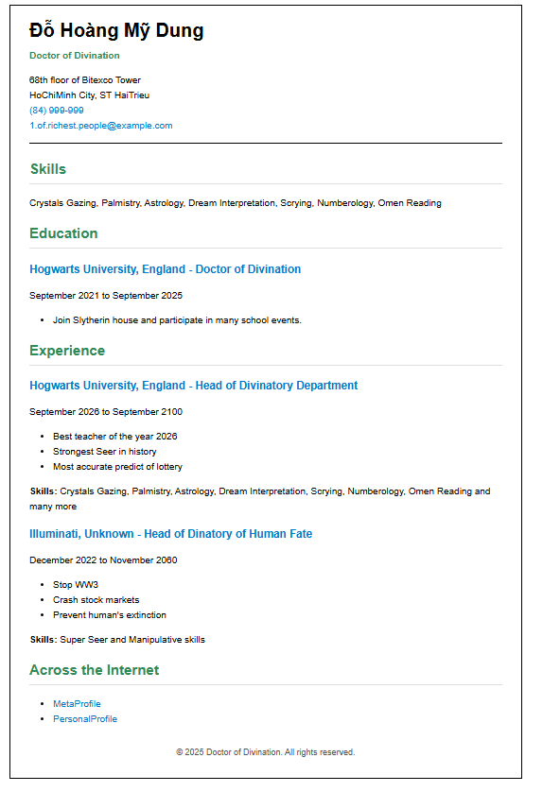
Figure 1: Exercise 1
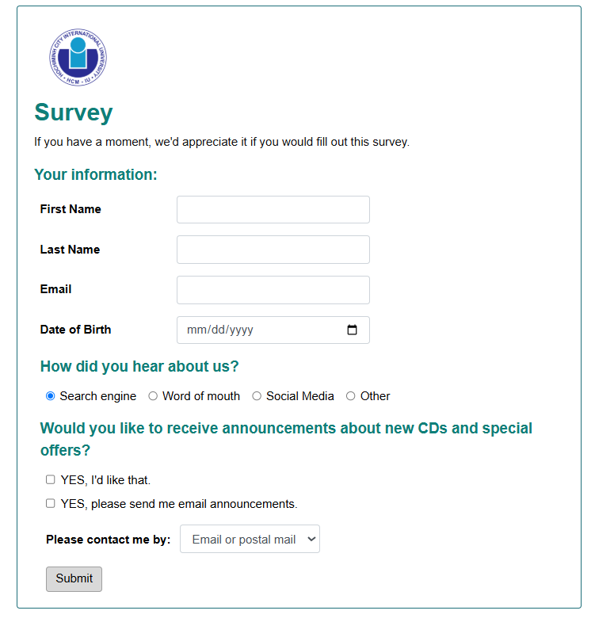
Figure 2: Exercise 2
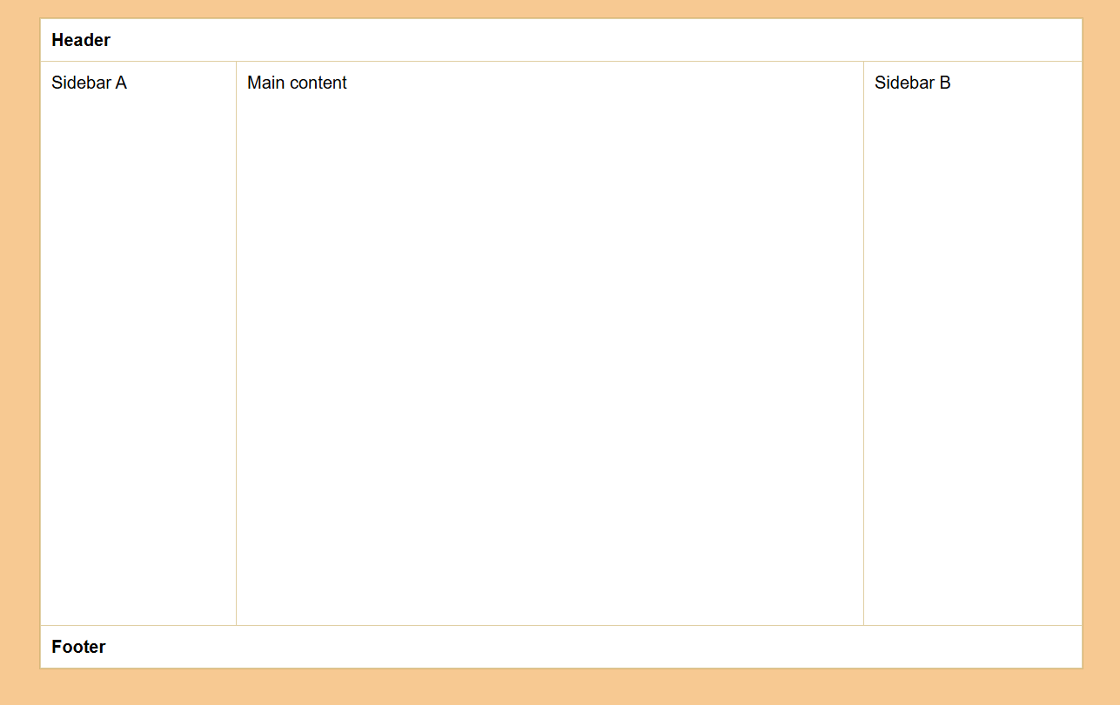
Figure 3: Exercise 3
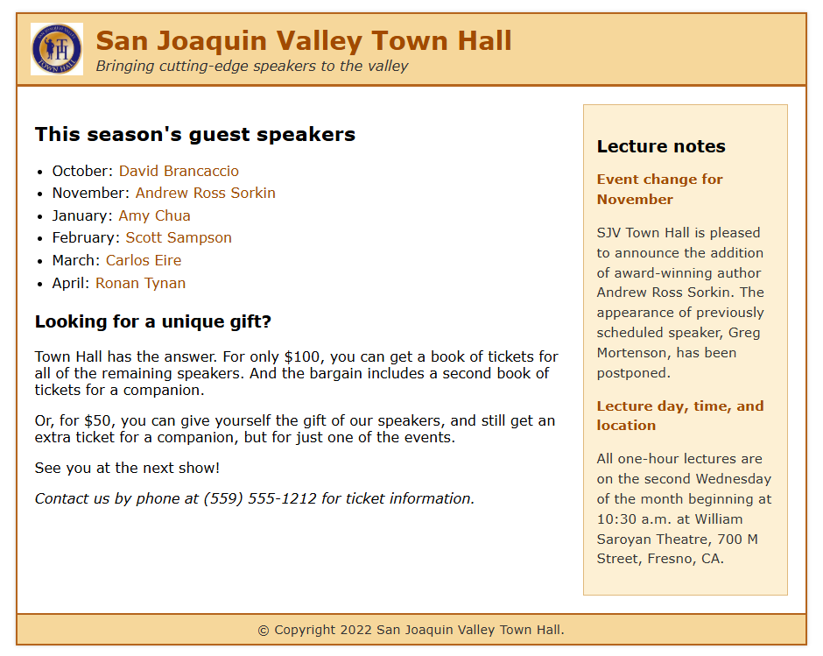
Figure 4: Exercise 4

Checklist
Exercise 2:
WHAT:
This lab builds a survey form using HTML and CSS with text, email, date, radio, checkbox, and select elements.
WHEN:
Used when collecting user feedback or registration details on a webpage.
WHY:
To learn how to create structured forms, group inputs correctly, and style them for a clean and readable layout.
HOW:
A <form> element contains labeled inputs. Radio buttons share the same name, checkboxes allow multiple selections, and a dropdown (<select>) provides contact options. CSS is used for spacing, colors, and alignment.
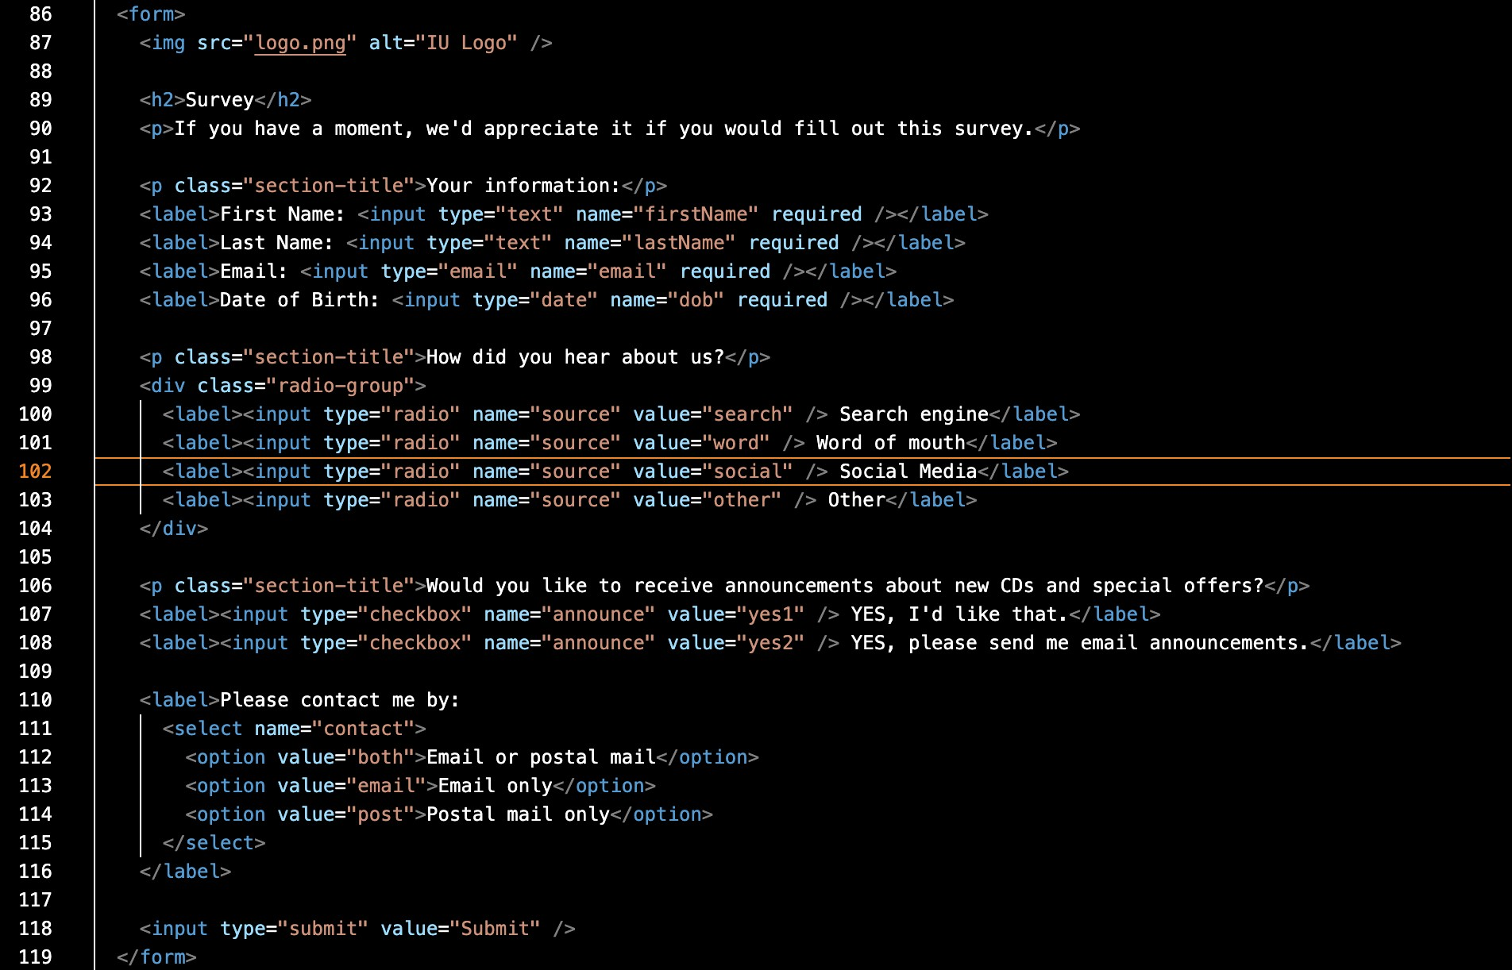
Exercise 3:

WHAT:
This task creates a three-column webpage layout using CSS Grid, including a header, two sidebars, a main area, and a footer.
WHEN:
Used when structuring a webpage that needs multiple sections aligned neatly — for example, blogs, dashboards, or news sites.
WHY:
CSS Grid allows precise control over layout structure (rows, columns, and spacing) without using floats or manual positioning.
HOW:
- The parent <div class="container"> is set to display: grid; - Layout defined with
- Each section (like <header>, .main, .sidebarA, .sidebarB, <footer>) is
assigned its grid area using
Exercise 4:
WHAT:
This exercise builds a two-column webpage for San Joaquin Valley Town Hall using HTML5 and CSS Flexbox. The layout includes a header with logo and title, main content area, sidebar, and footer.
WHEN:
Used when designing structured, professional webpages that combine text content with side information or announcements.
WHY:
Flexbox provides an easy and responsive way to align elements side by side without using floats or complex positioning. It keeps the layout consistent across devices.
HOW:
- The <main> section uses display: flex; to create two columns (.content and .sidebar).
- The header uses display: flex; to align the logo beside the title text.
- CSS colors (#f6d79b, #b5651d) and borders match the sample design.

