Pork Rasher Packaging Defect Detection
MMA3001 Numerical Methods and Machine Learning
Student ID 33318719 | Technical report | 10 October 2026

Abstract
This project evaluates whether annotated conveyor images can support automated localisation and counting of pork rasher packaging defects. A source-aware dataset audit reduced leakage before comparing taught regression methods with a pretrained YOLOv8n detector. The retained dataset contains 3,313 training, 119 validation and 80 test images. Detector input resolutions of 320 and 640 pixels were compared, and the 320-pixel model and confidence threshold of 0.65 were frozen before final testing.
On the final test set, the selected detector achieved mAP50 of 0.2444 and mAP50–95 of 0.0995. At the frozen operating point, 37 of 79 annotated defects were correctly detected, with nine false detections: precision was 80.4% and recall was 46.8%. Unsealed packaging was the strongest class; all seven loose-meat and twisted-meat annotations were missed. A constant one-defect baseline outperformed the detector for count error. The result is a functioning experimental inspection prototype with substantial limitations, rather than evidence of reliable production acceptance or rejection.

1 Engineering objective and scope
Packaging inspection aims to identify visible defects that may require an operator to review a product. Localisation is useful because an operator needs to see where a suspected problem occurs, while counts can summarise the number of annotated problems in an image. Dataset 3 in the supplied project materials provides a suitable engineering case without requiring a student-proposed dataset [1, 2].
The primary objective is to predict defect classes and bounding boxes from individual images. A secondary objective is to estimate the annotated defect count using regression methods taught in Week 5 [3]. These are related but different tasks: a correct count alone does not show that the correct defect was found. The project does not estimate seal strength, contamination, shelf life or food safety, and it does not control a physical conveyor or reject mechanism.
Success is assessed through reproducible preparation, suitable comparisons and held-out performance. For counting, the learned methods should improve on constant baselines. For detection, the two configurations are ranked using validation mAP50–95, followed by a fixed operating-point evaluation. No industrial accuracy requirement was supplied; an acceptable production threshold cannot be inferred from this experiment.

2 Dataset and preparation
The supplied Roboflow version 4 COCO export contains 3,549 readable RGB images at 720 × 540 pixels, with exposure augmentation up to ±10% [4]. All five used classes were retained for detector training and mapped to consecutive YOLO IDs; an unused superclass was excluded. Unannotated images were retained without assuming they show acceptable packaging.
Table 1. Split audit before and after duplicate quarantine. Boxes are annotation instances.
Split | Original images | Retained images | Retained sources | Retained boxes
Train | 3349 | 3313 | 1073 | 2887
Validation | 120 | 119 | 119 | 120
Test | 80 | 80 | 80 | 79

Records sharing a filename source before the .rf. suffix or identical file bytes were grouped. Overlaps existed between every pair of splits. Quarantine prioritised test over validation over training, removing lower-priority overlaps and retaining one representative per validation source. Training augmentation variants were retained. Overall, 37 images were excluded and the retained source sets are disjoint.
This reduces direct duplicate leakage but does not establish physical-tray independence. Nearby frames may show the same tray under different source names; tray and recording-session identifiers were unavailable. Unique source count is therefore more informative than augmented image count.
Table 2. Held-out class support after cleaning.
Defect class | Validation boxes | Test boxes
Loose meat | 3 | 3
Packaging error | 34 | 23
Twisted meat | 3 | 4
Unsealed | 80 | 49
Wrinkle | 0 | 0

Input and output contract
Preparation accepts a COCO ZIP with split images and JSON annotations. COCO boxes use pixel coordinates for the left edge, top edge, width and height. The pipeline validates image decoding, dimensions, category and image references, and finite nondegenerate boxes; valid boxes extending beyond an image are clipped. No clipping was required for this archive. Invalid inputs fail with an error rather than silently becoming clean samples. A nonempty output directory is rejected to prevent mixed preparation runs.
Prepared outputs comprise images, normalised YOLO labels, a dataset YAML file and a manifest recording source, split, checksum, dimensions and boxes. Regression returns a nonnegative real count in defects per image. Detection returns a class, confidence and box per prediction; exported evaluation boxes use original-image pixels. Missing image files and unsupported feature-grid settings raise errors.

3 Taught methods and count baseline
Count regression provides a low-cost benchmark grounded in the unit’s linear regression, decision tree, support vector and neural network material [3]. Its target is the number of annotation boxes in each image. To avoid giving augmented copies disproportionate influence, one representative from each of the 1,073 training sources was used; all 119 cleaned validation images were used for selection.

Image descriptors and fitted models
Each image was converted to RGB, resized to 96 × 72 pixels and scaled to the interval zero to one. A 2 × 2 or 4 × 4 spatial grid supplied eight descriptors per cell: three channel means, three channel standard deviations, and mean absolute grayscale differences in the vertical and horizontal directions. This gives 32 or 128 features. These descriptors preserve coarse colour and texture, but discard detailed defect geometry. No filenames or annotations were used as input features.
Twenty configurations were evaluated: two grid sizes crossed with mean and median constants, ordinary least squares, decision trees of maximum depth 3, 6 or 12, radial-basis support vector regression with C of 0.1, 1 or 10, and a neural network with one 32-unit hidden layer. Trees used at least five samples per leaf. SVR used epsilon 0.1. The neural network used regularisation alpha 0.1 and a maximum of 400 iterations. Applicable random seeds were 42. Standardisation was fitted on training data only for linear regression, SVR and the neural network. Predictions were clipped at zero without rounding.
Linear regression fits a weighted combination of features by least squares. Trees partition feature space into regions with constant predictions. SVR allows an epsilon-wide tolerance around predictions while penalising larger deviations, with C controlling the trade-off [5]. The neural network learns nonlinear combinations of descriptors. These alternatives test whether modest additional complexity improves upon the count distribution itself.
Table 3. Best validation configuration in each count-model family. Lower MAE and RMSE are better.
Model | Grid | MAE | RMSE
Median constant | 2 × 2 | 0.2437 | 0.6011
Mean constant | 2 × 2 | 0.3420 | 0.6165
Linear regression | 2 × 2 | 0.3261 | 0.6148
Decision tree depth 3 | 4 × 4 | 0.3046 | 0.6404
SVR C 0.1 | 4 × 4 | 0.2982 | 0.6073
Neural network 32 units | 2 × 2 | 0.3421 | 0.6439

Mean absolute error (MAE) averages the absolute difference between predicted and annotated counts. Root mean squared error (RMSE) gives greater weight to large errors. Both have units of defects per image. The selected median model predicts one defect for every image. No learned configuration improved its validation MAE; the best learned SVR was about 22% worse. Its coefficient of determination was −0.0208, showing no improvement over predicting the validation target mean under squared error. These outcomes argue against claiming useful count information from the chosen coarse features.

4 Detector and evaluation design
YOLOv8n was selected as a compact pretrained detector that can jointly localise and classify defects within the laptop’s GPU memory. Its convolutional feature extraction and anchor-free detection head offer a richer spatial representation than the regression descriptors [6]. Transfer learning starts from generic COCO weights and adapts the model to the five project classes; generic COCO detections are not used as project results.
Table 4. Controlled detector settings and observed training endpoints.
Setting | 320 configuration | 640 configuration
Input size setting | 320 pixels | 640 pixels
Batch size / seed | 8 / 42 | 8 / 42
Maximum epochs / patience | 50 / 15 | 50 / 15
Best checkpoint epoch | 13 | 8
Final training epoch | 28 | 23
Training wall time | 1,207.88 s | 1,036.90 s

Both runs used Ultralytics 8.4.175, zero data-loader workers and deterministic mode. The automatic optimiser selected AdamW, with recorded initial learning rate 0.001111 and momentum 0.9. Additional mosaic, mixup, horizontal flips, HSV changes, translations, scaling, rotations, shear and perspective augmentation were disabled because the supplied training export already contains variants. This conservative choice is a setting of this experiment, not evidence that augmentation would be harmful. Training monitored validation performance, with early stopping and the saved best checkpoint [7].

Metrics and selection sequence
Intersection over union (IoU) is the overlap area of a predicted and annotated box divided by their union area. Ultralytics mAP50 averages class average precision at IoU 0.50; mAP50–95 additionally averages across IoU thresholds from 0.50 to 0.95 in increments of 0.05. These metrics assess ranking and localisation over confidence levels. Classes without held-out examples cannot be assessed; wrinkle has no validation or test support.
For a concrete operating point, exported predictions were filtered by confidence and matched within each image and class. Predictions were processed from highest confidence downwards; each matched the unused annotation with highest IoU, provided IoU was at least 0.50. Unmatched predictions were false positives and unmatched annotations were false negatives. Precision is true positives divided by all predictions, recall is true positives divided by all annotations, and F1 is their harmonic mean. These pooled custom scores are distinct from Ultralytics class-averaged metrics and its own matching implementation.
The 320-pixel model was chosen by higher validation mAP50–95, supported by mAP50. A validation threshold sweep from 0.05 to 0.95 in steps of 0.05 selected the maximum pooled F1, breaking ties toward higher confidence. This sweep was adopted during development rather than preregistered. The chosen threshold, model and weight checksum were saved before opening the final test results. Test results were then scored once at the frozen threshold of 0.65; no test-driven retuning was performed.

5 Validation findings and model selection
Table 5. Re-evaluated detection metrics and each configuration’s selected validation operating point.
Metric | 320 pixels | 640 pixels
mAP50 | 0.4252 | 0.3266
mAP50–95 | 0.1810 | 0.1778
Confidence threshold | 0.65 | 0.30
True / false positives / missed | 67 / 19 / 53 | 68 / 19 / 52
Pooled precision | 77.9% | 78.2%
Pooled recall | 55.8% | 56.7%
Pooled F1 | 0.6505 | 0.6570
Count MAE | 0.3866 | 0.3950

The 320 model led on the selected primary metric by only 0.0032 mAP50–95. The 640 model had slightly higher pooled F1 at its own threshold, so the chosen model was not superior on every measure. With one seed per configuration and a small validation set, this comparison does not establish a statistically reliable resolution advantage. The lower input resolution was retained under the stated selection rule.
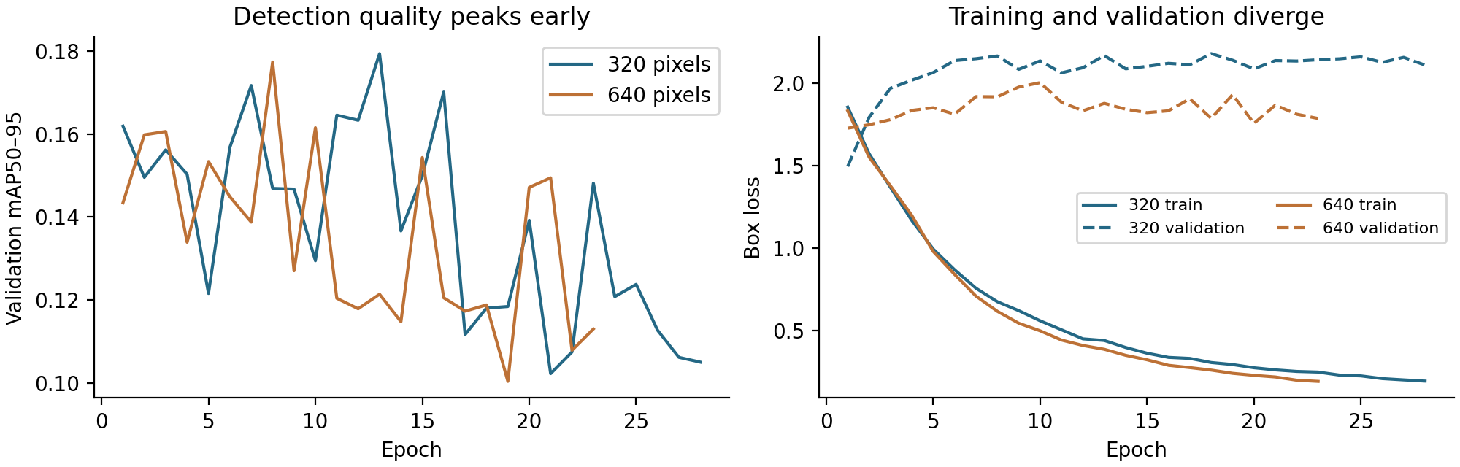
Figure 1. Recorded training histories. Curves are epoch metrics; Table 5 uses a separate evaluation of saved checkpoints. Dashed lines in the right panel are validation loss.
Validation detection quality peaked early while training box loss continued to decline. The increasing validation box loss is consistent with overfitting, although it does not identify its cause. Early stopping limited further fitting, and the earlier best checkpoints were evaluated rather than the last epochs. More pixels did not resolve the underlying generalisation problem in these two runs.
At confidence 0.25, the 320 model returned 72 true positives, 36 false positives and 48 misses. Raising confidence to 0.65 reduced false positives to 19 but increased misses to 53. Thus the chosen F1 compromise favours fewer false alarms at the cost of recall. Unsealed defects accounted for 59 of the 67 correct detections at this operating point; pooled F1 is therefore strongly influenced by the common class. The median count baseline remained better on validation count MAE (0.2437 versus 0.3866).

6 Runtime profiling and verification

Measured costs and their limits
GPU training ran on the student’s Windows 11 laptop with an AMD Ryzen 7 7435HS, 24 GB RAM and an NVIDIA RTX 4060 Laptop GPU with 8 GB VRAM. The recorded environment used Python 3.12.10, PyTorch 2.11.0+cu128 and Ultralytics 8.4.175. Training took approximately 20.1 minutes at 320 pixels and 17.3 minutes at 640 pixels. The second run stopped five epochs earlier; total time therefore cannot be used to conclude that larger images are intrinsically faster.
Training logs displayed GPU memory values around 0.33 GB and 1.25 GB respectively. These are framework log readings, not independent peak-VRAM measurements. Evaluation output showed about 2.0 ms and 1.6 ms inference per image, but the runs do not form a controlled end-to-end latency benchmark. Decoding, preprocessing, batching, postprocessing and any conveyor interface must be measured consistently before claiming a production frame rate.
The original CPU count experiments ran in a separate Linux environment with Python 3.12.14, NumPy 2.3.5 and scikit-learn 1.8.0, limited to two computational threads. Extracting training and validation descriptors took 4.70 s for the 2 × 2 grid and 4.81 s for the 4 × 4 grid. For the latter grid, SVR C 0.1 took 0.0240 s to fit and 0.0286 ms per image for batch prediction averaged over 20 repeats. Prediction timings exclude image decoding and descriptor extraction; they are not directly comparable with the laptop GPU readings.

Supplementary function profiling
A cProfile run during report preparation processed the 119 validation images with the 4 × 4 descriptor in the current Linux analysis environment. Elapsed time was 0.622 s including profiler overhead. The image decoder accounted for 0.182 s of self time and the image-resize implementation for 0.174 s. Together these operations represented approximately 57% of elapsed time. Cumulative times for their parent functions overlap and must not be added. This profile suggests that caching descriptors and avoiding repeated decoding would be more useful for repeated baseline searches than optimising an already cheap final regressor.
The profile is supplementary computational measurement, not another model-selection or test run. No GPU kernel profile, memory-bandwidth measurement or arithmetic-intensity analysis was completed. Doubling both input dimensions quadruples nominal pixel area, but an exact operation count for these trained models was not measured. The evidence supports a limited runtime comparison and a CPU preprocessing bottleneck diagnosis, not a hardware efficiency or roofline claim.

Implementation checks and reproducibility
The initial automated test report records 14 passing pytest tests covering geometry conversion, invalid boxes, duplicate grouping, feature values, count metrics, synthetic preparation and the final-test confirmation guard. Three subsequent analytical export-scoring checks were executed directly for IoU, duplicate and wrong-class matching, and empty-image/threshold behaviour. These were not a new 17-test pytest run. Actual GPU training and the final evaluation supply additional execution evidence, but unit tests alone cannot establish predictive quality.
The frozen model record includes the weight SHA-256 checksum beginning fd747d8605ef. The final scoring script checks that checksum, the expected 80 test filenames and category range before applying the fixed threshold. Results, environment records and scripts are associated with the project repository [8]. Explicit settings and checksums improve traceability; bit-for-bit reproducibility across hardware is not guaranteed.

7 Final held out test results
The final evaluation used all 80 retained test images and 79 annotated defects. Ultralytics mAP50 was 0.2444 and mAP50–95 was 0.0995. Both were lower than validation, indicating weaker performance on this held-out sample. At the frozen confidence of 0.65 and IoU of 0.50, the custom scorer counted 37 true positives, nine false positives and 42 misses. Pooled precision was 80.4%, recall 46.8% and F1 0.5920. All five classes were included in training. Zero correct loose-meat and twisted-meat detections indicate failures on this test set, not excluded tasks; wrinkle performance is unassessable because the test set contains no examples.
Table 6. Test class results at the frozen operating point. A dash means the denominator is zero.
Class | Labels | TP | FP | FN | Precision | Recall
Loose meat | 3 | 0 | 0 | 3 | — | 0.0%
Packaging error | 23 | 5 | 4 | 18 | 55.6% | 21.7%
Twisted meat | 4 | 0 | 0 | 4 | — | 0.0%
Unsealed | 49 | 32 | 5 | 17 | 86.5% | 65.3%
Wrinkle | 0 | 0 | 0 | 0 | — | —
Total | 79 | 37 | 9 | 42 | 80.4% | 46.8%

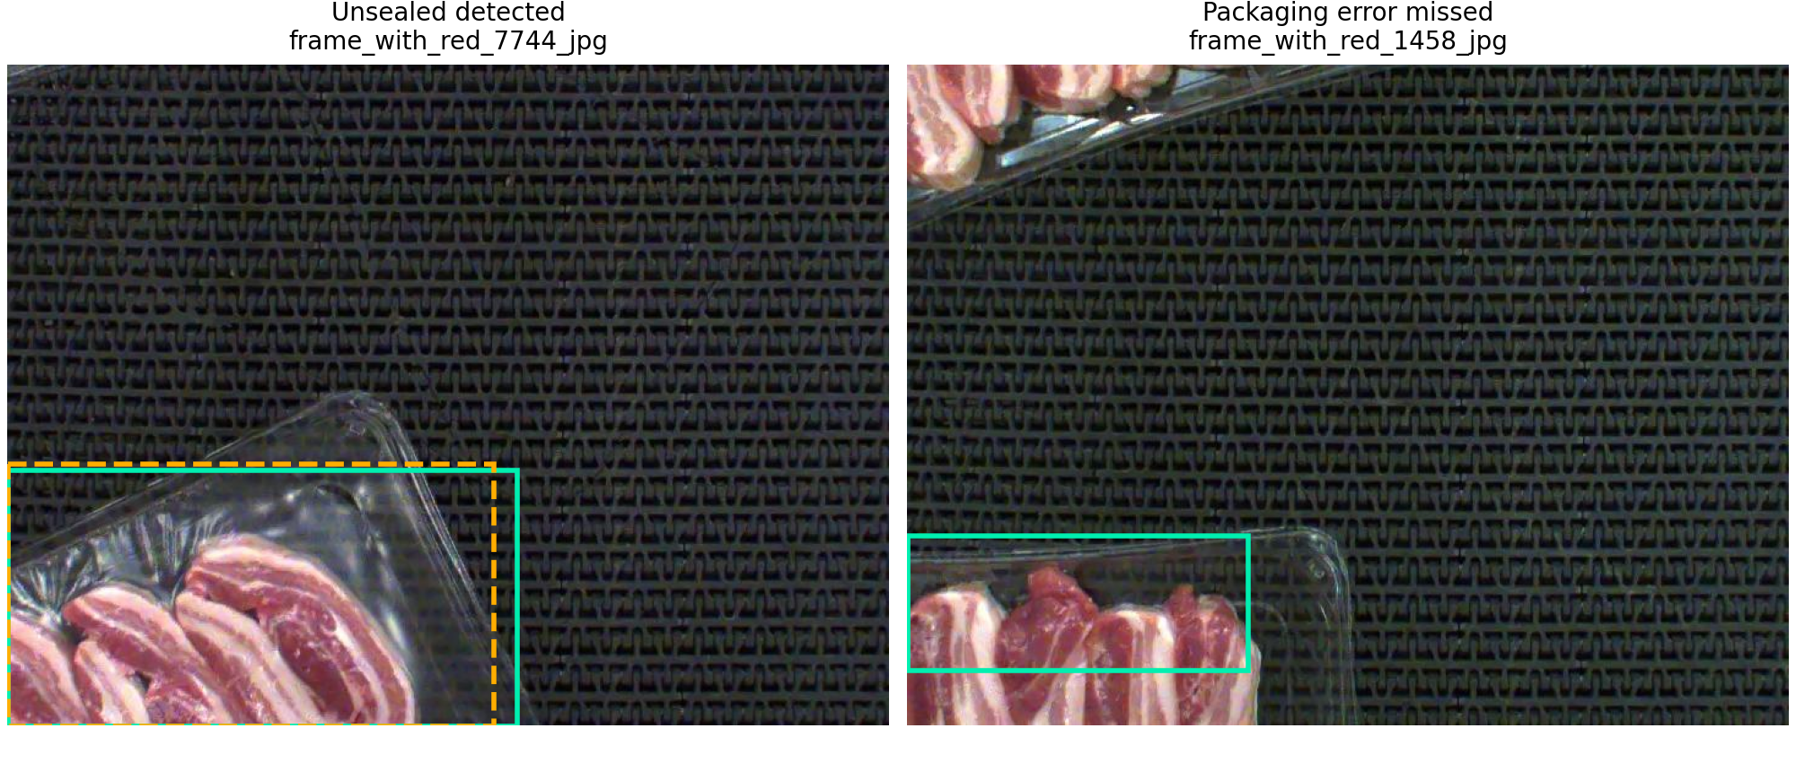
Figure 2. Selected test examples showing one success and one miss; these are illustrative, not a representative sample. Green solid boxes are annotations and orange dashed boxes are retained predictions. Images: Hello, Roboflow dataset version 4, CC BY 4.0 [4]; overlays added for this report.
Detector count MAE was 0.4875 and RMSE was 0.8441, with exact counts in 48 of 80 images. The frozen constant-one baseline achieved MAE 0.2875 and RMSE 0.5809. Thus detection did not improve counting, despite providing useful localisation in some images. One of 12 unannotated images had a prediction, and 26 of 68 annotated images had none. These image-level counts do not measure verified package acceptance or defect severity.

8 Interpretation and conclusions
The workflow meets its experimental aim of implementing, comparing and evaluating methods, but the detector misses more than half of annotated test defects. The concentration of correct detections in unsealed packaging limits any broad claim of multi-class inspection capability. Counting has an especially strong constant baseline because most images contain approximately one annotation. More complex models must be justified against that baseline rather than by complexity alone.
The labels also require careful interpretation. In engineering terms, an unsealed package is a packaging error, but this export treats packaging-error, unsealed and wrinkle as separate detection classes. The exact annotation rule separating the general packaging-error label from the more specific labels was not established. This report therefore preserves the supplied taxonomy without assuming that packaging-error means all other defects. Ambiguous class boundaries could contribute to confusion, but this was not tested.
Transparent film, reflections, partial trays and subtle boundaries may also make images difficult to interpret. No human accuracy or inter-annotator agreement study was performed, so visual difficulty remains a hypothesis. Limited independent examples, class imbalance, label inconsistency and differences between splits are other possible explanations; the present experiments cannot separate their effects.
The main validity limits are the absence of tray-independent grouping, the small number of rare-class examples, no held-out wrinkle examples, a single seed per resolution and validation reuse for selection. Evaluation JSON uses Ultralytics validation postprocessing, including multi-label handling; ordinary prediction mode may differ. The frozen operating-point results should consequently be described as evaluation-export results until deployment postprocessing has been checked against the same scorer.
The next useful work would be to obtain tray or recording-session identifiers, review labels using explicit defect definitions, and collect independent rare-class examples. A new group-separated validation set could then support repeated-seed comparisons and threshold selection based on the relative cost of false alarms and missed defects. End-to-end timing and operator review would be needed before integration. Since this test set has now been inspected, it must not be repeatedly used for tuning while being described as untouched.
The technical conclusion is that this prototype provides partial localisation capability, strongest for unsealed defects. Its missed-defect rate and the stronger count baseline limit its current usefulness for automated inspection.

9 AI use and personal reflection
ChatGPT/Codex substantially accelerated the implementation and analysis of this project. It assisted with reviewing requirements, proposing methods, auditing data, generating most of the initial code and documentation, troubleshooting execution, interpreting exported results and drafting this report. Its approximate contribution was most of the implementation and written material; I did not measure a precise percentage. I selected the supplied topic, provided the course materials and hardware information, and ran the GPU experiments on my laptop. AI assistance allowed me to obtain results quickly, but successful execution did not mean that the model was reliable or that I fully understood its operation.
I checked the run outputs through shell commands and personally inspected the losses reported at each epoch. These checks helped me follow the progress of training and review its numerical behaviour. They did not, by themselves, verify the correctness of every prediction or explain how the network reached its decisions. The results were uneven across defect classes: unsealed packaging was detected more successfully than the other categories, while overall test recall was 46.8%. This was a packaging-defect experiment, not an assessment of meat quality or food safety.
My main remaining limitation is understanding the model beyond its observable inputs and outputs. I cannot yet fully explain how its internal architecture produces a particular detection, why recognition performance differs so substantially between classes, or which learned visual features cause a success or failure. Although I can inspect the losses and reported metrics, the decision process still feels like a black box. At times, obtaining a prediction without being able to explain its reasoning felt more like observing an unexplained outcome than following a transparent engineering calculation.
This experience highlighted the difference between using an AI-assisted workflow and understanding the model it implements. AI made experimentation more accessible, but it also made it possible to progress faster than my conceptual understanding. My next learning priorities are to connect the network architecture and loss functions to the observed results, distinguish confidence from correctness, and examine individual errors alongside class-level metrics. I should treat possible explanations, such as visual ambiguity or class imbalance, as hypotheses until they have been tested.
The broader workflow included AI-assisted archive checks, analytical tests and comparisons against saved results. These should not be confused with the checks I performed personally. Some assistance required correction: the initial advice about project approval was revised after checking the brief, source overlaps were removed before training, and execution-path issues were resolved. I remain responsible for reviewing the submitted work, acknowledging the extent of AI assistance and being clear about both what I checked and what I do not yet understand.

References
[1] Monash University. MMA3001 Numerical Methods and Machine Learning: 2026 Project Brief. Supplied course document, 2026.
[2] Monash University. MMA3001 Project Datasets. Dataset 3, pork rasher packaging inspection. Supplied course document, 2026.
[3] Monash University. MMA3001 Week 5 notes: Linear Regression; Decision Tree Regression; Support Vector Regression; Neural Network Regression; Evaluating Regression Performance; Training Data Evaluation and Selection. Supplied teaching materials, 2026.
[4] Hello. Pork Rasher Error Packaging, version 4, COCO export. Roboflow Universe. CC BY 4.0. Dataset and metadata supplied with the project. https://universe.roboflow.com/hello-2aqe0/pork-rasher-error-packaging/dataset/4
[5] scikit-learn developers. Support Vector Machines, section on regression. Online documentation, consulted 10 October 2026. Experiments used scikit-learn 1.8.0. https://scikit-learn.org/stable/modules/svm.html#regression
[6] Ultralytics. Explore Ultralytics YOLOv8. Online model documentation, consulted 10 October 2026. https://docs.ultralytics.com/models/yolov8/
[7] Ultralytics. Model Training with Ultralytics YOLO. Online training documentation, consulted 10 October 2026. Experiments used Ultralytics 8.4.175. https://docs.ultralytics.com/modes/train/
[8] MMA3001 Project 33318719. Project source and experiment records, 10 October 2026. https://github.com/RaccoonNextDoor/MMA3001-Project-33318719

Experiment record locations
Quantitative tables use results/baseline/validation_metrics.csv, results/detector_validation/REVIEW.md and results/final_test/summary.json. Training plots use the per-resolution results.csv files. The fixed selection is recorded in results/detector_validation/frozen_selection.json; scoring implementations are scripts/analyze_export.py and scripts/score_final_test.py. The latest analysis records used for this draft are in local commits 5ec1148 and 8cefdc3; their publication to the remote repository has not been verified.
The archive SHA-256 is 379f6535f9560e72e16a8daf7a7231a61449910bde9dbbd8acc32be617f4a4d5. Final model weight SHA-256 is fd747d8605efa6044401a2d50ac8969cf5c3fa2dededd3c7c282cf1a6c080732. These identifiers distinguish the supplied dataset and selected checkpoint from similarly named files.

