All work Copyright ©2013 by .

Written by Laura Kruidhof

Version # 0.20

Friday, January 25, 2019

Table of Contents

Design History 4

Version 0.10 4

Version 0.20 4

Version 0.30 4

Version 0.40 4

Version 1.00 5

Game Overview 6

Philosophy 6

Common Questions 6

What is the game? 6

Why create this game? 6

What is the purpose of the game? 6

Where does the game take place? 6

What do I control? 6

How many characters do I control? 6

What can the character do? 6

How many levels are there going to be? 6

Do I score points? 6

Are there any obstacles or traps in the game? 7

What is the main focus? 7

What’s different? 7

Feature Set 8

General Features 8

Game Play 8

The Game World 9

The Streets 9

The Physical World 9

Key Locations 9

Travel 9

Scale 9

Objects 9

Day and Night 9

Time 9

Overview 10

2D/3D Rendering 10

Camera 10

Overview 10

Game Engine 10

Overview 10

Game Engine Detail 10

Collision Detection 10

Lighting Models 10

Overview 10

The World Layout 11

Overview 11

World Layout Detail 11

Game Characters 12

Overview 12

Enemies 12

User Interface 15

Overview 15

User Interface Detail #1 15

User Interface Detail #2 15

Weapons 16

Overview 16

Weapons Details 16

Musical Scores and Sound Effects 17

Overview 17

Red Book Audio 17

Sound Design 17

Music Play List 17

Single-Player Game 18

Overview 18

Single Player Game Detail #1 18

Story 18

Hours of Game play 18

Victory Conditions 18

“The First Ideas Appendix” 19

“In or Out Appendix” 19

“Who Did What?” 19

The First Ideas Document 20

General Setup: 20

Plotline: 20

Storyline: 20

Bonus idea: 20

In or Out Appendix 21

In the game 21

Not in the Game 21

Who Did What? 22

Kevin 22

Derek 22

Laura 22

Gerben 22

Stefan 22

# Design History

This is a brief explanation of the history of this document.

## Version 0.10

Adding most of the information in the Game overview, Feature set, Game World, Rendering system & Game characters.

## Version 0.20

Changing some of the information on Game overview for it to be more accurate. And adding information on the First ideas document & the In or Out Appendix.

## Version 0.30

## Version 0.40

## Version 1.00

Game Overview

This is where a general overview is given for the game.

## Philosophy

## Common Questions

### What is the game?

It is a racing game, where you race against an AI or other players to be the first to reach the finish.

### Why create this game?

This game is a school project, and we have been assigned to make a race game.

### What is the purpose of the game?

The purpose of single player mode is to defeat the AI in every level to unlock more levels, once you finished all levels you unlock more cars.

The purpose of multiplayer mode is to win the race against other players.

### Where does the game take place?

The game can take place in three different maps. Every level of single player mode takes place in a different map, and with multiplayer you can choose which map you want to play in.

### What do I control?

As a player you control a car, and you have the option to see in third person or

### How many characters do I control?

You and other players each control only one car.

### What can the character do?

The car can be controlled with W A S D. Where W moves the car forward, S to stop driving, or when already standing still to drive backwards., A to go left and D to go right.

### How many levels are there going to be?

There are going to be three levels with each unique maps.

### Do I score points?

No, you don’t score points.

In Single player mode you either with or lose.

And in Multiplayer mode you can get 1st place, 2nd place or 3rd place.

### Are there any obstacles or traps in the game?

The race tracks will include difficult turns that make the game more difficult, and some obstacles standing on the road that you will need to avoid.

### What is the main focus?

The main focus of the game is to be the first to reach the finish.

### What’s different?

How we tried to make our game stand out from other race games is by the story it has and the unique customization options for your car.

# Feature Set

## General Features

Movement :

You are able to drive your car using keys.

W = for moving forward

S = to go slower, or when standing still for going backwards

A = for turning left

D = for turning right

## Game Play

You race against an AI or other players and try to be the first to reach the finish.

# The Game World

## Overview

The game will be played in three different maps. Each map will have an unique look and racing track.

## The Physical World

### Key Locations

-

### Travel

In the menu of the game you will be able to choose which level you want to play, when you made your choice you will go to the corresponding map.

### Scale

-

### Objects

There will be all kinds of objects in every map to make the map look more interesting, and to be obstacles in the race track that you need to avoid.

### Day and Night

There is no day/night cycle, although each map will have a different look, (day, sunset or night).

### Time

-**Rendering System**

### Overview

Give an overview of how your game will be rendered and then go into detail in the following paragraphs.

### 2D/3D Rendering

3D

## Camera

### Overview

You can choose between a third person view (behind the car), or a first person view(from inside the car).

## Game Engine

### Overview

Unity

### Game Engine Detail

Unity

### Collision Detection

Unity

## Lighting Models

### Overview

Light will come from the sky in the maps.

# The World Layout

## Overview

## World Layout Detail

# Game Characters

## Overview

There isn’t a character bound to the player, the only thing that is decided about the player’s character is that they’re racing to stop the main villain “Spiet”.

## Enemies

The main villain is “Spiet”, someone with a lot of influence over the city. He earns his money by having illegal races in the city and making people bet on which driver they think is going to win.

**Concept Art**

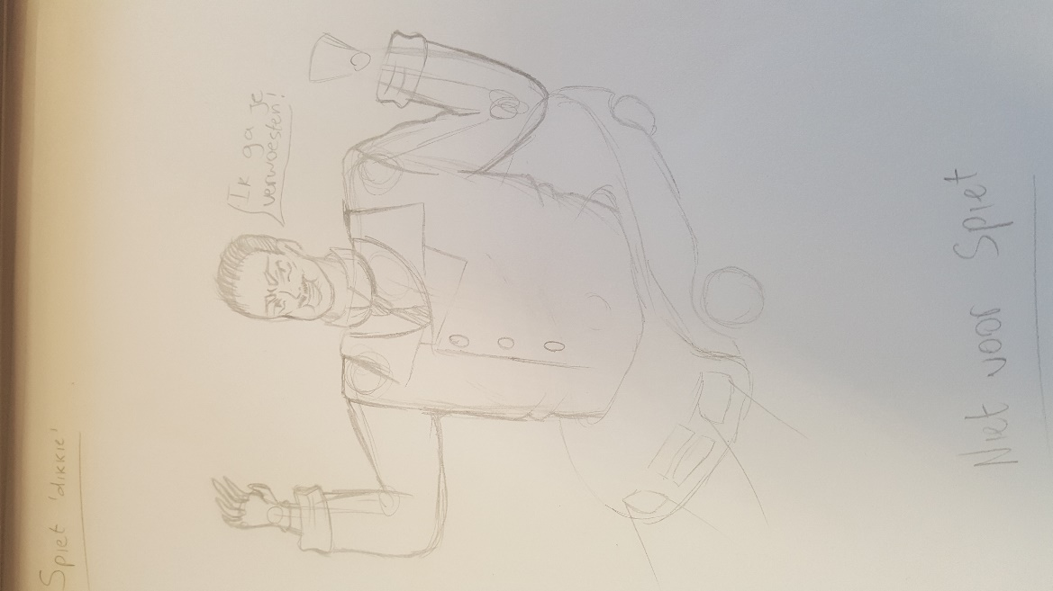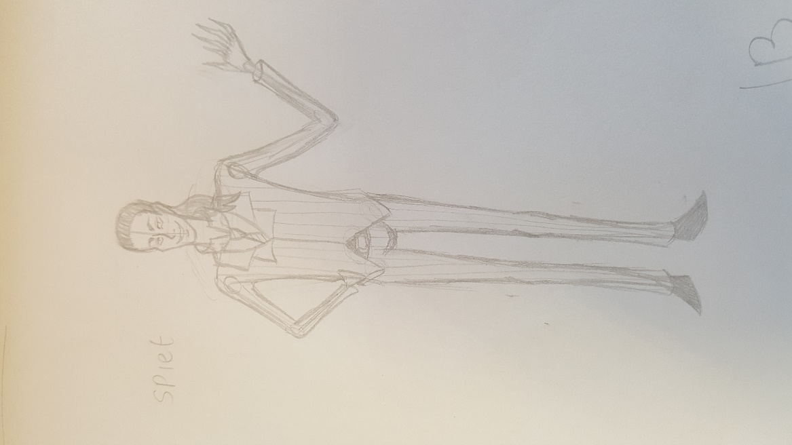

# User Interface

## Overview

## User Interface Detail #1

## User Interface Detail #2

# Weapons

## Overview

There are no weapons in this game.

## Weapons Details

-

# Musical Scores and Sound Effects

## Overview

The car in our game has sound effects for everything it can do.

It has sounds for:

- Starting the car

- Using the brakes

- Turning

## Red Book Audio

-

## Sound Design

-

## Music Play List

-

# Single-Player Game

## Overview

## Single Player Game Detail #1

## Story

You battle against an evil leader called “Spiet” who has taken control over the city. One of the ways he makes his money and gains popularity is by having illegal races in the city where people bet on who they think is going to win. The first step to defeating Spiet is to stop these races for once and for all. Now it is up to the player to race against the minions of Spiet until their opponent will be Spiet himself. And by defeating him, his followers will lose faith in Spiet, and his empire will dissolve.

## Hours of Game play

It takes about 30 minutes to 1 hour to complete single player mode.

## Victory Conditions

Beat all the Ai’s in every level by being faster than them.

# “The First Ideas Appendix”

In this appendix you will find our very first concept for this game. It is just us brainstorming about what we wanted to see happening and us thinking about the story.

# “In or Out Appendix”

In this appendix you will find an overview of the things we got into the game and things that had to be left out due to time or technical constraints.

# “Who Did What?”

This will be an overview of who did what in the game.

# 

# The First Ideas Document

## General Setup:

We planned to have three different maps that you could race on.

In a menu you would be able to choose single player or multiplayer mode.

In single player mode you would race through the three maps against an AI, with the last map being Spiet.

Once the player defeated all enemies on every map in single player you would unlock more cars.

In multiplayer mode you would be able to race against other people with controllers all looking at the same screen.

## Plotline:

-

## Storyline:

You battle against an evil leader called “Spiet” who has taken control over the city. One of the ways he makes his money and gains popularity is by having illegal races in the city where people bet on who they think is going to win. The first step to defeating Spiet is to stop these races for once and for all. Now it is up to the player to race against the minions of Spiet until their opponent will be Spiet himself. And by defeating him, his followers will lose faith in Spiet, and his empire will dissolve.

## Bonus idea:

- Having a lot of funny unlockable cars, for example a bicycle or Spiet’s car after you defeated him.

- Different kinds of obstacles on the road that you would need to avoid.

# In or Out Appendix

In this appendix we will describe the things that made it in to the game and things that we had to leave out or skip.

## In the game

- Scoreboard

- Different roads in every map

- Different color car to choose from depending on your House.

## Not in the Game

- Multiplayer mode

- Maps that look significantly different

- Significantly different looking cars to choose from

# Who Did What?

Kevin

Derek

Laura

Gerben

Stefan