ACLOUDGURU

UNDERSTANDING ARM
- resources – entity managed by azure > vms, storage accounts , virtual networks
- resource groups –
    - logical container for grouping resources
    - grouped based on life cycle and security

- Subscriptions
    - logical construct that groups together resource groups and associated resources
    - billing unit for the azure cloud
    - controlled by ARM

- ARM
    - orchestration layer for managing the azure cloud
    - use rest api endpoint (used to interact with the resources )
      - azure portal
      - azure CLI
      - azure PowerShell
- ARM’S do no interact to the resources themselves but instead they connect to a resource provider (to interact with storage resources ARM connects with microsoft storage )examples below RESOURCE PROVIDER ARE ASSOCIATED WITH THE RESOURCE ITSELF
    - microsoft compute
    - microsoft network
    - microsoft storage

USING THE AZURE PORTAL AND CLOUD SHELL
- web based portal for the azure cloud
- can manage and create resources
- manage and create resources using power shell
- STEPS TO CONFIGURE AZURE CLOUD SHELL
  - Select azure cloud shell button located at the top , select bash or powershell
  - Select show advanced settings (cloud shell must have storage)
  - create new storage account
- WHERE DIFFERENT THINGS ARE LOCATED WITHIN THE CLOUD ON THE HOME PAGE
    - Top right corner in this order are the following : cloud shell , notifications , settings , support+troubleshooting and feedback

AND POWERSHELL

USING THE AZURE CLI
- Command line utility used to manage azure resources
- create and manage resources inside cloud shell
- can create and manage resources from local machine by installing the azure CLI locally
- create scripts to automate tasks on azure resources
WHAT IS AZURE POWERSHELL
- Create and manage az resources without logging into azure portal
- create scripts and automate tasks
- set of cmdlets for managing az resources
- object oriented language

AZURE POWERSHELL BASIC OPERATIONS
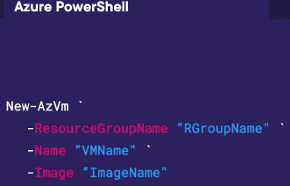

AZURE COMMANDLINE BASIC OPERATIONS
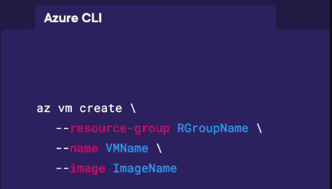

CREATING IN AZURE CLI AND POWER SHELL
POWER SHELL
- The back tick character ` allows azure to run continuous lines of code operating them to make code easier to run and edit
- #Create a resource group in PowerShell
New-AzResourceGroup -Name “RG1” -Location “EastUS”
- #Retrieve all resource groups in the current subscription
Get_AzResourceGroup
use the returned information to deploy a vnet to the resource group (if there are multiple resource groups you must specify which resource group you want to use or powershell will return an error

AZURE CLI

DISCOVERING ARMTEMPLATES
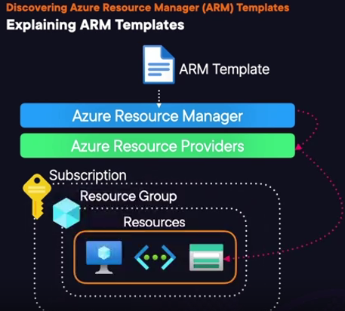

- azure resourcce manager templete (json files)
- IaC
- deploys enviorments quickly
- repeatable deployment
- Automated deployments
- helpful for a set of easy to repeat deployments that are very common

ARM TEMPLATE COMPONENTS
- $CHEMA(MANDATORY )
defines the types of properties that are available to be used in the template
the default template scop is a resource group deployment
“$CHEMA “:” htts://schema.management.azure.com/schemas/2019-04-01/deploymentTemplate.json”.
- “CONTENTVERSION (MANDATORY )
“1.0.0.0”,
“– used to manually set a version for the templete. (MANDATORY )
- PARAMETERS “:{} ,(OPTIONAL )
- in put value for a template (used for passing arguments )

- “FUNCTIONS” : [] (OPTIONAL)
abililty to save complex logic that is reused throughout the template

- “VARIABLES“ : {},
container filled w values to uses over and over again in a tempalte
dynamically generated values can be saves as variable to be used in the template
- “RESOURCES” : []
describes all resources that you want to be deployed or updated , can have one or more resources in one template

- “OUTPUT” : {} (OPTIONAL)
used to return values to be used in another application or script after deployment completes

USING ARM TEMPLATES DEMO
-EXPORT A DEPLOYMENT AS A TEMPLATE
- EXPLORE EXISTING TEMPLATES
- CREATE AND DEPLOY ARM WITHIN THE TEMPLATE ITESELF
ERRORS I RAN INTO

