**Intro**

* Traditional irrigation often overwaters, wasting up to 50 % of delivered water and stressing plants.
* Precision, sensor‑driven irrigation can cut consumption while improving crop quality and yield.
* 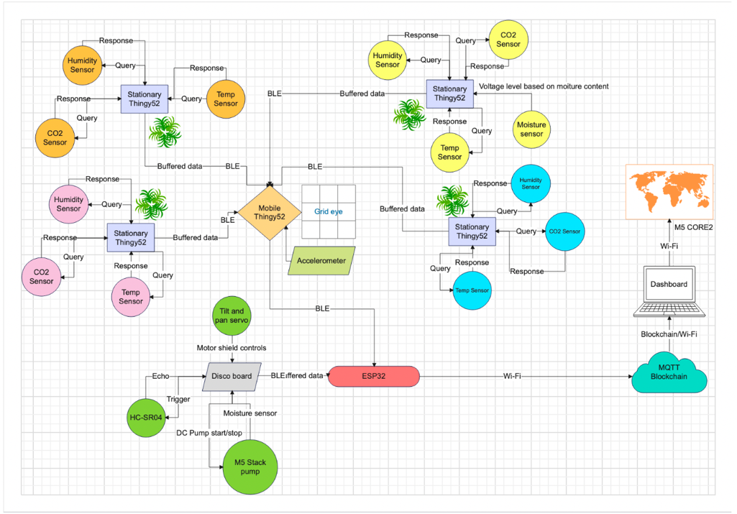Our goal: design a low‑cost, fully autonomous system that waters only when soil moisture drops below agronomic set‑points.
* The prototype targets small‑ to medium‑scale market gardens and can be expanded for broad‑acre farms.

**System Overview:**

**Sensing:**

Capacitive soil‑moisture probes (0–3 V output) sample each garden bed every 10 min.

Thing 52s measuring temp, co2 and pressure

**Control:**

An ESP32 microcontroller runs PID logic, logs data locally, and pushes metrics to InfluxDB over Wi‑Fi.

**Actuation:**

Solid‑state relays drive 12 V DC solenoid valves, opening individual zones for measured pulse volumes.

**Power & Comms:**

MQTT broker enables remote overrides via a mobile app dashboard.

**Findings / Results**

Sensor Accuracy – Sensor are all withing their specified ranges

BLE Polling Reliability – So long as the mobile node was sufficiently close to the required node, there was accuracy

End-to-End Latency – During testing we found this to be so

Irrigation Decision Accuracy - Found to be very accurate with a reasonable water level.

Actuator Responsiveness & Precision – Pump activates appropriately and within the time frame

Heat-Map Update Rate & Resolution – Could not complete this due to time constraints

MQTT & Blockchain Throughput – Present and accurate. Server response is <500 ms