Mukesh Patel School of Technology Management and Engineering
SVKM's NMIMS University

Research Paper
Weakly Compressible SPH Simulation of Liquid Sloshing in a Pivoted Rectangular Tank: Grid Convergence, Hydrostatic Verification and Two-Way Coupled Active Control
Authors: Hetansh Jain, Aryaman Mavani, Rahil Chawla
Supervisor: Dr. Sunny Nanade
Project: LiquidSloshingRL — Capstone Project
Research Paper component (Evaluation A.6)

Abstract
Liquid sloshing in partially filled containers produces moving loads that equivalent mechanical models capture only for small, near-resonant motion. This paper studies sloshing of 0.20 m of water in a 0.40 × 0.25 × 0.30 m acrylic tank that rocks about a single pivot at its base, using a weakly compressible smoothed particle hydrodynamics (WCSPH) solver (Chrono::FSI) coupled to a rigid-body tank. The gap addressed is that the reduced-order models used to design sloshing controllers are rarely checked against a resolved free-surface solution for the slow, large-angle motions that a controller actually commands. A tank-angle trajectory produced by a learned controller was imposed kinematically at particle spacings of 10, 5, 3 and 2 mm, and the liquid centroid was compared with a quasi-static hydrostatic solution, a Housner equivalent pendulum and linear potential theory. Successive refinements changed the centroid by 1.40, 0.70 and 0.35 mm on average. Against the exact hydrostatic centroid shift at the end of the tilt (−11.24 mm at −10.16°), the error fell from 12.0% to 6.0% to 3.1%, with an observed order of 1.12; the Richardson-extrapolated value lies 1.9% from theory (fine-grid GCI 6.4%). Over the full trajectory the 2 mm solution follows the hydrostatic model (correlation 0.999, mean absolute error 0.35 mm), whereas the pendulum model, forced only by angular velocity, does not (correlation 0.48). A free-sloshing test at 10 mm gave a first-mode frequency of 1.422 Hz (+4.2% versus potential theory) with a numerical damping ratio of about 0.087. In two-way coupled, torque-driven runs at 10 mm, a learned controller left about 15 times less bulk kinetic energy than PID but tripped the safety limit after 252 of 300 steps; an LQR designed on the pendulum model diverged. The contribution is a verified SPH reference for this pivoted-tank configuration and a quantified account of where the reduced-order model fails. No experimental validation was performed.

Keywords
Liquid sloshing; smoothed particle hydrodynamics; weakly compressible SPH; fluid–structure interaction; grid convergence index; equivalent mechanical model; Chrono::FSI; active sloshing control.

1. Introduction

1.1 Background
A liquid with a free surface in a moving container develops sloshing waves whose forces and moments act back on the container. The problem is central to seismic design of storage tanks [1, 2], propellant management in launch vehicles [3], and tanker and liquid-handling machinery [4, 5]. For design, the liquid is usually replaced by an equivalent mechanical model: an impulsive mass moving rigidly with the tank plus one or more convective masses on springs or pendulums tuned to the sloshing modes [1, 2, 6]. Such models are linear, first-mode and inexpensive, and are therefore attractive inside control design loops.
Mesh-free particle methods resolve the free surface directly, including large deformations and fragmentation. Smoothed particle hydrodynamics (SPH) has been applied to sloshing in rolling and pitching tanks and compared with laboratory measurements of liquid moments and wall pressures [7, 8, 9]. Chrono::FSI couples a GPU SPH solver to the Chrono multibody engine [10, 11], so a tank driven by a motor through a pivot can be simulated with the liquid loads acting back on the tank.

1.2 Problem Statement
A rigid rectangular tank, partially filled with water, rotates about one horizontal pivot at its base under a motor torque. The study asks three questions. (i) How accurately, and with what demonstrated grid convergence, does a WCSPH solution reproduce the analytically known liquid response for this configuration? (ii) Over a realistic, controller-generated tilt trajectory, how well do the equivalent pendulum model and simpler hydrostatic reasoning describe the resolved liquid motion? (iii) When the tank is driven by torque and the liquid loads are fed back to it (two-way coupling), what does the resolved simulation reveal about controllers designed on the reduced-order model?

1.3 Motivation
Controllers for sloshing are normally designed and trained on reduced-order models because a resolved simulation is several orders of magnitude slower. In this project the SPH solver ran 33 to 5,480 times slower than real time, depending on resolution (Section 6.7), while the reduced-order surrogate trains a policy in minutes. The usefulness of such a workflow depends on how far the reduced-order model can be trusted (the simulation-to-reality problem of learned control [12]), a question that is best answered with a resolved CFD reference whose own numerical error is known.

1.4 Objectives
- Build a WCSPH model of the pivoted tank in Chrono::FSI, with one-way (prescribed-motion) and two-way (torque-driven) coupling to the rigid tank.
- Establish the discretisation error of the SPH centroid response by a four-level particle-spacing study and a grid convergence index (GCI) estimate.
- Verify the solution against analytical references: the quasi-static hydrostatic centroid shift and the first-mode sloshing frequency from potential theory.
- Quantify the agreement of the Housner equivalent-pendulum model with the resolved solution over a controller-generated trajectory.
- Evaluate PID, LQR and a learned (PPO) controller in the two-way coupled SPH tank, and document the numerical limits of that test.

1.5 Scope
The study is simulation-only. The tank is rigid and rotates about a single axis; the excitation is pitch about the base pivot. The liquid is water at a single fill depth of 0.20 m. The SPH solver is used as provided by Chrono::FSI; no solver modifications were made. The convergence and verification results apply to the bulk centroid response (position and velocity of the liquid centre of mass); wall pressure, free-surface elevation at gauges and liquid moments were not extracted. No laboratory experiment was performed, so the results are verified against analytical solutions, not validated against measurement.

1.6 Contributions
- A four-resolution (10, 5, 3, 2 mm) WCSPH study of a pivoted, pitching tank, with an observed order of convergence of 1.12 and a fine-grid GCI of 6.4% for the settled centroid, and a verified Richardson-extrapolated value within 1.9% of the exact hydrostatic result.
- Evidence that, for slow controller-generated tilting, the resolved liquid response is dominated by quasi-static hydrostatic re-levelling, which the angular-velocity-forced Housner pendulum does not represent (correlation 0.48 versus 0.999 for the hydrostatic model).
- A measured first-mode frequency (1.422 Hz) and numerical damping ratio (≈0.087) for the coarse resolution, and a quantified mass-representation error of the lattice initialisation (−20% at 10 mm, −2.2% at 2 mm).
- A two-way coupled SPH comparison of PID, LQR and PPO control, with the boundary-penetration and stability limits of that test reported alongside the result.

2. Literature Review

2.1 Reduced-order sloshing models
Housner [1] split the hydrodynamic response of a rigid tank into an impulsive part, moving with the walls, and a convective part, represented by masses on springs at the sloshing frequencies. ACI 350.3-06 [2] codifies this for rectangular tanks, giving the impulsive and convective masses, their heights and the first-mode frequency as closed-form functions of the length-to-depth ratio. Li and Wang [6] derived an exact equivalent mechanical model for a rectangular tank from potential theory. Sivý et al. [13] used such models for sloshing loads and gave damping values for the liquid. The underlying linear potential theory is treated in depth by Ibrahim [4] and by Faltinsen and Timokha [5]. All of these models are linear and are derived for small translational or rotational excitation about a level free surface.

2.2 Experiments on pitching and rolling rectangular tanks
Akyıldız and Ünal [14] measured wall pressures in a pitching rectangular tank across fill depths and amplitudes. Liu et al. [15] tested a rectangular water tank under pitch excitation and reported strongly nonlinear, violent sloshing near resonance at low fill and a softening resonance at higher fill. Panigrahy et al. [16] measured the effect of baffles. Delorme et al. [8] set out canonical forced-roll sloshing cases with pressure measurements intended for code validation.

2.3 SPH for sloshing
SPH represents the liquid by particles carrying mass and momentum; field quantities are kernel interpolations over neighbours [17]. The weakly compressible formulation closes the system with a stiff equation of state, which allows explicit time integration but produces pressure noise. Density diffusion (δ-SPH) [18, 19] and particle-position corrections such as XSPH [20] are used to control it. Solid walls are commonly represented by layers of boundary markers whose pressure is extrapolated from the fluid [21] or by alternative marker-based schemes [22]. Souto-Iglesias et al. [7] and Delorme et al. [8] compared SPH with sloshing experiments in rolling tanks, and Rafiee et al. [9] compared SPH with laboratory sloshing measurements and found good agreement in pressures and free-surface shape. Chrono::FSI implements GPU SPH coupled to multibody dynamics [10, 11]. Systematic convergence reporting for discretised solutions is standardised by the GCI procedure of Celik et al. [23].

2.4 Sloshing control and learned flow control
Model-based slosh control shapes container motion or feeds back on an equivalent-model state [24, 25, 26]. Deep reinforcement learning (DRL) has been applied to active flow control with CFD in the loop [27, 28]. For sloshing specifically, Xie and Zhao [29] trained DRL controllers for actuated baffles; Ye et al. [30] combined DRL with SPH to control an elastic baffle; and Shakya et al. [31] combined DRL with a sliding-mode controller.

2.5 Research gap and approach
Two gaps motivate this work. First, SPH sloshing studies typically consider forced horizontal or roll motion about the tank centre and report agreement with experiment at one or two resolutions; a convergence-quantified SPH solution for a tank pitching about a pivot at its base, under the slow, large-angle motion that a stabilising controller commands, was not found in the literature reviewed. Second, controllers for such tanks are designed on reduced-order models whose accuracy for this regime is assumed rather than measured. This paper addresses both: it quantifies the SPH discretisation error against an exact hydrostatic solution, uses the converged solution as a reference for the reduced-order models, and then examines controllers in a two-way coupled SPH tank.

3. Proposed Methodology

3.1 Computational framework
The tank, pivot and motor are built procedurally in PyChrono from box primitives with analytically computed mass and inertia [10]. The liquid is represented by one of three interchangeable models behind a common interface: a Housner equivalent pendulum, used for fast controller training; an SPH backend in which the tank motion is prescribed (one-way coupling); and a closed-loop SPH tank in which a motor torque drives the tank and the SPH liquid loads act back on it (two-way coupling). The SPH backends use Chrono::FSI's ChFsiProblemCartesian with the SPH fluid solver; the rigid tank is a Chrono body whose wall boxes are registered as fluid–solid interfaces. The sections below describe the physical system, the SPH formulation as configured, the coupling, and the reduced-order references. Flowcharts of the simulation and control code are given in Appendix A.

3.2 Physical system model
Table 1 lists the physical parameters. The tank is an open-top acrylic box with 6 mm walls; its interior is 0.388 m long in the sloshing direction and 0.238 m wide. The pivot axis lies at the centre of the tank floor and is horizontal and normal to the length. The empty tank's centre of mass is 0.119 m above the pivot, so gravity on the tank is destabilising at level (an inverted pendulum); a free-swing SPH test confirmed this, with a 10⁻⁴ rad disturbance growing to 0.161 rad in 0.5 s without a motor. Figure 1 shows the free-body diagram.
Table 1. Physical parameters of the tank and liquid (from config/simulation_config.py and the analytical mass-property functions).
Quantity | Value | Source / note
Tank outer size L × W × H | 0.40 × 0.25 × 0.30 m | TankConfig
Wall thickness | 6 mm | TankConfig
Interior length × width | 0.388 × 0.238 m | outer − 2 × wall
Wall material density | 1180 kg/m³ (cast acrylic) | TankConfig
Tank mass | 3.469 kg | five-plate analytical sum
Tank CoM above pivot | 0.119 m | analytical
Tank moment of inertia about pivot, I_{O} | 0.156 kg·m² | parallel-axis sum
Fill depth h | 0.20 m | FluidConfig
Liquid | water, ρ = 1000 kg/m³ | FluidConfig
Liquid mass in tank interior | 18.47 kg | ρ × 0.388 × 0.238 × 0.20
Dynamic viscosity of water | 1.0 × 10⁻³ Pa·s | nominal (see Table 2)
Gravity | 9.81 m/s² (multibody, reduced-order); 9.8 m/s² (FSI) | see Section 7.4
Pivot damping | 0.02 N·m·s/rad | EnvironmentConfig

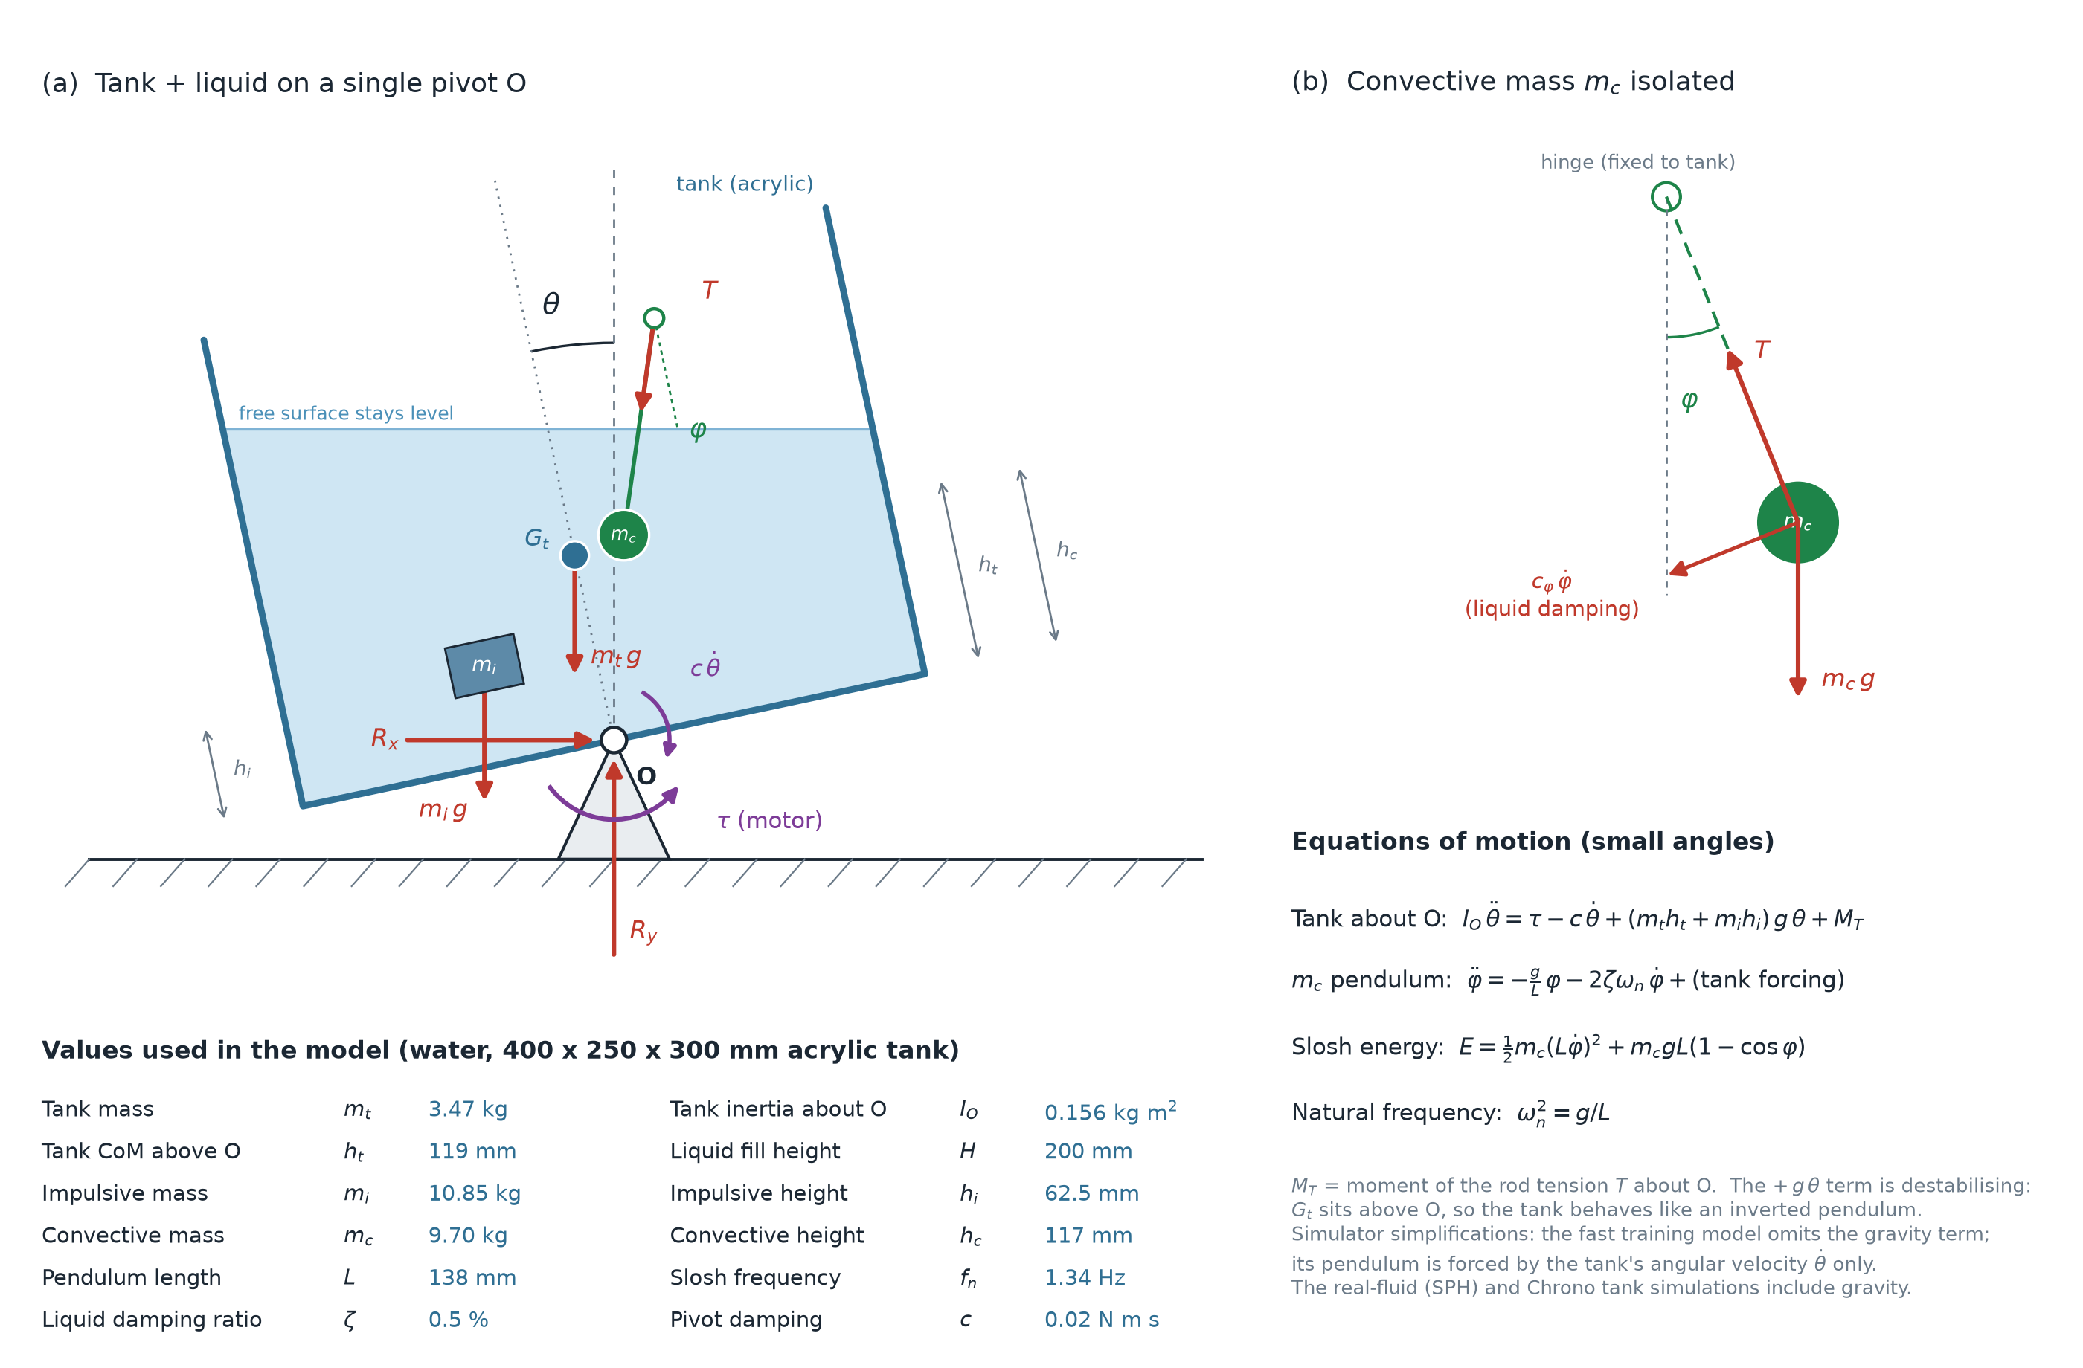
Figure 1. Free-body diagram of the tank on its single pivot O: motor torque, pivot damping, pivot reactions, tank weight and the liquid replaced by its Housner equivalent (impulsive mass rigid with the tank, convective mass on a pendulum). In the SPH model the liquid is resolved instead (Section 3.3).

3.3 Governing equations and WCSPH discretisation
The liquid is modelled as a weakly compressible Newtonian fluid. In Lagrangian form the continuity and momentum equations are
Dρ/Dt = −ρ ∇·v (1)
Dv/Dt = −(1/ρ) ∇p + Π + g (2)
where Π stands for the viscous dissipation, which in this study is represented by an artificial viscosity only (see below), closed by the Tait equation of state
p = (ρ₀ c_{s}² / γ) [ (ρ/ρ₀)^{γ} − 1 ], γ = 7 (3)
with reference density ρ₀ = 1000 kg/m³, artificial sound speed c_{s} = 10 v_{max} = 45 m/s and zero background pressure. In SPH, a field is interpolated from neighbouring particles b with a kernel W; here the cubic-spline kernel with support radius 2h_{k} and smoothing length h_{k} = dx. The standard particle forms of Eqs. (1)–(2) are [17]
Dρ_{a}/Dt = Σ_{b} m_{b} (v_{a} − v_{b})·∇_{a}W_{ab} + δ h_{k} c_{s} D_{a} (4)
Dv_{a}/Dt = −Σ_{b} m_{b} ( p_{a}/ρ_{a}² + p_{b}/ρ_{b}² + Π_{ab} ) ∇_{a}W_{ab} + g (5)
where D_{a} is the δ-SPH density-diffusion term [18, 19] and Π_{ab} is an artificial viscosity, which in Monaghan's form is Π_{ab} = −α h_{k} c_{s} (v_{ab}·r_{ab}) / [ρ̄_{ab}(|r_{ab}|² + 0.01h_{k}²)] for approaching particle pairs (v_{ab}·r_{ab} < 0) and zero otherwise [17]. Particles are advected with an XSPH-corrected velocity [20]
Dr_{a}/Dt = v_{a} + ε Σ_{b} (m_{b}/ρ̄_{ab}) (v_{b} − v_{a}) W_{ab} (6)
Chrono::FSI was used unmodified and configured through its parameter interface (Table 2). The kernel, the Tait exponent (γ = 7, hard-coded), the sound-speed rule (c_{s} = 10 v_{max} for fluid problems) and the artificial-viscosity term were confirmed by reading the solver source at the build commit [32]. The solver's “unilateral” viscosity is exactly the Monaghan term above, with ρ̄_{ab} = (ρ_{a} + ρ_{b})/2 and the 0.01h_{k}² regulariser, applied only to approaching pairs. The physical viscosity μ enters the solver's momentum equation only in its laminar-viscosity mode, or with the consistent Laplacian discretisation, and neither was used here. In all runs of this study, dissipation therefore comes from the artificial viscosity (α) and density diffusion (δ) alone, and the μ value passed to the solver has no effect.
With the variable time step enabled, each fluid step is [32]
Δt = min{ Δt_{max}, 0.3 min_{a}[ h_{k}/(c_{s} + max_{b}|h_{k} v_{ab}·r_{ab}/(r_{ab}² + 0.01h_{k}²)|), (h_{k}/|a_{a}|)^{1/2} ] } (7)
where a_{a} is the particle acceleration and Δt_{max} is the solver step listed in Table 3. The first step of a run uses Δt_{max}.
Table 2. SPH solver settings as set in physics/sph_backend.py and physics/closed_loop_sph_tank.py.
Setting | Value | Note
Formulation / integrator | WCSPH, explicit RK2 | Chrono::FSI SPH fluid solver
Equation of state | Tait, γ = 7 | background pressure 0 [32]
Max. velocity parameter v_{max} | 4.5 m/s | c_{s} = 10 v_{max} = 45 m/s [32]
Kernel / support | cubic spline / 2h_{k} | solver default, not overridden
Initial spacing / d₀ multiplier | dx (Table 3) / 1.0 | h_{k} = 1.0 dx
Density diffusion (δ-SPH) | on, δ = 0.1 | [18, 19]
Particle shifting | XSPH, ε = 0.5 | [20]
Viscosity method | artificial, unilateral | α = 0.03 (one-way runs), 0.1 (two-way runs)
Physical viscosity parameter μ | 0.001 Pa·s (one-way runs); 1.0 Pa·s (two-way runs) | inactive with this viscosity method (Section 3.3)
Wall boundary | ADAMI marker layers | [21]; HOLMES tested (Section 6.6)
Boundary-marker layers | 4 / 8 / 14 / 20 at dx = 10 / 5 / 3 / 2 mm | scaled with dx
Consistent gradient / Laplacian | off | —
Variable time step | on | Eq. (7); capped at the solver step of Table 3
Neighbour search | every step | num_proximity_search_steps = 1
Collision system (rigid) | Bullet, NSC | rigid step = fluid step

3.4 Boundary conditions, initial conditions and coupling
Walls. The floor and four side walls of the tank are rigid-body boxes from which Chrono::FSI generates boundary markers. With the ADAMI method [21], the markers carry a pressure and velocity extrapolated from nearby fluid particles so that the no-penetration condition is enforced through the pressure gradient. The number of marker layers was scaled with the particle spacing so that the physical thickness of the boundary layer stayed comparable across resolutions (Table 2); at 5 mm, keeping four layers made the run fail (Section 6.7). The top is open; the free surface is a natural boundary of the particle set.
Initial condition. The liquid is created as a block filling the tank interior (0.388 × 0.238 × 0.20 m) on a regular lattice of spacing dx, at rest, with uniform density ρ₀ and zero pressure (the solver's default particle initialisation, which this study did not override [32]). There is no hydrostatic pre-stress, so gravity first compresses the column slightly and the lattice relaxes. This produces a short settling transient: the liquid centroid dropped by about 11.3 mm within the first 0.06 s at 10 mm and by less than 1 mm at the finer spacings. All centroid results are reported as displacement from the centroid recorded at reset, in the tank's rotating frame.
One-way coupling. For the convergence and verification runs, the tank angle and rate are prescribed from a recorded trajectory through a ChLinkMotorRotationAngle joint; the angle is linearly interpolated across the internal substeps of each 0.02 s output interval, which was required for the joint to track the prescribed motion. The liquid does not act on the tank.
Two-way coupling. For the control runs, a ChLinkMotorRotationTorque joint applies the controller torque, clipped to a limit of 7.0 N·m, and the tank angle follows from the tank's own dynamics under the motor torque, gravity, pivot damping and the SPH liquid forces. Each episode starts with the tank level and a 0.05 rad/s angular-velocity kick. A safety check after every solver substep stops the run if the tank's angular speed exceeds 1.0 rad/s, which precedes the solver divergence observed otherwise.
Output quantities. The solver outputs particle positions and velocities. The quantities analysed are the liquid centroid displacement (mean particle position, rotated into the tank frame) and the bulk kinetic energy E = ½ M |v_{c}|², where v_{c} is the mean particle velocity expressed in the tank frame and M is the represented liquid mass. E includes the rigid-body transport of the liquid with the tank as well as sloshing, and excludes motion relative to the centroid; it is used here as a comparison measure, not as a complete sloshing energy.

3.5 Time integration and resolution cases
Four particle spacings were run on the same prescribed trajectory (Table 3). The solver step was reduced with the spacing, and the number of boundary-marker layers was increased. The represented liquid mass M = N dx³ ρ₀ was computed from the fluid-particle count N; at 10 and 2 mm N is logged directly, and at 5 and 3 mm it was recovered from the recorded energy and velocity (E = ½ M v²), which reproduces the logged counts exactly where both are available.
Table 3. Resolution cases for the prescribed-trajectory study. Real-time ratio = wall-clock time / simulated time.
dx (mm) | Fluid particles N | Represented mass M (kg) | Mass error vs 18.47 kg | BCE layers | Solver step (s) | Steps × 0.02 s | Wall clock (s) | Real-time ratio
10 | 14,763 | 14.76 | −20.1% | 4 | 1 × 10⁻⁴ | 500 | 328.5 | ≈33
5 | 139,840 | 17.48 | −5.4% | 8 | 5 × 10⁻⁵ | 500 | 1,769.8 | 177
3 | ≈668,900 | 18.06 | −2.2% | 14 | 3 × 10⁻⁵ | 300 | 6,384.9 | 1,064
2 | 2,258,100 | 18.07 | −2.2% | 20 | 2 × 10⁻⁵ | 300 | 32,890 | 5,482
The 3 mm count is inferred from the represented mass. All four rows used α = 0.03 (μ was set to 0.001 Pa·s but is inactive with this viscosity method). The 10 mm row is the corrected-viscosity rerun on the RTX 3090; the other rows were also run on the RTX 3090.

3.6 Reduced-order reference models
Hydrostatic (quasi-static) model. If the tank turns slowly, the free surface stays horizontal. In the tank frame it then has slope tanθ, and for a rectangular cross-section that does not uncover the floor (h ≥ (L/2) tanθ) the centroid of the trapezoidal liquid section shifts along the tank by
Δx_{hs} = L² tanθ / (12 h) (8)
where L = 0.388 m is the interior length and h = 0.20 m the fill depth. This follows from the first moment of the trapezoid and involves no fitted parameter. At the largest angle reached in the trajectory (−10.16°), (L/2)tanθ = 0.035 m < h, so Eq. (8) applies throughout.
Housner equivalent pendulum. Following ACI 350.3-06 [2], the liquid is split into an impulsive mass m_{i} = [tanh(0.866 L/h)/(0.866 L/h)] m and a convective mass m_{c} = 0.264 (L/h) tanh(3.16 h/L) m on a pendulum of length L_{p} = g/ω², with
ω² = (3.16 g / L) tanh(3.16 h / L) (9)
In the project code these formulae are evaluated with the outer tank length (0.40 m) and outer width, giving m = 20.0 kg, m_{i} = 10.85 kg, m_{c} = 9.70 kg, L_{p} = 0.138 m and f = 1.343 Hz, with damping ratio 0.5% [13]. The pendulum is forced by the tank angular velocity only; the tank angle itself does not enter its equation, so it describes oscillation about the equilibrium but not a sustained re-levelling under a held tilt. The sum m_{i} + m_{c} exceeds m by 2.7%, a known property of the first-mode approximation at this aspect ratio.
Linear potential theory. For the first antisymmetric mode of a rectangular tank of interior length L and depth h [4, 5]
ω₁² = g (π/L) tanh(π h / L) (10)
which gives f₁ = 1.364 Hz for L = 0.388 m, h = 0.20 m and g = 9.81 m/s².

3.7 Control formulation (secondary)
Control is used here as the source of a realistic tank trajectory and as the application of the two-way model, and is described briefly. The task is a Markov decision process with a 7-component state (tank angle and rate, liquid centroid position and velocity, and E), a normalised torque action and a reward r = −(E + 10⁻³ τ² + 10⁻² θ²) per 0.02 s control step. A proximal policy optimisation (PPO) agent [33, 34, 35] was trained on the Housner surrogate (Table 5). PID acts on the tank angle; LQR acts on the linearised tank–pendulum state [24, 26]. Figure 2 shows the closed loop. The prescribed trajectory for the CFD study (Section 4) was produced by this PPO policy acting on the surrogate.
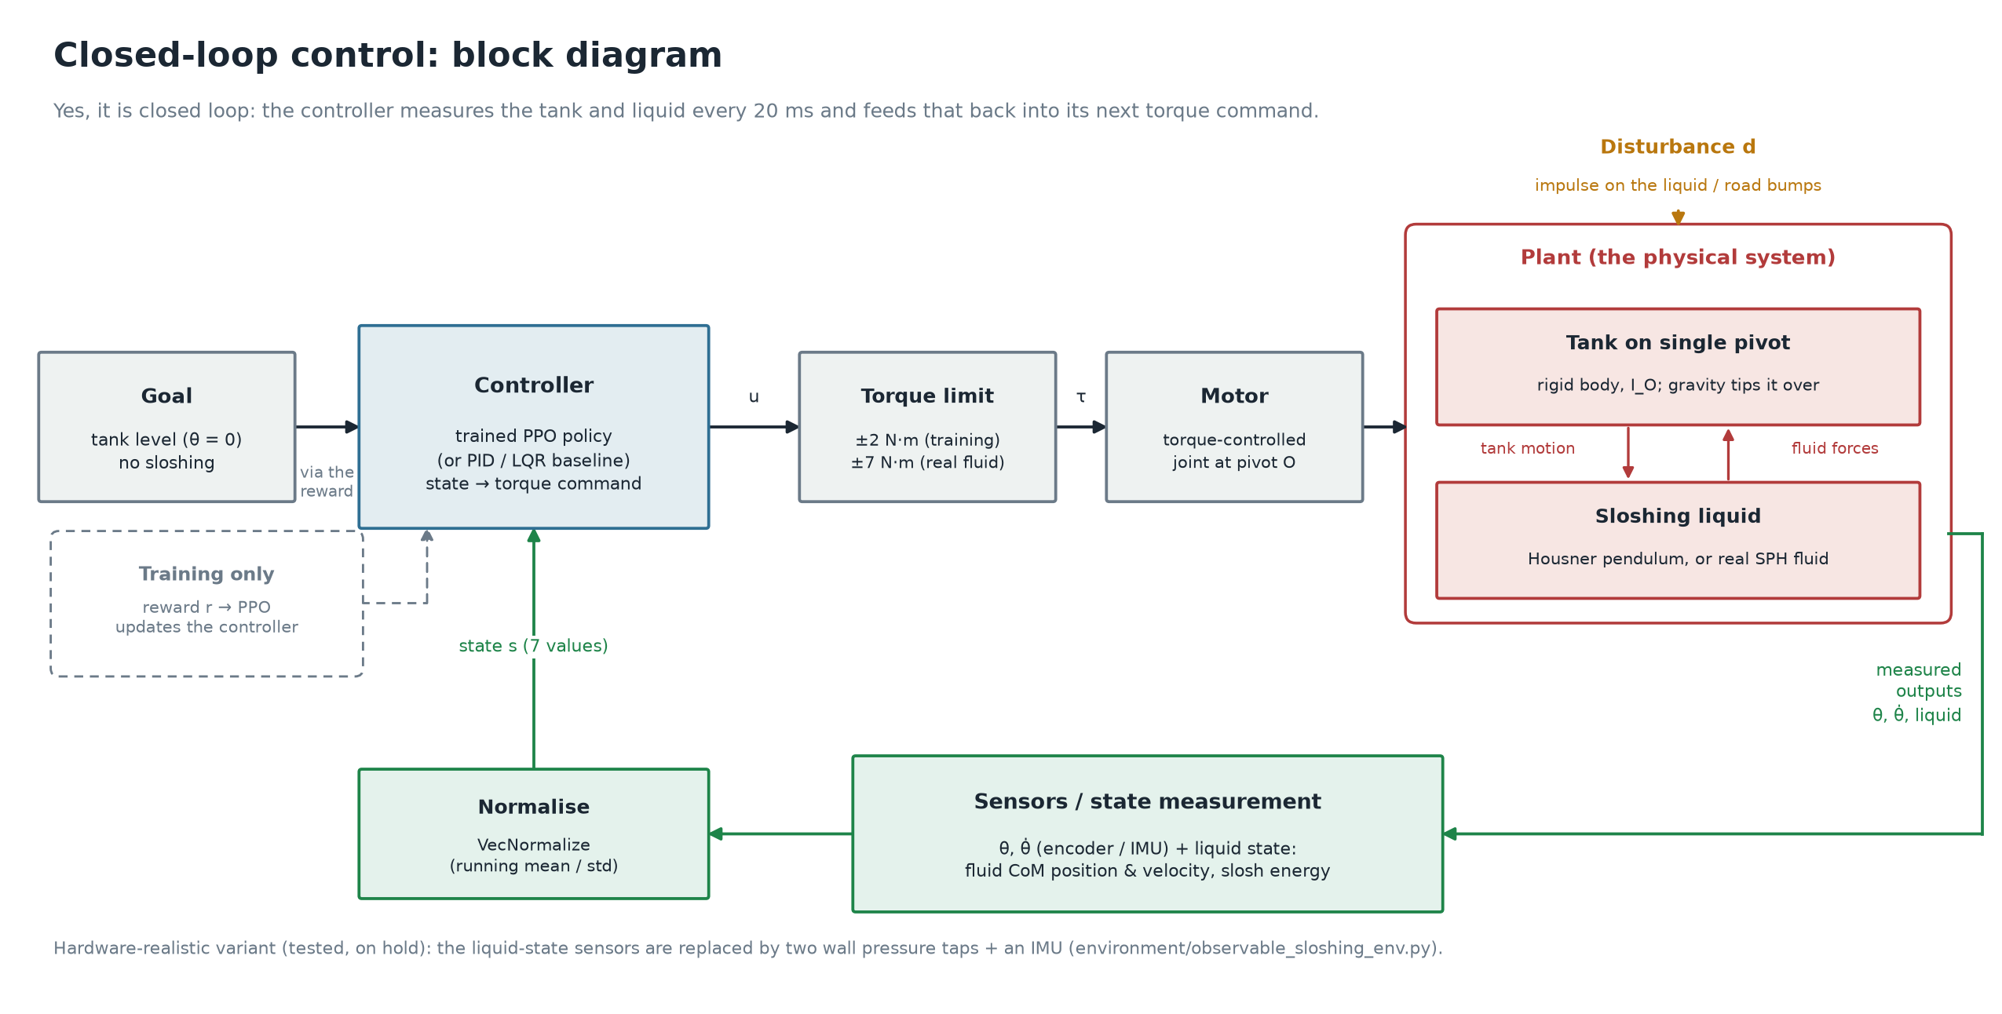
Figure 2. Closed-loop block diagram: the controller reads the measured state every 0.02 s and commands a motor torque; the plant is the tank with either the reduced-order or the SPH liquid model.

4. Dataset
The study uses no external dataset; all data are simulation output generated in this project and committed to its repository as CSV files sampled every 0.02 s. Table 4 lists the cases.
Table 4. Simulation cases and data files.
Case | Motion | Coupling | dx (mm) | Length | Output file(s)
Policy trajectory | Recorded PPO tilt: 0 → −10.16° at 6 s (max rate 0.096 rad/s), then nearly held (−10.23° at 10 s) | one-way | 10, 5, 3, 2 | 300–500 steps | sph_output_trained_seed0viscosity_fixed, dx005, dx003, dx002.csv
Free oscillation | Smooth ramp to 8.59° in 0.6 s, then held | one-way | 10 | 500 steps | sph_output_free_oscillation.csv
Closed-loop control | Torque from PID / LQR / PPO, 0.05 rad/s kick | two-way | 10 | ≤300 steps | closed_loop_real_sph_comparison.csv
Reduced-order | Same trajectories through the Housner pendulum | — | — | as above | tank_motion_*.csv
Each output row holds the liquid centroid displacement and velocity (tank frame) and E. Particle positions were also captured at a subsample of frames for visualisation.

5. Experimental Setup
Hardware and software. The prescribed-trajectory runs at all four resolutions and the free-oscillation run were performed on a workstation with an Intel Core i9 CPU, 32 GB RAM and an NVIDIA GeForce RTX 3090 (24 GB), running Windows with CUDA 13.0 and Visual Studio 2022. The two-way control runs were performed on a second machine with an Intel Core i7-14700F CPU, 32 GB DDR4 RAM (2 × 16 GB) and an NVIDIA GeForce RTX 5060 (Inno3D, 8 GB GDDR7), with CUDA 13.3. On both machines Chrono with the FSI module was built from source from the upstream main branch with a shallow clone; the commit hash was not written down at the time. The RTX 3090 build was cloned on 19 Sep 2026, and the upstream history shows only one commit on main between 15 and 21 Sep 2026, so that build is identified as commit 7571eed9f (16 Sep 2026). The RTX 5060 build was cloned on or about 5 Sep 2026; its exact commit cannot be recovered, but the solver code behind every setting and equation in Section 3.3 is unchanged apart from formatting between 3 and 16 Sep 2026. Python 3.10 and PyChrono 10.0.0 (conda-forge) were used for the non-FSI components. PPO used stable-baselines3 2.9.0, Gymnasium 1.3.0 and PyTorch 2.13–2.14, on the CPU, as recorded in the saved model files.
Procedure. For the resolution study, the same recorded trajectory was replayed at each spacing with the settings of Tables 2 and 3. The validation instant is step 300 (t = 6.0 s), where the tank has just reached −10.157° and its rate has fallen to 0.0011 rad/s, i.e. the liquid is close to quasi-static. GCI was computed for the three finest spacings with the procedure of Celik et al. [23], which allows non-uniform refinement ratios (here 1.67 and 1.5). For the free oscillation, the frequency was taken from the mean spacing of seven successive peaks after the hold begins, and the logarithmic decrement δ from successive peak-to-trough ranges, with ζ = δ/√(4π² + δ²). Each two-way controller run is a single deterministic episode.
Table 5. PPO training settings (secondary; config/simulation_config.py).
Hyperparameter | Value
Total timesteps / parallel environments | 500,000 / 8
Rollout length / minibatch / epochs | 1024 / 256 / 10
Learning rate / γ / GAE λ / clip | 3 × 10⁻⁴ / 0.99 / 0.95 / 0.2
Network (actor and critic) | 7 → 64 → 64, tanh
Control rate / physics step / episode | 50 Hz / 1 ms / 10 s
Seed | 0 (single seed)

6. Results

6.1 Resolution and mass representation
Table 3 shows that the lattice initialisation under-represents the liquid mass at coarse spacing: the 10 mm case holds 14.76 kg against 18.47 kg of water in the tank interior (−20%), because the lattice leaves a gap of the order of dx next to the walls. The deficit falls to −5.4% at 5 mm and to −2.2% at 3 and 2 mm. The effective free-surface height and liquid inertia therefore change with dx, which is one reason the 10 mm case behaves differently from the finer ones below.

6.2 Grid convergence and hydrostatic verification
Figure 3(b) compares the centroid response over the first 6 s of the policy trajectory with the hydrostatic model, Eq. (8). The mean absolute change between successive refinements over this window is 1.402 mm (10 → 5 mm), 0.697 mm (5 → 3 mm) and 0.354 mm (3 → 2 mm): each refinement halves the change. Table 6 gives the settled values at step 300.
Table 6. Liquid centroid displacement x at t = 6.0 s (θ = −10.157°) versus the hydrostatic value −11.238 mm.
dx (mm) | x_{SPH} (mm) | Error vs hydrostatic
10 | −14.05 | +25.0% (overshoot; excluded from GCI)
5 | −9.887 | −12.0%
3 | −10.566 | −5.98%
2 | −10.887 | −3.12%
Richardson extrapolation (5/3/2) | −11.447 | +1.86%
Observed order p | 1.118 | —
GCI_{fine} (2 mm) | 6.43% | —

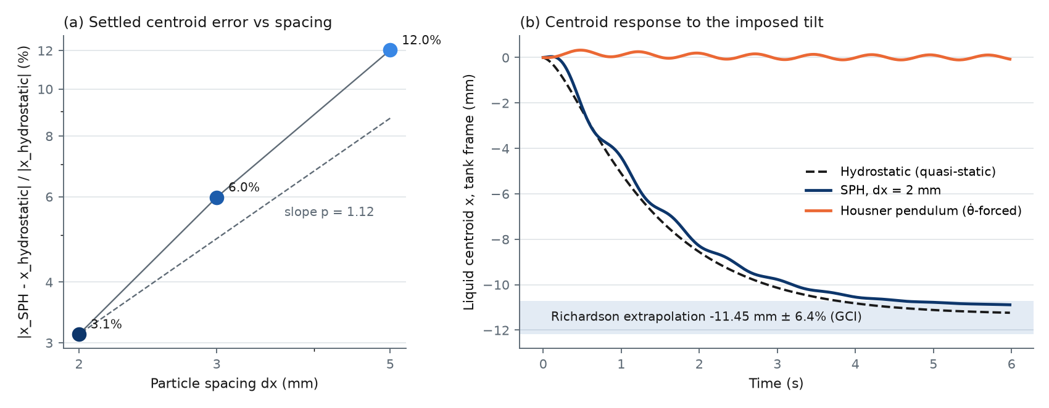
Figure 3. (a) Error of the settled SPH centroid against the hydrostatic value versus particle spacing (log–log), with a reference line of the observed slope. (b) Centroid response to the imposed tilt: 2 mm SPH, hydrostatic model (Eq. 8) and Housner pendulum; the shaded band is the Richardson-extrapolated value ± GCI.
The 5, 3 and 2 mm results converge monotonically towards the hydrostatic value, and the extrapolated value lies 1.86% from it, inside the 6.43% GCI band. This is a verification of the solution against an exact solution of the governing physics in the quasi-static limit, with a quantified discretisation uncertainty. The observed order (1.12) is lower than the formal order of the SPH operators; boundary treatment, kernel truncation at the free surface and the dx-dependent mass deficit (Section 6.1) are plausible contributors but were not separated. The 10 mm result lies on the other side of the hydrostatic value and continues to drift while the tank is held: at step 500 it reaches −39.18 mm against a hydrostatic −11.32 mm (a factor 3.5), whereas the 5 mm result settles near −10 mm. The 10 mm resolution is therefore outside the asymptotic range and should not be used for quantitative centroid predictions.

6.3 Free-sloshing frequency and damping
Figure 4 shows the response to a smooth tilt to 8.59° that is then held, so that the liquid oscillates freely. Table 7 compares the measured first-mode frequency with the references.
Table 7. Free-sloshing results at dx = 10 mm.
Quantity | SPH | Reference | Difference
First-mode frequency | 1.422 Hz | 1.364 Hz (potential theory, Eq. 10) | +4.2%
 |  | 1.343 Hz (Housner, outer L) | +5.9%
Logarithmic decrement δ | 0.550 | — | —
Damping ratio ζ | 0.087 | 0.005 (model value [13]) | ≈17×
Settled centroid shift | 13.36 mm | 9.48 mm (hydrostatic, 8.59°) | ×1.41
Max. centroid speed | 0.252 m/s | — | —

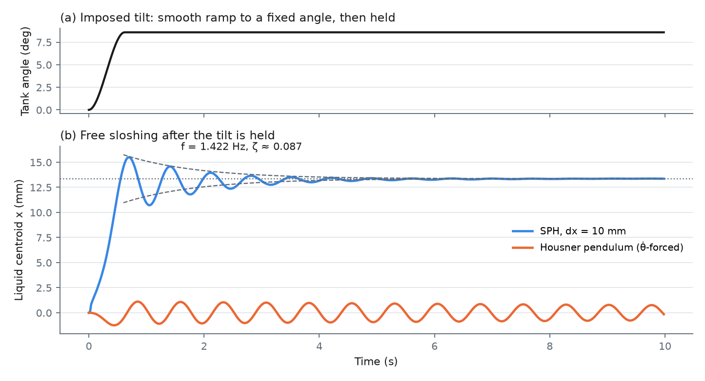
Figure 4. Free sloshing after a held tilt (dx = 10 mm). (a) Imposed tank angle. (b) SPH centroid with the fitted exponential envelope, and the Housner pendulum response to the same motion.
The frequency agrees with potential theory to 4.2%. The decay is, however, much faster than physical sloshing damping for a clean tank of this size: ζ ≈ 0.087 is about 17 times the 0.5% assumed in the reduced-order model, so the decay is dominated by numerical dissipation (artificial viscosity and density diffusion) at this resolution. The settled offset is 41% larger than hydrostatics, consistent with the 10 mm drift identified in Section 6.2. The frequency was measured at 10 mm only, so it carries no convergence estimate. The pendulum model, being forced only by the angular velocity during the 0.6 s ramp, reaches a maximum centroid displacement of only 1.25 mm and keeps oscillating about zero, whereas the liquid settles to a new offset.

6.4 Dynamic response versus the reduced-order models
Over the 300-step policy trajectory, the 2 mm solution correlates with the hydrostatic model at 0.999 with a mean absolute error of 0.35 mm, but with the Housner pendulum at only 0.477 with a mean absolute error of 8.29 mm. Adding the pendulum response to the hydrostatic shift changes the error only marginally (0.999, 0.31 mm). The peak bulk kinetic energy is 3.18 × 10⁻³ J in SPH against 7.5 × 10⁻⁶ J in the pendulum model. The trajectory's frequency content lies well below the 1.34 Hz sloshing mode (maximum tank rate 0.096 rad/s), so the liquid mainly re-levels quasi-statically; the Housner pendulum, which has no angle-dependent equilibrium, cannot represent this. Earlier one-way comparisons at 10 mm gave a pendulum correlation of 0.38 for the same trajectory and 0.05 for a 0.4 Hz decaying-sine drive, the latter reflecting the off-resonance attenuation of a single linear mode.
Figure 5 shows the convergence of the full centroid history and Figure 6 shows particle snapshots at 2 mm: the free surface stays horizontal in the world frame while the tank tilts, as the hydrostatic model assumes. Repeating the 10 mm run with μ = 1.0 and 0.001 Pa·s changed the centroid by 0.13 mm on average (0.88 mm maximum). Because μ does not enter the equations in this configuration (Section 3.3), this difference is not a viscous effect; its source, for example run-to-run floating-point variation on the GPU, was not isolated.
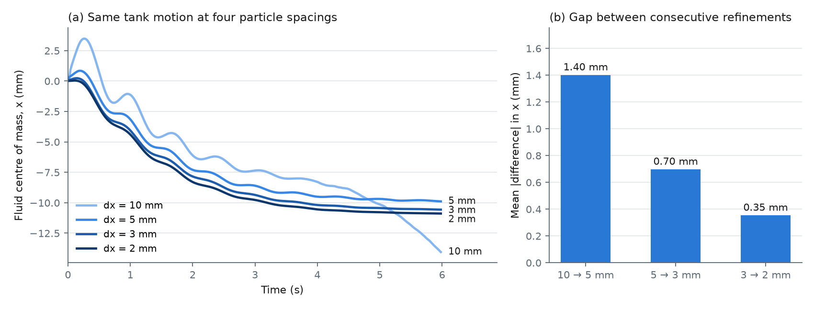
Figure 5. (a) Liquid centroid x (tank frame) at four particle spacings over the common 300-step window. (b) Mean absolute change between successive refinements.
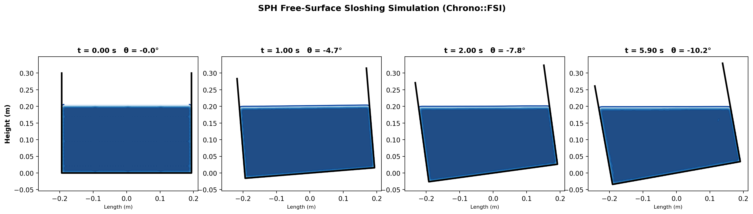
Figure 6. SPH density field at dx = 2 mm at four instants of the policy trajectory (kernel density of the particles, clipped to the tank interior).

6.5 Two-way coupled control
Table 8 and Figure 7 summarise single deterministic 300-step episodes in the torque-driven SPH tank at 10 mm (α = 0.1, torque limit 7.0 N·m).
Table 8. Two-way coupled SPH control runs (closed_loop_real_sph_comparison.csv).
Controller | Steps before trip (of 300) | Final E (J) | Max. torque (N·m) | Motor energy (J)
PID (tank angle) | 300 (no trip) | 0.0157 | 4.26 | 1.12
LQR (pendulum model) | 34 | 0.587 | 3.62 | —
PPO (checkpoint 514560) | 252 | 0.0010 | 4.69 | 1.19

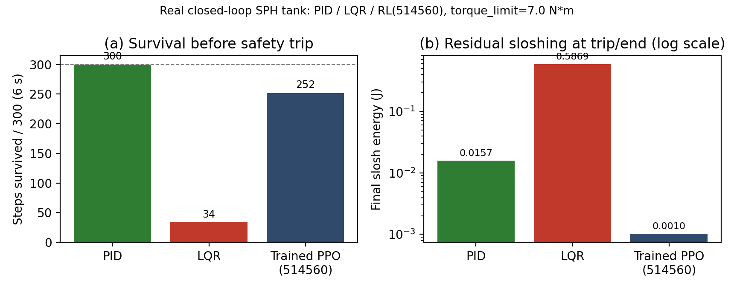
Figure 7. Two-way coupled SPH tank: (a) steps before the 1.0 rad/s safety trip; (b) bulk kinetic energy at the end of each run (log scale).
The LQR gain, designed on the linearised Housner model, destabilised the tank within 34 steps; this is the clearest consequence of the model mismatch found in Section 6.4. PID held the tank for the whole window with a residual E of 0.0157 J. The PPO policy, fine-tuned in the two-way SPH tank, left about 15 times less energy at its last step but reached the safety limit at step 252. Torque limits between 1 and 10 N·m were swept beforehand; survival peaked at 7.0 N·m (about 200–300 steps) and fell at both lower and higher limits. For scale, the peak liquid reaction torque measured under prescribed rocking was 4.78 N·m, about seven times the inertial plus gravitational torque of the empty tank (0.70 N·m). These runs are at the coarse 10 mm resolution, with a larger artificial viscosity (α = 0.1) than the one-way runs and a single episode each; they are a demonstration of the coupled model, not a converged result.

6.6 Boundary-condition limitations
In the two-way runs, particles were observed to cross the ADAMI walls transiently during rapid reversals of the tank rotation: for checkpoint 518144, up to 63.9% of particles in the worst frame lay outside the wall, by up to 2.54 cm, before returning within two to three control steps. Lowering α to 0.05 or 0.03 increased the violation (59–61%), a smaller solver step did not remove it reliably, and six instead of four marker layers made the run fail after 31 steps. The HOLMES boundary method [22] reduced the worst violation to 16.8% and 0.30 cm but shortened survival (116 versus 160 steps for 518144; 176 versus 250 for 514560). A policy fine-tuned under HOLMES, and the ADAMI-trained policy, both lost control in every clean evaluation under HOLMES. ADAMI was retained. Wall penetration under fast wall acceleration is therefore an unresolved numerical limitation of the two-way runs at 10 mm.

6.7 Computational cost
Table 3 lists the cost. Halving dx from 10 to 5 mm increased the particle count 9.5-fold and the wall-clock cost per simulated second about 5-fold; the 2 mm case ran 5,482 times slower than real time (9.1 h for 6 s). At 5 mm the first two attempts diverged at step 100 with a solver error; neither a smaller step nor more marker layers alone fixed this, and both together did. The 3 and 2 mm runs used proportionally scaled settings from the start and completed without failure. The 3 mm run, repeated with particle capture, reproduced its final centroid to within 9.6 μm, a run-to-run variation attributed to GPU floating-point reduction order.

7. Discussion

7.1 Interpretation
For the slow, large-angle motion that a stabilising controller produces, the resolved liquid response is governed by hydrostatic re-levelling, and the WCSPH solution converges to the exact hydrostatic shift as dx is reduced. The equivalent pendulum describes the oscillatory component about equilibrium but not the equilibrium itself, because in the form used it is driven only by the angular velocity. A controller designed on that model therefore sees the wrong quasi-static liquid moment, which is a plausible explanation for the LQR divergence in the coupled SPH tank.

7.2 Comparison with the literature
The 4.2% frequency difference from potential theory at 10 mm is of the same order as the differences between SPH and experiment reported for rolling tanks [7, 8] and for laboratory sloshing [9], although those studies consider different tanks and excitations and their numbers are not directly comparable. The large numerical damping at coarse resolution is consistent with the general observation that artificial viscosity and density diffusion dissipate free-surface waves [19]. Unlike the DRL sloshing studies [29, 30], which actuate baffles, the actuator here is the tank's own pivot drive.

7.3 Strengths
The central SPH result is supported by a four-level resolution study with a GCI estimate and by comparison with an exact solution that has no tunable parameter. All inputs are drawn from version-controlled code and configuration, and all derived numbers are recomputed by scripts from committed output files.

7.4 Limitations (critical review)
- No experimental validation. All comparisons are with analytical or reduced-order models. The results are verification, not validation; a laboratory tank with wall-pressure or free-surface measurements is required for the latter.
- Only bulk quantities. Wall pressure, free-surface elevation and liquid moment were not extracted; these are the quantities used in the experimental literature [8, 14].
- Verification only in the quasi-static limit. The converged agreement is with hydrostatics; the dynamic sloshing frequency and damping were measured at 10 mm only, where the solution is shown to be outside the asymptotic range, and the damping is dominated by numerics.
- No independent time-step study. The solver step was reduced together with dx, so temporal and spatial discretisation errors are not separated.
- Build provenance inferred. The solver settings were confirmed from the Chrono source, but the commit was inferred from clone dates rather than recorded, exactly for the RTX 3090 build and only approximately for the RTX 5060 build.
- No physical viscosity. All dissipation is artificial (α, δ); the water's real viscosity plays no role, so viscous boundary layers and physical slosh damping are not modelled.
- Inconsistent constants. The FSI solver used g = 9.8 m/s² while the rest of the model used 9.81 m/s² (a 0.1% difference in g, about 0.05% in frequency); the Housner model was evaluated with the outer tank length and width rather than the interior dimensions.
- Two-way runs are coarse. The control comparison used dx = 10 mm, α = 0.1, a single seed and one episode per controller, and suffers transient wall penetration; the PPO controller is stable only for about 5 s in this test.
- Mass deficit. The lattice initialisation under-represents the liquid mass by 2–20% depending on dx, which changes the effective fill and inertia.
- Physics not modelled. Surface tension, air, wall wetting and tank flexibility are absent.

8. Future Work
- Build a laboratory pitch rig of the same dimensions and measure wall pressure and free-surface elevation to validate the SPH model.
- Extract wall pressure and the liquid moment about the pivot from the particle data, and plot pressure time histories at fixed wall gauges for each resolution.
- Repeat the free-sloshing test at 5, 3 and 2 mm to obtain a converged frequency and damping, and plot ζ versus dx to separate numerical from physical damping.
- Run a time-step independence study at fixed dx.
- Initialise the liquid with a hydrostatic pressure field and boundary-fitted packing to remove the settling transient and mass deficit.
- Replace the angular-velocity-forced pendulum with an equivalent model that includes the angle-dependent hydrostatic moment, and re-design LQR on it.
- Repeat the two-way control comparison at 5 mm with the solver's laminar-viscosity model (so that the water viscosity actually enters), several seeds and episodes, and a wall treatment that prevents penetration.

9. Conclusion
A weakly compressible SPH model of a water tank pitching about a base pivot was built in Chrono::FSI and examined at four particle spacings. For a controller-generated tilt, the liquid centroid converged monotonically, with each refinement halving the change, and at the finest spacing it agreed with the exact hydrostatic shift to 3.1%; the extrapolated value lay within 1.9% of theory, inside a 6.4% GCI band. In this regime the resolved liquid re-levels quasi-statically, which the Housner pendulum in its angular-velocity-forced form does not capture. At the coarsest spacing the first-mode frequency agreed with potential theory to 4.2%, but the damping was dominated by numerical dissipation, and the centroid drifted. In the two-way coupled tank, an LQR controller designed on the pendulum model diverged, while a learned controller reduced the residual kinetic energy compared with PID within a limited stability window. The SPH solution is verified for the bulk quasi-static response; its dynamic and two-way results remain coarse and unvalidated against experiment.

References
[1] G. W. Housner, “The dynamic behavior of water tanks,” Bulletin of the Seismological Society of America, vol. 53, no. 2, pp. 381–387, 1963.
[2] ACI Committee 350, Seismic Design of Liquid-Containing Concrete Structures and Commentary (ACI 350.3-06). Farmington Hills, MI: American Concrete Institute, 2006.
[3] H. N. Abramson (ed.), “The Dynamic Behavior of Liquids in Moving Containers, with Applications to Space Vehicle Technology,” NASA SP-106, 1966.
[4] R. A. Ibrahim, Liquid Sloshing Dynamics: Theory and Applications. Cambridge: Cambridge University Press, 2005.
[5] O. M. Faltinsen and A. N. Timokha, Sloshing. Cambridge: Cambridge University Press, 2009.
[6] Y. Li and J. Wang, “A supplementary, exact solution of an equivalent mechanical model for a sloshing fluid in a rectangular tank,” Journal of Fluids and Structures, vol. 31, pp. 147–151, 2012, doi: 10.1016/j.jfluidstructs.2012.02.012.
[7] A. Souto-Iglesias, L. Delorme, L. Pérez-Rojas, and S. Abril-Pérez, “Liquid moment amplitude assessment in sloshing type problems with smooth particle hydrodynamics,” Ocean Engineering, vol. 33, no. 11–12, pp. 1462–1484, 2006.
[8] L. Delorme, A. Colagrossi, A. Souto-Iglesias, R. Zamora-Rodríguez, and E. Botía-Vera, “A set of canonical problems in sloshing, Part I: Pressure field in forced roll — comparison between experimental results and SPH,” Ocean Engineering, vol. 36, no. 2, pp. 168–178, 2009.
[9] A. Rafiee, F. Pistani, and K. Thiagarajan, “Study of liquid sloshing: numerical and experimental approach,” Computational Mechanics, vol. 47, pp. 65–75, 2011, doi: 10.1007/s00466-010-0529-6.
[10] A. Tasora, R. Serban, H. Mazhar, A. Pazouki, D. Melanz, J. Fleischmann, M. Taylor, H. Sugiyama, and D. Negrut, “Chrono: An open source multi-physics dynamics engine,” in High Performance Computing in Science and Engineering, Lecture Notes in Computer Science, Springer, pp. 19–49, 2016.
[11] M. Rakhsha, A. Pazouki, R. Serban, and D. Negrut, “Using a half-implicit integration scheme for the SPH-based solution of fluid–solid interaction problems,” Computer Methods in Applied Mechanics and Engineering, vol. 345, pp. 100–122, 2019, doi: 10.1016/j.cma.2018.09.027.
[12] W. Zhao, J. Peña Queralta, and T. Westerlund, “Sim-to-real transfer in deep reinforcement learning for robotics: A survey,” in Proc. IEEE Symposium Series on Computational Intelligence (SSCI), pp. 737–744, 2020.
[13] M. Sivý, M. Musil, O. Chlebo, and R. Havelka, “Sloshing effects in tanks containing liquid,” MATEC Web of Conferences, vol. 107, art. 00069, 2017, doi: 10.1051/matecconf/201710700069.
[14] H. Akyıldız and E. Ünal, “Experimental investigation of pressure distribution on a rectangular tank due to the liquid sloshing,” Ocean Engineering, vol. 32, no. 11–12, pp. 1503–1516, 2005, doi: 10.1016/j.oceaneng.2004.11.006.
[15] K. Liu, X. Li, P. Peng, Z. Zhou, and Z. Gao, “Experimental study on the sloshing of a rectangular tank under pitch excitations,” Water, vol. 16, no. 11, art. 1551, 2024, doi: 10.3390/w16111551.
[16] P. K. Panigrahy, U. K. Saha, and D. Maity, “Experimental studies on sloshing behavior due to horizontal movement of liquids in baffled tanks,” Ocean Engineering, vol. 36, pp. 213–222, 2009, doi: 10.1016/j.oceaneng.2008.11.002.
[17] J. J. Monaghan, “Simulating free surface flows with SPH,” Journal of Computational Physics, vol. 110, no. 2, pp. 399–406, 1994.
[18] D. Molteni and A. Colagrossi, “A simple procedure to improve the pressure evaluation in hydrodynamic context using the SPH,” Computer Physics Communications, vol. 180, no. 6, pp. 861–872, 2009.
[19] M. Antuono, A. Colagrossi, S. Marrone, and D. Molteni, “Free-surface flows solved by means of SPH schemes with numerical diffusive terms,” Computer Physics Communications, vol. 181, no. 3, pp. 532–549, 2010.
[20] J. J. Monaghan, “On the problem of penetration in particle methods,” Journal of Computational Physics, vol. 82, no. 1, pp. 1–15, 1989.
[21] S. Adami, X. Y. Hu, and N. A. Adams, “A generalized wall boundary condition for smoothed particle hydrodynamics,” Journal of Computational Physics, vol. 231, no. 21, pp. 7057–7075, 2012.
[22] D. W. Holmes, J. R. Williams, and P. Tilke, “Smooth particle hydrodynamics simulations of low Reynolds number flows through porous media,” International Journal for Numerical and Analytical Methods in Geomechanics, vol. 35, no. 4, pp. 419–437, 2011.
[23] I. B. Celik, U. Ghia, P. J. Roache, C. J. Freitas, H. Coleman, and P. E. Raad, “Procedure for estimation and reporting of uncertainty due to discretization in CFD applications,” Journal of Fluids Engineering, vol. 130, no. 7, art. 078001, 2008.
[24] J. T. Feddema, C. R. Dohrmann, G. G. Parker, R. D. Robinett, V. J. Romero, and D. J. Schmitt, “Control for slosh-free motion of an open container,” IEEE Control Systems Magazine, vol. 17, no. 1, pp. 29–36, 1997.
[25] M. Grundelius and B. Bernhardsson, “Control of liquid slosh in an industrial packaging machine,” in Proc. IEEE International Conference on Control Applications, vol. 2, pp. 1654–1659, 1999.
[26] K. Yano and K. Terashima, “Robust liquid container transfer control for complete sloshing suppression,” IEEE Transactions on Control Systems Technology, vol. 9, no. 3, pp. 483–493, 2001.
[27] J. Rabault, M. Kuchta, A. Jensen, U. Réglade, and N. Cerardi, “Artificial neural networks trained through deep reinforcement learning discover control strategies for active flow control,” Journal of Fluid Mechanics, vol. 865, pp. 281–302, 2019, doi: 10.1017/jfm.2019.62.
[28] J. Viquerat, P. Meliga, A. Larcher, and E. Hachem, “A review on deep reinforcement learning for fluid mechanics: An update,” Physics of Fluids, vol. 34, no. 11, art. 111301, 2022, doi: 10.1063/5.0128446.
[29] Y. Xie and X. Zhao, “Sloshing suppression with active controlled baffles through deep reinforcement learning–expert demonstrations–behavior cloning process,” Physics of Fluids, vol. 33, no. 1, art. 017115, 2021.
[30] M. Ye, Y. Ren, S. Zhang, H. Ma, X. Hu, and O. J. Haidn, “Sloshing suppression with a controlled elastic baffle via deep reinforcement learning and SPH simulation,” arXiv:2505.02354, 2025 (preprint).
[31] A. K. Shakya et al., “Deep reinforcement learning based super twisting controller for liquid slosh control problem,” IFAC-PapersOnLine, vol. 55, no. 1, pp. 734–739, 2022, doi: 10.1016/j.ifacol.2022.04.120.
[32] Project Chrono Development Team, Chrono::FSI-SPH source code (src/chrono_fsi/sph), github.com/projectchrono/chrono, commit 7571eed9f, 16 Sep 2026.
[33] J. Schulman, F. Wolski, P. Dhariwal, A. Radford, and O. Klimov, “Proximal policy optimization algorithms,” arXiv:1707.06347, 2017.
[34] A. Raffin, A. Hill, A. Gleave, A. Kanervisto, M. Ernestus, and N. Dormann, “Stable-Baselines3: Reliable reinforcement learning implementations,” Journal of Machine Learning Research, vol. 22, no. 268, pp. 1–8, 2021.
[35] M. Towers et al., “Gymnasium: A standard interface for reinforcement learning environments,” arXiv:2407.17032, 2024.

Appendix A: Soft Code Flowcharts
The flowcharts below follow the project's actual simulation and control code; the source files are named in each caption, and all numerical values come from the project configuration (config/simulation_config.py). Standard symbols are used: rounded boxes for start and end, rectangles for processes, parallelograms for input and output, and diamonds for decisions.
The project runs in stages. The tank, pivot and motor are first built from simple shapes, with mass and inertia computed analytically. A PPO controller is then trained on the fast surrogate model (500,000 steps), evaluated over 20 episodes, and fine-tuned for 50,000 steps on rigid-body Chrono physics. A tank-angle trajectory produced by the trained controller is recorded and replayed in the SPH solver at four particle spacings, and the SPH results are compared with the pendulum and hydrostatic models. Finally, the controller is fine-tuned and tested in the two-way coupled SPH tank, where the liquid acts back on the tank. The Chrono::FSI steps ran on the two GPU workstations.
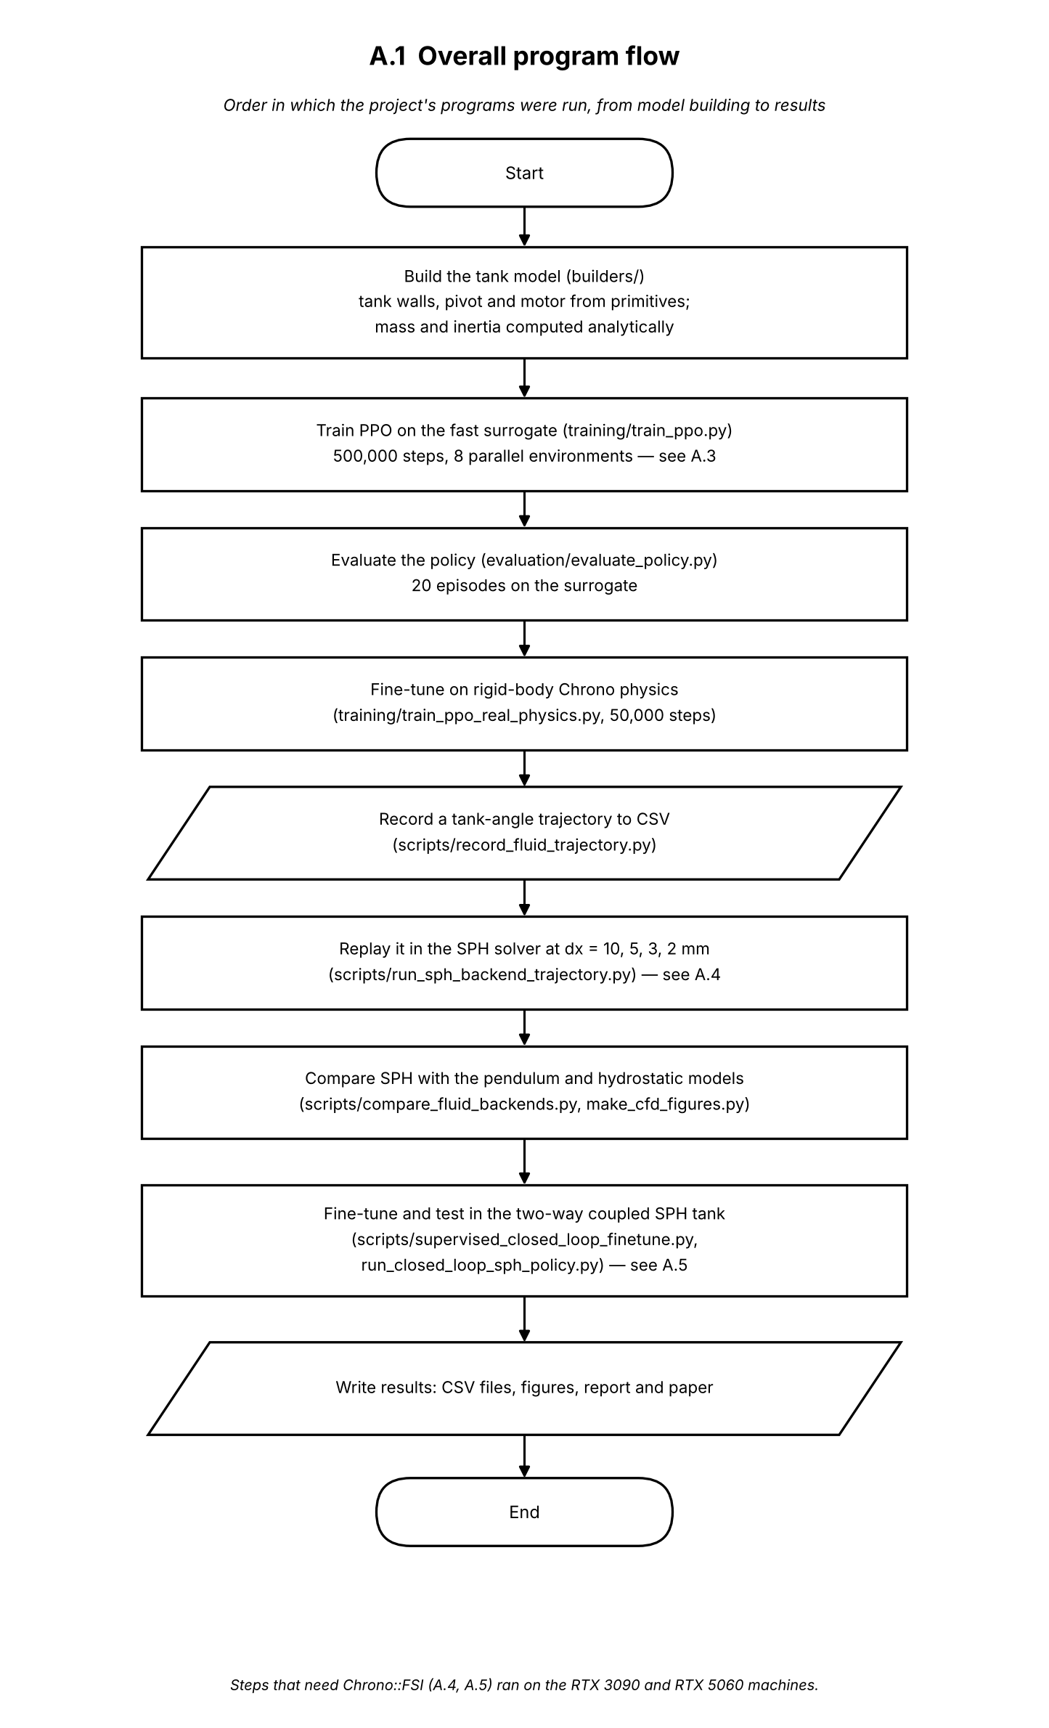
Figure A.1. Overall program flow: the order in which the project's programs were run.

Each episode begins with reset(): the tank and fluid model return to rest and the liquid receives a random impulse of 0–0.02 N·s in a random direction. Every 20 ms the controller reads a seven-value observation (tank angle and rate, liquid centre-of-mass position and velocity, and slosh energy) and returns an action between −1 and 1, which is clipped and scaled to a motor torque of at most 2 N·m. The torque is held for 20 physics substeps of 1 ms; in each substep the tank is advanced first and the fluid model is then advanced with the new tank angle and rate. After the substeps the reward is computed, penalising slosh energy, torque and tilt. The episode ends early if the tank tilts beyond 45°, and otherwise after 500 control steps (10 s). The same loop is used for PPO training, for evaluation and for the PID and LQR baselines.
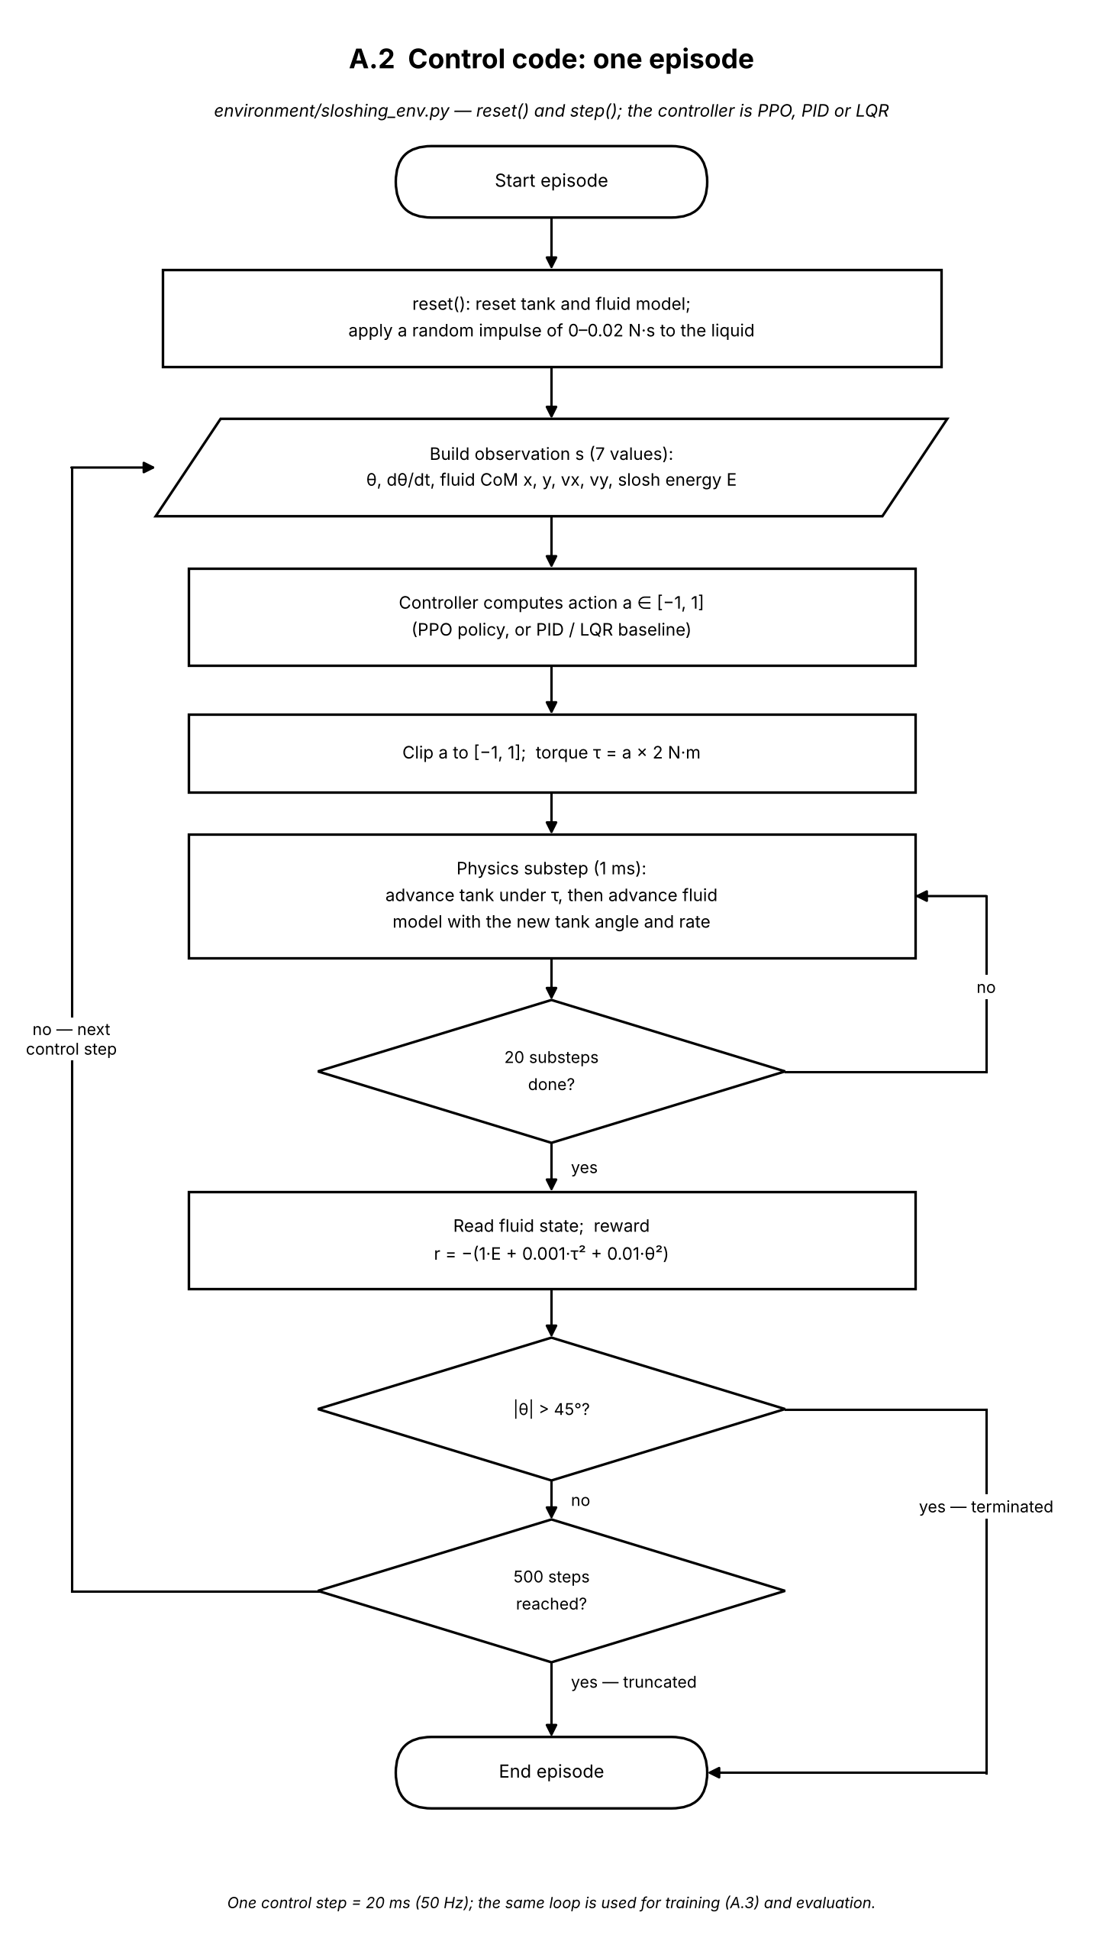
Figure A.2. Control code: one episode of the sloshing environment (environment/sloshing_env.py).

Training uses the stable-baselines3 implementation of PPO. Separate actor and critic networks, each with two hidden layers of 64 tanh units, are created, and eight copies of the environment of Fig. A.2 run in parallel behind a wrapper that normalises observations and rewards. Each round collects 1,024 steps from every environment (8,192 transitions), estimates advantages with GAE (γ = 0.99, λ = 0.95), and updates both networks for 10 epochs in minibatches of 256 using the clipped PPO objective (ε = 0.2). A checkpoint is saved every 50,000 steps, and after 500,000 steps (about 62 rounds) the final policy and its normalisation statistics are saved.
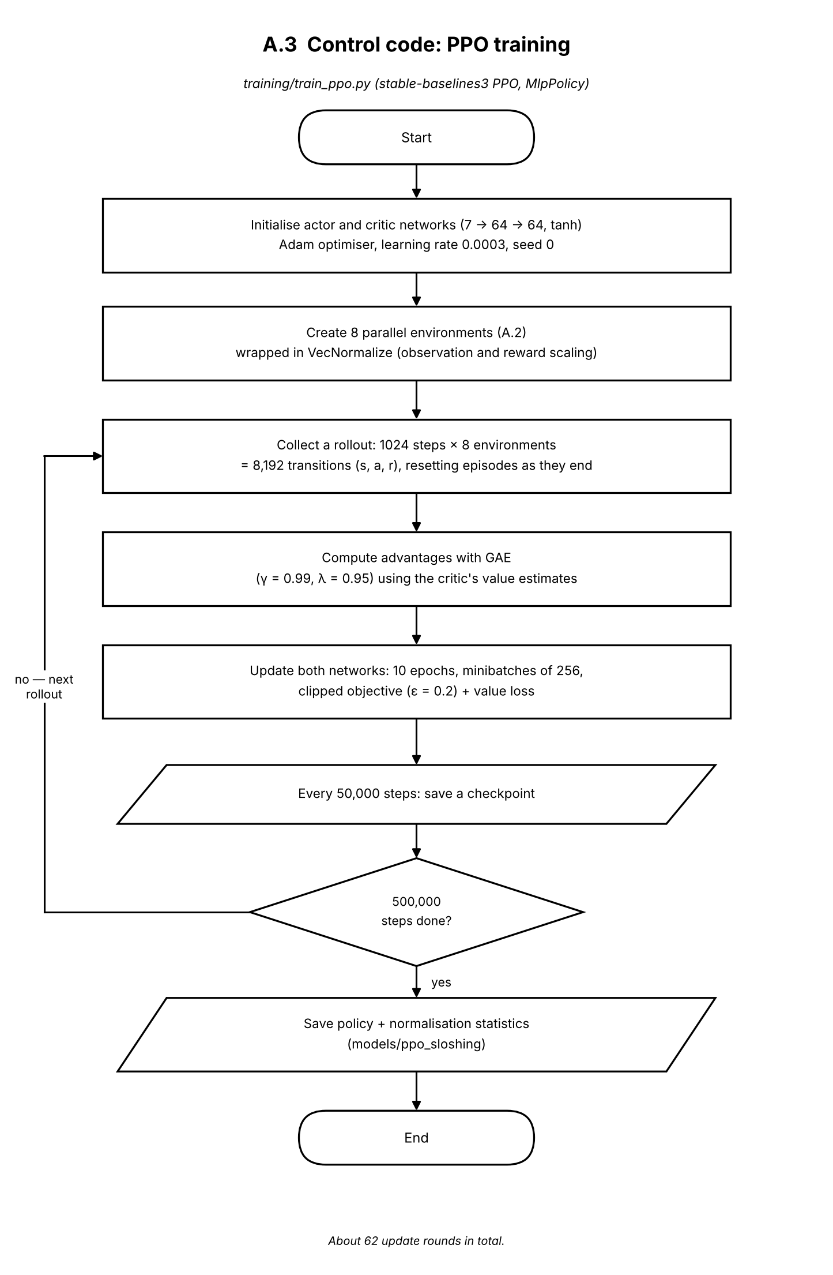
Figure A.3. Control code: PPO training (training/train_ppo.py).

In these runs the tank motion is prescribed rather than solved for (one-way coupling). The program reads the recorded trajectory (tank angle and rate every 20 ms) and first checks whether a complete output file already exists, in which case the run is skipped. Otherwise it builds the Chrono::FSI scene: the tank walls are converted to boundary markers and the water to a lattice of particles at spacing dx, with the solver settings described in the methodology. For each recorded row, the 20 ms interval is divided into solver substeps; in each one the tank angle is moved by linear interpolation towards the target and the SPH solver advances by one substep. At the end of the interval the liquid centroid, its velocity and the bulk kinetic energy are computed from the particles and stored. Results are written to disk every 25 rows, so an interruption loses little work.
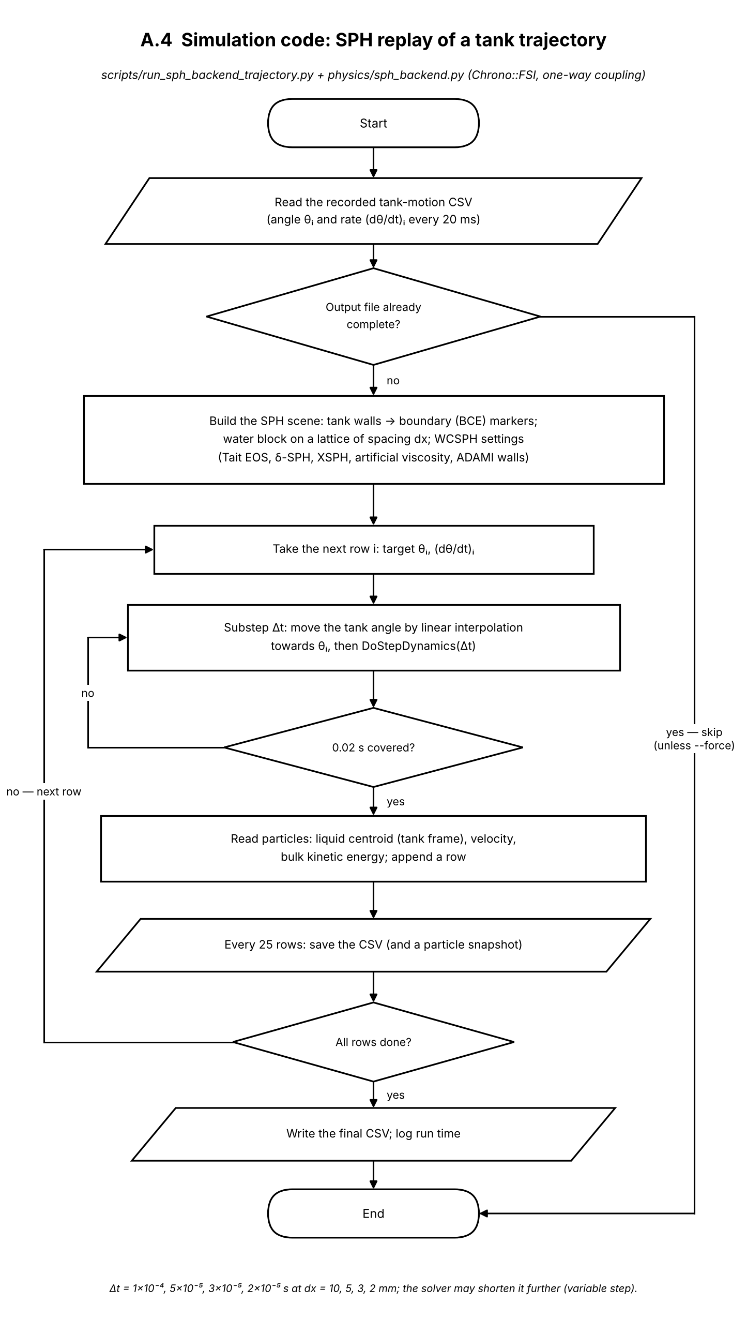
Figure A.4. Simulation code: SPH replay of a recorded tank trajectory (scripts/run_sph_backend_trajectory.py, physics/sph_backend.py).

Here the tank is driven by torque and the SPH liquid forces act back on it (two-way coupling). After loading the trained policy and its normalisation statistics, the program builds the tank with a torque motor at the pivot and starts it with a 0.05 rad/s kick. At each 20 ms step it first checks the tank's angular speed and stops the run if it exceeds 1.0 rad/s. Otherwise the policy chooses an action, which is converted to a torque limited to 7 N·m, and the coupled system advances in small substeps. The same speed check is repeated after every substep, so the run stops before the solver diverges rather than after. The tank state, the torque and the liquid quantities are recorded every step and saved periodically and at the end.
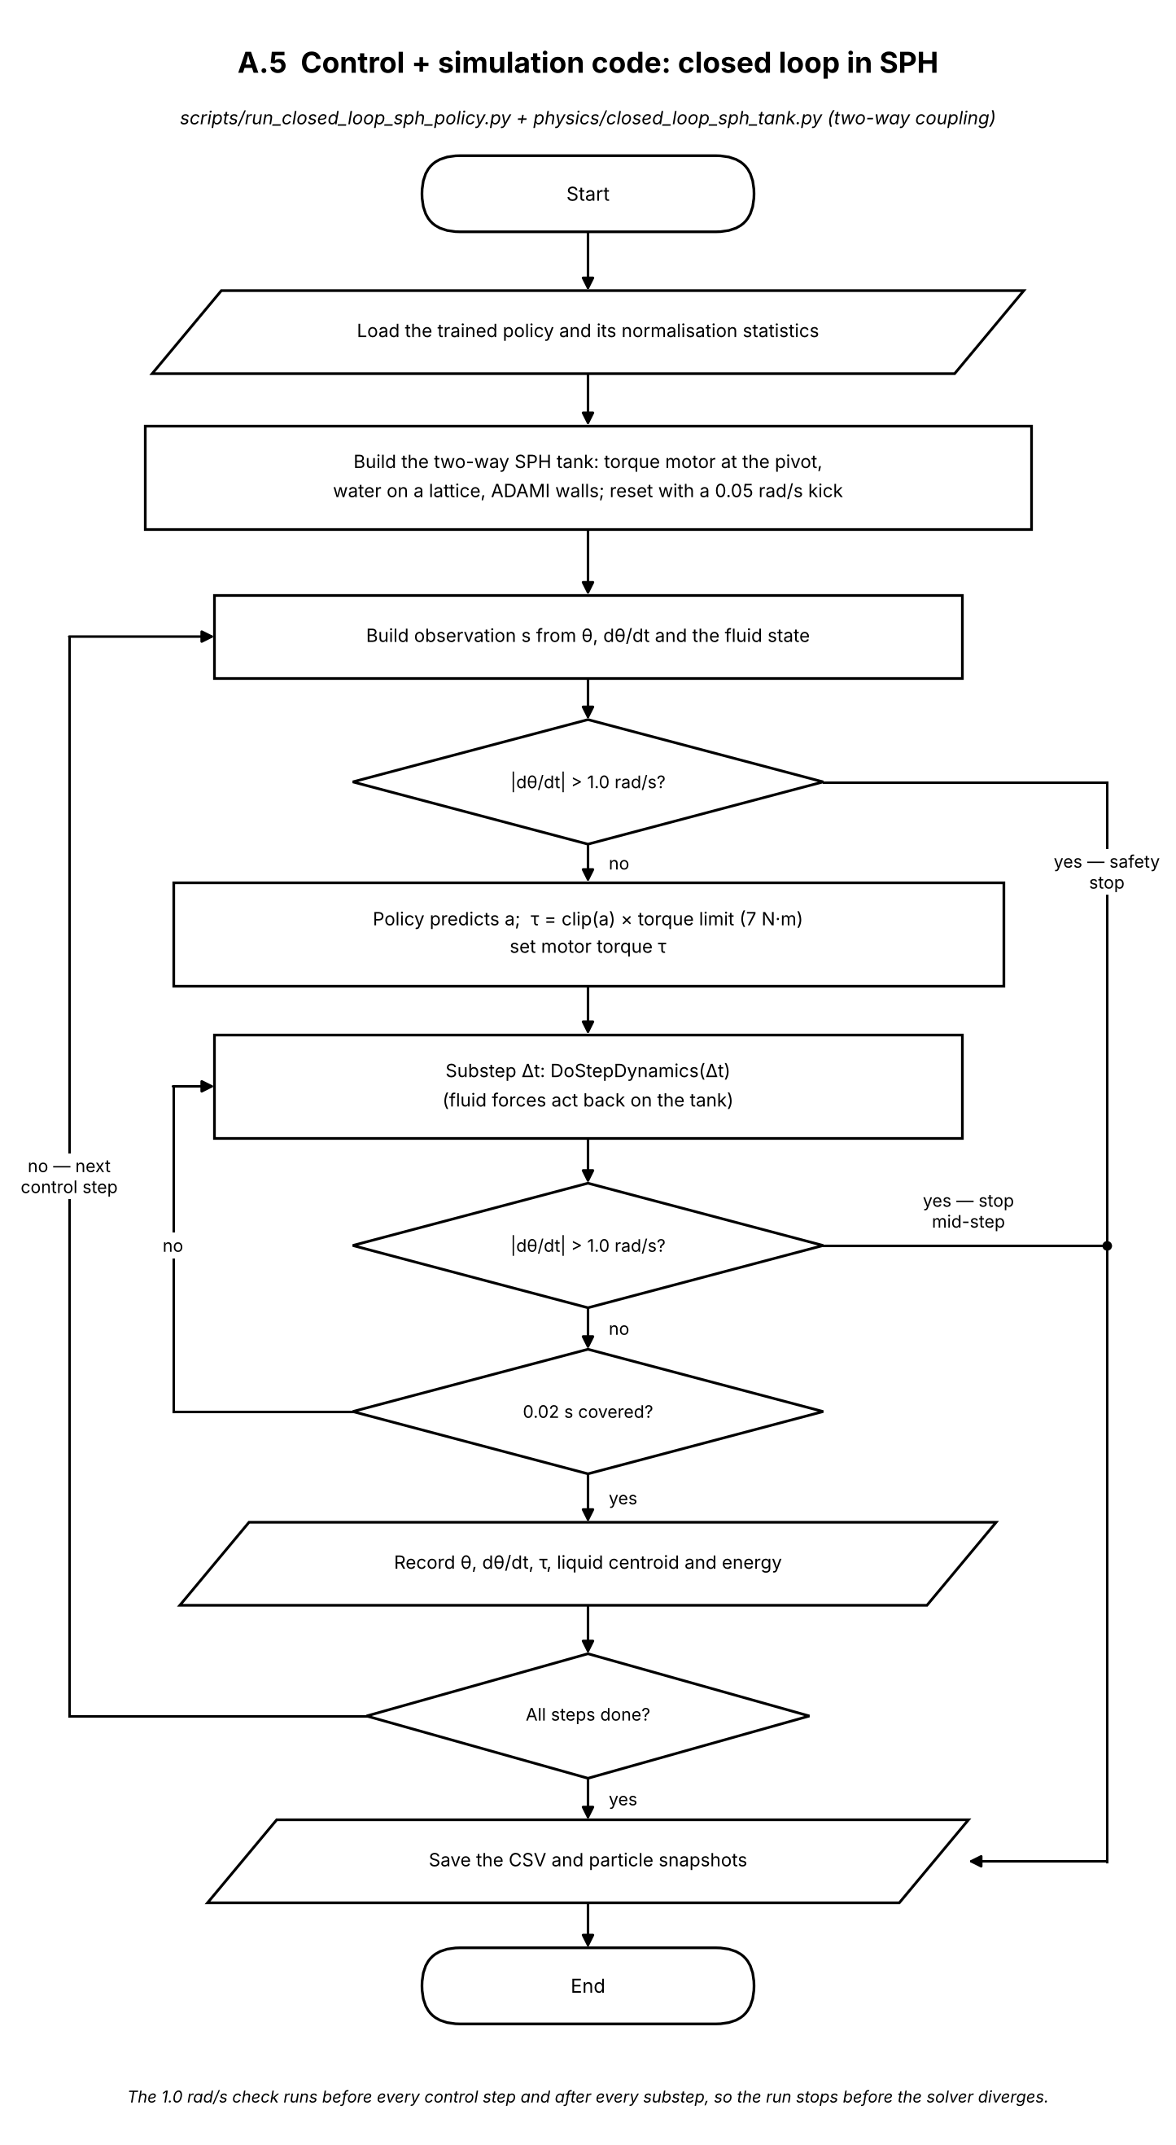
Figure A.5. Control and simulation code: closed loop in the two-way coupled SPH tank (scripts/run_closed_loop_sph_policy.py, physics/closed_loop_sph_tank.py).

The block diagram shows the same loop at system level. The goal, a level tank with no sloshing, reaches the controller through the reward during training. The controller output passes through the torque limit (±2 N·m in training, ±7 N·m in the SPH tank) to the motor at pivot O, which drives the plant: the tank on its pivot and the sloshing liquid, coupled in both directions. Disturbances act on the liquid. The measured tank angle, rate and liquid state are normalised and fed back as the seven-value state, closing the loop every 20 ms. The dashed path marks the training-only reward signal that PPO uses to update the controller.
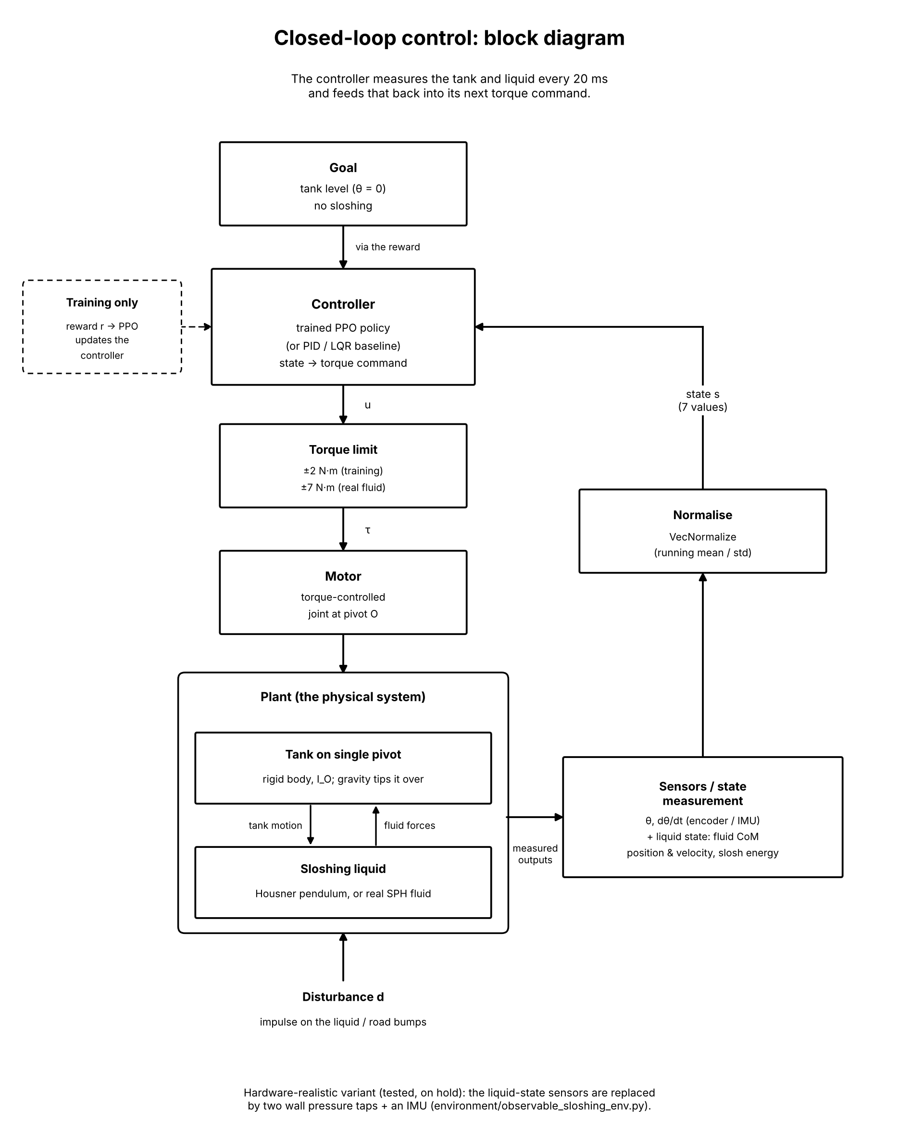
Figure A.6. Closed-loop control block diagram (system overview).

