ABSTRACT
A user's choice of music is influenced by their mood as well as their past musical tastes and musical substance. In this study, we introduce a powerful music recommendation system that makes music suggestions depending on the user's current mood. It primarily focuses on the Convolutional Neural Network (CNN) model, which distinguishes seven different facial expressions in humans using Mobile Net architecture. Three modules make up our system: the Recommendation Module, the Music Classification Module, and the Emotion Module. The Emotion Module uses CNN to determine the user's current mood after receiving a picture of their face as input. The Music Classification Module uses audio elements to classify music with an impressive accuracy rate of 98%.

INTRODUCTION
Since it is a popular kind of entertainment for music lovers and listeners and occasionally even imparts a therapeutic approach, music plays a significant part in improving a person's quality of life. Numerous music players have been created with features like fast-forward, reverse, variable playback speed, local playback, streaming playback with the multicast streams, and including volume modulation, genre classification, etc. in the modern world due to the rapid advancements in multimedia and technology. One of these techniques for identifying human emotional states (such as anger, fear, neutrality, happiness, disgust, sadness, and surprise) is deep learning-based facial expression identification. This technique seeks to accurately identify the emotional state by automatically detecting facial expressions. Labeled facial photos from the facial expression collection were used in this technique. are delivered to CNN, and CNN learns from these photos. The proposed CNN model then selects the appropriate facial expression
Using a camera, the necessary input is directly taken from the subject's face. This input can be used, among other things, to extract data that can be used to infer a person's mood. The list of songs that fit the "mood" derived from the input provided before can then be obtained using this data. This reduces the time-consuming and laborious effort of manually classifying songs into various lists and assists in creating a playlist that is suitable for a particular person depending on their emotional characteristics. The goal of the Facial Expression Based Music Player is to analyse the data, create a playlist based on it on an individual's emotional features.

LITERATURE SURVEY
TITLE: ” a new social web analysis metric to discover consumers' sentiment,” in Proc. IEEE International Symposium on Consumer Electronics, Hsinchu, Taiwan, pp”.
AUTHOR:R. L. Rosa, D. Z. Rodríguez, and G. Bressan, “SentiMeter-Br:
PUBLICATION: 153-154, Jun. 2013.
DESCRIPTION: aim to extract emotions in accordance with words, not differentiating whether or not a person is more emotional. Consequently, there is a gap in current studies in how people express themselves with greater or lesser intensity of feeling. People use social networks at certain times of day [14] and knowing their habits and behaviors may be useful for several applications; therefore, recording these data in logs is very important. By the implementation of logs, it is possible to develop a recommendation for a customized period of time. For instance, a person usually reads financial news, e.g., from 9a.m. to 10a.m. on Monday and Tuesday and tends to read entertainment news on Saturday.

TITLE: “Music recommendation system based on user s sentiments extracted from social networks,”
AUTHOR R. L. Rosa, D. Z. Rodriguez, and G. Bressan,
PUBLICATION: in Proc. IEEE International Conference on Consumer Electronics, Las Vegas, USA, pp. 408-409, Jan. 2015.
DESCRIPTION: The main goal of this paper is to demonstrate that a lexiconbased sentiment intensity metric associated to a correction factor can improve the performance of a music recommendation system, using a low complexity solution with advantages to the consumer electronic devices. The correction factor uses the characteristics of a person that can easily be extracted from social networks. The new metric, Esm, therefore presents a more accurate sentiment value. Additionally, the proposed recommendation system considered ergonomic factors of usability in order to improve the user’s quality of experience. In this context, the remainder of this paper is structured as follows. Section II presents the related work. Section III presents the proposed sentiment intensity model used to determine the eSM. Section IV shows the proposed recommendation system architecture based on sentiments. Section V presents the experimental results that include the proposed recommendation system with the eSM performance evaluation.
TITLE: “Towards understanding the challenges facing effective trust-aware recommendation”
AUTHOR: : Y. Shi, M. A. Larson, and A. Hanjalic.
PUBLICATION in Proc. on Recommender Systems and the Social Web, Barcelona, Spain, pp. 40-43, Sep. 2010.
DESCRIPTION: The Music Recommendation System that we have developed is able to extract some musical features that we call "Music Feature" automatically from a CD alone when inserted into the CD-ROM drive, without any prior information related to its pieces of music. A user then can enjoy a lot of music in the Music Server according to his or her mood by selecting some words that we call "Reference Words". They are classified by five different types of mood such as "Bright", "Exciting", "Quiet", "Sad" and "Healing", which will be configured with the above musical features. The system afso has an ability to learn how a user may feel by listening to those types of music and to recommend music properly.
TITLE: Recommender Systems and the Social Web
AUTHOR: Y. Shi, M. A. Larson, and A. Hanjalic
PUBLICATIONS: in Proc., Barcelona, Spain, pp. 40-43, Sep. 2010.
DESCRIPTION: There are three recommendation systems approaches, content-based, collaborative and hybrid-based. The content based approach works with the association between the description of an item and the user’s profile; the suggestion of items is based on the user’s preferences. The collaborative based approach analyses the user behavior and preferences and explores similar preferences between people [21], [22]. The hybrid approach combines both methods. A recommendation system is allocated on a server [23] containing a database with users’ preferences or history. The advantages of using the server allocation are that they do not overload the memory of the user’s device with data, since the client-side application is of low complexity. There is a data transmission flow between the client and server, but the current data network is not as restricted as it used to be. In the recommendation systems, the sentiment analysis began to be explored to suggest more updated contents and based on the person's mood and feelings. Tag-based recommendation [7], [8], [13] focuses on music use suggestions to search for words and count the word frequency; the system recommends songs containing the words that were searched by people. However, the recommendations are only based on words already searched by the user, limiting the suggestions of new words.

TITLE: "A new affect-perceiving interface and its application to personalized music selection,"
AUTHOR: J. Healey, R. Picard, and F. Dabek
PUBLICATIONS: ] in Proc. Workshop Perceptual UI, Nara, Japan, pp. 4-6, Nov. 1998
DESCRIPTION: The proposed sentiment model is presented in this section. The model shows that if a sentiment metric does not consider the user’s profile, the metric is not able to generate a real sentiment intensity value. A correction factor, which is discovered by subjective tests, needs to be applied in accordance with the user’s profile on 362 IEEE Transactions on Consumer Electronics, Vol. 61, No. 3, August 2015 social networks. The subjective tests were performed in two phases; firstly, in a laboratory environment to find which parameters of the user’s profile affect the sentiment value of a sentence and to evaluate the performance and cognitive factors of the framework. In the second phase, a remote subjective method was used to validate the proposed model. The tests conducted in a laboratory served to test initial theories, and the remote method served to validate these theories.
TITLE: “DEAP: a database for emotion analysis using physiological signals
AUTHOR:] S. Koelstra, C. Muhl, M. Soleymani, J. Lee, A. Yazdani, T. Ebrahimi, T. Pun, A. Nijholt, and I. Patras
PUBLICATIONS:IEEE Trans. Affect. Comput., vol. 3, no. 1, pp. 18-31, Jan. 2012.
DESCRIPTION: Most of the existing music recommendation systems use collaborative or content based recommendation engines. However, the music choice of a user is not only dependent to the historical preferences or music contents. But also dependent to the mood of that user. This paper proposes an emotion based music recommendation framework that learns the emotion of a user from the signals obtained via wearable physiological sensors. In particular, the emotion of a user is classified by a wearable computing device which is integrated with a galvanic skin response (GSR) and photo plethysmography (PPG) physiological sensors. This emotion information is feed to any collaborative or content based recommendation engine as a supplementary data. Thus, existing recommendation engine performances can be increased using these data.
Face Detection and Facial Expression Recognition System
Anagha S. Dhavalikar et al proposed Automatic Facial Expression recognition system. In This system there are three phase 1.Face detection 2. Feature Extraction and 3.Expression recognition. The First Phase Face Detection are done by RGB Color model, lighting compensation for getting face and morphological operations for retaining required face i.e eyes and mouth of the face. This System is also used AAM i.e Active Appearance Model Method for facial feature extraction In this method the point on the face like eye, eyebrows and mouth are located and it create a data file which gives information about model points detected and detect the face the an expression are given as input AAM Model changes according to expression.
Emotional Recognition from Facial Expression Analysis using Bezier Curve Fitting
Yong-Hwan Lee, Woori Han and Youngseop Kim proposed system based on Bezier curve fitting. This system used two step for facial expression and emotion first one is detection and analysis of facial area from input original image and next phase is verification of facial emotion of characteristics feature in the region of interest. The first phase for face detection it uses color still image based on skin color pixel by initialized spatial filtering ,based on result of lighting compassion then to estimate face position and facial location of eye and mouth it used feature map After extracting region of interest this system extract points of the feature map to apply Bezier curve on eye and mouth The for understanding of emotion this system uses training and measuring the difference of Hausdorff distance With Bezier curve between entered face image and image from database.

Using Animated Mood Pictures in Music Recommendation
Arto Lehtiniemi and Jukka Holm et al proposed system on animated mood picture in music recommendation. On this system the user interact with a collection of images to receive music recommendation with respect to genre of picture. This music recommendation system is developed by Nokia researched center. This system uses textual meta tags for describing the genre and audio signal processing.
Human-computer interaction using emotion recognition from facial expression.
F. Abdat, C. Maaoui et al and A. Pruski et al. They proposed an system fully automatic facial expression and recognition system based on three step face detection, facial characteristics extraction and facial expression classification. This system proposed anthropometric model to detect the face feature point combined to shi and Thomasi method. In this method the variation of 21 distances which describe the facial feature from neutral face and the classification base on SVM (Support Vector Machine).
Emotion-based Music Recommendation By Association Discovery from Film Music.
Fang-Fei Kuo et al and Suh-Yin Lee et al. With the growth of digital music, the development of music recommendation is helpful for users. The existing recommendation approaches are based on the users’ preference on music. However, sometimes, recommending music according to the emotion is needed. In this paper, we propose a novel model for emotion-based music recommendation, which is based on the association discovery from film music. We investigated the music feature extraction and modified the affinity graph for association discovery between emotions and music features. Experimental result shows that the proposed approach achieves 85% accuracy in average.
Moodplay: Interactive Mood-based Music Discovery and Recommendation
Ivana Andjelkovic et al and John O’Donovan et al they proposed that a large body of research in recommender systems focuses on optimizing prediction and ranking. However, recent work has highlighted the importance of other aspects of the recommendations, including transparency, control and user experience in general. Building on these aspects, we introduce MoodPlay, a hybrid recommender system music which integrates content and mood-based filtering in an interactive interface. We show how MoodPlay allows the user to explore a music collection by latent affective dimensions, and we explain how to integrate user input at recommendation time with predictions based on a pre-existing user profile. Results of a user study (N=240) are discussed, with four conditions being evaluated with varying degrees of visualization, interaction and control.
An Accurate Algorithm for Generating a Music Playlist based on Facial Expressions
Anukriti Dureha et al. In this he proposed Manual segregation of a playlist and annotation of songs, in accordance with the current emotional state of a user, is labor intensive and time consuming. Numerous algorithms have been proposed to automate this process. However the existing algorithms are slow, increase the overall cost of the system by using additional hardware (e.g. EEG systems and sensors) and have less accuracy. This paper presents an algorithm that automates the process of generating an audio playlist, based on the facial expressions of a user, for rendering salvage of time and labor, invested in performing the process manually. The algorithm proposed in this paper aspires to reduce the overall computational time and the cost of the designed system. It also aims at increasing the accuracy of the designed system. The facial expression recognition module of the proposed algorithm is validated by testing the system against user dependent and user independent dataset.
Enhancing Music Recommender Systems with Personality Information and Emotional States
Bruce Ferwerda et al and Markus Schedl et al proposed that the initial research assumptions to improve music recommendations by including personality and emotional states. By including these psychological factors, we believe that the accuracy of the recommendation can be enhanced. The system gives attention to how people use music to regulate their emotional states, and how this regulation is related to their personality.

PROBLEM STATEMENT
In this concept, the client is given recommendations for music based on the client's ongoing emotional state. The current idea was using a cooperative mechanism that will use data from previous clients to propose songs and This process involves some human labour, therefore we came up with a framework to classify various types of music, such as happy, sad, angry, and so forth. Mood-based song player It is a song player with Chrome as the front--End that can identify emotions, or the essence of the user, with the use of AI calculations made in Python. The client will be shown/prescribed a melody rundown based on the distinguished client's temperament. In this application, an image of a person using a stationary device with access to surrounding hardware is captured. Additionally, based on the captured image, it examines the data set informational collections that are often recorded in the surrounding device through handling, characterising the client's current mental state in a mathematical structure as a result of which music will be played. Other than that, we have a few standard features, such as line playlists for creating a single playlist and an irregular feature that uses the Python Eel library to select an irregular tune in response to any request. We have used libraries like OpenCV, EEL, Numpy, etc. for this. This concept is primarily put forth in light of how important music has become recently in terms of reducing stress. As a result, in order to identify the emotion, we are using the client's face as a primary source of information because frequently, face expressions describe the emotion. Additionally, we play music to alter the client's mood
CHALLENGES
Surroundings and body posture can provide the same amount of information on emotions as a face. But capturing context is a resource-consuming task, as it requires analysis of the whole image instead of just a face. Also, expressions of emotion with gestures is even less studied than facial expressions. According to our results, it seems that, for both regions of the face, anger is one of the easiest emotions to identify, while surprise is among the most difficult to recognize.

MOTIVATION
An eager motivation to avoid errors of omission (i.e. promotion focus) leads to rapids shifts of visual attention between elements of the task at hand and other cues in the context. These rapid shifts of attention should facilitate performance on the routine task of facial emotion recognition. Emotion recognition is the process of identifying human emotion. People vary widely in their accuracy at recognizing the emotions of others. Use of technology to help people with emotion recognition is a relatively nascent research area. Generally, the technology works best if it uses multiple modalities in context.

OBJECTIVE
The task is to build a machine learning model which can classify and suggest music based on emotions. The project will be used
- To identify the emotion in music.
- To classify music based on emotions.
- To suggest music based on users’ moods.
- To be able to compare the emotions between different music files to suggest music with similar emotions.

SYSTEM DESIGN\ARCHITECTURE
System design shows the overall design of system. In this section we discuss in detail the design aspects of the system:
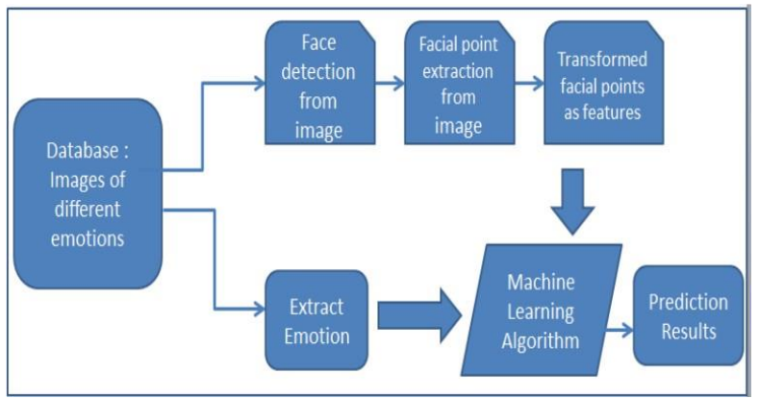
Phases in Facial Expression Recognition
The supervised learning method is used to train the facial expression recognition system, which collects photos of various face expressions. The system starts with a training and testing phase before acquiring images, detecting faces, processing those images, extracting features, and classifying them. Face recognition and feature extraction are performed on face photos, followed by classification into six groups that correspond to the six primary expressions listed below:
Image Acquisition
Static photos or image sequences are utilised to detect face expressions. A camera can record pictures of faces Face detection
Face detection
Face Detection is useful in detection of facial image, Face Detection is carried out in trainingVoila-Jones face detector dataset, developed with Opencv, uses the Haar classifier. The difference in the sum of the pixel values in the black and white regions is the value of the Haarlike feature, which is composed of connected rectangles of black and white and encodes the difference in average intensity in different portions of the image. Voila-Jones face detector dataset utilising the Haar classifier was implemented using Opencv. The value of the Haar-like feature is the difference between the sum of the pixel values in the blackand-white regions, which are connected rectangles that encode the difference in average intensity in various locations of the image.

Image Pre-processing
Noise is eliminated during image pre-processing, and brightness or pixel location variations are normalised.
a) Color Normalization
b) Histogram Normalization

Feature Extraction
The choice of the feature vector in a pattern classification issue is crucial. After pre-processing, the facial image is used to extract the key features. Scale, position translation, and changes in illumination level are some of the fundamental issues with image classification.
INPUT / OUTPUT DESIGN
The LBP algorithm is used to extract the significant characteristics and is outlined below:
Local Binary Pattern
The feature extraction method is called LBP. The original LBP operator encodes the local structure surrounding each pixel by pointing the pixels in an image with decimal numbers, often known as LBPs or LBP codes. By removing the value of the centre pixel, each pixel is compared to its eight neighbours in a 3 X 3 neighbourhood. In the final code, negative values are represented by 0 and all other values by 1. A binary number is created for each given pixel by adding all of these binary values clockwise, beginning with the top-left neighbour. The specified pixel is then given a label based on the generated binary number's equivalent decimal value. The LBPs or LBPs are the terms used to refer to the derived binary numbers.

METHODOLOGY
FACE DETECTION:
The main objective of face detection technique is to identify the face in the frame by reducingthe external noises and other factors. The steps involved in the FACE DETECTION PROCESS are
1. Image pyramid
2. Histogram of Oriented Gradients
3. Linear Classifier
Using an image pyramid with several scales, the resulting data are divided into the sample image. Simply extracting features using this method while minimising noise and other factors is its sole purpose.
The low pass image pyramid technique, also known as the Gaussian pyramid, involves smoothing the frame and sub sampling it by reducing its resolution. The process must be repeated several times to achieve the desired outcome, which is a frame that is similar to the original frame but has a lower resolution and a higher level of smoothing.
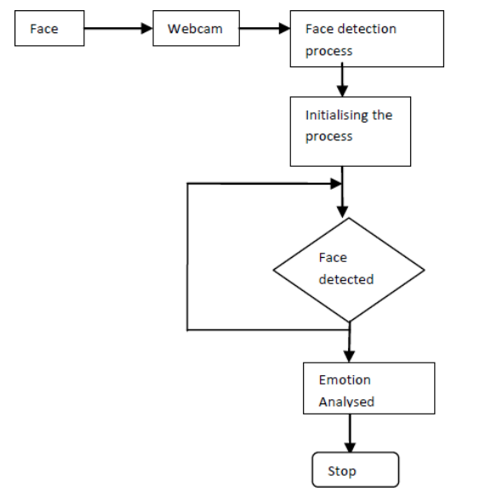
In the realm of image processing, a feature descriptor called HOG is a method that counts the occurrences of gradient orientation in a certain area of an image and is frequently used to identify objects in images. The basic goal of this technique is to use a set of distributions of intensity gradients to describe the face in the image
EMOTION CLASSIFICATION:
A bounding box will be added as an overlay to the image once the face has been properly detected in order to extract the ROI (face) for additional analysis. The 68 facial landmark points will then be recovered from the extracted ROI using the "Predictor" function, commonly known as a script, and saved in an array. The data from the features array will then be fed into a PCA reduction procedure, which will shrink the data and remove any associated coordinates, leaving only the necessary points as principle components. Each of the 68 points in the data's 68x2 array has coordinates on the x- and y-axes. The array will be transformed into a vector with 136 rows and 1 column. A set of photos and landmark maps for each image are used to train the facial landmark extraction code "Predictor."
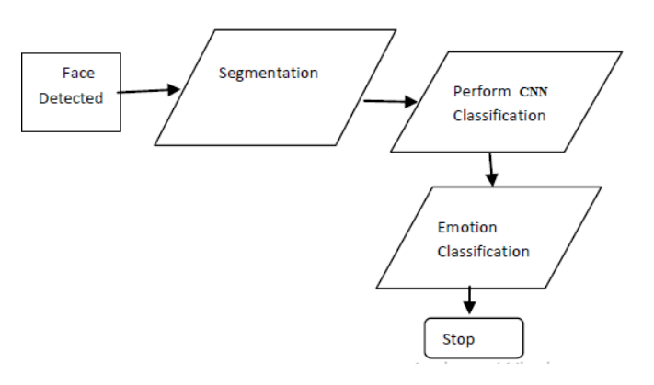
Using regression trees trained with the gradient boosting approach, the code learns how to extract the facial landmark map from a given face image based on the pixel’s intensity values indexed of each point. The data obtained after the CNN reduction process will be used for classification. In order to determine which class (feeling) the entered data belongs to, a multiclass CNN with a linear kernel is used to compare it with the stored data. A speed-reducing command will be executed to limit the wheelchair’s speed if any of the three emotions—anger, fear, or surprise—are detected in order to protect the user from harm.
MUSIC, MOVIE AND BOOK RECOMMENDATION:
Since the input is obtained in real-time, the camera is used to record the video before framing is completed. The framed photos are processed using a hidden markov model classification. The collected frames are taken into account in all frame and pixel formats for emotion classification. Every facial landmark's value is computed and saved for further use. The classifier's efficiency is between 90 and 95 percent, so even if the face changes as a result of environmental factors, the system can still recognise the face and the emotion being displayed. The values received from being set and from the value of the pixel are then used to identify the emotionsthat is received and the values present as threshold in the code are contrasted. Values are sent from the client to the web service. The song is played in response to the sensed emotion and the name sof the movie and book will be displayed. Movies , books and Each song has a set of designated emotions. The appropriate music will play when the desired feeling is conveyed. Happy, angry, sad, and surprised are the four emotions that can be employed. The personalised music recommendation engine should appropriately reflect individual tastes. It requires changes to get input that is specific to the requirements of different viewers. A better recommender might be possible if a better deep learning model is found for the recommendation. Compared to the earlier period, with download-able commercial music streaming websitesDigital music is currently widely available through mobile devices. The process of understanding all this digital music is incredibly time-consuming and results in data depletion. The development of a system for automatically scanning music libraries and recommending acceptable tracks to users might prove useful. Using the features of the music they have already heard, the music supplier will predict their clients' needs and then present them with the right tunes. The goal of our research is to develop a framework for music recommendations that can provide suggestions based on how comparable audio signal elements are. Convolutional neural networks (CNN) and recurrent neural networks are employed in this study (RNN). A personalised music recommendation system should accurately reflect individual tastes. ToFinding a better deep learning model for the suggestion will help create a better recommender because it is necessary to make modifications in order to get personalised recommendations for the needs of various listeners.

IMPLEMENTATION
The recommender system works by determining the cosine similarity of features extracted from one piece of music to another. Since the features used for extraction are vectors, their distance can be calculated. To start, we selected one song from each genre to serve as the foundation for the recommender system. Next, a neural network-based prediction of the fundamental musical genre is calculated. Recommendations are based on feature vectors that are generated before the classification layer. Cosine similarity calculations are carried out on additional music features after the base music features have been obtained.

Content-Based Recommendation Algorithm System.
INPUT / OUTPUT DESIGN
The important features are extracted using LBP algorithm which is described below:
Local BinaryPattern
LBP is the feature extraction technique. The original LBP operator points the pixels of an image with decimal numbers, which are called LBPs or LBP codes that encode the local structure around each pixel. Each pixel is compared with its eight neighbors in a 3 X 3 neighborhood by subtracting the center pixel value. In the result, negative values are encoded with 0 and the others with 1. For each given pixel, a binary number is obtained by merging all these binary values in a clockwise direction, which starts from the one of its top-left neighbor. The corresponding decimal value of the generated binary number is then used for labeling the given pixel. The derived binary numbers are referred to be the LBPs or LBP codes[.

CONVOLUTIONAL NEURAL NETWORKS
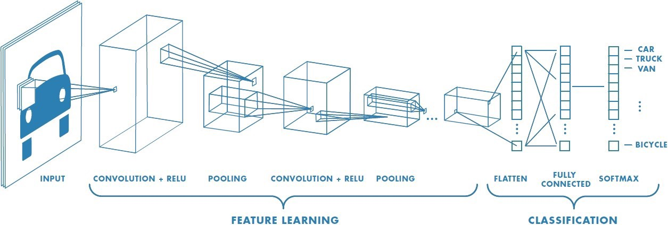

Figure 2 : Neural network with many convolutional layers
Convolution Layer
Convolution is the first layer to extract features from an input image. Convolution preserves the relationship between pixels by learning image features using small squares of input data. It is a mathematical operation that takes two inputs such as image matrix and a filter or kernel.

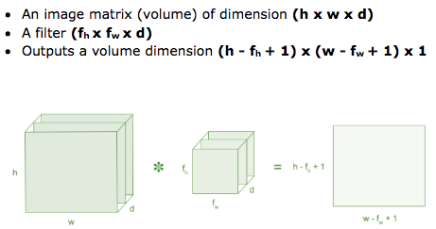
Figure 3: Image matrix multiplies kernel or filter matrix
Consider a 5 x 5 whose image pixel values are 0, 1 and filter matrix 3 x 3 as shown in below

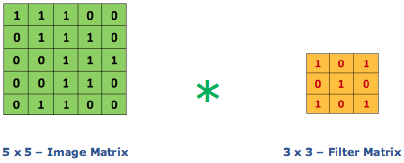
Figure 4: Image matrix multiplies kernel or filter matrix
Then the convolution of 5 x 5 image matrix multiplies with 3 x 3 filter matrix which is called “Feature Map” as output shown in below


Figure 5: 3 x 3 Output matrix
Convolution of an image with different filters can perform operations such as edge detection, blur and sharpen by applying filters. The below example shows various convolution image after applying different types of filters (Kernels).
Strides
Stride is the number of pixels shifts over the input matrix. When the stride is 1 then we move the filters to 1 pixel at a time. When the stride is 2 then we move the filters to 2 pixels at a time and so on. The below figure shows convolution would work with a stride of 2.

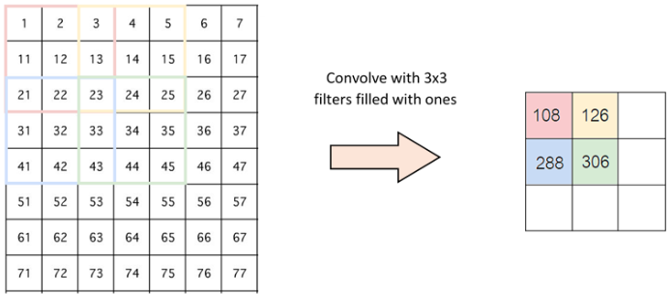
Figure 6 : Stride of 2 pixels
Padding
Sometimes filter does not fit perfectly fit the input image. We have two options:
- Pad the picture with zeros (zero-padding) so that it fits
- Drop the part of the image where the filter did not fit. This is called valid padding which keeps only valid part of the image.
Non Linearity (ReLU)
ReLU stands for Rectified Linear Unit for a non-linear operation. The output is ƒ(x) = max(0,x).
Why ReLU is important : ReLU’s purpose is to introduce non-linearity in our ConvNet. Since, the real world data would want our ConvNet to learn would be non-negative linear values.

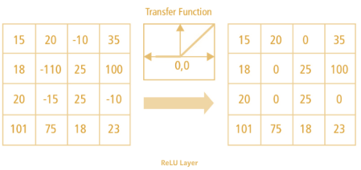
Figure 7 : ReLU operation
There are other non linear functions such as tanh or sigmoid that can also be used instead of ReLU. Most of the data scientists use ReLU since performance wise ReLU is better than the other two.
Pooling Layer
Pooling layers section would reduce the number of parameters when the images are too large. Spatial pooling also called subsampling or downsampling which reduces the dimensionality of each map but retains important information. Spatial pooling can be of different types:
- Max Pooling
- Average Pooling
- Sum Pooling
Max pooling takes the largest element from the rectified feature map. Taking the largest element could also take the average pooling. Sum of all elements in the feature map call as sum pooling.

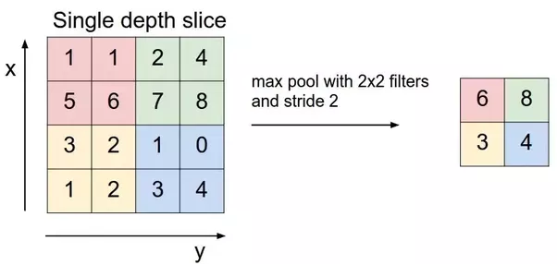
Figure 8 : Max Pooling
Fully Connected Layer
The layer we call as FC layer, we flattened our matrix into vector and feed it into a fully connected layer like a neural network.

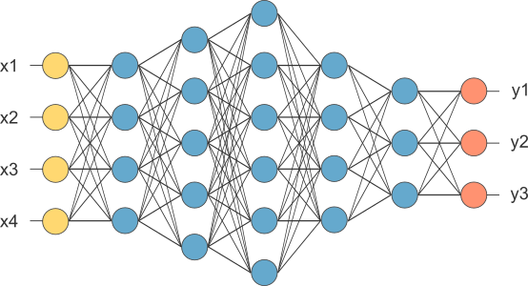
Figure 9 : After pooling layer, flattened as FC layer
In the above diagram, the feature map matrix will be converted as vector (x1, x2, x3, …). With the fully connected layers, we combined these features together to create a model. Finally, we have an activation function such as softmax or sigmoid to classify the outputs as cat, dog, car, truck etc.,

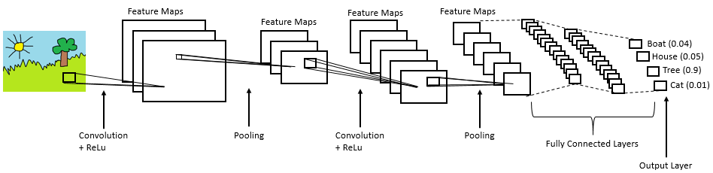
Figure 10 : Complete CNN architecture

CONCLUSION
In this project, we presented a music recommendation system based on emotion detected. The system uses a two-layer convolution network model for facial emotion recognition. The model classifies 7 different facial emotions from the image dataset. The model has comparable training accuracy and validation accuracy which convey that the model is having the best fit and is generalized to the data. We also recognize the room for improvement. It would be interesting to analyze how the system performs when additional emotions are taken into consideration. User preferences can be collected to improve the overall system using collaborative filtering. We plan to address these issues in future work.

REFERENCE
[1] Raut, Nitisha, "Facial Emotion Recognition Using Machine Learning" (2018). Master's Projects. 632. https://doi.org/10.31979/etd.w5fs-s8wd
[2] Hemanth P,Adarsh ,Aswani C.B, Ajith P, Veena A Kumar, “EMO PLAYER: Emotion Based Music Player”, International Research Journal of Engineering and Technology (IRJET), vol. 5, no. 4, April 2018, pp. 4822-87.
[3] Music Recommendation System: “Sound Tree”, Dcengo Unchained: Sıla KAYA, BSc.; Duygu KABAKCI, BSc.; Işınsu KATIRCIOĞLU, BSc. and Koray KOCAKAYA BSc. Assistant : Dilek Önal Supervisors: Prof. Dr. İsmail Hakkı Toroslu, Prof. Dr. Veysi İşler Sponsor Company: ARGEDOR
[4] Tim Spittle, lucyd, GitHub, , April 16, 2020. Accessed on: [Online], Available at: https://github.com/timspit/lucyd
[5] A. Abdul, J. Chen, H.-Y. Liao, and S.-H. Chang, “An Emotion-Aware Personalized Music Recommendation System Using a Convolutional Neural Networks Approach,” Applied Sciences, vol. 8, no. 7, p. 1103, Jul. 2018.
[6] Manas Sambare, FER2013 Dataset, Kaggle, July 19, 2020. Accessed on: September 9, 2020. [Online], Avalilable at: https://www.kaggle.com/msambare/fer2013
[7] MahmoudiMA, MMA Facial Expression Dataset, Kaggle, June 6, 2020. Accessed on: September 15, 2020. [Online], Available at: https://www.kaggle.com/mahmoudima/mma-facial-expression
[8] Dr. Shaik Asif Hussain and Ahlam Salim Abdallah Al Balushi, “A real time face emotion classification and recognition using deep learning model”, 2020 Journal. of Phys.: Conf. Ser. 1432 012087
[9] P. Lucey, J. F. Cohn, T. Kanade, J. Saragih, Z. Ambadar and I. Matthews, "The Extended Cohn-Kanade Dataset (CK+): A complete dataset for action unit and emotion-specified expression," 2010 IEEE Computer Society Conference on Computer Vision and Pattern Recognition - Workshops, San Francisco, CA, USA, 2010, pp. 94-101, doi: 10.1109/CVPRW.2010.5543262.
[10] Puri, Raghav & Gupta, Archit & Sikri, Manas & Tiwari, Mohit & Pathak, Nitish & Goel, Shivendra. (2020). Emotion Detection using Image Processing in Python.
[11] Patra, Braja & Das, Dipankar & Bandyopadhyay, Sivaji. (2013). Automatic Music Mood Classification of Hindi Songs.
[12] Lee, J., Yoon, K., Jang, D., Jang, S., Shin, S., & Kim, J. (2018). MUSIC RECOMMENDATION SYSTEM BASED ON GENRE DISTANCE AND USER PREFERENCE CLASSIFICATION.
[13] Kaufman Jaime C., University of North Florida, “A Hybrid Approach to Music Recommendation: Exploiting Collaborative Music Tags and Acoustic Features”, UNF Digital Commons, 2014.
[14] D Priya, Face Detection, Recognition and Emotion Detection in 8 lines of code!, towards data science, April 3, 2019. Accessed on: July 12, 2020 [Online], Available at: https://towardsdatascience.com/face-detection-recognition-and-emotion-detection-in-8-lines-of-code-b2ce32d4d5de

[15] bluepi, “\Classifying Different Types of Recommender Systems, November 14, 2015. Accessed on: July 7, 2020. [Online], Available on:https://www.bluepiit.com/blog/classifying-recommender-systems/#:~:text=There%20are%20majorly%20six%20types,system %20and%20Hybrid%20recommender%20system

