ABSTRACT

The music choice of a user is not only dependent on historical preferences or music contents but also dependent on the mood of that user. In this project, we present an effective music recommendation system, which recommends music based on the real-time mood of the user. It mainly focuses on Convolutional Neural Network (CNN) model which is based on Mobile Net architecture that classifies 7 different human facial emotions. Our system consists of three modules: Emotion Module, Music Classification Module and the Recommendation Module. The Emotion Module takes an image of the user's face as an input and makes use of CNN to identify their present mood. The Music Classification Module makes use of audio features to achieve a remarkable result of 98% while classifying songs into 4 different mood classes.

Chapter Name | Page No.

Abstract… I
Acknowledgement. II

Chapter 1 | Introduction………………………………… | 1-4
1.1 | Introduction…………………………….......... | 1-3
1.2 | Proposed System ……………………………. | 3-4
1.3 | Objectives of the work ……………………… | 4
1.4 | Existing System...…………………………… | 4
Chapter 2 | Literature Survey………………………….. | 5-14
Chapter 3 | Methodology.………………………………. | 15-18
3.1 | Block Diagram……………………………… | 15-16
3.2 | Face Detection………………........................ | 16-17
3.3 | Emotion Classification……………………... | 17-18
3.4 | Music Recommendation…………………… | 18
Chapter 4 | Hardware & Software Requirement…….. | 19-22
4.1 | System Analysis…………………………… | 19
4.2 | Software Requirement Specification……….. | 19-20
4.3 | Hardware & Software Requirement………… | 20-22
Chapter 5 | System Design……………………………... | 23-30
5.1 | Input/Output Design………………………... | 23
5.2 | Phases in Facial Expression Recognition…... | 23-24
5.3 | Local Binary Pattern………………………... | 24
5.4 | Convolutional Neural Network…………….. | 24
5.5 | Convolution Layer…………………………. | 25-30

LIST OF FIGURES

Figure No. | Title | Page No.
3.1 | Block diagram of Emotion Detection | 15
3.2 | Face detection process | 16
3.3 | Flow chart of face classification | 17
3.4 | OpenCV | 21
3.5 | E-speak | 22
5.1.1 | Face Detection using CNN classification | 23
5.3.1 | Convolutional neural network | 25
5.4.1 | Convolution layer | 25
5.4.2 | Image matrix | 26
5.4.3 | Output matrix | 26
5.5.4 | Stride of 2 pixels | 27
5.4.5 | ReLU operation | 28
5.4.6 | Max pooling | 29
5.4.7 | FC layer | 29
5.4.8 | Complete CNN architecture | 30

CHAPTER 1

INTRODUCTION

Introduction
Music plays an important role in enhancing an individual’s life as it is an important medium of entertainment for music lovers and listeners and sometimes even imparts a therapeutic approach. In today’s world, with ever-increasing advancements in the field of multimedia and technology, various music players have been developed with features like fast-forward, reverse, variable playback speed, local playback, streaming playback with the multicast streams and including volume modulation, genre classification etc. Deep learning-based facial expression recognition is one of these methods to detect emotion state (e.g., anger, fear, neutral, happiness, disgust, sadness and surprise) of human. This method aims to detect facial expressions automatically to identify the emotional state with high accuracy. In this method, labelled facial images from facial expression dataset are sent to CNN and CNN is trained by these images. Then, the proposed CNN model makes a determination which facial expression is performed.

Artificial intelligence (AI) has emerged as a prominent and essential field that has gained significant attention from researchers and programs. It has rapidly become an integral part of our daily lives through various applications such as chatbots, digital assistants like Siri, and other technological systems. Among the powerful applications of AI, face recognition techniques stand out, as evidenced by Google Photos' ability to group photos of individuals.

Facial emotion recognition is an area where many existing systems can identify emotions, and music recommendation systems are also prevalent. This paper proposes the integration of these two concepts, creating a system that recommends music based on facial emotion recognition. Emotion recognition has a broader scope in fields like robotics, enabling efficient sentiment analysis without the need for human involvement.

The automatic analysis and understanding of music by computers present new possibilities in the field of music information retrieval. Researchers from various disciplines such as computer science, digital signal processing, mathematics, and statistics applied to musicology are actively exploring research topics like automatic audio genre/mood classification, music similarity computation, audio artist identification, audio-to-score alignment etc.

One feasible application in this field is content-based music recommendation, which can benefit from contextual information. To achieve effective content-based music recommendation, multidisciplinary efforts are required, including emotion description, emotion detection/recognition, feature-based classification, and inference-based recommendation. Emotions in music can be represented as continuous quantities mapped into real numbers. Several models, such as the circumflex model and Thayer's model, have been proposed to describe emotions in music based on dimensions like arousal and valence.
Advancements in digital signal processing and feature extraction methods have facilitated the rapid development of automatic emotion detection and recognition in music. This capability holds significant potential for various applications, including music entertainment and human- computer interaction systems. Researchers have explored different dimensions, such as tempo and articulation, to detect emotions in music, categorizing them into moods like happiness, anger, sadness, and fear.
In conclusion, AI has made significant strides in various domains, including face recognition and music analysis. The integration of facial emotion recognition with music recommendation systems shows promise in enhancing user experiences and enabling more sophisticated applications.
In this concept music is recommended to the user by detecting the real time capturing of user’s emotions. Existing technique were using collaboration technique which will use previous user data to recommend music and This technique requires lot of manual work so, we proposed a system to arrange different music in different categories such as happy, sad or angry etc. Emotion-Based-music-player It's music player with chrome as front-End which has the capability to detect emotions I.e, the face of user with the help of machine learning algorithm using python. Based on the detected user’s mood song list will be displayed/recommend to the user. In this application image of a person is captured using a real time machine that has the access to the local machinery. and depending on the captured image it compares the database data sets that already saved in the local device through processing it defines the present mood of the user in numerical form based on this music will be played other than that we have some common features that are queue playlist so that we can have a individual playlist and the last one is random it uses python Eel library so that it can pick a random song with out any order. for this we have used libraries like OpenCV, EEL, numpy etc.this system is mainly proposed because music play a vital role in recent times that is to reduce stress.so,in order to detect the emotion we are using face as a main source of data because normally face expression defines the Emotion so according to the mood we play the music that it can change the user’s mood.

Proposed System

Our system consists of three modules: Emotion Module, Music Classification Module and Recommendation Module. The Emotion Module takes an image of the user's face as an input and makes use of CNN to identify their present mood. The Music Classification Module makes use of audio features to achieve a remarkable result of 98% while classifying songs into 4 different mood classes. The Recommendation Module suggests songs to the user by mapping their emotions to the mood type of the song, taking into consideration the preferences of the user. Here the model is trained, tested and validated using the manually collected image dataset with an accuracy of 98%.
Humans have a tendency to show their emotions unknowingly mainly they reflect the face. The proposed system helps us to provide an interaction between the user and the music system. This project mainly focuses on the user’s preferred music that is recommended due to the emotional awareness. In the initial stage of the proposed system, we have given 3 options and each contains its functionality. To this, we have given a list of songs and emotions based on spatial recognition. Once the application starts working it captures images with the webcam or any other
physiological devices. our main aim in this system is making a sophisticated music player that could make the user mood better and music is one of the best aid to change the mood. In this images captured by the system are compared with the data sets, and mainly 4 emotions are taken because human have many emotions and it is hard to predict because they differ from person to person and it will be hard to predict so, four common and easily identifiable moods of the person. And here there is another alternative methods can be used with the main concept i.e, random picking of songs that could help us to brighten our moods and the other mode is queue mode with this we can make a playlist on our own and in all the modes we are not using the previous user data but we using individual user data.

Objectives of the work
In this project, we proposed a music recommendation system based on CNN (Mobile Net architecture) for facial expression detection to recommend corresponding songs based on the user’s mood.
The whole system is fragmented into three modules: Emotion Module, Music Classification Module and Recommendation Module. Module deals with the usage of the convolutional neural network which uses a Mobile Net architecture and Haar Cascade Frontal face classifier which is used to detect the presence of face and extract the features needed to form a pattern that matches the facial expression.

The CNN is trained manually for the classification of 7 emotion states (happy, sad, surprise, angry, disgust, fear, neutral) with an accuracy of 98%. a) Mobile Net Architecture The core layer of Mobile Net is depth wise separable filters, named as Depth wise Separable Convolution.
The network structure is another factor to boost the performance. Finally, the width andresolution can be tuned to the trade-off between latency and accuracy. Depth wise separable convolutions which are a form of factorized convolutions which factorize a standard convolutioninto a depth wise convolution and a convolution called a point wise convolution. In Mobile Net,the depth wise convolution applies a single filter to each input channel. The point wise convolution then applies a convolution to combine the outputs the depth wise convolution.

Existing System:

We preferred the use of Deep Convolution Neural Network (DCNN) to extract the facial emotions recognition by using the Tensor Flow Machine Learning library in previous existing system, there is no software system to detect facial extraction and recommendation. It was time consuming process. There was no guarantee that the detection result is correct all the time.

CHAPTER 2

LITERATURE SURVEY

Authors: Charvi Jain, Mohammed Rehman, Rajesh Kumar Title: Emotion Detection and Characterization using Facial Features Published in: IEEE November 2018
The first step in the process is to detect the face in the input image, followed by the identification of facial features such as eyes and mouth. These features are then subjected to specific filters and transformations. The resulting outputs are fed into classifiers that utilize trained data to classify the emotions. The Fischerface classifier employs Principal Component Analysis (PCA) and Linear Discriminant Analysis (LDA) techniques, which contribute to its accuracy. PCA is used to reduce dimensionality, minimizing the number of variables in the dataset. Gabor filters, on the other hand, excel at recognizing texture in an image, including differentiating the mouth and eyes from the surrounding skin. This texture-based approach is advantageous for effective feature extraction [1].

Authors: Akiti Jaiswal, A. Krishnama Raju, Suman Deb Title: Facial Emotion Detection Using Deep Learning Published in: IEEE June 2020
The image classification system typically involves two stages: feature extraction and classification. In this paper [2], we utilize the deep learning library "Keras" provided by Google to develop a robust convolutional neural network (CNN) for facial emotion detection. We employ two different datasets and train our proposed network, evaluating its validation accuracy and loss accuracy. The datasets consist of images with facial expressions representing seven emotions, and we detect these expressions using a CNN-based emotion model created through deep learning. Deep neural networks, including CNNs, require large amounts of training data. In our proposed method, we achieve reduced computation time, increased validation accuracy, and decreased loss. Furthermore, we conduct performance evaluations by comparing our model with existing models. We test the neural network architectures on the FERC-2013 and JAFFE databases, which include seven primary emotions: sadness, fear, happiness, anger, neutral, surprise, and disgust [2].

Authors: Sabrina Begaj, Ali Osman Topal, Maaruf Ali
Title: Emotion Recognition Based on Facial Expressions Using Convolutional Neural Network (CNN)

Published in: 2015 IEEE
This study focuses on addressing the challenges associated with Emotion Recognition Datasets and explores different parameters and architectures of Convolutional Neural Networks (CNNs) for the detection of seven emotions in human faces: anger, fear, disgust, contempt, happiness, sadness, and surprise. The iCV MEFED (Multi-Emotion Facial Expression Dataset) is selected as the primary dataset for this research due to its novelty, interest, and high level of difficulty.
The initial CNN network architecture consists of four Convolutional Layers, four Max Pooling Layers, one Dropout Layer, and two Fully Connected Layers. The model comprises a total of 899,718 parameters. The image is passed through the model, starting with the Conv2D filter and subsequently applying the ReLu (rectified linear activation function). The pooling layer (MaxPooling2D) extracts the maximum values from the convolution layer, reducing the image dimensions. Finally, the Flatten and Dropout layers are applied [3].

Authors: Mahesh Babu K, M V Raghunadh
Title: Automatic Human Emotion Recognition System using Facial Expressions with Convolution Neural Network

Published in:Fourth InternationalConference on Electronics, Communication and Aerospace Technology (ICECA-2020)
This paper presents an automatic facial emotion classification system that utilizes Convolutional Neural Network (CNN) and Speeded Up Robust Features (SURF) for feature extraction. The proposed model achieves an accuracy of 91%, enabling effective tracking of human emotions through facial expressions. High boost filtering is employed as a specialized technique to reduce image noise while preserving low-frequency components.
The SURF feature extraction process consists of several steps. Firstly, the computation of the integral image is performed. Then, the Hessian Matrix Determinant is computed as the second step. The determinant response is normalized in the third step, followed by the application of Non-Maximal Suppression and thresholding in the fourth step. The computation of interest points is conducted as the fifth step, and finally, the Interest Point Descriptor is computed [4].

Authors: Hari Krishan Kondaveeti, Migili Vishal Goud Title: Emotion Detection using Deep Facial Features
Published in: 2020 IEEE International Conference on Advent Trends in Multidisciplinary Research and Innovation (ICATMRI)
The study of Face Emotion Recognition involves three main phases: pre-processing, feature extraction, and classification techniques. This paper aims to compare different deep learning architectures available in Keras for emotion detection. It utilizes Deep Facial Features in images by employing Transfer Learning from popular pre-trained models such as VGG16, ResNet152V2, InceptionV3, and Xception. Bottleneck features are generated for the input images, and the performance of these models is evaluated using a dataset that combines the Cohn- Kanade Dataset (CK+) and the Japanese female facial emotion (JAFFE) dataset.
Pre-processing plays a crucial role in maximizing the efficiency of the Face Emotion Recognition (FER) method. Various procedures are applied during image pre-processing, including image transparency, scaling, contrast correction, and additional enhancement processes. These techniques are employed to improve the quality of the emotion frames [5].

Authors: P. Meghana, S. SagarImambi, P. Sivateja, K. Sairam Title: The Application of Artificial Intelligence in Emotion Recognition
Published in: 2020 International Conference on Intelligent Computing and Human-Computer Interaction (ICHCI)
Facial recognition is an automated identification technology that utilizes facial features, including statistical or geometric features. It combines digital image processing, video processing, pattern recognition, and other related technologies [4]. Research has revealed that the human brain's ability to recognize faces involves the coordinated activity of thousands of neurons. Machine learning and deep learning algorithms have harnessed this understanding to develop intricate networks that mimic neural functions. Artificial Neural Networks (ANNs) are widely employed in the field, enabling the realization of automatic face recognition systems. By collecting and analyzing relevant literature, this paper aims to provide a brief overview of emotion recognition, explore its applications in various fields, and offer insights into the future direction of emotion recognition technology. It seeks to serve as a reference for researchers in this domain [6].

Authors: MuayadAliHamood Bakhtan, Dr. Munaisyah Abdullah
Title: Facial Emotion Recognition Using Deep Convolutional Neural Network Published in: 2020 6th International Conference on Advanced Computing & Communication Systems (ICACCS)
Facial emotion recognition has been revolutionized by deep learning techniques, and this study aimed to develop a Deep Convolutional Neural Network (DCNN) model that could accurately classify five different facial emotions. The model uses two convolution layers and dropout layers to prevent overfitting, and the input image is resized to 32 x 32 and processed through these layers, followed by ReLU activation and pooling. The second convolution layer produces a 2- dimensional array with feature values, which is flattened and fed to the neural network's dense layers. The output layer has five units, each representing a different facial emotion, and uses the softmax activation function to produce a probabilistic output. The model achieved an accuracy rate of 78.04% in classifying the five facial emotions and was evaluated using test samples. Although it struggled with Class 1 (happy), it demonstrated excellent prediction results for Classes 0 (angry) and 3 (neutral). The model has several advantages, including accurate classification of five different facial emotions, well-fit and generalized training and validation accuracy, use of the Adam optimizer to improve performance, and potential for real-time applications like feedback analysis. The system can also be integrated with other electronic devices for effective control. However, applications requiring higher accuracy rates may find the current accuracy of 78.04% insufficient [7].

Authors: Monika Singh, Bharat Bhushan Naib, Amit Kumar Goel Title: Facial Emotion Detection using Action Units
Published in: Proceedings of the Fifth International Conference on Communication and Electronics Systems (ICCES 2020)
This article presents an automatic facial expression detection system that focuses on seven parameters: anger, disgust, fear, surprise, sadness, contempt, and happiness. The system utilizes recorded images and employs an experimental algorithm tested on both the Advanced Visual Database and a natural building database. The method involves dividing the image into an image matrix, adjusting grayscale and scale, and rotating the lower area of the image. Facial features are described using an AAM model and Gabor wave conversion for efficient representation. The process includes facial recognition, feature extraction, and grading of highlighted facial features to determine the correct facial expression.

The system follows a workflow starting with image capture, preprocessing tasks such as scaling and adjusting brightness/contrast, and utilizes a database for training and classification. The article explores the use of facial recognition and graphic design for facial expression detection. The system incorporates three principles for accurate and efficient detection, including high- speed analysis, outperforming other feature techniques. Real-time changes in facial expressions are achieved through three designed expression types. Bayesian Network Classifier (BN) is employed for education and modeling, enabling real-time operation within the HRI system. Visualization techniques are utilized to identify facial features, focusing on core areas such as the mouth and eyebrows. The article concludes that the extracted features have a positive impact on facial recognition and expression. The sequence of events involves point operations on the image, face detection, cropping the facial region, applying Discrete Hartley Transform, lip detection, segmenting the lip region, generating an emotion template database, and comparing the cropped lip area with templates to identify the emotion [8].

Authors: Umar Rashid, Muhammad Waseem Iqbal, Syed Khuram Shahzad. Title: Emotion Detection of Contextual Text using Deep learning
Published in: IEEE 2015

The rise of social media has led to an overwhelming amount of textual data, necessitating an approach to extract meaningful information from it. Aimens system proposes a solution to detect emotions such as happy, sad, and angry from contextual conversations. The system employs the Long short term memory (LSTM) model with word2vec and doc2vec embeddings, achieving an F-score of 0.7185. The model is fine-tuned with hyper-parameters and utilizes the state-of-the- art Bi long short-term memory (LSTM) technique. Improved preprocessing steps are also implemented, including removing extra spaces, resolving character encoding, and correcting spelling. An annotated corpus is used to add interpretative labels, and word embedding techniques are applied before mapping the dataset through the vocabulary. The LSTM filters the dataset and detects happy, sad, and angry emotions from it. Advantages of the proposed method for emotion detection and classification include the use of a pre-trained word embedding with a large amount of emotion-based conversations, as well as the application of hyper parameter tuning to optimize model performance. The use of Bi-Long Short-term Memory also improves the accuracy of emotion prediction. The paper also contributes to the development of preprocessing techniques for data normalization, including character repetition removal and spelling correction. A disadvantage of the approach is the reduced accuracy observed when using

large amount of emotion-based conversations, as well as the application of hyper parameter tuning to optimize model performance. The use of Bi-Long Short-term Memory also improves the accuracy of emotion prediction. The paper also contributes to the development of preprocessing techniques for data normalization, including character repetition removal and spelling correction. A disadvantage of the approach is the reduced accuracy observed when using stop word removal, indicating that the technique may not be effective for contextual tasks. Additionally, the proposed method is limited to 3-turn conversations and may not be applicable to longer or more complex conversations. The paper acknowledges that future work may be needed to incorporate emotion lexicons and emoticon handling for improved performance [9].

Authors: Susu Yan1,2, Liang Ye 1,3,4, Shuai Han1,Tian Han2,3, YueLi5 and Esko Alasaarela
Title: Speech Interactive Emotion Recognition System Based on Random Forest

Published in: 2018 IEEE
The aim of this research paper is to develop a speech emotion recognition system using a Random Forest Classifier and Support Vector Machines. The study uses the Berlin Emotional Database, which contains seven emotions and corresponding labels for each speech. The paper explains the preprocessing steps, which include sample quantization, preemphasis, framing, windowing, and endpoint detection, to reduce noise and accentuate high frequency parts of the signal. The OpenSMILE software is used for feature extraction, and the emotional features are obtained by calculating statistics using 12 functions from 16 original acoustic features. The Random Forest Classifier achieves a recognition accuracy of 89%. The speech interactive emotion recognition system is established by collecting speech signals through a speech acquisition interface, performing end-point detection, extracting acoustic features, applying statistical functions, and inputting them into the classification model. The WeChat program is used to collect speech signals in MP3 format, which is converted to WAV format before feature extraction. The system can collect speech signals in less than 60 seconds, and the collected speech samples are sent to the background, which returns a JSON string including possible errors and the emotional category of the speech. The study shows the recognition results of the speech emotion recognition model by using the WeChat program, which is more suitable for the establishment of speech interaction emotion recognition systems due to its ease of use and design. The paper provides insight into the development of a speech emotion recognition system, with potential for further advancements in the field.
Advantages: The use of multiple classification algorithms, including logistic regression, support

vector machine, random forest, and Xgboost, allows for a comparison of performance and selection of the best algorithm for emotional recognition. Cross validation is used for model evaluation, which helps to reduce overfitting and improve generalization of the model. The random forest classifier is found to have a higher recognition accuracy than the support vector machine classifier, as determined by multiple evaluation metrics. The use of the WeChat program for the speech interactive emotion recognition platform allows for easy user accessibility and convenience.
Disadvantages: The sample size of 535 voice data may not be representative of the larger population and could limit the generalizability of the model. The use of 384 features for emotional recognition may be excessive and could result in overfitting or reduced performance. The speech interactive emotion recognition platform is limited to the capabilities of the WeChat program and may not be as versatile as other platforms [10].

Authors: Taiba Majid Wani, HasmahMansor, Teddy Surya Gunawan, Mira Kartiwi ,Syed Asif Ahmad Qadri Nanang Ismail
Title: Speech Emotion Recognition using Convolution Neural Networks and Deep Stride Convolutional Neural Networks

Published in: IEEE 2017
The field of Speech Emotion Recognition (SER) has seen an influx of techniques, with a focus on recognizing discriminant features in speech signals to classify emotions. Recently, deep learning techniques have shown promise in this field. In this study, a modified Deep Stride Convolutional Neural Network (DSCNN) architecture was proposed, with fewer convolutional layers to increase computational speed while maintaining accuracy. The proposed DSCNN and a state-of-the-art CNN model were trained and evaluated on spectrograms from the SAVEE speech emotion dataset for four emotions: angry, happy, neutral, and sad. The DSCNN achieved higher prediction accuracy (87.8%) compared to the CNN model (79.4%). Spectrograms, which provide rich information about the signal quality over time and various frequencies, were used as input to the model. The primary goal was to extract high-level discriminative features from speech signals using CNN architecture, with the spectrograms enhancing emotion recognition. The DSCNN utilized special strides for dimension reduction, avoiding the use of pooling layers, and improving computational efficiency. The proposed model shows promise in recognizing emotions from speech signals. This research involved two experiments to compare the performance of two different neural network models for Speech Emotion Recognition (SER) using the SAVEE database.

emotions: anger, happiness, sadness, and neutral. Spectrograms generated from the speech database were used as input to the models, and their performance improved as the number of training epochs increased from 500 to 1200 and 1500. However, DSCNN outperformed CNN by a significant margin, achieving an accuracy of 87.8% compared to 79.4% for CNN. The advantage of DSCNN lies in its ability to effectively identify emotions, while the disadvantage is that the architecture can still be improved. Further research is needed to optimize the DSCNN model for even more persuasive recognition of emotions [11].

Authors: Haiyan Chen, Zheng Liu,Xin Kang, Shun Nishide, Fuji Ren Title: Investigation voice features for Speech emotion recognition based on four kinds of machine learning methods
Published in: IEEE 2019

Speech emotion recognition covers the following areas: emotional feature extraction, dimensionality reduction of features quantities, and recognition of speech emotion through models. This paper makes a systematic comparison and analysis of four speech classification models: SVM, Random Forest, NN and KNN. The experimental results show that the effect of speech recognition based on SVM model is the most prominent one, with the total accuracy of 81.11%. The next is NN model, which reaches 80.56%.There are obvious shortcoming in KNN model and random forest model, whose accuracy are only 55.56% and 58.89% respectively. Speech emotional recognition is a kind of recognition of emotional speech signals, which can identify the emotional changes of each other through voice to understand the emotional state of each other. In this paper, we propose to compare the recognition effects of four emotional modes according to different speech features [12].

Authors: Kyong Hee Lee, Do Hyun Kim
Title: Design of a Convolutional Neural Network for Speech Emotion Recognition

Published in: IEEE 2021

Regarding speech emotion recognition (SER) using voice, recognition accuracy increases as more data are employed. In particular, in the case of deep learning, a large amount of data is essential. However, when using an existing data set, the size of the data set is limited, and the length of the data constituting the data set can be inconsistent. The data set used in this paper consists of audio files of utterances of various lengths. In this paper, one-dimensional data was

extracted from speech files, and two-dimensional Mel-spectrogram images were extracted and trained using deep learning techniques such as a multi-layer perceptron (MLP) and a convolutional neural network (CNN). In addition, to improve the test accuracy, audio files were reduced to less than two seconds and pre-processed. Using the CNN, we obtained a test accuracy of approximately 60%. Various services and products are now available due to improved speech recognition accuracy. The growing volume of voice data is expected to be used not only for simple voice recognition services but also for emotion recognition services using voice. A convolutional neural network (CNN) is a representative method of image deep learning. As a CNN sequentially processes images using small size filters, the learning speed is slower than multi-layer perceptron (MLP).Regarding the MLP, since only 20 MFCC features were extracted per file, it was confirmed that the effect of the audio file length, shorter than 0.4 seconds or longer than 6.9 seconds, was negligible. Using this MLP, we obtained a test accuracy of approximately 75% [13].

Authors: Huihui Cheng, Xiaoyu Tang
Title: Speech Emotion Recognition based on Interactive Convolutional Neural Network

Published in: 2020 IEEE
Speech emotion recognition (SER) plays an indispensable role in intelligent speech application. The MFCC that rich in frequency characteristic, is widely used as an input in the task of SER. However, the performance of previous work has been restricted by neglecting the interaction of different frequencies in MFCC, since the converged communication of frequency is also critical for us to generate discriminative emotion feature representations. Therefore, in this paper, we propose an interactive convolutional neural network (ICNN), where the input feature map will be factorized into different frequency scales for interactive convolution. presented an intelligent combination of the discriminating power of prosody and voice quality yields in an improved classification performance and raise the average recognition rate from 66.7% to 74.5%. In [2], speaker emotions were recognized using the Mel Frequency Cepstral Coefficient (MFCC) technique extracted from the speaker voice signal and the efficiency was found to be about 80%. This paper focuses on improving the performance of traditional CNN on SER by proposing an ICNN. In order to generate more discriminative emotion-related feature representations, an interactive convolution process is employed between different scales of feature map [14].

Authors: M. Aravind Rohan1, K.Sonali Swaroop2
Title: Emotion Recognition Through Speech Signal Using Python Published in: 2020 IEEE
Speech emotion recognition involves the identification of human emotions and emotional states through speech analysis. The emotions considered in this experiment include neutral, joy, and sadness. Emotions are influenced by physical characteristics such as muscular tension, skin elasticity, blood pressure, heart rate, breath, and speech. Python libraries are used for the analysis, with Keras being a high-level neural network API that runs on TensorFlow. Keras offers two main models: the sequential model and the functional model. The sequential model is suitable for building simple classification networks and encoder-decoder models, as it represents layers in a linear stack. The functional model, on the other hand, supports multi-input and multi-output architectures with shared layers, yielding accurate results in 95% of cases. Gaussian Naive Bayes classifier is a powerful algorithm based on Bayes' theorem, commonly used for predictive learning and classification tasks. It assumes that features follow a normal distribution [15].

CHAPTER 3

METHODOLOGY

The analysis in this section focuses on the dataset used for training and testing in a deep learning process, as well as the preprocessing steps applied to the dataset and the configuration of the Convolutional Neural Network (CNN) model. Understanding the properties and characteristics of the speech signal is crucial in this analysis, as the speech signal is a complex and dynamic signal that changes rapidly over time.
The proposed algorithm in this study aims to develop an emotion-based music recommendation system that generates personalized playlists based on the user's emotional state. The system consists of three main modules: the Emotion Extraction module, the Audio Feature Extraction module, and the Emotion-Audio Recognition module. The Emotion Extraction module and Audio Feature Extraction module are separate modules responsible for extracting emotion- related information and audio features, respectively. The Emotion-Audio Recognition module performs the mapping between these modules by querying the audio metadata file. Figure 1 provides a visual representation of the system's block diagram.

BLOCK DIAGRAM:
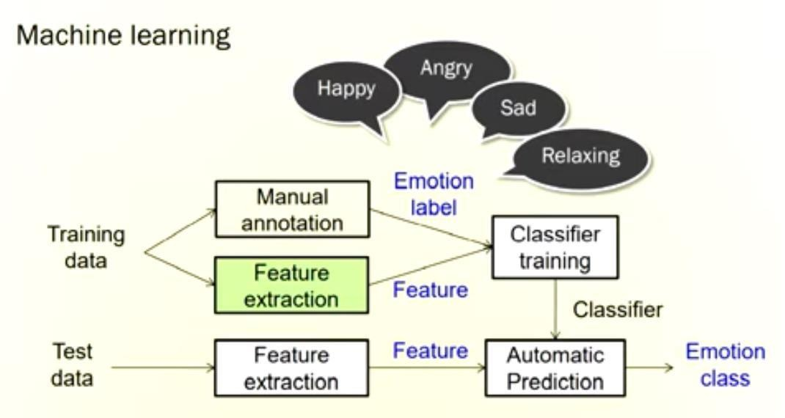
Fig: 3.1 Block Diagram of Emotion Detection

The system captures an image of the user either through a webcam or by accessing a stored image from the hard disk. To enhance the quality of the acquired image, tone mapping is applied to restore its original contrast. Once the image is enhanced, it is converted into a binary format. The face detection process is performed using the Viola and Jones algorithm, specifically utilizing the Frontal Cart property. This property is designed to detect upright and forward-facing facial features, using a threshold value typically set within the range of 16-20.

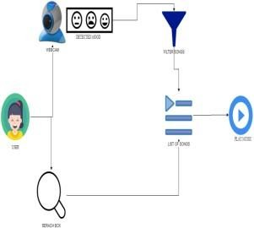
Fig: 3.2 Face Detection Process

FACE DETECTION:

The primary goal of the face detection technique is to identify and locate faces in an image while minimizing external disturbances and other factors. The face detection process involves the following steps:
- Image pyramid: The image is decomposed into multiple scales using an image pyramid. This technique helps extract features while reducing noise and other factors. The frame is smoothed and downsampled iteratively, resulting in a frame with decreased resolution and increased smoothing.
- Histogram of Oriented Gradients (HOG): HOG is a feature descriptor commonly used to detect objects in images. It quantifies the occurrences of gradient orientations within localized portions of an image. By utilizing HOG, the face within the image can be described using a set of intensity gradient distributions.
- Linear Classifier: Once the Histogram of Oriented Gradients features are extracted, a linear classifier is employed to classify whether a given region of the image contains a face or not.

By combining these steps, the face detection technique aims to accurately detect and localize faces in images while minimizing noise and other interferences.
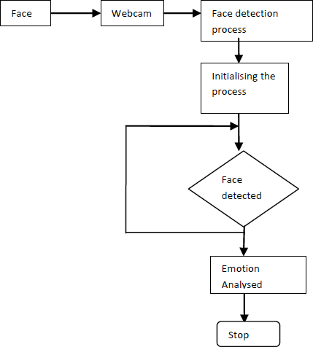
Start
Stop
Fig: 3.3 Flow Chart of Face Detection

3.3. EMOTION CLASSIFICATION:
Once the face is successfully detected, a bounding box is applied as an overlay on the image to extract the Region of Interest (ROI), which is the face itself. The ROI is then processed using a "Predictor" script to extract 68 facial landmark points, which are saved in an array.
The features array, containing the landmark points, is then inputted into a PCA (Principal Component Analysis) reduction code to reduce the data size and eliminate any correlated coordinates, resulting in only the necessary principal components. The 68x2 array representing the coordinates of each landmark point is converted into a vector with dimensions 136x1.
The "Predictor" code is trained with a set of images and landmark maps, teaching it how to extract the facial landmark map of a given face image based on the pixel intensity values indexed at each point. This is achieved using regression trees trained with a gradient boosting algorithm.
After the reduction operation using PCA, the obtained data is used for classification. A multiclass CNN (Convolutional Neural Network) with a linear kernel is employed to compare the inputted data with stored data to determine the emotion class to which it belongs. If the detected emotion

is anger, fear, or surprise, a command to decrease the speed of the wheelchair is executed to ensure the user's safety.

3.4 MUSIC RECOMMENDATION:
The input is acquired in real-time so the camera is used to capture the video and then the framing are done. The hidden Markov model classification are used for processing the framed images. The frames that are obtained are considered in all frames and all pixel formats for the purpose of emotion classification. The value of each landmark in the face is calculated and is stored for future use. The efficiency of classifier is about 90-95%. so that even when there is any changes in the face due to environmental conditions the system can still identify the face and the emotion being expressed. The emotions are then identified using the values that are obtained that are being set and from the value of the pixel that is received is being compared to that of the values that is present as threshold in the code. The values is transferred to the web service. The song are played from the emotion detected. The emotions are assigned for every song. When the emotion is transferred the respective song will be plays. There are four emotions that can be used and the emotions are happy, anger, sad, surprise. When the happy emotion is recognized the songs that are assigned for that particular emotion are played and the same happens with the other emotions as well that is it the songs are played for the emotions detected respectively.

CHAPTER 4

HARDWARE AND SOFTWARE REQUIREMENT

System Analysis:

In planning phase study of reliable and effective algorithms is done. On the other hand data were collected and were preprocessed for more fine and accurate results. Since huge amount of data were needed for better accuracy, we have collected the data surfing the internet. Since, we are new to this project we have decided to use local binary pattern algorithm for feature extraction and support vector machine for training the dataset. We have decided to implement these algorithms by using Open Cv framework.

Software Requirement Specification:

Requirement analysis is mainly categorized into two types:

Functional requirements:

The functional requirements for a system describe what the system should do. Those requirements depend on the type of software being developed, how the system should react to particular inputs and how the system should behave in particular situation.

Non-Functional requirements:

Nonfunctional requirements are requirements that are not directly concerned with the specified function delivered by the system. They may relate to emergent system properties such as reliability, response time and store occupancy. Some of the nonfunctional requirements related with this system are here by below:

a) Reliability:

Reliability based on this system defines the evaluation result of the system, correct identification of the facial expressions and maximum evaluation rate of the facial expression recognition of any input images.

Ease of Use:

The system is simple, user friendly, graphics user interface implemented so any can use this system without any difficulties.

Feasibility Study:

Before starting the project, feasibility study is carried out to measure the viable of the system. Feasibility study is necessary to determine if creating a new or improved system is friendly with the cost, benefits, operation, technology and time.

Technical Feasibility:

Technical feasibility is one of the first studies that must be conducted after the project has been identified. Technical feasibility study includes the hardware and software devices. The required technologies (C++ language and CLion IDE) existed.

Operational Feasibility:

Operational Feasibility is a measure of how well a proposed system solves the problem and takes advantage of the opportunities identified during scope definition. The following points were considered for the project’s technical feasibility:
  - The system will detect and capture the image of face
  - The captured image is then analyzed based on the category.

Economic Feasibility

The purpose of economic feasibility is to determine the positive economic benefits that include quantification and identification.

HARDWARE REQUIREMENTS:
System : intel i3/i5 2.4 GHz.
Hard Disk : 500 GB
Ram : 4/8 GB

SOFTWARE REQUIREMENTS:
Operating system: Windows XP / Above Software Tool: Open CV Python

Coding Language: Python

OpenCV:

OpenCV is a versatile library of programming functions designed for real-time computer vision tasks. It provides a modular structure with various shared or static libraries. The image processing module of OpenCV offers a range of capabilities such as linear and non-linear image filtering, geometric transformations, color space conversion, histograms, and more.
Our project utilizes specific libraries within OpenCV, including Viola-Jones or Haar classifier, LBPH (Lower Binary Pattern Histogram) face recognizer, and Histogram of Oriented Gradients (HOG). OpenCV is primarily written in C++, with interfaces available in C++, Python, Java, and MATLAB. It is compatible with different platforms such as Windows, Linux, macOS, as well as mobile platforms like Android, iOS, and Blackberry.
OpenCV finds application in various fields such as facial recognition, gesture recognition, object identification, mobile robotics, and image segmentation. Our project utilizes OpenCV version 2 and employs its functionalities for gesture-controlled camera access, image capture, image-to-text conversion, and voice conversion.

Purpose of Image processing:

The purpose of image processing can be categorized into five groups:
- Visualization: Enhancing the visibility of objects that are not easily observable.
- Image sharpening and restoration: Improving the quality and clarity of images.
- Image retrieval: Searching for specific images based on predefined criteria.
- Measurement of patterns: Extracting measurements and features from images.
- Image recognition: Identifying and classifying objects within images.


Fig: 3.4 Open CV

Espeak

It is a compact open-source software speech synthesizer for English and 11other languages for Linux and Windows platform. It is used to convert text to voice. It supports many languages in a small size. The programming for espeak software is done using rule files with feedback. It supports SSML. It can be modified by voice variant. These are text files which can change1characteristics such as1pitch range, add effects1such as echo, whisper and croaky voice, or make systematic adjustments to formant frequencies to change the sound of the voice. The default speaking speed of 180 words per minute is too fast to be intelligible. In our project Espeak is used to convert the text to voice signal.
Fig: 3.5 Espeak

CHAPTER 5

SYSTEM DESIGN

INPUT/ OUTPUT DESIGN:
System design shows the overall design of system. In this section we discuss in detail the design aspects of the system:
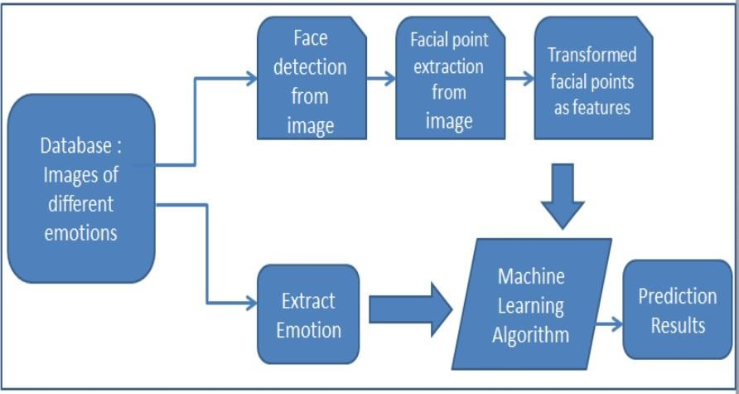
Fig: 5.1.1 Facial Emotion Recognition Using Machine Learning

    - Phases In Facial Expression Recognition

The facial expression recognition system is trained using a supervised learning approach, where it utilizes images of various facial expressions. The system consists of a training phase and a testing phase, which involves several stages including image acquisition, face detection, image preprocessing, feature extraction, and classification. The process can be summarized as follows:

Image Acquisition

Images containing facial expressions are collected either from a dataset or through real-time capture using a camera.

Face detection
  - Image Pre-processing:
Image pre-processing includes the removal of noise and normalization against the variation of pixel position or brightness.
- Color Normalization

- Histogram Normalization

Feature Extraction

Selection of the feature vector is the most important part in a pattern classification problem. The image of face after pre-processing is then used for extracting the important features. The inherent problems related to image classification include the scale, pose translation and variations in illumination level.

INPUT / OUTPUT DESIGN
The important features are extracted using LBP algorithm which is described below:

Local Binary Pattern:
LBP is a feature extraction technique that encodes the local structure of each pixel in an image. It compares each pixel with its eight neighbors in a 3x3 neighborhood by subtracting the center pixel value. Negative values are encoded as 0 and others as 1. The binary values are merged in a clockwise direction, starting from the top-left neighbor, to form a binary number. This binary number is then converted to decimal and used to label the given pixel. These derived binary numbers are known as LBP codes.

Convolution Neural Networks:

CNNs are vital in Deep Learning for Computer Vision tasks. They analyze and extract features from images using convolutional layers, pooling layers, and fully connected layers. This enables them to learn hierarchical representations of visual data, allowing them to classify images, detect objects, and segment images. CNNs revolutionized Computer Vision by capturing spatial dependencies and hierarchical patterns, leading to remarkable success in diverse applications.

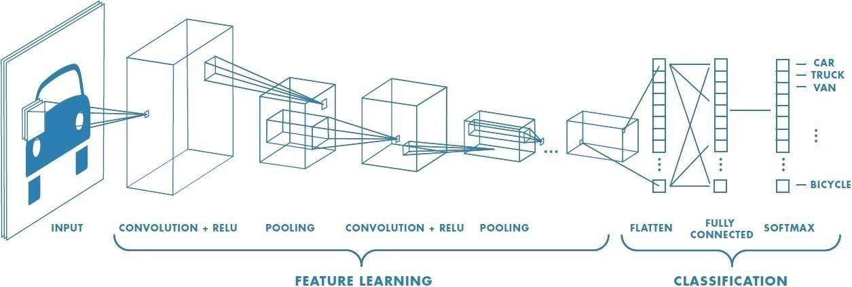

Fig: 5.3.1 Neural network with many convolutional layers

Convolution Layer:

Convolution is the first layer to extract features from an input image. Convolution preserves the relationship between pixels by learning image features using small squares of input data. It is a mathematical operation that takes two inputs such as image matrix and a filter or kernel.
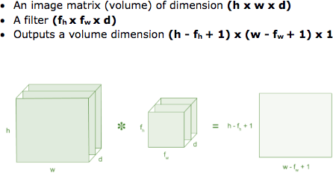
Fig: 5.4.1 Image matrix multiplies kernel or filter matrix

Consider a 5 x 5 whose image pixel values are 0, 1 and filter matrix 3 x 3 as shown in below

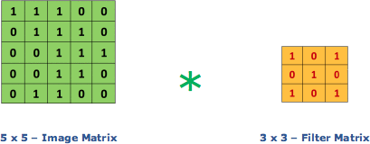
Fig 5.4.2: Image matrix multiplies kernel or filter matrix

Then the convolution of 5 x 5 image matrix multiplies with 3 x 3 filter matrix which is called
“Feature Map” as output shown in below
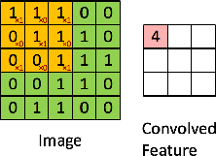

Fig 5.4.3: 3 x 3 Output matrix

Convolution of an image with different filters allows for operations like edge detection, blurring, and sharpening. By applying various types of filters (kernels), we can obtain different convolutional images that represent these operations.

Strides
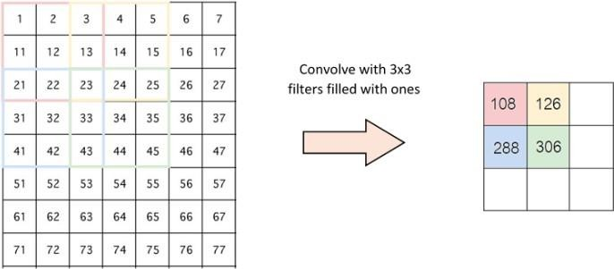In convolution, the stride refers to the number of pixel shifts applied to the input matrix. A stride of 1 means the filters move one pixel at a time, while a stride of 2 means the filters move two pixels at a time, and so on. When using a stride of 2, the filters skip every other pixel during the convolution operation. The figure below illustrates how convolution works with a stride of 2..

Fig 5.4.4: Stride of 2 pixels

In valid padding, the part of the image where the filter did not fit is dropped, keeping only the valid portion of the image. This means that the filter is applied only to the parts of the image where it fully overlaps without exceeding the boundaries. Valid padding ensures that the output size is smaller than the input size, as only the parts of the image that can be fully convolved with the filter are considered.

Padding:

In some cases, the filter may not perfectly fit the input image. In such situations, we have two options:
- Zero-padding: This involves padding the input image with zeros (zeros-padding) so that the filter can fit properly. Padding adds additional rows and columns of zeros around the input image, ensuring that the filter covers all the pixels. This is a commonly used technique to maintain the spatial dimensions of the input and output.
- Remove the excess: Alternatively, we can choose to remove the parts of the image where the filter does not fit. This means discarding the pixels that lie outside the filter's coverage area. This approach reduces the size of the output compared to the input image.
Both options have their advantages and depend on the specific requirements of the task at hand.

Non Linearity (ReLU):-

ReLU stands for Rectified Linear Unit, which is a non-linear activation function commonly used in Convolutional Neural Networks (CNNs). It applies the function ƒ(x) = max(0, x), where x represents the input.
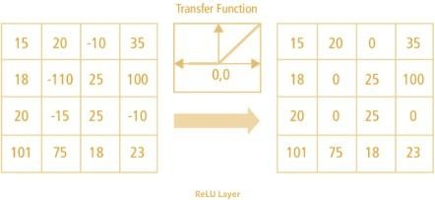ReLU is important in CNNs because it introduces non-linearity into the network, allowing it to learn and model complex relationships in the data. By applying ReLU, the network becomes capable of learning non-negative linear values, which is often suitable for real-world data. This non-linearity is crucial for CNNs to capture and represent more intricate patterns and features in images, leading to improved performance in tasks such as image classification, object detection, and image segmentation.
Fig 5.4.5: ReLU operation

ReLU, tanh, and sigmoid are popular nonlinear activation functions in deep learning. While tanh and sigmoid functions can be used, ReLU is preferred by data scientists due to its computational efficiency and ability to mitigate the vanishing gradient problem. ReLU's sparsity property also aids interpretability and efficiency.

Pooling Layer:
Pooling layers are utilized in Convolutional Neural Networks (CNNs) to reduce the number of parameters when working with large images. This technique, also known as subsampling or downsampling, helps in decreasing the dimensionality of each feature map while retaining crucial information. There are several types of spatial pooling, including max pooling, average pooling, and sum pooling .
In max pooling, the largest element from the rectified feature map is selected, while average pooling takes the average of the elements in the feature map. Sum pooling, on the other hand,

calculates the sum of all elements in the feature map. These pooling operations aid in reducing the spatial dimensions of the feature maps, enabling the network to focus on the most significant features while discarding less important details.
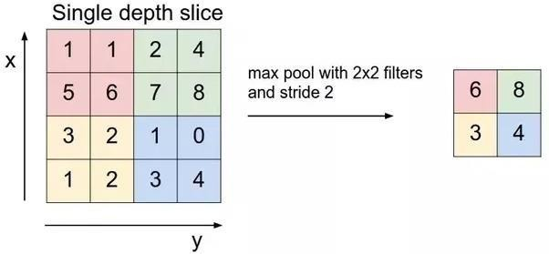
Fig 5.4.6: Max Pooling

Fully Connected Layer:

The fully connected (FC) layer in a neural network refers to a layer where the input matrix is flattened into a vector and then fed into the layer. This layer is similar to a traditional neural network layer, where each neuron is connected to every neuron in the previous and following layers. The FC layer enables the network to learn complex patterns and relationships by considering the interactions between all the features in the flattened vector.

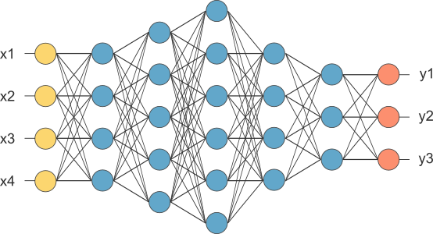
Fig 5.4.7: After pooling layer, flattened as FC layer

In the above diagram, the feature map matrix will be converted as vector (x1, x2, x3, …). With the fully connected layers, we combined these features together to create a model. Finally, we

have an activation function such as SoftMax or sigmoid to classify the outputs as cat, dog, car, truck etc
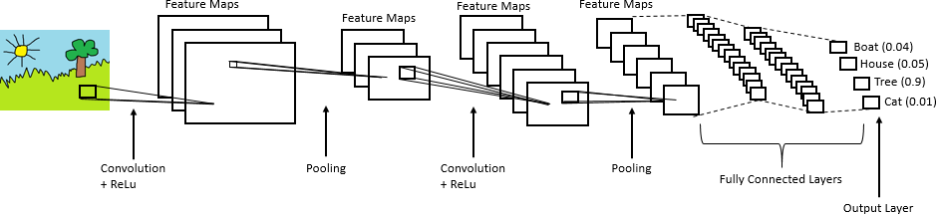
Fig 5.4.8: Complete CNN architecture

CONCLUSION AND FUTURE WORK

Conclusion:
In this project, we presented a music recommendation system based on emotion detected. The system uses a two-layer convolution network model for facial emotion recognition. The model classifies 7 different facial emotions from the image dataset. The model has comparable training accuracy and validation accuracy which convey that the model is having the best fit and is generalized to the data. We also recognize the room for improvement. It would be interesting to analyze how the system performs when additional emotions are taken into consideration. User preferences can be collected to improve the overall system using collaborative filtering. We plan to address these issues in future work.

Future Enhancement:
The music player based on facial recognition system is highly essential for all the person in modern day life ecology. This system is further enhanced with benefit able features for upgrading in future. The methodology of enhancement in the automatic play of songs is done by detection of the facial expression. The facial expression is detected by programming interface with the RPI camera. Our system currently excludes emotions such as disgust and fear. However, an alternative method could incorporate these emotions to enhance automatic music playback.

REFERENCES

- “C. Jain, K. Sawant, M. Rehman and R. Kumar, "Emotion Detection and Characterization using Facial Features," 2018 3rd International Conference and Workshops on Recent Advances and Innovations in Engineering (ICRAIE), Jaipur, India, 2018, pp. 1-6.

- A. Jaiswal, A. Krishnama Raju and S. Deb, "Facial Emotion Detection Using Deep Learning," 2020 International Conference for Emerging Technology (INCET), Belgaum, India, 2020, pp. 1-5.

- S. Begaj, A. O. Topal and M. Ali, "Emotion Recognition Based on Facial Expressions Using Convolutional Neural Network (CNN)," 2020 International Conference on Computing, Networking, Telecommunications & Engineering Sciences Applications (CoNTESA), Tirana, Albania, 2020, pp. 58-63.

- Ram Kumar Madupu, Chiranjeevi Kothapalli, Vasanthi Yarra “Automatic Human Emotion Recognition System using Facial Expressions with Convolution Neural Network” Fourth International Conference on Electronics, Communication and Aerospace Technology (ICECA- 2020).

- Hari Kishan Kondaveeti , Mogili Vishal Goud “Emotion Detection using Deep Facial Features” IEEE International Conference on Advent Trends in Multidisciplinary Research and Innovation (ICATMRI) 2020.

- Charvi Jain, Kshitij Sawant, Mohammed Rehman “The Application of Artificial Intelligence in Emotion Recognition” 2020 International Conference on Intelligent Computing and Human- Computer Interaction (ICHCI).

- E. Pranav, S. Kamal, C. Satheesh Chandran and M. H. Supriya, "Facial Emotion Recognition Using Deep Convolutional Neural Network," 2020 6th International Conference on
Advanced Computing and Communication Systems (ICACCS), Coimbatore, India, 2020, pp. 317-320.

- Monika Singh, Bharat Bhushan Naib, Amit Kumar Goel “Facial Emotion Detection using

Action Units” Proceedings of the Fifth International Conference on Communication and ElectronicsSystems (ICCES 2020).

- U. Rashid, M. W. Iqbal, M. A. Skiandar, M. Q. Raiz, M. R. Naqvi and S. K. Shahzad, "Emotion Detection of Contextual Text using Deep learning," 2020 4th International Symposium on Multidisciplinary Studies and Innovative Technologies (ISMSIT), Istanbul, Turkey, 2020, pp. 1-5.

- Susu Yan, Liang Ye, Shuai Han, Tian Han, Yue Li and Esko Alasaarela “Speech Interactive Emotion Recognition System Based on Random Forest”.

- T. M. Wani, T. S. Gunawan, S. A. A. Qadri, H. Mansor, M. Kartiwi and N. Ismail, "Speech Emotion Recognition using Convolution Neural Networks and Deep Stride Convolutional Neural Networks," 2020 6th International Conference on Wireless and Telematics (ICWT), Yogyakarta, Indonesia, 2020.

- H. Chen, Z. Liu, X. Kang, S. Nishide and F. Ren, "Investigating voice features for Speech emotion recognition based on four kinds of machine learning methods," 2019 IEEE 6th International Conference on Cloud Computing and Intelligence Systems (CCIS), Singapore, 2019, pp. 195-199.

- K. H. Lee and D. H. Kim, "Design of a Convolutional Neural Network for Speech Emotion Recognition," 2020 International Conference on Information and Communication Technology Convergence (ICTC), Jeju, Korea (South), 2020, pp. 1332-1335.

- H. Cheng and X. Tang, "Speech Emotion Recognition based on Interactive Convolutional Neural Network," 2020 IEEE 3rd International Conference on Information Communication and Signal Processing (ICICSP), Shanghai, China, 2020, pp. 163-167.

- M. A. Rohan, K. S. Swaroop, B. Mounika, K. Renuka and S. Nivas, "Emotion Recognition Through Speech Signal Using Python," 2020 International Conference on Smart Technologies in Computing, Electrical and Electronics (ICSTCEE), Bengaluru, India, 2020, pp. 342-34.

