

# DAYANANDA SAGAR COLLEGE OF ENGINEERING

(An Autonomous Institute affiliated to VTU, Belagavi, Approved by AICTE & ISO 9001:2008 Certified)

Accredited by National Assessment & Accreditation Council (NAAC) with ‘A’ grade, Shavige

Malleshwara Hills, Kumaraswamy Layout, Bengaluru-560078.

**Minor Project Report on**

# “Prepaid Plans Comparison”

## Submitted By

## Neelam Neha (1DS20CS135)

## Pavan Gowda S N (1DS20CS146)

## Pratisha F (1DS20CS153)

## Rachana K (1DS20CS160)

**Fifth Semester B.E (CSE) in**

**Emerging Technology**

## Under the guidance of

**Prof Ramya KM Assistant Professor**

**Dept. of CSE DSCE, Bangalore**

**ABSTRACT**

In the today’s digitalized world, data is the most essential asset and may cause significant impact. The challenge is to complete appetite of data. Data can be access from many different sources. The most usable source of data is website. Businesses tend to look for a competitor’s website or specific website for valuable information.

Web scraping use cases can be applied to see the industry trends, customer feedback about a particular product or service web scraping proves to be your smart decision-making tool. But it requires careful attention to choosing the right tools, languages and programs.

There is a lot of research conducted on the data collection methods. This research presents the effective use of robotic process automation in data collection. The research methodology used is assists with time saving, efficient and quick way of gathering information. This research incorporates an illustration of data extraction from website for work opportunities and an approach to automatically save produced data in the CSV design information document utilizing UiPath automation tool. This method will be valuable to small scale industries because of its simple execution strategy and simplicity of exportation of information in required design.

# TABLE OF CONTENTS

|  |  |  |
| --- | --- | --- |
| **Sr. No.** | **Contents** | **Page No.** |
| **1** | Introduction | 1 |
| **2** | Design And Implementation | 6 |
| **3** | Testing Results and Analysis | 11 |
| **4** | Conclusion and Future Enhancement | 17 |

In the today’s digitalized world, data is the most essential asset and may cause significant impact. The challenge

is to complete appetite of data. Data can be access from many different sources. The most usable source of data

is website. Businesses tend to look for a competitor’s website or specific website for valuable information. Web

scraping use cases can be applied to see the industry trends, customer feedback about a particular product or

service web scraping proves to be your smart decision-making tool. But it requires careful attention to choosing

the right tools, languages and programs [1]. There is a lot of research conducted on the data collection methods.

This research presents the effective use of robotic process automation in data collection. The research

methodology used is assists with time saving, efficient and quick way of gathering information. This research

incorporates an illustration of data extraction from website for work opportunities and an approach to

automatically save produced data in the CSV design information document utilizing UiPath automation tool.

This method will be valuable to small scale industries because of its simple execution strategy and simplicity of

exportation of information in required design

In the today’s digitalized world, data is the most essential asset and may cause significant impact. The challenge

is to complete appetite of data. Data can be access from many different sources. The most usable source of data

is website. Businesses tend to look for a competitor’s website or specific website for valuable information. Web

scraping use cases can be applied to see the industry trends, customer feedback about a particular product or

service web scraping proves to be your smart decision-making tool. But it requires careful attention to choosing

the right tools, languages and programs [1]. There is a lot of research conducted on the data collection methods.

This research presents the effective use of robotic process automation in data collection. The research

methodology used is assists with time saving, efficient and quick way of gathering information. This research

incorporates an illustration of data extraction from website for work opportunities and an approach to

automatically save produced data in the CSV design information document utilizing UiPath automation tool.

This method will be valuable to small scale industries because of its simple execution strategy and simplicity of

exportation of information in required design

In the today’s digitalized world, data is the most essential asset and may cause significant impact. The challenge

is to complete appetite of data. Data can be access from many different sources. The most usable source of data

is website. Businesses tend to look for a competitor’s website or specific website for valuable information. Web

scraping use cases can be applied to see the industry trends, customer feedback about a particular product or

service web scraping proves to be your smart decision-making tool. But it requires careful attention to choosing

the right tools, languages and programs [1]. There is a lot of research conducted on the data collection methods.

This research presents the effective use of robotic process automation in data collection. The research

methodology used is assists with time saving, efficient and quick way of gathering information. This research

incorporates an illustration of data extraction from website for work opportunities and an approach to

automatically save produced data in the CSV design information document utilizing UiPath automation tool.

This method will be valuable to small scale industries because of its simple execution strategy and simplicity of

exportation of information in required design

In the today’s digitalized world, data is the most essential asset and may cause significant impact. The challenge

is to complete appetite of data. Data can be access from many different sources. The most usable source of data

is website. Businesses tend to look for a competitor’s website or specific website for valuable information. Web

scraping use cases can be applied to see the industry trends, customer feedback about a particular product or

service web scraping proves to be your smart decision-making tool. But it requires careful attention to choosing

the right tools, languages and programs [1]. There is a lot of research conducted on the data collection methods.

This research presents the effective use of robotic process automation in data collection. The research

methodology used is assists with time saving, efficient and quick way of gathering information. This research

incorporates an illustration of data extraction from website for work opportunities and an approach to

automatically save produced data in the CSV design information document utilizing UiPath automation tool.

This method will be valuable to small scale industries because of its simple execution strategy and simplicity of

exportation of information in required design

In the today’s digitalized world, data is the most essential asset and may cause significant impact. The challenge

is to complete appetite of data. Data can be access from many different sources. The most usable source of data

is website. Businesses tend to look for a competitor’s website or specific website for valuable information. Web

scraping use cases can be applied to see the industry trends, customer feedback about a particular product or

service web scraping proves to be your smart decision-making tool. But it requires careful attention to choosing

the right tools, languages and programs [1]. There is a lot of research conducted on the data collection methods.

This research presents the effective use of robotic process automation in data collection. The research

methodology used is assists with time saving, efficient and quick way of gathering information. This research

incorporates an illustration of data extraction from website for work opportunities and an approach to

automatically save produced data in the CSV design information document utilizing UiPath automation tool.

This method will be valuable to small scale industries because of its simple execution strategy and simplicity of

exportation of information in required design

# Chapter 1: INTRODUCTION

## Introduction to RPA

RPA is defined as an art of using software robots to interact with Software-as-a-Service applications and IT systems to automate the rule-based manual jobs associated with repetitive and transactional processes. The robot mimics the interactions of an employee with a system's user interface.

## 1.1.1 Introduction Automation Anywhere

Automation Anywhere is one of the popular RPA tools that provides powerful features to automate complex business tasks. It is used to automate such processes that are repetitive, rule-based, and manually performed by humans. It offers end to end automation strategy for organizations.



Automation Anywhere is a web-based management system. It has a Control Room that helps in managing automated tasks. It is mainly used at the enterprise level and changes the way the enterprises operate. The primary aim of Automation Anywhere is to offer scalable, secure, and resilient services to its users.

### 1.1.2 About the RPA On Automation Anywhere Platform

Robotic Process Automation with Automation Anywhere is a robotic process automation solution that mimics the behaviour of a human business user to perform repetitive tasks. IBM RPA with Automation Anywhere provides an entry point into the world of automated digital labour and the digital workforce. By automating tasks with software-based labour, your human workforce becomes more productive allowing you to rethink who performs which tasks within the organization.

You can capture work interactions, for example, the tasks someone does to process an order, and then play them back by using a software robot, called a bot. A bot is software that performs work that humans would otherwise perform.

RPA with Automation Anywhere is part of the IBM Digital Business Automation platform. The platform augments task automation by adding workflow, data capture, content, and decision automation to bots.

## Objectives

Providing an easier and effective way to view a particular data from a website and helps saving time. Especially for those who are regularly working the telecom shops and dealing with more and more shopping each and every day. This method helps a lot for those kinds of people.

## 1.3 Problem Statement

To retrieve specific desired information from the website and store them in a csv file for future reference.

## 1.4 Scope of the Work and its Importance

Since it is very required for retailers who are maintain the telecom shops doing the telecom business such as recharges and all. The people who are very much interested towards buying the new things from online shopping websites, who are having the dilemma about to choosing the best website for best prices. This technique will also save the lot many times of people in searching the products in different websites. So instead, people may use this bot, from which we can get best product with some valuable price. So, this website will help a lot in time saving.

## 1.5 System Requirement Specification

It helps you to whether your system has the proper hardware and software to install Automation Anywhere.

Before installing the Automation Anywhere, verify that your environment supports the following requirements.



Fig.1

**1.5.1 Operating Systems**:

* Microsoft Windows Server 2012
* Microsoft Windows Server 2008 R2
* Microsoft Windows Server 2003
* Microsoft Windows 8.1/ 8
* Microsoft Windows 7
* Microsoft Windows Vista
* Microsoft Windows XP



Fig.2

**(Both 32-bit and 64-bit OS versions are supported)**

**1.5.2 Processor speed:** Recommended - 3 GHz or higher.

**1.5.3 RAM:** Recommended - 4 GB or higher.

**1.5.4 Hard Disk capacity:** 200 MB of free hard disk space for installation.

On an average an Automation Anywhere, script is approximately 100-150 KB. Additional free disk space is required to develop automation projects, as Automation Anywhere creates temporary files like screen-shots, server logs, audit files etc. during the execution of the automation scripts. actual free space required increases with the project size and hence it is recommended to have at least 40-50 GB of free disk space in order to implement long term projects.

**Chapter2: DESIGN AND IMPLEMENTATION**

**2.1 Flow Diagram:**

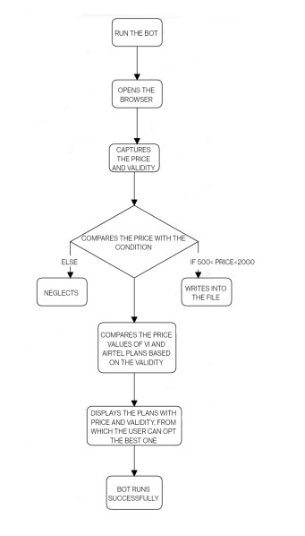

**2.1.1 Process to be automated:**

In this project we are automating the Mobile recharge plans. VI plans and Airtel plans are being automated by the bot. The ‘capture’ action captures the price and validity of a particular plan based on a condition. The capture action opens the browser mentioned in the ‘open browser’ action. The bot then captures the price and validity when the user clicks on these labels. The Loop action helps in capturing the entire page of the browser. ‘Increment’ action from the ‘Number’ action increments the Loop Counter. Loop Counter is a variable, which is necessary to keep in track about the number of iterations happening and ensure that the same price and validity is not repeated. This automation provides and easy access and reduces the time in scrolling the web page.

**2.2 Step by Step Implementation:**

* Use the Browser: Open action to open the Vodafone Idea prepaid plans website page from which we should extract the data.
* Use a Log to file action to write down the headings VI Plans and VI Validity into the specific csv file.
* Use a Loop action and select the while condition to record when the object exists.
* Inside the loop action, use the Recorder: Capture action to capture price of the prepaid plan from the website and save the outcome to variable Plan Price.
* Use an If condition to specify the required conditions such as select only the prices which are greater than 500 and less than 2000.
* Use another Recorder: Capture action to capture the validity of the prepaid plans.
* Use Log to File action in order to write down the prices and validity of the prepaid plans that satisfy the if conditions.
* Use a Number: Increment action in order to increment the loop counter variable in each iteration in the while loop.
* Perform the same order of operations to find the Price and Validity of Airtel prepaid plans by opening the Airtel prepaid plans website.
* Finally, it compares the prices of both the plans for the same validity and logs it to a textfile.

**Chapter3: TESTING/RESULT AND ANALYSIS**

**3.1 Bot Execution Procedure:**

**Steps:**

1)Browser Window: In this step, a new window containing the Vodafone’s plans is displayed.

2)Log to file: Then, it logs the headers of the VI plans that is, the price and validity to the VIplans.csv file in order to store the captured values of step 4 and 6.

3)Loop: Here, a while loop is used to run the contents below this step until the object exists in the window.

4)Recorder: It is used to capture the price details of the rows in the VI plans.

5)If: This is to check if the price captured lies in the specified range that is greater than 500 and lesser than 2000.

6)Recorder: Then the bot is capturing the validity of that corresponding price in this step.

7)Log to file: Then it is logging the price and validity captured from the recorder to the VIplans.csv file.

8)Number: Here, it is incrementing the count variable to increment the loop so that it moves to the next specified row in the plans.

9)Browser: Now, a new window is used to display the Airtel Plans.

10)Log to file: Then, it is logging the headers of the Airtel plans that is, the price and validity to the airtelplans.csv file in order to store the captured values.

11)Open: Here, it is opening the VI plans csv file and providing a session name.

12)Open: Here, it is opening the airtel plans csv file and providing a session name.

13)Loop: Here, it is using a while loop to run the contents below this step until the object exists in the window.

14)Recorder: This is used to capture the price details of the rows in the Airtel plans.

15)String: In this step, it is retrieving the price obtained in the previous step and used the string matching technique to extract only the numbers from the string and remove the rupee symbol. This is done so that it can be converted to the number format for its use in step 17.

16)Substring: Here , it obtains substring after the string matching technique.

17)If: This is to check if the price captured lies in the specified range that is greater than 500 and lesser than 2000.

18)Recorder: Then, it is capturing the validity of that corresponding price.

19)Log to file: In this step, it is logging the price and validity captured from the recorder to the airtelplans.csv file.

20)Number: Here, it is incrementing the count variable to increment the loop so that it moves to the next specified row in the plans.

21)Loop: In this step, it uses the VI plans csv file that is opened in step 11 using the same session variable in order to loop the rows of this plan for its use in step 23.

22)Loop: In this step, it uses the Airtel plans csv file that is opened in step 12 using the same session variable in order to loop the rows of this plan for its use in step 23.

23)If: Here, it is comparing both the plans in such a way that both have the same validity and their prices are unique.

24)Message box: This is used to display the price details of both the plans for the same validity.

25)Log to file: Then, it is storing the obtained values in a text file for future reference.

25)CSV close: Then, it is closing the csv file that has been opened in step 11.

26)CSV close: Then, it is closing the csv file that has been opened in step 12.

**3.2 Screenshots of instructions on control room:**

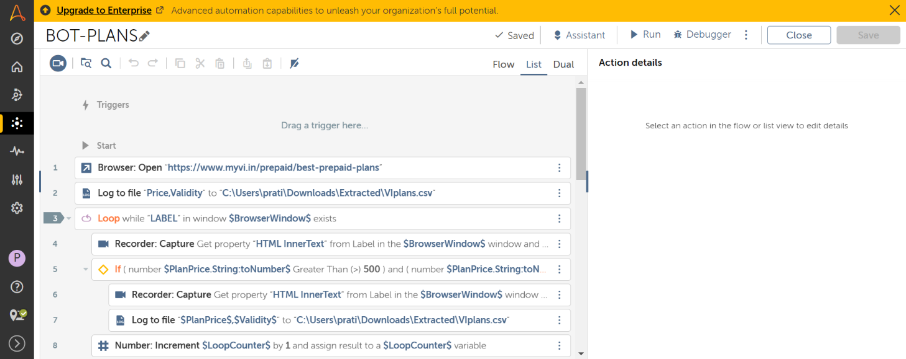

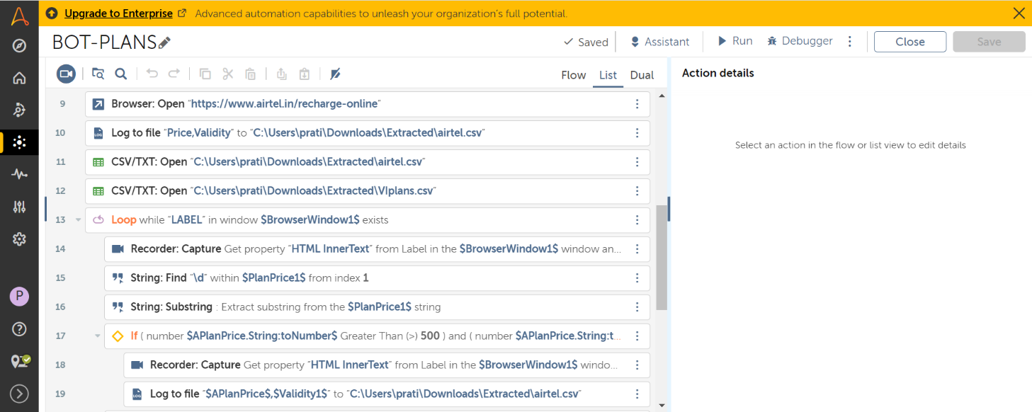

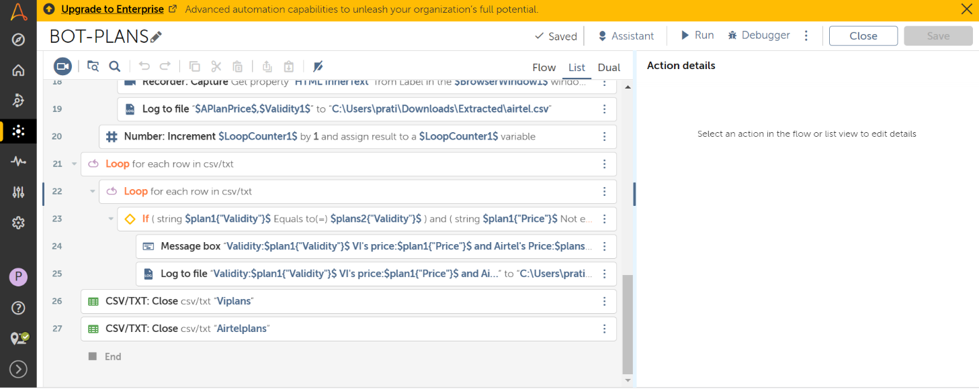

**On executing the bot:**

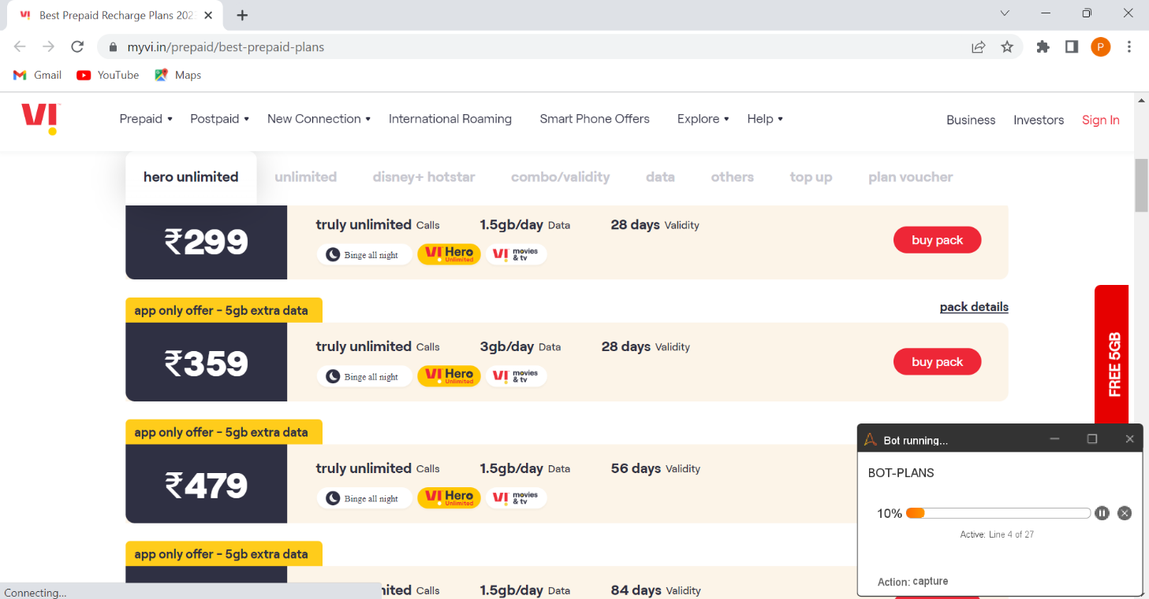

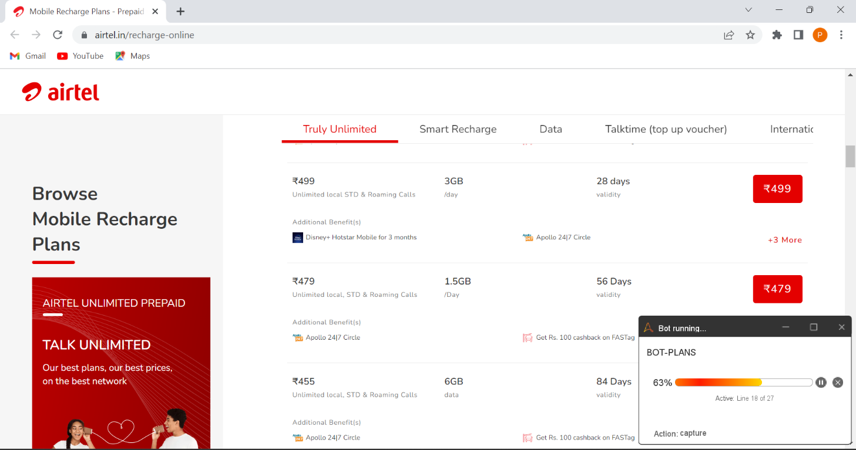

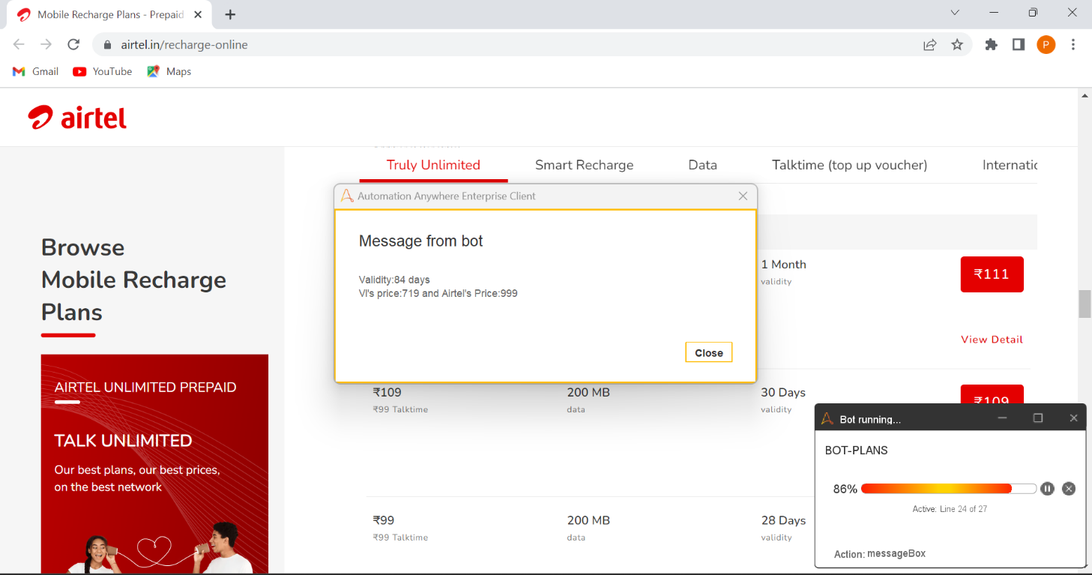

**Viewing the csv files and the textfile obtained after the execution:**

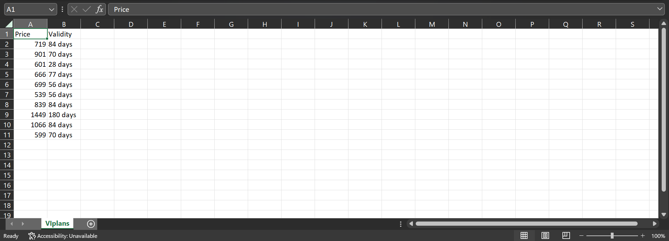

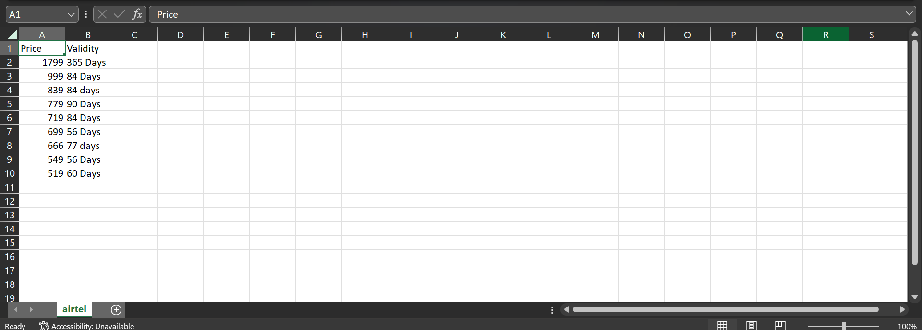

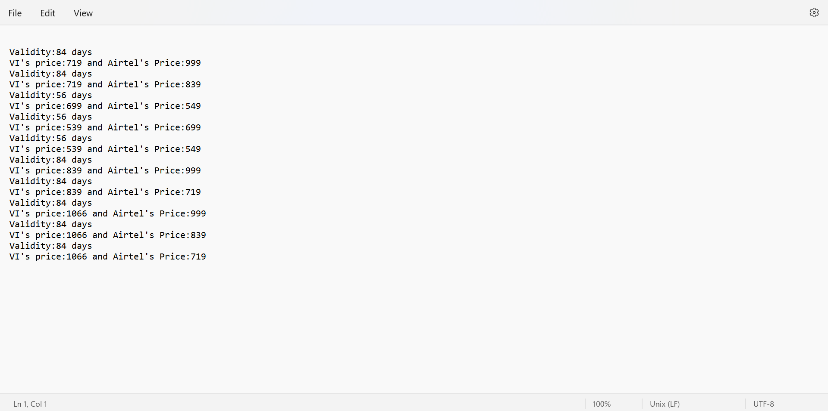

**Output:**

The bot displays the price details of both the plans for the same validity in a message box. And also, logs the output obtained into a text file for future reference.

**Result:**

This bot can be used to decide the best suitable price for the same validity in both the plans, and thereby saves time by not providing the need to compare them manually.

# Chapter4: CONCLUSION AND FUTURE ENHANCEMENT

## 4.1 CONCLUSION

Since the usage of the online websites for several purposes are increasing exponentially. Nowadays everyone is in dilemma about purchasing the things, like were to proceed and what to purchase so all. Likewise we have come up with a project were we can extract the date from the websites loads into a csv files. After which we can do necessary analysis on it. Our project mainly focuses on the recharge plans provided by the telecom companies. Here we are more focused on the VI plans and airtel plans, from both the websites we get the data plans like validity and the price of the plan and load into a different csv file after which our bot is going to give the output such that, for same validity it will give the plan price of the different companies. So, by this people who are working in the telecom shop or sectors they find the best solutions easily.

## 4.2 FUTURE ENHANCEMENT

## Since the requirement of the technology is growing rapidly across the world and need of this is very much required by people for betterment of the society. As it’s been mentioned earlier that the bot that was established by us is not only towards recharge plans, we can also make use of the same for different purposes such as comparing the prices of the items of different websites like amazon, flip kart and so on. Also, it is possible to send the best plans between certain range where we are estimating and send the same to a particular person through a email or WhatsApp. This bot is very much in need today for retailers as well as big MNC’s to compare the data and to analyses the data. Math company is one such company which make use of this kind of Bots for the betterment of the future generation this bot is very necessary.

## REFERENCES:

<Quora: https://www.quora.com>

IBM: https://www.ibm.com/in-en/products/robotic-process-automation

# 