**DAYANANDA SAGAR COLLEGE OF ENGINEERING**

(An Autonomous Institute affiliated to VTU, Belagavi, Approved by AICTE & ISO 9001:2008 Certified)

Accredited by National Assessment & Accreditation Council (NAAC) with ‘A’ grade, Shavige Malleshwara Hills, Kumaraswamy Layout, Bengaluru-560078.

**Minor Project Report**

**on**

**“VoIP Phone”**

Submitted By

Rahul Jagwani – 1DS20CS161

Rachana K – 1DS20CS160

**Fifth Semester B.E (CSE)**

**in**

**Computer Networks**

**19CS5DLCNL**

Under the guidance of

**Dr. Nagaraja J.**

**Associate Professor**

**Dept. of CSE**

**DSCE, Bangalore**

|  |  |  |
| --- | --- | --- |
| **S. No.** | **Contents** | **Page** |
| 1 | Abstract |  |
| 2 | Introduction |  |
| 3 | Design and Configuration |  |
| 4 | Topology |  |
| 5 | Real time and Simulation Mode Results |  |
| 6 | Conclusion and Future Enhancement |  |

**Abstract**

In this project, start by designing the topology. Create the network design and beautification. Add 4 routers (2811), 5 switches(2960-24TT) out of which one switch will be assigned for the server pool and the remaining switches are assigned for data and voice VLANs. Each switch can have any number of IP Phones (7960) and PCs. The switch assigned for server pool is connected to three servers: DHCP, DNS and Web server.

Then connect the Cisco VoIP power adapter to IP phone. Then connect the switches, routers, and servers. After this, continue with VLANs assignment plus all access and trunk ports on the switches. Subnetting and IP addressing was done by keeping in mind the address given in the problem statement (192.100.1.0). Then assigned the static addresses to DHCP, DNS and Web servers. Configure the DHCP server for data VLANs by making four network pools, NET A, NET B, NET C and NET D. Also configure the DHCP service for voice VLANs.

Enable inter VLAN routing between different routers plus assign IP DHCP helper addresses to routers. Then configure routers with the OSPF protocol. Then configure each router with VoIP telephony service and dial peer by mentioning destination pattern and session target.

**Introduction**

VoIP (voice over Internet Protocol) also called IP telephony is the transmission of voice and multimedia content over an internet connection. VoIP allows users to make voice calls from a computer, smartphone, other mobile devices, special VoIP phones and WebRTC-enabled browsers. VoIP is a technology useful for both consumers and businesses, as it typically includes other features that can't be found on common phone services. These features can include call recording, custom caller ID, or voicemail to e-mail. It is also helpful to organizations as a way to unify communications.

VoIP services convert a user's voice from audio signals to digital data, in which that data is then sent to another user -- or group of users -- over Ethernet or Wi-Fi. To accomplish this, VoIP will use codecs. Codecs are either a hardware- or software-based process that compresses and decompresses large amounts of VoIP data. Voice quality may suffer when compression is used, but compression reduces bandwidth requirements.

A VoIP phone system is a technology to make phone calls through your internet connection instead of a regular landline or a mobile network. A VoIP system converts analog voice signals into digital signals over your broadband connection. A VoIP server is used to connect calls to other telephone networks.

VoIP Phones are used for several applications such as:

* VoIP can allow for a number of audio, video, or text-based communication methods.
* Useful for businesses, so teams don't have to work with multiple different applications to communicate with one another effectively.
* Good for employees who work remotely as they have a number of options to call into meetings or communicate to other teammates.

**Design and Configuration**

**Subnetting:**

Given IP address: 192.100.1.0

Number of networks used: 13 ~ 2^4

Old subnet mask = 255.255.255.0

Since networks used are 13 which is similar to 2^4, thus add 4 1s to the old subnet mask which was 24 1s(11111111.11111111.11111111.00000000). So the new subnet mask will contain 28 1s(11111111.11111111.11111111.11110000)

New subnet mask= 255.255.255.240

For Block Size 4 0s from right side are there in the new subnet mask so our block size will be 2^4(16).

|  |  |  |
| --- | --- | --- |
| Network | Range | Broadcast |
| 192.100.1.0 | 192.100.1.1 – 192.100.1.14 | 192.100.1.15 |
| 192.100.1.16 | 192.100.1.17 – 192.100.1.30 | 192.100.1.31 |
| 192.100.1.32 | 192.100.1.33 – 192.100.1.46 | 192.100.1.47 |
| 192.100.1.48 | 192.100.1.49 – 192.100.1.62 | 192.100.1.63 |
| 192.100.1.64 | 192.100.1.65 – 192.100.1.78 | 192.100.1.79 |
| 192.100.1.80 | 192.100.1.81 – 192.100.1.94 | 192.100.1.95 |
| 192.100.1.96 | 192.100.1.97 – 192.100.1.110 | 192.100.1.111 |
| 192.100.1.112 | 192.100.1.113 – 192.100.1.126 | 192.100.1.127 |
| 192.100.1.128 | 192.100.1.129 – 192.100.1.142 | 192.168.1.143 |
| 192.100.1.144 | 192-100-1-145 - 192-100-1-158 | 192.100.1.159 |
| 192.100.1.160 | 192.100.1.161-192.100.1.174 | 192.100.1.175 |
| 192.100.1.176 | 192.100.1.177-192.100.1.190 | 192.100.1.191 |
| 192.100.1.192 | 192.100.1.193-192.100.1.206 | 192.100.1.207 |
| 192.100.1.208 | 192.100.1.209-192.100.1.222 | 192.100.1.223 |

1. **Voice VLAN Subnets :**

|  |  |  |  |
| --- | --- | --- | --- |
| VLAN Network Name | Network Address | IP Range | Broadcast address |
| NET A | 192.100.1.144 | 192.100.1.145-192.100.1.158 | 192.100.1.159 |
| NET B | 192.100.1.192 | 192.100.1.193-192.100.1.206 | 192.100.1.207 |
| NET C | 192.100.1.176 | 192.100.1.177-192.100.1.190 | 192.100.1.191 |
| NET D | 192.100.1.160 | 192.100.1.161-192.100.1.174 | 192.100.1.175 |

1. **Data VLAN Subnets :**

|  |  |  |  |
| --- | --- | --- | --- |
| VLAN Network Name | Network Address | IP Range | Broadcast address |
| NET A | 192.100.1.0 | 192.100.1.1-192.100.1.14 | 192.100.1.15 |
| NET B | 192.100.1.16 | 192.100.1.17-192.100.1.30 | 192.100.1.31 |
| NET C | 192.100.1.32 | 192.100.1.33-192.100.1.46 | 192.100.1.47 |
| NET D | 192.100.1.48 | 192.100.1.49-192.100.1.62 | 192.100.1.63 |
| Server Pool | 192.100.1.64 | 192.100.1.65-192.100.1.78 | 192.100.1.79 |

1. **Inter Router Subnets :**

|  |  |  |  |
| --- | --- | --- | --- |
| Router Name | Network Address | IP Range | Broadcast address |
| R0-R1 | 192.100.1.128 | 192.100.1.129-192.100.1.142 | 192.100.1.143 |
| R1-R2 | 192.100.1.80 | 192.100.1.81-192.100.1.94 | 192.100.1.95 |
| R2-R3 | 192.100.1.96 | 192.100.1.97-192.100.1.110 | 192.100.1.111 |
| R3-R0 | 192.100.1.112 | 192.100.1.113-192.100.1.126 | 192.100.1.127 |

**Configuration:**

**NETWORK SWITCHES CONFIGURATION:**

switch>enable

switch#

switch#conf t

switch(config)#vlan 10

switch(config-vlan)#name DATA

switch(config-vlan)#vlan 100

switch(config-vlan)#name VOICE

switch(config-vlan)#exit

switch(config)#

switch(config)#int fa0/1

switch(config-if)#switchport mode trunk

switch#exit

switch(config)#

switch(config)#int fa0/2-5

switch(config-if-range)#switchport mode access

switch(config-if-range)#switchport access vlan 10

switch(config-if-range)#switchport voice vlan 100

switch(config-if-range)#exit

switch(config)#do wr

**SERVER SWITCHES CONFIGURATION:**

switch>enable

switch#

switch#conf t

switch(config)#vlan 50

switch(config-vlan)#name DATA

switch(config-vlan)#exit

switch(config)#

switch(config)#int fa0/1

switch(config-if)#switchport mode trunk

switch#exit

switch(config)#

switch(config)#int fa0/2-5

switch(config-if-range)#switchport mode access

switch(config-if-range)#switchport access vlan 10

switch(config-if-range)#exit

switch(config)#do wr

**DHCP FOR VOICE CONFIGURATION IN ROUTER1:**

Router>enable

Router#

Router#conf t

Router(config)#

Router(config)#ip dhcp excluded-address 192.100.1.145

Router(config)#ip dhcp pool NETA

Router(dhcp-config)#network 192.100.1.144 255.255.255.240

Router(dhcp-config)#default router 192.100.1.145

Router(dhcp-config)#option 150 ip 192.100.1.145

Router(dhcp-config)#exit

Router(config)#

Router(config)#do wr

**INTER VLAN-ROUTING CONFIGURATION IN ROUTER1:**

Router>enable

Router#

Router#conf t

Router(config)#

Router(config)#int fa0/0.10

Router(config-subif)#

Router(config-subif)#encapsulation dot1q 10

Router(config-subif)#ip address 192.100.1.1 255.255.255.240

Router(config-subif)#ip helper-address 192.100.1.66

Router(config-subif)#exit

Router(config)#

Router(config)#int fa0/0.100

Router(config-subif)#

Router(config-subif)#encapsulation dot1q 100

Router(config-subif)#ip address 192.100.1.145 255.255.255.240

Router(config-subif)#exit

Router(config)#

Router(config)#do wr

**OSPF CONFIGURATION IN ROUTER0:**

Router>enable

Router#

Router#conf t

Router(config)#

Router(config)#router ospf 10

Router(config-router)#network 192.100.1.128 0.0.0.15 area 0

Router(config-router)#network 192.100.1.112 0.0.0.15 area 0

Router(config-router)#network 192.100.1.160 0.0.0.15 area 0

Router(config-router)#network 192.100.1.64 0.0.0.15 area 0

Router(config-router)#network 192.100.1.48 0.0.0.15 area 0

Router(config-router)#exit

Router(config)#

Router(config)#do wr

**VOIP CONFIGURATION IN ROUTER1:**

Router>enable

Router#

Router#conf t

Router(config)#

Router(config)#telephony-service

Router(config-telephony)#max-dn 5

Router(config-telephony)#max-ephones 5

Router(config-telephony)#ip source-address 192.100.1.145 port 2000

Router(config-telephony)#auto assign 1 to 20

Router(config-telephony)#exit

Router(config)#

Router(config)#ephone-dn 1

Router(config-ephone-dn)#number 101

Router(config-ephone-dn)#exit

Router(config)#

Router(config)#ephone-dn 2

Router(config-ephone-dn)#number 102

Router(config-ephone-dn)#exit

Router(config)#

Router(config)#do wr

**DIAL PEER CONFIGURATION IN ROUTER1:**

Router>enable

Router#

Router#conf t

Router(config)#

Router(config)#dial-peer voice 1 voip

Router(config-dial-peer)#destination-pattern 2..

Router(config-dial-peer)#session target ipv4:192.100.1.82

Router(config-dial-peer)#exit

Router(config)#

Router(config)#dial-peer voice 2 voip

Router(config-dial-peer)#destination-pattern 3..

Router(config-dial-peer)#session target ipv4:192.100.1.98

Router(config-dial-peer)#exit

Router(config)#

Router(config)#dial-peer voice 3 voip

Router(config-dial-peer)#destination-pattern 4..

Router(config-dial-peer)#session target ipv4:192.100.1.130

Router(config-dial-peer)#exit

Router(config)#

Router(config)#do wr

**Topology**

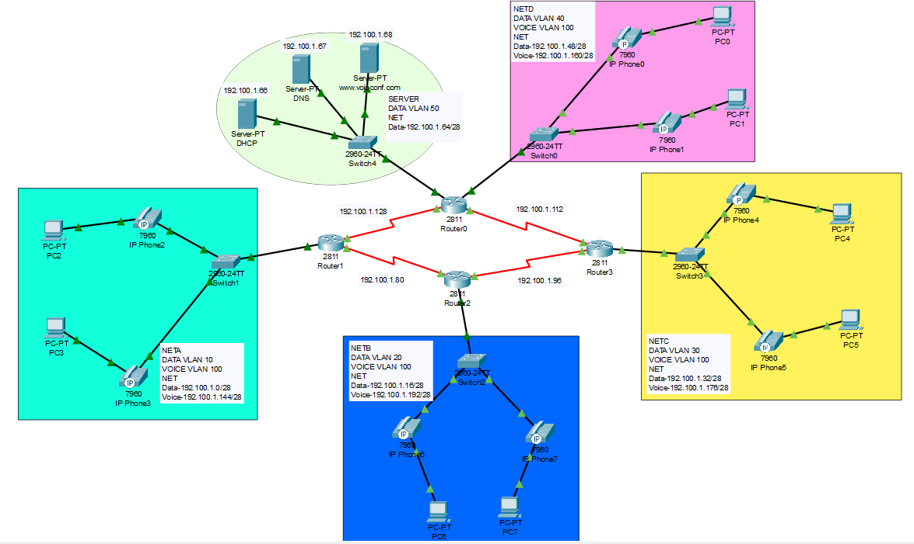

**Real Time and Simulation Mode Results**

**Real time Mode Results :**

Without calling:

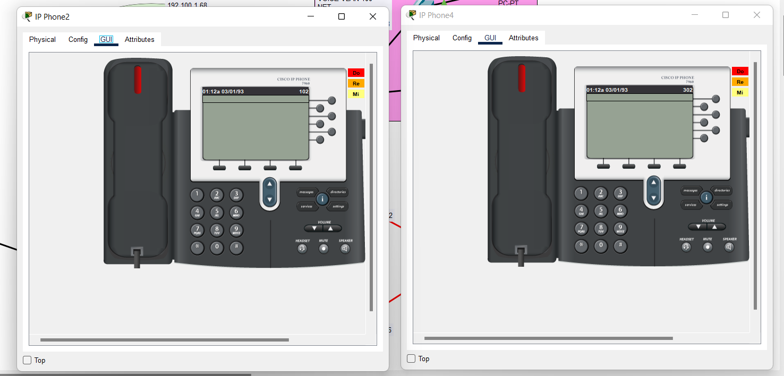

One IP Phone calling another IP Phone :

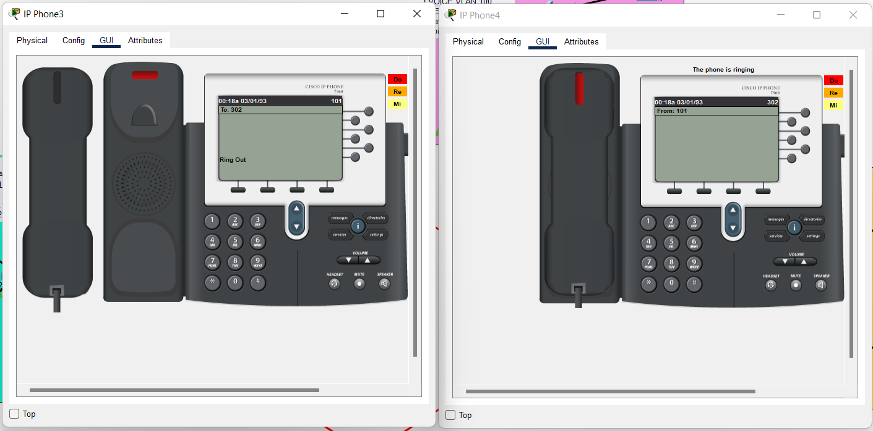

Both IP Phones are connected :

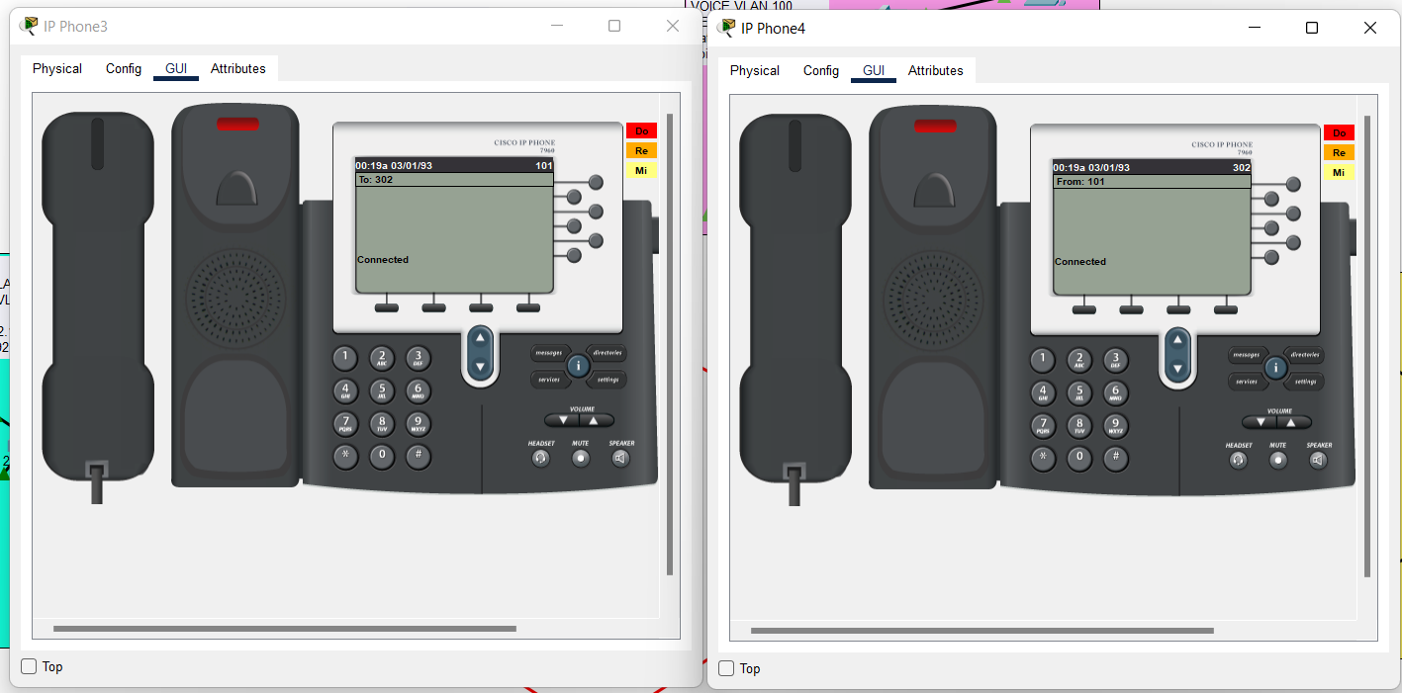

**Simulation Mode Results :**

Sending a packet from one PC to another PC :

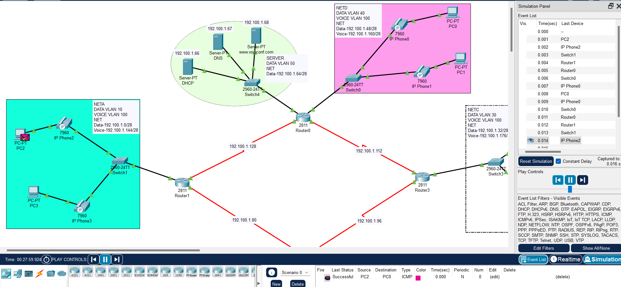

**Conclusion and future Enhancement**

There are many benefits of [**VoIP phone service**](https://www.nextiva.com/products/voip-phone-service.html), but the most popular benefit of VoIP is that you can make and receive phone calls from anywhere you have an internet connection. No more being bound to a specific desk at the office – you now have [**virtual phone numbers**](https://www.nextiva.com/blog/what-is-a-virtual-phone-number.html) that follow you anywhere. Use VoIP phone app to receive calls from your desktop computer or any mobile-compatible device with our mobile app.

Businesses like VoIP because it’s easier to scale (vs traditional landlines) and add phone numbers as your team grows.

Because you don’t need to have a technician come out to install physical phone lines. VoIP has easy installation – all you really need is an existing internet connection and VoIP provider.

Other popular VoIP features for business include integration with existing software applications, like [**Microsoft Teams integrations**](https://www.nextiva.com/integrations/microsoft-teams.html)**.** Plus, advanced voicemail features like visual voicemail and voicemail transcriptions are sent to your email.

A VoIP phone system is a technology to make phone calls through your internet connection instead of a regular landline or a mobile network. A VoIP system converts analog voice signals into digital signals over your broadband connection. A VoIP server is used to connect calls to other telephone networks.

So in conclusion, VoIP phones make communication between devices much simpler.