**TRIGONOMETRIC FUNCTIONS**

1. If  then  is equal to

1. 1 2. 2 3.3 4. 4

2. The equation  is possible if

1.  2.  3.  4. None

3. If  then  is equal to

1. 0 2. 1 3. 4. 6

4. If then  is equal to

1. 2 2.  3.  4. 

5. In any triangle, if then angle C is

1.  2.  3.  4. 

6. If  then  is

1.  2.  3.  4. None

7. If  then  can be

1.  2.  3.  4. 

8. If  and  then

1.  3. 

2.  4. 

9. 

1.  2.  3.  4. 

10. If  then the maximum value of  is

1.  2.  3. 1 4. None

11. The minimum value of  is equal to

1.  2.  3.  4. None

12. If  and then

1. A>B 2.A<B 3. A=B 4. None

13. If  then  is equal to

1.  2.  3. 1 4. -1

14. Circular ring of radius is 7 cm is re shaped in to an arc of a sector subtending an angle of 60o. Then the radius of the sector is equal to

1. 420 cm 2. 42 cm 3.7/60 cm 4. 60/7 cm

15. at A=60o is

1.  2.  3.1 4. 

16. If x,y,z are in A.P, then  is equal to

1.  2.  3.  4. 

17. If  then  is

1.  2.  3.  4. 

18. A quadratic equation whose roots are  and  can be

1.  2.  3.  4. None

19.  1. tan260  2.tan810  3.tan5404. tan180

20.  is equal to

1.  2.  3.  4. 

21. The value of cos155o +cos85o+cos35o is

1. 0 2.  3.  4. - 

22. If  then for all real x

1.  2.  3.  4. 

23. The number of solution of  in  is

1. 2 2. 3 3.0 4. 1

24. The number of values of  in the interval  satisfying the equation

is

1. 4 2. 6 3.1 4. 2

25. If  then the general value of  is

1.  3. 

2.  4. 

26. If  then the general value of  is

1.  2.  3.  4. 

27. If then general solution of this equation is

1.  2. 

3.  4. 

28. If  then the general value of  is

1.  2.  3.  4. None

29. The general value of  satisfying the equation  is

1.  2. 

3.  4. 

30. The solution of  in the interval  is

1.  2.  3.  4. None

31. The solution set of the system of equation  where  and  are real, is

1.  2.  3.  4. None

32. If A+B+C= π andcosA = cosBcosC then the value of cotBcotC is

1. 2. 3. - 4. -3

33.If 1+sinx+sin2x+…………to = 4+2, 0<x< then x=

1. 2. 3. 4.or

34.sin25o + sin210o + sin215o + ………………..+sin285o + sin290o =

1. 7 2.8 3.9 4. 9

35. If  then  is equal to

1. 2. 3. 4.

36. Value of 

1. 1 2.2 3. 4. None

37. If an arc  long of a wheel subtends an angle of  at its centre, then the radius of the wheel is

1. 50 cm 2.40 cm 3.30 cm 4. 60 cm

38.  1.  2. 3. 4. 1

39. The value of 

1. 1 2. 0  4. 2

40.The horizontal distance between two towers is 60 meters and the angular depression of the top of the first tower as seen from the top of the second is . If the height of the second tower be 150 meters, then the height of the first tower is

1.  2. 90 m 3. 4. None

41. A ladder rests against a wall so that its top touches the roof of the house. If the ladder makes an angle of  with the horizontal and height of the house bemeters, then the length of the ladder is

1.  2. 12m 3. 4. None

42 . In a if  then the value of  is

1. 1 2. 2 3.3 4. 4

43. In a . The measure of  is

1.  2.  3.  4. None

44.If, then is

1. isosceles only 2. Right angled only

3. Equilateral 4. Right angled or isosceles

45. In a  then  is

1.  2.  3.  4. 

46. If  and  then,

1.  2.  3.  4. None

47. In triangle ABC, if  and  then  is equal to

1. 2 2. 3 3.4 4. 5

48. If  then  is equal to

1.  2.  3. ab 4. None

49. If  then k is

1.  2.  3.  4. 

50. If  then  equals

1. -1 2.0 3.1 4. None

51. In then the general value of  is

1.  2.  3.  4. 

52. then

1.  2.  3.  4. None

53. Number of solution of equation  lying in the interval  is

1. 0 2. 1 3.2 4. 3

54. General solution of the equation  is

1.  2.  3.  4. None

55. General values of  satisfying the equation  is

1.  2.  3.  4. All of these

56. If the angles of a triangle are in the ratio, the corresponding sides are in the ratio

1.  2.  3.  4. 

57. In anif and the side  then area of the triangle is

1. 1 2. 2 3. 4. 

58. The perimeter of a is 6 times the arithmetic mean of the sines of its angles. If the side  is 1, then the angle A is,

1.  2.  3.  4. 

59. An observer in a boat finds that the angle of elevation of a tower standing on the top of a cliff is  and that of the top of cliff is . If the height of the tower be 60 meters, then the height of the cliff is

1. 30m 2. 3.  4. None

60. A man whose eye level is 1.5 meters above the ground observes the angle of elevation of the tower to be . If the distance of the man from the tower be 10 meters, the height of the tower is

1.  2.  3.  4. None

**ANSWERS**

1. **Ans (3)** 

 

2. **Ans (1)** We have 

Now,  

Therefore,  and  have the same sign.

Now,  

But  . Therefore, 

3. **Ans (3)** 

Now 

4. **Ans (1)**  or or



5. **Ans(4)** 











6. **Ans (2)** 



If 

If 

7.**Ans (4) **



8. **Ans (1)**  or 

From the second relation, we have



and

9. **Ans (3)** Applying 

We have 



10. **Ans (1)** Let 

Now 

Now, 

11. **Ans (2)**  



12. **Ans (1)** 







13. **Ans (2)** 



14. **Ans (2)** 



15.**Ans (2)** 

16. **Ans (2)** 

17. **Ans (3)** 





Now, 



We have taken +ve sign as  . By Eqs.(i) and(ii), we have 

18. **Ans (3) **

Also, 

Hence, the only equation which can have roots 

and is 

19.**Ans (3)**



20. **Ans (2)**



21.**Ans(1)** cos155o +cos85o+cos35o = 22. **Ans (2)**  

 

Now, 







23. **Ans (2)** The given equation is 









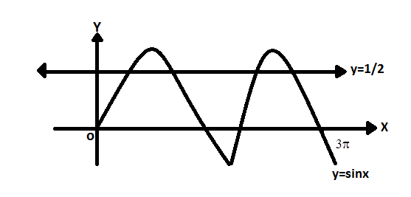24. **Ans(1)**



and has 4 values.

25. **Ans (1)**  Given 







We have, 

for general value of 



or



So, 

26. **Ans (3)** Given 















[Note: ]



27. **Ans (2)** 





is not possible as  is not defined at 

Hence, 

28. A**ns (3)**





Hence  or 

But  is ruled out.

29. **Ans (4)**  We have, 



Also, we can take 



30. **Ans (2)** We have 

If  then 



If  the  which is not possible

31. **Ans (2)**We have 





Which is not possible (as  )

Thus, the solution set is a null set.

32.**Ans(2)**



33. **Ans (4)**



34. **Ans (3)**



=



35. **Ans (1)**



36. **Ans (1)**



37. **Ans (4) **



38.**Ans(2)**  

39. **Ans (2)** 





40. **Ans (3)** 

41. **Ans (2)** Length of ladder=

42. **Ans (2)** 



 



43. **Ans (3)** 









44. **Ans (4)** 





or

or

is isosceles or right angled.

45. **Ans (2)** Since, 

Now, 



i.e,  

46. **Ans (2)** 







47. **Ans (2)** 











48. A**ns (2)** 



Or  Or 

49. **Ans (1)** The given condition can be written as

 

It shows that 

50. **Ans (2)** 

Or 













51. **Ans (2)** 



=0,(from the given condition)



52. **Ans (2)** We have 

Or 



or

or

Now, put

and

Since therefore ,only

53. **Ans (3)** Given 









in

Hence the number of solution is 2.

54. **Ans (1)** Let  and 

i.e

From the equation, 





55. **Ans (4)** Using 

Given equation is :



or

Thus  where and  are integers.

56. **Ans (4)** Let A,2A,3A be the angles.



angles are 

sides are in the ration 

57. **Ans (4)** 





is equilateral

area

58. **Ans (1)** By the given condition





Since, 





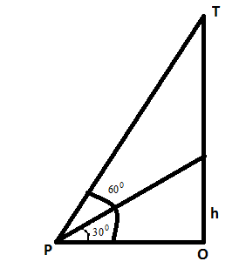 

59. **Ans (1)** 

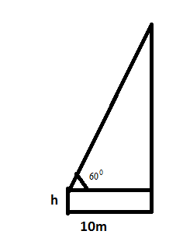

60. **Ans (1)** 