I come from Data Engineering background with expertise in Python programming, and I don’t have any knowledge of building websites. The assignment was the first website creation project I undertook, and thankfully using ChatGPT, and my basic Python knowledge, I was able to create a basic website.

While starting to build the website, I discovered that iterative prompting, and giving it time to think in terms of building each module gives better results. The observations I had during this process are written in the Notes section of every prompt.

Following are the prompts I used:

**Prompt**:

Give me code to build an ecommerce website using Python and Flask. The website should have the following functionality:

- Registration module to register new users

- Login module which log a registered user using their username and password

- Change password module to change the registered user's password

- Forgot password module to reset a new password for the registered user

- Product catalog with amount, images, and description

- Add to cart module which allows the registered user to add products from the product catalog in their cart

- Checkout and Payment module to complete the purchase

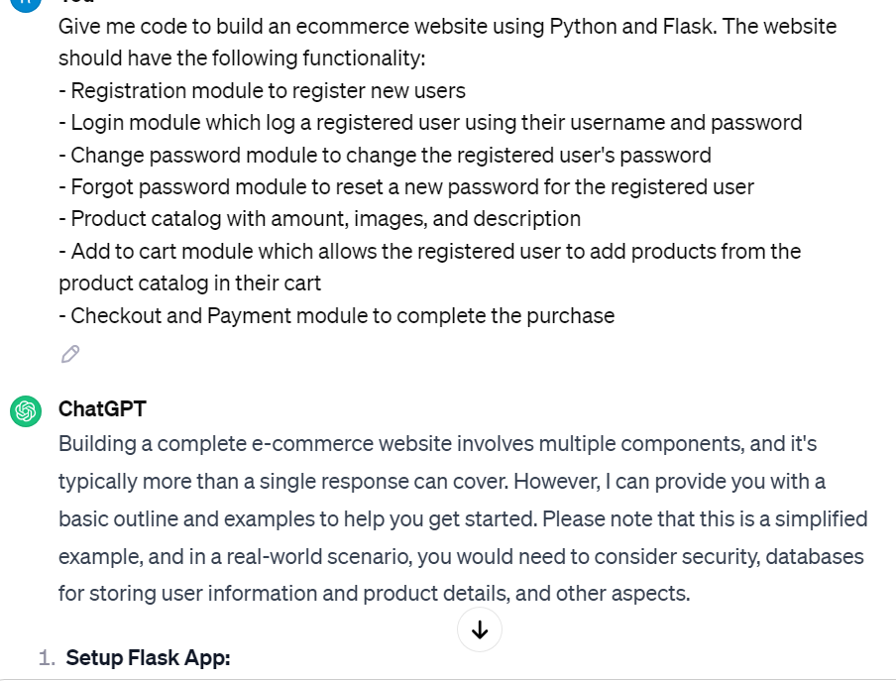

Note: This gave me a whole host of code for the above prompts. However, I discovered this would be insufficient for my purpose, and so I decided to take iterative approach and giving it time to think to build out each module individually.

I didn’t know how the project should be setup in Visual Code, so I asked it the below prompt:

Prompt: Can you give the project structure for this in Visual Code?

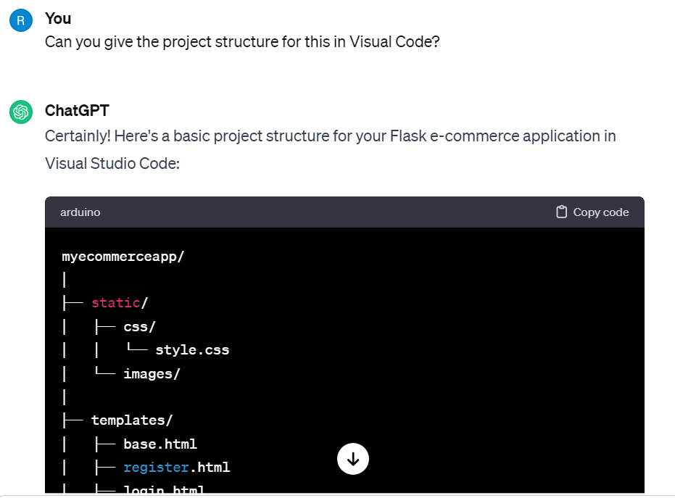

myecommerceapp/

│

├── static/

│ ├── css/

│ │ └── style.css

│ └── images/

│

├── templates/

│ ├── base.html

│ ├── register.html

│ ├── login.html

│ ├── change_password.html

│ ├── forgot_password.html

│ ├── product_catalog.html

│ ├── add_to_cart.html

│ ├── checkout.html

│ └── order_success.html

│

├── venv/ # Your virtual environment

│

├── app.py

├── products.py

└── requirements.txt

Then I asked it the contents of requirements.txt

Prompt: Can you give me the contents of requirements.txt?

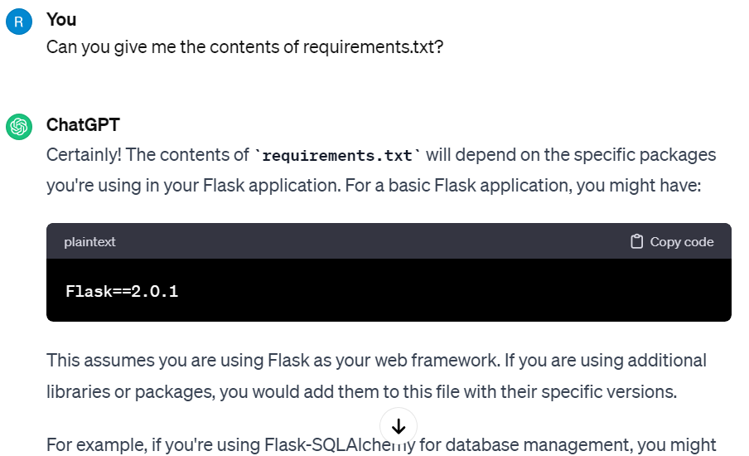

Flask==2.0.1

Flask-SQLAlchemy==3.0

After having this information, I started building out the individual module.

Prompt:

I want to create an ecommerce website using Python and Flask. There are several modules to implement, and I'll guide you through them.

To start with, when anyone tries to open the website, they should land on the Product Catalog page. The page should have products in a grid with 2 rows and 5 columns.

Each product should have a name, price, size, an image of the product, and an add to cart button.

The page should also have Login, Register, Cart, Reset Password and Forgot Password links in the navbar. I'll guide you what to do with these functionalities later. As of now, I want a placeholder for Login and Register.

Add any exception handling as necessary.

Add any colourful styling to improve the asthetics of the website.

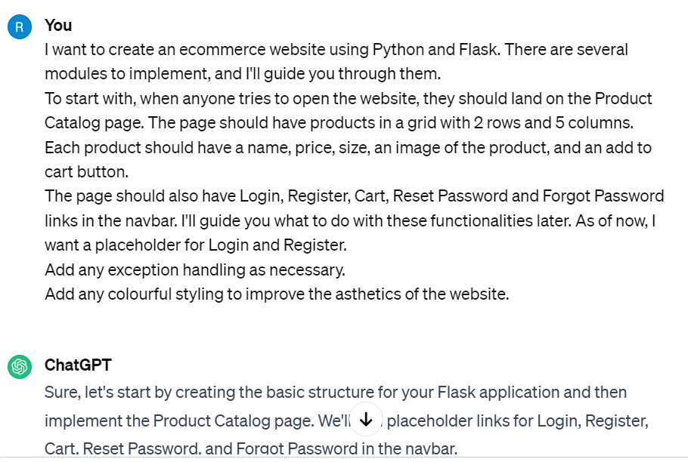

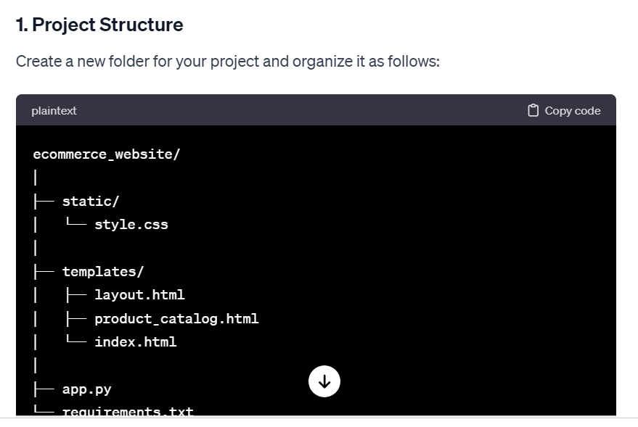

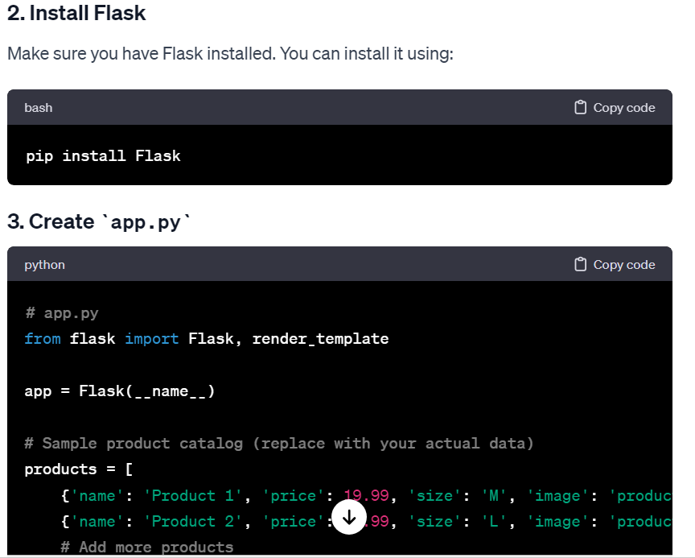

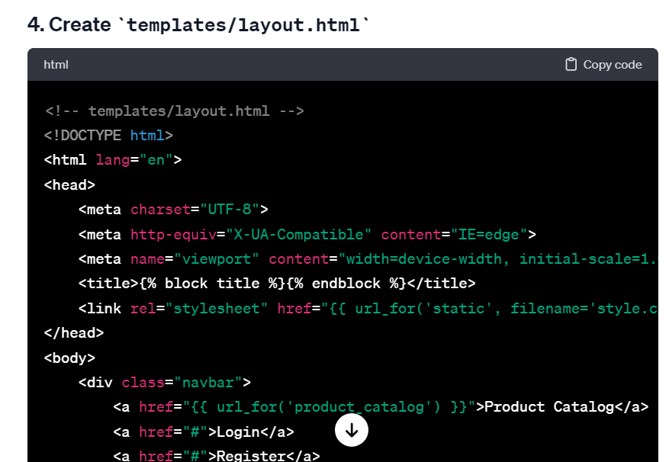

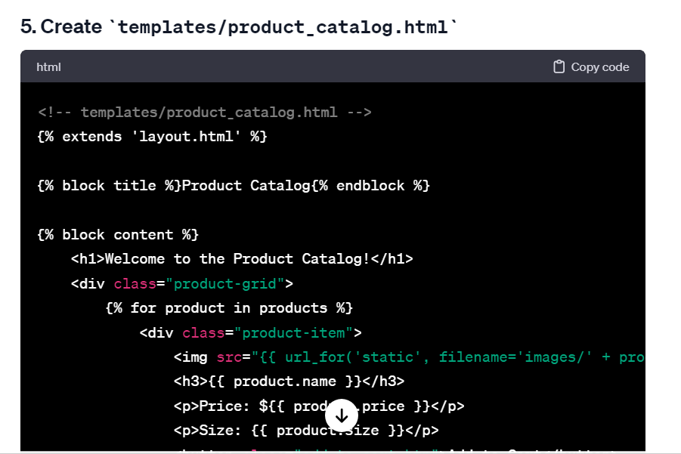

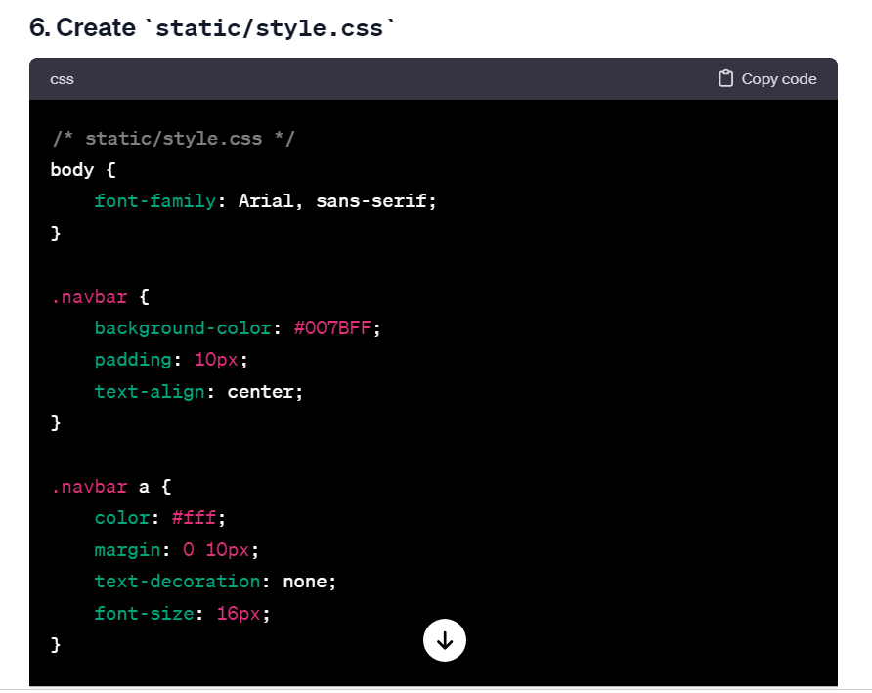

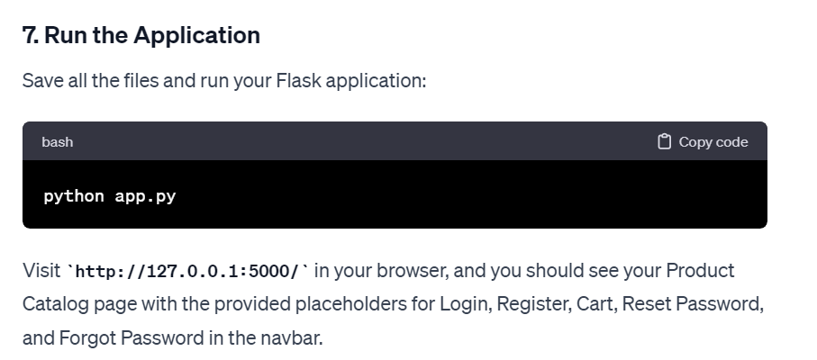

Prompt:

Can you give me the code to implement a Register User functionality?

The code should be able to store the username and password of any user who registers on the website. Once registered, they should land on the Login page.

If an existing user tries to register again, flash the message "The user is already registered."

Add any exception handling as necessary.

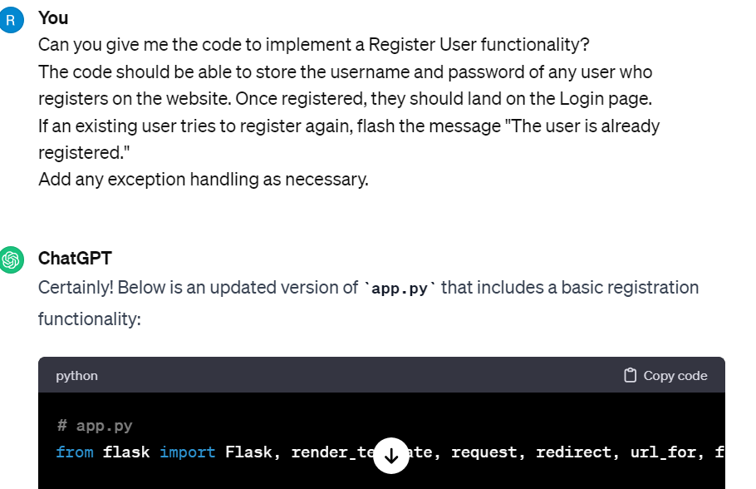

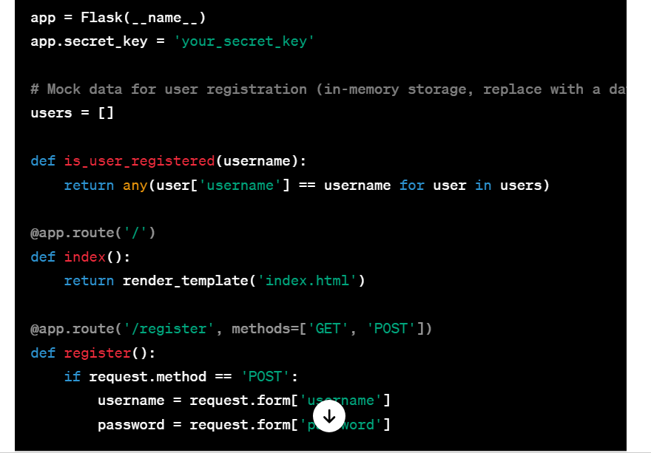

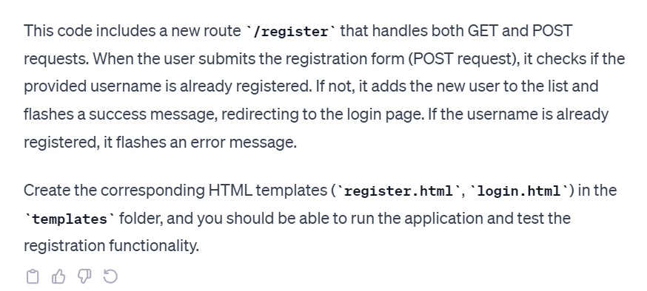

Prompt: Further to the Register User functionality developed, I now need to add a Login functionality.

Only a registered user should be able to login using the username, and password they had registered with. If their credentials are correct, they should land on the Product Catalog page.

If their credentials are incorrect, flash a message "Pls check your credentials.".

They should be able to try their username and password credentials only thrice. If it exceeds this count, flash a message "Sorry, you've exceeded login attempts for the day. Pls try after 24 hours."

Link the Login on navbar to this login functionality.

Add any error handling as necessary.

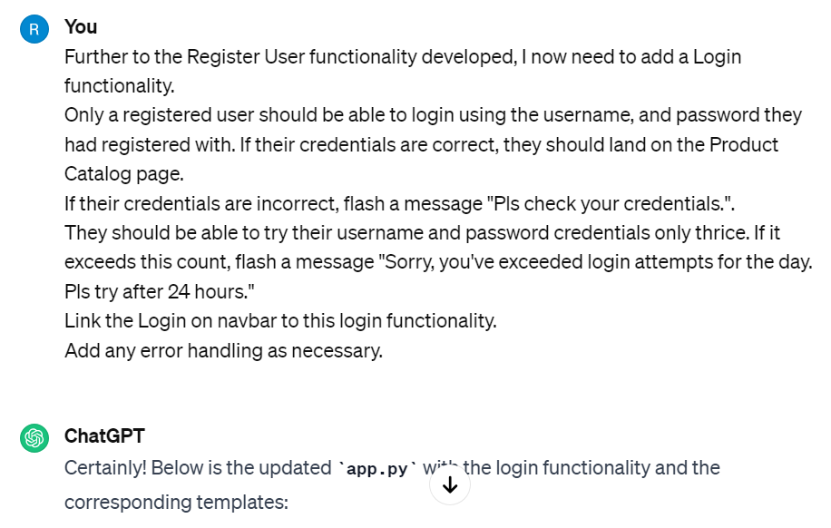

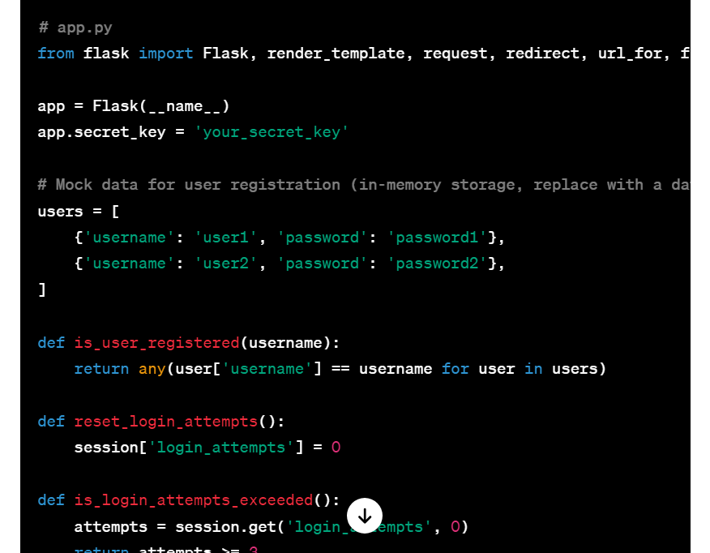

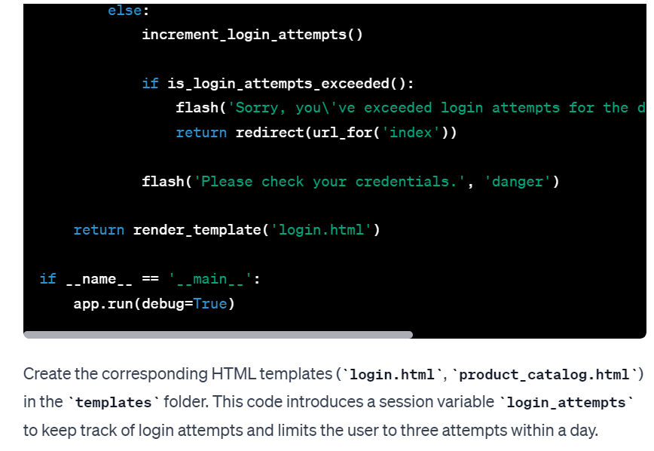

Prompt:

Add another Menu on the navbar called Cart.

When the user clicks on the Add to cart button, they should either be redirected to the register or login depending on whether they're an existing user or not.

If they're an existing user and are trying to add to cart after they've logged in successfully, they should be able to add the product to the cart. This product should then be reflected in the Cart Menu on navbar.

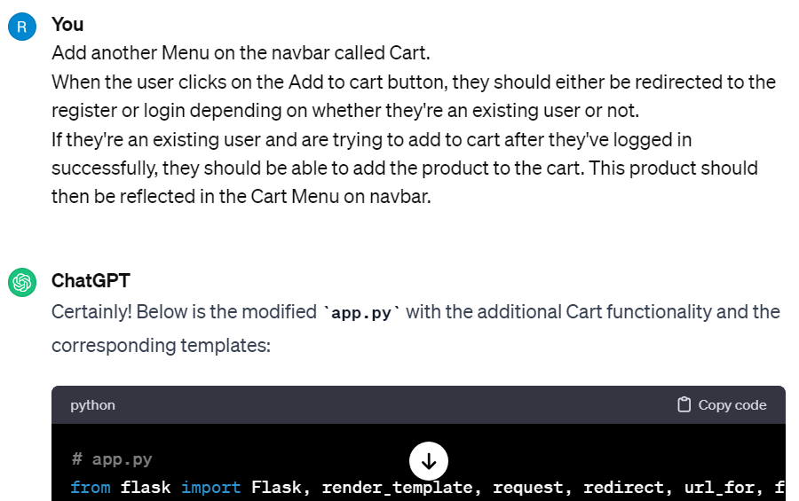

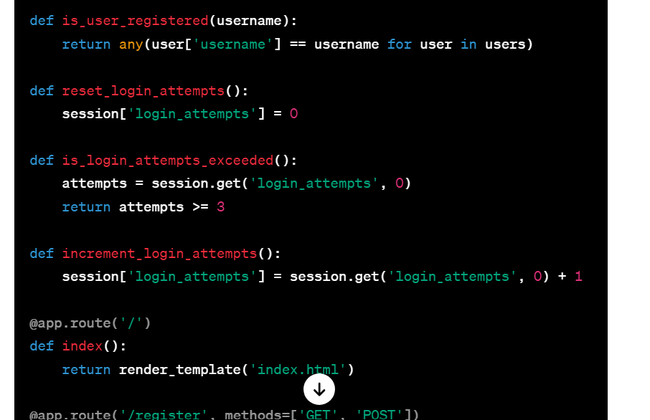

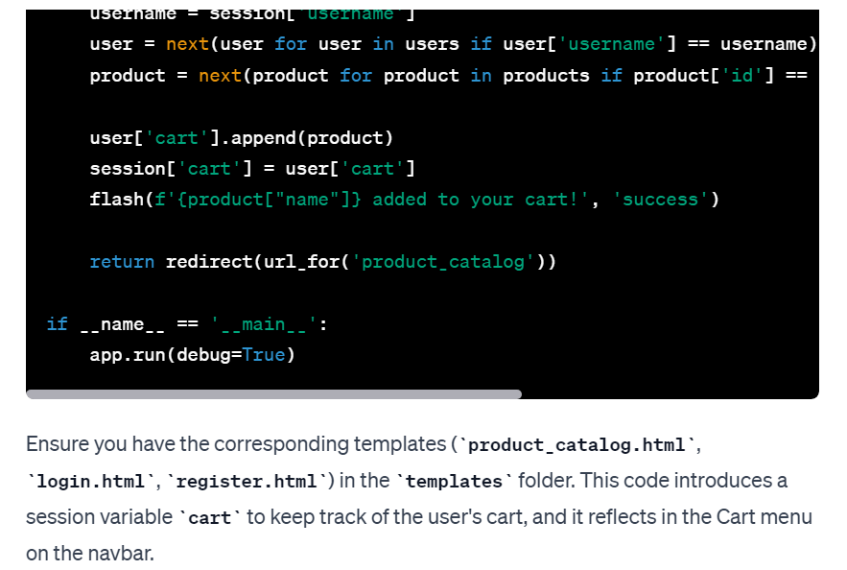

Prompt:

Once the user lands on the Cart page, have a Checkout button which should redirect the user to the Checkout page.

The checkout page should have space for adding the user's name, address, mobile number, and bank details.

It should also have a Make Payment button. Once the user clicks on Make Payment button, it should flash a message "Thanks for placing the order" and should redirect to the Product Catalog page.

Add any error handling as necessary.

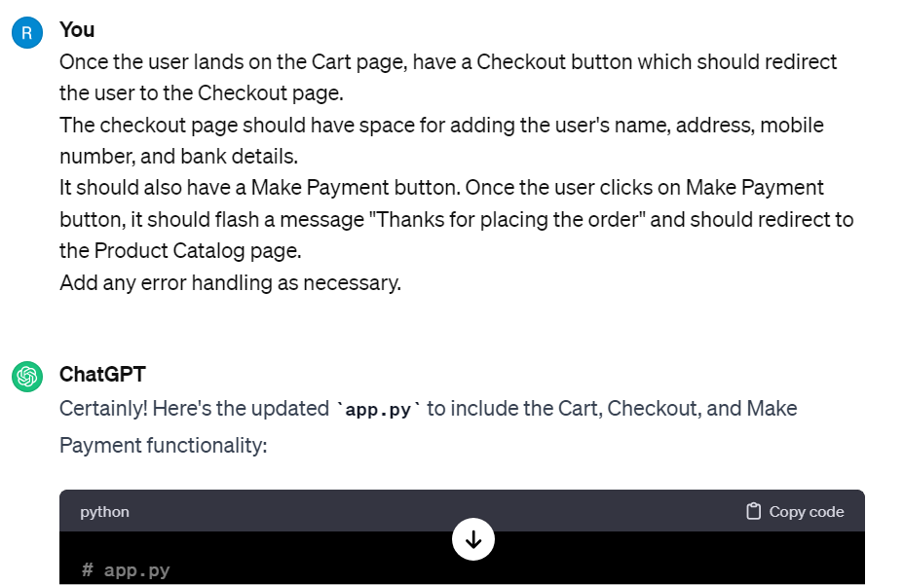

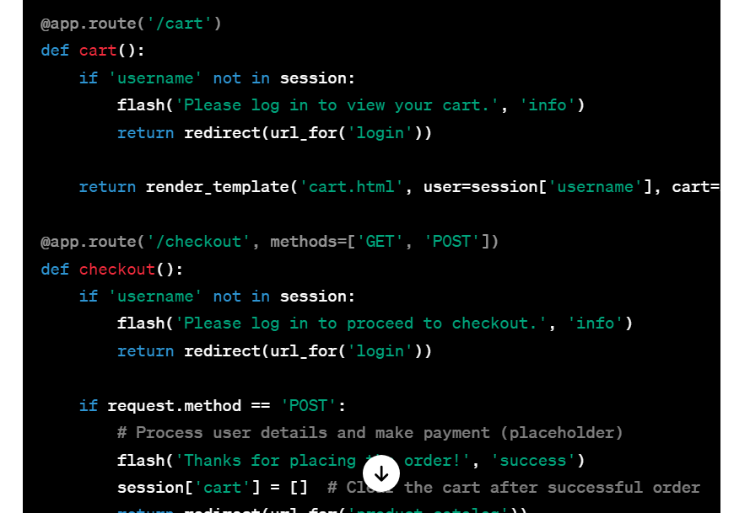

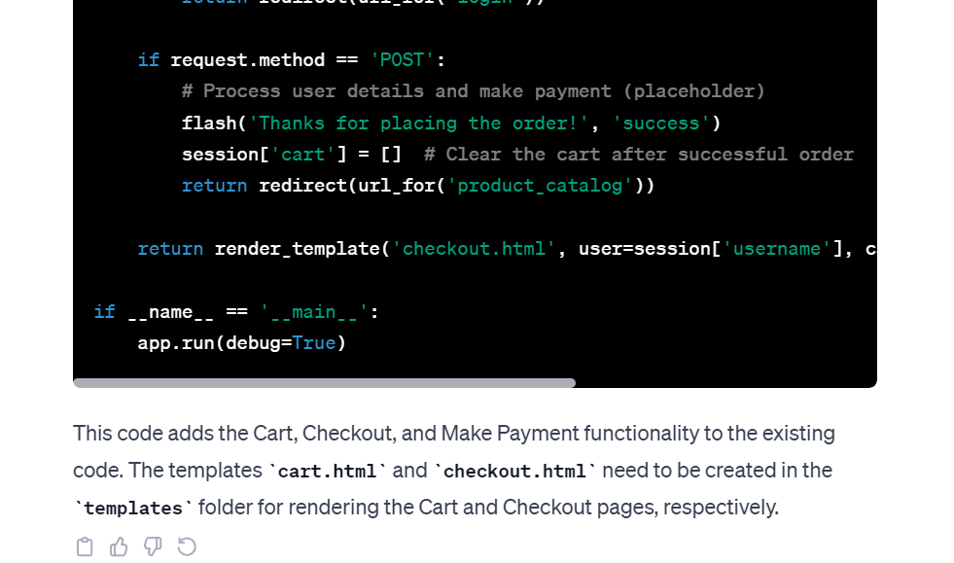

Prompt:

after a user places an order, they should get a message Your order is successfully placed. You'll get further details on the mobile number you used for placing the order.

thanks, but it should render a new html for this message. can you give me the html for this?

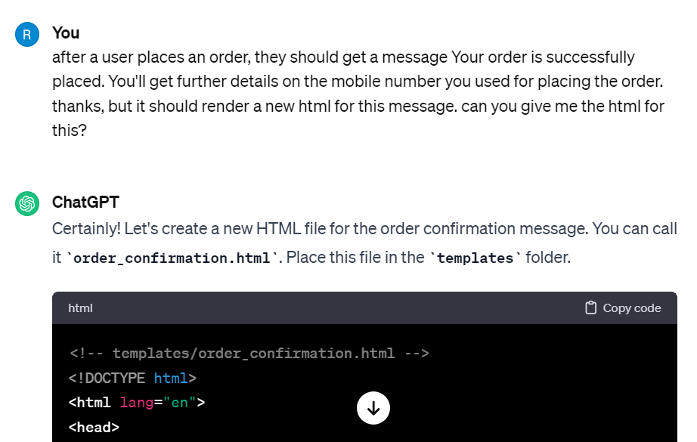

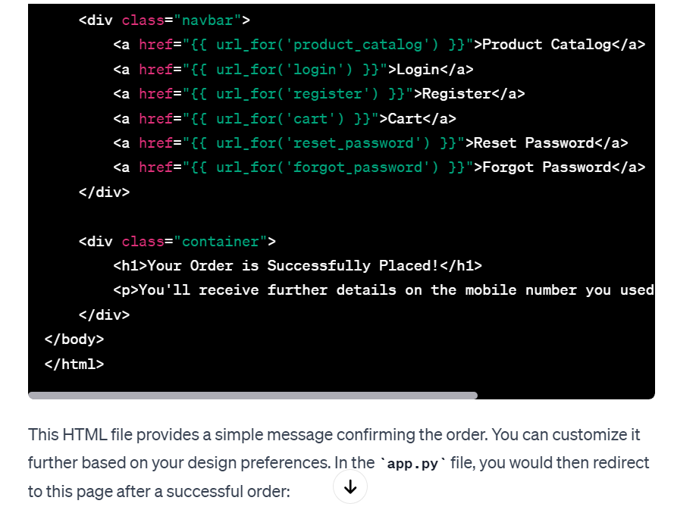

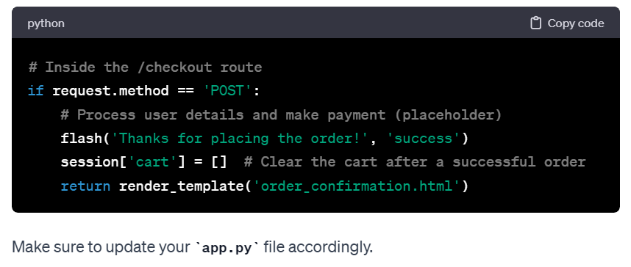

Prompt:

Write code for resetting password.

The page should ask for username, new password, and have a Reset Password button. Once the user clicks on the reset password button, they should land on the login page, and should be able to login with this new password.

The code should discard the old password that was stored, and update this new password. Have this menu in the navbar.

Add any error handling as necessary.

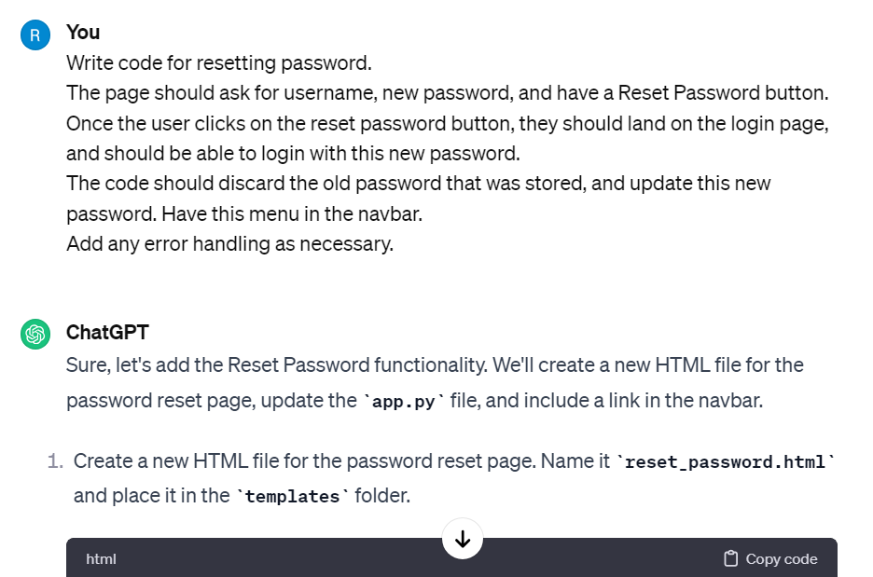

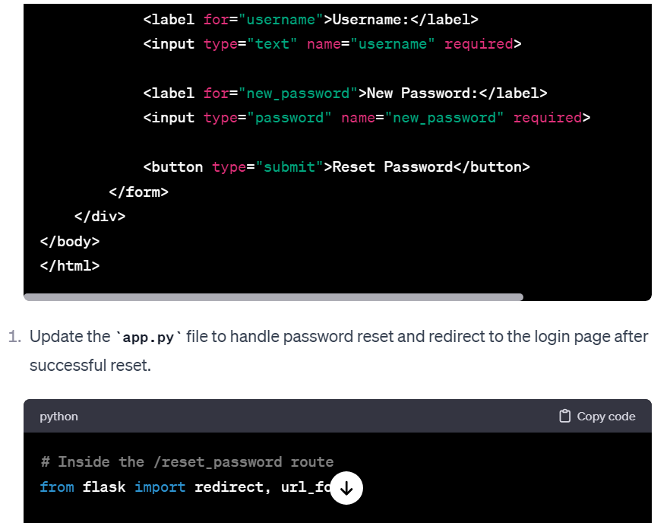

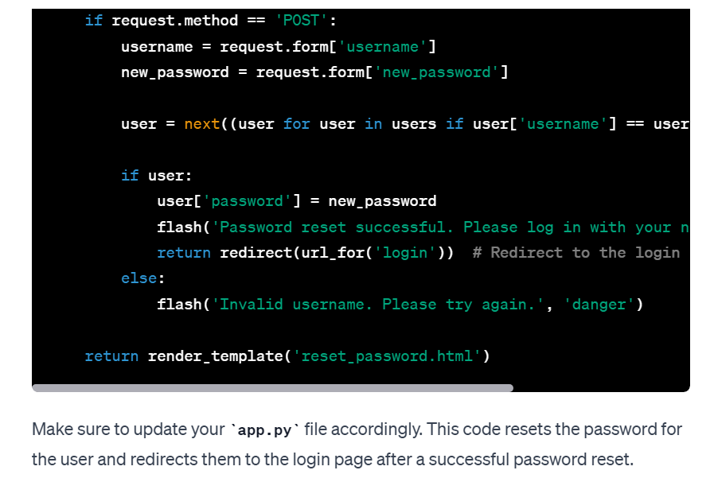

Prompt:

Write a module for Forgot Password.

Add this menu to the navbar.

Once the user clicks on Forgot Password, they should be redirected to the Reset Password page.

Add any error handling as necessary.

