Assignment-3

Rachana

2022-11-12

library(“mlbench”)

set.seed(2017)   
X=runif(100)*10   
Y=X*4+3.45   
Y=rnorm(100)*0.29*Y+Y

plot(Y~X)

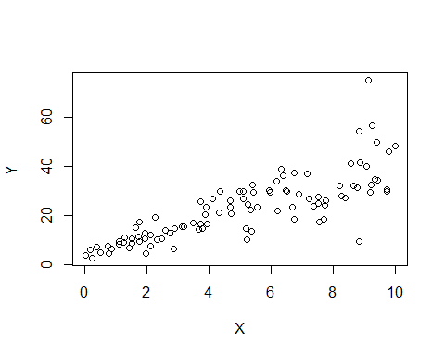 # Based on the plot do you think we can fit a linear model to explain Y based on X? #yes, i think we can fit a linear model to explain Y based on X , as X tends to increase y also increases, hence we can understsnd that there is a positive correlation between X&Y.

#Construct a simple linear model of Y based on X. Write the equation that explains Y based on X. What is the accuracy of this model?

model <- lm(Y~X)  
summary(model)

##   
## Call:  
## lm(formula = Y ~ X)  
##   
## Residuals:  
## Min 1Q Median 3Q Max   
## -26.755 -3.846 -0.387 4.318 37.503   
##   
## Coefficients:  
## Estimate Std. Error t value Pr(>|t|)   
## (Intercept) 4.4655 1.5537 2.874 0.00497 **   
## X 3.6108 0.2666 13.542 < 2e-16 ***  
## ---  
## Signif. codes: 0 '***' 0.001 '**' 0.01 '*' 0.05 '.' 0.1 ' ' 1  
##   
## Residual standard error: 7.756 on 98 degrees of freedom  
## Multiple R-squared: 0.6517, Adjusted R-squared: 0.6482   
## F-statistic: 183.4 on 1 and 98 DF, p-value: < 2.2e-16

#The equation that explains Y based on X is

$${\text Y = 4.4655 * X + 3.6108}$$

#What is the accuracy of this model?

#we can give the accuracy of the model by Multiple R - Squared Value which is 0.6517 indicating that the model is 65.17% accurate.

#Explain the relation between the Coefficient of Determination - R Squared of the model above with that to the correlation coefficient of X and Y

#Correlation coefficient of X and Y  
cor(Y,X)^2

## [1] 0.6517187

#Coefficient of Determination - R Squared  
summary(model)$r.squared

## [1] 0.6517187

#In simple linear regression models which consist of only one independent variable and one dependent variable, square of the correlation is equal to the coefficient of determination. Both the values of the coefficient of determination (r2) and the correlation coefficient of Y and X would be same.

#We will use the ‘mtcars’ dataset for this question. The dataset is already included in your R distribution. The dataset shows some of the characteristics of different cars. The following shows few samples (i.e. the first 6 rows) of the dataset. The description of the dataset can be found here.

head(mtcars)

## mpg cyl disp hp drat wt qsec vs am gear carb  
## Mazda RX4 21.0 6 160 110 3.90 2.620 16.46 0 1 4 4  
## Mazda RX4 Wag 21.0 6 160 110 3.90 2.875 17.02 0 1 4 4  
## Datsun 710 22.8 4 108 93 3.85 2.320 18.61 1 1 4 1  
## Hornet 4 Drive 21.4 6 258 110 3.08 3.215 19.44 1 0 3 1  
## Hornet Sportabout 18.7 8 360 175 3.15 3.440 17.02 0 0 3 2  
## Valiant 18.1 6 225 105 2.76 3.460 20.22 1 0 3 1

plot(mtcars$hp~mtcars$wt)

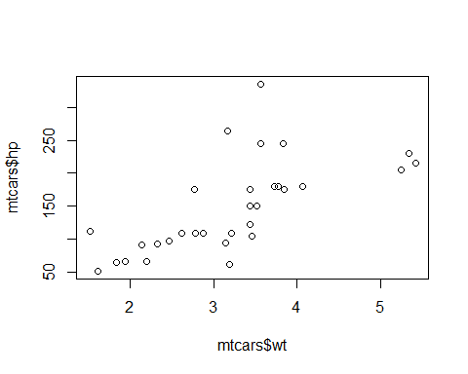

model1=lm(formula=hp~wt, data=mtcars)  
summary(model1)

##   
## Call:  
## lm(formula = hp ~ wt, data = mtcars)  
##   
## Residuals:  
## Min 1Q Median 3Q Max   
## -83.430 -33.596 -13.587 7.913 172.030   
##   
## Coefficients:  
## Estimate Std. Error t value Pr(>|t|)   
## (Intercept) -1.821 32.325 -0.056 0.955   
## wt 46.160 9.625 4.796 4.15e-05 ***  
## ---  
## Signif. codes: 0 '***' 0.001 '**' 0.01 '*' 0.05 '.' 0.1 ' ' 1  
##   
## Residual standard error: 52.44 on 30 degrees of freedom  
## Multiple R-squared: 0.4339, Adjusted R-squared: 0.4151   
## F-statistic: 23 on 1 and 30 DF, p-value: 4.146e-05

#James thinks that horse power (hp) of a car can be determined based on the weight of the car (wt) where we got the accuracy as 43.39% of the variability in horse power (hp) on weight(wt)

#Determining the Horse Power Basis the Mile Per Gallon, chris thoughts

model2 <- lm(hp~mpg,data=mtcars)  
summary(model2)

##   
## Call:  
## lm(formula = hp ~ mpg, data = mtcars)  
##   
## Residuals:  
## Min 1Q Median 3Q Max   
## -59.26 -28.93 -13.45 25.65 143.36   
##   
## Coefficients:  
## Estimate Std. Error t value Pr(>|t|)   
## (Intercept) 324.08 27.43 11.813 8.25e-13 ***  
## mpg -8.83 1.31 -6.742 1.79e-07 ***  
## ---  
## Signif. codes: 0 '***' 0.001 '**' 0.01 '*' 0.05 '.' 0.1 ' ' 1  
##   
## Residual standard error: 43.95 on 30 degrees of freedom  
## Multiple R-squared: 0.6024, Adjusted R-squared: 0.5892   
## F-statistic: 45.46 on 1 and 30 DF, p-value: 1.788e-07

#Whereas Chris thinks that horse power (hp) of a car can be determined based on the mile per gallon (mpg), from the linear model we built we got to see that 60.24% of the variability in horse power (hp) can be determined by the mile per gallon (mpg).

#hence from the results we got, we can say that hp can be determined based on mile per gallon(chrish thoughts) as it has more accuracy than weight(james).

#2(b). Build a model that uses the number of cylinders (cyl) and the mile per gallon (mpg) values of a car to predict the car Horse Power (hp)

model3 <- lm(hp~cyl+mpg,data=mtcars)  
summary(model3)

##   
## Call:  
## lm(formula = hp ~ cyl + mpg, data = mtcars)  
##   
## Residuals:  
## Min 1Q Median 3Q Max   
## -53.72 -22.18 -10.13 14.47 130.73   
##   
## Coefficients:  
## Estimate Std. Error t value Pr(>|t|)   
## (Intercept) 54.067 86.093 0.628 0.53492   
## cyl 23.979 7.346 3.264 0.00281 **  
## mpg -2.775 2.177 -1.275 0.21253   
## ---  
## Signif. codes: 0 '***' 0.001 '**' 0.01 '*' 0.05 '.' 0.1 ' ' 1  
##   
## Residual standard error: 38.22 on 29 degrees of freedom  
## Multiple R-squared: 0.7093, Adjusted R-squared: 0.6892   
## F-statistic: 35.37 on 2 and 29 DF, p-value: 1.663e-08

#Using this model, what is the estimated Horse Power of a car with 4 cylinder and mpg of 22

predict(model3,data.frame(cyl=c(4),mpg=c(22)))

## 1   
## 88.93618

#The estimated horsepower (hp) with 4 cylinders (cyl) and with a mpg of 22 is “88.93618 hp”.

#3. For this question, we are going to use BostonHousing dataset. The dataset is in ‘mlbench’ package, so we first need to instal the package, call the library and the load the dataset using the following commands

#a) Build a model to estimate the median value of owner-occupied homes (medv)based on the following variables: crime crate (crim), proportion of residential land zoned for lots over 25,000 sq.ft (zn), the local pupil-teacher ratio (ptratio) and weather the whether the tract bounds Chas River(chas). Is this an accurate model? library(mlbench)

library(mlbench)

## Warning: package 'mlbench' was built under R version 4.2.2

data(BostonHousing)   
  
model4 <- lm(medv~crim+zn+ptratio+chas,data=BostonHousing)  
summary(model4)

##   
## Call:  
## lm(formula = medv ~ crim + zn + ptratio + chas, data = BostonHousing)  
##   
## Residuals:  
## Min 1Q Median 3Q Max   
## -18.282 -4.505 -0.986 2.650 32.656   
##   
## Coefficients:  
## Estimate Std. Error t value Pr(>|t|)   
## (Intercept) 49.91868 3.23497 15.431 < 2e-16 ***  
## crim -0.26018 0.04015 -6.480 2.20e-10 ***  
## zn 0.07073 0.01548 4.570 6.14e-06 ***  
## ptratio -1.49367 0.17144 -8.712 < 2e-16 ***  
## chas1 4.58393 1.31108 3.496 0.000514 ***  
## ---  
## Signif. codes: 0 '***' 0.001 '**' 0.01 '*' 0.05 '.' 0.1 ' ' 1  
##   
## Residual standard error: 7.388 on 501 degrees of freedom  
## Multiple R-squared: 0.3599, Adjusted R-squared: 0.3547   
## F-statistic: 70.41 on 4 and 501 DF, p-value: < 2.2e-16

#Is this an accurate model?

#accuracy is 0.3599. as the accuracy is less wwe can tel, that it is not considered as a good model and dosen’t make good predicitions for business problems.

#3(b)(i). Imagine two houses that are identical in all aspects but one bounds the Charles River and the other does not. Which one is more expensive and by how much?

#Based on the above model, price of the house going to increase if the house is bound to the Charles River

#To identify home which is more expensive comparing the one that bounds the Chas river and the one’s do not, we consider the coefficient of the chas value in the above linear model. The coefficient is 4.58393, indicates that the houses that bounds by the Chas river are 4.58393 times more expensive than the houses which do not bounds by the river.

#Additionally, the dataset’s values for the Chas River are either 1 or 0, meaning that homes that are close to the river are given a value of 1, otherwise 0. Therefore, the value of houses that are not bounded by a river will not change by any amount.

#(c) Finding which of the variables are statistically important:

#All the variables including crime rate,proportion of residential land zoned for lots over 25,000 sq.ft,the local pupil-teacher ratio,the tract bounds Chas River are statistically important as they have very low p value

#(d)Determining the order of importance of the 4 variables using ANOVA analysis:

variables<-anova(model4)  
variables

## Analysis of Variance Table  
##   
## Response: medv  
## Df Sum Sq Mean Sq F value Pr(>F)   
## crim 1 6440.8 6440.8 118.007 < 2.2e-16 ***  
## zn 1 3554.3 3554.3 65.122 5.253e-15 ***  
## ptratio 1 4709.5 4709.5 86.287 < 2.2e-16 ***  
## chas 1 667.2 667.2 12.224 0.0005137 ***  
## Residuals 501 27344.5 54.6   
## ---  
## Signif. codes: 0 '***' 0.001 '**' 0.01 '*' 0.05 '.' 0.1 ' ' 1

#The importance of variables can be determined by their Sum of Squares value. Higher the Sum of squares, the more important is the variable in estimating the value of a dependent variable

#Order of importance of variables:

#1.crime rate by town-6440.8

#2.pupil-teacher ratio by town-4709.5

#3.n-proportion of residential land zoned for lots over 25,000 sq.ft.-3554.3

#4. the tract bounds along the Charles River (chas) - 667.2