**NAME: RACHANA SHETTY USN:4AL17IS036 DATE:05.08.19**

1)TASK POINTS: 5

This challenge requires you to print  HELLO WORLD! on a single line, and then print the already provided input string to [stdout](https://en.wikipedia.org/wiki/Standard_streams" \l "Standard_output_.28stdout.29).

**Input Format**

You do not need to read any input in this challenge.

**Output Format**

Print  on the first line, and the string from the given input on the second line.

**Sample Input 0**

Welcome to C programming.

**Sample Output 0**

Hello, World!

Welcome to C programming.

SOLUTION:

#include <stdio.h>

#include <string.h>

#include <math.h>

#include <stdlib.h>

int main()

{

char s[100];

scanf("%[^\n]%\*c", &s);

printf(“%s”);

return 0;

}

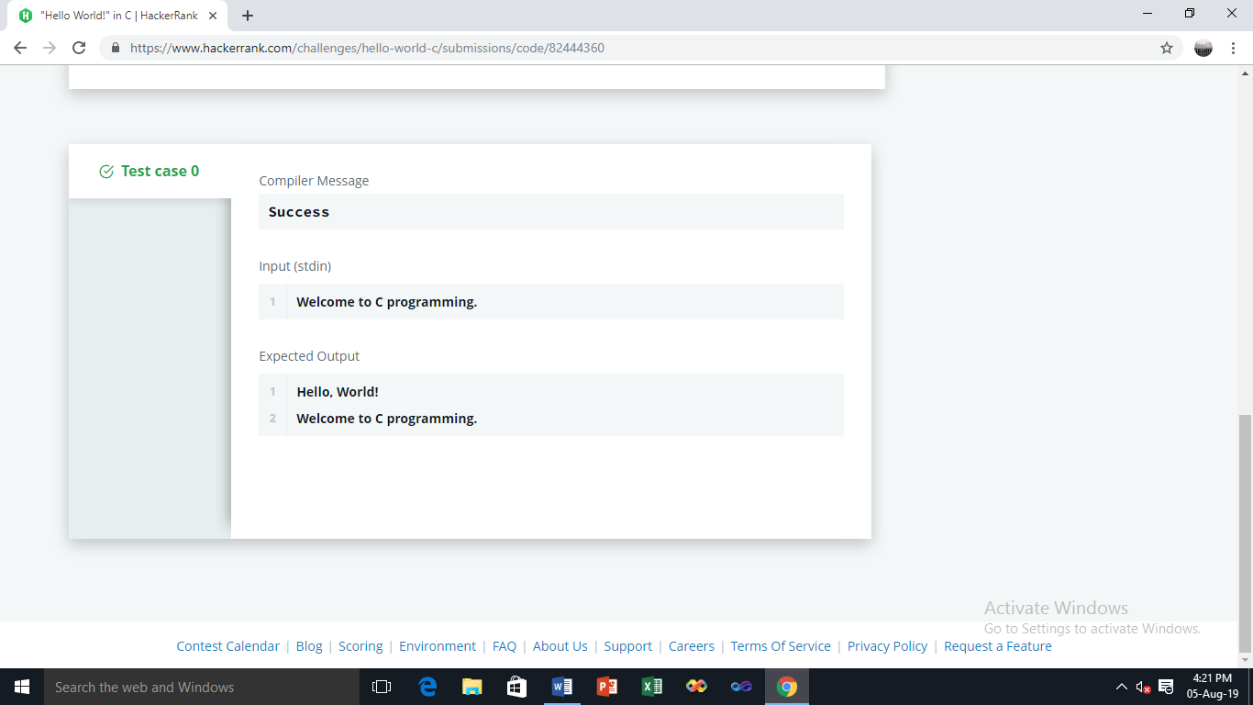

-------------------------------------------------------------------

**2) Task**

Your task is to take two numbers of int data type, two numbers of float data type as input and output their sum:

1. Declare  variables: two of type int and two of type float.
2. Read  lines of input from stdin (according to the sequence given in the 'Input Format' section below) and initialize your variables.
3. Use the  and  operator to perform the following operations:
   * Print the sum and difference of two int variable on a new line.
   * Print the sum and difference of two float variable rounded to one decimal place on a new line.

**Input Format**

The first line contains two integers.   
The second line contains two floating point numbers.

**Constraints**

* integer variables
* float variables

**Output Format**

Print the sum and difference of both integers separated by a space on the first line, and the sum and difference of both float (scaled to  decimal place) separated by a space on the second line.

**Sample Input**

10 4

4.0 2.0

**Sample Output**

14 6

6.0 2.0

**SOLUTION:**

**#include <stdio.h>**

**#include <string.h>**

**#include <math.h>**

**#include <stdlib.h>**

**int main()**

**{**

**int i, j;**

**float f, g;**

**scanf("%d %d %f %f", &i, &j, &f, &g);**

**printf("%d %d\n%.1f %.1f", i+j, i-j, f+g, f-g);**

**return 0;**

**}**

**OUTPUT:**

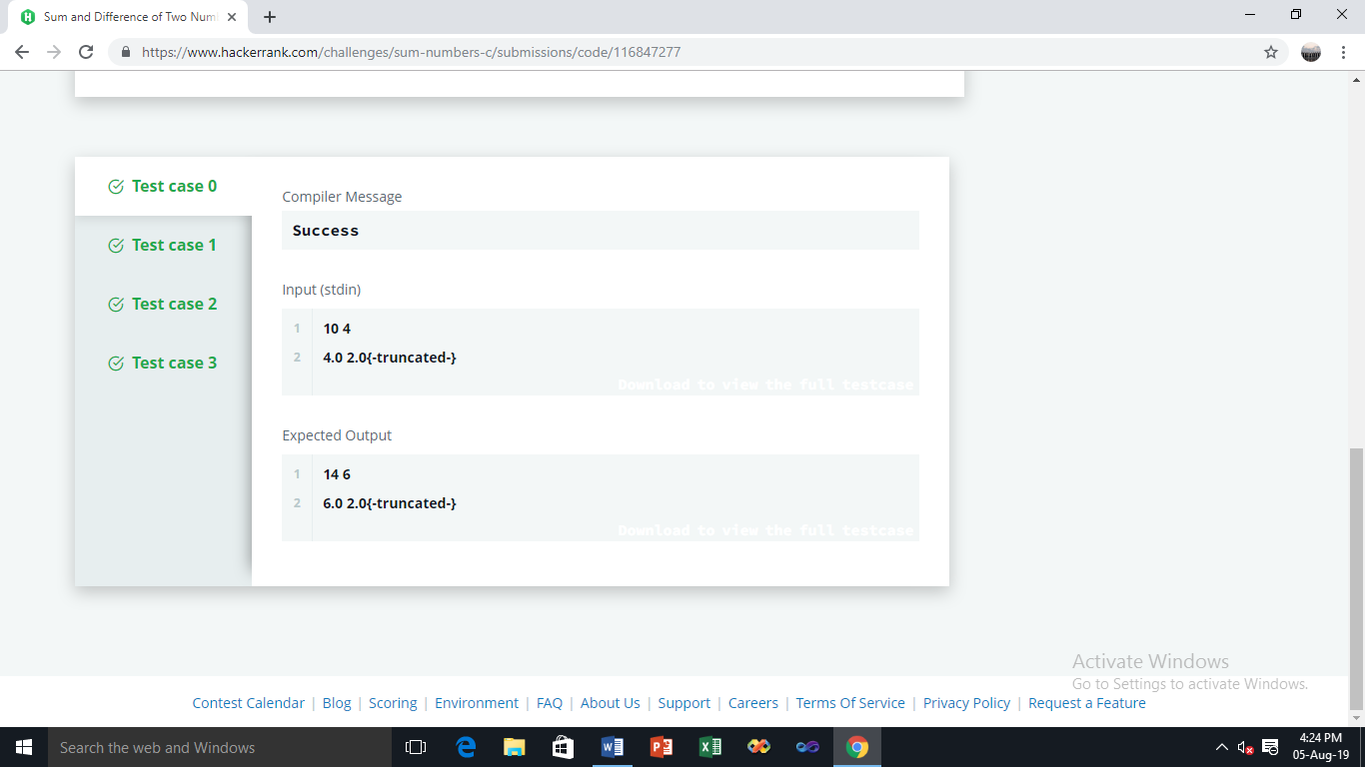

**POINTS:5**

# 3)Functions in C

**Task**

You have to write a function int max\_of\_four(int a, int b, int c, int d) which reads four arguments and returns the greatest of them.

+= : Add and assignment operator. It adds the right operand to the left operand and assigns the result to the left operand.

a += b is equivalent to a = a + b;

**Input Format**

Input will contain four integers -  , one in each line.

**Output Format**

Print the greatest of the four integers.   
Note: I/O will be automatically handled.

**Sample Input**

3

4

6

5

**Sample Output**

6

# SOLUTION:

# #include <stdio.h>

# int max\_of\_four(int a, int b, int c, int d)

# {

# int m1,m2;

# return((m1=a>b?a:b)>(m2=c>d?c:d))?m1:m2;

# 

# }

# int main() {

# int a, b, c, d;

# scanf("%d %d %d %d", &a, &b, &c, &d);

# int ans = max\_of\_four(a, b, c, d);

# printf("%d", ans);

# 

# return 0;

# }

# OUTPUT:

# 

# POINTS:10

# 4) Pointers in C

**Task**

You have to complete the function void update(int \*a,int \*b), which reads two integers as argument, and sets  with the sum of them, and  with the absolute difference of them.

**Input Format**

The input will contain two integers,  and , separated by a newline.

**Output Format**

You have to print the updated value of  and , on two different lines.

Note: Input/ouput will be automatically handled. You only have to complete the function described in the 'task' section.

**Sample Input**

4

5

# SOLUTION:

# #include <stdio.h>

# #include<stdlib.h>

# void update(int \*a,int \*b) {

# \*a=\*a+\*b;

# \*b=abs(\*a-(2\*\*b));

# 

# }

# int main() {

# int a, b;

# int \*pa = &a, \*pb = &b;

# 

# scanf("%d %d", &a, &b);

# update(pa, pb);

# printf("%d\n%d", a, b);

# return 0;

# }

# 

# POINTS:10

5) **Task**

In this challenge, you have to input a five digit number and print the sum of digits of the number.

**Input Format**

The input contains a single five digit number, .

**Constraints**

**Output Format**

Print the sum of the digits of the five digit number.

**Sample Input 0**

10564

**Sample Output 0**

16

# SOLUTION:

# #include <stdio.h>

# #include <string.h>

# #include <math.h>

# #include <stdlib.h>

# int main() {

# 

# int n,sum=0;

# scanf("%d", &n);

# while(n>0){

# sum=sum+(n%10);

# n=n/10;

# }

# printf("%d",sum);

# return 0;

# 

# }

# OUTPUT:

# 

**POINTS:15**