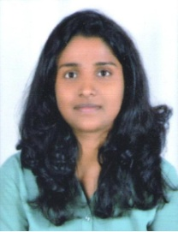

**RACHANA D SURSE**

Mayur society jail road, Nashikroad

Contact no:8378946832

Email:rachana2568@gmail.com

|  |
| --- |
| Career Objectives |

To work on a challenging job profile which provides an opportunity to enhance my technical skills and knowledge this could provide me as insight into new aspect so that it would be helpful for my career.

|  |
| --- |
| Academic |

* Bachelor Of Information Technology Engineering From Met Bkc Clg,Adgaon Nashik 2019(65.26%)
* Completed 12th Science From Maharashtra Junior Clg Khaperkheda,Nagpur 2014(59.08%)
* Completed 10th From Jawaharlal Nehru Port Vidyalaya,Uran New Mumbai 2012(72.36%)

|  |
| --- |
| Technical Skills |

* Programming language:java,Html

|  |
| --- |
| Strength |

* Work with positive attitude.
* Self confidence And Great Patience.
* Willingness to Learn.
* Adaptability to change enviornment

|  |
| --- |
| Co-Curriculum |

* Done the Project In Last Year Of Engineering Was Smart Survillence System For Shopping Malls.

|  |
| --- |
| Personal Information |

DOB:7 Dec 1996

Marital Status:Single

Nationality : Indian

Hobbies:Listening Music,Painting

Languages:Marathi , Hindi , English

|  |
| --- |
| Declaration |

I here by declare that above information is true and correct to the best of my knowledge.

Date:

Place: (RachanaSurse.)