AI Based Question Answering System
Dr Manimala S¹, Yellapu Prahasith², Vivek R Navale³ , Dhanush Srinath⁴, Fiza N Shaikh⁵
^{1,2,3,4} B.E Student, Dept. of Computer Science Engineering, JSS Science & Technology University, Mysore, India - 570006
⁵ Faculty, Dept. of Computer Science Engineering, JSS Science & Technology University, Mysore, India - 570006

---------------------------------------------------------------------***---------------------------------------------------------------------

Abstract – Academic assessments are the only available metrics of evaluating student knowledge today. But the current procedure of manually setting questions and evaluating student answers tend to be hectic, expensive and time-consuming. Human intervention in the entire process consumes instructors’ valuable time and can end up being biased intentionally or unintentionally. The goal of this project is to build an automated software module to provide an inexpensive and a more effective alternative to the existing examination system. The software will assess students’ knowledge in the particular courses by generating potential questions and evaluating the student’s understanding of the course. Natural language Processing Toolkit is used to understand and interpret the user answers along side some open-source machine learning modules which ensure the software performance is accurate and reliable.

Key Words: Subjective Question-Answer Generation, Objective Question-Answer Generation, Subjective Answer Evaluation, Keywords Extraction

1.INTRODUCTION

Examination systems were introduced into the education system to understand and evaluate learner’s understanding of the course but over course of time, the examination system became competitive in nature and no longer tends to serve the purpose of evaluating the learner and provisioning him to improve. Newer technologies and inventive approaches for teaching courses have arrived but there haven’t been any measures taken to ensure proper testing of their knowledge, without making it biased or unfair.

A good assessment should test the knowledge of the learner thoroughly in the course and should evaluate learner understanding using fair means. It must also ensure that the conduction of the assessment is undergone in malpractice free environment, thus ensuring the assessment is fair.

With the help of Natural Language Processing Toolkit the learner responses and subject material is processed by the machine learning models, that extract key words like important headings and phrases from the subject material to frame questions around the same.

For objective questions, a pre-trained machine learning module is used to generate distractor options which are close to the correct answer, to increase the difficulty of the question and challenge the learner.

The learner understanding is evaluated by checking for the similarity between the correct answer and learner response using mathematical vector notations. `

2. LITERATURE SURVEY

2.1 TEXT SUMMARISATION USING PRE-TRAINED TRANSFORMER

The review paper titled “Sample Efficient Text Summarisation using a Single Pre-Trained Transformer” by Urvashi Kandelwal, Kevin Clark, Dan Jurafsky, Lukasz Kaiser revolves around summarisation of a large document of text into a smaller meaning that conveys the context and abstract of the document.

2.2 COSINE SIMILARITY TO CALCULATE TEXT RELEVANCE BETWEEN TWO DOCUMENTS

The review paper titled “The implementation of Cosine Similarity to Calculate Text Relevance between Two Documents” by D Gunawan, C A Sembiring, M A Budiman deals with the relevance between two documents by using text similarity measures such as cosine similarity. This research utilizes a classification algorithm called Naïve Bayes to provide web pages’ similarity.

2.3 EXTRACTIVE TEXT SUMMARISATION USING DEEP NATURAL LANGUAGE FUZZY PROCESSING

The review paper titled “Extractive Text Summarisation using Deep Natural Language Fuzzy Processing” b Neelima G, Veeramanickam M.R.M, Sergey Gorbachev, Sandip A. Kale revolves around summarization of document into smaller meaning and useful set of sentences. It uses a fuzzy logic, where the Naïve-Bayes approach is deployed to determine the important sentences from the given document.

2.4 UNSUPERVISED KEYPHRASE EXTRACTION USING MASKED DOCUMENT EMBEDDING

The review paper tiled “A Masked Document Embedding Rank Approach for Unsupervised Key-phrase Extraction” by Linhan Zhang, Qian Chen, Wen Wang, Chong Deng, Shiliang Zhang, Bing Li, Wei Wang, and Xin Cao revolves around extracting keywords from a large document of text. It uses a BERT-Based model to generate the keywords. It selectively masks words in the document based on their relevance and use, thus extracting key phrases.

3. PROPOSED WORK

The proposed solution is a two interfaced platform, for the two user groups, tutor and learner. The platform is initiated with a tutor uploading the respective subject material required for the working of the software. The student assessments are made available to use followed by this. Two types of assessments are generated for each uploaded subject material, objective and subjective questions. The questions are generated using the software and once the questions are generated, the answer pairs for all the above questions are produced. Additionally, for MCQ type questions, distractor options that are similar to the actual answers are created to challenge the learner. After generation of the question-answer pair, the user responses for all the questions in the assessment are calculated and evaluated with the ideal answers generated for respective questions. Based on how similar the response and the ideal answers are, a score is generated for the student to assess their performance in the assessment.

3.1 SYSTEM ARCHITECTURE

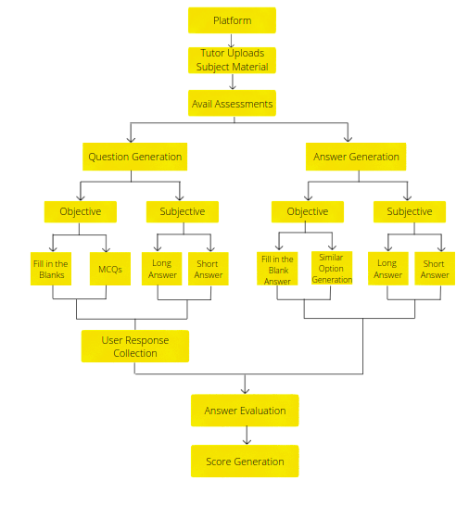
Figure 1 - Flow Chart

A. Question Generation – The subject material uploaded by the tutor is processing using Natural Language Processing techniques and based on the processing, questions are generated from the subject material based on their relevance with the subject.

B. Answer Generation – The answers to the formed questions are identified from the corpus and generated as a pair of question and answers, which will later be utilized to compare and contrast the learner performance.

C. Answer Evaluation – The answers evaluation is performed by measuring the similarity distance between the ideal answers generated and learner responses.

3.2 ML MODELS AND PARAMETERS

The questions answer generation is performed using open-source Google produced BERT Model also known as the hugging face model. It performs keyword extraction on the obtained text corpus. Alongside this open-source model, other open-source pre trained models like race-distractors model, multitask qg-ag model and sv2 model for the processing of the natural language and to predict the question and answers from the text corpus.

3.3 METHODOLOGY

3.3.1 SUBJECTIVE QUESTION ANSWER GENERATION

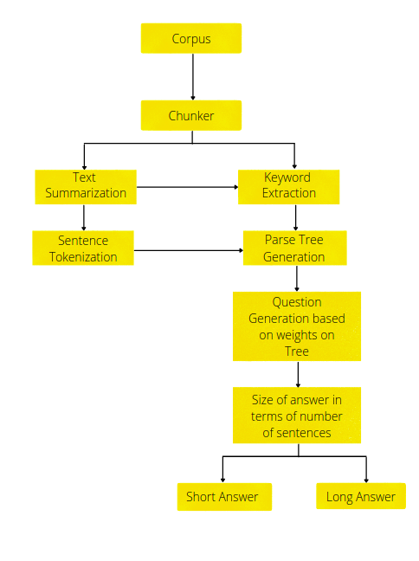
Figure 2 - Subjective Question Answer Generation

The corpus is first divided into chunks and then text summarization is performed. The summarized text is later tokenized as sentences, which form the parse tree. Simultaneously the model also generates keywords using BERT model and sv2 model which are used as weights on the parse tree and based on the keywords and weights on sub tree, subjective questions are generated by appending the keyword to one of the existing 7 question frames that suit the keyword and context better. The ideal answer is then generated from the parse tree.

3.3.2 OBJECTIVE QUESTION ANSWER GENERATION

The corpus first undergoes text summarization using BERT model and then the summarized text undergoes keyword extraction to find potential answers to generate objective questions. Once relevant keywords are extracted suing sv2 model, questions are generated by omitting the keywords in the sentences. Multiple options are created to that question using race-distractors which created key words from the given corpus that have high relevance and similarity to the answer.
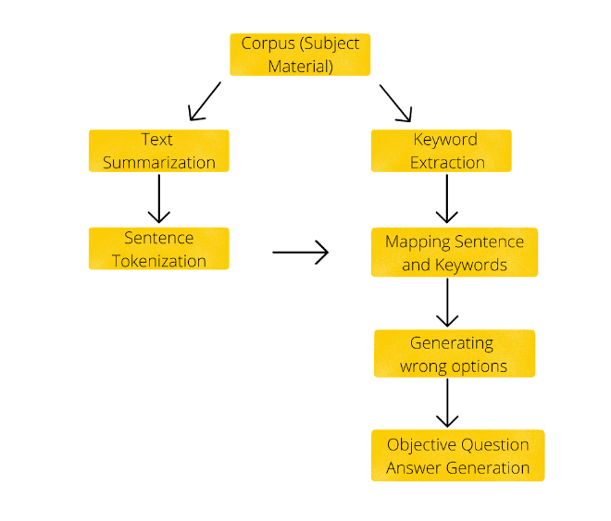
Figure 3 - Objective Question Answer Generation

3.3.3 SUBJECTIVE ANSWER EVALUATION

Subjective score is generated using 3 similarity measures to ensure that the score generated is absolutely credible and doesn’t deviate much from the human score. The 3 similarity measures used are Synset similarity to check the similarity of words with even their synonyms, Cosine similarity to vectorize the words and check for text angle difference, Jaccard similarity to ensure the main keywords aren’t missing from the user response.

4. RESULTS

The proposed model was implemented over 100 sample subject material with varying noise and subject content. The questions generated for the following subject material <link sample subject material> are :

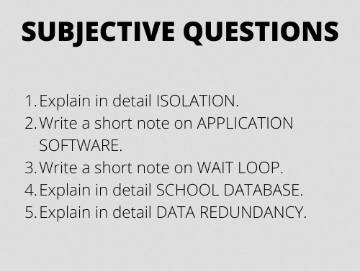
Figure 4 - Subjective Questions generated on following sample corpus <link sample corpus>
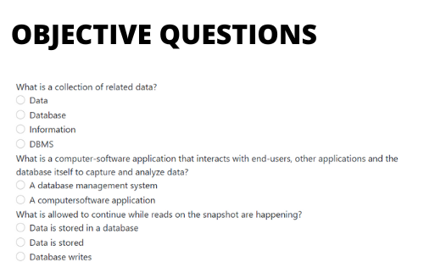
Figure 5 – Objective Questions generated on same corpus
The model accuracy in evaluating the learner knowledge to the posed questions is compared and contrasted below.
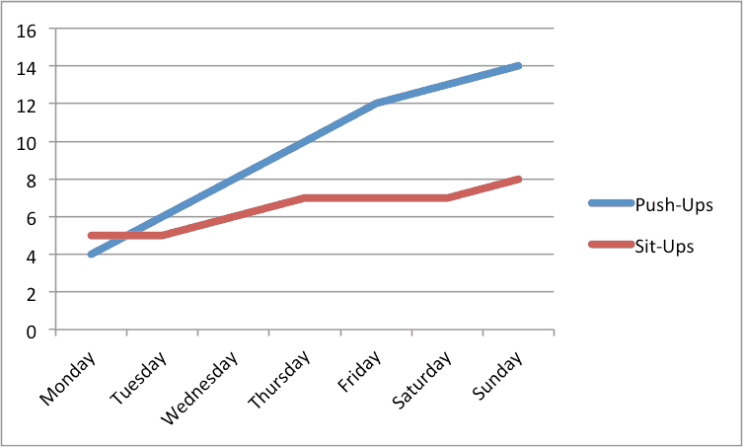
Figure 6 – Line graph of actual score vs Model score on the following sample corpus link

5. CONCLUSIONS

The proposed AI Based Question answering system aims to reduce the favourism in the assessment system and create impactful assessment that help learner understand the course better. But the proposed system is limited to subjects that don’t involve diagrams or mathematical formulation and derivations. Also, evaluation of literature could pose challenges to the system as such evaluations are based on perspectives and can vary from person to person.

The model can be improved by using new age technologies like Image-Alt to frame questions on diagrams by understanding the meaning of images in the corpus. Also, Neural Network Models can be utilized to identify patterns in learner assessment approach and give a personalized training recommendation for the learner where analysis is performed on learner’s weak concepts and more support can be provided to the learner to understand those concepts better.

ACKNOWLEDGEMENT

It gives us immense pleasure to write an acknowledgement to this project, a contribution of all the people who helped to realize it. We extend our deep regards to Dr. S.B. Kivade, Honorable Principal of JSS Science and Technology University, for providing an excellent environment for our education and his encouragement throughout our stay in college. We would like to convey our heartfelt thanks to our HOD, Dr. M.P. Pushpalatha, for giving us the opportunity to embark on this topic. We would like to thank our project guide, Dr. Manimala S for their invaluable guidance and enthusiastic assistance and for providing us support and constructive suggestions for the betterment of the project, without which this project would not have been possible. We appreciate the timely help and kind cooperation of our lecturers, other staff members of the department and our seniors, with whom we have come up all the way during our project work without whose support this project would not have been a success. Finally, we would like to thank our friends for providing numerous insightful suggestions. We also convey our sincere thanks to all those who have contributed to this learning opportunity at every step of this project.

REFERENCES

- Sijimol P J, Surekha Mariam Varghese, Handwritten Short Answer Evaluation System (HSAES).
- Md. Motiur Rahman, Fazlul Hsan Siddiqui, NLP-based Automatic Answer Script Evaluation.
- Ghader Kurdi, Jared Leo, Bijlan Parsia, Ulli Sattler, Salam Al-Emari, A Systematic Review of Automatic Question Generation for Educational Purposes.
- Holy Lovenia, Felix Limanta, Agus Gunawan, Automatic Question-Answers Pairs Generation From Text.
- Bidyut Das, Mukta Majumder, Santanu Phadikar, Arif Ahmed Sekh, Automatic Question Generation and Answer Assessment: A Survey.

BIOGRAPHIES

 | Dr Manimala S,  Professor at JSS Science & Technology University,  Dept. of Computer Science Engineering
 | Yellapu Prahasith  Student of JSS Science & Technology University,  Dept. of Computer Science Enginerring
 | Vivek R Navale  Student of JSS Science & Technology University,  Dept. of Computer Science Enginerring
 | Dhanush Srinath  Student of JSS Science & Technology University,  Dept. of Computer Science Enginerring
 | Fiza N Shaikh  Student of JSS Science & Technology University,  Dept. of Computer Science Enginerring

