INAPPROPRIATE & ABUSIVE CONTENT CENSORSHIP
Rachana P Bennur¹, Samruddhi C Shetty², Anagha P³ , Hema G R⁴, Prof. Shalini K C⁵
^{1,2,3,4} B.E Student, Dept. of Computer Science Engineering, JSS Science & Technology University, Mysore, India - 570006
⁵ Faculty, Dept. of Computer Science Engineering, JSS Science & Technology University, Mysore, India - 570006

---------------------------------------------------------------------***---------------------------------------------------------------------

Abstract – With the growth and easy access of internet, kids today have access to content that are not appropriate for their age. Studies have shown that this can impact their mental development negatively. To prevent a kid from watching inappropriate content, while not affecting the eligible users, is important. The current solutions that determine the user based on the login credentials is not efficient in combating the problem. This project is an attempt to provide safe streaming environment by classifying the videos as nsfw or sfw and to actively predicting the age of the user while he tries to watch a nsfw video. If the user is underaged, the video will be blocked. Further, every comment is checked for its toxicity before pasting on the platform.

Key Words: Age Prediction, Video Classification, Sentiment Analysis, Non-Safe For Work (NSFW), Safe For Work (SFW).

1.INTRODUCTION

Social media today is one of the best ways to connect to people, learn and engage in communications. With several social media platforms available, streaming videos has become a primary entertainment on social media. However, sites across internet have content varying from age-appropriate to age-inappropriate videos. Such age-inappropriate videos can affect the mental development of kids.

However, it is difficult for the parents to keep a check constantly on the content that children watch. Currently the streaming platforms blocks the NSFW content based on the age that the user has given in the login credentials. However, there is a loophole that the account belonging to an adult could be used by a kid to watch NSFW content.

In order to combat this issue, we are building an age prediction module, which predicts the age of the user actively by capturing real time facial images when the user clicks on any video that is labelled as “age-inappropriate”. The content is blocked to the user if their age is determined as underaged (below 12). With the help of pre-trained machine learning modules, the video content uploaded on the streaming platform is labelled as “Safe for Work” and “Not Safe for Work”.

User’s safe streaming is further ensured by inclusion of censorship over abusive comments, where all the comments of a video undergo sentiment analysis and if the comments turn out to be toxic or inappropriate, they are either blurred or are not displayed to the other users in the comments section.

2. LITERATURE SURVEY

2.1 EXTRACTIVE TEXT SUMMARISATION USING DEEP NATURAL LANGUAGE FUZZY PROCESSING

The review paper titled “Extractive Text Summarisation using Deep Natural Language Fuzzy Processing” by Neelima G, Veeramanickam M.R.M, Sergey Gorbachev, Sandip A. Kale revolves around summarization of document into smaller meaning and useful set of sentences. It uses a fuzzy logic, where the Naïve-Bayes approach is deployed to determine the important sentences from the given document.

2.2 UNSUPERVISED KEYPHRASE EXTRACTION USING MASKED DOCUMENT EMBEDDING

The review paper titled “A Masked Document Embedding Rank Approach for Unsupervised Key-phrase Extraction” by Linhan Zhang, Qian Chen, Wen Wang, Chong Deng, Shiliang Zhang, Bing Li, Wei Wang, and Xin Cao revolves around extracting keywords from a large document of text. It uses a BERT-Based model to generate the keywords. It selectively masks words in the document based on their relevance and use, thus extracting key phrases.

2.3 GENDER AND AGE DETECTION USING DEEP LEARNING

The review paper titled “Gender and Age Detection Using Deep Learning Techniques” by Prof. Supriya Mandar Khatavkar, Abhinav Banerjee, Hemanka Sarma, Anurag Sharma, revolves around estimating the age of an individual by using Convolution Neural Network algorithms (CNN) to extricate the facial features.

2.4 SENTIMENT ANALYSIS IN SOCIAL MEDIA

The review paper titled “Sentiment Analysis in Social media and It’s Application: Systematic Literature Review” by Zulfadzli Drus, Haliyana Khalid explores around utilizing the high-density data available on social media platforms to perform some meaningful tasks by analyzing the sentiment behind the available meda.

3. PROPOSED WORK

The user logins into the platform using his/her login credentials. Then the user is directed to the homepage, where he/she can access the video based on their requirement. Every video present on the homepage will be labelled as age-appropriate or inappropriate based on the content classification algorithm running in the background. If the user tries to access the age-restricted video, then the platform captures his/her image using the web camera and the age prediction algorithm determines whether the user is underage or an adult.
If the user is underaged, the video is blocked, and the user is redirected back to the homepage. Otherwise, the user is allowed to watch the video. The toxic comment classifier algorithm is run against all the videos on the platform to segregate toxic comments. If the comment is toxic, it is removed from the platform, otherwise posted.

3.1 SYSTEM ARCHITECTURE

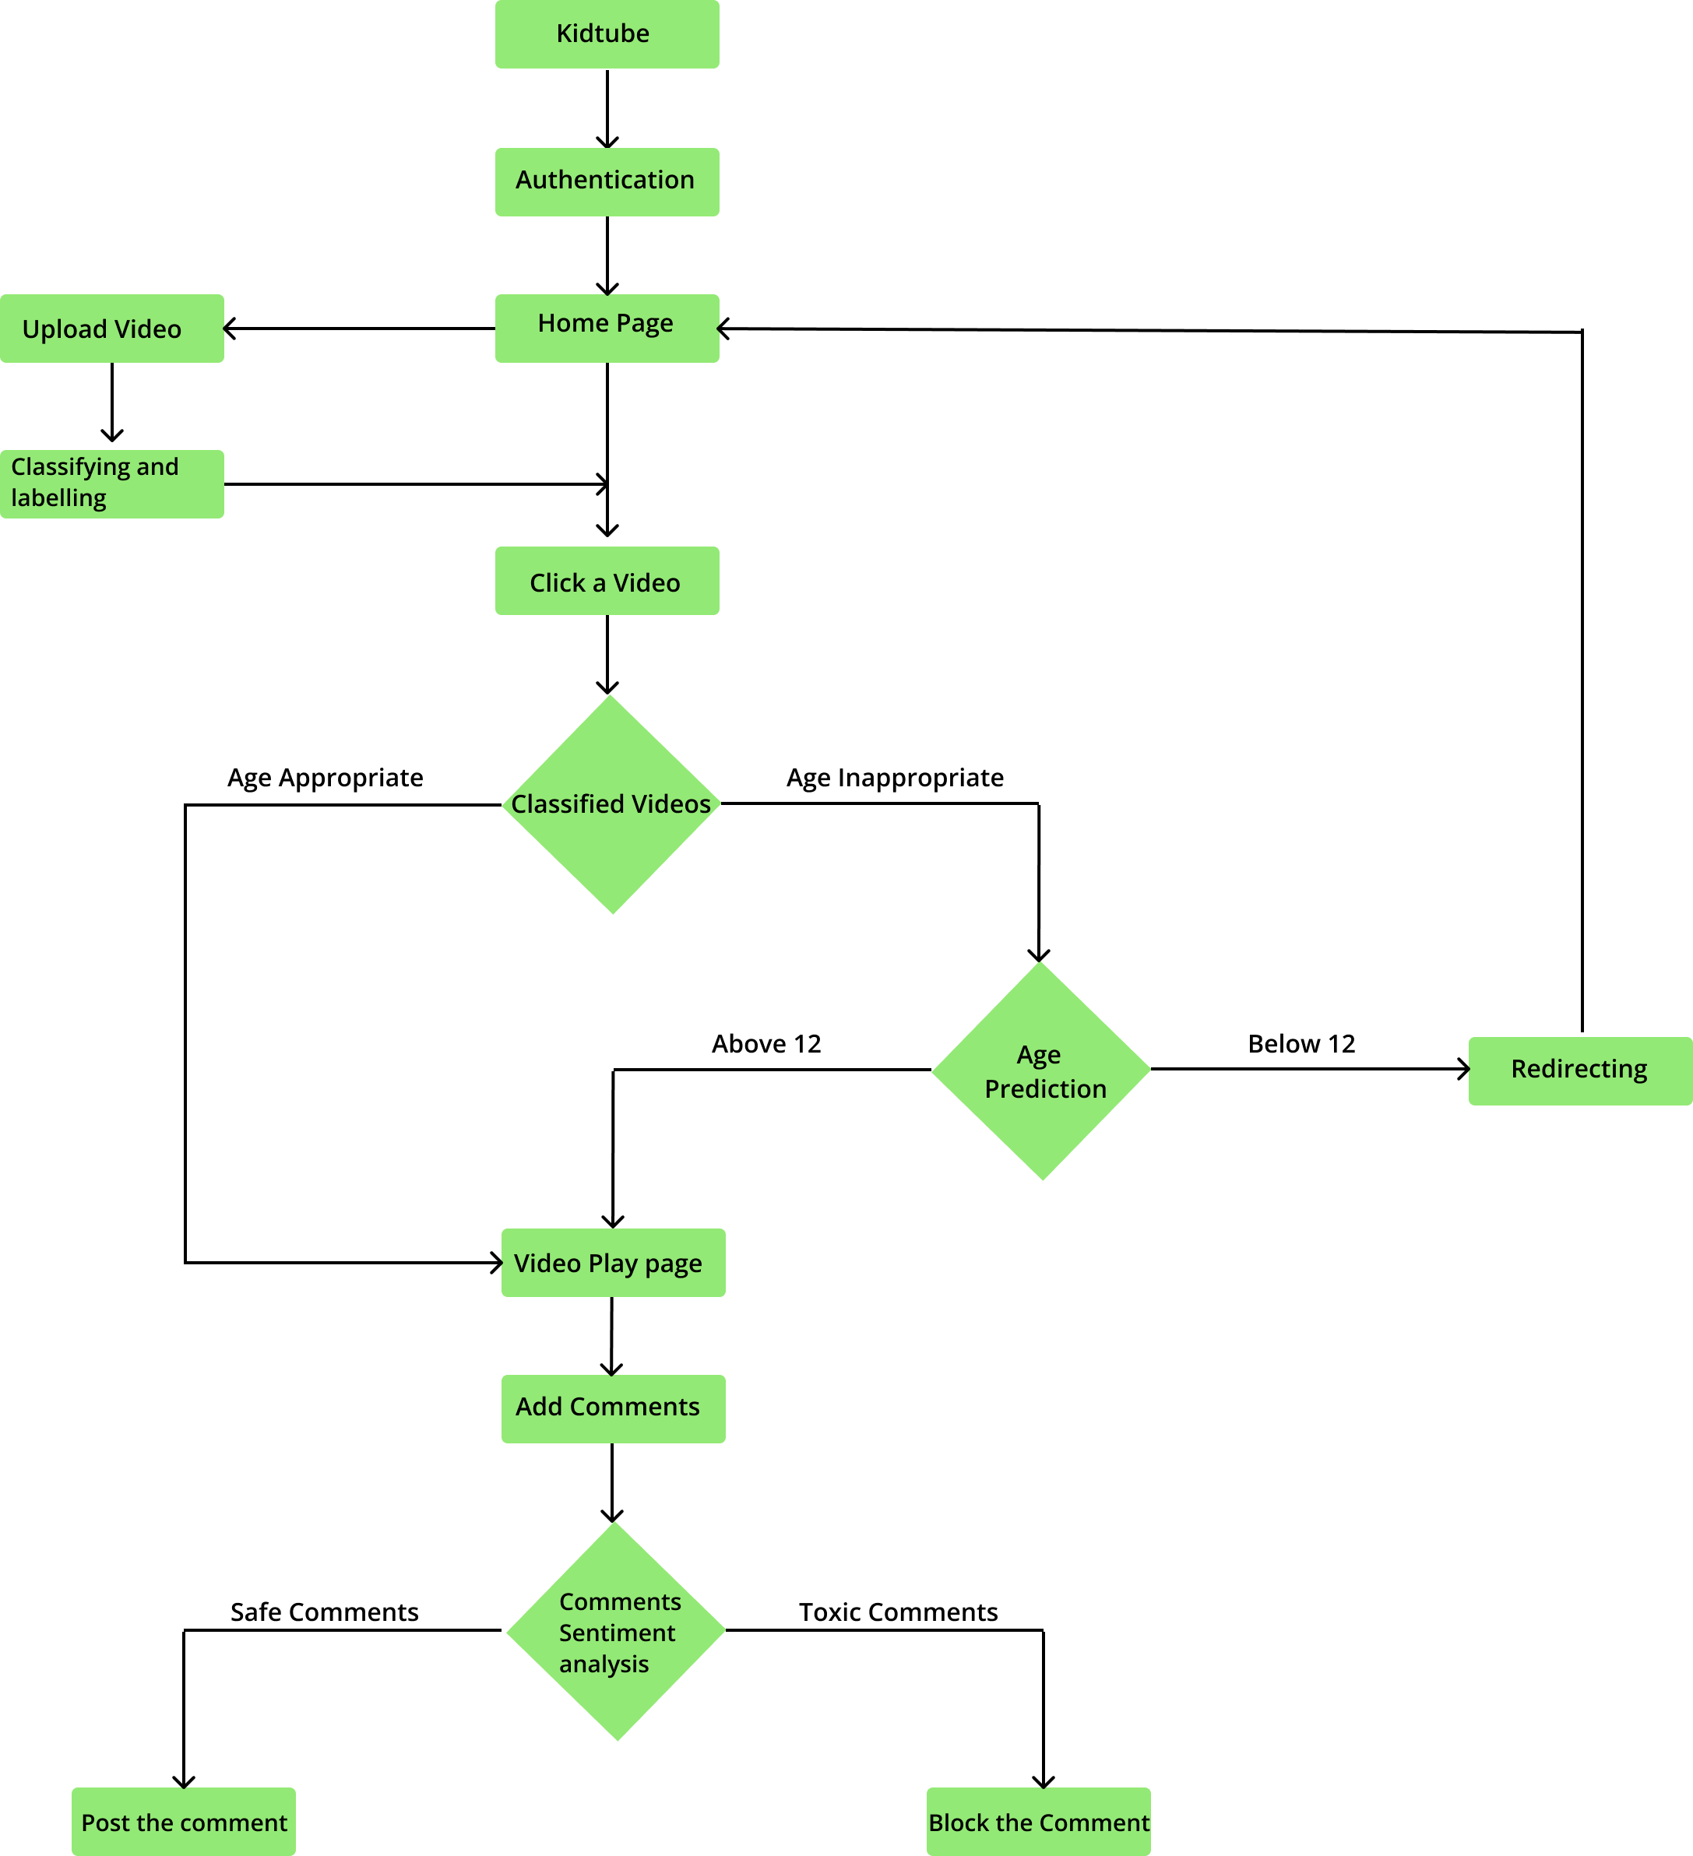
Figure 1 Flow Chart

A . Content Analysis of the video: The content analysis of the video predicts whether the video contains inappropriate content or not. It is achieved by extracting the frames of the videos and analyzing the frames using pre-trained module. To train this model, we choose Convolution Neural Network (CNN).

B. Automatic Age Estimation: The automatic age estimation module predicts whether the user is underage or appropriate aged to watch content that is recognized as “adult content”. The module captures real-time facial images of the user through a web camera or the selfie camera and employs CNN architecture to classify the age of the user.

C. Automated Immodest Comment Classifier: Automated immodest comment classifier segregates toxic comments from non-toxic using NLP and RNN architectures. The toxic comments are censored on the platform.

3.2 ML MODELS AND PARAMETERS

We are using pretrained ML models for age-detection, video classification and comment classification. Age Prediction is achieved by using Caffenet model, which is a CNN (convolutional Neural Network) model that works by taking a set of DAG. Yahoo-NSFW model classifies a video by capturing random frames in a video and analyzing it.

3.3 METHODOLOGY

3.3.1 AGE PREDICTION

Facelytics or analytics of face, is the process of extracting physical features of a face, to determine characteristic features like gender and age. Using deep learning architecture CNN model Caffenet, which has major layers such as Convolution, Relu, SoftMax, Pooling, LRN, Inner Product of varying kernel size and stride. Caffenet model assigns weights to the region of interest in the captured facial image to perform feature extraction. Following the same, it is passed as input to another pre-trained caffenet convolution model which contains multiple classes of ages, defined in prototxt which are predicted by the model with a sigmoid value.

3.3.2 SENTIMENT ANALYSIS

Sentiment analysis is a subset of text analysis where each text is classified as positive, negative or neutral based on the toxicity of the text. Before analysis, the text is preprocessed to remove noise, summarized if the text is large. Then parts of speech tagging used to identify structural words. Following this, toxicity is determined by assigning weights to each word and determining the weighted average of the whole text. Thus, the text is classified.

3.3.3 VIDEO CLASSIFICATION

Every uploaded video is classified as NSFW(Not Safe For Work) or SFW(Safe For Work) using Yahoo’s Open Source NSFW TensorFlow model. It is performed on multiple stages, starting with accessing multiple frames from the video to perform classification on content type from the image. The model uses a general purpose caffe deep neural network. The model is fed in with an input image and receives a value(probability) to detect NSFW content. The value generated is safe to view if it is below 0.2, and is considered neutral upto 0.8, above which it is considered NSFW.

Additionally, audio is also extracted from the video and transcribed. The text obtained after transcribing is analyzed using parallel dots API to check for offensive language.

Thus, the scores generated from both the modules (audio-text, video-image) is aggregated to classify the video overall as NSFW or SFW.

