## ARDUINO

[Arduino](http://arduino.cc/) is an open-source platform used for building electronics projects. Arduino consists of both a physical programmable circuit board (often referred to as a [microcontroller](http://en.wikipedia.org/wiki/Microcontroller)) and a piece of [software](http://arduino.cc/en/Main/Software), or IDE (Integrated Development Environment) that runs on your computer, used to write and upload computer code to the physical board.

## *What's on the board?*

## There are many varieties of Arduino boards that can be used for different purposes. Some boards look a bit different from the one below, but most Arduinos have the majority of these components in common:

[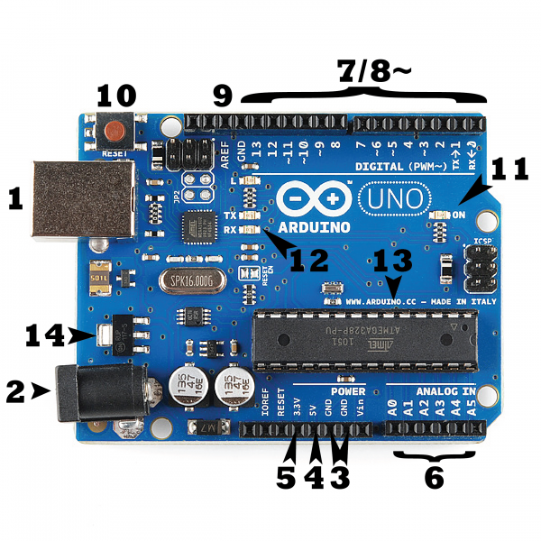](https://cdn.sparkfun.com/assets/b/f/e/9/c/513824face395f6d3d000000.png)

**Pins (5V, 3.3V, GND, Analog, Digital, PWM, AREF)**

The pins on your Arduino are the places where you connect wires to construct a circuit (probably in conjuction with a [breadboard](https://learn.sparkfun.com/tutorials/how-to-use-a-breadboard/) and some [wire](https://learn.sparkfun.com/tutorials/working-with-wire). They usually have black plastic ‘headers’ that allow you to just plug a wire right into the board. The Arduino has several different kinds of pins, each of which is labeled on the board and used for different functions.

* **GND (3)**: Short for ‘Ground’. There are several GND pins on the Arduino, any of which can be used to ground your circuit.
* **5V (4) & 3.3V (5)**: As you might guess, the 5V pin supplies 5 volts of power, and the 3.3V pin supplies 3.3 volts of power. Most of the simple components used with the Arduino run happily off of 5 or 3.3 volts.
* **Analog (6)**: The area of pins under the ‘Analog In’ label (A0 through A5 on the UNO) are Analog In pins. These pins can read the signal from an analog sensor (like a [temperature sensor](https://www.sparkfun.com/products/10988)) and convert it into a digital value that we can read.
* **Digital (7)**: Across from the analog pins are the digital pins (0 through 13 on the UNO). These pins can be used for both digital input (like telling if a button is pushed) and digital output (like powering an LED).
* **PWM (8)**: You may have noticed the tilde (~) next to some of the digital pins (3, 5, 6, 9, 10, and 11 on the UNO). These pins act as normal digital pins, but can also be used for something called Pulse-Width Modulation (PWM). We have [a tutorial on PWM](https://learn.sparkfun.com/tutorials/pulse-width-modulation), but for now, think of these pins as being able to simulate analog output (like fading an LED in and out).
* **AREF (9)**: Stands for Analog Reference. Most of the time you can leave this pin alone. It is sometimes used to set an external reference voltage (between 0 and 5 Volts) as the upper limit for the analog input pins.

### *Reset Button*

Just like the original Nintendo, the Arduino has a reset button **(10)**. Pushing it will temporarily connect the reset pin to ground and restart any code that is loaded on the Arduino. This can be very useful if your code doesn’t repeat, but you want to test it multiple times. Unlike the original Nintendo however, blowing on the Arduino doesn't usually fix any problems.

### *Power LED Indicator*

Just beneath and to the right of the word “UNO” on your circuit board, there’s a tiny LED next to the word ‘ON’ **(11)**. This LED should light up whenever you plug your Arduino into a power source. If this light doesn’t turn on, there’s a good chance something is wrong. Time to re-check your circuit!

### *TX RX LEDs*

TX is short for transmit, RX is short for receive. These markings appear quite a bit in electronics to indicate the pins responsible for [serial communication](https://learn.sparkfun.com/tutorials/serial-communication). In our case, there are two places on the Arduino UNO where TX and RX appear -- once by digital pins 0 and 1, and a second time next to the TX and RX indicator LEDs **(12)**.

### *Main IC*

The black thing with all the metal legs is an IC, or Integrated Circuit **(13)**. Think of it as the brains of our Arduino. The main IC on the Arduino is slightly different from board type to board type, but is usually from the ATmega line of IC’s from the ATMEL company.

### *Voltage Regulator*

The voltage regulator **(14)** is not actually something you can (or should) interact with on the Arduino. But it is potentially useful to know that it is there and what it’s for. The voltage regulator does exactly what it says -- it controls the amount of voltage that is let into the Arduino board.

### [Arduino Uno (R3)](https://www.sparkfun.com/products/11021)

The Uno is a great choice for your first Arduino. It's got everything you need to get started, and nothing you don't. It has 14 digital input/output pins (of which 6 can be used as PWM outputs), 6 analog inputs, a USB connection, a power jack, a reset button and more. It contains everything needed to support the microcontroller; simply connect it to a computer with a USB cable or power it with a AC-to-DC adapter or battery to get started

**RASEBERRY PI(RPI)**

[**Raspberry Pi (RPi)**](https://www.analyticsinsight.net/unlocking-enterprise-potential-behind-iot-strategy/)**defines as a series of single-board computers that are now increasingly being used to connect IoT devices. RPi can be plugged into a computer monitor. It is a capable little device that enables people to explore computing and learn how to program in languages like Scratch and Python.**

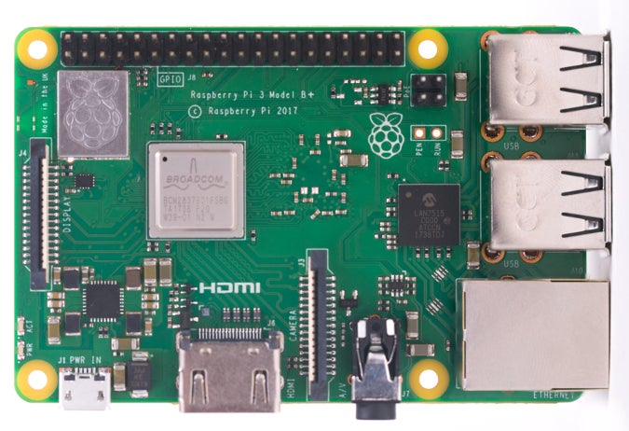

**JUMPER WIRES**

A **jump wire** (also known as **jumper**, **jumper wire**, **DuPont wire**) is an [electrical wire](https://en.wikipedia.org/wiki/Electrical_wire), or group of them in a cable, with a connector or pin at each end (or sometimes without them – simply "tinned"), which is normally used to interconnect the components of a [breadboard](https://en.wikipedia.org/wiki/Breadboard) or other prototype or test circuit, internally or with other equipment or components, without soldering.[[1]](https://en.wikipedia.org/wiki/Jump_wire#cite_note-1)

Individual jump wires are fitted by inserting their "end connectors" into the slots provided in a breadboard, the [header connector](https://en.wikipedia.org/wiki/Pin_header#Header_connector) of a circuit board, or a piece of test equipment.

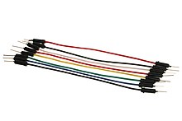

Jumper wires typically come in three versions: male-to-male, male-to-female and female-to-female. The difference between each is in the end point of the wire. Male ends have a pin protruding and can plug into things, while female ends do not and are used to plug things into. Male-to-male jumper wires are the most common and what you likely will use most often. When connecting two ports on a breadboard, a male-to-male wire is what you’ll need.

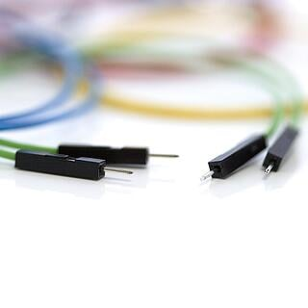

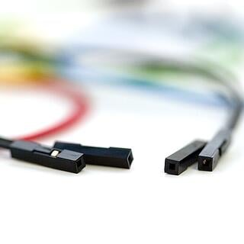

**ULTRASONIC SENSOR**

An ultrasonic sensor is an electronic device that measures the distance of a target object by emitting ultrasonic sound waves, and converts the reflected sound into an electrical signal. Ultrasonic waves travel faster than the speed of audible sound (i.e. the sound that humans can hear). Ultrasonic sensors have two main components: the transmitter (which emits the sound using piezoelectric crystals) and the receiver (which encounters the sound after it has travelled to and from the target).

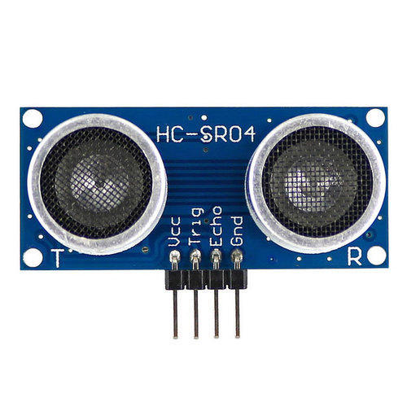

In order to calculate the distance between the sensor and the object, the sensor measures the time it takes between the emission of the sound by the transmitter to its contact with the receiver. The formula for this calculation is [D = ½ T x C](https://www.arrow.com/en/research-and-events/articles/ultrasonic-sensors-how-they-work-and-how-to-use-them-with-arduino) (where D is the distance, T is the time, and C is the speed of sound ~ 343 meters/second). For example, if a scientist set up an ultrasonic sensor aimed at a box and it took 0.025 seconds for the sound to bounce back, the distance between the ultrasonic sensor and the box would be:

|  |
| --- |
| **D = 0.5 x 0.025 x 343** |

or about 4.2875 meters.

**TEMPERATURE SENSOR**

A temperature sensor is a device used to measure temperature. This can be air temperature, liquid temperature or the temperature of solid matter.

There are different types of temperature sensors available and they each use different technologies and principles to take the temperature measurement.

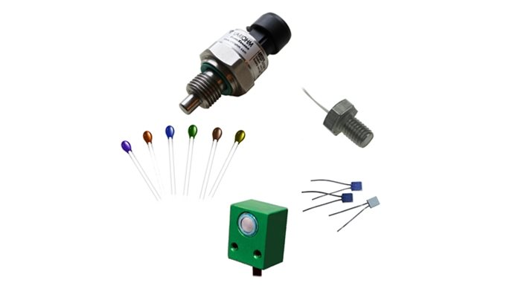

## Different Types of Temperature Sensor

**Thermistors** can be very small in size. They consist of a sensing element which can be either glass or epoxy coated and have 2 wires so they can be connected to an electric circuit. They measure temperature by measuring the change in resistance of the electric current. Thermistors are available as either NTC or PTC and are often low cost.

**RTDs** or Resistance Temperature Detectors work in a similar way to Thermistors and measure ohmic resistance to measure temperature. They are connected to a circuit in a similar way to a thermistor but they have a much wider temperature range and can measure extreme temperatures.

**Thermocouples** use two conductors, made up of different metals that are joined at the end to form a junction. When this junction is subjected to heat, a voltage is produced that is directly proportional to the temperature input. They are highly versatile as different metal combinations allow for different measurement ranges; however, they lack the fine accuracy of NTC’s and RTD’s making them the least precise out of the three types

**Temperature Probes** are a very common and diverse type of temperature sensor. They consist of either a thermistor, a thermocouple or RTD sensing element and can be finished with a terminal head.

**BREAD BOARD**

Breadboards are temporary work boards for electronic circuits. The general shape of a breadboard is shown in Fig. 6.3. Compatible with most breadboards, 24-gauge wire is used to connect circuits; solid wire, not stranded. Sometimes, kits may be available with various colors of fixed lengths to specifically fit breadboards. These are a nice convenience.

.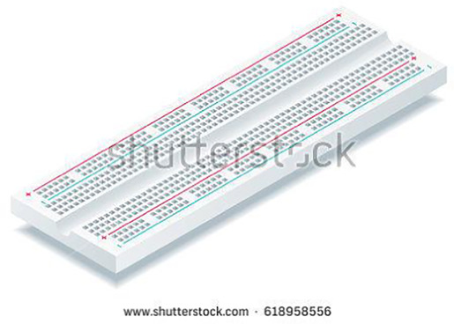

 The horizontal rows are connected throughout the row and may make a complete row with the addition of a simple jumper at the center point. These rows are noted with red and blue or black markings

The vertical columns are connected vertically down half the width of the board. A jumper may be inserted at the middle location to connect the full width of the breadboard. The horizontal rows are typically used for power and ground, and, with the middle NOT connected, one can apply more than one power level, such as 12 V, 3.3 V, and ground. Fig. 6.4 shows the orientation of the board for our purposes. As noted in Fig. 6.4, vertical columns are for connections to each leg of your integrated circuit (IC). Like the three integrated circuits shown in Fig. 6.5, your IC should straddle the center valley.

**PIR SENSOR**

PIR sensors allow you to sense motion, almost always used to detect whether a human has moved in or out of the sensors range. They are small, inexpensive, low-power, easy to use and don't wear out. For that reason they are commonly found in appliances and gadgets used in homes or businesses. They are often referred to as PIR, "Passive Infrared", "Pyroelectric", or "IR motion" sensors.

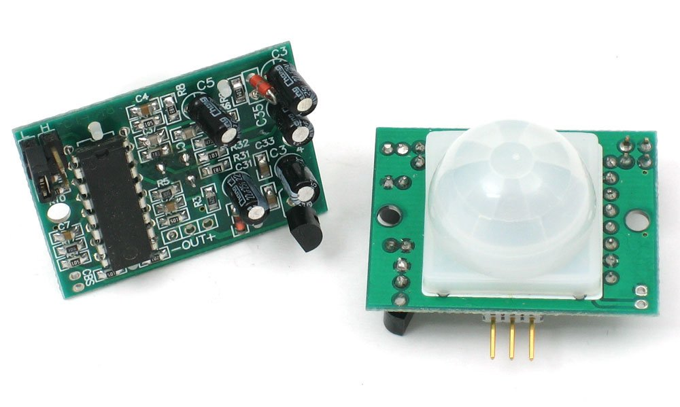

PIRs are basically made of a [pyroelectric sensor](http://en.wikipedia.org/wiki/Pyroelectric) (which you can see below as the round metal can with a rectangular crystal in the center), which can detect levels of infrared radiation. Everything emits some low level radiation, and the hotter something is, the more radiation is emitted. The sensor in a motion detector is actually split in two halves. The reason for that is that we are looking to detect motion (change) not average IR levels. The two halves are wired up so that they cancel each other out. If one half sees more or less IR radiation than the other, the output will swing high or low.

**BUZZER**

An audio signaling device like a beeper or buzzer may be electromechanical or [piezoelectric](https://www.elprocus.com/what-is-a-piezoelectric-material-working/) or mechanical type. The main function of this is to convert the signal from audio to sound. Generally, it is powered through DC voltage and used in timers, alarm devices, printers, alarms, computers, etc. Based on the various designs, it can generate different sounds like alarm, music, bell & siren.

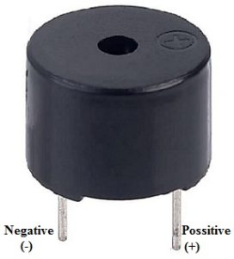

Buzzer Pin Configuration

The **pin configuration of the buzzer** is shown below. It includes two pins namely positive and negative. The positive terminal of this is represented with the ‘+’ symbol or a longer terminal. This terminal is powered through 6Volts whereas the negative terminal is represented with the ‘-‘symbol or short terminal and it is connected to the GND terminal.

**Types of Buzzer**

* Piezoelectric
* Electromagnetic
* Mechanical
* Electromechanical
* Magnetic

**RESISTER**

A passive electrical component with two terminals that are used for either limiting or regulating the flow of electric current in electrical circuits.

The main purpose of resistor is to reduce the current flow and to lower the voltage in any particular portion of the circuit. It is made of copper wires which are coiled around a ceramic rod and the outer part of the resistor is coated with an insulating paint.

The SI unit of resistor is Ohm.

Each resistor has one connection and two terminals. We will look at the three types of symbols that are used to represent the resistor.

The terminals of the resistor are each of the lines extending from the squiggle (or rectangle). Those are what connect to the rest of the circuit. The resistor circuit symbols are usually enhanced with both a resistance value and a name. The value, displayed in ohms, is obviously critical for bothThere are two basic [types of resistors](https://byjus.com/physics/types-of-resistors/) as follows:

* Linear resistor
* Non-linear resistor

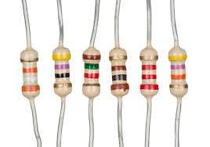

**LED**

A light-emitting diode (LED) is a semiconductor device that emits light when an electric current flows through it. When current passes through an LED, the electrons recombine with holes emitting light in the process. LEDs allow the current to flow in the forward direction and blocks the current in the reverse direction.

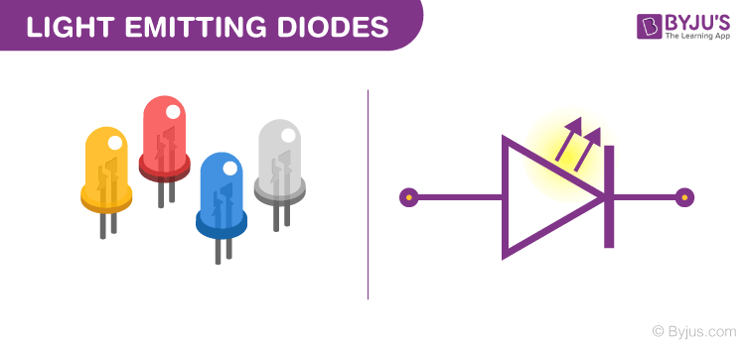

The colour of an LED is determined by the material used in the semiconducting element. The two primary materials used in LEDs are aluminium gallium indium phosphide alloys and indium gallium nitride alloys. Aluminium alloys are used to obtain red, orange and yellow light, and indium alloys are used to get green, blue and white light. Slight changes in the composition of these alloys change the colour of the emitted light.

## Below are a few standards[LED uses](https://byjus.com/physics/uses-of-led/):

* Used for TV back-lighting
* Used in displays
* Used in Automotives
* LEDs used in the dimming of lights

**Types of LED:**

* Miniature LEDs
* High-Power LEDs
* Flash LED
* Bi and Tri-Colour
* Red Green Blue LEDs
* Alphanumeric LED
* Lighting LED