AI-Based Text Summarization Platform
Abstract
The AI-Based Text Summarization Platform is a full-stack web application developed to automatically generate concise summaries from lengthy text and PDF documents using Artificial Intelligence and Natural Language Processing (NLP). The system helps users quickly understand large amounts of information by providing summarized content, important bullet points, and extracted keywords.
The application supports both direct text summarization and PDF document summarization. It uses the Hugging Face Inference API with the Facebook BART Large CNN model for generating AI-based summaries. The frontend of the application is developed using React.js, while the backend is developed using Node.js and Express.js.
Additional features such as drag-and-drop PDF upload, keyword extraction, bullet-point generation, and downloadable summary PDFs make the project more interactive and user-friendly.

Introduction
In today’s digital world, users often deal with lengthy articles, research papers, reports, and documents. Reading and understanding large content consumes significant time and effort. Text summarization helps reduce the content size while preserving important information.
The AI-Based Text Summarization Platform was developed to solve this problem by using Artificial Intelligence techniques to generate meaningful summaries automatically.
The platform allows users to:
- Paste text and summarize it
- Upload PDF documents for summarization
- Extract important bullet points
- Extract keywords
- Download summaries as PDF files
The project demonstrates the practical implementation of Natural Language Processing (NLP), full-stack web development, and API integration.

Objectives
The main objectives of the project are:
- To develop an AI-powered text summarization system
- To summarize large text efficiently
- To support PDF document summarization
- To extract important information from lengthy content
- To provide a user-friendly web interface
- To implement AI and NLP concepts in a real-world application

Technologies Used
Frontend Technologies
React.js
React.js is used to build the frontend user interface. It provides a dynamic and interactive single-page application experience.
Axios
Axios is used to send HTTP requests between frontend and backend.
CSS
CSS is used to style the application and improve user interface design.
jsPDF
jsPDF is used to generate downloadable PDF summaries.
Backend Technologies
Node.js
Node.js is used as the backend runtime environment.
Express.js
Express.js is used to build REST APIs and manage backend routes.
Multer
Multer is used to upload PDF files from users.
pdf-parse
pdf-parse extracts text content from uploaded PDF files.
dotenv
dotenv is used to securely store API keys using environment variables.

AI / NLP Technologies
Hugging Face Inference API
The Hugging Face API is used to access pre-trained NLP models.
Facebook BART Large CNN Model
The facebook/bart-large-cnn model is used for abstractive text summarization.

System Architecture
The system consists of two major components:
Frontend
The frontend handles:
- User interaction
- Text input
- PDF upload
- Displaying summaries
- Displaying bullet points
- Displaying keywords
- Downloading summaries
Backend
The backend handles:
- API requests
- PDF text extraction
- AI model communication
- Summary generation
- Keyword extraction

Working of the Project
Step 1: User Input
The user selects either:
- Text Summarization
- PDF Summarization
Step 2: Text Extraction
- If the user enters text directly, the text is sent to the backend.
- If the user uploads a PDF, text is extracted using pdf-parse.
Step 3: Chunk Processing
Large text is divided into smaller chunks to avoid API limitations and improve summarization quality.
Step 4: AI Summarization
The backend sends the text chunks to the Hugging Face API.
The AI model generates:
- Summary
- Bullet points
- Important keywords
Step 5: Display Results
The frontend displays:
- Final summarized text
- Bullet points
- Keywords
Step 6: Download Summary
Users can download the generated summary as a PDF document.

Output
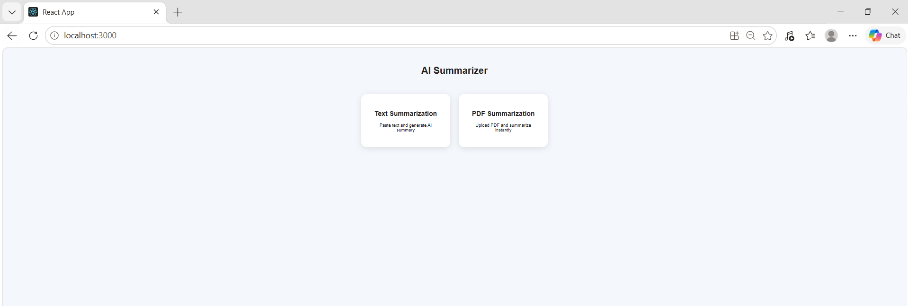
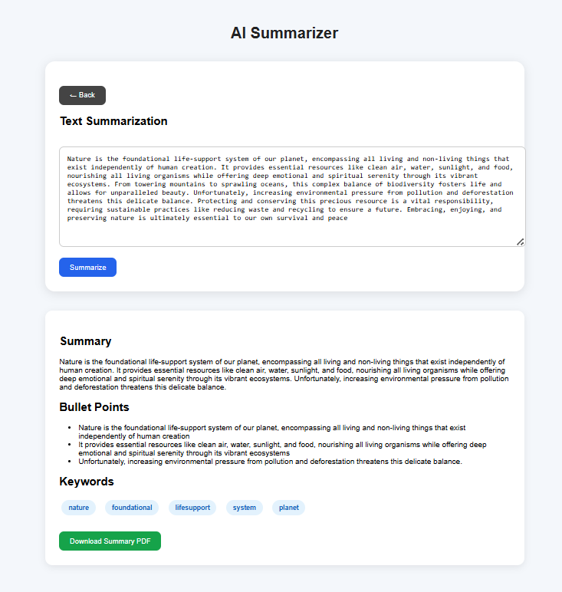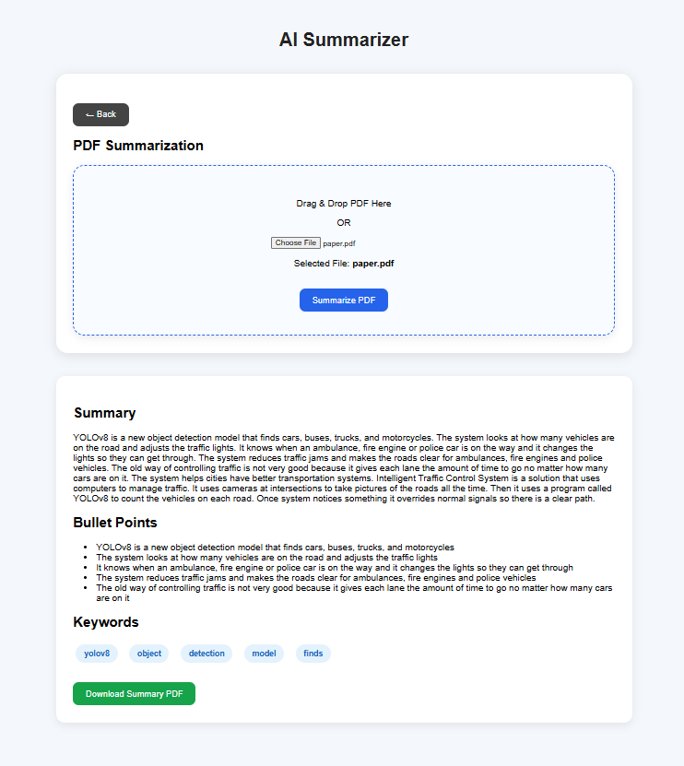

Features of the Project
1. Text Summarization
The application allows users to directly enter large text content into the text area and generate concise AI-based summaries. This feature helps users quickly understand lengthy articles, reports, research papers, and documents without reading the complete content.
2. PDF Summarization
Users can upload PDF documents and automatically generate summaries from the extracted text. The system reads the content from PDF files using text extraction techniques and processes it through the AI summarization model. This feature is useful for summarizing notes, reports, academic documents, and articles.
3. Bullet Point Extraction
The platform generates important bullet points from the summarized content. Instead of displaying only paragraph summaries, the application organizes key information into readable points, making the output more structured and easier to understand.
4. Keyword Extraction
Important keywords are automatically extracted from the text and displayed separately. This helps users quickly identify the major topics, important terms, and main concepts present in the document.

5. Drag and Drop PDF Upload
The application provides a drag-and-drop feature for uploading PDF files. Users can simply drag a PDF into the upload area instead of manually selecting files, improving user experience and making the application more interactive.
6. Download Summary as PDF
After generating the summary, users can download the summarized content as a PDF file. This feature allows users to save summaries for future reference, sharing, or documentation purposes.
7. Dynamic User Interface
The platform contains a dynamic and interactive user interface where users can switch between Text Summarization and PDF Summarization without reloading the webpage. This improves usability and creates a smooth user experience.
8. AI-Based Summarization
The project uses the Hugging Face AI model (facebook/bart-large-cnn) for abstractive summarization. The AI model understands the meaning of the content and generates human-like summaries instead of simply copying sentences from the original text
9. Chunk Processing for Large Text
Large documents are divided into smaller chunks before sending them to the AI model. This improves processing efficiency, handles API limitations, and ensures better summarization for lengthy content.
10. Responsive and Clean Design
The frontend is designed with a clean and responsive layout using React.js and CSS. The interface is user-friendly and works smoothly for different screen sizes and devices.

API Endpoints
Text Summarization API
POST /api/summarize

PDF Summarization API
POST /api/summarize-pdf

Advantages of the Project
- Saves reading time
- Simplifies lengthy documents
- Easy to use
- Supports PDF documents
- Provides structured information
- Uses modern AI technology

Limitations
- Depends on internet connection
- Free API may sometimes respond slowly
- Very large PDFs may take longer to process
- Summary quality depends on input quality

Conclusion
The AI-Based Text Summarization Platform successfully demonstrates the use of Artificial Intelligence and Natural Language Processing for summarizing large text and PDF documents. The system reduces reading effort and helps users quickly understand important information.
The project combines frontend development, backend API development, AI integration, and file processing into a complete full-stack application. The implementation of features such as PDF summarization, keyword extraction, drag-and-drop upload, and downloadable summaries improves usability and demonstrates practical real-world application development.
References
- React.js Documentation
- Node.js Documentation
- Express.js Documentation
- Hugging Face Documentation
- pdf-parse Documentation
- jsPDF Documentation

