Strings

1.Demonstrate various string constructor with proper java programs.

class StringConstructors {

public static void main(String[] args) {

// Constructor 1: Initializes a newly created String object so that it represents an empty character sequence.

String s1 = new String();

System.out.println("Empty String: " + s1);

// Constructor 2: Initializes a newly created String object so that it represents the same sequence of characters as the argument.

String s2 = new String("Hello, World!");

System.out.println("String with characters: " + s2);

// Constructor 3: Allocates a new String object so that it represents the sequence of characters currently contained in the character array argument.

char[] charArray = {'H', 'e', 'l', 'l', 'o'};

String s3 = new String(charArray);

System.out.println("String from char array: " + s3);

// Constructor 4: Allocates a new String object so that it represents the sequence of characters currently contained in the character array argument.

byte[] byteArray = {65, 66, 67, 68, 69};

String s4 = new String(byteArray);

System.out.println("String from byte array: " + s4);

}

}

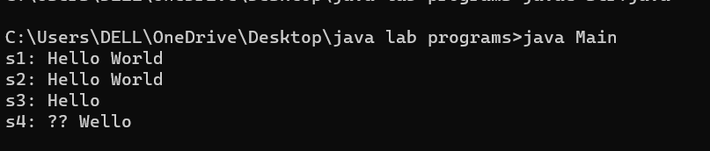

2.Demostrate string length, string literal, string concat

3.Demostrate tostring()

4. Using getchars() , extract Bmsce from “ Welcome to Bmsce college”

class StringProperties {

public static void main(String[] args) {

String s1 = "Hello";

String s2 = "World";

// Concatenation using + operator

String s3 = s1 + " " + s2;

System.out.println("Concatenated string: " + s3);

// Concatenation using concat() method

String s4 = s1.concat(" ").concat(s2);

System.out.println("Concatenated string using concat(): " + s4);

// String length

System.out.println("String length: " + s1.length());

// String literal

System.out.println("String literal: " + s1);

// toString()

String ss = new String("Hello, World!");

String ss1 = s1.toString();

System.out.println("ss and ss1 are the same: " + (ss == ss1));

// using getChars()

String str = "Welcome to Bmsce college";

char[] buffer = new char[10];

str.getChars(7, 17, buffer, 0);

String extracted = new String(buffer);

System.out.println("Extracted substring: " + extracted);

}

}

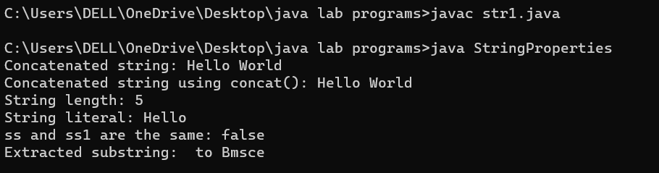

5.Demostrate getbytes(),tocharArray() with proper java programs

class Main {

public static void main(String[] args) {

String str = "Hello World!";

byte[] byteArray = str.getBytes();

for (byte b : byteArray) {

System.out.println((char) b);

}

String str1 = "Hello World!";

char[] charArray = str1.toCharArray();

for (char c : charArray) {

System.out.print(c);

}

}

}

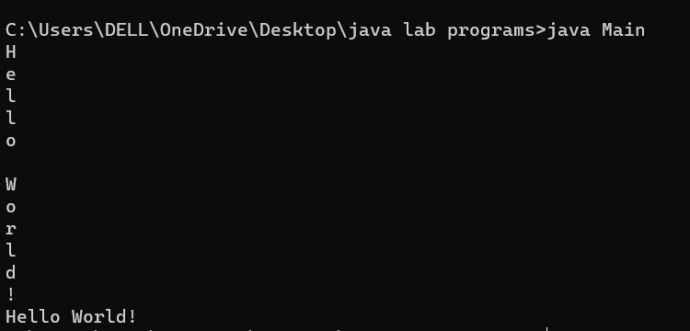

6.Check the following output and write the java programs using string function

Bmsce equals Bmsce -&gt; true

Bmsce equals College -&gt; false

Bmsce equals BMSCE -&gt; false

Bmsce equalsIgnoreCase BMSCE -&gt; true

7. Using regionmatches() find the substring “Bmsce college “ from the string “Welcome to

Bmsce College of Engineering” , if matches display substring is matched otherwise display not

Matched

class Main {

public static void main(String[] args) {

String s1 = "Bmsce";

String s2 = "College";

String s3 = "BMSCE";

System.out.println("s1 equals s1 -> " + s1.equals(s1));

System.out.println("s1 equals s2 -> " + s1.equals(s2));

System.out.println("s1 equals s3 -> " + s1.equals(s3));

String str = "Welcome to Bmsce College of Engineering";

String subStr = "Bmsce college ";

boolean isMatched = str.regionMatches(true, 7, subStr, 0, subStr.length());

if (isMatched) {

System.out.println("Substring is matched");

} else {

System.out.println("Substring is not matched");

}

}

}

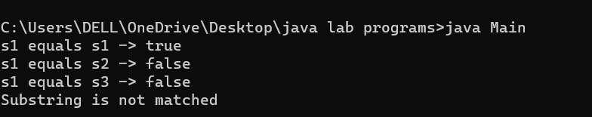

8. Demonstrate startwith() to give output true and false.

9. Demonstrate endswith() to give output true and false.

10. Demostrate a java program to show the output for equals() versus ==

class Main {

public static void main(String[] args) {

String str = "Bmsce college";

if (str.startsWith("Bmsce")) {

System.out.println("true");

} else {

System.out.println("false");

}

String str1 = "Bmsce college";

if (str1.endsWith("college")) {

System.out.println("true");

} else {

System.out.println("false");

}

String str2= new String("Hello");

String str3= new String("Hello");

String str4 = "Hello";

System.out.println("Using equals: " + str2.equals(str3));

System.out.println("Using ==: " + (str2 == str3));

System.out.println("Using equals: " + str2.equals(str4));

System.out.println("Using ==: " + (str2 == str4));

}

}

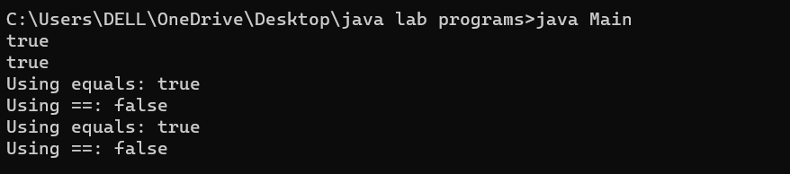

11. Write a java program to perform sorting for alphabets using compareto()

“van”, “watch”,”ball”, “cat”,”xmas”,”yatch”,” zee”,”

apple”,”ice”,”jug”,”kite”,”lift”,”man”,”net”,”orange”,”dog”,”ent”,”free”,”gun”,”hen”,”parrot”,”q

ueen”,”ring”,”star”,”tree”,”umbrella”

import java.util.Arrays;

class Main {

public static void main(String[] args) {

String[] alphabet = {"van", "watch", "ball", "cat", "xmas", "yatch", "zee",

"apple", "ice", "jug", "kite", "lift", "man", "net", "orange", "dog", "ent", "free", "gun", "hen", "parrot", "queen", "ring", "star", "tree", "umbrella"};

Arrays.sort(alphabet);

for (String letter : alphabet) {

System.out.println(letter);

}

}

}

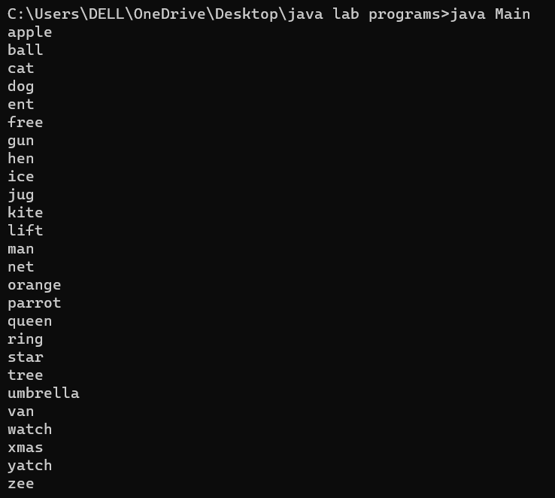

12. Write a Java program to perform sorting of numbers from 10 to 1 using compareto()

import java.util.Arrays;

class SortNumbers {

public static void main(String[] args) {

Integer[] numbers = {1, 2, 3, 4, 5, 6, 7, 8, 9, 10};

Arrays.sort(numbers, (o1, o2) -> o2.compareTo(o1));

System.out.println(Arrays.toString(numbers));

}

}



13. Write a Java program using substring() , indexof(), + , for replacing “was” to “is”

“Thwas was a test. Thwas was, too.”

class Main{

public static void main(String[] args) {

String str = "Thwas was a test. Thwas was, too.";

int index = str.indexOf("was");

String result = "";

while (index != -1) {

result += str.substring(0, index) + "is";

str = str.substring(index + 3);

index = str.indexOf("was");

}

result += str;

System.out.println(result);

}

}

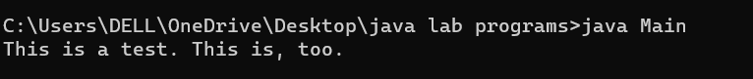

14. Write a java program to demonstrate concat() for s1=”hello” and s2=”world”

15. Write a java program to demonstrate replace(). Replace “College” with “Commege”

16. Write a java program to demonstrate trim() for “ Hello Friends “

class Main {

public static void main(String[] args) {

String s1 = "hello";

String s2 = "world";

String result = s1.concat(s2);

System.out.println(result);

String str = "The University of College Name";

String result1= str.replace("College", "Commege");

System.out.println(result1);

String str1 = " Hello Friends ";

String result2 = str1.trim();

System.out.println(result2);

}

}

