Lab Manual

Lab 2: Smart Environment Monitor (ESP32 + DHT11/DHT22)

Sl .No | Team Member Name | SRN

1. Aim and objectives
Aim: Build an ESP32-based monitor that reads temperature and humidity from a DHT11/DHT22 sensor, raises a local alarm (LED + buzzer) when a threshold is crossed.
By the end of this lab, students will be able to:
- Interface a single-wire digital sensor (DHT11/DHT22) with an ESP32 and read it with the Adafruit DHT library.
- Print formatted sensor data to the Arduino IDE Serial Monitor and Serial Plotter.
- Drive digital outputs (LED, active buzzer) from threshold logic, using hysteresis to avoid flickering alarms.
Prerequisites: basic C/C++ (variables, if, functions), Arduino IDE usage, breadboard wiring, and Ohm's law for LED resistors.

2. Components and software
Each bench needs the hardware below plus a laptop with internet access and a 2.4 GHz Wi-Fi network (the ESP32 cannot join 5 GHz networks).
Item | Qty | Notes
ESP32 DevKit V1 (ESP-WROOM-32, 30 or 38 pin) | 1 | Any ESP32 dev board works; pin numbers below use GPIO labels
DHT11 or DHT22 (AM2302) sensor | 1 | 3-pin module preferred (pull-up already on board)
10 kΩ resistor | 1 | Only for a bare 4-pin DHT sensor (data pull-up)
5 mm LED (red) | 1 | Alert indicator
220 Ω resistor | 1 | LED current limiting (~5 mA at 3.3 V)
Active buzzer, 3.3–5 V | 1 | Active type beeps on a DC HIGH; passive type needs tone()
Breadboard + male-to-male jumper wires | 1 set
Micro-USB or USB-C data cable | 1 | Must be a data cable, not charge-only
Software
- Arduino IDE 2.x with the esp32 by Espressif Systems board package (Boards Manager).
- Libraries (Library Manager): DHT sensor library by Adafruit and Adafruit Unified Sensor.

3. Theory

3.1 DHT11 vs DHT22
Both sensors combine a capacitive humidity element and a thermistor with a small microcontroller that sends a 40-bit reading over a single data wire. The DHT22 is more accurate and has a wider range; the DHT11 is cheaper and adequate for classroom thresholds.
Parameter | DHT11 | DHT22 (AM2302)
Temperature range | 0 to 50 °C | −40 to 80 °C
Temperature accuracy | ±2 °C | ±0.5 °C
Humidity range | 20–80 % RH (typ.) | 0–100 % RH
Humidity accuracy | ±5 % RH | ±2–5 % RH
Resolution | 1 °C / 1 % RH | 0.1 °C / 0.1 % RH
Minimum sampling interval | 1 s | 2 s
Supply voltage | 3.3–5 V | 3.3–6 V
Figures are typical datasheet values; check the datasheet for your module.

3.2 Single-wire protocol (overview)
The ESP32 pulls the data line LOW for at least 1 ms (DHT22) or 18 ms (DHT11) to request a reading. The sensor answers with 40 bits: 16 bits humidity, 16 bits temperature and an 8-bit checksum. Each bit is a HIGH pulse whose length encodes 0 (~26 µs) or 1 (~70 µs). The Adafruit library handles this timing; students only call readTemperature() and readHumidity(). A NaN result means the checksum or timing failed.

3.3 Heat index
The heat index combines temperature and relative humidity into a "feels like" temperature. The library's computeHeatIndex(t, h, false) returns it in °C and can be used as an alternative alert trigger.

3.4 Thresholds and hysteresis
A single threshold makes an alarm chatter when the reading hovers near it (30.0, 29.9, 30.1…). Hysteresis uses two limits: the alarm turns ON above the upper limit and OFF only below a lower one.
Condition | Alert state | Example (T_high = 30 °C, Δ = 1 °C)
T > T_high | Turn ON | Above 30 °C
T < T_high − Δ | Turn OFF | Below 29 °C
Anywhere in between | No change (keep the previous state) | 29–30 °C
This manual uses T_high = 30 °C and Δ = 1 °C, so the alert clears below 29 °C.

3.5 Event-driven notifications
A notification should fire once when the state changes (normal → alert, and optionally alert → normal), not on every loop. Otherwise a 2-second loop would send 1,800 messages an hour. A cooldown timer (e.g. 5 minutes) adds further protection.

3.6 Notification services
- Telegram Bot API: a bot created with @BotFather gets a token. The ESP32 sends an HTTPS request to api.telegram.org with the token, the chat ID and the message text. Free, near-instant, and needs no third-party account.
- IFTTT Webhooks: the ESP32 makes an HTTP request to maker.ifttt.com/trigger/<event>/with/key/<key> with up to three values. An applet turns that event into an email (or phone notification). Free-tier limits apply; check IFTTT's current plan terms.

4. Circuit and pin connections
The whole circuit is 8 wires. Connect them one at a time, in the numbered order shown in the picture and the table, and tick each one off before moving on. Keep the USB cable unplugged until the final check.
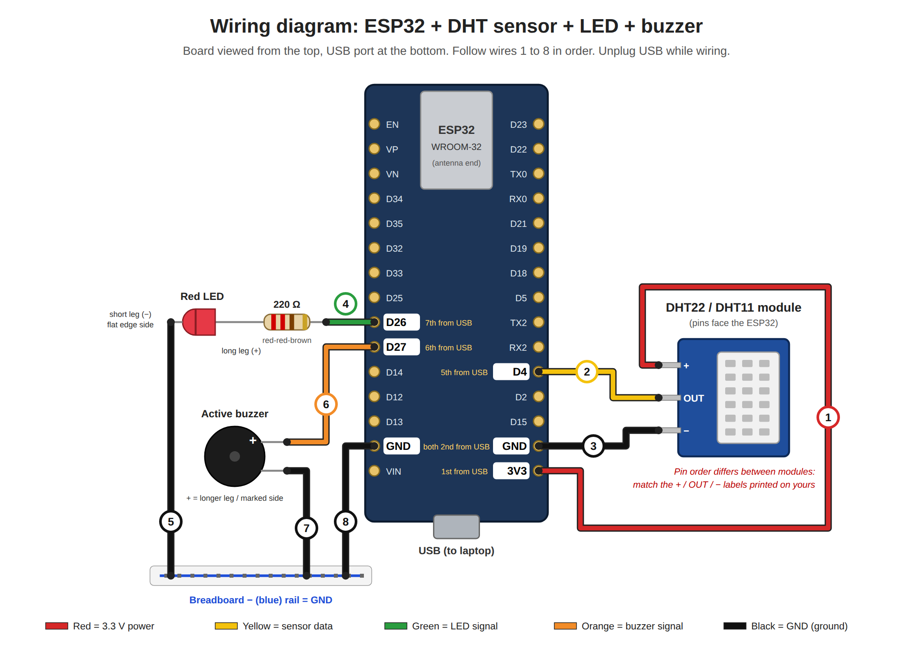

Before you start: find the pins
- Hold the ESP32 with the USB port pointing toward you and the silver metal can (antenna) pointing away.
- Read the tiny white labels printed next to each pin. On most boards GPIO 4 is printed as D4, GPIO 26 as D26, and so on.
- If the labels are hard to read, count pins from the USB end: on the right side, 3V3 is the 1st pin, GND the 2nd, D4 the 5th. On the left side, GND is the 2nd, D27 the 6th, D26 the 7th.
- Push the ESP32 into the breadboard so it straddles the centre gap. Each pin then has its own short row of holes; a jumper wire placed in the same row connects to that pin.
- Some 38-pin boards have a different layout. Always trust the printed label over the pin count.

Know your parts
- LED: the long leg is + (anode). The short leg, on the side with a flat edge on the rim, is − (cathode). Reversed, it simply won't light.
- 220 Ω resistor: colour bands red-red-brown(-gold). It can go either way round.
- Active buzzer: the + leg is longer and the top usually has a + mark or sticker. An active buzzer beeps when connected straight to 3.3 V; a passive one stays silent.
- DHT module: 3 pins marked + / OUT / − (or VCC / DATA / GND, or S for signal). The order differs between brands, so wire by the printed letters, not by position.

Wiring steps
Wire | Colour | From | To
1 | Red | ESP32 3V3 (right side, 1st from USB) | DHT + (VCC)
2 | Yellow | ESP32 D4 (right side, 5th from USB) | DHT OUT (DATA / S)
3 | Black | ESP32 GND (right side, 2nd from USB) | DHT − (GND)
4 | Green | ESP32 D26 (left side, 7th from USB) | One end of the 220 Ω resistor; the other resistor end goes to the LED long leg
5 | Black | LED short leg | Breadboard − (blue) rail
6 | Orange | ESP32 D27 (left side, 6th from USB) | Buzzer + leg
7 | Black | Buzzer − leg | Breadboard − (blue) rail
8 | Black | ESP32 GND (left side, 2nd from USB) | Breadboard − (blue) rail
Wire colours are a convention, not a requirement: any colour works electrically, but sticking to red for power and black for ground makes mistakes easy to spot.

Check before plugging in USB
- ☐ Red wire goes to 3V3, not VIN or 5V.
- ☐ No wire touches two ESP32 rows at once, and no bare legs touch each other.
- ☐ LED long leg faces the resistor; short leg goes to the blue rail.
- ☐ Buzzer + goes to D27; buzzer − goes to the blue rail.
- ☐ The blue rail is connected to an ESP32 GND pin (wire 8). Without it, the LED and buzzer won't work.
- ☐ Ask the lab instructor to check the circuit, then plug in USB. If the board gets hot or the power LED doesn't light, unplug immediately and recheck wire 1 and 3.
Quick LED/buzzer test: before uploading code, briefly move the green wire from D26 to 3V3. The LED should light. Do the same with the orange wire to test the buzzer. Move both back afterwards.
Bare 4-pin DHT sensor: pin 1 = VCC, pin 2 = DATA, pin 3 = not connected, pin 4 = GND. Add a 10 kΩ resistor between DATA and VCC.
Pins to avoid: GPIO 6–11 (internal flash), GPIO 34–39 (input only), and strapping pins GPIO 0, 2, 12, 15 for the sensor.

5. Part A — Read the sensor and print to Serial Monitor
The ESP32 reads temperature, humidity and heat index every 2 seconds and prints one line per reading at 115200 baud.

Procedure
- Install the ESP32 board package: File → Preferences → Additional boards manager URLs, add https://espressif.github.io/arduino-esp32/package_esp32_index.json, then Tools → Board → Boards Manager, search "esp32" and install.
- Install DHT sensor library and Adafruit Unified Sensor from Sketch → Include Library → Manage Libraries.
- Wire only the DHT sensor (Section 4).
- Select Tools → Board → ESP32 Dev Module and the correct Port.
- Paste the sketch below. Set DHTTYPE to DHT11 or DHT22 to match your sensor.
- Upload. If the IDE shows "Connecting……" for long, hold the BOOT button until uploading starts.
- Open Tools → Serial Monitor and set the baud rate to 115200.
- Breathe gently on the sensor and note how temperature and humidity change. Record readings in Section 9.
- Optional: close the Serial Monitor and open Tools → Serial Plotter to see live graphs.

Code: partA_read_dht.ino
#include <DHT.h>
#define DHTPIN 4 // DHT data pin
#define DHTTYPE DHT22 // change to DHT11 if needed
DHT dht(DHTPIN, DHTTYPE);
void setup() {
Serial.begin(115200);
dht.begin();
Serial.println("Smart Environment Monitor - Part A");
}
void loop() {
delay(2000); // DHT22 needs >= 2 s between reads
float h = dht.readHumidity();
float t = dht.readTemperature(); // Celsius
if (isnan(h) || isnan(t)) {
Serial.println("Failed to read from DHT sensor!");
return;
}
float hi = dht.computeHeatIndex(t, h, false);
Serial.print("Temp: "); Serial.print(t, 1); Serial.print(" °C | ");
Serial.print("Humidity: "); Serial.print(h, 1); Serial.print(" % | ");
Serial.print("Heat index: "); Serial.print(hi, 1); Serial.println(" °C");
}

Expected output
Smart Environment Monitor - Part A
Temp: 27.4 °C | Humidity: 61.2 % | Heat index: 29.1 °C
Temp: 27.5 °C | Humidity: 61.0 % | Heat index: 29.2 °C

6. Part B — Threshold alert with LED and buzzer
When temperature rises above 30 °C the LED turns on and the buzzer beeps; both stop once it falls below 29 °C (1 °C hysteresis).

Procedure
- Add the LED (with 220 Ω) on GPIO 26 and the active buzzer on GPIO 27 (Section 4).
- Upload the sketch below.
- Note the room temperature, then set TEMP_HIGH about 1–2 °C above it so you can trigger it in class.
- Warm the sensor by holding it between your fingers or breathing on it. Do not use a flame or lighter.
- Confirm the LED lights and the buzzer beeps, and the Serial Monitor prints ALERT ON.
- Let the sensor cool and confirm ALERT OFF appears only after the reading drops below TEMP_HIGH − HYST.
- Record the temperatures at which the alert turned on and off.

Code: partB_threshold_alert.ino
#include <DHT.h>
#define DHTPIN 4
#define DHTTYPE DHT22
#define LED_PIN 26
#define BUZZER_PIN 27
const float TEMP_HIGH = 30.0; // alert ON above this (°C)
const float HYST = 1.0; // alert OFF below TEMP_HIGH - HYST
DHT dht(DHTPIN, DHTTYPE);
bool alertActive = false;
unsigned long lastRead = 0, lastBeep = 0;
bool buzzerOn = false;
void setup() {
Serial.begin(115200);
pinMode(LED_PIN, OUTPUT);
pinMode(BUZZER_PIN, OUTPUT);
digitalWrite(LED_PIN, LOW);
digitalWrite(BUZZER_PIN, LOW);
dht.begin();
}
void loop() {
unsigned long now = millis();
// 1) Read the sensor every 2 s (non-blocking)
if (now - lastRead >= 2000) {
lastRead = now;
float h = dht.readHumidity();
float t = dht.readTemperature();
if (isnan(h) || isnan(t)) {
Serial.println("Sensor read failed");
} else {
Serial.printf("Temp: %.1f °C | Humidity: %.1f %% | Alert: %s\n",
t, h, alertActive ? "ON" : "OFF");
// 2) Threshold with hysteresis
if (!alertActive && t > TEMP_HIGH) {
alertActive = true;
Serial.println(">>> ALERT ON: temperature above threshold");
} else if (alertActive && t < TEMP_HIGH - HYST) {
alertActive = false;
Serial.println(">>> ALERT OFF: temperature back to normal");
}
}
}
// 3) Outputs: LED steady, buzzer beeps 200 ms on / 800 ms off
digitalWrite(LED_PIN, alertActive ? HIGH : LOW);
if (alertActive) {
unsigned long period = buzzerOn ? 200 : 800;
if (now - lastBeep >= period) {
lastBeep = now;
buzzerOn = !buzzerOn;
digitalWrite(BUZZER_PIN, buzzerOn ? HIGH : LOW);
}
} else {
buzzerOn = false;
digitalWrite(BUZZER_PIN, LOW);
}
}
millis() replaces delay() so the buzzer can beep while the program keeps timing the next sensor read. Part C builds on this pattern.
Passive buzzer? Replace the two digitalWrite(BUZZER_PIN, …) lines in the beep block with tone(BUZZER_PIN, 2000) and noTone(BUZZER_PIN).

9. Observations and troubleshooting

9.1 Observation table (fill in during the lab)
Sensor used: DHT11 / DHT22 · Threshold T_high = ____ °C · Hysteresis Δ = ____ °C
S. No. | Condition | Temperature (°C) | Humidity (% RH) | Heat index (°C) | LED status | Buzzer Status
1 | Room, undisturbed
2 | After breathing on sensor
3 | Held in hand, 30 s
4 | Held in hand, 60 s (above threshold)
5 | Released, cooling
6 | Back below T_high − Δ

9.2 Troubleshooting
Symptom | Likely cause | Fix
Failed to read from DHT sensor! every time | Wrong pin, wrong DHTTYPE, or no pull-up on a bare sensor | Check DATA is on GPIO 4, match DHT11/DHT22 in code, add 10 kΩ DATA–VCC
Occasional NaN readings | Reading faster than the sensor allows | Keep at least 2 s between reads
Serial Monitor shows garbage characters | Baud rate mismatch | Set Serial Monitor to 115200
Port not listed / upload fails | Charge-only cable or missing driver | Use a data cable; install CP210x or CH340 driver; hold BOOT while uploading
LED never lights | LED reversed or wrong pin | Long leg to resistor/GPIO 26, short leg to GND
Buzzer only clicks | Passive buzzer used | Use tone() / noTone() (Part B note)

