PES UNIVERSITY
Internet of Things
Course code UE24CS342AA3
Grafana for the Internet of Things
A Beginner's Lab Manual for Students

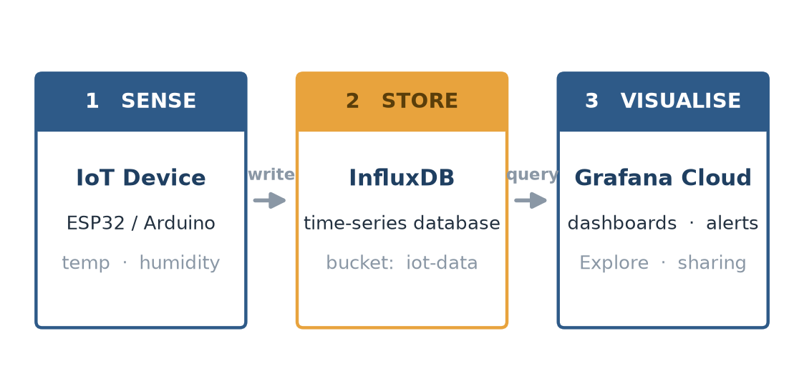
The IoT data pipeline you will build: device to InfluxDB to Grafana.

University | PES University
Course | Internet of Things
Course code | UE24CS342AA3
Level | Beginner (no prior Grafana or database experience)
Tools | Grafana Cloud free tier + InfluxDB Cloud

Work through the labs in order. Each one ends with a checkpoint; do not move on until your screen matches it.

What is inside this manual
Seven labs that take you from an empty browser tab to a live, alerting IoT dashboard.

Before you begin
The two free accounts and the one Python library you need.
Lab 1 - Create your Grafana Cloud account
Sign up for the free tier and open your first dashboard.
Lab 2 - Get sensor data into InfluxDB
Create a database and load simulated readings from a device.
Lab 3 - Connect InfluxDB to Grafana
Add InfluxDB as a data source and prove the connection works.
Lab 4 - Explore your data
Query readings with Flux and read the result table.
Lab 5 - Build your first dashboard
Draw temperature, humidity and status panels.
Lab 6 - Make the dashboard dynamic
Add a device selector so one dashboard serves every device.
Lab 7 - Alert when it is too hot
Raise an alert when temperature crosses a threshold.
Reference
Troubleshooting, a glossary, a Flux cheat sheet and the full sensor script.

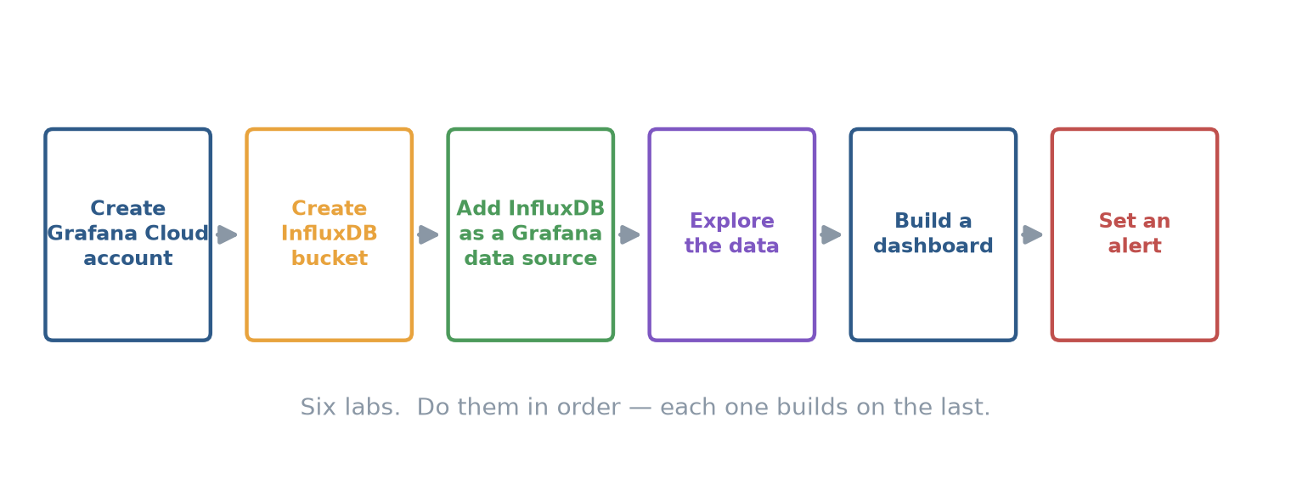
The seven labs in order. Each builds on the one before it.

How to use this manual
Read this page once before you start Lab 1.

What you will be able to do
- Explain how a sensor reading travels from an IoT device to a dashboard.
- Create a Grafana Cloud account and connect it to a time-series database.
- Write a basic Flux query and read the table it returns.
- Build a dashboard with time-series, stat and gauge panels.
- Add a dropdown that filters every panel by device.
- Create an alert rule that fires when a sensor value crosses a threshold.

What you need
Two free accounts and one small Python library. No hardware is required - Lab 2 includes a script that generates realistic sensor readings for you, so you can complete every lab on a laptop.
Item | Where to get it | Cost
Grafana Cloud account | grafana.com/products/cloud - click Create free account | Free tier
InfluxDB Cloud account | cloud2.influxdata.com - sign up for the free plan | Free tier
Python 3.9 or newer | python.org or your lab machine (check with python --version) | Free
influxdb-client library | Run: pip install influxdb-client | Free
A web browser | Chrome, Firefox or Edge, up to date | Free

How the boxes in this manual work
A Checkpoint box tells you what your screen should show before you continue. An Exercise box asks you to change something and observe the result. Watch out boxes flag the mistakes that cost students the most time.

Time and difficulty
Budget about 45 minutes per lab. Labs 1 to 3 are the fiddly ones - they involve accounts and tokens. Once the data source is connected, Labs 4 to 7 go quickly. Do not skip Lab 3's checkpoint; every later lab depends on it.

Why Grafana for IoT
The idea behind every lab that follows.

A sensor is useless until someone can see its readings
An ESP32 reading a temperature sensor once a second produces 86,400 numbers a day. A text file of those numbers tells you nothing at a glance. Grafana turns that stream into a moving line you can read in one second, a big number that shows the current value, and an alert that emails you the moment the freezer gets too warm.
Grafana is a visualisation and alerting layer. It does not store your data and it does not talk to sensors directly. It sits at the end of the pipeline, reads from a database, and draws what it finds.
Figure 1. Device writes to InfluxDB; Grafana queries InfluxDB and draws the result.

The three stages of the pipeline
Stage | What it does | In this course
Sense | A device reads its sensors and formats the values | ESP32 or the Python simulator
Store | A time-series database keeps each reading with its timestamp | InfluxDB
Visualise and alert | A tool queries the store and draws it for people | Grafana Cloud

Why a time-series database, not a spreadsheet
IoT data has three properties a spreadsheet handles badly: it arrives continuously, every row is stamped with a time, and you almost always ask questions about ranges of time ("the last hour", "last Tuesday"). InfluxDB is built for exactly this. Grafana understands its structure natively, which is why the two are a standard pairing in IoT courses.

What the free tier gives you
Grafana Cloud's free tier is permanent and needs no credit card. For a classroom it is more than enough. The limits that matter to you are the ones below; if you exceed them the plan simply stops accepting new data rather than charging you.
Free tier allowance | Limit | Enough for
Metrics (active series) | 10,000 per month | Thousands of sensor series
Logs and traces | 50 GB each per month | Well beyond a class project
Users | 3 active users | You and two classmates, or a shared login
Data retention | 14 days | A two-week experiment window

Watch out
The 14-day retention applies to the free tier. Data older than 14 days is dropped. For a semester-long project, either export your data or ask your instructor about a paid student plan. For these labs, 14 days is plenty.

Lab 1 | Create your Grafana Cloud account
Fifteen minutes. By the end you will be logged in to your own Grafana instance.

- Open grafana.com/products/cloud in your browser.
- Click Create free account. Enter your email and a password, then confirm your email address from the message Grafana sends you.
- When asked for a stack name, type something you will recognise, for example iot-lab-yourname. A stack is your private Grafana instance plus its storage.
- Choose the Free plan. Grafana starts a 14-day trial with generous limits; when it ends your account rolls onto the free-forever tier automatically.
- Skip the prompts that offer to install an agent or connect a pre-built data source. You will add your own in Lab 3.
- When the setup wizard finishes, click Launch Grafana. You land on the Grafana home page.
Checkpoint
You are inside Grafana and can see the left-hand navigation menu with Home, Dashboards, Explore, Connections, Alerting and Administration. Note your stack's URL (it looks like yourname.grafana.net) - you will use it again.

Get to know the screen
Every Grafana screen you will use in this course lives inside the layout below. The left menu is how you move between tasks; the large area on the right is where dashboards and query results appear.
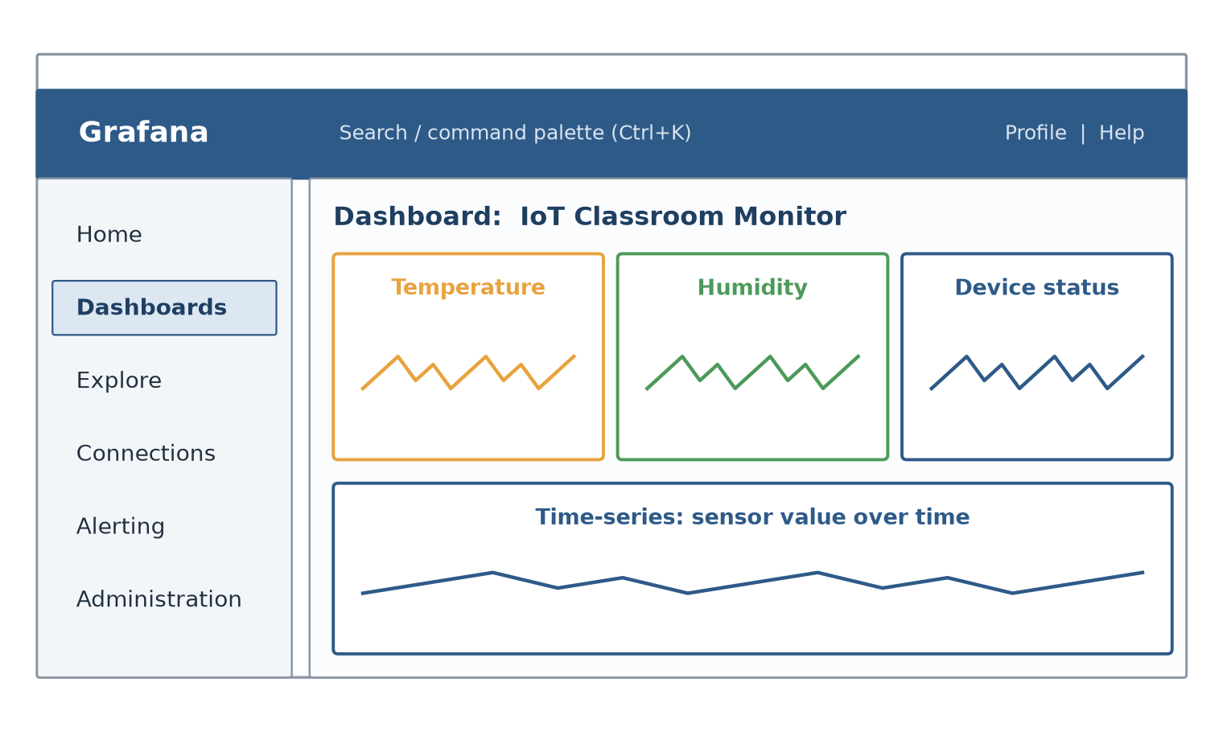
Figure 2. The Grafana interface. The left menu is your map for the whole course.

The six menu items you will actually use
Menu item | What it is for
Home | Your landing page and a list of recent dashboards.
Dashboards | Where you build and open dashboards (Labs 5 and 6).
Explore | Ad-hoc querying with no dashboard - your testing bench (Lab 4).
Connections | Where you add a data source such as InfluxDB (Lab 3).
Alerting | Where alert rules and notification channels live (Lab 7).
Administration | Users, API keys and stack settings. You will rarely open this.

Watch out
If you lose your stack URL, go to grafana.com and sign in - your stack is listed on your account page. Bookmark it now.

Lab 2 | Get sensor data into InfluxDB
Twenty-five minutes. You will create a database and fill it with simulated sensor readings.

Grafana draws data that already exists - it cannot create it. So you fill the database first, then point Grafana at it. In this lab you create the bucket and run a small Python script that plays the part of your IoT device.

Step 1 - Create your InfluxDB bucket
- Sign up at cloud2.influxdata.com and choose the free plan. Pick any region close to you (for example, Mumbai or Singapore).
- In the left menu open Load Data then Buckets, and click Create bucket.
- Name the bucket iot-data and set the retention period to 7 days. Click Create.
- Open Load Data then API Tokens and click Generate API token, choosing the Custom option.
- Give the token read and write access to the iot-data bucket, then click Generate.
- Copy the token and paste it somewhere safe for the next few minutes. You cannot view it again after you close the window.
Watch out
A token is a password. Never commit it to Git or paste it into a shared document. If you lose it, generate a new one - there is no way to recover an old token.

Step 2 - Install the library and run the simulator
Appendix B has the simulator. Save it as simulate_sensors.py and edit the four settings at the top.
TERMINAL
# simulate_sensors.py - edit these four lines, then run the file
INFLUX_URL = "https://<your-region>.aws.cloud2.influxdata.com"
INFLUX_TOKEN = "<paste your API token here>"
INFLUX_ORG = "<your email or organisation name>"
BUCKET = "iot-data"

python simulate_sensors.py # run from a terminal; press Ctrl+C to stop

Checkpoint
The script prints a line for each batch, for example wrote 3 points at 12:04:07. Let it run two minutes before you continue.

Step 3 - Prove the data is really there
Open Data Explorer, choose the iot-data bucket, filter on the sensor measurement, and click Submit. You should see a table of rows and a rising graph.
Exercise
Change the simulator's INTERVAL from 1 second to 5 seconds and watch the Data Explorer graph get coarser. This is the difference between sample rate and chart resolution - a distinction that matters in Lab 5.

Lab 3 | Connect InfluxDB to Grafana
Fifteen minutes. This is the single most important lab - every later one depends on it.

Grafana calls any data store it reads from a data source. You will add your InfluxDB bucket as one, using the token from Lab 2. Grafana talks to InfluxDB using a query language; for this course you will use Flux, InfluxDB's own language.
- In Grafana, open Connections in the left menu, then click Add new connection.
- Type InfluxDB in the search box and select the InfluxDB data source.
- Click Add new data source in the top right corner.
- Set Query language to Flux. This changes the fields below it.
- For URL, paste the InfluxDB URL from your Lab 2 script (it ends in cloud2.influxdata.com).
- Fill in Organization and Default Bucket with the same values you used in the script (iot-data for the bucket).
- Paste your API Token into the token field. Under advanced settings, leave TLS verification on.
- Click Save and test at the bottom of the page.
Checkpoint
Grafana shows a green banner reading datasource is working. 1 bucket found. That message is your proof that Grafana can read your database. If it shows an authentication error, your token is wrong or lacks read access - regenerate it and try again.

If Save and test fails
Message | What it means | Fix
401 Unauthorized | Token is wrong or missing | Re-paste the token exactly, with no spaces
403 Forbidden | Token has no read access to the bucket | Regenerate the token with read access
bucket not found | Bucket name is misspelled | Use iot-data exactly, all lowercase
connection refused | URL is wrong | Check the URL matches your InfluxDB region

Watch out
Avoid apostrophes and other punctuation in bucket and token names. Grafana and InfluxDB handle plain names far more reliably, and a stray character here produces confusing errors later.

Lab 4 | Explore your data
Twenty minutes. Learn to query before you build panels - it makes Lab 5 easy.

Explore is Grafana's scratch pad. It runs a query and shows you the raw result, with no dashboard to configure. Every panel you build in Lab 5 starts life as a query you proved here.
- Open Explore (the compass icon) in the left menu.
- In the data-source dropdown at the top left, select your InfluxDB data source.
- In the query editor, paste the Flux query below.
- Click Run query (or press Shift+Enter).
- In the top-right time picker, set the range to Last 15 minutes.
FLUX - AVERAGE TEMPERATURE PER TIME WINDOW
from(bucket: "iot-data")
|> range(start: v.timeRangeStart, stop: v.timeRangeStop)
|> filter(fn: (r) => r["_measurement"] == "sensor")
|> filter(fn: (r) => r["_field"] == "temperature")
|> aggregateWindow(every: v.windowPeriod, fn: mean, createEmpty: false)
|> yield(name: "mean")

Reading the query line by line
Line | What it does
from(bucket: ...) | Opens the iot-data bucket - the database to read.
range(start, stop) | Keeps only rows inside the time range on screen. The v. prefix means Grafana fills in the value.
filter ... _measurement | Keeps rows from the sensor measurement only.
filter ... _field | Keeps the temperature field, dropping humidity and pressure.
aggregateWindow ... mean | Averages readings into one point per time window, so the chart stays readable.
yield(name: mean) | Names the result so Grafana can label it.

Checkpoint
Explore shows a line graph and a table underneath. Each table row has a _time column, a _value column holding the temperature, and _measurement and _field columns describing what the row is.

Exercise
Change mean to max in the aggregateWindow line and run again. Then swap the _field filter from temperature to humidity. You are now editing real Flux - this is the skill the rest of the course is built on.

Lab 5 | Build your first dashboard
Thirty minutes. Turn four proven queries into a dashboard a human can read.

A dashboard is a grid of panels. Each panel is one query plus one visualisation choice. Grafana offers many panel types; the six below cover almost everything an IoT project needs.
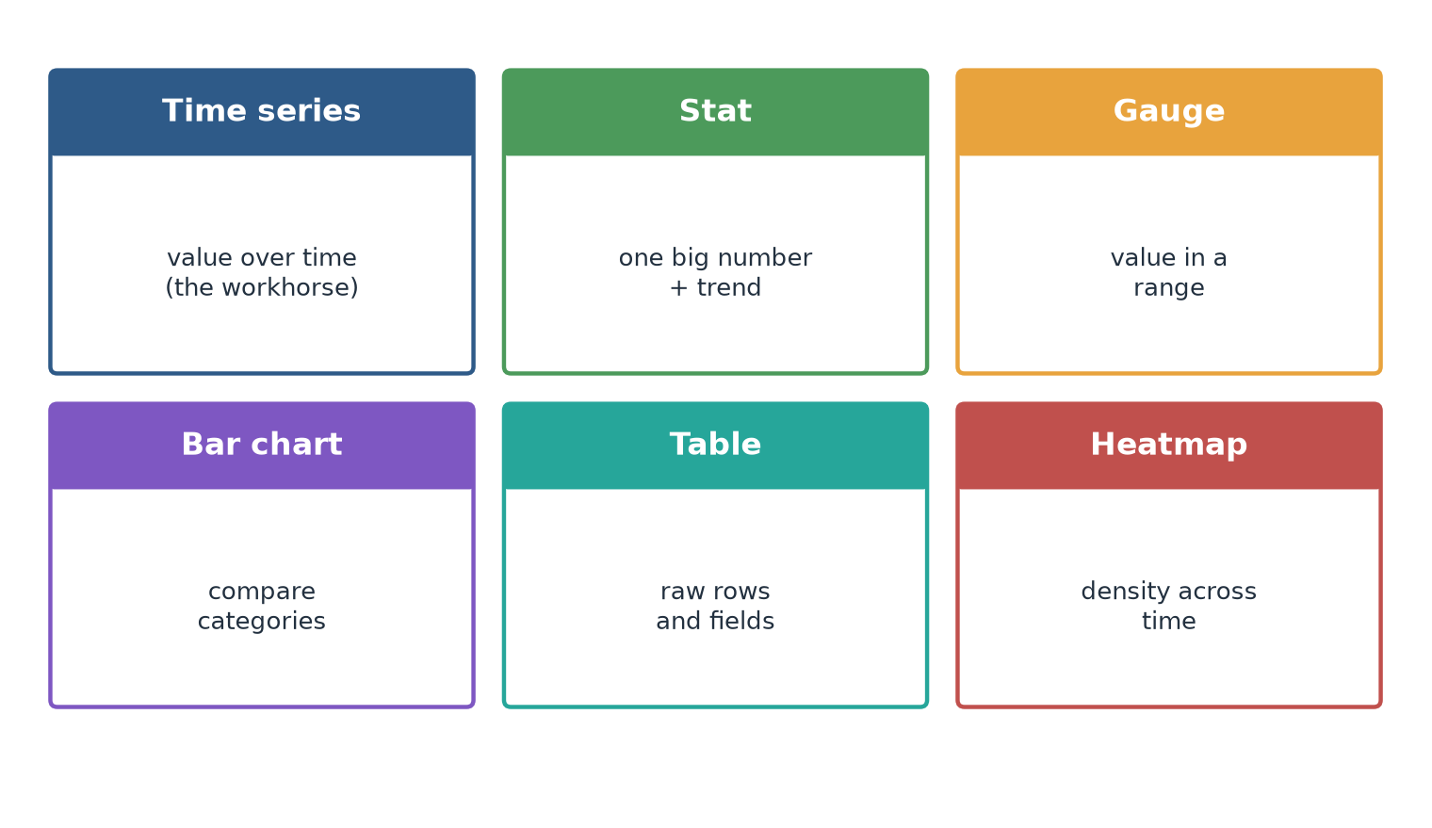
Figure 3. The six panel types used in this course.

Create the dashboard and the first panel
- Open Dashboards in the left menu, then click New and New dashboard.
- Click Add visualization, then choose your InfluxDB data source.
- Paste the temperature query from Lab 4 into the query editor and click Run query.
- On the right, choose the Time series visualisation.
- Set the panel title to Temperature over time.
- Under Standard options, set the unit to Temperature &gt; Celsius.
- Click Apply to save the panel to the dashboard.
Checkpoint
Your dashboard shows one full-width panel drawing a temperature line with the title 'Temperature over time' and a Celsius axis. You have built your first Grafana panel.

Add a current-value panel and a gauge
- Click Add then Visualization to add a second panel.
- Reuse the temperature query, but set the visualisation to Stat. Change aggregateWindow's function to last so the panel shows the newest reading.
- Title it Current temperature and set the unit to Celsius. Click Apply.
- Add a third panel: switch the query's field to humidity and choose the Gauge visualisation.
- Title it Humidity, set the unit to Humidity &gt; Percent (0-100), and set the min to 0 and the max to 100.
- Drag the panel edges so the two small panels sit side by side above the wide line chart.
Checkpoint
Your dashboard has three panels: a wide temperature line at the bottom, a big current-temperature number and a humidity gauge above it. Save the dashboard with the name IoT Classroom Monitor (top-right Save icon).

Exercise
Add thresholds to the temperature line: in the panel editor open Thresholds and add a red line at 30 degrees. The line turns red above 30 - the visual hint you will turn into a real alert in Lab 7.

Lab 6 | Make the dashboard dynamic
Twenty minutes. One dashboard that serves every device, instead of one per device.

Right now your panels are hard-wired to one device. If your class adds a second sensor you would have to copy the whole dashboard. A template variable fixes this: a dropdown at the top of the dashboard that every panel reads from.
- Open your IoT Classroom Monitor dashboard and click the Dashboard settings gear icon.
- Open the Variables tab and click New variable.
- Set Select variable type to Query.
- Name the variable device. This is the name you will use inside queries.
- In the query field, paste the Flux below and click outside the box.
- Leave Multi-value off for now, then click Apply and Save dashboard.
FLUX - LIST EVERY DEVICE NAME IN THE BUCKET
import "influxdata/influxdb/schema"
schema.tagValues(bucket: "iot-data", tag: "device")

Make the panels listen to the dropdown
A variable does nothing until a query uses it. Open each panel, and add one filter line that compares the device tag to the variable. In Grafana, a variable is referenced with a dollar sign inside the query, and Grafana substitutes the selected value before sending it to InfluxDB.
FLUX - ADD THIS LINE TO EVERY PANEL QUERY
|> filter(fn: (r) => r["device"] == v.device)

Checkpoint
A device dropdown appears at the top of your dashboard listing esp32-01, esp32-02 and esp32-03. Choosing a different device redraws every panel in about a second.

Two finishing touches
- Auto-refresh: in the top-right time picker, set refresh to 10s. Your dashboard now updates itself like a real control room.
- Rows: add a row named Live for the stat and gauge panels and a row named History for the line chart, so a classmate can find things at a glance.
Exercise
Turn on Multi-value for the device variable, then select two devices at once. Grafana automatically changes the equality filter into a membership test. This is how production dashboards compare devices side by side.

Lab 7 | Alert when it is too hot
Twenty-five minutes. A dashboard nobody is watching is useless - alerts are the payoff.

An alert rule watches a query and fires when a condition is true. Grafana splits this into three parts you configure in order: the query that fetches the value, a reduce step that turns the series into a single number, and a condition that tests that number.
- Open Alerting in the left menu and click Alert rules, then New alert rule.
- Name the rule Temperature too high.
- In section 1, choose your InfluxDB data source and paste the temperature query below. Set the evaluation time range to Last 5 minutes.
- In section 2, add a Reduce expression with function Last and input A. This gives the most recent temperature as one number.
- In section 3, set the condition to Is above 30, reading from the reduce expression.
- Set Evaluate every 1m for 1m so the rule checks once a minute.
- Add a Contact point - choose Email and enter your own address - and attach a notification message.
- Click Save rule and exit.
FLUX - THE NEWEST TEMPERATURE READING FOR THE SELECTED DEVICE
from(bucket: "iot-data")
|> range(start: v.timeRangeStart, stop: v.timeRangeStop)
|> filter(fn: (r) => r["_measurement"] == "sensor")
|> filter(fn: (r) => r["_field"] == "temperature")
|> filter(fn: (r) => r["device"] == v.device)
|> last()

Checkpoint
The rule appears in the Alert rules list with state Normal (green). When temperature rises above 30 degrees, the state changes to Alerting (red) and you receive an email.

Test it without waiting for the weather
Exercise
Edit the rule and lower the threshold from 30 to 20, then save. Within a minute the rule should flip to Alerting and you should get an email - proof the whole chain works. Set it back to 30 when you are done.

Watch out
Alerts need a contact point that actually delivers. Email contact points may need your instructor to enable SMTP on the stack. If no email arrives, check Alerting &gt; Contact points first - the rule is usually fine and the delivery path is the problem.

Reference
Troubleshooting, a glossary, a Flux cheat sheet and the full sensor script.

Troubleshooting
Symptom | Most likely cause | Fix
Grafana says no data | Time range excludes your readings | Widen the time picker to Last 6 hours
Charts are flat or empty | Simulator stopped running | Re-run simulate_sensors.py in a terminal
Only one point shows | aggregateWindow window too large | Shorten the dashboard time range
Device dropdown is empty | Tag name is not device | Check the simulator writes a device tag
Panel shows wrong field | Filter still set to temperature | Change the _field filter to the field you want
Alert never fires | Contact point not configured | Add and test a contact point in Alerting

Glossary
Term | Meaning
Bucket | A named container for data in InfluxDB. Yours is called iot-data.
Data source | A connection Grafana uses to read a database. You added InfluxDB as one.
Field | The measured quantity - temperature, humidity or pressure.
Flux | InfluxDB's query language, the one you write in Explore and panels.
Measurement | The table-like category a reading belongs to. Yours is called sensor.
Panel | One query plus one visualisation on a dashboard.
Series | A stream of timestamped values. A metric Grafana stores.
Stack | Your private Grafana Cloud instance plus its storage.
Tag | A key-value label on a reading, such as device = esp32-01.
Template variable | A dashboard dropdown that feeds a value into queries.
Time series | Data indexed by time - the shape of all IoT data.
Token | The secret key that lets Grafana read your InfluxDB bucket.

Appendix A - Flux cheat sheet
The handful of building blocks that cover most IoT queries.

Start every query the same way
EVERY QUERY OPENS THE BUCKET AND SETS THE TIME RANGE
from(bucket: "iot-data")
|> range(start: v.timeRangeStart, stop: v.timeRangeStop)
|> filter(fn: (r) => r["_measurement"] == "sensor")

The operations you will reach for
Goal | Function to add
One field only | filter(fn: (r) => r["_field"] == "temperature")
One device only | filter(fn: (r) => r["device"] == v.device)
Smooth the line | aggregateWindow(every: v.windowPeriod, fn: mean, createEmpty: false)
Newest value | last()
Peak value | aggregateWindow(every: v.windowPeriod, fn: max, createEmpty: false)
Name the result | yield(name: "result")

Macros Grafana fills in for you
The values beginning with v. are macros. You type the macro; Grafana replaces it with a real value before sending the query on, based on the time range or variable on screen.
Macro | Replaced with
v.timeRangeStart | The start of the time range currently on screen
v.timeRangeStop | The end of the time range currently on screen
v.windowPeriod | A sensible averaging window for the current zoom level
v.device | The value selected in your device template variable

Appendix B - The sensor simulator
The complete script from Lab 2. Save it as simulate_sensors.py.

Install the library once with pip install influxdb-client, edit the four settings at the top, and run python simulate_sensors.py. It writes one reading per second for three devices until you stop it with Ctrl+C.
PYTHON - SIMULATE_SENSORS.PY
import time, random, datetime
from influxdb_client import InfluxDBClient, Point, WritePrecision
from influxdb_client.client.write_api import SYNCHRONOUS

# ---- EDIT THESE FOUR VALUES ----
INFLUX_URL = "https://<your-region>.aws.cloud2.influxdata.com"
INFLUX_TOKEN = "<paste your API token here>"
INFLUX_ORG = "<your email or organisation name>"
BUCKET = "iot-data"

INTERVAL = 1 # seconds between readings
DEVICES = ["esp32-01", "esp32-02", "esp32-03"]

client = InfluxDBClient(url=INFLUX_URL, token=INFLUX_TOKEN, org=INFLUX_ORG)
write = client.write_api(write_options=SYNCHRONOUS)

def reading(device):
return (Point("sensor")
.tag("device", device)
.tag("location", "lab")
.field("temperature", round(random.uniform(22, 31), 2))
.field("humidity", round(random.uniform(40, 65), 1))
.field("pressure", round(random.uniform(1000, 1015), 1))
.time(datetime.datetime.utcnow(), WritePrecision.NS))

print("Writing to", BUCKET, "- press Ctrl+C to stop.")
while True:
points = [reading(d) for d in DEVICES]
write.write(bucket=BUCKET, record=points)
print("wrote", len(points), "points at", time.strftime("%H:%M:%S"))
time.sleep(INTERVAL)

Tip
Keep this script running in a terminal beside your browser while you work through Labs 4 to 7. If your charts freeze, the first thing to check is whether the script is still alive.

Appendix C - Self-check
Tick these off when you can do each one without the manual.

The seven checkpoints
Lab | You can do this without help
1 | Log in to your own Grafana Cloud stack and name its six menu items
2 | Create an InfluxDB bucket and confirm readings arrived in Data Explorer
3 | Add InfluxDB as a Grafana data source and explain the success message
4 | Write a Flux query and describe the _time and _value columns
5 | Build a dashboard with a time series, a stat and a gauge panel
6 | Add a device variable and make every panel respond to it
7 | Create an alert rule and explain query, reduce and condition

Where to go next
Once the seven labs feel comfortable, these are the natural next steps, in rough order of difficulty:
- Feed the dashboard from a real ESP32 instead of the simulator - the data shape is identical.
- Add a table panel that lists the last ten readings per device.
- Use transformations to join temperature and humidity into one chart.
- Build a second dashboard with annotations that mark when a door opened.
- Connect a second data source, such as a weather API, and overlay outdoor temperature.

End of manual. If something in these labs did not work, note the exact error message and bring it to your instructor - the Troubleshooting table on the Reference page solves most of the common ones.

