Kimuntu AI Riipen Project
Project Foundation and Baseline Text Classification
Project Partner: Kimuntu Power Inc.
Name: Nassejje Racheal
Course: Artificial Intelligence and Robotics
Stuedent ID: 237-415

1. Problem Understanding

1.1 Problem statement
Kimuntu Power Inc. operates Kimuntu AI, whose Legal Track provides AI-guided legal assistance for Canada and the United States, covering family law, criminal matters, business contracts, consumer rights, immigration, labour law and civil litigation.
Users submit legal questions as free text, in their own words. Routing these manually does not scale, so the system must automatically classify each query into a defined category, allowing it to reach the correct decision-support rules, service recommendations and chatbot responses.
This assessment builds the first component of that system, a baseline classifier that assigns a legal category to a user query.

1.2 Proposed classification categories
The assignment requires proposing suitable legal text categories. Rather than adopting generic legal divisions, the seven categories below are derived directly from the service areas Kimuntu AI publishes for its Legal Track, so that every predicted class corresponds to a capability the platform already offers and therefore has a defined downstream action.
Category | Kimuntu service area | Example user query
Family law | Custody, child support, divorce agreements | "How is custody decided if we were never married?"
Criminal | Criminal case analysis and research | "What happens at a first appearance hearing?"
Business contracts | Contract drafting and review | "Is my freelance contract binding without a signature?"
Consumer rights | Consumer protection and disputes | "A supplier refused my refund — what are my rights?"
Immigration & refugee | Immigration and refugee applications | "What documents do I need for a spousal sponsorship?"
Labour & employment | Labour law and workplace matters | "Can my employer dismiss me without notice?"
Civil litigation | Civil litigation risk analysis | "Should I sue in small claims court or settle?"

These seven categories represent the target design for Kimuntu AI once company data becomes available. For the Week 1 baseline a public proxy dataset is used.

1.3 Derived project requirements
The assessment brief asks that the Kimuntu AI project requirements be reviewed and translated into a technical design. The requirements below are derived from Kimuntu’s published product description together with the needs of a legal-domain application.
Functional requirements
ID | Requirement | Priority
FR-1 | Accept a user query as free text and return one legal category | Must
FR-2 | Return a confidence score with every prediction, plus the runner-up category | Must
FR-3 | Route predictions below a confidence threshold to the chatbot for clarification or to human review rather than guessing | Must
FR-4 | Mask personal information (names, emails, telephone numbers, URLs) before classification or storage | Must
FR-5 | Pass the predicted category to the decision support and recommendation components in a structured form | Must
FR-6 | Support multi-label output where a query spans two legal areas | Should
FR-7 | Support French and Spanish queries | Should

Data requirements
ID | Requirement
DR-1 | Labelled queries covering every category the platform offers, including immigration; a public proxy until Kimuntu data is available
DR-2 | Real user queries collected only with consent, with personal data masked before labelling
DR-3 | A held-out test set never used for training or tuning
DR-4 | A data card for each dataset recording source, licence, size, language and known gaps

Non-functional requirements
ID | Requirement | Source
NFR-1 | No personal data retained in logs or training artefacts; handling consistent with PIPEDA, GDPR and CCPA given the Canadian, US and international user base | Assumed
NFR-2 | English first; French and Spanish in later versions, matching the platform’s stated language support | Kimuntu product page
NFR-3 | Every prediction traceable to a model version; training reproducible from code and a fixed random seed | Assumed
NFR-4 | The system presents legal information, not legal advice, and states this to the user | Assumed

Of these, FR-1 and FR-5 are delivered by the Week 1 baseline. FR-2 and FR-3 are evidenced in Section 5.4, and DR-4 in Section 3.6.

2. System Design
The diagram below shows how the four required components, the text classifier, the legal decision support system, the recommendation system and the chatbot work together to answer a user’s legal query.
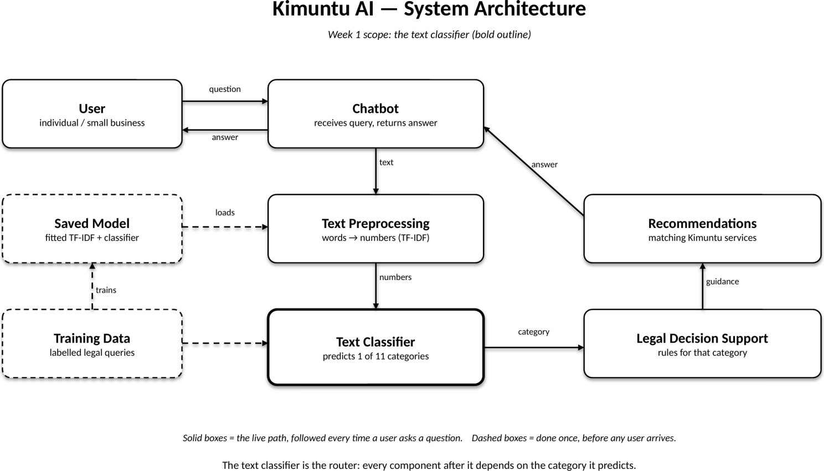
Figure 1: Kimuntu AI system architecture.

2.1 How the components work together
Solid boxes show the live request path, taken every time a user asks a question. Dashed boxes show offline, training-time components that run once.
Live path: the user submits a legal question through the chatbot interface. The text is passed to a preprocessing stage, which cleans it and converts it into numerical TF-IDF features. The text classifier receives these features and predicts one of the available legal categories. That predicted category is passed to the legal decision support system, which selects the rules and guidance relevant to the category. The recommendation system then matches the query to appropriate Kimuntu services and documents, and the chatbot returns the answer and recommendations to the user.
The text classifier acts as the router for the entire system. Every downstream component, decision support, recommendations and chatbot responses, depends on the predicted category being correct, which is why this assessment focuses on establishing a reliable baseline classifier first.

3. Dataset Preparation

3.1 Dataset source and justification
As the Kimuntu Power Inc.’s own user data is not yet available, so we have publicly available proxy dataset is used for the Week 1 baseline, as permitted by the assessment brief.
Dataset: Legal Advice Reddit (jonathanli/legal-advice-reddit, Hugging Face Hub), derived from posts to the r/legaladvice community and published alongside Li et al., NLLP 2022.
It contains approximately 98,900 posts in which members of the public describe real legal problems in their own words, each carrying a single community-assigned topic label.
This dataset is selected because its inputs closely resemble those Kimuntu AI will receive: unstructured legal questions written by non-specialists, varying widely in length, vocabulary and clarity.

3.2 Data splits
The dataset comes with predefined train, validation and test splits, which are retained rather than re-partitioned. Retaining the published splits keeps results comparable with the source benchmark and removes any risk of introducing leakage through a custom split. The table below shows each split as supplied and after the duplicate removal described in Section 3.5.
Split | Posts as supplied | After deduplication
Training | 9,887 | 9,856
Validation | 9,887 | 9,885
Test | 79,136 | 79,074
Total | 98,910 | 98,815

The test split is substantially larger than the training split, which is unusual relative to a conventional 80/10/10 partition. This is accepted for two reasons: a large held-out set yields a more reliable estimate of generalisation performance, and 9,887 training examples are sufficient for a TF-IDF and logistic regression baseline.

3.4 Class distribution
The training set is moderately imbalanced. The distribution below is computed on the final training set of 9,856 posts, after the duplicate removal described in Section 3.5.
Category | Training posts | Percentage
housing | 2,374 | 24.09%
employment | 1,581 | 16.04%
family | 1,191 | 12.08%
driving | 940 | 9.54%
criminal | 868 | 8.81%
business | 576 | 5.84%
digital | 526 | 5.34%
contract | 517 | 5.25%
insurance | 431 | 4.37%
school | 430 | 4.36%
wills | 422 | 4.28%
Total | 9,856 | 100%

Housing is the majority class at 24.09% (2,374 posts) and wills the smallest at 4.28% (422 posts), a ratio of approximately 5.6 to 1. Three consequences follow for the evaluation design:
- A majority-class baseline, which always predicts housing, achieves approximately 24% accuracy. Any trained model must exceed this figure to demonstrate that it has learned anything useful.
- Weaker recall is anticipated on the smaller classes (wills, insurance, school), since fewer training examples are available for the model to learn their characteristic vocabulary.
- Macro F1 is reported alongside accuracy. Macro F1 averages performance across all eleven classes equally, so strong performance on large classes cannot mask poor performance on small ones.

3.5 Cleaning and preprocessing steps
The following preparation decisions were applied identically to all three splits:
- Field combination: each post has a short title and a longer body. Both carry useful signal, so they are concatenated into a single text field, which becomes the model input.
- Missing values: missing titles or bodies are replaced with an empty string before concatenation, preventing the literal string "nan" from entering the feature space.
- Whitespace: leading and trailing whitespace introduced by the concatenation is removed.
- Duplicate detection: repeated post texts are identified and counted. A duplicate appearing in both the training and evaluation splits would allow the model to recognise text it has already memorised, inflating reported performance — a form of data leakage.
- Column selection: only the text and text_label columns are retained; metadata fields (post identifier, timestamp, URL) are discarded as they carry no predictive signal and could otherwise leak information.

4. Baseline Text Classification Model

4.1 Two models for comparison
Two models were built so that the trained classifier can be judged against a meaningful floor rather than in isolation.
- Majority-class baseline (DummyClassifier, strategy = most_frequent). This model always predicts housing, the most frequent training class, and learns nothing from the text. Its purpose is to establish the score achievable without any learning at all; a trained model that cannot exceed it has added no value.
- TF-IDF with Logistic Regression. Text is converted to numerical features by a TF-IDF vectoriser and classified by multinomial logistic regression. Both steps are combined in a single scikit-learn Pipeline.

4.2 Why TF-IDF and logistic regression
TF-IDF (Term Frequency – Inverse Document Frequency) represents each post as a vector of word weights. Term frequency counts how often a word occurs in a post; inverse document frequency reduces the weight of words occurring across most posts. The product gives high weight to words that are frequent within a post.
Logistic regression then learns, for each of the eleven categories, a weight for every word indicating how strongly that word argues for or against the category, and predicts the most probable class. It was chosen as the baseline algorithm because it trains quickly on sparse high-dimensional text features.
Both steps are wrapped in a Pipeline so that the TF-IDF vocabulary and document frequencies are fitted on the training split only.

5. Model Evaluation

5.1 Results
The validation split was evaluated first so that the test split remained untouched until the final model was selected. Accuracy and macro F1 are reported for both models on both splits.
Model | Split | Accuracy | Macro F1
Majority baseline | Validation | 0.2413 | 0.0353
TF-IDF + LogReg | Validation | 0.8247 | 0.7626
Majority baseline | Test | 0.2414 | 0.0354
TF-IDF + LogReg | Test | 0.8215 | 0.7607

Macro F1 averages the per-class F1 scores with equal weight, so every category counts the same regardless of how many examples it has. It is reported alongside accuracy because the baseline demonstrates exactly why accuracy alone is insufficient: predicting housing for every post yields 24.1% accuracy but a macro F1 of 0.035, since the model scores zero on the remaining ten classes.
The trained classifier improves accuracy from 0.241 to 0.822 and macro F1 from 0.035 to 0.761 — a twenty-one-fold improvement in macro F1. Validation and test figures agree closely (accuracy 0.825 against 0.822), indicating that the model generalises rather than overfitting the training split.

5.2 Per-class results on the test set
Precision, recall and F1 for each of the eleven categories on the 79,074 held-out test posts:
Category | Precision | Recall | F1 | Support
housing | 0.919 | 0.966 | 0.942 | 19,087
family | 0.870 | 0.907 | 0.888 | 9,545
employment | 0.808 | 0.928 | 0.864 | 12,734
driving | 0.828 | 0.858 | 0.843 | 7,532
wills | 0.905 | 0.788 | 0.843 | 3,376
school | 0.858 | 0.743 | 0.796 | 3,455
criminal | 0.682 | 0.762 | 0.720 | 6,946
digital | 0.676 | 0.657 | 0.666 | 4,210
insurance | 0.743 | 0.602 | 0.665 | 3,451
contract | 0.708 | 0.492 | 0.581 | 4,134
business | 0.684 | 0.474 | 0.560 | 4,604
Macro average | 0.789 | 0.743 | 0.761 | 79,074
Weighted average | 0.817 | 0.821 | 0.816 | 79,074

Precision answers: of the posts the model assigned to this category, what fraction truly belonged to it. Recall answers: of the posts that truly belonged to this category, what fraction the model found. F1 is their harmonic mean. Support is the number of true test posts in the class.

5.3 Confusion matrix
The matrix below is row-normalised: each row shows how the posts of one true category were distributed across the model’s predictions. The diagonal holds correct predictions; off-diagonal cells show the nature of each error.
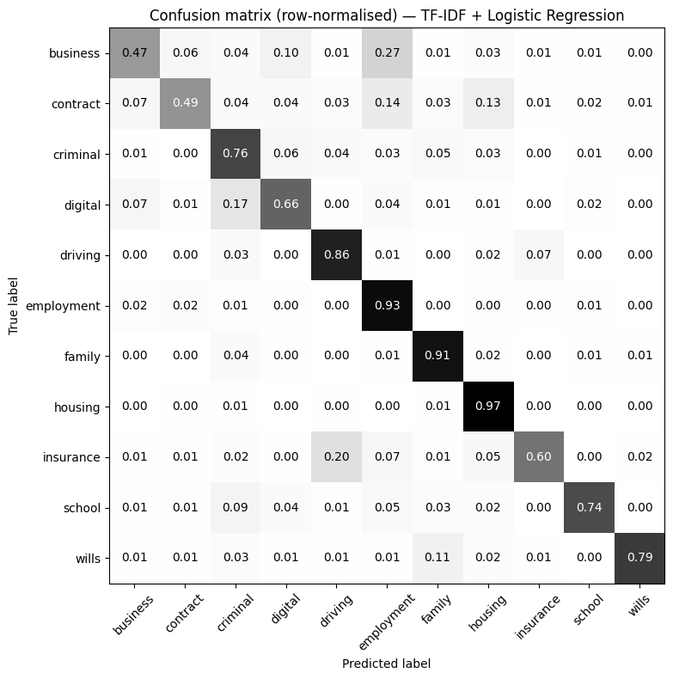
.

5.4 Prediction confidence and safe routing
Requirements FR-2 and FR-3 state that the classifier must return a confidence score and that low-confidence predictions must be referred rather than guessed at. Logistic regression outputs a probability per class, so the highest probability serves as the confidence score.
Confidence separates correct from incorrect predictions clearly: mean confidence is 0.703 when the prediction is correct and 0.439 when it is wrong. The score is therefore informative, not arbitrary, and can be used to decide which queries to auto-route.
Confidence threshold | Queries auto-routed | Accuracy on those queries
0.4 | 78.8% | 0.891
0.5 | 68.6% | 0.914
0.6 | 58.6% | 0.932
0.7 | 48.7% | 0.947
0.8 | 37.7% | 0.960

Each threshold trades coverage for reliability. At 0.7, the model auto-routes 48.7% of queries at 94.7% accuracy, referring the remainder to the chatbot for clarification or to human review. For a legal application this trade is favourable: a clarifying question costs the user a few seconds, whereas a confidently wrong routing may send them to the wrong body of law. Selecting the operating threshold on a coverage-versus-accuracy basis is proposed for Week 2.

5.5 Model interpretability
Section 4.2 justified logistic regression partly on the inspectability of its coefficients. Examining the highest-weighted terms for each category confirms that the model responds to legally meaningful vocabulary rather than incidental wording:
Category | Ten most influential terms
business | business, company, llc, work, sell, store, selling, product, start, paid
contract | contract, agreement, signed, loan, lease, contractor, wedding, cancel, gym, payment
criminal | police, charges, arrested, probation, criminal, assault, crime, charged, jail, theft
digital | online, internet, website, game, computer, copyright, instagram, youtube, video, account
driving | ticket, car, driving, traffic, speeding, parking, license, court, accident, road
employment | employer, work, job, unemployment, employees, boss, fired, employment, hr, working
family | divorce, custody, child, ex, support, kids, father, married, mom, abusive
housing | landlord, apartment, rent, lease, tenant, eviction, house, tenants, property, moved
insurance | insurance, car, accident, policy, medicaid, fault, claim, driver, company, vehicle
school | school, university, class, students, student, college, teacher, grade, campus, semester
wills | estate, trust, passed, inheritance, died, death, mother, assets, executor, father

Every category is driven by terms a lawyer would recognise as characteristic of that area. This is a material property for a legal application: a prediction that cannot be explained cannot be audited.

6. Interpretation

6.1 What the results show
The classifier substantially outperforms the majority-class baseline on every measure, confirming that the text of a legal query carries sufficient signal to predict its category. Performance is strongest where a category has both large training support and distinctive vocabulary: housing (F1 0.942), family (0.888) and employment (0.864).
Performance is weakest on business (F1 0.560) and contract (0.581). In both, precision is acceptable (0.684 and 0.708) while recall is poor (0.474 and 0.492): when the model assigns these labels it is usually correct, but it misses roughly half of the posts that genuinely belong to them. Those posts are absorbed into larger neighbouring classes rather than scattered at random.

6.2 Error analysis
The confusion matrix shows that the model’s errors are systematic and semantically coherent rather than arbitrary. The principal confusions are:
True category | Predicted as | Rate | Likely cause
business | employment | 0.27 | Business owners posting about staff and hiring.
insurance | driving | 0.20 | Insurance claims following road traffic accidents.
digital | criminal | 0.17 | Hacking, online fraud and harassment are both.
contract | employment | 0.14 | Employment contracts belong to both categories.
contract | housing | 0.13 | Tenancy agreements are contracts.
wills | family | 0.11 | Inheritance disputes arise between relatives.
school | criminal | 0.09 | Disciplinary matters involving alleged offences.

Each pair describes a genuine overlap in subject matter: a car insurance claim after a collision belongs equally to insurance and driving, and a lease is simultaneously a housing matter and a contract. The r/legaladvice scheme permits only one flair per post, so the author was forced to choose where two categories applied.
A material proportion of the measured error is therefore label ambiguity in the dataset rather than failure of the classifier. This matters for the Kimuntu application: routing a genuinely dual-topic query to either of its two valid categories would still produce a useful response. It is also the direct justification for the multi-label recommendation in Section 6.4.

6.3 Limitations of the baseline
- Proxy data. The model is trained on public Reddit posts rather than Kimuntu’s own user queries. Performance on real Kimuntu traffic is unknown and the model must be retrained once company data becomes available.
- Label set mismatch. The eleven dataset labels only partially correspond to the seven categories proposed for Kimuntu in Section 1.
- Single-label assumption. The task is framed as assigning exactly one category, which the error analysis shows is not always appropriate.
- No semantic understanding. TF-IDF treats each document as an unordered bag of words. It cannot distinguish "I sued my landlord" from "my landlord sued me", and it cannot recognise that "sacked", "fired" and "terminated" are near-synonyms unless each appears in training.
- Jurisdiction. The corpus is predominantly United States law. Kimuntu AI’s Legal Track covers both Canada and the United States, so the proxy data addresses roughly half of the intended jurisdictional scope. Canadian-specific terminology, procedure and statute names are under-represented in training.
- Missing service area. Kimuntu AI offers immigration and refugee application support, but the proxy dataset contains no immigration category. The classifier cannot currently route this service line at all, and no amount of tuning on this dataset will remedy that — it requires labelled immigration queries.
- Class imbalance. The smaller categories receive less training signal, which contributes to their weaker recall.
- Labelling authority. Flairs are applied by community members and moderators rather than legal professionals, so the ground truth itself contains noise.
- Near-duplicate detection. Duplicate removal matched posts on exact text. Near-duplicates — the same question reposted with minor rewording — would not have been caught, and if present across splits would inflate the reported score. The risk is low for independently written forum posts, but it was not measured.

6.4 Proposed improvements
- Multi-label classification. Allow a post to carry more than one category, directly addressing the dominant source of error identified in 6.2.
- Class weighting. Apply class_weight="balanced" in logistic regression so that under-represented categories exert proportionally greater influence during training, targeting the low recall on business, contract and insurance.
- Richer features. Add word bigrams to the TF-IDF vectoriser so that phrases such as "security deposit" or "non-compete clause" are captured as single features rather than independent words.
- Hyperparameter tuning. Use the validation split to search the regularisation strength C and the TF-IDF min_df and max_features settings, selecting on macro F1.
- Transformer embeddings. Replace TF-IDF with sentence embeddings from a pre-trained language model, which capture meaning and word order rather than surface word counts, and compare against this baseline.
- Confidence thresholds. Return the predicted category only when the model’s probability exceeds a threshold, and otherwise route the query to a human or ask a clarifying question — appropriate behaviour for a legal application where a confidently wrong answer is worse than no answer.
- Immigration data. Source or synthesise labelled immigration and refugee queries, since this published Kimuntu service area is entirely absent from the current training data and cannot be learned from it.
- Canadian coverage. Supplement the predominantly United States corpus with Canadian legal queries so that both jurisdictions in Kimuntu AI’s stated scope are represented.
- Company data. Obtain Kimuntu’s own queries, map them to the seven proposed categories, and retrain.
- Near-duplicate check. Apply fuzzy matching or minhashing across splits to confirm that no near-duplicate posts bridge training and evaluation.
- Privacy pipeline. Implement the FR-4 masking stage before any Kimuntu user data is ingested, so that personal information is removed prior to storage rather than afterwards.

7. Individual Contribution

7.1 Assigned role
Role: Group Coordinator.
As coordinator of a seventeen-member group drawn from two programmes (BCS and BDSAI), my responsibilities were to organise and maintain a shared understanding of the assessment requirements across the group.
Then with Tugume Andrew (236201) we produced the evaluation, accuracy, macro F1, per-class metrics and the confusion matrix (Section 5, Figure 2, and the Colab notebook).

7.2 Evidence
- Colab notebook: NASSEJJE_RACHEAL_AI_ROBOTICS.ipynb, containing all cells from data loading through evaluation, each preceded by an explanatory markdown cell.
- Report Sections 1 to 6, and Figure 2 (confusion matrix).

7.4 Group members
The following students form the project group and we all contributed towards this report
Name | Student ID | Programme
BIYINZIKA EMMANUEL ONYUTA | 224760 | BCS
NAMUSANA REBECCA | 228798 | BCS
KAWUMA MICHAEL | 078909 | BCS
MUSTAPHA SULEIMAN ALI | 172620 | BCS
NAZIF SABO DANLADI | 191367 | BCS
TWIJUKYE DISMAS | 185632 | BCS
NASSEJJE RACHEAL | 237415 | BDSAI
TUGUME ANDREW | 236201 | BDSAI
BABOUCARR A BOBB | 192831 | BDSAI
MUHEKE MUSA JUMA | 238242 | BDSAI
KAZIBWE BENJAMIN | 236035 | BCS
CHOL MANGONG AJAL BOL | 159627 | BCS
ATUHAIRE LYNNET | 221516 | BCS
ALYAMPA JORDAN | 245130 | BCS
HENOK TESFAHIWET LBAB FIDEL | 236571 | BCS
ARINDA DEOGRACIOUS | 236192 | BDSAI
NAKAMATTE STELLA | 236722 | BCS

References
Kimuntu Power Inc. (2026) Kimuntu AI. Available at: https://kimuntupower.com/kimuntu-ai/ (Accessed: 24 October 2026).
Kimuntu Power Inc. (2026) Company website. Available at: https://kimuntupower.com/ (Accessed: 24 October 2026).
Li, J. (2022) Legal Advice Reddit dataset. Hugging Face Hub. Available at: https://huggingface.co/datasets/jonathanli/legal-advice-reddit (Accessed: 23 October 2026).
r/legaladvice (n.d.) Reddit community. Available at: https://www.reddit.com/r/legaladvice/ (Accessed: 23 October 2026).

