Rapport stage M2

Moi même

Mardi 9 février 2020

**Contents**

**Acknowledgements 3**

**Présentation de la structure d’accueil 3**

**Literature review 4**

1. Structure and dynamics of ecosystems: how can species coexist in same envi-

ronment? . . . . . . . . . . . . . . . . . . . . . . . . . . . . . . . . . . . . . 4

1. Concepts and definition for studying ecosystems’ dynamic. . . . . . . . . . . . 4
2. Tools to study diversity in ecosystems and their limits . . . . . . . . . . . . . . 5
3. Emergence of a more global approach based on functional traits. . . . . . . . . 7
   1. General overview . . . . . . . . . . . . . . . . . . . . . . . . . . . . . 7
   2. Improvement of the method over the years . . . . . . . . . . . . . . . 7
4. The advent of functional diversity . . . . . . . . . . . . . . . . . . . . . . . . 9
   1. Benefits of this approach . . . . . . . . . . . . . . . . . . . . . . . . . 10

**Introduction 10**

**Materials & Methods 15**

1. Sampling and specimens . . . . . . . . . . . . . . . . . . . . . . . . . . . . . 15
2. Morphological measurements and functional traits . . . . . . . . . . . . . . . . 16
3. Data analysis . . . . . . . . . . . . . . . . . . . . . . . . . . . . . . . . . . . 16
   1. Data pre-processing . . . . . . . . . . . . . . . . . . . . . . . . . . . 16
   2. Factorial Analysis of Mixed Data (FAMD) . . . . . . . . . . . . . . . 18
4. niche area overlap . . . . . . . . . . . . . . . . . . . . . . . . . . . . . . . . . 18
5. Niche distance . . . . . . . . . . . . . . . . . . . . . . . . . . . . . . . . . . . 18

**Results 19**

1. Factorial Analysis of Mixed Data . . . . . . . . . . . . . . . . . . . . . . . . . 19
2. Functional niche area and overlap . . . . . . . . . . . . . . . . . . . . . . . . 20
3. Kernel density estimation . . . . . . . . . . . . . . . . . . . . . . . . . . . . . 22

**Discussion 23**

1 Community structure in Bay of Biscay’s canyons . . . . . . . . . . . . . . . . 23

1. **Phylogenetic tree 27**
2. **Morphological measurements 27**
3. **Correlation plot 27**

## Acknowledgements

## Présentation de la structure d’accueil

## Literature review

**1 Structure and dynamics of ecosystems: how can species coexist in same environment?**

Of all the questions raised when it comes to study Nature, the most common yet complex one is “how do organisms and environment interact with each other?” (Sutherland *et al.* 2013). In other words, what are the processes and rules that define structure and functioning of ecosystems? Taken as a whole, an ecosystem can be seen as a giant network: all individuals from every species are linked to one another through intra- and inter-specific relationships, that implies competition, parasitism, predation…; and each individual is linked to its physical environment, on which it depends for food prospection, shelter and/or favorable conditions for breeding. The main purpose of ecology is to study those links and ultimately, to be able to map the central relationshipsandflowsthatarekeystomaintainstableecosystems(Albouy*etal.*2011). Community ecologists, regardless of the ecosystem they are studying, try to answer some fairly similar questions such as “how do species share environmental resources?” or “how can species relying on the same resource to thrive and survive can coexist?”. Indeed, the mere observation that species can live and develop a population without encroaching each other suggests that, even if species compete to access the same resources, the use of resources is balanced and allows stable relationships between species to develop. Most of all, if species depend on the same resources to survive, how can diversity within an ecosystem last over time?

## 2 Concepts and definition for studying ecosystems’ dynamic.

To answer those questions, the structure and dynamic of ecosystems need to be investigated and ecological concepts must be defined.

First, a “community” is made up of all living organisms (all species combined), which interact and occupy a specific habitat. Within this habitat, the concept of “ecological niche” reflects the fact that distinct populations use differently space and trophic resources to meet their needs. In 1917, Grinnell was the first to scientifically as “ecological niche” all the requirements that a species needs to thrive (Grinnell 1917). This concept covers both biotic (food abundance and availability, competition within and among species, predation-prey relationships …) and abiotic conditions (environmental factors such as temperature or pression, shelter availability …), and it shapes the areas suited for species according to their needs. This definition is refined by Hutchinson (1957): resources and their availability are the main drivers for the coexistence of species, since resources are essential for species to thrive and are therefore considered limiting factors. Furthermore, Hutchinson’s definition distinguishes the concepts of (i)“fundamental niche”, which is a potential niche for a given species that offers all the optimal conditions for that species to flourish and (ii) “realized niche”, which corresponds to the actual resources used by a species and which is often smaller than the fundamental niche, mainly because of competition between species. If resources are limited, competition between species that seek to simultaneously exploit the same resources may arise, either because they hunt the same prey or because they live in the same specific habitat and are therefore more likely to meet (Blondel & Bourlière 1979). When the resources are abundant enough, species may be able to share it without entering competition (Nagelkerke *et al.* 2018). According to competition theory, community structures are defined by the way species are able to share or not resources. Therefore, to study the structure and dynamics of community and to identify the main factors that enable species to coexist, it is essential to determine the degree by which species share resources, in other words, quantify the overlap between ecological niches (Geange *et al.* 2011).

## 3 Tools to study diversity in ecosystems and their limits

Niche overlap can be approached from the habitat (beta overlap) or food (alpha overlap) perspective (Mouillot *et al.* 2005). In both cases, a high degree of overlap means that the species are likely to compete for the same resources making their coexistence virtually impossible. Conversely, a low deree of overlap tends to suggest that species, even if they rely in part on the same resources, have a sufficiently wide range of accessible resources not to compete with each other (Mouillot *et al.* 2005). No overlap means that species occupy distinct niches, are likely to use very different resources and that no competition is expected (see 1. This approach has been widely developed over the last decades to study the distribution of abundance and the mechanisms favoring species coexistence, in particular to predict the impact of disturbances, such as the introduction of invasive species or climate change (Albouy *et al.* 2011; Geange *et al.* 2011; Martini *et al.* 2020).

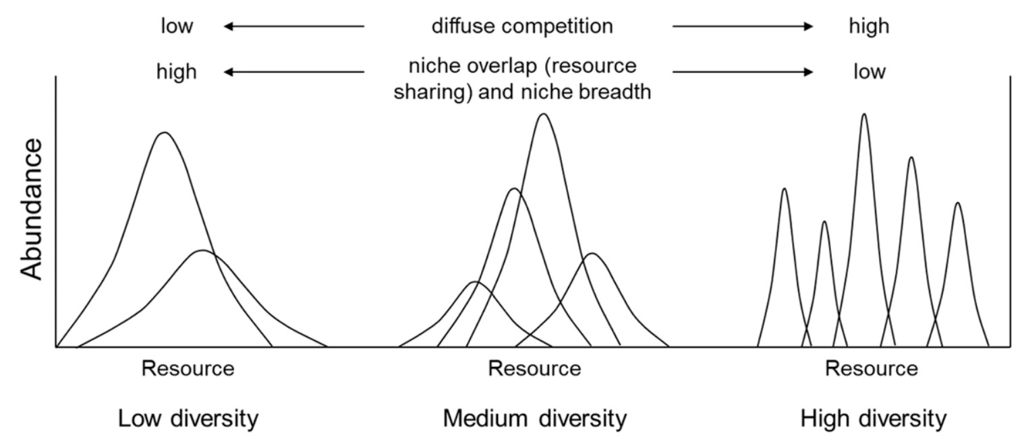

Figure 1: Caracteristics of niches along a resource gradient at different levels of species diversity, from Kim & Ohr (2020).

To quantify niche overlap, several indices have been developed since the 60’s. Indices and threshold values are commonly used for studying specific, taxonomic or phylogenetic diversity.

However, used alone, a result of diversity estimation through any index is usually poor and inaccurate, because complex and rich systems can not be described only by the result of a computation (Mejri 2009). Indeed, four of the best-known niche overlap indices, which are based on the intensity of utilisation of a resource use by species, were compared by Linton *et al.* (1981) to assess the precision and accuracy: Morisita (1959) updated by Horn (1966), Schoener (1968) and Pianka (1973). Even if they lead to the same general conclusions, these four indices often give different results, because they use different computation parameters (Blondel & Bourlière 1979). Moreover, they are often highly sensitive to sample size, which adds uncertainty when it comes to interpreting their values (Linton *et al.* 1981). Finally, Grossman (2009) points out that threshold values for those indices can be considered as arbitrary and might differ from one ecosystem to another, leading to an impossibility of comparing them. For all these reasons, using those indices to estimate if species share or not the same resources, and if so, how much is shared, does not seem relevant (Mouillot *et al.* 2005). As such, they provide a qualitative assessment of the overlap rather than a quantitative one (Linton *et al.* 1981).

Therefore, to understand how the structure and the dynamics of an ecosystem are defined and howsuchcomplexrelationshipscanlastforseveralgenerations, numericalmodelsareoftenused (see Ecopath models, [https://ecopath.org](https://ecopath.org/)). This approach requires a simplification of the ecosystem, because simulating very complex models make the outcome virtually impossible to compute (Albouy *et al.* 2011). Simplifying an ecosystem can be done in many ways: focusing on specific compartments of the ecosystem (*e.g*: pelagic or benthic fauna), grouping species based on their trophic level, or taxonomy or similaire behavior … Obviously, simplifying with any of these methods comes down to approximating the relationships and much of the complexity of an ecosystem, but if done properly, models are still able to produce reliable simulations of what is going on in real life (Albouy *et al.* 2011; Evans 2012; Piroddi *et al.* 2015). Yet, the main difficulty is to determine the criteria that are relevant to gather species and to simplify models. Whether they are too restrictive, or not enough, these criteria condition not only the accuracy of the model, but also its ability to be generalized (Moon *et al.* 2017; Pease *et al.* 2015; Pont *et al.* 2006). For instance, if a model uses a taxonomic grouping of species, it will only be suited to study other ecosystems that contain the ame set of species or taxonomic groups. Its transposition to other unrelated ecosystems will thus be limited, if not impossible (Moon *et al.* 2017). In the end, this modeling approach imposes a specific model for each ecosystem, which is highly time consuming and limits the possibilities of comparisons between ecosystems (Martini *et al.* 2020; Mcgill *et al.* 2006). Therefore, this approach remains very specific to a studied ecosystem and the species that compose it.

## 4 Emergence of a more global approach based on functional traits.

### 4.1 General overview

Community ecology aim to establish general rules explaining the functioning of communities. Species-centred approaches only provide information for a few specific systems but not general principles, that can be applied to a wide variety of communities or ecosystems (Albouy *et al.* 2011; Martini *et al.* 2020). Therefore, ecologists had to find a way to study ecosystems, to (i) give clues of how species interacts with each other and (ii) to assess how strongly species are related to their environment. Indeed, some scientists emphasized the urge to get rid of methods that were highly dependent of species, time or space, such as the ones described previously, and to use a more predictable and quantitative science that could play a major role in assessing global changes issues (Brind’Amour *et al.* 2011; Mcgill *et al.* 2006; Olden & Jackson 2002). To this extend, Mcgill *et al.* (2006) define a **trait** as a “well-defined, measurable property of organisms, usually measured at the individual level and used comparatively across species” and suggest that community ecology should try to understand how these traits interact with fundamental niches to define realized niches. The notion of “trait” has been widely used in the literature, but with slightly different meanings. For instance, Violle *et al.* (2007) defined a trait as “any morphological, physiological or phenological feature measurable at the individual level, from cell to whole organism”. To ensure a consistent approach to community ecology studies, Martini *et al.* (2020) suggests that the definition of Violle *et al.* (2007) is precise enough, that it should serve as a reference and therefore should be used systematically. Yet, not all measurable traits provide the same information: for ecologists, traits that inform about (i) the interactions between species and the environment and (ii) the fitness of individuals are the most valuables (Kremer *et al.* 2017). These specific traits are defined as “functional traits” and can relate to behavior, life history, morphology or physiology, influencing the general performances of organisms Martini *et al.* (2020); Mcgill *et al.* (2006). They provide information on the main functions of organisms, such as acquisition of food or locomotion (Mejri 2009).

### 4.2 Improvement of the method over the years

The functional-traits approach was first developed in studies based on terrestrial plants. They showedthatthemorphologyofspecieswascorrelatedwiththeirenvironmentandthatchangesin their habitat could lead to changes of their morphology because this approach relies on the plasticity of traits (Boissezon 2014; Lavorel *et al.* 1997; Martini *et al.* 2020). Applied to aquatic animals, structure-function relationship has been well documented since the 1970s (Gosline 1971; Lagler *et al.* 1977; Webb 1984) and approaches based on morphological traits seemed suitable to compare species (Norton 1995) or to explore niches and compare communities (Winemiller 1991). For instance, Albouy *et al.* (2011) developped a model to determine the diet of any marine species based on morphological traits, and thus establish trophic guilds. Yet, the model could not predict diet overlap nor resource partitionning among species, because of intrinsic variability in the diet of fish. Indeed, morphology alone is hardly a clue to determine diet, for generalist species are able to switch prey depending on which is more abundant, and they do not display specific morphological traits (Sibbing & Nagelkerke 2000). *Moreoever, trophic level impacts how specialised a species can be in terms of diet: apex predators will often favor one feeding strategies among others, so they are very efficient for one strategy, and have limitating capacities in others. This principle can be summed up as a “trade-off strategy”: greater abilities for one strategy lead to a decrease of abilities in other areas Norton (1995), because of morphological specificities (Nagelkerke* et al. *2018).*

Conversely, when studying morphological trait associated with swimming performances, Webb (1984) noticed that most species were not specialized i.e not displaying any particular traits) and had fairly good performances in 3 of the main swimming methods (powerful short acceleration, cruise and maneuvrability). Similarly, using only morphological traits to describe mains functions such as food acquisition does not seem relevant. Indeed, Grossman (2009) showed that species with strong morphological divergences sometimes use the same resources in a similar way, whereas morphologically close species can have very different diets. In order to overcome the limits imposed by their morphology and/or habitat for the acquisition of food, organisms can indeed modulate their behavior and show great adaptability (Blondel & Bourlière 1979; Grossman 2009). In fact, if morphology sets limits to resource use, species usually display some plasticity to adapt to prey availability and environmental conditions (Ibañez *et al.* 2007; Sibbing & Nagelkerke 2000). The link between morphology and food acquisition is therefore not so robust.

While the flexibility and intrinsic variabiliy of species should not be ignored, they can be hard to predict (Diderich 2006; Martini *et al.* 2020). It is therefore essential to identify and select relevant traits, that can be used to explain most interactions between species and their environment. This is one of the main challenges of the functional traits approach, because the selected traits must be sufficiently variable beteen the levels being compared (species, populations, individuals …), and the observed variations must explain the actual differences in fitness or coexistence of species (Kremer *et al.* 2017).

Yet, the flexibility in traits is what makes this approach so useful, as it allows for the quantification of intraspecific variability (especially when the environmental conditions change Martini *et al.* (2020)) and interspecific variability that explains the interactions between species and their environment. In a nutshell, the traits to be used for functional trait approach must offer the best compromise between being (i) sufficiently informative with respect to the objectives, (ii) generic enough to be comparable across species — even if they are very different morphologically — and (iii) easily measurable to ensure repeatability between studies (Dumay *et al.* 2004; Kremer *et al.* 2017).

## 5 The advent of functional diversity

The functional approach is relatively recent. It developed in the 1980s with the collapse of populations, species extinctions and the biodiversity crisis (Wilson *et al.* 1988). The functions performed by species began to be studied in greater depth when ecologists noticed that if a species disappeared from an ecosystem, it did not necessarily mean that the whole ecosystem was disturbed or even collapsed (Mejri 2009). The question “Are all species essential for the proper functioning of ecosystems?” became central, as did the need to define the role of species within ecosystems. In other words, can we consider that species are “redundant” if they play the same role, fulfill the same function, in an ecosystem? To answer these questions, the functional trait approach seems relevant because it provides information on the roles of species in their environment, which is complementary to those provided by classical diversity indices, such as specific diversity, richness distribution or evenness (Marcon 2015; Mejri 2009).

More importantly, functional traits and species role attribution are crucial in determining functional diversity, which is the primary factor explaining stability and productivity, and should therefore be preferred to specific or taxonomic diversity when studying community ecology (Dumay *et al.* 2004; Mejri 2009). In fact, the resilience and health of ecosystems depends much more on the range of functions and functional traits exhibited by species than on the number of species *per se* (i.e. species richness). Indeed, indices of specific abundance and diversity assume that all species are equivalent, and do not take into account the functions provided by these species (Mejri 2009). From this functional perspective, the richness of an ecosytem is determined by the extent of functional diversity provided by the species (Rocklin 2004).

To estimate functional diversity, species must first be classified into “functional groups”, which reflects the similarities of species according to 3 criteria. Within a functional group, species must (i) share the same habitat and trophic level (Brind’Amour *et al.* 2016), (ii) play a similar role in the habitat, through the functions they provide (Dumay *et al.* 2004; Mejri 2009), and (iii) display similar responses to changing environmental pressures (Brind’Amour *et al.* 2016; Dumay *et al.* 2004; Mejri 2009).

To form these groups and to evaluate the response of species for each of these 3 items, morphological traits are often used, because they reflect the capacities as well as their modes of interaction with their environment. They can therefore be used as indicators of trophic networks or habitats (Brind’Amour *et al.* 2016). Indeed, according to the “niche filtering hypothesis”, which considers habitat characteristics as filters, only species that with adapted traits can thrive in a specific set of environmental conditions (Brind’Amour *et al.* 2011; Zobel 1997). This assumption also means that species, if they share similar functional traits, must use the same resources, probably in the same way, and thus have overlapping niches. Conversely, if species have very different functional traits from each other, they probably use resources in very different ways, or even distinct resources.

### 5.1 Benefits of this approach

Species in a same functional group can be considered “functionally equivalent”, with similar or interchangeable functions. The ecosystem in which they occur then has “functional redundancy”, which reduces the risk of a functional loss in the event of ecosystem disturbance. Conversely, a species can also be the only representative of a functional group (qualified as a

“monospecific group”). It is then considered “essential”, because if it disappears, the functions it provides will also disappear, causing a major disturbance of the ecosystem and other essential functions (Mejri 2009).

For conservation issues and the prediction of climate change impacts on ecosystems and biodiversity, the functional approach and the study of niche overlap seem relevant, as these tools provide a quantitative estimate of the resilience and/or resistance to change of communities and ecosystems. At a specific level, knowing which species have the most specialised diet or which are the species are essential, from a functional perspective, are really useful to target species that needs to be protected in conservation plans (Cooke *et al.* 2020; Mejri 2009; Norton 1995). In addition, those tools can also be used to predict changes in diet niche for species in competition, if one of the abundances is affected by fishing pressure (Diderich 2006) or if an invasive species colonizes the environment (Albouy *et al.* 2011; Geange *et al.* 2011; Nagelkerke *et al.* 2018). As these approaches are not based on species or taxonomy, they are better suited to the generalization and identification of the ecosystem services provided (Martini *et al.* 2020; Mcgill *et al.* 2006) and the relationships involved in stable coexistence of species (Albouy *et al.* 2011). They thus improve our ability to predict ecological dynamics and their fluctuations, in an environment facing strong anthropic influence (Kremer *et al.* 2017).

+ principe d’exclusion !!!

## Introduction

The deep ocean is the largest marine habitat of Earth, and represents 95% of ocean’s volume (Danovaro *et al.* 2017; Salazar *et al.* 2016; Webb *et al.* 2010). From a biology perspective, deep-sea encompasses everything beneath euphotic (or epipelagial) zone, where the solar radiations are too low and precludes photosynthesis (Baker *et al.* 2020; Danovaro *et al.* 2017; Salazar *et al.* 2016) (Figure 2). Between 200 to 1000m deep (mesopelagic zone), light fades and temperature decreases, because solar luminance is absorbed exponentially in upper sea layers (Reynolds & Lutz 2001). From 1000 to 4000m deep (bathypelagic zone), no sunlight remains and the habitat is pitch-black; salinity and temperature are stable (between -1.8 to 2°C), and pressure keeps on increasing by 1 atm every 10m (Danovaro *et al.* 2017).

Despite these extreme conditions, deep-sea is far from being lifeless. In fact, deep-sea is considered to be the largest biome of the Earth, and contains 70% of ocean’s microbial cells and 60% of its heterotrophic activity, playing a crucial role in biogeochemical cycles (Salazar

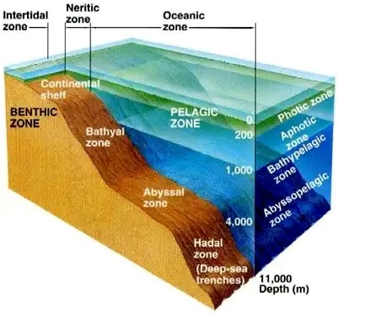

Figure 2: Sea layers along depth, from (fig 2018-06-17CDT19:13:06-05:00)

.

*et al.* 2016). Studies from Grassle & Maciolek (1992); Parkes *et al.* (1994); Todo *et al.* (2005) shown that life could be found everywhere in the deep-sea, with remarkably high and stable diversity. Moreoever, these very particular conditions have resulted in a high specialization of the inhabiting fauna, with species that are absent from shallower waters (García-Seoane *et al.* 2021). With first studies launched in the 60’s, less that 0.0001% of the area has been investigated so far and this habitat remains understudied (Danovaro *et al.* 2017; Richards *et al.* 2019). Thus, deep-sea remains the most unknown biome of the planet with estimated 10 million species that are yet to discover (Danovaro *et al.* 2017; Grassle & Maciolek 1992). In particular, data are lacking to evaluate the impact of climate change on the biodiversity of the largest reservoir of biomass, mainly because exploring deep-sea is difficult and requires specific tools, such as rovers (Danovaro *et al.* 2008; Danovaro 2014). Firstly, deep-sea were regarded as a ore reservoir, where manganese and other metal deposits could be found and extracted, or even as a dumping site for nuclear wastes (Baker *et al.* 2020; Gillet 2013; Halfar & Fujita 2002). But since past decades, capacity of exploration of the deep-sea expanded spectacularly, allowing to discover more about the deep-sea ecosystems (Danovaro 2014).

In particular, continental margins, which separates continental shelf from abyssal plains are investigated, because their heterogeneous topography implies varied habitats and hydrodynamics, with impacts on the whole food webs (Danovaro *et al.* 2009; Fernandez-Arcaya *et al.* 2017). Along continental margins, deep-sea canyons, that incises the edges of continental shelf, appears to be “biodiversity hotspots” for pelagic life, in terms of diversity and abundance (Aïssi *et al.* 2012; Danovaro *et al.* 2009; Gillet 2013; Robertson *et al.* 2020). Because they are a crucial role in transfering organic matter and sediments from rich and productive shallow shelf to the low-nutrients deep-sea, canyons constitute peculiar habitats, with evidences of an important biomass and diversity of benthic organisms (Canals *et al.* 2006; Danovaro *et al.* 2009; De Leo 2012), but also of fish assemblages (Sion *et al.* 2019; Stefanescu *et al.* 1994) around them. Indeed, canyons have higher nutrients concentrations than in adjacent areas, due to down-welling currents creating a funnel-effect (Fernandez-Arcaya *et al.* 2017). Thus, primary production is enhanced, and makes canyons favourable habitats for filters and suspension feeders (Fernandez-Arcaya *et al.* 2017; Sion *et al.* 2019), but also for low to medium trophic levels organisms, such as euphausiids, shrimps, squids and meso- and bathypelagic fishes (Aïssi *et al.* 2012; Gaskett *et al.* 2001; Pusch *et al.* 2004). Abundance of nutrients and preys attracts top predators (cetacean, sharks, large pelagic), some of them being only encountered in those habitats (Aïssi *et al.* 2012). Specialized habitats, deep-sea canyons displays high level of endemism (Danovaro *et al.* 2009, 2017), are source of rich marine biodiversity and many services (Fernandez-Arcaya *et al.* 2017). Among those, canyons play a role in sustaining deep-sea food webs through the transport of nutrients, providing habitat for nursery and refuges (Fernandez-Arcaya *et al.* 2017). Company *et al.* (2008) suggests that by those services, canyons enhance recruitement of commercialised species, and thus, may mitigate the effect of their overexploitation. Therefore, canyons can be described as “keystone structures”, as an interface between productive continental shelf and deep-sea, with evidence of their benefits and supports for fisheries (Company *et al.* 2012; Fernandez-Arcaya *et al.* 2017).

Meso- and bathypelagic fishes are found abundantly in every ocean, except Arctic, and are the dominant zooplankton consumers in most oceans, playing a key role in trophic networks (Davison*etal.*2015;Salvanes&Kristoffersen2009). Livingbetween200-1000m(mesopelagic) and over 1000m (bathypelagic) deep, those deep-sea fishes displays very high biomass, estimatedtobearoundtenbilliontonnesintotal(García-Seoane*etal.*2021;Gjoesaeter&Kawaguchi 1980; Richards *et al.* 2019). Though, abundance of those fishes varies along depth and daytime, because most of them perform vertical diel migration to feed on shallower depth during night, and abundance’s estimation can be biaised by sampling time (Catul *et al.* 2011; Gaskett *et al.* 2001; García-Seoane *et al.* 2021; Pusch *et al.* 2004; Salvanes & Kristoffersen 2009). Performing migrations, meso- and bathypelagic fishes ensure biogeochemical cycling through respiration and excretion but also when predated by carnivorous (García-Seoane *et al.* 2021; Spitz *et al.* 2019). Because of their ubiquity, their biomass and the high efficiency of energy transfer from phytoplankton ( respiring 10% of the primary production), meso- and bathypelagic fish play an important part of the biological pump (García-Seoane *et al.* 2021; Spitz *et al.* 2019). Mesoand bathypelagic fish can show different adaptations to their environment such as sensitive eyes, dark body and ventral light organs (photophores) to match their low-light habitat and reduced metabolic rates to lower oxygen consumption in poorly oxygenated waters (Salvanes & Kristoffersen 2009; Farré *et al.* 2016). Photophores have a role in camouflage, foraging, courtship behavior, with different patterns between males and females, and are also species specific which helps identification (Paitio *et al.* 2020; Salvanes & Kristoffersen 2009). Finally, depth and associated pressure play a role in the morphology of deep-sea fishes, which tend to have more elongated body with increasing depth, while manifesting an enlargement of the anterior body that increase gill surface and the ability to capture oxygen (Farré *et al.* 2016)

In terms of life history, Childress *et al.* (1980) and Salvanes & Kristoffersen (2009) observed some differences between meso- and bathypelagic fishes. The first are characterised by a relatively small size (2-15cm long), slow growth and have a rather long life span, with repeated reproduction and high reproductive rate. Conversely, bathypelagic fishes tend to have larger size, rapid growth but short lives and late reproduction, that seems to occur during the last year of their life. Yet, most of the life history traits of these fishes remains unknown and needs to be further investigated. The mesopelagic communities are dominated by Myctophidae family, in terms of abundance, diversity and biomass, and represents at least 20% of the whole oceanic ichthyofauna (Catul *et al.* 2011; Kozlov 1995; Pusch *et al.* 2004).

Several studies focused on exploring deep-sea fish diversity near seamounts, mid-ocean ridges or in abyssal depths (Cook *et al.* 2013; Sutton *et al.* 2013), but very little is known about mesoand bathypelagic species inhabiting deep-sea canyons (Kenchington *et al.* 2020). Nevertheless, the essential role of the oceanic pelagic fish community in food webs, linking the epipelagic organic matter to top predators requires a better knowledge of species constituting this fundamental compartment (Davison *et al.* 2015; Gaskett *et al.* 2001). Furthermore, considering how important canyonsareforfisheriesandcarbonsequestration, knowingmoreaboutthecommunitiesinhabiting them is crucial to ensure sustainability of ecosystems and provided services, through marine management and conservation (Fernandez-Arcaya *et al.* 2017; van den Beld *et al.* 2017b).

The continental slope of the Bay of Biscay divides in two the France’s Atlantic EEZ (Exclusive Economic Zone) and is incised by about 135 canyons (Bourillet *et al.* 2006; Spitz *et al.* 2019; van den Beld *et al.* 2017a) (Figure 3). If proven to be rich in coldwater coral reefs, the largest part or the area remains poorly explored, especially deep-pelagic communities (García-Seoane *et al.* 2021; van den Beld *et al.* 2017b; Webb *et al.* 2010). In consequence, the similarity or differences within species inhabiting these ecosystems are unknown (Kenchington *et al.* 2020).

One way to characterize an ecosystem is to look at the factors that control biodiversity patterns and to identify the key functions provided by this ecosystem (Aneesh Kumar *et al.* 2017; Brind’Amour *et al.* 2011; Farré *et al.* 2016). Functional diversity, which is the value and range of functional traits displayed by the organisms of a given ecosystem, can inform on ecosystems functioning and about their resilience facing a change in the environment (Dumay *et al.* 2004; Martini *et al.* 2020). Moreover, the use of functional traits to characterize functional niches of species highlights some competition or adaptation processes within a community of an ecosystem (Aneesh Kumar *et al.* 2017). Indeed, comparison of functional niches is an effective way of assessing ecological similarity of species, based on the way they share, or not, certain morphological, behavioral or physiological characteristics (Aneesh Kumar *et al.*

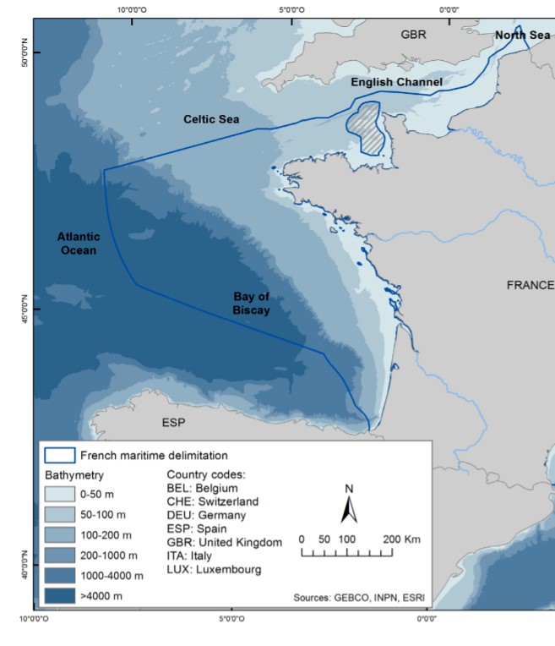

Figure 3: Location of the studied area, from (Béarez *et al.* 2017).

2017; Farré *et al.* 2016; Winemiller 1991). This approach seems particularly well suited to study

fish communities, because morphological traits are considered being good indicators of ecological habits of species, indicating how species use available resources (Farré *et al.* 2016; Winemiller 1991). Successfully applied for freshwater ecosystems and marine coastal environments, this approach has not been much used on deep-sea communities where functional traits shaping ecological niches remains mostly unknown Aneesh Kumar *et al.* (2017); Farré *et al.* (2016). Conditions become more extreme and the food availability decreases with depth, so deep-sea are often thought to be poor in terms of functional diversity, suggesting that competition is highly probable to access the little food available (Aneesh Kumar *et al.* 2017). Yet, Preciado *et al.* (2017) showed that these communities do not seem to display high dietary overlap, indicating a high degree of resources partitioning. Moreoever, along depth, dietary overlap even seems to decrease because specialization is stronger (Carrassón & Cartes 2002).

Hence, the aim of this work is to assess functional diversity of deep-sea canyons fish of the Bay of Biscay, which, for the moment, is barely known (Kenchington *et al.* 2020). Using functional traits to characterize functional niches of species, our main goals are (i) to characterise functional diversity of most-abundant canyon species, (ii) to measure the range and degree of overlap of functional niches and (iii) to explore the methods and parameters (number of individuals to measure, species, site) for this type of study. Because species displaying the same functional niche can be considered as part of the same functional group, our hypothesis is that species occupying similar functional niches insure redundant function within an ecosystem and be in competition, whereas species displaying very different functional niches would be segregated.

## Materials & Methods

## 1 Sampling and specimens

Fishes were collected during Ifremer’s EVHOE (EValuation Halieutique de l’Ouest Européen) research cruises, surveying the Bay of Biscay every fall onboard the *R/V Thalassa*. Several hauls are regularly performed at night to investigate pelagic deep fauna. Each station is precisely defined with its GPS coordinates and located above canyons, at the the edge of continental shelf. Pelagic trawling is performed during night, between 700 and 2000 meters, because those fishes perform diel vertical migrations and tends to come closer to the surface at nighttime. To this end, 25 meters-wide opening trawl is used, with as mesh size decreasing from 76mm to 48mm at the end of the trawl. The trawl-haul duration was 1 hour at 4 kn. Once the trawl is pulled back onboard, fishes are sorted, identified, up to species, and frozen at -20°C. Eleven of the most abundant species in the Bay of Biscay have been selected for this study. All teleost, four of them belong to the Myctophid family (lanternfish), which is the most abundant and widely spread family across all oceans (de Busserolles *et al.* 2014) and could represent up to 65% of the pelagic deep-sea biomass (Poulsen *et al.* 2013): *Lampanyctus crocodilus*, *Myctophum punctatum*, *Notoscopelus kroeyeri* and *Ceratoscopelus maderensis*. The second most represented family is the Platytrocidae with two species: *Searsia koefoedi* & *Normichthys operosus*. This family seems to be found in all oceans but not in Mediterranean Sea (Orrell & Hartel 2016). Finally, five families are represented by one species each: *Xenodermichthys copei* (Alepocephalidae); *Arctozenus risso* (Paralepididae), *Argyropelecus olfersii* (Sternoptychidae - Hatchetfishes), *Serrivomer beanii* (Serrivomeridae) and *Stomias boa* (Stomiidae) which are common species, found abundantly in every ocean (Carvalho & Almeida 1988; Froese & Pauly 2019; Geidner 2008; Germain *et al.* 2019). See A.1 for phylogenetic tree of studied species.

## 2 Morphological measurements and functional traits

In lab, fish were thaw and 24 morphological measurements were taken on individuals, using an electronic caliper with a precision up to 0.01mm. Part of these measurements had previously been taken by students from La Rochelle University during pratictal class from 2018 (*n=99*), 2019 (*n=45*), 2020 (*n=9*) and the rest during this study (*n=212*). For the sake of statistical robustness and representativity, at least 25 individuals were measured for each species (Table 1).

Table 1: Number of individuals measured for each species, with their size mean and range values

|  |  |  |  |  |  |
| --- | --- | --- | --- | --- | --- |
| Species | Previous measurements from students | Data acquired during this study | Total | Mean standard length (mm) | Size range (mm) |
| Lampanyctus crocodilus | 39 | 0 | 39 | 107.60 | 73.3 - 146.5 |
| Xenodermichthys copei | 38 | 0 | 38 | 109.68 | 82.3 - 132 |
| Normichthys operosus | 0 | 38 | 38 | 104.69 | 75.64 - 131.62 |
| Argyropelecus olfersii | 37 | 0 | 37 | 56.55 | 32.16 - 89.07 |
| Notoscopelus kroyeri | 6 | 30 | 36 | 76.30 | 52.63 - 130.84 |
| Searsia koefoedi | 5 | 31 | 36 | 119.94 | 84.8 - 142.75 |
| Arctozenus risso | 20 | 10 | 30 | 158.36 | 117.6 - 181.31 |
| Serrivomer beanii | 0 | 30 | 30 | 546.17 | 373 - 879 |
| Ceratoscopelus maderensis | 0 | 30 | 30 | 62.72 | 53.29 - 78.95 |
| Stomias boa | 0 | 26 | 26 | 239.00 | 144 - 311 |
| Myctophum punctatum | 8 | 17 | 25 | 65.48 | 52.53 - 80.14 |

Following what had been made on similar studies and according to our measurements, a total of 21 functional traits were computed from morphological measurements and informs on 3 main functions: food acquisition, locomotion and habitat (see Table 2).

## 3 Data analysis

All data analysis were performed using R version 4.0.3 R Core Team (2021).

### 3.1 Data pre-processing

Because measurements came from several observators, raw data had to be checked for outliers.

To do so, all values (except SL) were standardized by SL to get rid and the interquartile range

(IQR) method of outlier detection was applied to remove outliers. According to this method, for

Table2:

Descriptionandformulasofthefunctionalstraitscomputedfrommorphologicalmeasurements,following(

Albouy

*etal.*

2011

;

AneeshKu-

mar

*etal.*

2017

;

Boyle&Horn

2006

;

Brind’Amour

*etal.*

2016

;

Diderich

2006

;

Dumay

*etal.*

2004

;

Habib

*etal.*

2019

;

Ibañez

*etal.*

2007

;

Sibbing

&Nagelkerke

2000

;

Webb

1984

;

Winemiller

1991

)

.Abbreviationsusedinformulasareprovidedbyrawmeasurementsanddetailedinappendices

B.2

,

B.3

&

B.4

.OGA,GIT,PC,PHTarecategorialvariablesdirectlyprovidedbyrawmeasurementswithGITandOGAscoresdetailedrespectivelyin

appendices

B.5

&

B.6

.

**Function**

Functionaltrait

Description

FORMULA

**Feeding**

Oralgapeaxis

Feedingpositionanddepthinthewatercolumn

OGA

Eyesize

Detectionofpreysandvisualacuityforpredators

ED/HD

Orbitallength

Preyssizeandbehavior(buried,camouflaged)

ED/SL

OralgapesurfaceTypeandsizeofpreys

MW*MD/BW*BD

Oralgapeshape

Strategytocaptureprey

MD/MW

OralgapepositionFeddingpositioninthewatercolumn

MO/HD

LowerjawlengthCompromisebetweenpowerandopeningspeedofthemouth

LJL/SL

Gillrakertype

Filtrationcapacitiesoffish

GIT

Gilloutflow

Succioncapacitiesoffish

OW

OperculumvolumeOperculumvolume(chercheràquoiçasert)

OD/OW

Headlength

Maximumpreysize

HL/SL

Pyloriccaeca

Presence/Absenceofpyloriccaeca

PC

Anusposition

Digestivetractlength

PAL/SL

**Locomotion**

Bodydepth

SwimmingcapacitiesoffishlinkedtotheirfoodprospectionbehaviorBD/SL

PectoralfinpositionManeuvrabilityoffish

PFI/PFB

PectoralfininsertionInsertiondelapectorale(chercheràquoiçasert)

PPL/SL

TransversalshapePositioninthewatercolumnandhydrodynamism

BD/BW

CaudalthrottlewidthSwimmingstrategy(cruiser/sprinter)andendurance

CPD

DorsalfininsertionSwimmingbehavior(chercheràquoiçasert)

PDL/SL

**Habitat**

Eyeposition

Positioninthewatercolumn(pelagic/sedentary)

EH/HD

PresencephotophoresPresence/Absenceofphotophores(chercheràquoiçasert)

PHT

each variable (measurement) and for each species, outliers are defined as every value outside this interval:

[*Q*1 − 1*.*5 ∗ *QR,Q*3 + 1*.*5 ∗ *IQR*]

with *Q*1 and *Q*3 being respectively first and third quartile, *IQR* = *Q*3 − *Q*1.

Missing values that were previously presents in the data set (*n=52*) and those induced by outlier removal function (*n=307*), are then imputed following k-Nearest Neighbor (kNN) method (Zhang 2012). Based on non-missing values points, kNN algorithm computes Euclidian distances between points, and assumes that missing value can be approximated by the values of points that are the closest. To this end *tidymodels* R package and *step_knnimpute* function (Kuhn & Wickham 2020) were used, with a number of nearest

neighbors (*k*) of √*N*, with *N* being the number of observations, i.e individuals, of the dataset. Accuracy was then checked with linear regression of each variable with SL. From this cleaned dataset, functional traits were computed using formulas in Table 2.

### 3.2 Factorial Analysis of Mixed Data (FAMD)

To assess similarity or differences in species in terms of traits, FAMD was performed. This type of analysis is suited for dataset containing a mix of qualitative and quantitative variables, and performs PCA (Principal Component Analysis) on quantitative variables and MCA (Multiple Correspondence Analysis) on qualitative variables. In the same way that PCA, FAMD is used to assess similarity/difference of individuals and to check for association between the variables. To this end, *FactoMineR* and especially *FAMD* function were used. Because *Serrivomer beanii* does not have pectoral nor pelvic fins, and because this analysis can not handle missing values, zero values were attributed for PFB, PFI, PPL and PVL. AJOUTER LE FAIT QU’ON AIT FAIT DES ACP AVEC/SANS cette espèce et AVEC/SANS ces variables.

TROUVER COMMENT JUSTIFIER LE NOMBRE D’AXES A RETENIR. A HCPC

## 4 niche area overlap

Justifier qu’on calcule la surface des niches sur la 1ere FAMD car ce sont les axes qui portent le + d’infos etc...

## 5 Niche distance

Utilisation de la fct distinctiveness_global du package funrar

## Results

## 1 Factorial Analysis of Mixed Data

The first 5 FAMD components explained 80% of the total variation (Table 3). The first axis

(30.5% of explained variance) is strongly correlated with shape of the body and of the head with traits such as *body depth* (a = 11.7), *lower jaw length* (a=11.5), *oral gape axis* (a=11.1), orbital length (a = 8.35) and head length (a = 8.21) (Table 3). Along this axis, all traits have increasing values toward the right, mouth orientation shifting upward (see C.7 for details). Three groups of fish can be distinguished (Figure 4). For low PC1 values, species have a low transversal shape (meaning that both BD and BW have similar values, consistent with an elongated body), short lower jaw, small oral gape surface and a terminal oral axis, such as *A. risso*, *S. boa* and *S. beanii*. On the right of this axis, species display high body depth values suggesting a laterally compressed form and a superior-oriented oral axis, such as *A. olfersii*. The second axis (21.6% of explained variance) is correlated to feeding, through food prospection behaviour with *pectoral fin insertion* (a = 11.4), *eye size* (a = 9, *pectoral fin position* (a = 7.1) and food acquisition through *gill raker type* (a = 17.8) and *oral gape axis* (a = 12,3) (Table 3). This axis separates the three species on the left, *A. risso* and *S. boa* display higher values of pectoral fin insertion, meaning that the fin is inserted further on the body than *S. boa*, while the fin position on the body depth is lower. As *S. beanii* does not have pectoral fin, same analysis has been run without traits referring to pectoral or pelvic fins to look and confirmed the discrimination between these species. The third axis (explaining 12.2% of total variance) mainly carries traits linked to the swimming and foraging behavior, with strong influence of *anus position* (a = 23.8), *gill raker type* (a = 19.2), *dorsal fin insertion* (a = 15.5) and *pectoral fin position* (a = 14.2) (Table 3). On the left of this axis, species are characterized by a rather high pectoral fin insertion and close-to-head dorsal fin insertion and anus position (Figures 5 and C.8). Finally, the fourth axis (explaining 7.9% of variance) is mainly related to traits linked to prey selection, with *pyloric caeca* (a = 31.6), *operculum volume* (a = 17) and *presence of photophores* (a = 10.9) (Table 3). The remaining PC scores (20% of variance) are mainly linked to food acquisition. Because *X. copei* is the only species having pyloric caeca, this variable clearly separates that species from the other, on the PC4 axis. Overall, several species’ ellipses are overlapping in both Figure 4 and Figure 5. In the first, all 4 Myctophidae and 2 Platytroctidae species, plus *X. copei* are more or less overlapping, not displaying much differences along PC1 nor PC2. On the same figure *A. risso* and *S. boa* seems to slightly overlap each other niches, which are mainly separated along PC2. *S. beanii* and *A. olfersii* are the only two species not showing any overlap. In Figure 5 *A. risso* and *A. olfersii* are showing some overlap. On the same figure, the same species (except *X. copei*) than Figure 4 overlaps. Especially, *N. operosus* and *S. koefoedi* have very similar looking niches, which seems virtually fully overlapping. *L. crocodilus*, which have the widest niche among these species, overlaps *C. maderensis*, *M. punctatum* and *N. kroyeri* niches.

Table 3: Correlation between 5 first PC’s component and functional traits. In bold, correlations higher than threshold (4.8)

|  |  |  |  |  |  |
| --- | --- | --- | --- | --- | --- |
|  | PC1 (30.5%) | PC2 (21.6%) | PC3 (12.2%) | PC4 (7.9%) | PC5 (7.8%) |
| Eye size | 1.29 | **9.01** | 3.52 | 4.08 | 1.40 |
| Orbital length | **8.35** | 2.38 | 0.00 | 2.24 | 4.54 |
| Oral gape surface | **7.78** | 3.06 | 2.93 | 0.10 | 2.78 |
| Oral gape shape | 0.18 | 3.10 | 0.05 | **9.49** | **10.41** |
| Oral gape position | 0.42 | 1.21 | 1.99 | **9.16** | 3.94 |
| Lower jaw length | **11.52** | 0.00 | 0.04 | 1.97 | 2.44 |
| Gill outflow | **5.47** | 0.82 | 0.02 | 2.22 | **22.48** |
| Operculum volume | 2.52 | 0.03 | 1.61 | **17.02** | **5.68** |
| Head length | **8.21** | 3.10 | 2.50 | 0.78 | 4.50 |
| Anus position | 0.00 | **5.28** | **23.81** | 0.07 | 0.77 |
| Body depth | **11.68** | 0.93 | 1.41 | 0.64 | 1.92 |
| Pectoral fin position | 1.72 | **7.15** | **14.22** | 0.37 | 0.32 |
| Pectoral fin insertion | **4.95** | **11.39** | 0.05 | 0.12 | 0.74 |
| Transversal shape | **5.96** | 4.33 | 5.45 | 1.70 | 2.10 |
| Caudal throttle width | 3.72 | **5.01** | 0.28 | 1.60 | **16.30** |
| Dorsal fin insertion | 2.58 | 4.78 | **15.52** | 0.00 | 1.33 |
| Eye position | 0.19 | **5.41** | 0.78 | 2.34 | 1.40 |
| Oral gape axis | **11.07** | **12.28** | 3.32 | 3.27 | **7.13** |
| Gill raker type | 4.38 | **17.80** | **19.23** | 0.32 | 3.42 |
| Pyloric caeca | 0.23 | 0.48 | 0.04 | **31.62** | **5.81** |
| Presence photophores **7.79** 2.45 3.23 **10.89** 0.59 | | | | | |

## 2 Functional niche area and overlap

The niche area estimation showed that *N. kroyeri* had the narrowest niche among the studied community, followed by *N. operosus* and *S. koeoedi* (Table 4). In fact, all Myctophidae (except *L. crocodilus*) and Platytrocidae have rather narrow niches (Figure 4). Conversely, *A. olfersii* is the species with the widest niche, more than 7 times wider than *N. kroyeri*. Boostrapped niche area estimation function did not show any difference in the surface of estimated niche through sample size *n*. Areas values seems to be more influenced by the individuals sampled for estimation rather than the number of inviduals itself. Yet, estimated niche area value are tightly converging for *n* = 30.

Niche overlap analysis confirms that 9 species have overlapping niches in Figure 4and that smallest niches overlaps each other the most (Table 5). The maximum overlap is found between *M. punctatum* and *N. kroyeri*, as almost 69% of the latter’s niche is covered by the first. In total, these two species share nearly 22% of their niches. Same observation is made between

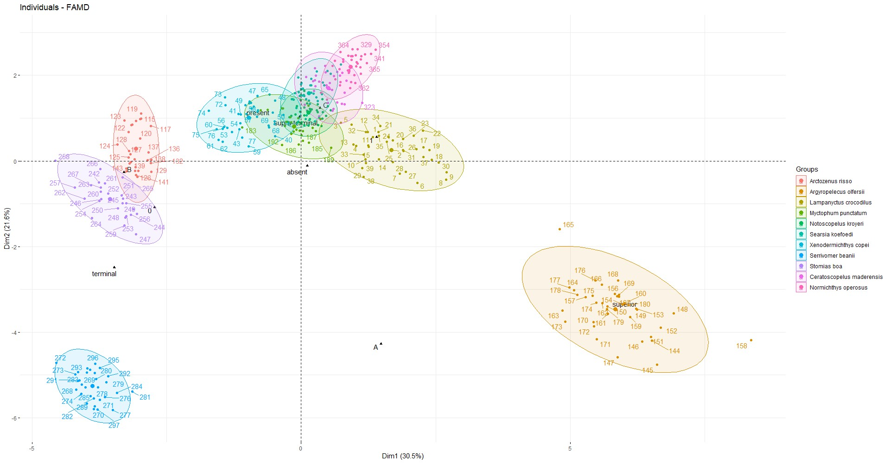

Figure 4: FAMD results for PC 1 and 2.

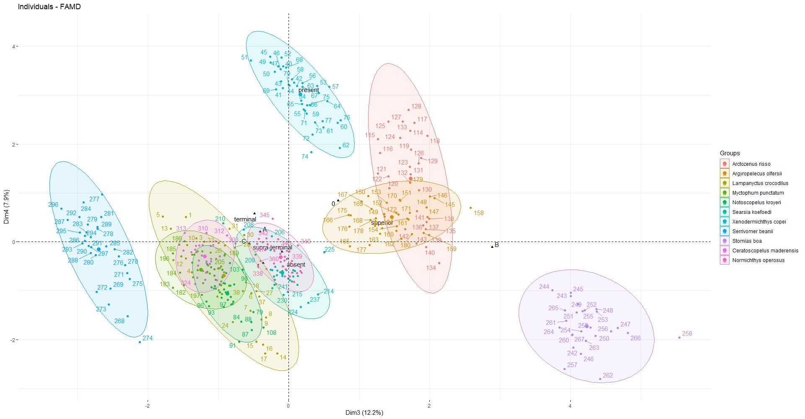

Figure 5: FAMD results for PC 3 and 4.

Table 4: Standardized area of functional niches.

|  |  |
| --- | --- |
| Species | Area |
| Argyropelecus olfersii | 7.39 |
| Lampanyctus crocodilus | 4.00 |
| Xenodermichthys copei | 2.60 |
| Stomias boa | 2.54 |
| Myctophum punctatum | 2.13 |
| Serrivomer beanii | 1.89 |
| Arctozenus risso | 1.78 |
| Ceratoscopelus maderensis | 1.75 |
| Searsia koefoedi | 1.33 |
| Normichthys operosus | 1.18 |
| Notoscopelus kroyeri | 1.00 |

*S. koefoei* whose niche is 65% covered by *C. maderensis*. These two species have the highest total overlap value, with 28% of their niches overlapping. Finally, *N. kroyeri* and *N. operosus* show minimum total overlap value of 0.21%. This is due to some individuals of the latter in *N.*

*kroyeri*’s ellipse (see 4).

PROBLEME CHIFFRE SIGNIF.

Table 5: Species niche overlap. All the others comparisons that are not present in this table did not present any overlap.

|  |  |  |  |  |
| --- | --- | --- | --- | --- |
| Species1 | Species2 | Overlap of Species 2 over Species 1 (%) | Overlap of Species 1 over Species 2 (%) | Total overlap (%) |
| Searsia koefoedi | Ceratoscopelus maderensis | 65.44 | 49.64 | 28.23 |
| Notoscopelus kroyeri | Searsia koefoedi | 65.38 | 49.17 | 28.06 |
| Myctophum punctatum | Notoscopelus kroyeri | 32.28 | 68.69 | 21.96 |
| Myctophum punctatum | Xenodermichthys copei | 44.86 | 36.64 | 20.17 |
| Ceratoscopelus maderensis | Normichthys operosus | 31.77 | 47.10 | 18.97 |
| Notoscopelus kroyeri | Ceratoscopelus maderensis | 41.58 | 23.72 | 15.11 |
| Myctophum punctatum | Searsia koefoedi | 20.27 | 32.44 | 12.48 |
| Searsia koefoedi | Normichthys operosus | 15.02 | 16.89 | 7.95 |
| Notoscopelus kroyeri | Xenodermichthys copei | 22.93 | 8.80 | 6.36 |
| Searsia koefoedi | Xenodermichthys copei | 17.47 | 8.92 | 5.90 |
| Lampanyctus crocodilus | Myctophum punctatum | 6.49 | 12.20 | 4.24 |
| Arctozenus risso | Stomias boa | 9.41 | 6.60 | 3.88 |
| Myctophum punctatum | Ceratoscopelus maderensis | 5.78 | 7.01 | 3.17 |
| Lampanyctus crocodilus | Ceratoscopelus maderensis | 2.50 | 5.70 | 1.74 |
| Lampanyctus crocodilus | Notoscopelus kroyeri | 1.20 | 4.79 | 0.96 |
| Notoscopelus kroyeri | Normichthys operosus | 0.46 | 0.39 | 0.21 |

Finally, looking at niches’ dissimilarities confirms what can be seen on previous figures, which is that all Myctophidae and Platytrocidae species studied here have rather similar niches. Conversely, *A. olfersii*, *S. beanii* and *S. boa* tend to have more distinct niches, which are consistent results with what can be seen on Figure 4. Here, species with the most atypical morphological feature are the more distinct in terms of niche.

## 3 Kernel density estimation

The estimation of kernel density overlaps for functional traits of the 7 overlapping species and shows that these species are all overlaping for 7 of the 17 computed traits (see Table 6: Niche dissimilarity of studied species

|  |  |
| --- | --- |
| Species | Distinctiveness value |
| Argyropelecus olfersii | 0.54 |
| Serrivomer beanii | 0.51 |
| Stomias boa | 0.46 |
| Arctozenus risso | 0.40 |
| Lampanyctus crocodilus | 0.37 |
| Xenodermichthys copei | 0.37 |
| Ceratoscopelus maderensis | 0.31 |
| Normichthys operosus | 0.31 |
| Notoscopelus kroyeri | 0.30 |
| Searsia koefoedi | 0.29 |
| Myctophum punctatum | 0.29 |

figure 6). The overlap is maximum for the position of the oral gape with an overlap value of 0.34. This means that, along this functional trait, these 6 species share nearly 34% of their density. For this trait, most of the distributions are centered around a range of values of [0.5-0.8], yet *L. crocodilus* display a pretty wide distribution, despite being the most sampled species (see Table 1). This same observation can be done for this particular species for traits n°11 (body depth) and n°13 (pectoral fin insertion). Species also share nearly 25% and 29% of their density when looking at body depth (trait n°11) and eye position (trait n°17), respectively. Finally, lower jaw length (trait n°6) and pectoral fin position (trait n°12) values also seem to be common to those species, with 16% and 19% of density shared, respectively. To a lesser extent, species share nearly 12% of the eye size values (trait n°2). On most plots of Figure 6, *N. kroyeri* and *M. punctatum* have very similar distributions. When looking at these 2 species only, analysis show that they are overlapping for every 17 traits, with particularly high values for eye size (o = 0.915), gill outflow (o = 0.882), operculum volume (o = 0.901), pectoral fin insertion (o = 0.828) and caudal throttle width (o = 0.782).

## Discussion

## 1 Community structure in Bay of Biscay’s canyons

For deep-sea fish species, resource partionning is mainly linked to the size of prey and swimming ability (Aneesh Kumar *et al.* 2017). Our results showed clear dissimilarities in functional traits, related to habitat, feeding and locomotion meaning that studied species display differences in the way they use resources. Especially, species seems to be highly separated by the

way they feed, which also give informations on their habitat (Schoenfuss & Blob 2007). Indeed, based on our results, body and head morphology as well as food prospection and acquisition separates species in four distinct groups. First, *A. olfersii* have the most distinct yet biggest niche of all studied species (see Table 6 and Table 4), with very differenciated morphological

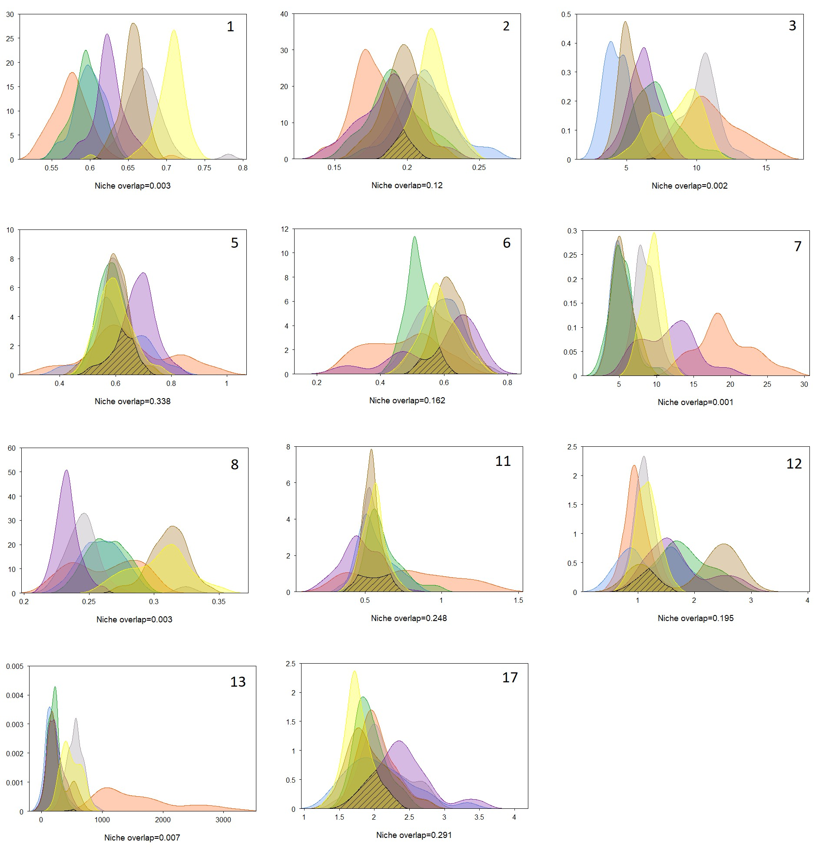

Figure 6: Kernel density overlap for 11 functional traits and overlaping species. Colors correspond to following species: orange - *L. crocodilus*; brown - *C. maderensis*; yellow - *N. operosus*; purple - *X. copei*; green - *N. kroyeri*; blue - *M. punctatum*; grey - *S. koefoedi*. Here, are displayed every traits that showed non-null overlap.

Table 7: Kernel density overlap values for the 17 computed traits. Values in bold are significant (p < 0.01) and shown in Figure 6.

|  |  |  |
| --- | --- | --- |
| Trait code | Functional trait | Total overlap (o) |
| 1 | Eye size | 0.00 |
| 2 | Orbital length | **0.12** |
| 3 | Oral gape surface | 0.00 |
| 4 | Oral gape shape | 0.00 |
| 5 | Oral gape position | **0.34** |
| 6 | Lower jaw length | **0.16** |
| 7 | Gill outflow | 0.00 |
| 8 | Operculum volume | 0.00 |
| 9 | Head length | 0.00 |
| 10 | Anus position | 0.00 |
| 11 | Body depth | **0.25** |
| 12 | Pectoral fin position | **0.20** |
| 13 | Pectoral fin insertion | **0.01** |
| 14 | Transversal shape | 0.00 |
| 15 | Caudal throttle width | 0.00 |
| 16 | Dorsal fin insertion | 0.00 |
| 17 | Eye position | **0.29** |

and habitat-related traits (see 4). *A. olfersii* showed an atypical laterally compressed body, long lower jaw, superior-oriented gape-axis and absent/rudimentary gill rakers (see B.5). All these elements are consistent with *A. olfersii* being a predator, mainly feeding on teleostei juveniles, euphausiids and gelatinous organisms (Eduardo *et al.* 2020). These morphological features suggests that this species catch its preys from underneath, with what might be a succion mecanism. On the opposite side of the morphologic spectrum are found the elongated, short-head fishes, with (supra-) terminal oriented mouth. Because running the same analysis without pectoral fin related traits did not lead to *S. beanii* overlapping neither *A. risso* or *S. boa*’ ellipse, the differences observed between these three species on Figure 4 mainly relies on gill rakers type (absent for *S. beanii*, low-developped for *A. risso* and *S. boa*) and eye size, which are bigger for the two latest. These characteristics suggests that *A. risso* and *S. boa* have similar functional traits, in terms of morphology and habitat, which explains niches overlap on Figure 4. All three species being primarly piscivorous top predators with sharp teeth, *S. beanii* has been reported having a generalist diet, feeding on wide range of preys (cephalopods, teleosts, crustaceans …) (Geidner 2008). Ultimately, this varied diet require less time and energy prospecting for food (Geidner 2008). This is consistent with what can be seen on Figure 5, where *S. beanii*’s seems to have a different swimming strategy (PC3) than *A. risso* and *S. boa*. Conversely, the latter has a rather selective diet which is dependant of their hunting strategie (Sutton & Hopkins 1996). Because Stomiids uses lures to attract preys, they are dependants on preys appeal for lures to feed and target rather big ones, which narrows the range of potential preys (Geidner 2008; Germain *et al.* 2019). Yet, *S. boa* seems to have a rather spread niche area (see 4), which might be explained by the fact it mainly feed on Myctophidae, being the most diversedfamily ofthe meso- bathypelagic ecosystems (García-Seoane *et al.* 2021; Sutton & Hopkins 1996).

one obvious observation is that Myctophidae seem to use resources in very similar ways.

PC1 –> Morpho du corps et de la tête strongly correlated with shape of the body and of the head with traits such as *body depth* (a = 11.7), *lower jaw length* (a=11.5), *oral gape axis* (a=11.1), orbital length (a = 8.35) and head length (a = 8.21) (Table 3). Along this axis, all traits have increasing values toward the right (see C.7 for details)

PC2 –> habitat (food prospection (loco) et acquisition) correlated to feeding, through food prospection behaviour with *pectoral fin insertion* (a = 11.4), *eye size* (a = 9), *pectoral fin position* (a = 7.1) and food acquisition through *gill raker type* (a = 17.8) and *oral gape axis* (a = 12,3) (Table 3).

PC3 –> Locomotion linked to the locomotion, with strong influence of *anus position* (a =

23.8), *gill raker type* (a = 19.2), *dorsal fin insertion* (a = 15.5) and *pectoral fin position* (a = 14.2) (Table 3). On the left of this axis, species are characterized by a rather high pectoral fin insertion and close-to-head dorsal fin insertion and anus position (see Figures 5 and C.8).

PC4 –> Prey selection related to traits linked to prey selection, with *pyloric caeca* (a = 31.6), *operculum volume* (a = 17) and *presence of photophores* (a = 10.9) (Table 3). The remaining PC scores (20% of variance) are mainly linked to food acquisition.

–> Dimorphisme pas pris en compte mais peut jouer sur la morpho –> Geidner

Numerous studies have also confirmed that mouth size and oral anatomy influence the trophic niche of species (e.g., Wainwright and Richard, 1995; Colborne et al., 2013). –> PC1

Previous studies showed that functional niche overlap and species abundances were linked

(Aneesh Kumar *et al.* 2017; Mason *et al.* 2008). More precisely, the most abundant species of an ecosystem tend to be functionnally separated from the others (Farré *et al.* 2016). One explanation is that less-abundant (or rare) species have highly specialized morphological features, which may narrow the range of ressources available to use (Aneesh Kumar *et al.* 2017). In this ecosystem, Myctophidae, which dominates in terms of abundance and diversity (Catul *et al.* 2011; García-Seoane *et al.* 2021), seem to share similar functional traits. Moreover, our results showed similarities between Myctophidae and Platytrocidae, the two families overlapping each other niches. –> Vrai pour A. olfersii (voir Eduardo2020) –> l’une des familles les + visibles de ces écsosystèmes In terms of abundance and biomass, representatives of the family Sternoptychidae (hatchetfishes) are one of the most conspicuous components of the mesopelagic ichthyofauna (Gjøsaeter and Kawaguchi, 1980). Other species showing highest abundance ((Sutton & Sigurdsson 2008)

Faire le lien entre la taille de la niche et la compétition : + la niche est petite, plus il y a de proba que la compétition en soit la raison

Zhao 2014 –> mêmes conclusions sur l’augmentation de la taille de la niche en fct du nbe d’individus.

communautaire : certaines espèces sont-elles redondantes ? Plusieurs espèces occupent la même niche en cas de chevauchement, occupent la même niche fonctionnelle. Se focaliser sur les fonctions plutôt que sur l’espèce. - Individus appartenant à la meme niche peuvent être considérés comme appartenant à la même boîte fonctionelle.

Discussion: niches trophiques, comportements, habitats, sensibilité des espèces, particularité des espèces, voir les avantages de partager les niches

# Phylogenetic tree

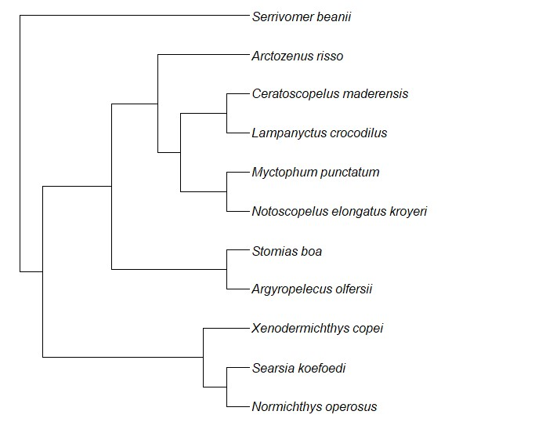

Figure A.1: Phylogenic tree of studied species, using R *rotl* package (OpenTreeOfLife *et al.*

2019) .

# Morphological measurements

# Correlation plot

**References**

(2018-06-17CDT19:13:06-05:00) The Deep Sea ~ MarineBio Conservation Society. 11

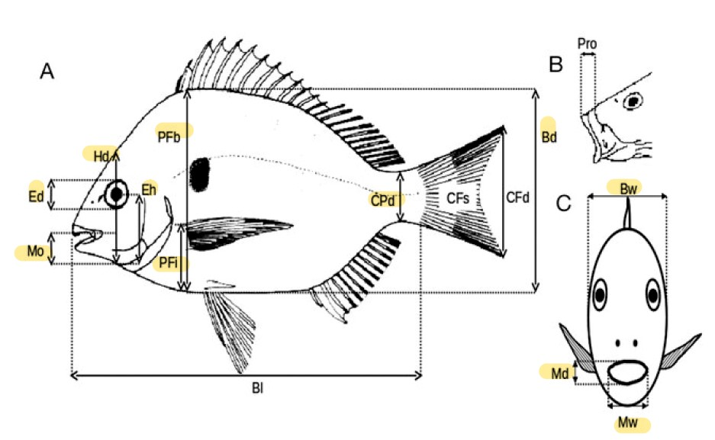

Figure B.2: Morphological measurements, from Albouy *et al.* (2011). BD, body depth; BW, body width;CPD, caudal peduncle minimal depth; ED, eye diameter; EH, distance between the bottom of the head and the eye center along the head depth axis; HD, head depth along the vertical axis of the eye; MD, mouth depth; MO, distance between the tip of the upper jaw and bottom of the head; MW, mouth width; PFB, body depth at the level of the pectoral insertion; PFI, distance between the insertion of pectoral fin and the bottom of the body.

Aïssi M, Fiori C, Alessi J (2012) Mediterranean submarine canyons as stepping stones for pelagic top predators: The case of sperm whale. In *Mediterranean Submarine Canyons: Ecology and Governance*, S. 99–103. Würtz M, Gland (Switzerland) and Malaga (Spain): IUCN. 11, 12

Albouy C, Guilhaumon F, Villéger S, *et al.* (2011) Predicting trophic guild and diet overlap from functional traits: Statistics, opportunities and limitations for marine ecology. *Marine Ecology Progress Series*, **436**, 17–28. 4, 5, 6, 7, 10, 17, 28

Aneesh Kumar K, Tuset V, Manjebrayakath H, *et al.* (2017) Functional approach reveals low niche overlap among common deep-sea fishes from the south-eastern Arabian Sea. *Deep Sea*

*Research Part I: Oceanographic Research Papers*, **119**, 16–23. 13, 15, 17, 23, 26

Baker M, Ramirez-Llodra E, Tyler P (2020) *Natural Capital and Exploitation of the Deep Ocean*. Oxford University Press. 10, 11

Béarez P, Pruvost P, Feunteun E, *et al.* (2017) Checklist of the marine fishes from metropolitan France. *Cybium: international journal of ichthyology*, **41**, 351–371. 14

Blondel J, Bourlière F (1979) La niche écologique, mythe ou réalité ? *Terre Vie. Revue Ecologie.*,

**33**. 5, 6, 8

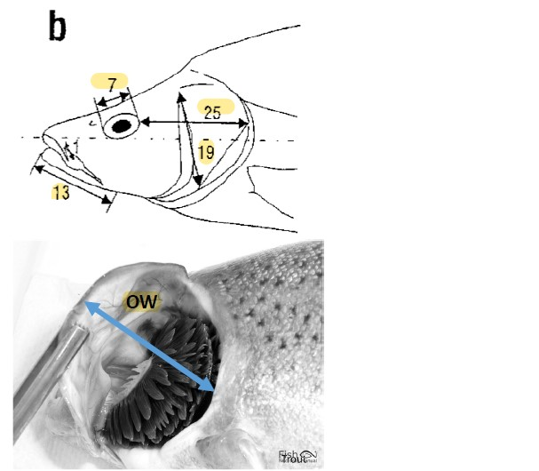

Figure B.3: Morphological measurements of the head, from Diderich (2006), following Sibbing &Nagelkerke(2000). 7beingED, eyediameter; 13LJL, distancebetweenthetipandtheinsertion point of lower jaw; 19 OD, depth of the operculum from point of insertion to bottom; 25 POL, shortest distance between the eye and the end of the head; OW, operculum maximum width.

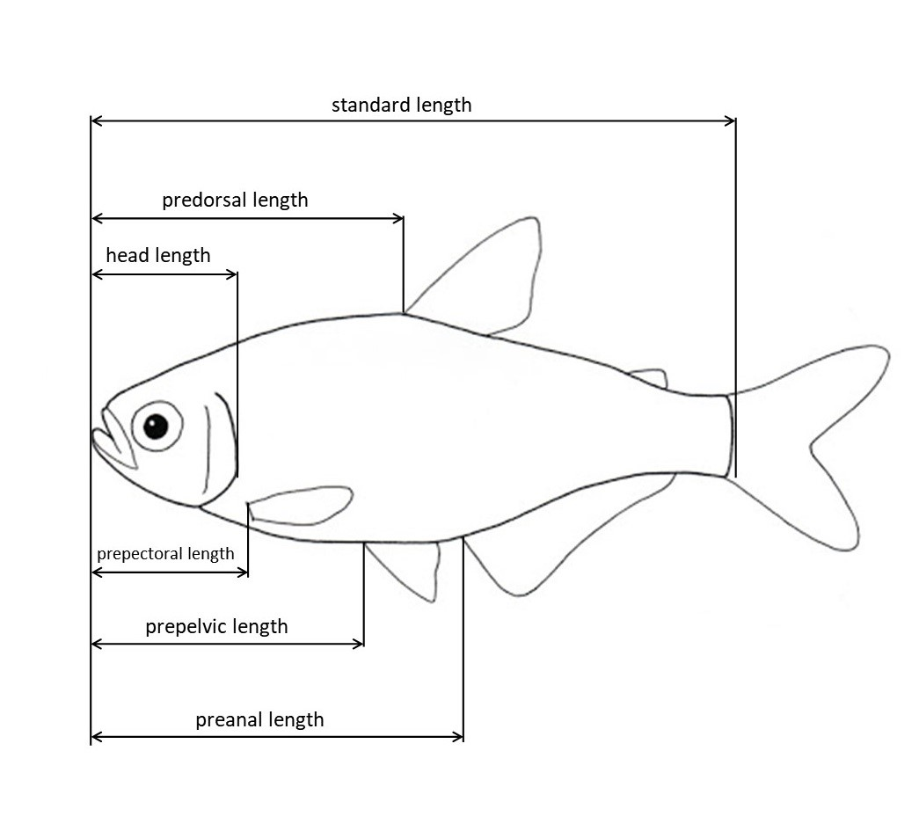

Figure B.4: Morphological measurements of the head, adpated from Keat-Chuan Ng *et al.*

(2017); Habib *et al.* (2019). HL, head length, from the nose to the closest-to-caudal-fin point of the operculum; PAL, distance bewteen the tip of the nose and the insertion of anal fin; PDL, distance bewteen the tip of the nose and the insertion of dorsal fin, PPL, distance bewteen the tip of the nose and the insertion of pectoral fin; PVL, distance bewteen the tip of the nose and the

insertion of pelvic fin; SL, standard length.

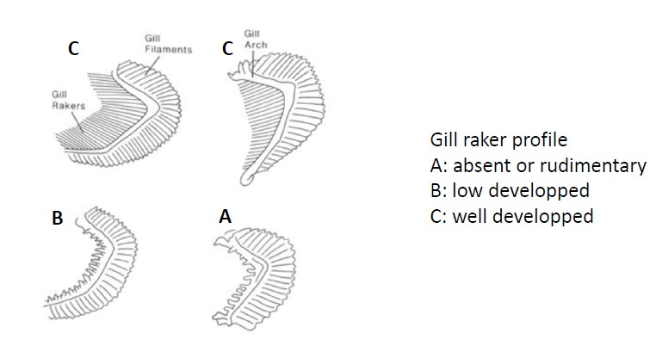

Figure B.5: Scores of gill rakers types GIT, based on their length.

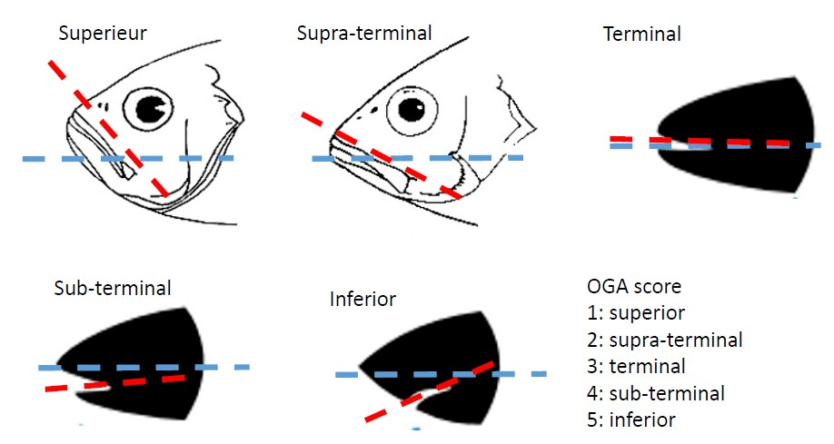

Figure B.6: Scores of oral gape axis OGA, based on the angle between mouth orientation (red) and a fictive mid-depth lateral lign (blue).

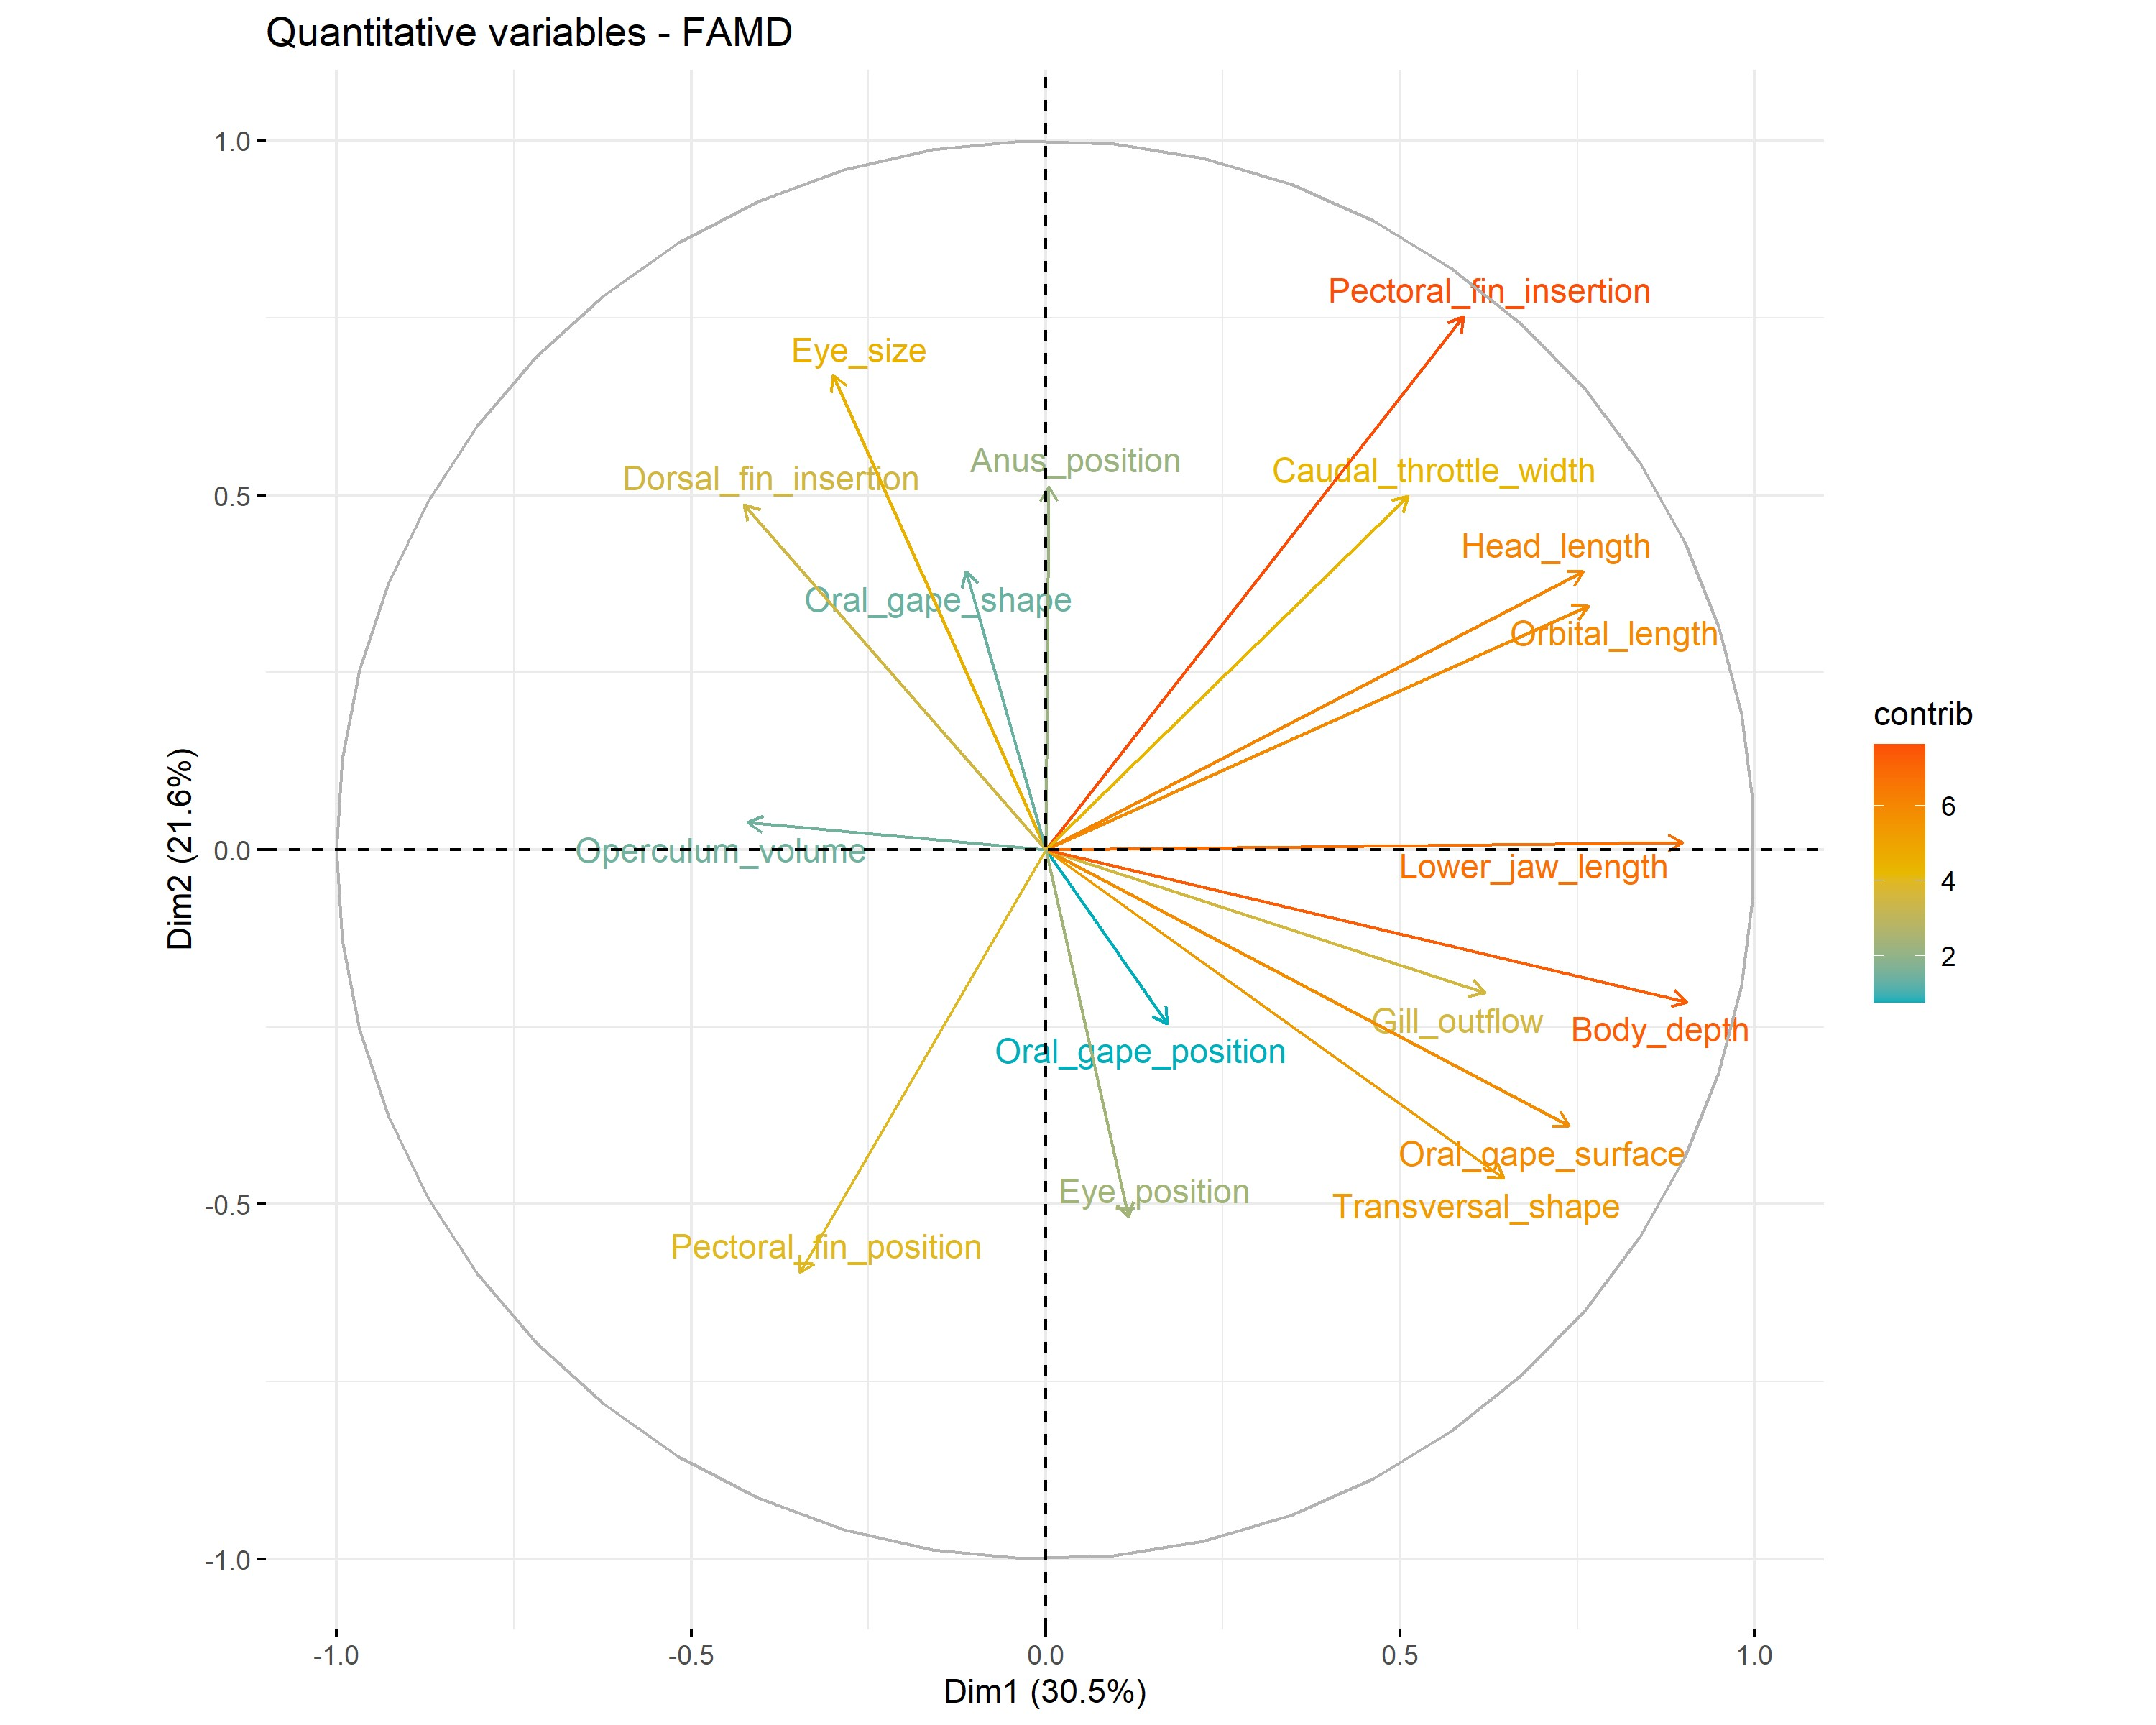

Figure C.7: Correlation circle of axis 1 and 2. The ’contrib’ variable refers to the representativity of the variable on the axis. The higher the value is, the more the corresponding variable contributes to the axis.

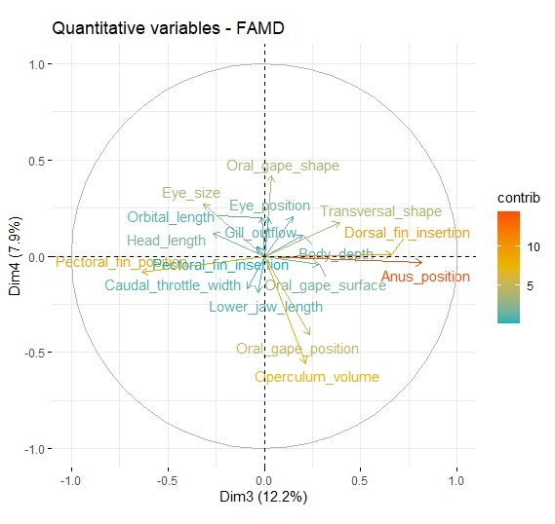

Figure C.8: Correlation circle of axis 3 and 4. The ’contrib’ variable refers to the representativity of the variable on the axis. The higher the value is, the more the corresponding variable contributes to the axis.

Boissezon A (2014) Distribution et dynamique des communautés de Characées: Impact des facteurs environnementaux régionaux et locaux. 7

Bourillet JF, Zaragosi S, Mulder T (2006) The French Atlantic margin and deep-sea submarine systems. *Geo-Marine Letters*, **26**, 311–315. 13

Boyle K, Horn M (2006) Comparison of feeding guild structure and ecomorphology of intertidal fish assemblages from central California and central Chile. *Marine Ecology Progress Series*, **319**, 21. 17

Brind’Amour A, Boisclair D, Dray S, Legendre P (2011) Relationships between species feeding traits and environmental conditions in fish communities: A three-matrix approach. *Ecological Applications*, **21**, 363–377. 7, 9, 13

Brind’Amour A, Rochet M, Ordines F, *et al.* (2016) Environmental drivers explain regional variation of changes in fish and invertebrate functional groups across the Mediterranean Sea from 1994 to 2012. *Marine Ecology Progress Series*, **562**, 19–35. 9, 17

Canals M, Puig P, de Madron XD, Heussner S, Palanques A, Fabres J (2006) Flushing submarine canyons. *Nature*, **444**, 354–357. 11

Carrassón M, Cartes JE (2002) Trophic relationships in a Mediterranean deep-sea fish community: Partition of food resources, dietary overlap and connections within the benthic boundary layer. *Marine Ecology Progress Series*, **241**, 41–55. 15

Carvalho F, Almeida A (1988) Notes on *xenodermichthys copei*(Gill, 1884), (pisces: Alepocephalidae). *Cybium: international journal of ichthyology*, **12**, 161–66. 16

Catul V, Gauns M, Karuppasamy P (2011) A Review on mesopelagic fishes belonging to family Myctophidae. *Reviews in Fish Biology and Fisheries*, **21**, 339–354. 12, 13, 26

Childress JJ, Taylor SM, Cailliet GM, Price MH (1980) Patterns of growth, energy utilization and reproduction in some meso- and bathypelagic fishes off Southern California. *Marine Biology*, **61**, 27–40. 13

Company JB, Puig P, Sardà F, Palanques A, Latasa M, Scharek R (2008) Climate Influence on Deep Sea Populations. *PLOS ONE*, **3**, e1431. 12

Company JB, Ramirez-Llodra E, Sardà F, *et al.* (2012) Submarine canyons in the Catalan Sea (NW Mediterranean): Megafaunal biodiversity patterns and anthropogenic threats. In

*Mediterranean Submarine Canyons: Ecology and Governance*, S. 133–144. Würtz M, Gland

(Switzerland) and Malaga (Spain): IUCN. 12

Cook AB, Sutton TT, Galbraith JK, Vecchione M (2013) Deep-pelagic (0–3000m) fish assemblage structure over the Mid-Atlantic Ridge in the area of the Charlie-Gibbs Fracture Zone.

*Deep Sea Research Part II: Topical Studies in Oceanography*, **98**, 279–291. 13

Cooke RSC, Eigenbrod F, Bates AE (2020) Ecological distinctiveness of birds and mammals at the global scale. *Global Ecology and Conservation*, **22**, e00970. 10

Danovaro R (2014) Challenging the paradigms of deep-sea ecology. *Trends in Ecology & Evolution*, **29**, 465–475. 11

Danovaro R, Bianchelli S, Gambi C, Mea M, Zeppilli D (2009) A-, *β*-, *γ*-, *δ*- and *ϵ*-diversity of deep-sea nematodes in canyons and open slopes of Northeast Atlantic and Mediterranean margins. *Marine Ecology Progress Series*, **396**, 197–209. 11, 12

Danovaro R, Corinaldesi C, Dell’Anno A, Snelgrove PVR (2017) The deep-sea under global change. *Current Biology*, **27**, R461–R465. 10, 11, 12

Danovaro R, Gambi C, Dell’Anno A, *et al.* (2008) Exponential Decline of Deep-Sea Ecosystem Functioning Linked to Benthic Biodiversity Loss. *Current Biology*, **18**, 1–8. 11

Davison PC, Koslow JA, Kloser RJ (2015) Acoustic biomass estimation of mesopelagic fish:

Backscattering from individuals, populations, and communities. *ICES Journal of Marine*

*Science*, **72**, 1413–1424. 12, 13

de Busserolles F, Marshall NJ, Collin SP (2014) The eyes of lanternfishes (myctophidae,

teleostei): Novel ocular specializations for vision in dim light. *The Journal of Comparative Neurology*, **522**, 1618–1640. 15

De Leo F (2012) *Submarine Canyons : Hotspots of Deep-Sea Benthic Abundance and Biodiversity*. Thesis, [Honolulu] : [University of Hawaii at Manoa], [August 2012]. 11

Diderich WP (2006) Ecomorphology as a predictor of fish diet: A case study on the north sea benthic fish community. S. 66. 8, 10, 17, 29

Dumay O, Tari PS, Tomasini JA, Mouillot D (2004) Functional groups of lagoon fish species in Languedoc-Roussillon, southern france. *Journal of Fish Biology*, **64**, 970–983. 8, 9, 13, 17

Eduardo LN, Bertrand A, Mincarone MM, *et al.* (2020) Hatchetfishes (stomiiformes: Sternoptychidae) biodiversity, trophic ecology, vertical niche partitioning and functional roles in the

western tropical atlantic. *Progress in Oceanography*, **187**, 102389. 25

Evans MR (2012) Modelling ecological systems in a changing world. *Philosophical Transactions of the Royal Society B: Biological Sciences*, **367**, 181–190. 6

Farré M, Tuset VM, Cartes JE, Massutí E, Lombarte A (2016) Depth-related trends in morphological and functional diversity of demersal fish assemblages in the western Mediterranean Sea. *Progress in Oceanography*, **147**, 22–37. 12, 13, 15, 26

Fernandez-Arcaya U, Ramirez-Llodra E, Aguzzi J, *et al.* (2017) Ecological Role of Submarine

Canyons and Need for Canyon Conservation: A Review. *Frontiers in Marine Science*, **4**. 11, 12, 13

Froese R, Pauly D (2019) FishBase. http://fishbase.org. 16

García-Seoane E, Wienerroither R, Mork KA, Underwood MJ, Melle W (2021) Biogeographical patterns of meso- and bathypelagic fish along a Northeastern Atlantic transect. *ICES Journal of Marine Science*. Fsaa255. 11, 12, 13, 26

Gaskett AC, Bulman C, He X, Goldsworthy SD (2001) Diet composition and guild structure of mesopelagic and bathypelagic fishes near Macquarie Island, Australia. *New Zealand Journal of Marine and Freshwater Research*, **35**, 469–476. 12, 13

Geange SW, Pledger S, Burns KC, Shima JS (2011) A unified analysis of niche overlap incorporating data of different types. *Methods in Ecology and Evolution*, **2**, 175–184. 5, 10

Geidner M (2008) *Spatial and trophic ecology of the sawtooth eel, Serrivomer beanii, a biomassdominant bathypelagic fish over the northern Mid-Atlantic Ridge*. Dissertation, Florida Atlantic University, Florida (USA). 16, 25

GermainD,SchnellN,MeunierF(2019) Histologicaldataonboneandteeth intwodragonfìshes

(Stomiidae; Stomiiformes): Borostomiaspanamensis Regan & Trewavas, 1929 and Stomias boa Reinhardt 1842. *Cybium*, **43**, 103–107. 16, 25

Gillet H (2013) SYNThèse et analyse des données eXistantes sur un écosystème profond transfrontalier : le gouf de Capbreton – « SYNTAX ». *Rapport technique final. Fonds Commun de Coopération Eurorégion Aquitaine/Euskadi*, S. 234. 11

Gjoesaeter J, Kawaguchi K (1980) A review of the world resources of mesopelagic fish. *FAO Fisheries Technical Papers (FAO)*. 12

Gosline WA (1971) *Functional Morphology and Classification of Teleostean Fishes*. University of Hawaii Press. 7

Grassle JF, Maciolek NJ (1992) Deep-Sea Species Richness: Regional and Local Diversity Estimates from Quantitative Bottom Samples. *The American Naturalist*, **139**, 313–341. 11

Grinnell J (1917) The niche-relationships of the california thrasher. *The Auk*, **34**, 427–433. 4 Grossman GD (2009) Food resource partitioning in a rocky intertidal fish assemblage. *Journal of Zoology*, **1**, 317–355. 6, 8

Habib SS, Naz S, Mehmood R (2019) Morphometric relationships of some specified species of family cyprinidae in Jinnah Barrage Punjab, Pakistan. *Journal of Entomology and Zoology Studies*, S. 5. 17, 30

Halfar J, Fujita RM (2002) Precautionary management of deep-sea mining. *Marine Policy*, **26**, 103–106. 11

Horn HS (1966) Measurement of ”Overlap” in comparative ecological studies. *The American Naturalist*, **100**, 419–424. 6

Hutchinson G (1957) Concluding remarks. *Cold Spring Harbor Symposia on Quantitative Biology*, **22**, 415–427. 4

Ibañez C, Tedesco PA, Bigorne R, *et al.* (2007) Dietary-morphological relationships in fish assemblages of small forested streams in the Bolivian Amazon. *Aquatic Living Resources*, **20**, 131–142. 8, 17

Keat-Chuan Ng C, Aun-Chuan Ooi P, Wong W, Khoo G (2017) A review of fish taxonomy conventions and species identification techniques. *Journal of Survey in Fisheries Sciences*, **4**, 54–93. 30

Kenchington TJ, Themelis DE, DeVaney SC, Kenchington EL (2020) The Meso- and Bathypelagic Fishes in a Large Submarine Canyon: Assemblage Structure of the Principal Species in the Gully Marine Protected Area. *Frontiers in Marine Science*, **7**. 13, 15

Kim D, Ohr S (2020) Coexistence of plant species under harsh environmental conditions: An evaluation of niche differentiation and stochasticity along salt marsh creeks. *Journal of Ecology and Environment*, **44**, 19. 5

Kozlov AN (1995) A review of the trophic role of mesolelagic fish of the family Myctophidae in the Southern Ocean ecosystem. *CCAMLR Science*, **2**, 71–77. 13

Kremer CT, Williams AK, Finiguerra M, *et al.* (2017) Realizing the potential of trait-based aquatic ecology: New tools and collaborative approaches. *Limnology and Oceanography*, **62**, 253–271. 7, 8, 10

Kuhn M, Wickham H (2020) *Tidymodels: A Collection of Packages for Modeling and Machine Learning Using Tidyverse Principles.* 18

Lagler K, Bardach J, Miller R, May Passino D (1977) *Ichthyology*. Wiley, New York, New York,

USA. 7

Lavorel S, McIntyre S, Landsberg J, Forbes TDA (1997) Plant functional classifications: From general groups to specific groups based on response to disturbance. *Trends in Ecology & Evolution*, **12**, 474–478. 7

Linton LR, Davies RW, Wrona FJ (1981) Resource utilization indices: An assessment. *Journal of Animal Ecology*, **50**, 283–292. 6

Marcon E (2015) Mesures de la biodiversité. Master, Kourou. 9

Martini S, Larras F, Boyé A, *et al.* (2020) Functional trait-based approaches as a common framework for aquatic ecologists. *Limnology and Oceanography*, S. lno.11655. 5, 6, 7, 8, 10, 13

Mason NWH, Irz P, Lanoiselée C, Mouillot D, Argillier C (2008) Evidence that niche specialization explains species–energy relationships in lake fish communities. *Journal of Animal Ecology*, **77**, 285–296. 26

Mcgill B, Enquist B, Weiher E, Westoby M (2006) Rebuilding community ecology from functional traits. *Trends in Ecology & Evolution*, **21**, 178–185. 6, 7, 10

Mejri S (2009) *Caractérisation Fonctionnelle de l’ichtyofaune d’une Future Aire Marine Protégée, La Baie de Malloula (Nord Ouest de La Tunisie)*. Dissertation. 6, 7, 9, 10

Moon JB, Dewitt TH, Errend MN, *et al.* (2017) Model application niche analysis: Assessing the transferability and generalizability of ecological models. *Ecosphere*, **8**, e01974. 6

Morisita M (1959) Measuring of the dispersion and analysis of distribution patterns. *Memories of the Faculty of Science, Kyushu University.*, **Series E: Biology**, 215–235. 6

Mouillot D, Stubbs W, Faure M, *et al.* (2005) Niche overlap estimates based on quantitative functional traits: A new family of non-parametric indices. *Oecologia*, **145**, 345–53. 5, 6

Nagelkerke LA, van Onselen E, van Kessel N, Leuven RS (2018) Functional feeding traits as predictors of invasive success of alien freshwater fish species using a food-fish model. *PLOS ONE*, **13**. 5, 8, 10

Norton SF (1995) A functional approach to ecomorphological patterns of feeding in cottid fishes. *Environmental Biology of Fishes*, **44**, 18. 7, 8, 10

Olden J, Jackson D (2002) A comparison of statistical approaches for modelling fish species distributions. *Freshwater Biology*, **47**, 1976–1995. 7

OpenTreeOfLife, Redelings B, Reyes LLS, *et al.* (2019) Open tree of life synthetic tree. 27

Orrell T, Hartel K (2016) Platytroctidae. In *The Living Marine Resources of the Eastern Central Atlantic*, Bd. 3: Bony fises part 1 (Elopiformes to Scorpaeniformes) von *FAO Species Identification Guide For Fishery Purposes*, S. 1771–1782. Carpenter K.E and De Angelis N., Rome. 16

Paitio J, Yano D, Muneyama E, *et al.* (2020) Reflector of the body photophore in lanternfish is mechanistically tuned to project the biochemical emission in photocytes for counterillumination. *Biochemical and Biophysical Research Communications*, **521**, 821–826. 12

Parkes RJ, Cragg BA, Bale SJ, *et al.* (1994) Deep bacterial biosphere in Pacific Ocean sediments. *Nature*, **371**, 410–413. 11

Pease AA, Taylor JM, Winemiller KO, King RS (2015) Ecoregional, catchment, and reach-scale environmental factors shape functional-trait structure of stream fish assemblages. *Hydrobiologia*, **753**, 265–283. 6

Pianka ER (1973) The structure of lizard communities. *Annual Review of Ecology and Systematics*, **4**, 53–74. 6

Piroddi C, Teixeira H, Lynam CP, *et al.* (2015) Using ecological models to assess ecosystem status in support of the european marine strategy framework directive. *Ecological Indicators*, **58**, 175–191. 6

Pont D, Hugueny B, Beier U, *et al.* (2006) Assessing river biotic condition at a continental scale:

A European approach using functional metrics and fish assemblages. *Journal of Applied Ecology*, **43**, 70–80. 6

Poulsen JY, Byrkjedal I, Willassen E, *et al.* (2013) Mitogenomic sequences and evidence from unique gene rearrangements corroborate evolutionary relationships of myctophiformes

(neoteleostei). *BMC Evolutionary Biology*, **13**, 111. 16

Preciado I, Cartes JE, Punzón A, Frutos I, López-López L, Serrano A (2017) Food web functioning of the benthopelagic community in a deep-sea seamount based on diet and stable isotope analyses. *Deep Sea Research Part II: Topical Studies in Oceanography*, **137**, 56–68. 15

Pusch C, Hulley P, Kock KH (2004) Community structure and feeding ecology of mesopelagic fishes in the slope waters of King George Island (South Shetland Islands, Antarctica). *Deep Sea Research Part I: Oceanographic Research Papers*, **51**, 1685–1708. 12, 13

R Core Team (2021) *R: A Language and Environment for Statistical Computing*. R Foundation for Statistical Computing, Vienna, Austria. 16

Reynolds GT, Lutz RA (2001) Sources of light in the deep ocean. *Reviews of Geophysics*, **39**,

123–136. 10

Richards TM, Gipson EE, Cook A, Sutton TT, Wells RJD (2019) Trophic ecology of meso- and bathypelagic predatory fishes in the Gulf of Mexico. *ICES Journal of Marine Science*, **76**, 662–672. 11, 12

Robertson CM, Demopoulos AWJ, Bourque JR, *et al.* (2020) Submarine canyons influence macrofaunal diversity and density patterns in the deep-sea benthos. *Deep Sea Research Part I: Oceanographic Research Papers*, **159**, 103249. 11

Rocklin D (2004) Taxonomic and functional biodiversity of the fish communities in the grand cul-de-sac marin (French West Indies) marine reserve seagrass habitat. 9

Salazar G, Cornejo-Castillo FM, Benítez-Barrios V, *et al.* (2016) Global diversity and biogeography of deep-sea pelagic prokaryotes. *The ISME Journal*, **10**, 596–608. 10

Salvanes A, Kristoffersen J (2009) Mesopelagic fishes. In *Elements of Physical Oceanography:*

*A Derivative of the Encyclopedia of Ocean Sciences*, S. 239–245. Steele J, Thorpe S, Turekian K, University of Bergen, Norway, academic press Aufl.. 12, 13

Schoener TW (1968) Sizes of feeding territories among birds. *Ecology*, **49**, 123–141. 6

Schoenfuss H, Blob R (2007) The importance of functional morphology for fishery conservation and management: Applications to Hawaiian amphidromous fishes. *Bishop Museum Bulletin in Cultural and Environmental Studies*, **3**. 23

Sibbing FA, Nagelkerke LA (2000) Resource partioning by Lake Tana barbs predicted from fish morphometrics and prey characteristics. *Reviews in Fish Biology and Fisheries*, **10**, 393–437. 8, 17, 29

Sion L, Calculli C, Capezzuto F, *et al.* (2019) Does the Bari Canyon (Central Mediterranean) influence the fish distribution and abundance? *Progress in Oceanography*, **170**, 81–92. 12

Spitz J, Munschy C, Chouvelon T (2019) Biodiversité et Contamination du micronecton profond - Faisabilité du suivi et Etat de référence - EVHOE 2017 & 2018. Rapport scientifique,

Observatoire PELAGIS (UMS 3462, La Rochelle Université/CNRS) - Ifremer. 12, 13

Stefanescu C, Nin-Morales B, Massuti E (1994) Fish assemblages on the slope in the Catalan Sea (western Mediterranean): Influence of a submarine canyon. *Journal of the Marine Biological Association of the United Kingdom*, **74**, 499–512. 12

Sutherland WJ, Freckleton RP, Godfray HCJ, *et al.* (2013) Identification of 100 fundamental ecological questions. *Journal of Ecology*, **101**, 58–67. 4

Sutton T, Sigurdsson T (2008) Vertical and horizontal distribution of mesopelagic fishes along a transect across the northern Mid-Atlantic Ridge. *ICES Journal of Marine Science*, **CM 2008**, 1.12. 26

Sutton TT, Hopkins TL (1996) Trophic ecology of the stomiid (Pisces: Stomiidae) fish assemblage of the eastern Gulf of Mexico: Strategies, selectivity and impact of a top mesopelagic predator group. *Marine Biology*, **127**, 179–192. 25, 26

Sutton TT, Letessier TB, Bardarson B (2013) Midwater fishes collected in the vicinity of the

Sub-Polar Front, Mid-North Atlantic Ocean, during ECOMAR pelagic sampling. *DEEP-SEA RESEARCH PART II-TOPICAL STUDIES IN OCEANOGRAPHY*, **98**, 292–300. 13

Todo Y, Kitazato H, Hashimoto J, Gooday AJ (2005) Simple Foraminifera Flourish at the

Ocean’s Deepest Point. *Science*, **307**, 689–689. 11

van den Beld IM, Guillaumont B, Menot L, Bayle C, Arnaud-Haond S, Bourillet JF (2017a)

Marine litter in submarine canyons of the bay of biscay. *Deep Sea Research Part II: Topical*

*Studies in Oceanography*, **145**, 142–152. 13

van den Beld IMJ, Bourillet JF, Arnaud-Haond S, *et al.* (2017b) Cold-Water Coral Habitats in Submarine Canyons of the Bay of Biscay. *Frontiers in Marine Science*, **4**. 13

Violle C, Navas ML, Vile D, *et al.* (2007) Let the concept of trait be functional! *Oikos*, **116**, 882–892. 7

Webb PW (1984) Form and function in fish swimming. *Scientific American*, S. 17. 7, 8, 17

Webb TJ, Berghe EV, O’Dor R (2010) Biodiversity’s Big Wet Secret: The Global Distribution of Marine Biological Records Reveals Chronic Under-Exploration of the Deep Pelagic Ocean. *PLOS ONE*, **5**, e10223. 10, 13

Wilson EO, Peter FM, National Academy of Sciences (US), Smithsonian Institution (1988) *Biodiversity*. 9

Winemiller KO (1991) Ecomorphological diversification in lowland freshwater fish assemblages from five biotic regions. *Ecological Monographs*, **61**, 343–365. 7, 15, 17

Zhang S (2012) Nearest neighbor selection for iteratively kNN imputation. *Journal of Systems and Software*, **85**, 2541–2552. 18

Zobel M (1997) The relative of species pools in determining plant species richness: An alternative explanation of species coexistence? *Trends in Ecology & Evolution*, **12**, 266–269. 9