Rapport stage M2

Moi même

Mardi 9 février 2020

**Contents**

**Acknowledgements 3**

**Présentation de la structure d’accueil 3**

**Literature review 4**

1. Structure and dynamics of ecosystems: how can species coexist in same envi-

ronment? . . . . . . . . . . . . . . . . . . . . . . . . . . . . . . . . . . . . . 4

1. Concepts and definition for studying ecosystems’ dynamic. . . . . . . . . . . . 4
2. Tools to study diversity in ecosystems and their limits . . . . . . . . . . . . . . 5
3. Emergence of a more global approach based on functional-traits . . . . . . . . 6
   1. General overview . . . . . . . . . . . . . . . . . . . . . . . . . . . . . 6
   2. Improvement of the method over the years . . . . . . . . . . . . . . . 7
4. The advent of functional diversity . . . . . . . . . . . . . . . . . . . . . . . . 8
   1. Benefits of this approach . . . . . . . . . . . . . . . . . . . . . . . . . 9

**Materials & Methods 10**

1. Biological material . . . . . . . . . . . . . . . . . . . . . . . . . . . . . . . . 10
2. Functional traits . . . . . . . . . . . . . . . . . . . . . . . . . . . . . . . . . . 10
3. Data analysis . . . . . . . . . . . . . . . . . . . . . . . . . . . . . . . . . . . 11
   1. Data pre-processing . . . . . . . . . . . . . . . . . . . . . . . . . . . 13
   2. lkez . . . . . . . . . . . . . . . . . . . . . . . . . . . . . . . . . . . . 13

**A Morphological measurements 13**

## Acknowledgements

## Présentation de la structure d’accueil

## Literature review

**1 Structure and dynamics of ecosystems: how can species coexist in same environment?**

Of all the questions raised when it comes to study Nature, the most common yet complex one is “how do organisms and environment interact with each other?” (Sutherland *et al.* 2013). In other words, what are the processes and rules that define structure and functioning of ecosystems? Taken as a whole, an ecosystem can be seen as a giant network: all individuals from every species are linked to one another through intra- and inter-specific relationships, that implies competition, parasitism, predation…; and each individual is linked to its physical environment, on which it depends for food prospection, shelter and/or favorable conditions for breeding. The main purpose of ecology is to study those links and ultimately, to be able to map the central relationships and flows that are keys to maintain stable ecosystems (Albouy*etal.*2011). Community ecologists, regardless of the ecosystem they are studying, try to answer some fairly similar questions such as “how do species share environmental resources?” or “how can species relying on the same resource to thrive and survive can coexist?”. Indeed, the mere observation that species can live and develop a population without encroaching each other suggests that, even if species compete to access the same resources, the use of resources is balanced and allows stable relationships between species to develop. Most of all, if species depend on the same resources to survive, how can diversity within an ecosystem last over time?

## 2 Concepts and definition for studying ecosystems’ dynamic.

First, a “community” is made up of all species which live and interact within a specific habitat. In a community, the concept of “ecological niche” reflects the fact that distinct groups of individuals use differently space and trophic resources to meet their needs. In 1917, Grinnell was the first to define scientifically as “ecological niche” all the requirements that a species needs to thrive (Grinnell 1917). This concept covers both biotic (food abundance and availability, competition within and among species, predation-prey relationships …) and abiotic conditions (environmental factors such as temperature or pression, shelter availability …) which shape the suitable areas for species survival. This definition is refined by Hutchinson (1957): resources and their availability are the main drivers for the coexistence of species, since resources are essential for species to thrive and are therefore considered limiting factors. Furthermore, Hutchinson’s definition distinguishes the concepts of (i)“fundamental niche” which is a potential niche for a given species that offers all the optimal conditions for that species to flourish and (ii) “realized niche”, which corresponds to the actual resources used by a species and which is often smaller than the fundamental niche, mainly because of competition between species. When resources are limited, competition between species that seek to simultaneously exploit the same resources may arise, either because they forage the same prey or because they need to occupy the same specific habitat (Blondel & Bourlière 1979). When the resources are abundant enough, species may be able to share it without entering competition (Nagelkerke *et al.* 2018). According to competition theory, community structures results from the species ablility to share or not resources. Therefore, to study the structure and dynamics of community and to identify the main factors that enable species to coexist, it is essential to determine the degree by which species share resources, in other words, quantify the overlap between ecological niches (Geange *et al.* 2011).

## 3 Tools to study diversity in ecosystems and their limits

Niche overlap can be approached from the habitat (beta overlap) or food (alpha overlap) perspective (Mouillot *et al.* 2005). In both cases, a high degree of overlap means that the species are likely to compete for the same resources making their coexistence virtually impossible. Conversely, a low deree of overlap tends to suggest that species, even if they rely in part on the same resources, have a sufficiently wide range of accessible resources not to compete with each other (Mouillot *et al.* 2005). No overlap means that species occupy distinct niches, are likely to use very different resources and that no competition is expected. This approach has been

widely developed over the last decades to study the distribution of abundance and the mechanisms favoring species coexistence, in particular to predict the impact of disturbances, such as the introduction of invasive species or climate change (Albouy *et al.* 2011; Geange *et al.* 2011; Martini *et al.* 2020).

Several indices have been developed since the 60’s to quantify niche overlap. Indices and threshold values are commonly used for studying specific, taxonomic or phylogenetic diversity. However, used alone, a result of diversity estimation through any index is usually poor and inaccurate, because complex and rich systems can not be described only by the result of a computation (Mejri 2009). Indeed, four of the best-known niche overlap indices, which are based on the intensity of utilisation of a resource use by species, were compared by Linton *et al.* (1981) to assess the precision and accuracy: Morisita (1959) updated by Horn (1966), Schoener (1968) and Pianka (1973). Even if they lead to the same general conclusions, these four indices often give different results, because they use different computation parameters (Blondel & Bourlière 1979). Moreover, they are often highly sensitive to sample size, which adds uncertainty when it comes to interpreting their values (Linton *et al.* 1981). Finally, Grossman (2009) points out that threshold values for those indices can be considered as arbitrary and might differ from one ecosystem to another, leading to an impossibility of comparing them. For all these reasons, using those indices to estimate if species share or not the same resources, and if so, how much is shared, does not seem relevant (Mouillot *et al.* 2005). As such, they provide a qualitative assessment of the overlap rather than a quantitative one (Linton *et al.* 1981).

Therefore, to understand how the structure and the dynamics of an ecosystem are defined and how such complex relationships can last for several generations, numerical models are often used (see Ecopath models, [https://ecopath.org](https://ecopath.org/)). This approach requires a simplification of the ecosystem, because simulating very complex models make the outcome virtually impossible to compute (Albouy *et al.* 2011). Simplifying an ecosystem can be done in many ways: focusing on specific compartments of the ecosystem (*e.g*: pelagic or benthic fauna), grouping species based on their trophic level, or taxonomy or similaire behavior …. Obviously, simplifying with any of these methods comes down to approximating the relationships and much of the complexity of an ecosystem, but if done properly, models are still able to produce reliable simulations of what is going on in real life (Albouy *et al.* 2011; Evans 2012; Piroddi *et al.* 2015). Yet, the main difficulty is to determine the criteria that are relevant to gather species and to simplify models. Whether they are too restrictive, or not enough, these criteria condition not only the accuracy of the model, but also its ability to be generalized (Moon *et al.* 2017; Pease *et al.* 2015; Pont *et al.* 2006). For instance, if a model uses a taxonomic grouping of species, it will only be suited to study other ecosystems that contain the ame set of species or taxonomic groups. Its transposition to other unrelated ecosystems will thus be limited, if not impossible (Moon *et al.* 2017). In the end, this modeling approach imposes a specific model for each ecosystem, which is highly time consuming and limits the possibilities of comparisons between ecosystems (Martini *et al.* 2020; Mcgill *et al.* 2006). Therefore, this approach remains very specific to a studied ecosystem and the species that compose it.

## 4 Emergence of functional approaches based on species characteristics.

### 4.1 General overview

Community ecology aim to establish general rules explaining the functioning of communities. Species-centred approaches only provide information for a few specific systems but not general principles, that can be applied to a wide variety of communities or ecosystems (Albouy *et al.* 2011; Martini *et al.* 2020). Therefore, ecologists had to find a way to study ecosystems, to (i) give clues of how species interacts with each other and (ii) to assess how strongly species are related to their environment. Indeed, some scientists emphasized the urge to get rid of methods that were highly dependent of species, time or space, such as the ones described previously, and to use a more predictable and quantitative science that could play a major role in assessing global changes issues (Brind’Amour *et al.* 2011; Mcgill *et al.* 2006; Olden & Jackson 2002). To this extend, Mcgill *et al.* (2006) define a **trait** as a “*well-defined, measurable property of organisms, usually measured at the individual level and used comparatively across species*” and suggest that community ecology should try to understand how these traits interact with fundamental niches to define realized niches. The notion of “trait” has been widely used in the literature, but with slightly different meanings. For instance, Violle *et al.* (2007) defined a trait as “any morphological, physiological or phenological feature measurable at the individual level, from cell to whole organism”. To ensure a consistent approach to community ecology studies, Martini *et al.* (2020) suggests that the definition of Violle *et al.* (2007) is precise enough, that it should serve as a reference and therefore should be used systematically. Yet, not all measurable traits provide the same information: for ecologists, traits that inform about (i) the interactions between species and the environment and (ii) the fitness of individuals are the most valuables (Kremer *et al.* 2017). These specific traits are defined as “functional traits” and can relate to behavior, life history, morphology or physiology, influencing the general performances of individuals Martini *et al.* (2020); Mcgill *et al.* (2006). They provide information on the main functions of organisms, such as acquisition of food or locomotion (Mejri 2009).

### 4.2 Improvement of the method over the years

The functional-traits approaches were first developed in studies based on terrestrial plants. They showed that the morphology of species was correlated with their environment and thus functional traits can explain habitat selection and distribution of species (Boissezon 2014; Lavorel *et al.* 1997; Martini *et al.* 2020). Applied to aquatic animals, structure-function relationship has been well documented since the 1970s (Gosline 1971; Lagler *et al.* 1977; Webb 1984) and approaches based on morphological traits seemed suitable to define ecological niches, compare species within a community or, communities between ecosystems (Norton 1995, Winemiller 1991). For instance, Albouy *et al.* (2011) developped a model to determine the diet of any marine species based on morphological traits, and thus establish trophic guilds. Yet, the model could not predict diet overlap nor resource partitionning among species, because of intrinsic variability in the diet of fish. Indeed, morphology alone is hardly a clue to determine diet in terms of prey species, for generalist species are able to switch prey depending on which is more abundant, and they do not display specific morphological traits (Sibbing & Nagelkerke 2000). *Moreoever, trophic level impacts how specialised a species can be in terms of diet: apex predators will often favor one feeding strategies among others, so they are very efficient for one strategy, and have limitating capacities in others. This principle can be summed up as a “trade-off strategy”: greater abilities for one strategy lead to a decrease of abilities in other areas Norton (1995), because of morphological specificities (Nagelkerke* et al. *2018).*

Conversely on morphological trait associated with swimming performances, Webb (1984) noticed that most species were not specialized i.e not displaying any particular traits) and had fairly good performances in three of the main swimming methods (powerful short acceleration, cruise and maneuvrability). Similarly, using only morphological traits to predict main functions such as food acquisition does not always seem relevant. Grossman (2009) showed that species with strong morphological divergences can sometimes use the same resources in a similar way, whereas morphologically close species can have very different diets. In order to overcome the limits imposed by their morphology and/or habitat for the acquisition of food, organisms can indeed modulate their behavior and show great adaptability (Blondel & Bourlière 1979; Grossman 2009). In fact, if morphology sets limits to resource use, species usually display some plasticity to adapt to prey availability and environmental conditions (Ibañez *et al.* 2007; Sibbing & Nagelkerke 2000). The link between morphology and food acquisition is therefore not so robust.

While the flexibility and intrinsic variability of species should not be ignored, they can be hard to predict (Diderich 2006; Martini *et al.* 2020). It is therefore essential to identify and select relevant traits, that can be used to explain most interactions between species and their environment. This is one of the main challenges of the functional traits approach, because the selected traits must be sufficiently variable between the levels being compared (species, populations, individuals …), and the observed variations must explain the actual differences in fitness or coexistence of species (Kremer *et al.* 2017).

Yet, the trait variability is what makes this approach so useful, as it allows for the quantification of intraspecific (especially when the environmental conditions change Martini *et al.* (2020)) and interspecific differences that can explains the interactions between species and their environment. In a nutshell, the traits to be used for functional trait approach must offer the best compromise between being (i) sufficiently informative with respect to the objectives, (ii) generic enough to be comparable across species — even if they are very different morphologically — and (iii) easily measurable to ensure repeatability between studies (Dumay *et al.* 2004; Kremer *et al.* 2017).

## 5 The advent of functional diversity

The functional approach is relatively recent. It developed in the 1980s with the collapse of populations, species extinctions and the biodiversity crisis (Wilson *et al.* 1988). The functions performed by species began to be studied in greater depth when ecologists noticed that if a species disappeared from an ecosystem, it did not necessarily mean that the whole ecosystem was disturbed or even collapsed (Mejri 2009). The question “Are all species essential for the proper functioning of ecosystems?” became central, as did the need to define the role of species within ecosystems. In other words, can we consider that species are “redundant” if they play the same role, fulfill the same function, in an ecosystem? To answer these questions, the functional trait approach seems relevant because it provides information on the roles of species in their environment, which is complementary to those provided by classical diversity indices, such as specific diversity, richness distribution or evenness (Marcon 2015; Mejri 2009).

More importantly, functional traits and species role attribution are crucial in determining functional diversity, which is the primary factor explaining stability and productivity, and should therefore be preferred to specific or taxonomic diversity when studying community ecology (Dumay *et al.* 2004; Mejri 2009). In fact, the resilience and health of ecosystems depends much more on the range of functions and functional traits exhibited by species than on the number of species *per se* (i.e. species richness). Indeed, indices of specific abundance and diversity assume that all species are equivalent, and do not take into account the functions provided by these species (Mejri 2009). From this functional perspective, the richness of an ecosystem is determined by the extent of functional diversity provided by the species (Rocklin 2004).

To estimate functional diversity, species must first be classified into “functional groups”, which reflects the similarities of species according to three criteria. Within a functional group, species must (i) share the same habitat and trophic level (Brind’Amour *et al.* 2016), (ii) play a similar role in the habitat, through the functions they provide (Dumay *et al.* 2004; Mejri 2009), and (iii) display similar responses to changing environmental pressures (Brind’Amour *et al.* 2016; Dumay *et al.* 2004; Mejri 2009).

To form these groups and to evaluate the response of species for each of these three items, morphological traits are often used, because they reflect the capacities as well as their modes of interaction with their environment. They can therefore be used as indicators of trophic networks or habitats (Brind’Amour *et al.* 2016). Indeed, according to the “niche filtering hypothesis”,

which considers habitat characteristics as filters, only species that with adapted traits can thrive in a specific set of environmental conditions (Brind’Amour *et al.* 2011). This assumption also means that species, if they share similar functional traits, must use the same resources, probably in the same way, and thus have overlapping niches. Conversely, if species have very different functional traits from each other, they probably use resources in very different ways, or even distinct resources.

### 5.1 Benefits of this approach

Species in a same functional group can be considered “functionally equivalent”, with similar or interchangeable functions and sharing the same functional niche. The ecosystem in which they occur then has “functional redundancy”, which reduces the risk of a functional loss in the event of ecosystem disturbance. Conversely, a species can also be the only representative of a functional group (qualified as a “monospecific group”). It is then considered “essential”, because if it disappears, the functions it provides will also disappear, causing a major disturbance of the ecosystem and other essential functions (Mejri 2009).

For conservation issues and the prediction of climate change impacts on ecosystems and biodiversity, the functional approach and the study of niche overlap seem relevant, as these tools provide a quantitative estimate of the resilience and/or resistance to change of communities and ecosystems. At a specific level, knowing which species have the most specialised diet or which are the species are essential, from a functional perspective, are really useful to target species that needs to be protected in conservation plans (Mejri 2009; Norton 1995). In addition, those tools can also be used to predict changes in diet niche for species in competition, if one of the abundances is affected by fishing pressure (Diderich 2006) or if an invasive species colonizes the environment (Albouy *et al.* 2011; Geange *et al.* 2011; Nagelkerke *et al.* 2018). As these approaches are not based on species or taxonomy, they are better suited to the generalization and identification of the ecosystem services provided (Martini *et al.* 2020; Mcgill *et al.* 2006) and the relationships involved in stable coexistence of species (Albouy *et al.* 2011). They thus improve our ability to predict ecological dynamics and their fluctuations, in an environment facing strong anthropic influence (Kremer *et al.* 2017).

## Materials & Methods

## 1 Biological material

Fish were collected during Ifremer’s EVHOE (EValuation Halieutique de l’Ouest Européen) research cruises, surveying the Bay of Biscay every fall onboard the *R/V Thalassa*. Several hauls are regularly performed at night to investigate pelagic deep fauna. Each station is precisely defined with its GPS coordinates and located above canyons, at the the edge of continental shelf. Although they are considered to be “biodiversity hotspot”, canyons communities are yet relatively unknown in meso and bathypelagic layers, because of the logistic and material difficulties that their exploration implies (Gillet 2013). Pelagic trawling is performed during night, between 700 and 2000 meters, because those fishes perform diel vertical migrations and tends to come closer to the surface at nighttime. To this end, 25 meters-wide opening trawl is used, with as mesh size decreasing from 76mm to 48mm at the end of the trawl, at a toing speed of 4 knots for about an hour. Once the trawl is pulled back onboard, fishes are sorted, identified, up to species and frozen a t-20°C. For this study

Eleven of the most abundant species in the Bay of Biscay have been selected for this study. All teleost, 4 of them belong to the Myctophid family (lanternfish), which is the most abundant and widely spread family across all oceans (de Busserolles *et al.* 2014) and could represent up to 65% of the pelagic deep-sea biomass (Poulsen *et al.* 2013): *Lampanyctus crocodilus*, *Myctophum punctatum*, *Notoscopelus kroeyeri* and *Ceratoscopelus maderensis*. The second most represented family is the Platytrocidae with 2 species: *Searsia koefoedi* & *Normichthys operosus*. This family seems to be found in all oceans but not in Mediterranean Sea (Orrell & Hartel 2016). Finally, 3 families are represented by one species each: *Xenodermichthys copei* (Alepocephalidae); *Arctozenus risso* (Paralepididae) and *Argyropelecus olfersii* (Sternoptychidae), which are common species, found in every ocean (Carvalho & Almeida 1988; Froese & Pauly 2019).

## 2 Functional traits

In lab, fish were thaw and 24 morphological measurements were taken on individuals, using an electronic caliper with a precision up to 0.01mm. Part of these measurements had previously been taken by students from La Rochelle University during pratictal class. For the sake of

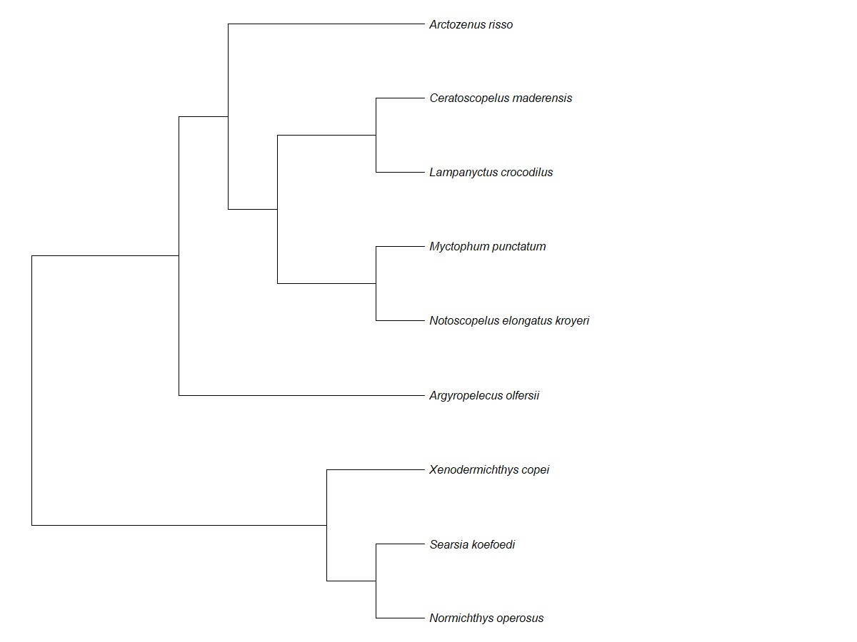

Figure 1: Phylogenic tree of studied species, using R *rotl* package (OpenTreeOfLife *et al.* 2019) .

statistical robustness and representativtiy, at least 20 individuals were measured for each species (Table 1).

Table 1: Species individual count and abundance

|  |  |  |
| --- | --- | --- |
| *Species* | Count | Abundance (%) |
| *Arctozenus risso* | 20 | 7.75 |
| *Argyropelecus olfersii* | 37 | 14.34 |
| *Lampanyctus crocodilus* | 39 | 15.12 |
| *Myctophum punctatum* | 25 | 9.69 |
| *Notoscopelus kroyeri* | 36 | 13.95 |
| *Searsia koefoedi* | 5 | 1.94 |
| *Xenodermichthys copei* | 38 | 14.73 |
| *Ceratoscopelus maderensis* | 20 | 7.75 |
| *Normichthys operosus* | 38 | 14.73 |

Following what had been made on similar studies and according to our measurements, a total of 21 functional traits were computed from morphological measurements and informs on 3 main functions: food acquisition, swimming behavior and habitat (see Table 2).

## 3 Data analysis

All data analysis were performed using R version 4.0.3 R Core Team (2021).

Table2:

Description and formulas of the functionals traits computed from morphological measurements ,following(

Albouy

*etal.*

2011

;

AneeshKu-

mar

*etal.*

2017

;

Boyle&Horn

2006

;

Brind’Amour

*etal.*

2016

;

Diderich

2006

;

Dumay

*etal.*

2004

;

Habib

*etal.*

2019

;

Ibañez

*etal.*

2007

;

Sibbing

&Nagelkerke

2000

;

Webb

1984

;

Winemiller

1991

.Abbreviationsusedinformulasareprovidedbyrawmeasurementsanddetailedinappendice

)

A.1

.OGA,GIT,PC,PHTareallcategorialvariablesdirectlyprovidedbyrawmeasurements.

)

**Function**

Functionaltrait

Description

FORMULA

**Feeding**

Oralgapeaxis

Feedingpositionanddepthinthewatercolumn

OGA

Eyesize

Detectionofpreysandvisualacuityforpredators

ED/HD

Orbitallength

Preyssizeandbehavior(buried,camouflaged)

ED/SL

OralgapesurfaceTypeandsizeofpreys

MW*MD/BW*BD

Oralgapeshape

Strategytocaptureprey

MD/MW

OralgapepositionFeddingpositioninthewatercolumn

MO/HD

LowerjawlengthCompromisebetweenpowerandopeningspeedofthemouth

LJL/SL

Gillrakertype

Filtrationcapacitiesoffish

GIT

Gilloutflow

Succioncapacitiesoffish

OW

OperculumvolumeOperculumvolume(chercheràquoiçasert)

OD/OW

Headlength

Maximumpreysize

HL/SL

Pyloriccaeca

Presence/Absenceofpyloriccaeca

PC

Anusposition

Digestivetractlength

PAL/SL

**Locomotion**

Bodydepth

SwimmingcapacitiesoffishlinkedtotheirfoodprospectionbehaviorBD/SL

PectoralfinpositionManeuvrabilityoffish

PFI/PFB

PectoralfininsertionInsertiondelapectorale(chercheràquoiçasert)

PPL/SL

TransversalshapePositioninthewatercolumnandhydrodynamism

BD/BW

CaudalthrottlewidthSwimmingstrategy(cruiser/sprinter)

CPD

DorsalfininsertionSwimmingbehavior(chercheràquoiçasert)

PDL/SL

**Others**

Eyeposition

Positioninthewatercolumn(pelagic/sedentary)

EH/HD

PresencephotophoresPresence/Absenceofphotophores(chercheràquoiçasert)

PHT

### 3.1 Data pre-processing

Because measurements came from several observators, raw data had to be checked for outliers.

To do so, data were standardised by SL and the interquartile range (IQR) method of outlier detection was applied to remove outliers ADD REF. According to this method, for each variable (measurement) and for each species, outliers are defined as every value outside this interval:

[*Q*1 − 1*.*5 ∗ *QR,Q*3 + 1*.*5 ∗ *IQR*]

with *Q*1 and *Q*3 being respectively first and third quartile, *IQR* = *Q*3 − *Q*1

Missing values that were previously present in the data set (*n=28*) and those induced by outlier removal function (*n=179*), are then imputed following k-Nearest Neighbor (kNN) method, which as proven to be effective ADD REF. Based on non-missing values points, kNN algorithm computes Euclidian distances between points, and assumes that missing value can be approximated by the values of points that are the closest. To this end *tidymodels* R package and *step_knnimpute* function (Kuhn & Wickham 2020) were used, with a number of nearest

neighbors (*k*) of √*N*, with *N* being the number of observations, i.e individuals, of the dataset. ADD ACCURACY OF PREDICTIONS? Accuracy was checked with linear regression of each variable with SL.

### 3.2 lkez

# Morphological measurements

**References**

Albouy C, Guilhaumon F, Villéger S, *et al.* (2011) Predicting trophic guild and diet overlap from functional traits: Statistics, opportunities and limitations for marine ecology. *Marine Ecology Progress Series*, **436**, 17–28. 4, 5, 6, 7, 9, 10, 12, 14

Aneesh Kumar K, Tuset V, Manjebrayakath H, *et al.* (2017) Functional approach reveals low niche overlap among common deep-sea fishes from the south-eastern Arabian Sea. *Deep Sea*

*Research Part I: Oceanographic Research Papers*, **119**, 16–23. 12

Blondel J, Bourlière F (1979) La niche écologique, mythe ou réalité ? *Terre Vie. Revue Ecologie.*,

**33**. 5, 7

Boissezon A (2014) Distribution et dynamique des communautés de Characées: Impact des facteurs environnementaux régionaux et locaux. 7

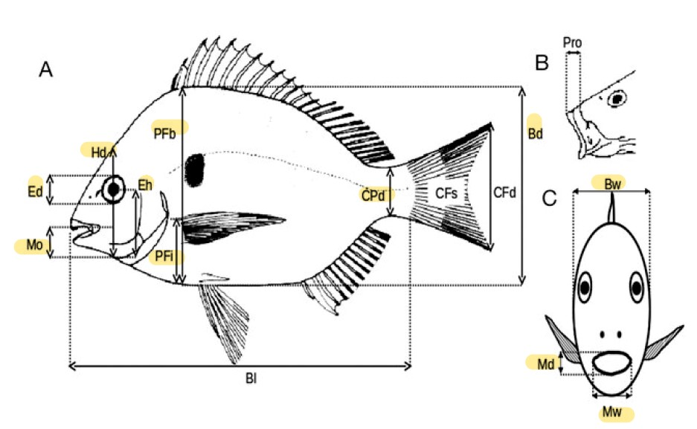

Figure A.1: Morphological measurements, from Albouy *et al.* (2011). BD, body depth; BW, body width;CPD, caudal peduncle minimal depth; ED, eye diameter; EH, distance between the bottom of the head and the eye center along the head depth axis; HD, head depth along the vertical axis of the eye; MD, mouth depth; MO, distance between the tip of the upper jaw and bottom of the head; MW, mouth width; PFB, body depth at the level of the pectoral insertion; PFI, distance between the insertion of pectoral fin and the bottom of the body.

Boyle K, Horn M (2006) Comparison of feeding guild structure and ecomorphology of intertidal fish assemblages from central California and central Chile. *Marine Ecology Progress Series*, **319**, 21. 12

Brind’Amour A, Boisclair D, Dray S, Legendre P (2011) Relationships between species feeding traits and environmental conditions in fish communities: A three-matrix approach. *Ecological Applications*, **21**, 363–377. 6, 9

Brind’Amour A, Rochet M, Ordines F, *et al.* (2016) Environmental drivers explain regional variation of changes in fish and invertebrate functional groups across the Mediterranean Sea from 1994 to 2012. *Marine Ecology Progress Series*, **562**, 19–35. 9, 12

Carvalho F, Almeida A (1988) Notes on xenodermichthys copei (gill, 1884), (pisces: Alepocephalidae). *Cybium: international journal of ichthyology*, **12**, 161–66. 10

de Busserolles F, Marshall NJ, Collin SP (2014) The eyes of lanternfishes (myctophidae,

teleostei): Novel ocular specializations for vision in dim light. *The Journal of Comparative Neurology*, **522**, 1618–1640. 10

Diderich WP (2006) Ecomorphology as a predictor of fish diet: A case study on the north sea benthic fish community. S. 66. 8, 9, 12, 15

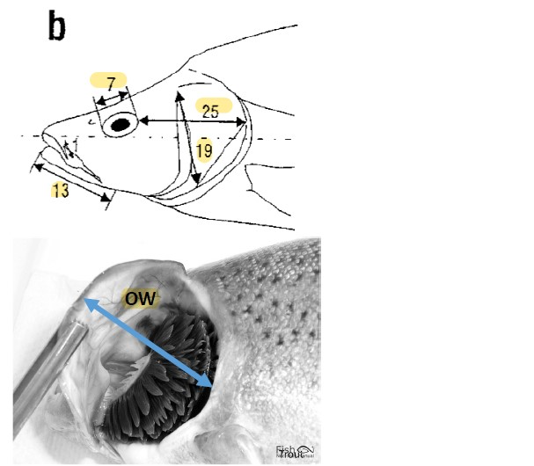

Figure A.2: Morphological measurements of the head, from Diderich (2006), following Sibbing &Nagelkerke(2000). 7beingED, eyediameter; 13LJL, distancebetweenthetipandtheinsertion point of lower jaw; 19 OD, depth of the operculum from point of insertion to bottom; 25 POL, shortest distance between the eye and the end of the head; OW, operculum maximum width.

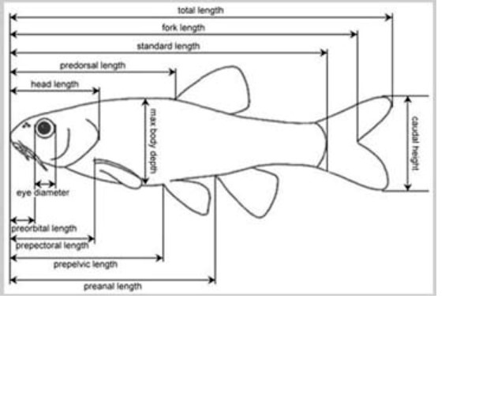

Figure A.3: Morphological measurements of the head, adpated from Keat-Chuan Ng *et al.*

(2017); Habib *et al.* (2019). HL, head length, from the nose to the closest-to-caudal-fin point of the operculum; PAL, distance bewteen the tip of the nose and the insertion of anal fin; PDL, distance bewteen the tip of the nose and the insertion of dorsal fin, PPL, distance bewteen the tip of the nose and the insertion of pectoral fin; PVL, distance bewteen the tip of the nose and the insertion of pelvic fin; SL, standard length.

Dumay O, Tari PS, Tomasini JA, Mouillot D (2004) Functional groups of lagoon fish species in languedoc roussillon, southern france. *Journal of Fish Biology*, **64**, 970–983. 8, 9, 12

Evans MR (2012) Modelling ecological systems in a changing world. *Philosophical Transactions of the Royal Society B: Biological Sciences*, **367**, 181–190. 6

Froese R, Pauly D (2019) FishBase. http://fishbase.org. 10

Geange SW, Pledger S, Burns KC, Shima JS (2011) A unified analysis of niche overlap incorporating data of different types. *Methods in Ecology and Evolution*, **2**, 175–184. 5, 9

Gillet H (2013) SYNThèse et analyse des données eXistantes sur un écosystème profond transfrontalier : le gouf de capbreton – « SYNTAX ». *Rapport technique final. Fonds Commun de Coopération Eurorégion Aquitaine/Euskadi*, S. 234. 10

Gosline WA (1971) *Functional Morphology and Classification of Teleostean Fishes*. University of Hawaii Press. 7

Grinnell J (1917) The niche-relationships of the california thrasher. *The Auk*, **34**, 427–433. 4

Grossman GD (2009) Food resource partitioning in a rocky intertidal fish assemblage. *Journal of Zoology*, **1**, 317–355. 5, 7, 8

Habib SS, Naz S, Mehmood R (2019) Morphometric relationships of some specified species of family cyprinidae in jinnah barrage punjab, pakistan. *Journal of Entomology and Zoology Studies*, S. 5. 12, 16

Horn HS (1966) Measurement of ”Overlap” in comparative ecological studies. *The American Naturalist*, **100**, 419–424. 5

Hutchinson G (1957) Concluding remarks. *Cold Spring Harbor Symposia on Quantitative Biology*, **22**, 415–427. 4

Ibañez C, Tedesco PA, Bigorne R, *et al.* (2007) Dietary-morphological relationships in fish assemblages of small forested streams in the bolivian amazon. *Aquatic Living Resources*, **20**, 131–142. 8, 12

Keat-Chuan Ng C, Aun-Chuan Ooi P, Wong W, Khoo G (2017) A review of fish taxonomy conventions and species identification techniques. *Journal of Survey in Fisheries Sciences*, **4**, 54–93. 16

Kremer CT, Williams AK, Finiguerra M, *et al.* (2017) Realizing the potential of trait-based aquatic ecology: New tools and collaborative approaches. *Limnology and Oceanography*,

**62**, 253–271. 7, 8, 10

Kuhn M, Wickham H (2020) *Tidymodels: A Collection of Packages for Modeling and Machine Learning Using Tidyverse Principles.* 13

Lagler K, Bardach J, Miller R, May Passino D (1977) *Ichthyology*. Wiley, New York, New York, USA. 7

Lavorel S, McIntyre S, Landsberg J, Forbes TDA (1997) Plant functional classifications: From general groups to specific groups based on response to disturbance. *Trends in Ecology & Evolution*, **12**, 474–478. 7

Linton LR, Davies RW, Wrona FJ (1981) Resource utilization indices: An assessment. *Journal of Animal Ecology*, **50**, 283–292. 5, 6

Marcon E (2015) Mesures de la biodiversité. Master, Kourou. 8

Martini S, Larras F, Boyé A, *et al.* (2020) Functional trait-based approaches as a common framework for aquatic ecologists. *Limnology and Oceanography*, S. lno.11655. 5, 6, 7, 8, 10

Mcgill B, Enquist B, Weiher E, Westoby M (2006) Rebuilding community ecology from functional traits. *Trends in Ecology & Evolution*, **21**, 178–185. 6, 7, 10

Mejri S (2009) *Caractérisation Fonctionnelle de l’ichtyofaune d’une Future Aire Marine Protégée, La Baie de Malloula (Nord Ouest de La Tunisie)*. Dissertation. 5, 7, 8, 9

Moon JB, Dewitt TH, Errend MN, *et al.* (2017) Model application niche analysis: Assessing the transferability and generalizability of ecological models. *Ecosphere*, **8**, e01974. 6

Morisita M (1959) Measuring of the dispersion and analysis of distribution patterns. *Memories of the Faculty of Science, Kyushu University.*, **Series E: Biology**, 215–235. 5

Mouillot D, Stubbs W, Faure M, *et al.* (2005) Niche overlap estimates based on quantitative functional traits: A new family of non-parametric indices. *Oecologia*, **145**, 345–53. 5

Nagelkerke LAJ, van Onselen E, van Kessel N, Leuven RSEW (2018) Functional feeding traits as predictors of invasive success of alien freshwater fish species using a food-fish model. *PLOS ONE*, **13**, e0197636. 5, 7, 9

Norton SF (1995) A functional approach to ecomorphological patterns of feeding in cottid fishes. *Environmental Biology of Fishes*, **44**, 18. 7, 9

Olden J, Jackson D (2002) A comparison of statistical approaches for modelling fish species distributions. *Freshwater Biology*, **47**, 1976–1995. 6

OpenTreeOfLife, Redelings B, Reyes LLS, *et al.* (2019) Open tree of life synthetic tree. 11 Orrell T, Hartel K (2016) Platytroctidae. In *The Living Marine Resources of the Eastern Central Atlantic*, Bd. 3: Bony fises part 1 (Elopiformes to Scorpaeniformes von *FAO Species Identification Guide For Fishery Purposes*, S. 1771–1782. Rome, carpenter k.e and de angelis n. Aufl.. 10

Pease AA, Taylor JM, Winemiller KO, King RS (2015) Ecoregional, catchment, and reach-scale environmental factors shape functional-trait structure of stream fish assemblages. *Hydrobiologia*, **753**, 265–283. 6

Pianka ER (1973) The structure of lizard communities. *Annual Review of Ecology and Systematics*, **4**, 53–74. 5

Piroddi C, Teixeira H, Lynam CP, *et al.* (2015) Using ecological models to assess ecosystem status in support of the european marine strategy framework directive. *Ecological Indicators*, **58**, 175–191. 6

Pont D, Hugueny B, Beier U, *et al.* (2006) Assessing river biotic condition at a continental scale: Aeuropeanapproachusingfunctionalmetricsandfishassemblages. *JournalofApplied Ecology*, **43**, 70–80. 6

Poulsen JY, Byrkjedal I, Willassen E, *et al.* (2013) Mitogenomic sequences and evidence from unique gene rearrangements corroborate evolutionary relationships of myctophiformes (neoteleostei). *BMC Evolutionary Biology*, **13**, 111. 10

R Core Team (2021) *R: A Language and Environment for Statistical Computing*. R Foundation for Statistical Computing, Vienna, Austria. 11

Rocklin D (2004) Taxonomic and functional biodiversity of the fish communities in the grand cul-de-sac marin (french west indies) marine reserve seagrass habitat. 9

Schoener TW (1968) Sizes of feeding territories among birds. *Ecology*, **49**, 123–141. 5

Sibbing FA, Nagelkerke LA (2000) Resource partioning by lake tana barbs predicted from fish morphometrics and prey characteristics. *Reviews in Fish Biology and Fisheries*, **10**, 393–437. 7, 8, 12, 15

Sutherland WJ, Freckleton RP, Godfray HCJ, *et al.* (2013) Identification of 100 fundamental ecological questions. *Journal of Ecology*, **101**, 58–67. 4

Violle C, Navas ML, Vile D, *et al.* (2007) Let the concept of trait be functional! *Oikos*, **116**, 882–892. 6, 7

Webb PW (1984) Form and function in fish swimming. *Scientific American*, S. 17. 7, 12 Wilson EO, Peter FM, National Academy of Sciences (US), Smithsonian Institution (1988) *Biodiversity*. 8

Winemiller KO (1991) Ecomorphological diversification in lowland freshwater fish assemblages from five biotic regions. *Ecological Monographs*, **61**, 343–365. 7, 12