

LA ROCHELLE UNIVERSITÉ

MASTER’S THESIS

# titre

*Supervisor: Jérôme Spitz & Author: Rachel Dubourg*

*Benoit Simon-Bouhet*

*A thesis submitted in fulfilment of the requirements for the degree of master’s degree*

June 3, 2021

**Acknowledgements**

## Contents

**Acknowledgements 1**

**Présentation de la structure d’accueil 3**

**Literature review 4**

1. Structure and dynamics of ecosystems: how can species coexist in same envi-

ronment? . . . . . . . . . . . . . . . . . . . . . . . . . . . . . . . . . . . . . 4

1. Concepts and definition for studying ecosystems’ dynamic. . . . . . . . . . . . 4
2. Tools to study diversity in ecosystems and their limits . . . . . . . . . . . . . . 5
3. Emergence of a more global approach based on functional traits. . . . . . . . . 7
   1. General overview . . . . . . . . . . . . . . . . . . . . . . . . . . . . . 7
   2. Improvement of the method over the years . . . . . . . . . . . . . . . 7
4. The advent of functional diversity . . . . . . . . . . . . . . . . . . . . . . . . 8
   1. Benefits of this approach . . . . . . . . . . . . . . . . . . . . . . . . . 9

**Introduction 10**

**Materials & Methods 14**

1. Sampling and specimens . . . . . . . . . . . . . . . . . . . . . . . . . . . . . 14
2. Morphological measurements and functional traits . . . . . . . . . . . . . . . . 15
3. Data analysis . . . . . . . . . . . . . . . . . . . . . . . . . . . . . . . . . . . 15
   1. Data pre-processing . . . . . . . . . . . . . . . . . . . . . . . . . . . 17
   2. Factorial Analysis of Mixed Data (FAMD) . . . . . . . . . . . . . . . 17
4. Functional niche analysis . . . . . . . . . . . . . . . . . . . . . . . . . . . . . 18
5. Kernel density estimation . . . . . . . . . . . . . . . . . . . . . . . . . . . . . 18

**Results 18**

1. Factorial Analysis of Mixed Data . . . . . . . . . . . . . . . . . . . . . . . . . 18
2. Functional niche surface and overlap . . . . . . . . . . . . . . . . . . . . . . . 21
3. Kernel density estimation . . . . . . . . . . . . . . . . . . . . . . . . . . . . . 23

**Discussion 24**

**Conclusion 30**

1. **Appendice 39**
2. **Abstract 45**
3. **Résumé 45**

**List of Figures**

* + 1. Caracteristics of niches along a resource gradient . . . . . . . . . . . . . . . . 5
    2. Sea layers . . . . . . . . . . . . . . . . . . . . . . . . . . . . . . . . . . . . . 10
    3. Map of the studied area . . . . . . . . . . . . . . . . . . . . . . . . . . . . . . 13
    4. FAMD results for first and second axis . . . . . . . . . . . . . . . . . . . . . . 20
    5. FAMD results for third and fourth axis . . . . . . . . . . . . . . . . . . . . . . 21
    6. Kernel density distribution of overlapping species . . . . . . . . . . . . . . . . 25
  1. Phylogenic tree of studied species . . . . . . . . . . . . . . . . . . . . . . . . 39
  2. Body morphological measurements . . . . . . . . . . . . . . . . . . . . . . . 40
  3. Head morphological measurements . . . . . . . . . . . . . . . . . . . . . . . . 41
  4. Fins morphological measurements . . . . . . . . . . . . . . . . . . . . . . . . 42
  5. Gill raker types categorical scores . . . . . . . . . . . . . . . . . . . . . . . . 42
  6. Oral gape axis categorical scores . . . . . . . . . . . . . . . . . . . . . . . . . 42
  7. FAMD’s correlation circle for first and second axis . . . . . . . . . . . . . . . 43
  8. FAMD’s correlation circle for third and fourth axis . . . . . . . . . . . . . . . 44

**List of Tables**

* + 1. Count, size’s mean and range values of species . . . . . . . . . . . . . . . . . 15
    2. Functional traits descriptions and formulas . . . . . . . . . . . . . . . . . . . . 16
    3. Correlations values of fifth first principal component and functional traits . . . 20
    4. Standardized surface of functional niches . . . . . . . . . . . . . . . . . . . . 22
    5. Overlap of species’ ellipses . . . . . . . . . . . . . . . . . . . . . . . . . . . . 22
    6. Dissimilarities values of species’ niches . . . . . . . . . . . . . . . . . . . . . 23
    7. Kernel density overlap values for the 17 traits . . . . . . . . . . . . . . . . . . 24

**Présentation de la structure d’accueil**

## Literature review

1. **Structure and dynamics of ecosystems: how can species coexist in same environment?**

Of all the questions raised when it comes to study Nature, the most common yet complex one is “how do organisms and environment interact with each other?” (Sutherland *et al.* 2013). In other words, what are the processes and rules that define structure and functioning of ecosystems? Taken as a whole, an ecosystem can be seen as a giant network: all individuals from every species are linked to one another through intra- and inter-specific relationships, that implies competition, parasitism, predation…; and each individual is linked to its physical environment, on which it depends for food prospection, shelter and/or favorable conditions for breeding. The main purpose of ecology is to study those links and ultimately, to be able to map the central relationshipsandflowsthatarekeystomaintainstableecosystems(Albouy*etal.*2011). Community ecologists, regardless of the ecosystem they are studying, try to answer some fairly similar questions such as “how do species share environmental resources?” or “how can species relying on the same resource to thrive and survive can coexist?”. Indeed, the mere observation that species can live and develop a population without encroaching each other suggests that, even if species compete to access the same resources, the use of resources is balanced and allows stable relationships between species to develop. Most of all, if species depend on the same resources to survive, how can diversity within an ecosystem last over time?

1. **Concepts and definition for studying ecosystems’ dynamic.**

To answer those questions, the structure and dynamic of ecosystems need to be investigated and ecological concepts must be defined.

First, a “community” is made up of all living organisms (all species combined), which interact and occupy a specific habitat. Within this habitat, the concept of “ecological niche” reflects the fact that distinct populations use differently space and trophic resources to meet their needs. In 1917, Grinnell was the first to scientifically as “ecological niche” all the requirements that a species needs to thrive (Grinnell 1917). This concept covers both biotic (food abundance and availability, competition within and among species, predation-prey relationships …) and abiotic conditions (environmental factors such as temperature or pression, shelter availability …), and it shapes the areas suited for species according to their needs. This definition is refined by Hutchinson (1957): resources and their availability are the main drivers for the coexistence of species, since resources are essential for species to thrive and are therefore considered limiting factors. Furthermore, Hutchinson’s definition distinguishes the concepts of (i)“fundamental niche”, which is a potential niche for a given species that offers all the optimal conditions for that species to flourish and (ii) “realized niche”, which corresponds to the actual resources used by a species and which is often smaller than the fundamental niche, mainly because of competition between species. If resources are limited, competition between species that seek to simultaneously exploit the same resources may arise, either because they hunt the same prey or because they live in the same specific habitat and are therefore more likely to meet (Blondel & Bourlière 1979). When the resources are abundant enough, species may be able to share it without entering competition (Nagelkerke *et al.* 2018). According to competition theory, community structures are defined by the way species are able to share or not resources. Therefore, to study the structure and dynamics of community and to identify the main factors that enable species to coexist, it is essential to determine the degree by which species share resources, in other words, quantify the overlap between ecological niches (Geange *et al.* 2011).

### 3 Tools to study diversity in ecosystems and their limits

Niche overlap can be approached from the habitat (beta overlap) or food (alpha overlap) perspective (Mouillot *et al.* 2005). In both cases, a high degree of overlap means that the species are likely to compete for the same resources making their coexistence virtually impossible. Conversely, a low deree of overlap tends to suggest that species, even if they rely in part on the same resources, have a sufficiently wide range of accessible resources not to compete with each other (Mouillot *et al.* 2005). No overlap means that species occupy distinct niches, are likely to use very different resources and that no competition is expected (see 1. This approach has been widely developed over the last decades to study the distribution of abundance and the mechanisms favoring species coexistence, in particular to predict the impact of disturbances, such as the introduction of invasive species or climate change (Albouy *et al.* 2011; Geange *et al.* 2011; Martini *et al.* 2020).

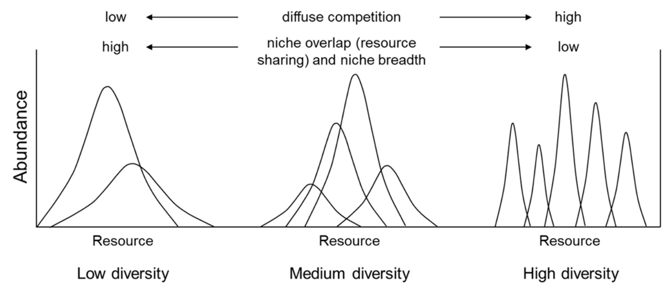

Figure 1: Caracteristics of niches along a resource gradient at different levels of species diversity, from Kim & Ohr (2020).

To quantify niche overlap, several indices have been developed since the 60’s. Indices and threshold values are commonly used for studying specific, taxonomic or phylogenetic diversity.

However, used alone, a result of diversity estimation through any index is usually poor and inaccurate, because complex and rich systems can not be described only by the result of a computation (Mejri 2009). Indeed, four of the best-known niche overlap indices, which are based on the intensity of utilisation of a resource use by species, were compared by Linton *et al.* (1981) to assess the precision and accuracy: Morisita (1959) updated by Horn (1966), Schoener (1968) and Pianka (1973). Even if they lead to the same general conclusions, these four indices often give different results, because they use different computation parameters (Blondel & Bourlière 1979). Moreover, they are often highly sensitive to sample size, which adds uncertainty when it comes to interpreting their values (Linton *et al.* 1981). Finally, Grossman (2009) points out that threshold values for those indices can be considered as arbitrary and might differ from one ecosystem to another, leading to an impossibility of comparing them. For all these reasons, using those indices to estimate if species share or not the same resources, and if so, how much is shared, does not seem relevant (Mouillot *et al.* 2005). As such, they provide a qualitative assessment of the overlap rather than a quantitative one (Linton *et al.* 1981).

Therefore, to understand how the structure and the dynamics of an ecosystem are defined and howsuchcomplexrelationshipscanlastforseveralgenerations, numericalmodelsareoftenused (see Ecopath models, [https://ecopath.org](https://ecopath.org/)). This approach requires a simplification of the ecosystem, because simulating very complex models make the outcome virtually impossible to compute (Albouy *et al.* 2011). Simplifying an ecosystem can be done in many ways: focusing on specific compartments of the ecosystem (*e.g*: pelagic or benthic fauna), grouping species based on their trophic level, or taxonomy or similaire behavior … Obviously, simplifying with any of these methods comes down to approximating the relationships and much of the complexity of an ecosystem, but if done properly, models are still able to produce reliable simulations of what is going on in real life (Albouy *et al.* 2011; Evans 2012; Piroddi *et al.* 2015). Yet, the main difficulty is to determine the criteria that are relevant to gather species and to simplify models. Whether they are too restrictive, or not enough, these criteria condition not only the accuracy of the model, but also its ability to be generalized (Moon *et al.* 2017; Pease *et al.* 2015; Pont *et al.* 2006). For instance, if a model uses a taxonomic grouping of species, it will only be suited to study other ecosystems that contain the ame set of species or taxonomic groups. Its transposition to other unrelated ecosystems will thus be limited, if not impossible (Moon *et al.* 2017). In the end, this modeling approach imposes a specific model for each ecosystem, which is highly time consuming and limits the possibilities of comparisons between ecosystems (Martini *et al.* 2020; Mcgill *et al.* 2006). Therefore, this approach remains very specific to a studied ecosystem and the species that compose it.

**4 Emergence of a more global approach based on functional traits.**

#### 4.1 General overview

Community ecology aim to establish general rules explaining the functioning of communities. Species-centred approaches only provide information for a few specific systems but not general principles, that can be applied to a wide variety of communities or ecosystems (Albouy *et al.* 2011; Martini *et al.* 2020). Therefore, ecologists had to find a way to study ecosystems, to (i) give clues of how species interacts with each other and (ii) to assess how strongly species are related to their environment. Indeed, some scientists emphasized the urge to get rid of methods that were highly dependent of species, time or space, such as the ones described previously, and to use a more predictable and quantitative science that could play a major role in assessing global changes issues (Brind’Amour *et al.* 2011; Mcgill *et al.* 2006; Olden & Jackson 2002). To this extend, Mcgill *et al.* (2006) define a **trait** as a “well-defined, measurable property of organisms, usually measured at the individual level and used comparatively across species” and suggest that community ecology should try to understand how these traits interact with fundamental niches to define realized niches. The notion of “trait” has been widely used in the literature, but with slightly different meanings. For instance, Violle *et al.* (2007) defined a trait as “any morphological, physiological or phenological feature measurable at the individual level, from cell to whole organism”. To ensure a consistent approach to community ecology studies, Martini *et al.* (2020) suggests that the definition of Violle *et al.* (2007) is precise enough, that it should serve as a reference and therefore should be used systematically. Yet, not all measurable traits provide the same information: for ecologists, traits that inform about (i) the interactions between species and the environment and (ii) the fitness of individuals are the most valuables (Kremer *et al.* 2017). These specific traits are defined as “functional traits” and can relate to behavior, life history, morphology or physiology, influencing the general performances of organisms Martini *et al.* (2020); Mcgill *et al.* (2006). They provide information on the main functions of organisms, such as acquisition of food or locomotion (Mejri 2009).

#### 4.2 Improvement of the method over the years

The functional-traits approach was first developed in studies based on terrestrial plants. They showed that the morphology of species was correlated with their environment and that changes in their habitat could lead to changes of their morphology because this approach relies on the plasticity of traits (Boissezon 2014; Lavorel *et al.* 1997; Martini *et al.* 2020). Applied to aquatic animals, structure-function relationship has been well documented since the 1970s (Gosline 1971; Lagler *et al.* 1977; Webb 1984) and approaches based on morphological traits seemed suitable to compare species (Norton 1995) or to explore niches and compare communities (Winemiller 1991). For instance, Albouy *et al.* (2011) developped a model to determine the diet of any marine species based on morphological traits, and thus establish trophic guilds. Yet, the model could not predict diet overlap nor resource partitionning among species, because of intrinsic variability in the diet of fish. Indeed, morphology alone is hardly a clue to determine diet, for generalist species are able to switch prey depending on which is more abundant, and they do not display specific morphological traits (Sibbing & Nagelkerke 2000). Moreoever, trophic level impacts how specialised a species can be in terms of diet: apex predators will often favor one feeding strategies among others, so they are very efficient for one strategy, and have limitating capacities in others. This principle can be summed up as a “trade-off strategy”: greater abilities for one strategy lead to a decrease of abilities in other areas Norton (1995), because of morphological specificities (Nagelkerke *et al.* 2018).

While the flexibility and intrinsic variabiliy of species should not be ignored, they can be hard to predict (Diderich 2006; Martini *et al.* 2020). It is therefore essential to identify and select relevant traits, that can be used to explain most interactions between species and their environment. This is one of the main challenges of the functional traits approach, because the selected traits must be sufficiently variable beteen the levels being compared (species, populations, individuals …), and the observed variations must explain the actual differences in fitness or coexistence of species (Kremer *et al.* 2017).

Yet, the flexibility in traits is what makes this approach so useful, as it allows for the quantification of intraspecific variability (especially when the environmental conditions change Martini *et al.* (2020)) and interspecific variability that explains the interactions between species and their environment. In a nutshell, the traits to be used for functional trait approach must offer the best compromise between being (i) sufficiently informative with respect to the objectives, (ii) generic enough to be comparable across species — even if they are very different morphologically — and (iii) easily measurable to ensure repeatability between studies (Dumay *et al.* 2004; Kremer *et al.* 2017).

### 5 The advent of functional diversity

The functional approach is relatively recent. It developed in the 1980s with the collapse of populations, species extinctions and the biodiversity crisis (Wilson *et al.* 1988). The functions performed by species began to be studied in greater depth when ecologists noticed that if a species disappeared from an ecosystem, it did not necessarily mean that the whole ecosystem was disturbed or even collapsed (Mejri 2009). The question “Are all species essential for the proper functioning of ecosystems?” became central, as did the need to define the role of species within ecosystems. In other words, can we consider that species are “redundant” if they play the same role, fulfill the same function, in an ecosystem? To answer these questions, the functional trait approach seems relevant because it provides information on the roles of species in their environment, which is complementary to those provided by classical diversity indices, such as specific diversity, richness distribution or evenness (Marcon 2015; Mejri 2009).

More importantly, functional traits and species role attribution are crucial in determining functional diversity, which is the primary factor explaining stability and productivity, and should therefore be preferred to specific or taxonomic diversity when studying community ecology (Dumay *et al.* 2004; Mejri 2009). In fact, the resilience and health of ecosystems depends much more on the range of functions and functional traits exhibited by species than on the number of species *per se* (i.e. species richness). Indeed, indices of specific abundance and diversity assume that all species are equivalent, and do not take into account the functions provided by these species (Mejri 2009). From this functional perspective, the richness of an ecosytem is determined by the extent of functional diversity provided by the species (Rocklin 2004).

To estimate functional diversity, species must first be classified into “functional groups”, which reflects the similarities of species according to 3 criteria. Within a functional group, species must (i) share the same habitat and trophic level (Brind’Amour *et al.* 2016), (ii) play a similar role in the habitat, through the functions they provide (Dumay *et al.* 2004; Mejri 2009), and (iii) display similar responses to changing environmental pressures (Brind’Amour *et al.* 2016; Dumay *et al.* 2004; Mejri 2009).

To form these groups and to evaluate the response of species for each of these 3 items, morphological traits are often used, because they reflect the capacities as well as their modes of interaction with their environment. They can therefore be used as indicators of trophic networks or habitats (Brind’Amour *et al.* 2016). Indeed, according to the “niche filtering hypothesis”, which considers habitat characteristics as filters, only species that with adapted traits can thrive in a specific set of environmental conditions (Brind’Amour *et al.* 2011; Zobel 1997). This assumption also means that species, if they share similar functional traits, must use the same resources, probably in the same way, and thus have overlapping niches. Conversely, if species have very different functional traits from each other, they probably use resources in very different ways, or even distinct resources. Quantifying the overlap between species is key to understand their coexistence or exclusion (Costa-Pereira *et al.* 2019).

#### 5.1 Benefits of this approach

Species in a same functional group can be considered “functionally equivalent”, with similar or interchangeable functions. The ecosystem in which they occur then has “functional redundancy”, which reduces the risk of a functional loss in the event of ecosystem disturbance. Conversely, a species can also be the only representative of a functional group (qualified as a

“monospecific group”). It is then considered “essential”, because if it disappears, the functions it provides will also disappear, causing a major disturbance of the ecosystem and other essential functions (Mejri 2009).

For conservation issues and the prediction of climate change impacts on ecosystems and biodiversity, the functional approach and the study of niche overlap seem relevant, as these tools provide a quantitative estimate of the resilience and/or resistance to change of communities and ecosystems. At a specific level, knowing which species have the most specialised diet or which are the species are essential, from a functional perspective, are really useful to target species that needs to be protected in conservation plans (Cooke *et al.* 2020; Mejri 2009; Norton 1995). In addition, those tools can also be used to predict changes in diet niche for species in competition, if one of the abundances is affected by fishing pressure (Diderich 2006) or if an invasive species colonizes the environment (Albouy *et al.* 2011; Geange *et al.* 2011; Nagelkerke *et al.* 2018). As these approaches are not based on species or taxonomy, they are better suited to the generalization and identification of the ecosystem services provided (Martini *et al.* 2020; Mcgill *et al.* 2006) and the relationships involved in stable coexistence of species (Albouy *et al.* 2011). They thus improve our ability to predict ecological dynamics and their fluctuations, in an environment facing strong anthropic influence (Kremer *et al.* 2017).

## Introduction

The deep ocean is the largest marine habitat of Earth, and represents 95% of ocean’s volume (Danovaro *et al.* 2017; Salazar *et al.* 2016; Webb *et al.* 2010). From a biology perspective, deepsea encompasses everything beneath euphotic (or epipelagial) zone, where the solar radiations are too low and precludes photosynthesis (Baker *et al.* 2020; Danovaro *et al.* 2017; Salazar *et al.* 2016) (Figure 2). Between 200 to 1000m deep (mesopelagic zone), light fades and temperature decreases, because solar luminance is absorbed exponentially in upper sea layers (Reynolds & Lutz 2001). From 1000 to 4000m deep (bathypelagic zone), no sunlight remains and the habitat is pitch-black; salinity and temperature are stable (between -1.8 to 2°C), and pressure keeps on increasing by 1 atm every 10m (Danovaro *et al.* 2017).

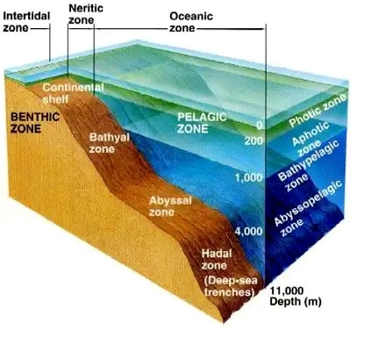

Figure 2: Sea layers along depth, from (fig 2018-06-17CDT19:13:06-05:00)

.

Despite these extreme conditions, deep-sea is far from being lifeless. In fact, deep-sea is considered to be the largest biome of the Earth, and contains 70% of ocean’s microbial cells and 60% of its heterotrophic activity, playing a crucial role in biogeochemical cycles (Salazar *et al.* 2016). Studies from Grassle & Maciolek (1992); Parkes *et al.* (1994); Todo *et al.* (2005) shown that life could be found everywhere in the deep-sea, with remarkably high and stable diversity. Moreover, these very particular conditions have resulted in a high specialization of the inhabiting fauna, with species that are absent from shallower waters (García-Seoane *et al.* 2021). With first studies launched in the 60’s, less that 0.0001% of the area has been investigated so far and this habitat remains understudied (Danovaro *et al.* 2017; Richards *et al.* 2019). Thus, deep-sea remains the most unknown biome of the planet with estimated 10 million species that are yet to discover (Danovaro *et al.* 2017; Grassle & Maciolek 1992). In particular, data are lacking to evaluate the impact of climate change on the biodiversity of the largest reservoir of biomass, mainly because exploring deep-sea is difficult and requires specific tools, such as rovers (Danovaro *et al.* 2008; Danovaro 2014). Firstly, deep-sea were regarded as a ore reservoir of its soil, where manganese and other metal deposits could be found and extracted, or even as a dumping site for nuclear wastes (Baker *et al.* 2020; Gillet 2013; Halfar & Fujita 2002). But since past decades, capacity of exploration of the deep-sea expanded spectacularly, allowing to discover more about the deep-sea ecosystems(Danovaro 2014).

In particular, continental margins, which separates continental shelf from abyssal plains are investigated, because their heterogeneous topography implies varied habitats and hydrodynamics, with impacts on the whole food webs (Danovaro *et al.* 2009; Fernandez-Arcaya *et al.* 2017). Along continental margins, deep-sea canyons, that incises the edges of continental shelf, appears to be “biodiversity hotspots” for pelagic life, in terms of diversity and abundance (Aïssi *et al.* 2012; Danovaro *et al.* 2009; Gillet 2013; Robertson *et al.* 2020). Caynons are also reported having a high level of endemism (Danovaro *et al.* 2009, 2017). Because they have a crucial role in transferring organic matter and sediments from rich and productive shallow shelf to the lownutrients deep-sea, canyons constitute peculiar habitats, with evidences of an important biomass and diversity inside and around them (Canals *et al.* 2006; Danovaro *et al.* 2009; De Leo 2012; Sion *et al.* 2019; Stefanescu *et al.* 1994). Indeed, canyons have higher nutrients concentrations than in adjacent areas, due to down-welling currents creating a funnel-effect (Fernandez-Arcaya *et al.* 2017). Thus, primary production is enhanced, and makes canyons favorable habitats for filters and suspension feeders (Fernandez-Arcaya *et al.* 2017; Sion *et al.* 2019), but also for low to medium trophic levels organisms, such as euphausiids, shrimps, squids and meso- and bathypelagic fishes (Aïssi *et al.* 2012; Gaskett *et al.* 2001; Pusch *et al.* 2004). Abundance of nutrients and preys attracts top predators (cetacean, sharks, large pelagic), some of them being only encountered in these habitats (Aïssi *et al.* 2012). Finally, canyons provides many ecological services and play a role in sustaining deep-sea food webs through the transport of nutrients, providing habitat for nursery and refuges (Fernandez-Arcaya *et al.* 2017). Company *et al.* (2008) suggests that by these services, canyons enhance recruitment of commercialized species, and thus, may mitigate the effect of their overexploitation. Therefore, canyons can be described as “keystone structures”, as an interface between productive continental shelf and deep-sea, with evidence of their benefits and supports for fisheries (Company *et al.* 2012; Fernandez-Arcaya *et al.* 2017).

Meso- and bathypelagic fishes are found abundantly in every ocean, except Arctic, and are the dominant zooplankton consumers in most oceans, playing a key role in trophic networks (Davison*etal.*2015;Salvanes&Kristoffersen2009). Livingbetween200-1000m(mesopelagic) and over 1000m (bathypelagic) deep, these deep-sea fishes displays very high biomass, estimatedtobearoundtenbilliontonnesintotal(García-Seoane*etal.*2021;Gjoesaeter&Kawaguchi 1980; Richards *et al.* 2019). Though, abundance of these fishes varies along depth and daytime, because most of them perform vertical diel migration to feed on shallower depth during night, and abundance’s estimation can be biased by sampling time (Catul *et al.* 2011; Gaskett *et al.* 2001; García-Seoane *et al.* 2021; Pusch *et al.* 2004; Salvanes & Kristoffersen 2009). Performing migrations, meso- and bathypelagic fishes ensure biogeochemical cycling through respiration and excretion but also when predated by carnivorous (García-Seoane *et al.* 2021; Spitz *et al.* 2019). Because of their ubiquity, their biomass and the high efficiency of energy transfer from phytoplankton (respiring 10% of the primary production), meso- and bathypelagic fish play an important part of the biological pump (García-Seoane *et al.* 2021; Spitz *et al.* 2019). Mesoand bathypelagic fish can show adaptations to their environment such as highly sensitive eyes, dark body and ventral light organs (photophores) to match their low-light habitat and reduced metabolic rates to lower oxygen consumption in poorly oxygenated waters (Salvanes & Kristoffersen 2009; Farré *et al.* 2016). Photophores have a role in camouflage, foraging, courtship behavior, with different patterns between males and females. They are also species specific which helps identification (Paitio *et al.* 2020; Salvanes & Kristoffersen 2009). Finally, depth and associated pressure play a role in the morphology of deep-sea fishes, which tend to have more elongated body with increasing depth, while manifesting an enlargement of the anterior body that increase gill surface and the ability to capture oxygen (Farré *et al.* 2016). Most of the life history traits of meso- and bathypelagic fish remains unknown and needs to be further investigated, with relatively poor and non consistent literature (Childress *et al.* 1980; Salvanes & Kristoffersen 2009). The mesopelagic communities are dominated by Myctophidae family, in terms of abundance, diversity and biomass, and represents at least 20% of the whole oceanic ichthyofauna (Catul *et al.* 2011; Kozlov 1995; Pusch *et al.* 2004).

Several studies focused on exploring deep-sea fish diversity near seamounts, mid-ocean ridges or in abyssal depths (Cook *et al.* 2013; Sutton *et al.* 2013), but very little is known about meso- and bathypelagic species inhabiting deep-sea canyons (Kenchington *et al.* 2020). Nevertheless, given the essential role of the oceanic pelagic fish community in food webs, linking the epipelagic organic matter to top predators, requires a better knowledge of species constituting this fundamental compartment (Davison *et al.* 2015; Gaskett *et al.* 2001). Furthermore, considering how important canyons are for fisheries and carbon sequestration, knowing more about the communities inhabiting them is crucial to ensure sustainability of ecosystems and provided services, through marine management and conservation (Fernandez-Arcaya *et al.* 2017; van den Beld *et al.* 2017b).

Located in the temperate North-east Atlantic Ocean, the Bay of Biscay’s continental shelf is highly productive, with nearly 700 fish species and 35% of the world total marine mammals identified in this region (Borja *et al.* 2019). This productivity relies on heavy rivers discharge and strong influence of eastward winds, tides and eddies (Borja *et al.* 2019; Akpınar *et al.* 2020). Thus, plankton, benthic and pelagic communities have been widely studied for several decades, with some fish communities being annualy monitored (Borja *et al.* 2019; Doray *et al.* 2018). Conversely, there is little knowledge on canyon, abyssal and bathyal communities in this area

(Borja *et al.* 2019). The continental slope of the Bay of Biscay divides in two the of France’s Atlantic EEZ (Exclusive Economic Zone) and is incised by about 135 canyons (Bourillet *et al.* 2006; Spitz *et al.* 2019; van den Beld *et al.* 2017a) (Figure 3). If proven to be rich in coldwater coral reefs, the largest part or the area remains poorly explored, especially deep-pelagic communities (García-Seoane *et al.* 2021; van den Beld *et al.* 2017b; Webb *et al.* 2010). In consequence, the similarity or differences within species inhabiting these ecosystems are unknown (Kenchington *et al.* 2020).

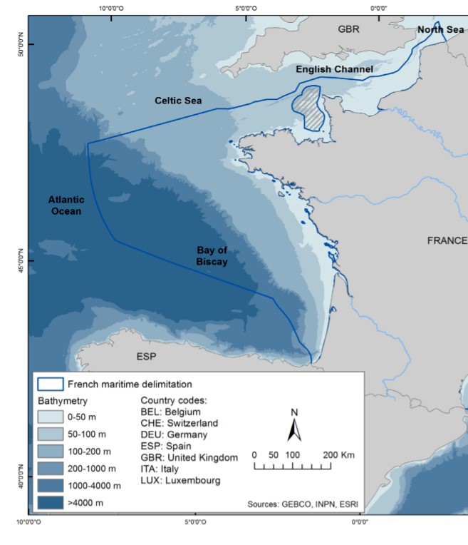

Figure 3: Location of the studied area, from (Béarez *et al.* 2017).

One way to characterize an ecosystem is to look at the factors that control biodiversity patterns and to identify the key functions provided by this ecosystem (Aneesh Kumar *et al.* 2017; Brind’Amour *et al.* 2011; Farré *et al.* 2016). Functional diversity, which is the value and range of functional traits displayed by the organisms of a given ecosystem, can inform on ecosystems functioning and about their resilience facing a change in the environment (Dumay *et al.* 2004; Martini *et al.* 2020). Moreover, the use of functional traits to characterize functional niches of species highlights some competition or adaptation processes within a communtinity of an ecosystem (Aneesh Kumar *et al.* 2017). Indeed, comparison of functional niches is an effective way of assessing ecological similarity of species, based on the way they share, or not, certain morphological, behavioral or physiological characteristics (Aneesh Kumar *et al.* 2017; Farré *et al.* 2016; Winemiller 1991).

This approach seems particularly well suited to study fish communities, because morphological traits are considered being good indicators of ecological habits of species, indicating how species use available resources (Farré *et al.* 2016; Winemiller 1991). Successfully applied for freshwater ecosystems and marine coastal environments, this approach has not been much used on deep-sea communities where functional traits shaping ecological niches remains mostly unknown (Aneesh Kumar *et al.* 2017; Farré *et al.* 2016). Conditions become more extreme and the food availability decreases with depth, so deep-sea are often thought to be poor in terms of functional diversity (Aneesh Kumar *et al.* 2017; Mason *et al.* 2008; Novotny 2018). This would mean that most (if not all) deep-sea species are generalists, and suggests that competition is highly probable to access the little food available .

Because species displaying the same functional niche can be considered as part of the same functional group, our hypothesis is that species occupying similar functional niches insure redundant function within an ecosystem and be in competition, whereas species displaying very different functional niches would be segregated. Hence, the aim of this work is to assess functional diversity of deep-sea canyons fish of the Bay of Biscay, which, for the moment, is barely known (Kenchington *et al.* 2020). Using functional traits to assess functional niches of species, our main objectives are (i) to characterize functional diversity of most-abundant canyon species, (ii) to measure the range and degree of overlap of functional niches and (iii) to identify the traits that structure the most these communities.

## Materials & Methods

### 1 Sampling and specimens

Fishes were collected during Ifremer’s EVHOE (EValuation Halieutique de l’Ouest Européen) research cruises, surveying the Bay of Biscay every fall onboard the *R/V Thalassa*. Several hauls are regularly performed at night to investigate pelagic deep fauna. Each station is precisely defined with its GPS coordinates and located above canyons, at the edge of continental shelf. Pelagic trawling is performed during night, between 700 and 2000 meters, because those fishes perform diel vertical migrations and tends to come closer to the surface at nighttime. To this end, 25 meters-wide opening trawl is used, with as mesh size decreasing from 76mm to 48mm at the end of the trawl. The trawl-haul duration was 1 hour at 4 kn. Once the trawl is pulled back onboard, fishes are sorted, identified, up to species, and frozen at -20°C. Eleven of the most abundant species in the Bay of Biscay have been selected for this study. All teleost, four of them belong to the Myctophid family (lanternfish), which is the most abundant and widely spread family across all oceans (de Busserolles *et al.* 2014) and could represent up to 65% of the pelagic deep-sea biomass (Poulsen *et al.* 2013): *Lampanyctus crocodilus*, *Myctophum punctatum*, *Notoscopelus kroeyeri* and *Ceratoscopelus maderensis*. The second most represented family is the Platytroctidae with two species: *Searsia koefoedi* & *Normichthys operosus*. This family seems to be found in all oceans but not in Mediterranean Sea (Orrell & Hartel 2016). Finally, five families are represented by one species each: *Xenodermichthys copei* (Alepocephalidae); *Arctozenus risso* (Paralepididae), *Argyropelecus olfersii* (Sternoptychidae - Hatchetfishes), *Serrivomer beanii* (Serrivomeridae) and *Stomias boa* (Stomiidae) which are common species, found abundantly in every ocean (Carvalho & Almeida 1988; Froese & Pauly 2019; Geidner 2008; Germain *et al.* 2019). See A.1 for phylogenetic tree of studied species.

### 2 Morphological measurements and functional traits

In lab, fish were thaw and 24 morphological measurements were taken on individuals, using an electronic caliper with a precision up to 0.01mm. Part of these measurements had previously been taken by students from La Rochelle University during practictal class from 2018 (*n=99*), 2019 (*n=45*), 2020 (*n=9*) and the rest during this study (*n=212*). For the sake of statistical robustness and representativity, at least 25 individuals were measured for each species (Table

1).

Table 1: Number of individuals measured for each species, with their mean size and range values

|  |  |  |  |  |  |
| --- | --- | --- | --- | --- | --- |
| Species | Previous measurements from students | Data acquired during this study | Total | Mean standard length (mm) | Size range (mm) |
| Lampanyctus crocodilus | 39 | 0 | 39 | 107.60 | 73.3 - 146.5 |
| Xenodermichthys copei | 38 | 0 | 38 | 109.68 | 82.3 - 132 |
| Normichthys operosus | 0 | 38 | 38 | 104.69 | 75.64 - 131.62 |
| Argyropelecus olfersii | 37 | 0 | 37 | 56.55 | 32.16 - 89.07 |
| Notoscopelus kroyeri | 6 | 30 | 36 | 76.30 | 52.63 - 130.84 |
| Searsia koefoedi | 5 | 31 | 36 | 119.94 | 84.8 - 142.75 |
| Arctozenus risso | 20 | 10 | 30 | 158.36 | 117.6 - 181.31 |
| Serrivomer beanii | 0 | 30 | 30 | 546.17 | 373 - 879 |
| Ceratoscopelus maderensis | 0 | 30 | 30 | 62.72 | 53.29 - 78.95 |
| Stomias boa | 0 | 26 | 26 | 239.00 | 144 - 311 |
| Myctophum punctatum | 8 | 17 | 25 | 65.48 | 52.53 - 80.14 |

Following what had been made on similar studies and according to our measurements, a total of 21 functional traits were calculated from morphological measurements and informs on 3 main functions: food acquisition, locomotion and habitat (see Table 2).

### 3 Data analysis

All data analysis were performed using R version 4.0.3 R Core Team (2021).

Table2:

Descriptionandformulasofthefunctionalstraitscomputedfrommorphologicalmeasurements,following(

Albouy

*etal.*

2011

;

AneeshKu-

mar

*etal.*

2017

;

Boyle&Horn

2006

;

Brind’Amour

*etal.*

2016

;

Diderich

2006

;

Dumay

*etal.*

2004

;

Habib

*etal.*

2019

;

Ibañez

*etal.*

2007

;

Sibbing

&Nagelkerke

2000

;

Webb

1984

;

Winemiller

1991

)

.Abbreviationsusedinformulasareprovidedbyrawmeasurementsanddetailedinappendices

A.2

,

A.3

&

A.4

.OGA,GIT,PC,PHTarecategorialvariablesdirectlyprovidedbyrawmeasurementswithfirsttwoscoresdetailedrespectivelyin

appendices

A.5

&

A.6

.

**Function**

Functionaltrait

Description

FORMULA

**Feeding**

Oralgapeaxis

Feedingpositionanddepthinthewatercolumn

OGA

Eyesize

Detectionofpreysandvisualacuityforpredators

ED/HD

Orbitallength

Preyssizeandbehavior(buried,camouflaged)

ED/SL

OralgapesurfaceTypeandsizeofpreys

MW*MD/BW*BD

Oralgapeshape

Strategytocaptureprey

MD/MW

OralgapepositionFeddingpositioninthewatercolumn

MO/HD

LowerjawlengthCompromisebetweenpowerandopeningspeedofthemouth

LJL/SL

Gillrakertype

Filtrationcapacitiesoffish

GIT

Gilloutflow

Succioncapacitiesoffish

OW

Headlength

Maximumpreysize

HL/SL

Pyloriccaeca

Presence/Absenceofpyloriccaeca

PC

Anusposition

Digestivetractlength

PAL/SL

**Locomotion**

Bodydepth

SwimmingcapacitiesoffishlinkedtotheirfoodprospectionbehaviorBD/SL

PectoralfinpositionManeuvrabilityoffish

PFI/PFB

PectoralfininsertionManeuvrabilityoffish

PPL/SL

TransversalshapePositioninthewatercolumnandhydrodynamism

BD/BW

CaudalthrottlewidthSwimmingstrategy(cruiser/sprinter)andendurance

CPD

DorsalfininsertionSwimmingtypeandbehavior

PDL/SL

**Habitat**

Eyeposition

Positioninthewatercolumn(pelagic/sedentary)

EH/HD

PresencephotophoresPresence/Absenceofphotophores(chercheràquoiçasert)

PHT

OperculumvolumeFilteringcapacityandoxygencaptation

OD/OW

#### 3.1 Data pre-processing

Because measurements came from several observers, raw data had to be checked for outliers.

To do so, all values (except SL) were standardized by SL to get rid and the interquartile range

(IQR) method of outlier detection was applied to remove outliers. According to this method, for each variable (measurement) and for each species, outliers are defined as every value outside this interval:

[*Q*1 − 1*.*5 ∗ *QR,Q*3 + 1*.*5 ∗ *IQR*]

with *Q*1 and *Q*[1] being respectively first and third quartile, *IQR* = *Q*3 − *Q*1.

Missing values that were previously present in the data set (*n=52*) and those induced by outlier removal function (*n=307*), are then imputed following k-Nearest Neighbor (kNN) method. Based on non-missing values points, kNN algorithm computes Euclidian distances between points, and assumes that missing value can be approximated by the values of points that are the closest. To this end *tidymodels* R package and *step_knnimpute* function (Kuhn & Wickham

2020) were used, with a number of nearest neighbors (*k*) of √*N*, with *N* being the number of observations, i.e individuals, of the dataset. Accuracy was then checked with linear regression of each variable with SL. From this cleaned dataset, functional traits were computed using formulas in Table 2.

### 4 Functional niche analysis

Coordinates of projected points in the FAMD factorial first and second dimensions were used to compute functional niche surfaces and ellipse overlap. This analysis was only run on the two first PC, because they are the one carrying the more information on the community’s structure. Our process being similar to isotopic niche analysis, which is much more documented, we used *Stable Isotope Bayesian Ellispes in R* (SIBER) package and adapted it to our purpose (Jackson *et al.* 2011). Species pair-comparisons were performed, for which both ellipse surface and overlap between ellipses were computed using *maxLikeOverlap* function. Absolute niche surfaces were then standardized by the smallest niche, to give relative difference in size niches. Relative overlap was assess by dividing the overlap value by the size of niche, for both species compared. Finally, total overlap was determined by dividing the overlap value by the sum of both compared species niche surface. Niche surface was also estimated for various sample size (*n*), with bootstraped method. To this end, 100 to 10000 individuals of our data set were randomly sampled, and niche’s surface was computed. This process has been repeated 10000 times.

Functional niches were further investigated using *funrar* R package, to compute functional rarity (Matthias Grenié *et al.* 2017). Based on Violle *et al.* (2017) indices characterizing rarity of functions within a system, the aim is to assess local functional diversity of traits in our dataset. To this end, we first computed a distance matrix, using Gower’s distance as it can deal with both quantitatives and qualitatives variables (Brind’Amour *et al.* 2016; Matthias Grenié *et al.* 2017). On this matrix was applied *distinctiveness global* function, that measures how functionnally rare a species is, comparing to other species of the community. Distinctiveness results range from 0 to 1 (where the species is, locally, functionnally distant/different from the other) (Matthias Grenié *et al.* 2017).

### 5 Kernel density estimation

In case of niche overlapping, it is interesting to detail the traits that are most similar between species. To this end, we used (Mouillot *et al.* 2005) parametric kernel density function, which has been used in a similar context by Aneesh Kumar *et al.* (2017). Along a trait axis, the function returns the overlap value between *N* overlapping species, ranging from 0 (no overlap) to 1 (*N* species have identical densities).

## Results

### 1 Factorial Analysis of Mixed Data

The first 5 FAMD components explained 80% of the total variation (Table 3). The first principal component (PC1) (30.5% of explained variance) is strongly correlated with shape of the body and of the head with traits such as *body depth* (a = 11.7), *lower jaw length* (a=11.5), *oral gape axis* (a=11.1), orbital length (a = 8.35) and head length (a = 8.21), thus, mostly to feeding and locomotion (Table 3). Along this horizontal axis, all traits have increasing values toward the right, mouth orientation shifting upward (Figure A.7 for details). Three groups of fish can be distinguished 4. For low PC1 values, species have a low transversal shape (meaning that both BD and BW have similar values, consistent with an elongated body), short lower jaw, small oral gape surface and a terminal oral axis, such as *A. risso*, *S. boa* and *S. beanii*. On the right of this axis, species display high body depth values suggesting a laterally compressed form and a superior-oriented oral axis, such as *A. olfersii*.

The second axis (21.6% of explained variance) is correlated to feeding behavior, through food prospection with *pectoral fin insertion* (a = 11.4), *eye size* (a = 9), *pectoral fin position* (a =

7.1) and food acquisition through *gill raker type* (a = 17.8) and *oral gape axis* (a = 12,3) (Table 3). This vertical axis separates the three species on the left, *A. risso* and *S. boa* display higher values of pectoral fin insertion, meaning that the fin is inserted further on the body than *S. boa*, while the fin position on the body depth is lower. As *S. beanii* does not have pectoral fin, same analysis has been run without traits referring to pectoral or pelvic fins to look and confirmed the discrimination between these species were highly dependant if these traits. Same results than Figure 4 were obtained.

The third axis (explaining 12.2% of total variance) mainly carries traits linked to the foraging and swimming behavior, with strong influence of *anus position* (a = 23.8), *gill raker type* (a = 19.2), *dorsal fin insertion* (a = 15.5) and *pectoral fin position* (a = 14.2) (Table 3). On the left of this horizontal axis, species are characterized by a rather high pectoral fin insertion and close-to-head dorsal fin insertion and anus position (Figures 5 and A.8). Finally, the fourth axis (explaining 7.9% of variance) is mainly related to feeding and habitat traits, with *pyloric caeca* (a = 31.6), *operculum volume* (a = 17) and *presence of photophores* (a = 10.9) (Table 3). Because *X. copei* is the only species having pyloric caeca, this variable clearly separates that species from the other, on the PC4 axis. The remaining PC scores (20% of variance) are mainly linked to food acquisition. Overall, FAMD analysis detects similarities between species niches’,

with ellipses overlapping. Conversely, some species are well segregated along these first four axis, suggesting the existence of several functional groups within studied community.

Because PC1 and PC2 have most of the weight in the functional analysis, it suggests that the traits they carry are the most relevant to segregate species. In particular, *lower jaw length*, *body depth*, *pectoral fin insertion* and *eye size* are the quantitative traits that are the most distinct among species and helps to distinguish them. As for qualitative variables, it seems that *oral gape axis* and *gill raker type* are the one which separates the most species. This makes sense considering they have the most modalities, allowing a more precise description than binaries *presence of photophores* and *pyloric caeca* scores.

Table 3: Correlation between 5 first PC’s and functional traits. In bold, correlations higher than threshold (4.8).

|  |  |  |  |  |  |  |
| --- | --- | --- | --- | --- | --- | --- |
| **Function** | Trait | PC1 (30.5%) | PC2 (21.6%) | PC3 (12.2%) | PC4 (7.9%) | PC5 (7.8%) |
| **Feeding** | Oral gape axis  Eye size  Orbital length  Oral gape surface  Oral gape shape  Oral gape position  Lower jaw length | **11.07**  1.29 **8.35 7.78** 0.18 0.42  **11.52** | **12.28**  **9.01** 2.38 3.06 3.10 1.21  0.00 | 3.32 3.52 0.00 2.93 0.05 1.99  0.04 | 3.27 4.08 2.24 0.10 **9.49 9.16**  1.97 | **7.13** 1.40 4.54 2.78  **10.41**  3.94  2.44 |
|  | Gill raker type | 4.38 | **17.80** | **19.23** | 0.32 | 3.42 |
|  | Gill outflow | **5.47** | 0.82 | 0.02 | 2.22 | **22.48** |
|  | Head length | **8.21** | 3.10 | 2.50 | 0.78 | 4.50 |
|  | Pyloric caeca | 0.23 | 0.48 | 0.04 | **31.62** | **5.81** |
|  | Anus position | 0.00 | **5.28** | **23.81** | 0.07 | 0.77 |
| **Locomotion** | Body depth  Pectoral fin position  Pectoral fin insertion Transversal shape | **11.68**  1.72 **4.95**  **5.96** | 0.93 **7.15**  **11.39**  4.33 | 1.41  **14.22**  0.05  5.45 | 0.64  0.37 0.12  1.70 | 1.92 0.32 0.74  2.10 |
|  | Caudal throttle width | 3.72 | **5.01** | 0.28 | 1.60 | **16.30** |
|  | Dorsal fin insertion | 2.58 | 4.78 | **15.52** | 0.00 | 1.33 |
| **Habitat** | Eye position  Presence photophores | 0.19 **7.79** | **5.41** 2.45 | 0.78  3.23 | 2.34  **10.89** | 1.40  0.59 |
|  | Operculum volume | 2.52 | 0.03 | 1.61 | **17.02** | **5.68** |

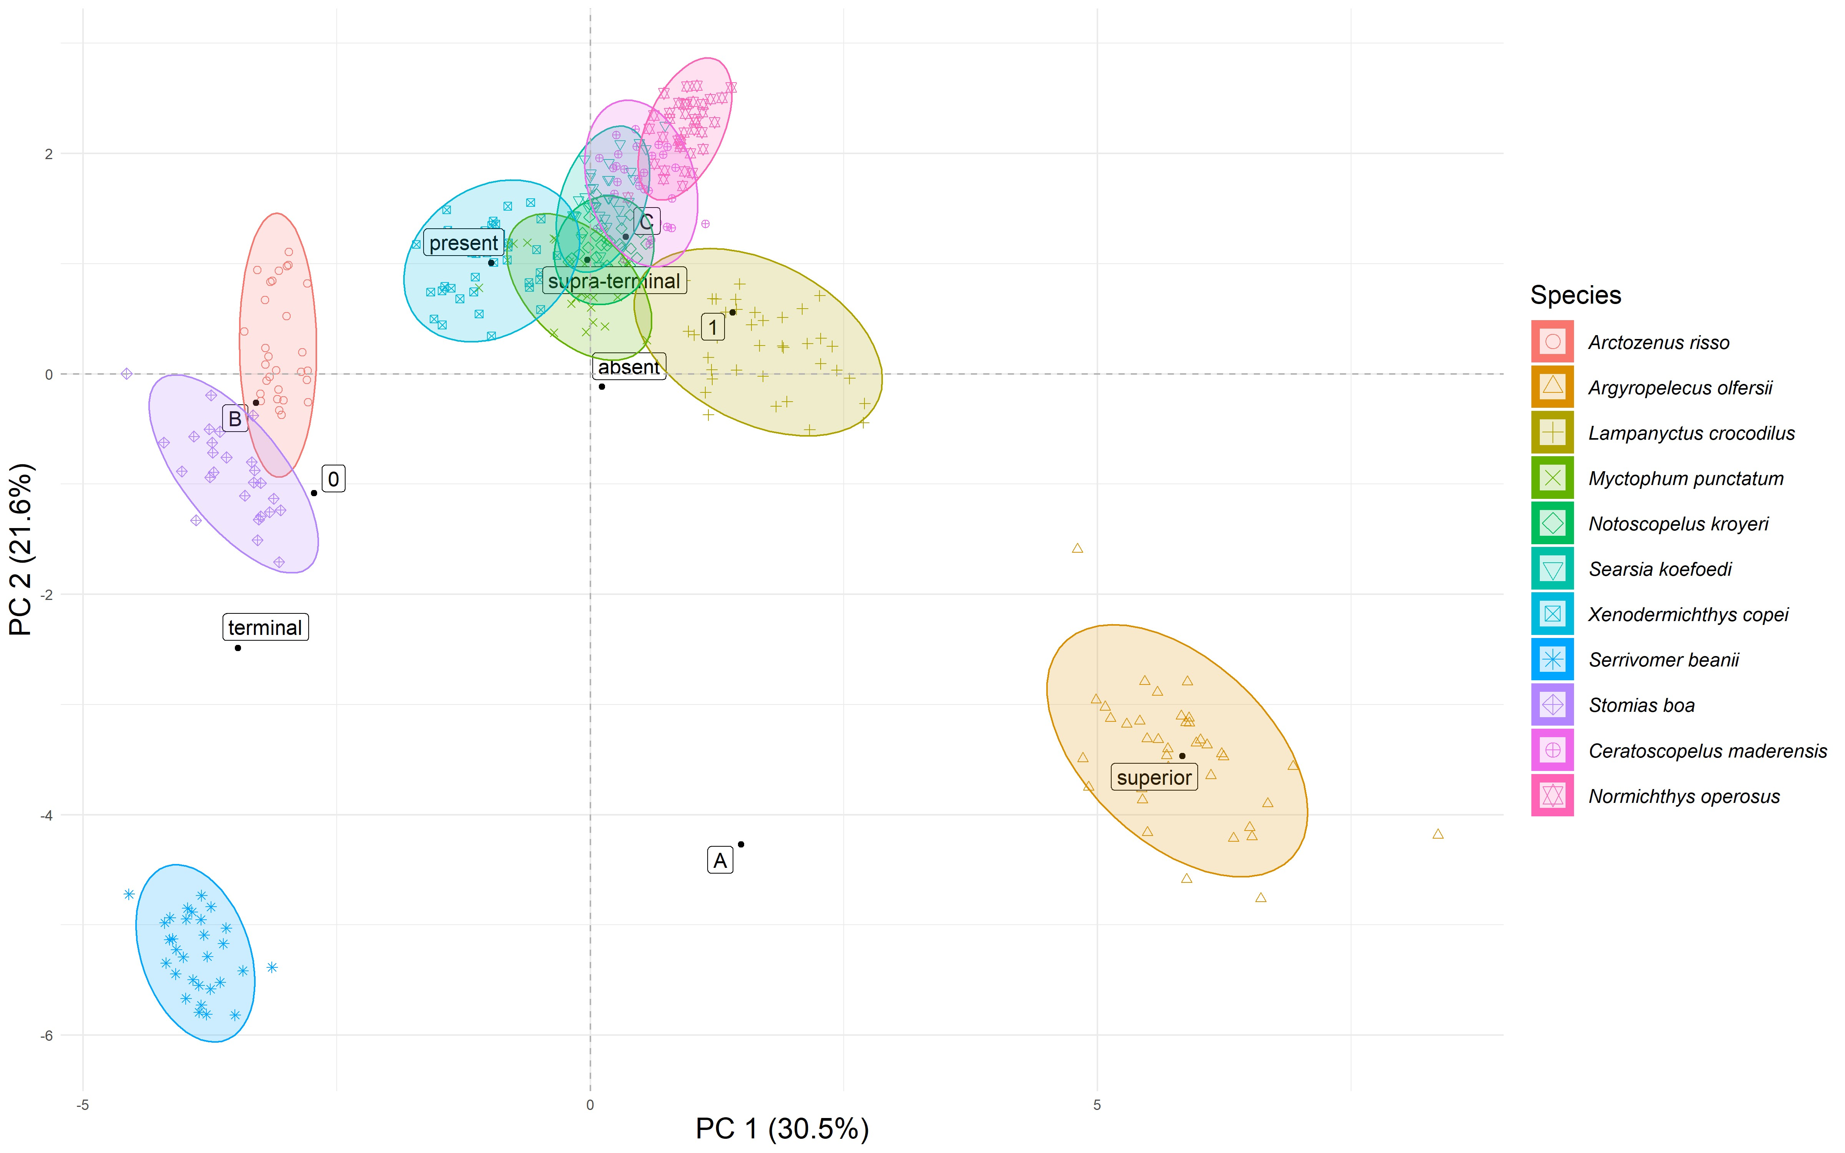

Figure 4: FAMD results for PC 1 and 2.

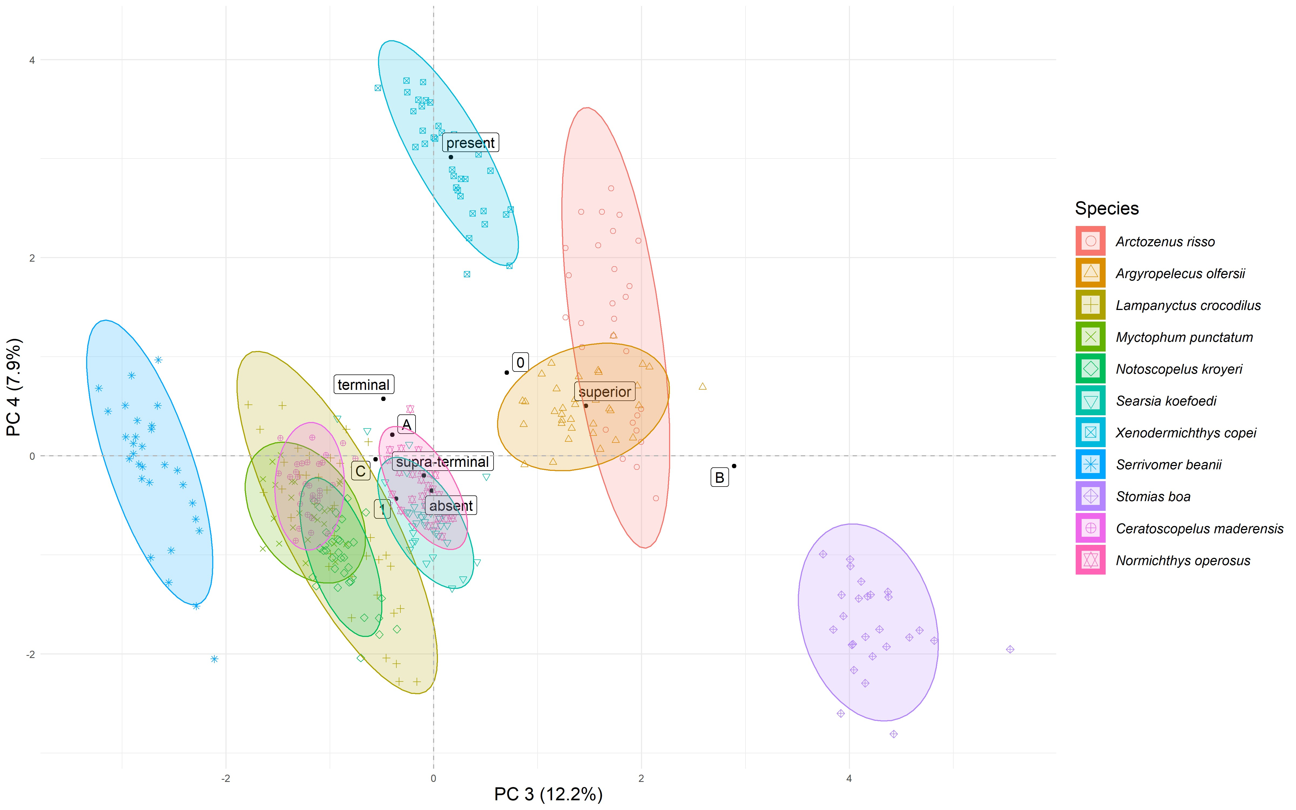

Figure 5: FAMD results for PC 3 and 4.

### 2 Functional niche surface and overlap

Overall, several species’ ellipses overlaps on these first four principal components (Figures 4 and 5). For these species, the aim is now to measure the intensity of these overlaps. On the first and second principal components, all 4 Myctophidae and 2 Platytroctidae species, plus *X. copei* are more or less overlapping, not displaying much differences along PC1 nor PC2 (Figure 4). *A. risso* and *S. boa* seems to slightly overlap each other niches, which are mainly separated along PC2 (Figure 4). *S. beanii* and *A. olfersii* are the only two species not showing any overlap. *A. risso* and *A. olfersii* are showing some overlap (Figure 5). On the same figure, the same species (except *X. copei*) than Figure 4 overlaps. Especially, *N. operosus* and *S. koefoedi* have very similar looking niches, which seems virtually fully overlapping. *L. crocodilus*, which have the widest niche among these species, overlaps *C. maderensis*, *M. punctatum* and *N. kroyeri*’s niches.

The niche surface estimation showed that *N. kroyeri* had the narrowest niche among the studied community, followed by *N. operosus* and *S. koeofedi* (Table 4). Then, *C. maderensis*, *A. risso*, *S. beanii* and *M. punctatum*, *S. boa* and *X. copei* all have niches almost two to three times wider than *N. kroyeri*’s. Finally, comparing to *N. kroyeri*’s niche, *L. crocodilus*’s is four time wider, while *A. olfersii*’s is more than seven time wider. In fact, all Myctophidae (except *L.*

*crocodilus*) and Platytroctidae have rather small niches and are the one overlapping in Figure 4.

Bootsrapped niche surface estimation did not show any difference in the surface of estimated niche through sample size *n*. Hence, surface of niches seems to be more influenced by the trait variability of the sampled individuals rather than the number of inviduals itself. Yet, estimated niche surface value are tightly converging for *n* = 30.

Table 4: Standardized surface of functional niches.

Species Relative surface

Argyropelecus olfersii 7.4

Lampanyctus crocodilus 4.0

Xenodermichthys copei 2.6

Stomias boa 2.5

Myctophum punctatum 2.1

Serrivomer beanii 1.9

Arctozenus risso 1.8

Ceratoscopelus maderensis 1.7

Searsia koefoedi 1.3

Normichthys operosus 1.2

Notoscopelus kroyeri 1.0

Niche overlap analysis confirms that 9 species show overlapping niches with at least one other species (Figure 4) and that smallest niches overlaps each other the most (Table 5). The maximum overlap is found between *M. punctatum* and *N. kroyeri*, as almost 69% of the latter’s niche is covered by the first. In total, these two species share 22% of their niches. *S. koefoedi* is sharing more than 28% of its niche with both *C. maderensis* and *N. kroyeri*, which are the two highest total overlap values here (Table 5). Overall, *N. kroyeri*’s niche is fully overlapped by six other species. *C. maderensis*, *S. koefoedi* and *M. punctatum* are overlapping five other species. Finally, *L. crocodilus*, *X. copei* and *N. operosus* are involved in overlap with three other species, and *A. risso* and *S. boa* are only overlapping each other (Table 5). Finally, *N. kroyeri* and *N. operosus* show minimum total overlap value of 0.2%. This is due to some individuals of the latter in *N. kroyeri*’s ellipse (Figure 4).

Table 5: Species’ ellipses overlap. All the others comparisons that are not present in this table did not present any overlap.

|  |  |  |  |  |
| --- | --- | --- | --- | --- |
| Species1 | Species2 | Total overlap (%) | Overlap of Species 2 over Species 1 (%) | Overlap of Species 1 over Species 2 (%) |
| Searsia koefoedi | Ceratoscopelus maderensis | 28.20 | 65.40 | 49.60 |
| Notoscopelus kroyeri | Searsia koefoedi | 28.10 | 65.40 | 49.20 |
| Myctophum punctatum | Notoscopelus kroyeri | 22.00 | 32.30 | 68.70 |
| Myctophum punctatum | Xenodermichthys copei | 20.20 | 44.90 | 36.60 |
| Ceratoscopelus maderensis | Normichthys operosus | 19.00 | 31.80 | 47.10 |
| Notoscopelus kroyeri | Ceratoscopelus maderensis | 15.10 | 41.60 | 23.70 |
| Myctophum punctatum | Searsia koefoedi | 12.50 | 20.30 | 32.40 |
| Searsia koefoedi | Normichthys operosus | 7.90 | 15.00 | 16.90 |
| Notoscopelus kroyeri | Xenodermichthys copei | 6.40 | 22.90 | 8.80 |
| Searsia koefoedi | Xenodermichthys copei | 5.90 | 17.50 | 8.90 |
| Lampanyctus crocodilus | Myctophum punctatum | 4.20 | 6.50 | 12.20 |
| Arctozenus risso | Stomias boa | 3.90 | 9.40 | 6.60 |
| Myctophum punctatum | Ceratoscopelus maderensis | 3.20 | 5.80 | 7.00 |
| Lampanyctus crocodilus | Ceratoscopelus maderensis | 1.70 | 2.50 | 5.70 |
| Lampanyctus crocodilus | Notoscopelus kroyeri | 1.00 | 1.20 | 4.80 |
| Notoscopelus kroyeri | Normichthys operosus | 0.20 | 0.50 | 0.40 |

Niches distinctiveness informs on functional diversity of species within a community, increasing values meaning that, locally, species display rarer functions. Here, Myctophidae and Playtroctidae families are all equally functionnally distinct from one another (Table 6). Even if the values are rather close, *S. koefoedi* and *M. punctatum* seems to be the most alike species. Conversely, *A. olfersii*, *S. beanii* and *S. boa* tend to have more distinct niches, which are consistent with previous results (Figure 4). Here, species with the most atypical morphological feature are the more distinct in terms of niche.

Table 6: Niche dissimilarity of studied species

|  |  |
| --- | --- |
| Species | Distinctiveness value |
| Argyropelecus olfersii | 0.54 |
| Serrivomer beanii | 0.51 |
| Stomias boa | 0.46 |
| Arctozenus risso | 0.40 |
| Lampanyctus crocodilus | 0.37 |
| Xenodermichthys copei | 0.37 |
| Ceratoscopelus maderensis | 0.31 |
| Normichthys operosus | 0.31 |
| Notoscopelus kroyeri | 0.30 |
| Searsia koefoedi | 0.29 |
| Myctophum punctatum | 0.29 |

### 3 Kernel density estimation

Kernel density estimation helps to understand which are the traits that have the same distributions for species. Looking at these distributions for overlapping species gives informations on traits, and thus, functions similarities among species. The estimation of kernel density for the

7 overlapping species shows that these species are overlapping for 7 of the 17 computed traits (Figure 6; Table 7). The overlap is maximum for *oral gape position* (trait n°5) with an overlap value of 0.34. This means that, along this functional trait, these 6 species share nearly 34% of the trait density distribution. For this trait, most of the distributions are centered around a range of values of [0.5-0.8], yet *L. crocodilus* display a pretty wide distribution, despite being the most sampled species (Table 1). This same observation can be done for this particular species for *body depth* (trait n°11) and *pectoral fin insertion* (trait n°13). Species also share nearly 25% and 29% of their density when looking at *body depth* (trait n°11) and*eye position* (trait n°17), respectively. Finally, *lower jaw length* (trait n°6) and *pectoral fin position* (trait n°12) values also seem to be common to those species, with 16% and 19% of density shared, respectively. To a lesser extent, species share nearly 12% of the *eye size* values (trait n°2).

Furthermore, we can notice that *oral gape surface* (trait n°3), *operculum volume* (trait n°8) and *pectoral fin insertion* (trait n°13) display bimodal distributions (Figure 6. For these traits, *L. crocodilus*, *N. operosus* and *S. koefoedi* constitutes one mode, and the resting species the other. Conversely, *eye size* (trait n°1) shows multimodal distribution, with nearly every species having its proper mode.

For most traits, *N. kroyeri* (green) and *M. punctatum* (blue) have very similar distributions

(6). When looking at these two species only, analysis show that they are overlapping for every 17 traits, with particularly high values for *eye size* (o = 0.915), *operculum volume* (o = 0.901), *gill outflow* (o = 0.882), *pectoral fin insertion* (o = 0.828) and *caudal throttle width* (o = 0.782),

with the mean overlap of the 17 traits being *o*¯ = 0.561.

Table 7: Kernel density overlap values for the 17 computed traits for the seven overlapping species. Values in bold are significant (p < 0.01) and shown in Figure 6.

|  |  |  |
| --- | --- | --- |
| Trait code | Functional trait | Total overlap (o) |
| 1 | Eye size | 0.00 |
| 2 | Orbital length | **0.12** |
| 3 | Oral gape surface | 0.00 |
| 4 | Oral gape shape | 0.00 |
| 5 | Oral gape position | **0.34** |
| 6 | Lower jaw length | **0.16** |
| 7 | Gill outflow | 0.00 |
| 8 | Operculum volume | 0.00 |
| 9 | Head length | 0.00 |
| 10 | Anus position | 0.00 |
| 11 | Body depth | **0.25** |
| 12 | Pectoral fin position | **0.20** |
| 13 | Pectoral fin insertion | **0.01** |
| 14 | Transversal shape | 0.00 |
| 15 | Caudal throttle width | 0.00 |
| 16 | Dorsal fin insertion | 0.00 |
| 17 | Eye position | **0.29** |

## Discussion

The results of our study provide evidence of both segregation and overlap of functional niches within the deep-sea fish community inhabiting canyons of the Bay of Biscay. Specifically, differences among species were primarily shaped by traits referring to body and head morphology and by foraging related traits, which also give information on their habitat (Schoenfuss & Blob 2007). Most of the detected overlap is found between some Myctophidae, Platytroctidae and Alepocephalidae species. However, the overlap appeared to be higher between families rather than within families. Species with the most atypical morphology (*i.e A. risso*, *A. olfersii*, *S. beanii* and *S. boa*) have clearly distinct niches and showed null/low overlap within the community. These results reveals that the most common species of deep-sea communities of the Bay of Biscay show a relatively high functional diversity and several degree of segregation. This supports the hypothesis of a high partitioning of resources in these ecosystems and promotes coexistence of species, which might be essentially driven by food resources, but

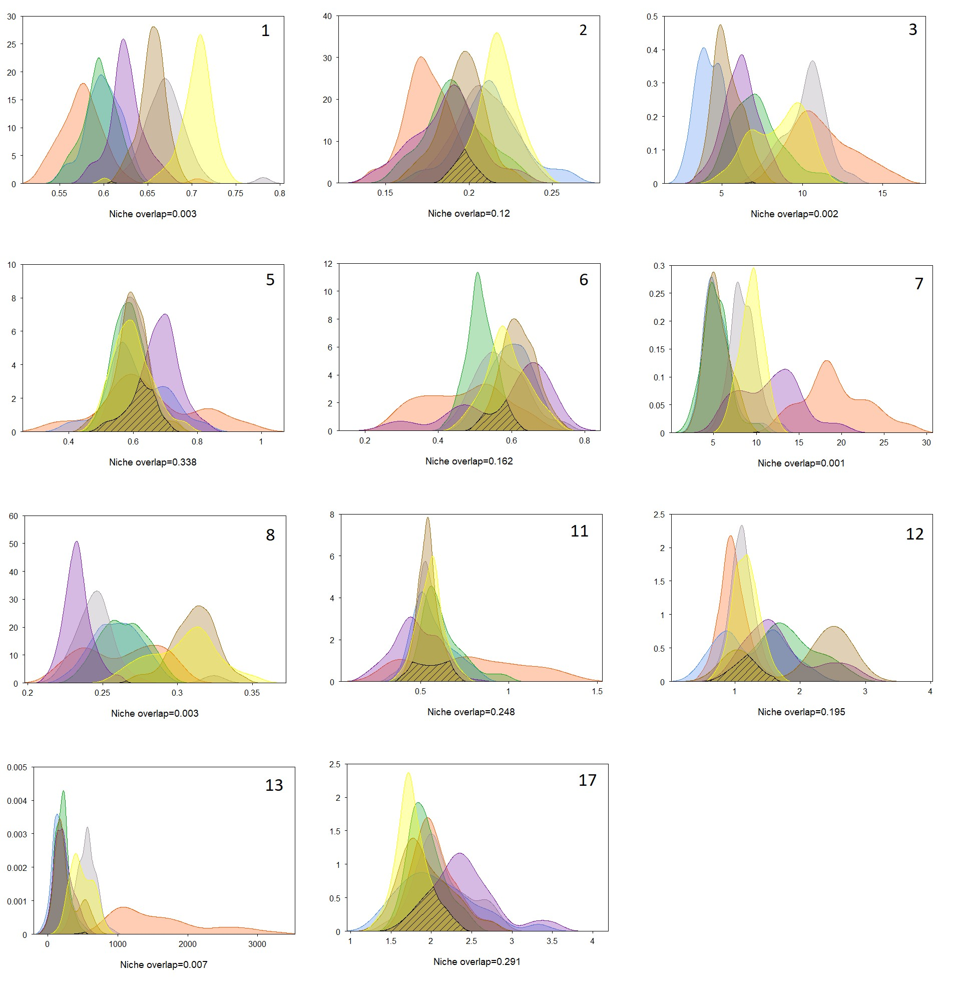

Figure 6: Kernel density overlap for 11 functional traits and the overlaping species. Colors correspond to following species: orange - *L. crocodilus*; brown - *C. maderensis*; yellow - *N. operosus*; purple - *X. copei*; green - *N. kroyeri*; blue - *M. punctatum*; grey - *S. koefoedi*. Overlap is represented by shaded lines. Here, are displayed every traits that showed non-null overlap.

also swimming abilities (Aneesh Kumar *et al.* 2017; Preciado *et al.* 2017).

NSuch difference could explain a part of trait variability and even

In this study, the relationship between species functional traits and environmental (bioticorabiotic) parameters were not investigated. In an ecosystem, species interact also with their environment. Whether it shapes the habitat or define availability of resource breadth, environment is influencing realized niche (Costa-Pereira *et al.* 2019; Ibañez *et al.* 2007; Kremer *et al.* 2017). Adding these parameters in future studies could potentially allow to associate the different niches to particular environmental characteristics, as well as investigate site influence. Because traits are morphological responses to environmental constraints, their interpretation could vary from one context to another, making it hard to extract the main drivers of trait variation. (Kremer *et al.* 2017). Comparing communities living in different sites is relevant to link some functional traits with habitat particularities thus assess how environment influence functional niches (Mejri 2009). In a context of climate change, studying this relationship is important to predict how disturbances of the habitat could affect fish communities (Brind’Amour *et al.* 2011).

~~Similarly, potential seasonal effect on functional traits was not assessed. Because plankton diversity and abundance is varying with seasons, species that directly relies on this resource as theirmainfoodresourcemightexpressseasonalpatternsintheirfood-relatedtraits(Kremer~~*~~etal.~~* ~~2017).~~

~~Previous studies showed that functional niche overlap and species abundances were linked~~

~~(Aneesh Kumar~~ *~~et al.~~* ~~2017; Mason~~ *~~et al.~~* ~~2008). More precisely, the most abundant species of an ecosystem tend to be functionally separated from the others (Farré~~ *~~et al.~~* ~~2016). For Bay of Biscay’s canyons specifically, no studies assessing the species diversity and abundance were found. Looking at literature from other studies meso- and bathypelagic communities give divergent results. For García-Seoane~~ *~~et al.~~* ~~(2021) and Kenchington~~ *~~et al.~~* ~~(2020), deep-sea pelagic fish assemblages are dominated by Gonostomatidae (famility not studied here), Eduardo~~ *~~et al.~~* ~~(2020) considers Sternoptychidae (family of~~ *~~A. olfersii~~*~~) as one of the most conspicuous components of the mesopelagic ichthyofauna and (Sutton & Sigurdsson 2008) refers to~~ *~~S. boa~~* ~~and~~ *~~S. beanii~~* ~~as the most abundant species. Therefore, explicit work of diversity and abundance of fishes inhabiting Bay of Biscay canyons might be needed to have more precise functional niche overlap estimations.~~

Here, morphological measurements alone highlighted clear differences among species, with segregation along functional traits. However, using only morphological traits to describe functional niche segregation has some limits (da Silva *et al.* 2019). Grossman (2009) showed that species with strong morphological divergences sometimes use the same resources in a similar way, whereas morphologically close species can have very different diets. In order to overcome the limits imposed by their morphology and/or habitat for the acquisition of food, organisms can indeed modulate their behavior and show great adaptability (Blondel & Bourlière 1979; Grossman 2009). Although morphology sets limits to resource use, species can exhibit some plasticity to adapt to prey availability and environmental conditions (Ibañez *et al.* 2007; Sibbing & Nagelkerke 2000). Completing present results with data on dietary preferences could increase robustness and confirm first conclusions. To do so, Preciado *et al.* (2017) suggests that both stable isotope analysis and stomach content analysis give complementary, or even opposites informations. Considering few information known about present studied species, additional analysis might also help drawing conclusions from functional analysis. Especially, examining stomach content can be useful when not enough functional traits were computed, or if the latter can not explain much of the variability found between species (Albouy *et al.* 2011). This will also inform on how, for deep-sea species communities, functional traits change regarding trophic level or diet, and thus, help interpretation of functional diversity assessment.

First, *A. olfersii* have the most distinct and widest niche of all studied species, with very differentiated morphological and habitat-related traits. *A. olfersii* showed an atypical laterally compressed body, long lower jaw, superior-oriented gape-axis and absent/rudimentary gill rakers. All these elements are consistent with *A. olfersii* being a predator, mainly feeding on teleostei juveniles, euphausiids and gelatinous organisms (Eduardo *et al.* 2020). These morphological features suggests that this species catch its prey from underneath, with what might be a succion mecanism. On the opposite side of the morphologic spectrum are found the elongated, short-headfishes, with(supra-) terminal-oriented mouth. Because running the same analysis without pectoral fin related traits did not lead to *S. beanii* overlapping neither *A. risso* or *S. boa*’ ellipse, the differences observed between these three species mainly relies on gill rakers type (absent for *S. beanii*, low-developped for *A. risso* and *S. boa*) and eye size, which are bigger for the two latest. All these three species being primarily piscivorous top predators with sharp teeth, *S.beanii* has been reported having a generalist diet, feeding on wide range of preys (cephalopods, teleosts, crustaceans …) (Geidner 2008). Ultimately, such mixed diet can require less time and energy prospecting for food (Geidner 2008). This is consistent with *S. beanii* which seems to have a different swimming strategy than *A. risso* and *S. boa*. Conversely, the latter has a rather selective diet which is dependent of their foraging strategy (Sutton & Hopkins 1996). Stomiids use lures to attract prey, they are dependent on prey appeal for lures to feed and target rather big ones, which narrows the range of potential preys (Geidner 2008; Germain *et al.* 2019). #

Being opposed in Figure 4, *A.risso* and *A. olfersii* nonetheless seem to share some of their locomotion strategies, with their niche partly overlapping (see Figure 5). For the moment, being the only known species of its genus, very little is known about *A. risso* and recent studies highlighted confusions between this particular species and what might be a new species, based on morphological differences (Ho & Duhamel 2019). Though lack of literature limits their interpretation, our results suggests that both *A. olfersii* and *A.risso* might feed on same preys. If the first tend to have a wider spreaded global niche (see Table 4), the latter seems to have a wider range of potential preys (see Figure 5). Moreover, *A. olfersii* is the only species that has a stretched niche along PC3, while all other species displayed on Figure 5 tend to have it stretched along PC4 . This might indicate a narrower range of prey diversity, which could be linked to the differences in feeding behavior showed on PC1 (see Figure 4). Finally, it is interesting to notice that despite close phylogenic history between *S. boa* and *A. olfersii*, both belonging to Stomiiformes order (see Figure A.1), no similarities in niche’s occupation were found. This suggest that, when looking at how species share resources, functional traits override some effects of phylogeny (Kremer *et al.* 2017).

Overall, these four species have the most distinct niches among the all eleven studied species and live in deeper waters (Froese & Pauly 2019). These species showing strong morphological features are mesopelagic top predators, confirming the observed relation between oral anatomy and trophic level (Colborne *et al.* 2013; Wainwright & Richard 1995). Consistent with Farré *et al.* (2016) observations, redundancy seems to decrease with depth, as these four deep-living species show null/low redundancy. Therefore, these four species occupy different niches and should have low competitive interactions (Mouillot *et al.* 2005).

On the other hand, higher overlap is found among species belonging to Myctophidae and Platytroctidae. Indeed, the six species have close niches based on the morphology of their body and head (PC1), their feeding strategies (PC2), their diet (PC3) and prey selection (PC4), suggesting similar use of resources. Morphologically, these species are all characterised by a rather large and elongated body, supra-terminal oral orientation, well developped gill rakers and the presence of photophores (except *N. operosus*). Both families have relatively big eyes, which are highly specialized for dim-light environments and detecting/localizing sources of light (de Busserolles *et al.* 2014; Novotny 2018). Platytroctidae also display a luminous organ, called shoulder organ, that produces light through bioluminescent fluid that appears to disorient predators (Novotny 2018).

Myctophidae perform diel vertical migration to feed on wide variety of shallower-water zooplankton preys, which Platyctroctidae do not (Sutton 2013). Furthermore, Myctophidae are reported to be opportunistic predators, feeding on euphausiids, copepods, ostracods, fish eggs and larvae, depending on the available food and the habitat Catul *et al.* (2011); Kozlov (1995). Yet, Platytroctidae seems to have a more specialized diet, not being truly a generalist Novotny (2018). This may explain the segregation observed between the two families, with Myctophids’ niches all overlapping one another, while both species of Platytroctidae overlaps each other too (see PC3 on Figure 5).

When looking at niches surfaces, *L. crocodilus* displays the widest niche among these two families, four time the size of the smallest one. Eventually, this wider niche lead to overlap with functionally close species, such as *M. punctatum*, *C. maderensis* and *N. kroyeri*. The latter conversely display the smallest niche, overlapped by all species of Myctophidae and Platyctroctidae. Because all six species have rather close niches, size of niche might therefore inform on the way species partition resources. One hypothesis might be that species with wider niche have higher flexibility in resource utilisation and can thus feed on more diverse preys. For example, *L. crocodilus* wide feeding-niche can be explained by seasonal variations of preferred prey type Fanelli *et al.* (2014). Conversely, species that have small niches might have more restricted diet variability, because their main prey type are equally abundant all year or because they are not morphologically able to feed on other prey type (Mejri 2009). Another hypothesis is the competition theory in which communities’ structures are constraints by competition relationships, which make sense here regarding the similarity in niches of these species (Geange *et al.* 2011). Under this hypothesis, the size of the niche is directly influenced by the availability of prey, which depends on what the other species of the community predate and how resources are shared.

In our case, *N. kroyeri* and *M. punctatum* have highly overlapped niches, the latter overlapping nearly 69% of the first. Because *M. punctatum*’s niche is twice wider, this might suggest that while both species are competiting for the same resource, *N. kroyeri* is limited in its resource use by *M. punctatum*. For these two species, phylogenic closeness might explain the likeness of niches, as it is linked to functional-trait diversity (Tucker *et al.* 2018). Indeed, traits density estimation showed very similar results for both species, which are 56% overlapping on the 17 functional-traits studied. Overlap is the highest for traits that are linked to foraging strategies, suggesting that while the two species use the same resource, they also do it in the same way. Hence, *N. kroyeri* and *M. punctatum* can theoretically compete, especially if their food is limiting.

Finally, *X. copei*, which is not Myctophidae nor Platyctroctidae but Alepocephalidae, show only a slight overlapping of the three latter niches. Yet, *X. copei* has the third widest realized niche of all studied species, mostly elongated, indicating a rather high morphological variability (see Table 4 & PC1 on Figure 4). This species being the only one here to have pyloric caeca, its relative segregation might be influenced by that specific feature, which plays a role in digestion abilities. An other explanation might be the high variability of prey they feed on, depending on the habitat they are living in. Mauchline & Gordon (1983) indeed showed that, for this species, diet varied along life stage, with juveniles feeding exclusively on copepods and ostracods, while adults showed a much more diverse diet, including euphausiids and other fish from deeper waters.

Looking at overlap for each traits helps us to understand how *X. copei* resembles to Myctophidae and Platyctroctidae. *X. copei* showed similar trait-density variation with most species of these two families, being the closest with *M. punctatum*. In particular, these two species are similar regarding at morphological features, such as body depth, pectoral fin position and insertion. For this latter trait, high resemblance is found between *X. copei* and Myctophidae (except *L. crocodilus*),

while the two Platyctroctidae species look similar to one another. Finally, considering all these traits together suggest that despite high morphological and locomotion similarities, *X. copei* is unlikely to compete with neither Myctophidae or Platyctroctidae, because they are targeting different preys.

Again, no obvious effect of phylogeny is found here, Alepocephalidae being evolutionnary close to Platyctroctidae (see Figure A.1), null/low overlap is found.

## Conclusion

Because studies of functional diversity on submarine canyons communities are scarce, comparisons with other systems are limited. This work provides a first overview of how deep-sea fish functional niches are structured in the canyons of the Bay of Biscay. We found that deepsea fish species displayed significant functional diversity, which is consistent with Aneesh Kumar *et al.* (2017) and Carrington *et al.* (2021). Some of these species being functionally specialized, suggesting low competitive interactions, conversely to what might be expected in such a nutrient poor environment. These results are in agreement with Preciado *et al.* (2017), who showed that these communities do not seem to display high dietary overlap, indicating a high degree of resources partitioning. Finally, overlap even seems to decrease with depth, because specialization is stronger (Carrassón & Cartes 2002; Farré *et al.* 2016).

Furthermore, having better knowledge of these communities is crucial to evaluate their vulnerability facing disturbance of ecosystem. Carrington *et al.* (2021) highlighted that, if diversity in deep-sea ecosystems is not to be questioned, very little is known about the way species inhabiting these systems might respond to pressures shifting. Because diversity range within an ecosystem is a good indicator of its health, measuring functional diversity might help quantify the effect of environmental disturbance Carrington *et al.* (2021); Villéger (2017). Despite being, currently, rather spared by anthropic influence, deep-sea ecosystems are nonetheless facing several threats. With the improvement of technology, deep-sea exploitation, and especially fishing, is increasing (Carrington *et al.* 2021). Yet, because of their slow life histories and the complexity of their diversity, deep-sea communities might be more sensitive to biodiversity loss than shallow-water communities (Carrington *et al.* 2021; Danovaro *et al.* 2017). An other concerning issue that deep-sea communities is facing is ocean pollution. In particular, submarine canyons being conduits linking shallow to deeper waters, they are particularly exposed to pollution coming from continental shelf. In particular, studies have shown high density of marine litter in Bay of Biscay’s canyons (van den Beld *et al.* 2017a). Being mainly microplastic, this pollution affects all water column, from pelagic to deep-sea species (Pereira *et al.* 2020). Metallic and organic pollutants contamination has also been reported for deep-sea communities (Spitz *et al.* 2019).

Finally, climate change could be the most influent yet harder to quantify threat of all for these communities. Inhabiting deep-sea environments for million of years, meso- and baythpelagic species had to adapt to previous changes, but none was as fast and intense as the current one (Catul *et al.* 2011). In particular, by 2100, ocean warming is projected to induce an 1°C increase in deep-waters, reducing oxygen concentrations and acidifying water (Danovaro *et al.* 2017). These changes are foreseen to be even more important in shallower waters, on which deep-sea communities feed on, with already happening changes (Danovaro *et al.* 2017). Ultimately, this will affect capacity of these community to recover from other disturbance, with potential detrimental impacts on their metabolism, growth rate and reproduction success. Because of their essential role, ensuring energy transfer from shallow to deep-waters, health of meso- and bathypelagic communities is key determining the whole trophic chain (Davison *et al.* 2015; Gaskett *et al.* 2001). If deep-sea fish abundance were to decrease, the established relations between competiting species will change, with repercussion on higher trophic levels. Aïssi *et al.* (2012) and Kenchington *et al.* (2020) emphasized the importance of canyons deep-sea communities as major food supply supporting whale, large pelagic predators and also marine birds.

To mitigate global change effects on deep-sea communities, and thus others compartments, an effective management of these resources have to be decided. To do so, a much complete understanding of functional diversity and composition of these communities is required, and could help predict impact and responses to global change and exploitation (Carrington *et al.* 2021; Dumay *et al.* 2004; Kremer *et al.* 2017). Special effort should be made to expand knowledge on biology, life history and trophic relations of deep-sea communities, which is essential to address the additive effects of human pressures and global change (Danovaro *et al.* 2017).

## References

(2018-06-17CDT19:13:06-05:00) The Deep Sea ~ MarineBio Conservation Society. 10

Aïssi M, Fiori C, Alessi J (2012) Mediterranean submarine canyons as stepping stones for pelagic top predators: The case of sperm whale. In *Mediterranean Submarine Canyons: Ecology and Governance*, S.

99–103. Würtz M, Gland (Switzerland) and Malaga (Spain): IUCN. 11, 31

Akpınar A, Charria G, Theetten S, Vandermeirsch F

(2020) Cross-shelf exchanges in the northern Bay of

Biscay. *Journal of Marine Systems*, **205**, 103314. 13

Albouy C, Guilhaumon F, Villéger S, *et al.* (2011) Predicting trophic guild and diet overlap from functional traits: Statistics, opportunities and limitations for marine ecology. *Marine Ecology Progress Series*, **436**, 17–28. 4, 5, 6, 7, 10, 16, 27, 40

Aneesh Kumar K, Tuset V, Manjebrayakath H, *et al.*

(2017) Functional approach reveals low niche overlap among common deep-sea fishes from the southeastern Arabian Sea. *Deep Sea Research Part I: Oceanographic Research Papers*, **119**, 16–23. 13, 14,

16, 18, 26, 30

Baker M, Ramirez-Llodra E, Tyler P (2020) *Natural Capital and Exploitation of the Deep Ocean*. Oxford University Press. 10, 11

Béarez P, Pruvost P, Feunteun E, *et al.* (2017) Checklist of the marine fishes from metropolitan France. *Cybium: international journal of ichthyology*, **41**, 351– 371. 13

Blondel J, Bourlière F (1979) La niche écologique, mythe ou réalité ? *Terre Vie. Revue Ecologie.*, **33**. 5, 6, 27

Boissezon A (2014) Distribution et dynamique des communautés de Characées: Impact des facteurs environnementaux régionaux et locaux. 7

Borja A, Amouroux D, Anschutz P, Gómez-Gesteira M,

Uyarra MC, Valdés L (2019) Chapter 5 - The Bay of

Biscay. In *World Seas: An Environmental Evaluation*

*(Second Edition)* (herausgegeben von C Sheppard), S.

113–152. Academic Press. 13

Bourillet JF, Zaragosi S, Mulder T (2006) The French

Atlantic margin and deep-sea submarine systems. *Geo-Marine Letters*, **26**, 311–315. 13

Boyle K, Horn M (2006) Comparison of feeding guild structure and ecomorphology of intertidal fish assemblages from central California and central Chile. *Marine Ecology Progress Series*, **319**, 21. 16

Brind’Amour A, Boisclair D, Dray S, Legendre P (2011) Relationships between species feeding traits and environmental conditions in fish communities: A threematrix approach. *Ecological Applications*, **21**, 363– 377. 7, 9, 13, 26

Brind’Amour A, Rochet M, Ordines F, *et al.* (2016) Environmental drivers explain regional variation of changes in fish and invertebrate functional groups across the Mediterranean Sea from 1994 to 2012. *Marine Ecology Progress Series*, **562**, 19–35. 9, 16, 18

Canals M, Puig P, de Madron XD, Heussner S, Palanques A, Fabres J (2006) Flushing submarine canyons.

*Nature*, **444**, 354–357. 11

Carrassón M, Cartes JE (2002) Trophic relationships in a Mediterranean deep-sea fish community: Partition of food resources, dietary overlap and connections within the benthic boundary layer. *Marine Ecology Progress Series*, **241**, 41–55. 30

Carrington VG, Papa Y, Beese CM, *et al.* (2021) How functionally diverse are fish in the deep? A comparison of fish communities in deep and shallow-water systems. *Diversity and Distributions*, **n/a**. 30, 31

Carvalho F, Almeida A (1988) Notes on *xenodermichthys copei*(Gill, 1884), (pisces: Alepocephalidae). *Cybium: international journal of ichthyology*,

**12**, 161–66. 15

Catul V, Gauns M, Karuppasamy P (2011) A Review on mesopelagic fishes belonging to family Myctophidae. *Reviews in Fish Biology and Fisheries*, **21**, 339–354.

12, 29, 31

Childress JJ, Taylor SM, Cailliet GM, Price MH (1980) Patterns of growth, energy utilization and reproduction in some meso- and bathypelagic fishes off Southern California. *Marine Biology*, **61**, 27–40. 12

Colborne SF, Peres-Neto PR, Longstaffe FJ, Neff BD

(2013) Effects of foraging and sexual selection on ecomorphologyofafishwithalternativereproductive tactics. *Behavioral Ecology*, **24**, 1339–1347. 28

Company JB, Puig P, Sardà F, Palanques A, Latasa M, ScharekR(2008)ClimateInfluenceonDeepSeaPopulations. *PLOS ONE*, **3**, e1431. 11

Company JB, Ramirez-Llodra E, Sardà F, *et al.* (2012) Submarine canyons in the Catalan Sea (NW Mediterranean): Megafaunal biodiversity patterns and anthropogenic threats. In *Mediterranean Submarine Canyons: Ecology and Governance*, S. 133–144. Würtz M, Gland (Switzerland) and Malaga (Spain): IUCN. 12

Cook AB, Sutton TT, Galbraith JK, Vecchione M (2013) Deep-pelagic (0–3000m) fish assemblage structure over the Mid-Atlantic Ridge in the area of the CharlieGibbsFractureZone. *DeepSeaResearchPart II:Topical Studies in Oceanography*, **98**, 279–291. 12

Cooke RSC, Eigenbrod F, Bates AE (2020) Ecological distinctiveness of birds and mammals at the global scale. *Global Ecology and Conservation*, **22**, e00970.

10

Costa-Pereira R, Araújo MS, Souza FL, Ingram T

(2019) Competition and resource breadth shape niche variation and overlap in multiple trophic dimensions. *Proceedings of the Royal Society B: Biological Sciences*, **286**, 20190369. 9, 26

da Silva VEL, Silva-Firmiano LPS, Teresa FB, Batista VS, Ladle RJ, Fabré NN (2019) Functional Traits of Fish Species: Adjusting Resolution to Accurately Express Resource Partitioning. *Frontiers in Marine Science*, **6**. 26, 27

Danovaro R (2014) Challenging the paradigms of deepsea ecology. *Trends in Ecology & Evolution*, **29**, 465–

475. 11

Danovaro R, Bianchelli S, Gambi C, Mea M, Zeppilli D (2009) A-, *β*-, *γ*-, *δ*- and *ϵ*-diversity of deep-sea nematodes in canyons and open slopes of Northeast Atlantic and Mediterranean margins. *Marine Ecology Progress Series*, **396**, 197–209. 11

Danovaro R, Corinaldesi C, Dell’Anno A, Snelgrove PVR (2017) The deep-sea under global change. *Current Biology*, **27**, R461–R465. 10, 11, 31

Danovaro R, Gambi C, Dell’Anno A, *et al.* (2008) Exponential Decline of Deep-Sea Ecosystem Functioning Linked to Benthic Biodiversity Loss. *Current Biology*, **18**, 1–8. 11

Davison PC, Koslow JA, Kloser RJ (2015) Acoustic biomass estimation of mesopelagic fish: Backscattering from individuals, populations, and communities. *ICES Journal of Marine Science*, **72**, 1413–1424. 12,

31

de Busserolles F, Marshall NJ, Collin SP (2014) The eyes of lanternfishes (myctophidae, teleostei): Novel ocular specializations for vision in dim light. *The*

*Journal of Comparative Neurology*, **522**, 1618–1640.

15, 28

De Leo F (2012) *Submarine Canyons : Hotspots of Deep-Sea Benthic Abundance and Biodiversity*. Thesis, [Honolulu] : [University of Hawaii at Manoa],

[August 2012]. 11

Diderich WP (2006) Ecomorphology as a predictor of fish diet: A case study on the north sea benthic fish community. S. 66. 8, 10, 16, 41

Doray M, Petitgas P, Romagnan JB, *et al.* (2018) The PELGAS survey: Ship-based integrated monitoring of the Bay of Biscay pelagic ecosystem. *Progress in*

*Oceanography*, **166**, 15–29. 13

Dumay O, Tari PS, Tomasini JA, Mouillot D

(2004) Functional groups of lagoon fish species in Languedoc-Roussillon, southern france. *Journal of Fish Biology*, **64**, 970–983. 8, 9, 14, 16, 26, 31

Eduardo LN, Bertrand A, Mincarone MM, *et al.* (2020) Hatchetfishes (stomiiformes: Sternoptychidae) biodiversity, trophic ecology, vertical niche partitioning and functional roles in the western tropical atlantic.

*Progress in Oceanography*, **187**, 102389. 26, 27

Evans MR (2012) Modelling ecological systems in a changing world. *Philosophical Transactions of the*

*Royal Society B: Biological Sciences*, **367**, 181–190.

6

Fanelli E, Papiol V, Cartes JE, Rodriguez-Romeu O

(2014) Trophic ecology of Lampanyctus crocodilus on north-west Mediterranean Sea slopes in relation to reproductive cycle and environmental variables.

*Journal of Fish Biology*, **84**, 1654–1688. 29

Farré M, Tuset VM, Cartes JE, Massutí E, Lombarte

A (2016) Depth-related trends in morphological and functional diversity of demersal fish assemblages in the western Mediterranean Sea. *Progress in Oceanography*, **147**, 22–37. 12, 13, 14, 26, 28, 30

Fernandez-Arcaya U, Ramirez-Llodra E, Aguzzi J, *et al.*

(2017) Ecological Role of Submarine Canyons and Need for Canyon Conservation: A Review. *Frontiers in Marine Science*, **4**. 11, 12

Froese R, Pauly D (2019) FishBase. http://fishbase.org. 15, 28

García-Seoane E, Wienerroither R, Mork KA, Underwood MJ, Melle W (2021) Biogeographical patterns of meso- and bathypelagic fish along a Northeastern

Atlantic transect. *ICES Journal of Marine Science*. Fsaa255. 11, 12, 13, 26, 28

Gaskett AC, Bulman C, He X, Goldsworthy SD (2001) Diet composition and guild structure of mesopelagic and bathypelagic fishes near Macquarie Island, Australia. *New Zealand Journal of Marine and Freshwater Research*, **35**, 469–476. 11, 12, 31

Geange SW, Pledger S, Burns KC, Shima JS (2011) A unifiedanalysisofnicheoverlapincorporatingdataof different types. *Methods in Ecology and Evolution*, **2**,

175–184. 5, 10, 29

Geidner M (2008) *Spatial and trophic ecology of the sawtooth eel, Serrivomer beanii, a biomass-dominant bathypelagic fish over the northern Mid-Atlantic Ridge*. Dissertation, Florida Atlantic University, Florida (USA). 15, 26, 27, 28

Germain D, Schnell N, Meunier F (2019) Histological data on bone and teeth in two dragonfìshes (Stomiidae; Stomiiformes): Borostomiaspanamensis Regan & Trewavas, 1929 and Stomias boa Reinhardt 1842. *Cybium*, **43**, 103–107. 15, 28

Gillet H (2013) SYNThèse et analyse des données eXistantes sur un écosystème profond transfrontalier : le gouf de Capbreton – « SYNTAX ». *Rapport technique final. Fonds Commun de Coopération Eurorégion Aquitaine/Euskadi*, S. 234. 11

Gjoesaeter J, Kawaguchi K (1980) A review of the world resources of mesopelagic fish. *FAO Fisheries*

*Technical Papers (FAO)*. 12

Gosline WA (1971) *Functional Morphology and Classification of Teleostean Fishes*. University of Hawaii

Press. 7

Grassle JF, Maciolek NJ (1992) Deep-Sea Species Richness: Regional and Local Diversity Estimates from Quantitative Bottom Samples. *The American Naturalist*, **139**, 313–341. 11

Grinnell J (1917) The niche-relationships of the california thrasher. *The Auk*, **34**, 427–433. 4

Grossman GD (2009) Food resource partitioning in a rocky intertidal fish assemblage. *Journal of Zoology*, **1**, 317–355. 6, 27

Habib SS, Naz S, Mehmood R (2019) Morphometric relationships of some specified species of family cyprinidae in Jinnah Barrage Punjab, Pakistan. *Journal of Entomology and Zoology Studies*, S. 5. 16, 42 Halfar J, Fujita RM (2002) Precautionary management of deep-sea mining. *Marine Policy*, **26**, 103–106. 11

Ho HC, Duhamel G (2019) A new species of the fish genus Arctozenus from the Kerguelen Islands, with comments on the lost teeth in adults (Aulopiformes: Paralepididae). *Zootaxa*, **4651**, 497–512. 28

Horn HS (1966) Measurement of ”Overlap” in comparative ecological studies. *The American Naturalist*, **100**,

419–424. 6

Hutchinson G (1957) Concluding remarks. *Cold Spring*

*Harbor Symposia on Quantitative Biology*, **22**, 415–

427. 4

Ibañez C, Tedesco PA, Bigorne R, *et al.* (2007) Dietarymorphological relationships in fish assemblages of small forested streams in the Bolivian Amazon.

*Aquatic Living Resources*, **20**, 131–142. 16, 26, 27

Jackson AL, Parnell AC, Inger R, Bearhop S (2011) Comparing isotopic niche widths among and within communities: SIBER – Stable Isotope Bayesian Ellipses in R. *Journal of Animal Ecology*, S. 595–602.

18

Keat-Chuan Ng C, Aun-Chuan Ooi P, Wong W, Khoo G (2017) A review of fish taxonomy conventions and species identification techniques. *Journal of Survey in Fisheries Sciences*, **4**, 54–93. 42

Kenchington TJ, Themelis DE, DeVaney SC, Kenchington EL (2020) The Meso- and Bathypelagic Fishes in a Large Submarine Canyon: Assemblage Structure of the Principal Species in the Gully Marine Protected

Area. *Frontiers in Marine Science*, **7**. 12, 13, 14, 26, 31

Kim D, Ohr S (2020) Coexistence of plant species under harsh environmental conditions: An evaluation of niche differentiation and stochasticity along salt marsh creeks. *Journal of Ecology and Environment*,

**44**, 19. 5

Kozlov AN (1995) A review of the trophic role of mesolelagic fish of the family Myctophidae in the Southern Ocean ecosystem. *CCAMLR Science*, **2**, 71– 77. 12, 29

Kremer CT, Williams AK, Finiguerra M, *et al.* (2017)

Realizing the potential of trait-based aquatic ecology: New tools and collaborative approaches. *Limnology and Oceanography*, **62**, 253–271. 7, 8, 10, 26, 28, 31

Kuhn M, Wickham H (2020) *Tidymodels: A Collection of Packages for Modeling and Machine Learning Using Tidyverse Principles.* 17

Lagler K, Bardach J, Miller R, May Passino D (1977) *Ichthyology*. Wiley, New York, New York, USA. 7

Lavorel S, McIntyre S, Landsberg J, Forbes TDA (1997) Plant functional classifications: From general groups to specific groups based on response to disturbance. *Trends in Ecology & Evolution*, **12**, 474–478. 7

Linton LR, Davies RW, Wrona FJ (1981) Resource utilization indices: An assessment. *Journal of Animal*

*Ecology*, **50**, 283–292. 6

Marcon E (2015) Mesures de la biodiversité. Master, Kourou. 8

Martini S, Larras F, Boyé A, *et al.* (2020) Functional trait-based approaches as a common framework for aquatic ecologists. *Limnology and Oceanography*, S. lno.11655. 5, 6, 7, 8, 10, 14

Mason NWH, Irz P, Lanoiselée C, Mouillot D, Argillier C (2008) Evidence that niche specialization explains species–energy relationships in lake fish communities. *Journal of Animal Ecology*, **77**, 285–296. 14, 26

Matthias Grenié, Pierre Denelle, Caroline M Tucker,

François Munoz, Cyrille Violle (2017) *Funrar: An R Package to Characterize Functional Rarity*. R package version 1.2.1. 18

Mauchline J, Gordon JDM (1983) Diets of clupeoid, stomiatoid and salmonoid fish of the Rockall Trough, northeastern Atlantic Ocean. *Marine Biology*, **77**, 67–

78. 30

Mcgill B, Enquist B, Weiher E, Westoby M (2006) Rebuilding community ecology from functional traits. *Trends in Ecology & Evolution*, **21**, 178–185. 6, 7,

10

Mejri S (2009) *Caractérisation Fonctionnelle de l’ichtyofaune d’une Future Aire Marine Protégée, La Baie de Malloula (Nord Ouest de La Tunisie)*. Dissertation. 6, 7, 8, 9, 10, 26, 29

Moon JB, Dewitt TH, Errend MN, *et al.* (2017) Model application niche analysis: Assessing the transferability and generalizability of ecological models. *Ecosphere*, **8**, e01974. 6

Morisita M (1959) Measuring of the dispersion and analysis of distribution patterns. *Memories of the Faculty of Science, Kyushu University.*, **Series E: Biology**, 215–235. 6

Mouillot D, Stubbs W, Faure M, *et al.* (2005) Niche overlap estimates based on quantitative functional traits: A new family of non-parametric indices. *Oecologia*, **145**, 345–53. 5, 6, 18, 28

Nagelkerke LA, van Onselen E, van Kessel N, Leuven RS (2018) Functional feeding traits as predictors of invasive success of alien freshwater fish species using a food-fish model. *PLOS ONE*, **13**. 5, 8, 10, 26

Norton SF (1995) A functional approach to ecomorphological patterns of feeding in cottid fishes. *Environmental Biology of Fishes*, **44**, 18. 7, 8, 10

Novotny M (2018) The Assemblage Structure and

Trophic Ecology of a Deep-Pelagic Fish Family (Platytroctidae) in the Gulf of Mexico. *HCNSO Student Theses and Dissertations*, S. 69. 14, 28, 29

Olden J, Jackson D (2002) A comparison of statistical approaches for modelling fish species distributions.

*Freshwater Biology*, **47**, 1976–1995. 7

OpenTreeOfLife, Redelings B, Reyes LLS, *et al.* (2019) Open tree of life synthetic tree. 39

Orrell T, Hartel K (2016) Platytroctidae. In *The Living Marine Resources of the Eastern Central Atlantic*, Bd. 3: Bony fises part 1 (Elopiformes to Scorpaeniformes) von *FAO Species Identification Guide For Fishery Purposes*, S. 1771–1782. Carpenter K.E and De Angelis N., Rome. 15

Paitio J, Yano D, Muneyama E, *et al.* (2020) Reflector of the body photophore in lanternfish is mechanistically tuned to project the biochemical emission in photocytes for counterillumination. *Biochemical and Biophysical Research Communications*, **521**, 821–826. 12

Parkes RJ, Cragg BA, Bale SJ, *et al.* (1994) Deep bacterial biosphere in Pacific Ocean sediments. *Nature*, **371**, 410–413. 11

Pease AA, Taylor JM, Winemiller KO, King RS (2015) Ecoregional, catchment, and reach-scale environmental factors shape functional-trait structure of stream fish assemblages. *Hydrobiologia*, **753**, 265–283. 6

Pereira JM, Rodríguez Y, Blasco-Monleon S, Porter A, Lewis C, Pham CK (2020) Microplastic in the stomachs of open-ocean and deep-sea fishes of the NorthEast Atlantic. *Environmental Pollution*, **265**, 115060. 31

Pianka ER (1973) The structure of lizard communities. *Annual Review of Ecology and Systematics*, **4**, 53–74.

6

Piroddi C, Teixeira H, Lynam CP, *et al.* (2015) Using ecological models to assess ecosystem status in support of the european marine strategy framework directive. *Ecological Indicators*, **58**, 175–191. 6

Pont D, Hugueny B, Beier U, *et al.* (2006) Assessing river biotic condition at a continental scale: A European approach using functional metrics and fish assemblages. *Journal of Applied Ecology*, **43**, 70–80.

6

Poulsen JY, Byrkjedal I, Willassen E, *et al.* (2013) Mitogenomic sequences and evidence from unique gene rearrangements corroborate evolutionary relationships of myctophiformes (neoteleostei). *BMC*

*Evolutionary Biology*, **13**, 111. 15

Preciado I, Cartes JE, Punzón A, Frutos I, López-López L, Serrano A (2017) Food web functioning of the benthopelagic community in a deep-sea seamount based on diet and stable isotope analyses. *Deep Sea Research Part II: Topical Studies in Oceanography*, **137**, 56–68. 26, 27, 30

Pusch C, Hulley P, Kock KH (2004) Community structure and feeding ecology of mesopelagic fishes in the slope waters of King George Island (South Shetland Islands, Antarctica). *Deep Sea Research Part I: Oceanographic Research Papers*, **51**, 1685–1708. 11,

12

R Core Team (2021) *R: A Language and Environment for Statistical Computing*. R Foundation for Statistical Computing, Vienna, Austria. 15

Reynolds GT, Lutz RA (2001) Sources of light in the deep ocean. *Reviews of Geophysics*, **39**, 123–136. 10

Richards TM, Gipson EE, Cook A, Sutton TT, Wells RJD (2019) Trophic ecology of meso- and bathypelagic predatory fishes in the Gulf of Mexico. *ICES*

*Journal of Marine Science*, **76**, 662–672. 11, 12

Robertson CM, Demopoulos AWJ, Bourque JR, *et al.*

(2020) Submarine canyons influence macrofaunal diversity and density patterns in the deep-sea benthos.

*Deep Sea Research Part I: Oceanographic Research Papers*, **159**, 103249. 11

Rocklin D (2004) Taxonomic and functional biodiversity of the fish communities in the grand cul-de-sac marin (French West Indies) marine reserve seagrass habitat. 9

Salazar G, Cornejo-Castillo FM, Benítez-Barrios V, *et al.* (2016) Global diversity and biogeography of deep-sea pelagic prokaryotes. *The ISME Journal*, **10**, 596–608. 10, 11

Salvanes A, Kristoffersen J (2009) Mesopelagic fishes. In *Elements of Physical Oceanography: A Derivative of the Encyclopedia of Ocean Sciences*, S. 239–245. Steele J, Thorpe S, Turekian K, University of Bergen,

Norway, academic press Aufl.. 12

Schoener TW (1968) Sizes of feeding territories among birds. *Ecology*, **49**, 123–141. 6

Schoenfuss H, Blob R (2007) The importance of functional morphology for fishery conservation and management: Applications to Hawaiian amphidromous fishes. *Bishop Museum Bulletin in Cultural and Environmental Studies*, **3**. 24

Sibbing FA, Nagelkerke LA (2000) Resource partioning by Lake Tana barbs predicted from fish morphometrics and prey characteristics. *Reviews in Fish Biology and Fisheries*, **10**, 393–437. 8, 16, 27, 41

Sion L, Calculli C, Capezzuto F, *et al.* (2019) Does the Bari Canyon (Central Mediterranean) influence the fish distribution and abundance? *Progress in Oceanography*, **170**, 81–92. 11

Spitz J, Munschy C, Chouvelon T (2019) Biodiversité et Contamination du micronecton profond - Faisabilité du suivi et Etat de référence - EVHOE 2017 & 2018. Rapport scientifique, Observatoire PELAGIS (UMS

3462, La Rochelle Université/CNRS) - Ifremer. 12,

13, 31

Stefanescu C, Nin-Morales B, Massuti E (1994) Fish assemblages on the slope in the Catalan Sea (western Mediterranean): Influence of a submarine canyon.

*Journal of the Marine Biological Association of the United Kingdom*, **74**, 499–512. 11

Sutherland WJ, Freckleton RP, Godfray HCJ, *et al.* (2013) Identification of 100 fundamental ecological questions. *Journal of Ecology*, **101**, 58–67. 4

Sutton T, Sigurdsson T (2008) Vertical and horizontal distribution of mesopelagic fishes along a transect across the northern Mid-Atlantic Ridge. *ICES Journal of Marine Science*, **CM 2008**, 1.12. 26

Sutton TT (2013) Vertical ecology of the pelagic ocean: Classical patterns and new perspectives: Vertical ecology of the pelagic ocean. *Journal of Fish Biology*, **83**, 1508–1527. 29

Sutton TT, Hopkins TL (1996) Trophic ecology of the stomiid (Pisces: Stomiidae) fish assemblage of the eastern Gulf of Mexico: Strategies, selectivity and impact of a top mesopelagic predator group. *Marine*

*Biology*, **127**, 179–192. 27, 28

Sutton TT, Letessier TB, Bardarson B (2013) Midwater fishes collected in the vicinity of the Sub-Polar Front, Mid-North Atlantic Ocean, during ECOMAR pelagic sampling. *DEEP-SEA RESEARCH PART II-*

*TOPICAL STUDIES IN OCEANOGRAPHY*, **98**, 292– 300. 12

Todo Y, Kitazato H, Hashimoto J, Gooday AJ (2005)

Simple Foraminifera Flourish at the Ocean’s Deepest

Point. *Science*, **307**, 689–689. 11

Tucker CM, Davies TJ, Cadotte MW, Pearse WD (2018) On the relationship between phylogenetic diversity and trait diversity. *Ecology*, **99**, 1473–1479. 29

van den Beld IM, Guillaumont B, Menot L, Bayle C, Arnaud-Haond S, Bourillet JF (2017a) Marine litter in submarine canyons of the bay of biscay. *Deep Sea Research Part II: Topical Studies in Oceanography*,

**145**, 142–152. 13, 31

van den Beld IMJ, Bourillet JF, Arnaud-Haond S, *et al.*

(2017b) Cold-Water Coral Habitats in Submarine Canyons of the Bay of Biscay. *Frontiers in Marine Science*, **4**. 12, 13

Villéger S (2017) Functional ecology of fish: Current approaches and future challenges. *Aquatic Science*, S. 19. 30

Violle C, Navas ML, Vile D, *et al.* (2007) Let the concept of trait be functional! *Oikos*, **116**, 882–892. 7

Violle C, Thuiller W, Mouquet N, *et al.* (2017) Functional Rarity: The Ecology of Outliers. *Trends in Ecology & Evolution*, **32**, 356–367. 18

Wainwright PC, Richard BA (1995) Predicting patterns of prey use from morphology of fishes. *Environmental Biology of Fishes*, **44**, 97–113. 28

Webb PW (1984) Form and function in fish swimming. *Scientific American*, S. 17. 7, 16

Webb TJ, Berghe EV, O’Dor R (2010) Biodiversity’s Big Wet Secret: The Global Distribution of Marine Biological Records Reveals Chronic UnderExploration of the Deep Pelagic Ocean. *PLOS ONE*,

**5**, e10223. 10, 13

Wilson EO, Peter FM, National Academy of Sciences (US), Smithsonian Institution (1988) *Biodiversity*. 8

Winemiller KO (1991) Ecomorphological diversification in lowland freshwater fish assemblages from five biotic regions. *Ecological Monographs*, **61**, 343–365. 7, 14, 16

Zobel M (1997) The relative of species pools in determining plant species richness: An alternative explanation of species coexistence? *Trends in Ecology &*

*Evolution*, **12**, 266–269. 9

## Appendice

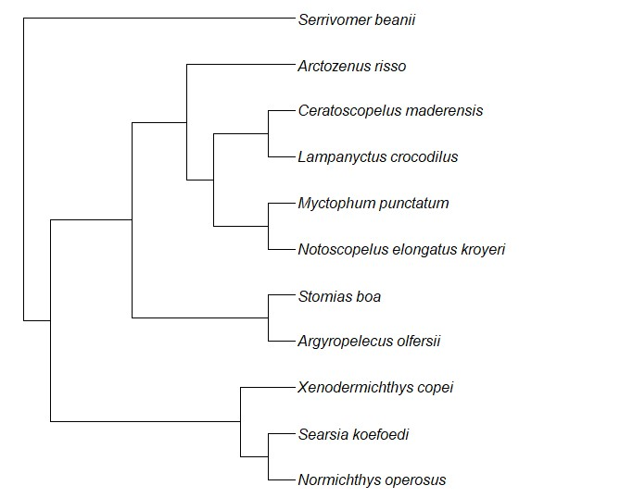

Figure A.1: Phylogenic tree of studied species, using R *rotl* package (OpenTreeOfLife *et al.* 2019) .

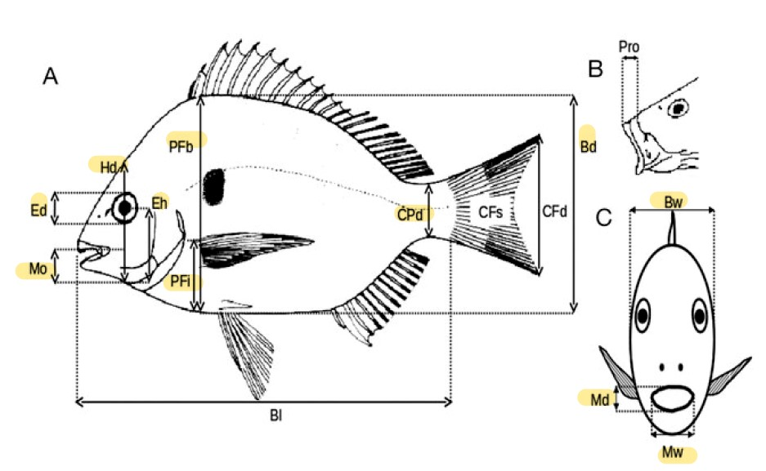

Figure A.2: Morphological measurements, from Albouy *et al.* (2011). BD, body depth; BW, body width;CPD, caudal peduncle minimal depth; ED, eye diameter; EH, distance between the bottom of the head and the eye center along the head depth axis; HD, head depth along the vertical axis of the eye; MD, mouth depth; MO, distance between the tip of the upper jaw and bottom of the head; MW, mouth width; PFB, body depth at the level of the pectoral insertion; PFI, distance between the insertion of pectoral fin and the bottom of the body.

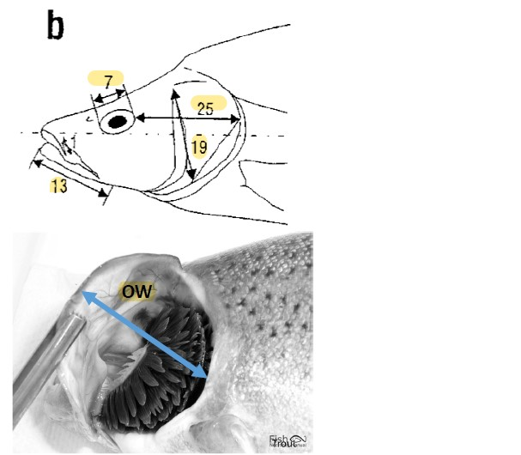

Figure A.3: Morphological measurements of the head, from Diderich (2006), following Sibbing &Nagelkerke(2000). 7beingED, eyediameter; 13LJL, distancebetweenthetipandtheinsertion point of lower jaw; 19 OD, depth of the operculum from point of insertion to bottom; 25 POL, shortest distance between the eye and the end of the head; OW, operculum maximum width.

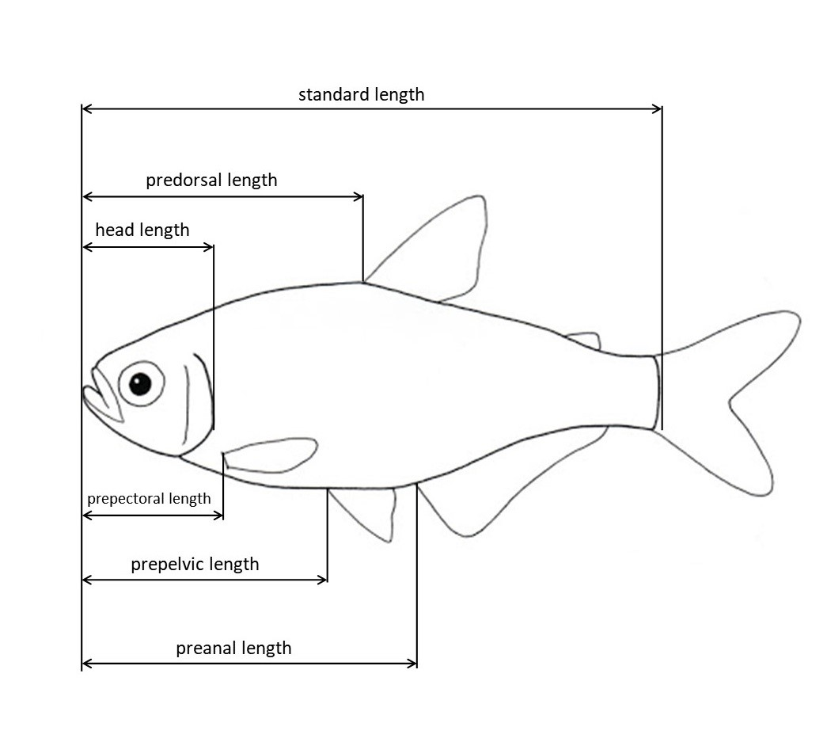

Figure A.4: Morphological measurements of the head and fins, adapted from Keat-Chuan Ng *et al.* (2017); Habib *et al.* (2019). HL, head length, from the nose to the closest-to-caudal-fin point of the operculum; PAL, distance bewteen the tip of the nose and the insertion of anal fin; PDL, distance bewteen the tip of the nose and the insertion of dorsal fin, PPL, distance bewteen the tip of the nose and the insertion of pectoral fin; PVL, distance bewteen the tip of the nose and

the insertion of pelvic fin; SL, standard length.

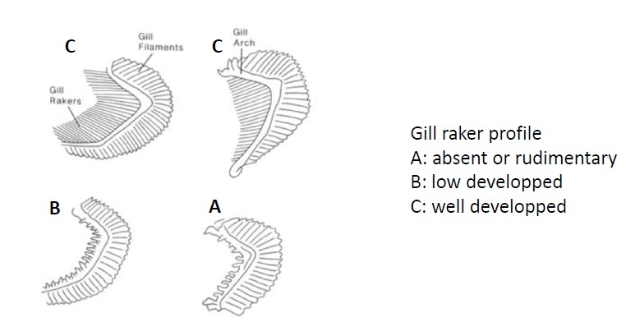

Figure A.5: Scores of gill rakers types GIT, based on their length.

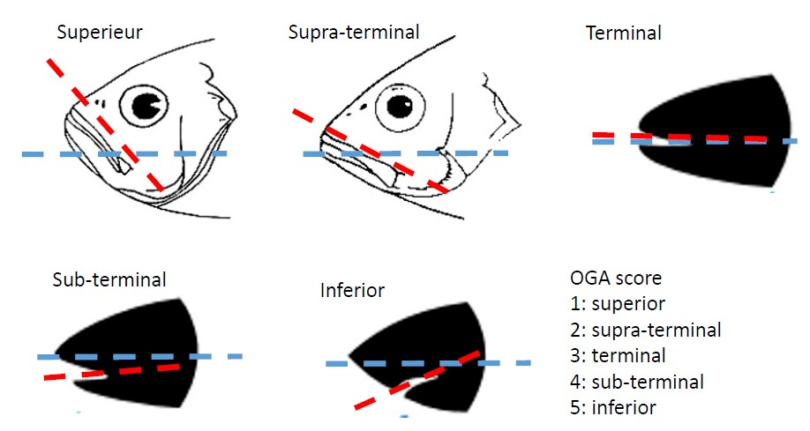

Figure A.6: Scores of oral gape axis OGA, based on the angle between mouth orientation (red) and a fictive mid-depth lateral lign (blue).

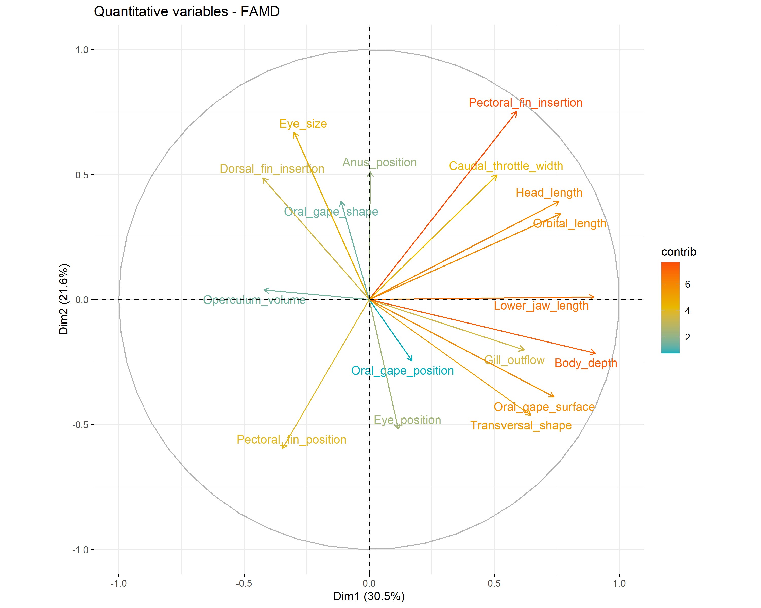

Figure A.7: Correlation circle of axis 1 and 2. The ”contrib” variable refers to the representativity of the variable on the axis. The higher the value is, the more the corresponding variable contributes to the axis.

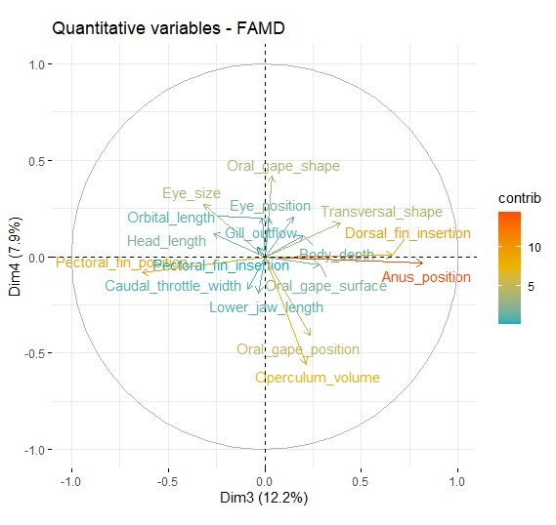

Figure A.8: Correlation circle of axis 3 and 4. The ”contrib” variable refers to the representativity of the variable on the axis. The higher the value is, the more the corresponding variable contributes to the axis.

## Abstract

The deep ocean is the largest biome of the Earth, yet, these extrem ecosystems remain mostly unknown, with only 0.001% of it having been investigated. At the interface between nutrientsrich continental waters to impoverished deep-sea waters, are found submarine canyons. Being highly heterogeneous, these habitats appears to be ”biodiversity hotspots” and support many ecological services. Species and communities living in such habitat are understudied and very little is known on resource partitioning supporting co-existence of species and functioning of deep sea ecosystems. In this study, our objectives was to characterise functional diversity through morphology, of 11 common species of Bay of Biscay’s canyons, and to measure the degree of overlap bewteen functional niches. Our results revealed significant differences in functional niches between species and in functional traits for species with relatively close niches. Ecological data being scarce on studied species, this work confirms that functional analyses is adapted to deep-sea fishes and that it give informations on the main functions performed by species. Finally, our results supports the hypothesis of high functional diversity in deep-sea ecosystems, promoting co-existence of species du to high resource partitioning. The present work is a first attempt to compare the morpho-functional characteristics and niche partitioning in the deep-sea fish assemblages from the canyons of Bay of Biscay.

Key words: Functional diversity, niche overlap, functional traits, resource partitioning, deepsea fishes, Bay of Biscay, canyons.

## Résumé

Les eaux profondes constituent le plus grand biome de la Terre, pourtant, ces écosystèmes extrêmes restent pour la plupart inconnus, seuls 0,001% d’entre eux ayant été étudiés. À l’interface entre les eaux continentales riches en nutriments et les eaux profondes appauvries, on trouve les canyons sous-marins. Très hétérogènes, ces habitats apparaissent comme des ”points chauds de la biodiversité” et assurent de nombreux services écologiques. Les espèces et les communautés vivant dans ces habitats sont peu étudiées et l’on sait très peu de choses sur le partage des ressources favorisant la coexistence des espèces et le fonctionnement des écosystèmes d’eaux profondes. Dans cette étude, nos objectifs étaient de caractériser la diversité fonctionnelle, à travers la morphologie, de 11 espèces communes des canyons du Golfe de Gascogne, et de mesurer le degré de chevauchement entre les niches fonctionnelles. Nos résultats ont révélé des différences significatives dans les niches fonctionnelles entre les espèces et dans les traits fonctionnels pour les espèces ayant des niches relativement proches. Les données écologiques étant rares sur les espèces étudiées, ce travail confirme que l’analyse fonctionnelle est adaptée aux poissons d’eaux profondes et qu’elle donne des informations sur les principales fonctions remplies par les espèces. Enfin, nos résultats soutiennent l’hypothèse d’une grande diversité fonctionnelle dans les écosystèmes d’eaux profondes, favorisant la coexistence des espèces grâce à un partage élevé des ressources. Le présent travail est le premire se proposant de comparer les caractéristiques morpho-fonctionnelles et le partage de niche des assemblages de poissons des canyons du Golfe de Gascogne.

Mots clés : Diversité fonctionnelle, chevauchement de niche, traits fonctionnels, partitionnement des ressources, poissons d’eau profonde, Golfe de Gascogne, canyons.

1. **.2 Factorial Analysis of Mixed Data (FAMD)**

   To assess similarity or differences in species in terms of traits, FAMD was performed. This type of analysis is suited for dataset containing a mix of qualitative and quantitative variables, and performs PCA (Principal Component Analysis) on quantitative variables and MCA (Multiple Correspondence Analysis) on qualitative variables. In the same way that PCA, FAMD is used to assess similarity/difference of individuals and to check for association between the variables. To this end, *FactoMineR* package was used. Because *Serrivomer beanii* does not have pectoral nor pelvic fins, and because this analysis can not handle missing values, zero values were attributed for PFB, PFI, PPL and PVL. Because of this specific particularity, complementarty analysis was run. First, same FAMD analysis was run without *S. beanii*, to assess discrimination between all remaining species. Then, the analysis was run without previously cited traits, to look for their weight and to verify that observed differences were not exclusively dependants of these traits. Categorical variables were managed as follow: scores were used for both oral gape axis and gill raker type (see Figures A.6 and A.5), whereas pyloric caeca and photophores were binary defined (0 = absent, 1 = present). For each principal component (PC), trait that have correlation superior or equal to threshold is consider significant, threshold (t) being define by *t* = 100*/*number of variables. Here, 21 functional traits were computed, meaning that *t* ≈ 4*.*8.

   The drawn ellipse assumes multivariate distribution, at 95% confidence interval.