Parameter values:
In both of as-is model and q2 model, we set one month consists of 25 working days, one day consists of 8 working hours and one week consists of 5 working days. Our mean is 450 and our bin is 1h.

1.as-is (Mean=450):

Activity Durations: The transition from “Register Request” to “Check Credits” and “Disable Incoming Transaction” shows moderate delays, indicating stable but suboptimal processing.
Bottlenecks: The “Review the case for potential fraud” activity exhibits high variability in duration (wide orange bands), suggesting inconsistent handling due to limited resources or manual processes.
Case Throughput (Woped): Simulations yield ~148 cases . Assuming each simulation represents a month, Q1’s capacity is approximately 148 cases/month.
Spectrum Patterns: Frequent orange lines in fraud review and external investigation steps indicate delays, limiting throughput and scalability.
Limitations: Resource constraints in fraud review create inefficiencies, as seen in the spectrum’s prolonged durations, aligning with the modest throughput in Woped simulations.

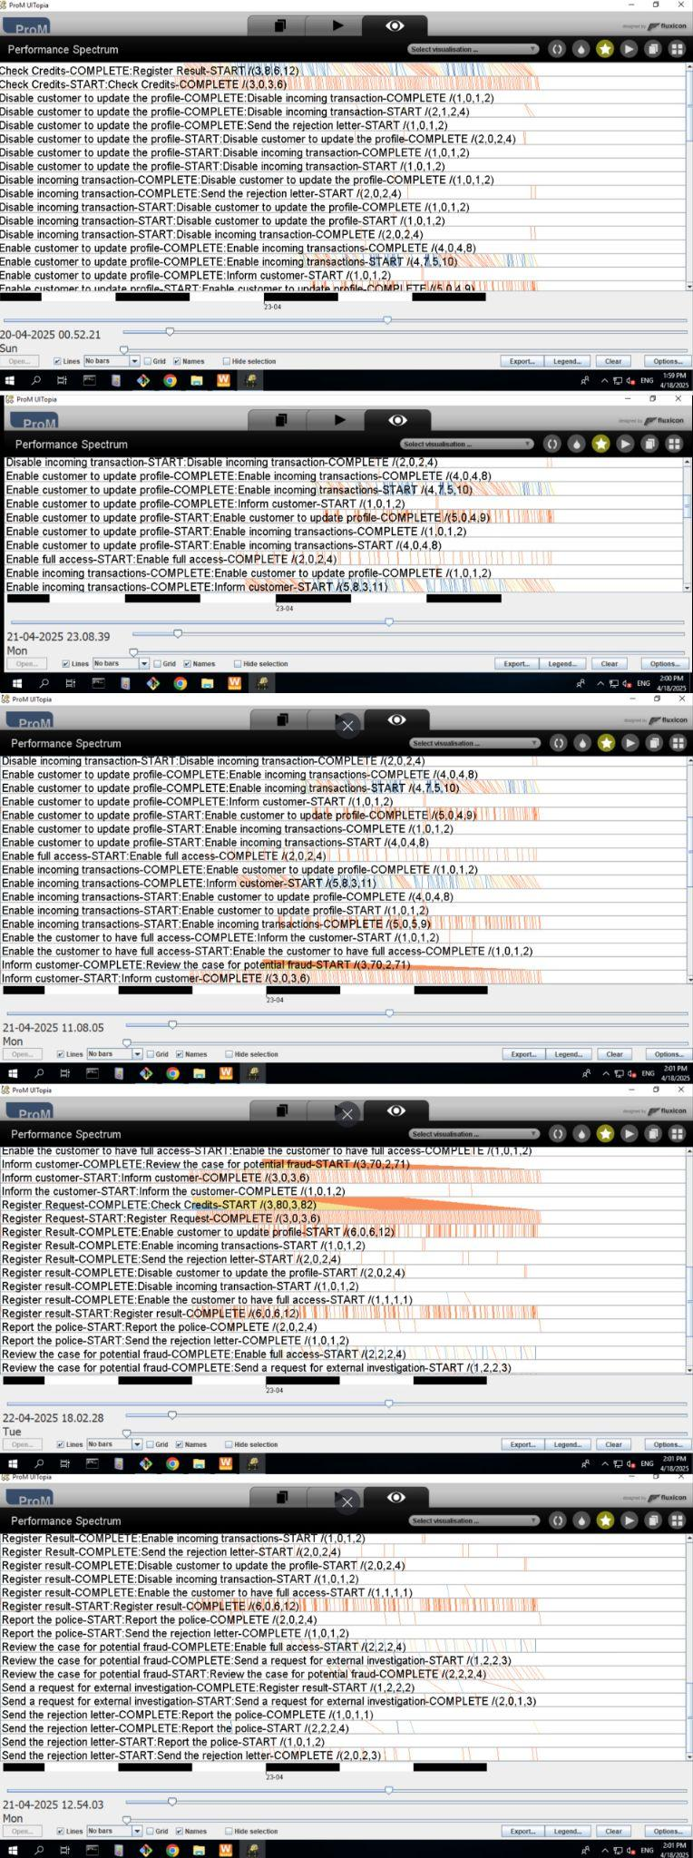

Figure1. Performance Spectrum Before Organizational Restructuring

2.q2(Mean=450)：
Improved Activity Durations: The “Review the case for potential fraud” activity shows reduced variability and shorter durations compared to Q1 , indicating that additional resources streamlined this step.
Reduced Bottlenecks: Transitions like “Disable Incoming Transaction” and “Send Rejection Letter” have tighter duration bands, reflecting consistent processing times.
Case Throughput (Woped): Simulations yield ~212 cases, a 43.24% increase over Q1’s ~149 cases. Assuming a monthly period, Q2’s capacity is approximately 212 cases/month.
Spectrum Patterns: Q2’s spectrum shows fewer orange lines and more compact duration bands, especially for fraud review, suggesting improved flow and reduced wait times.
Resource Impact: Role reassignments likely redistributed workload from overburdened staff (e.g., fraud reviewers) to underutilized ones, boosting throughput.
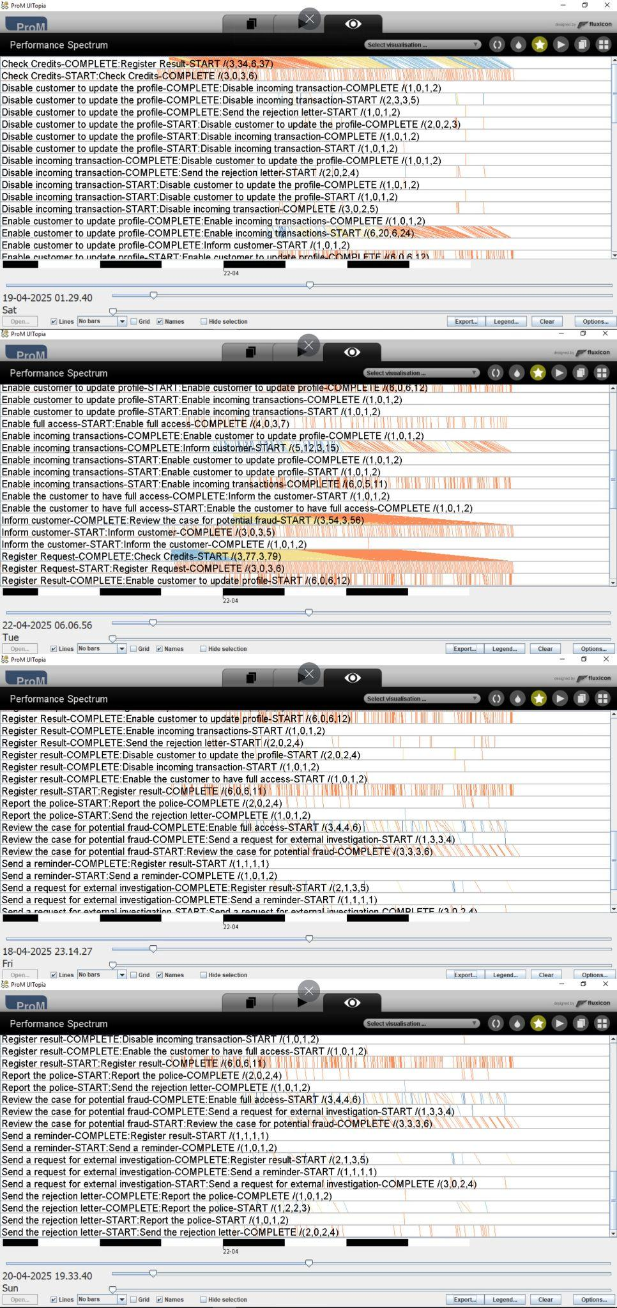
Figure2. Performance Spectrum After Organizational Restructuring




3.Dotted Chart Analyse：
as-is Resource Patterns:The dots of “Review the case for potential fraud” are densely packed for certain resources, indicating overburdened staff. The dots of “Send Rejection Letter” are sparse, suggesting underutilized roles.

q2 Resource Patterns: The dots of “Review the case for potential fraud” are more evenly distributed, with fewer overlaps, showing that fraud review tasks are shared across more staff. The dots of “Send Rejection Letter,” and “Inform Customer” are denser, reflecting increased activity by reassigned resources.

Impact of Resource Changes: Q2’s balanced workload reduces bottlenecks in fraud review and leverages idle capacity, contributing to the 43.24% throughput increase (212 vs. 148 cases).

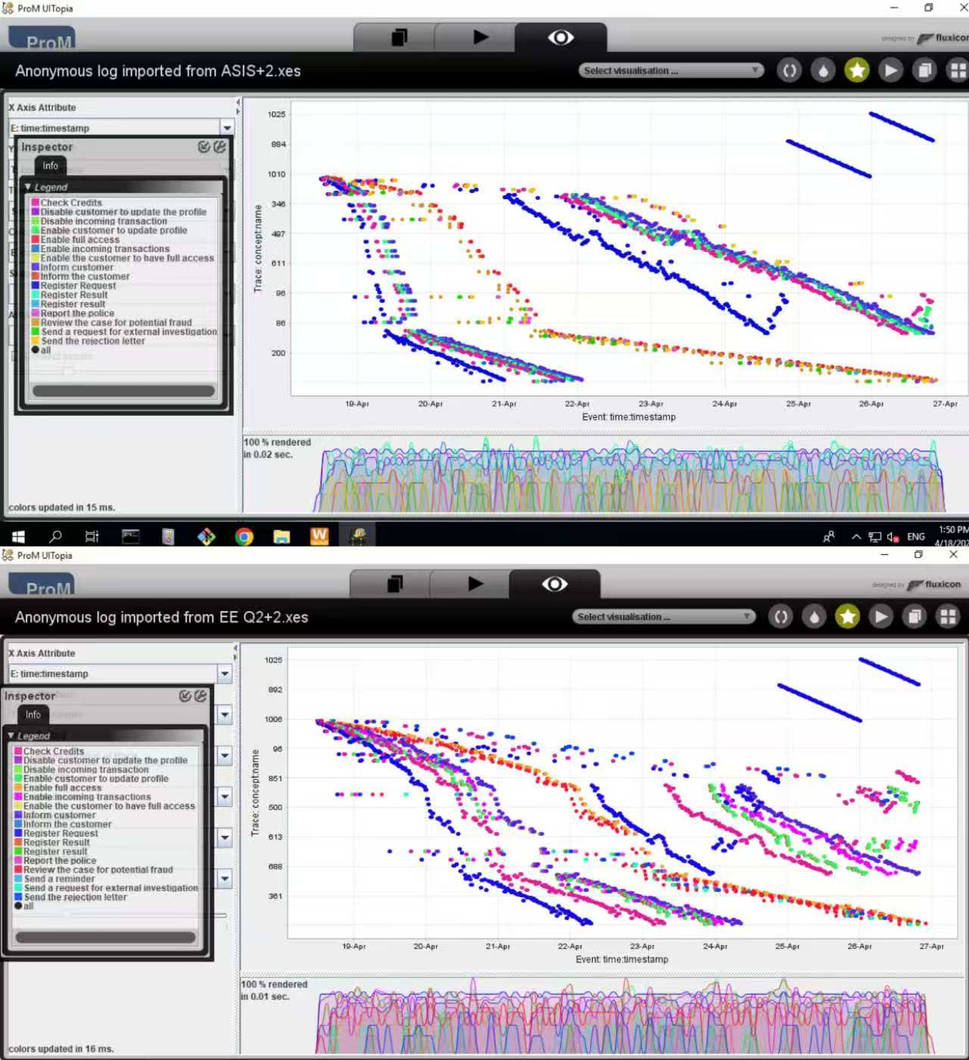
Figure3. Dotted Chart Before Organizational Restructuring VS Dotted Chart After Organizational Restructuring

