How many cases can the company handle now completely per month with the current setting?
We simulated the as-is model several times.
 | Simulation 1 | Simulation 2 | Simulation 3 | Average
Cases Completed | 151 | 148 | 151 | 150.0
After adjusting the mean value from 1200 to 450 to get the best performance, the average number of cases that can be processed each month is about 150, the maximum is 151, and the minimum is 148 in the following three simulations.

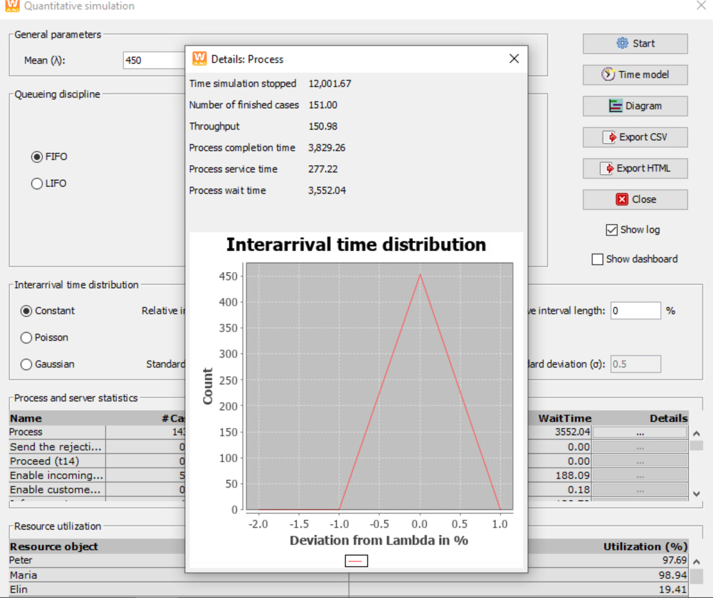
Simulation 1: number of finished cases: 151
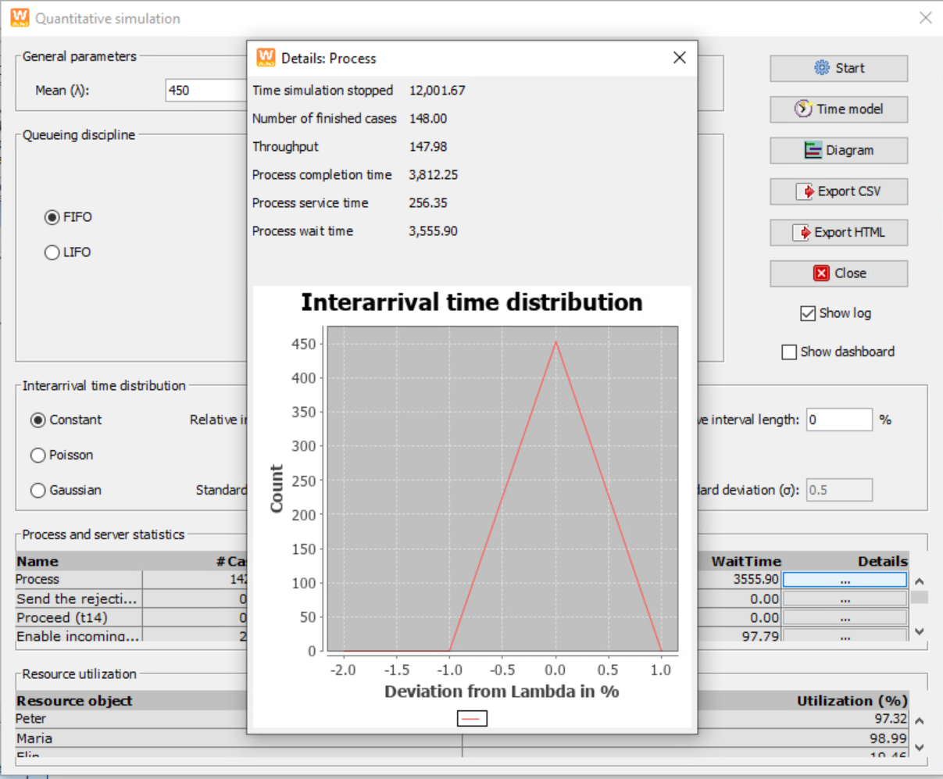
Simulation 2: number of finished cases: 148
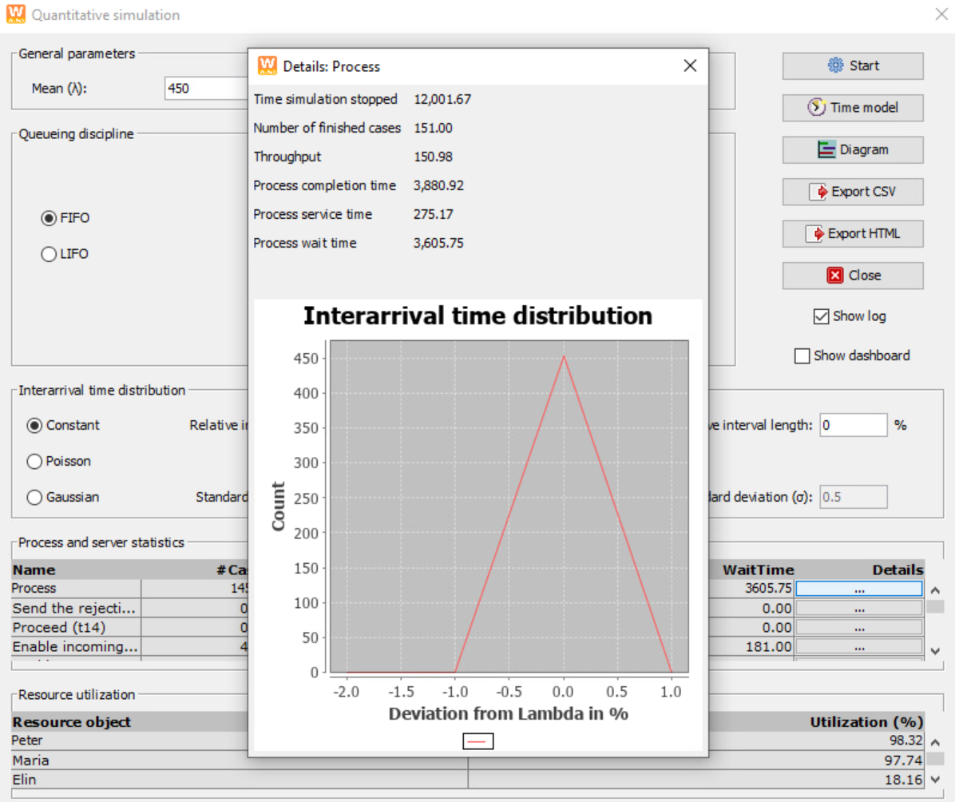
Simulation 3: number of finished cases: 151

