1.Problem Context
The current process suffers from delays in the fraud investigation stage, due to limited resource availability. As a potential improvement, we explored whether changing the role or group of employees—without violating the regulation that no employee can hold more than one role or group—could help enhance the process efficiency.

2. The Adjustment
We reassigned Paul, who originally worked as a CRM Officer in the CRM department, to the fraud investigation department with the new role of Fraud Investigator. This was done in compliance with the restriction that each employee must belong to only one group and role.

3. Simulation Results
We ran three process simulations both before and after the change, and recorded the number of completed cases per month in each scenario (excluding cancellation cases):
Scenario | Simulation 1 | Simulation 2 | Simulation 3 | Average Cases Completed
Before Change | 151 | 148 | 151 | 150.0
After Change | 212 | 206 | 211 | 209.7

4. Insights & Analysis
By reallocating Paul to the fraud investigation team, we significantly reduced the bottleneck in that stage.
This change increased the average case completion rate by nearly 40% (from 150 to ~210 cases/month).
The improvement is consistent across all three simulations, demonstrating the stability of the effect.
No additional resources were added—only a role and group change was made—making this solution cost-efficient and regulation-compliant.
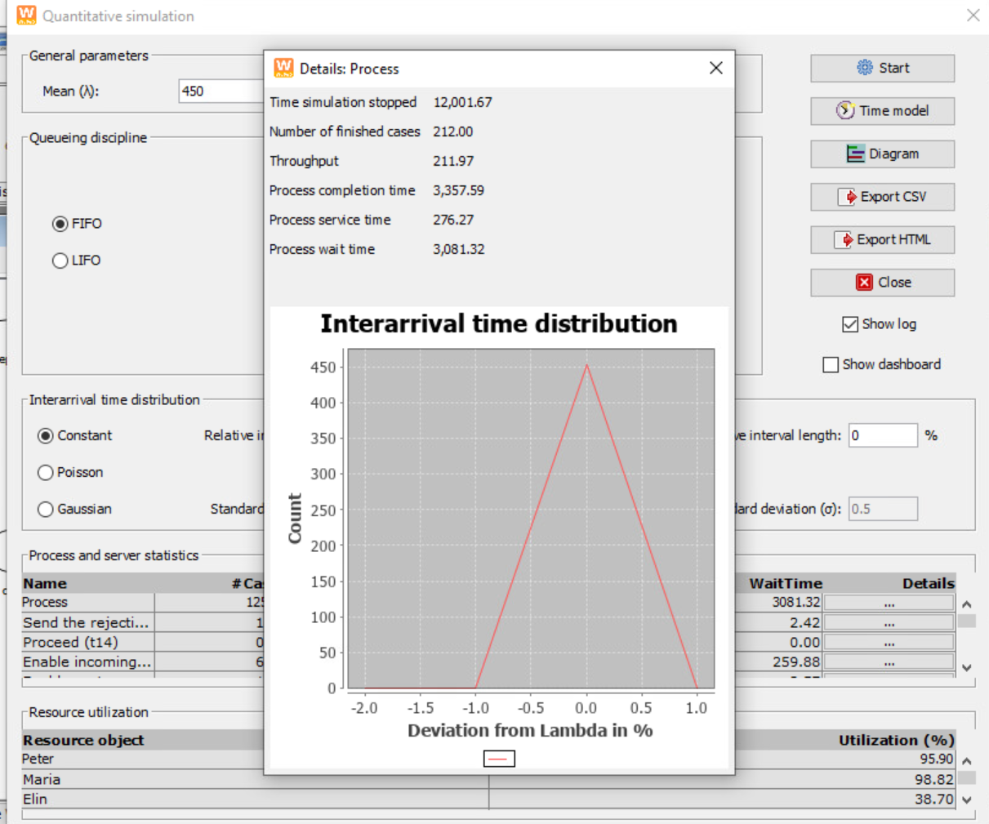
simulation 1:number of finished cases:212
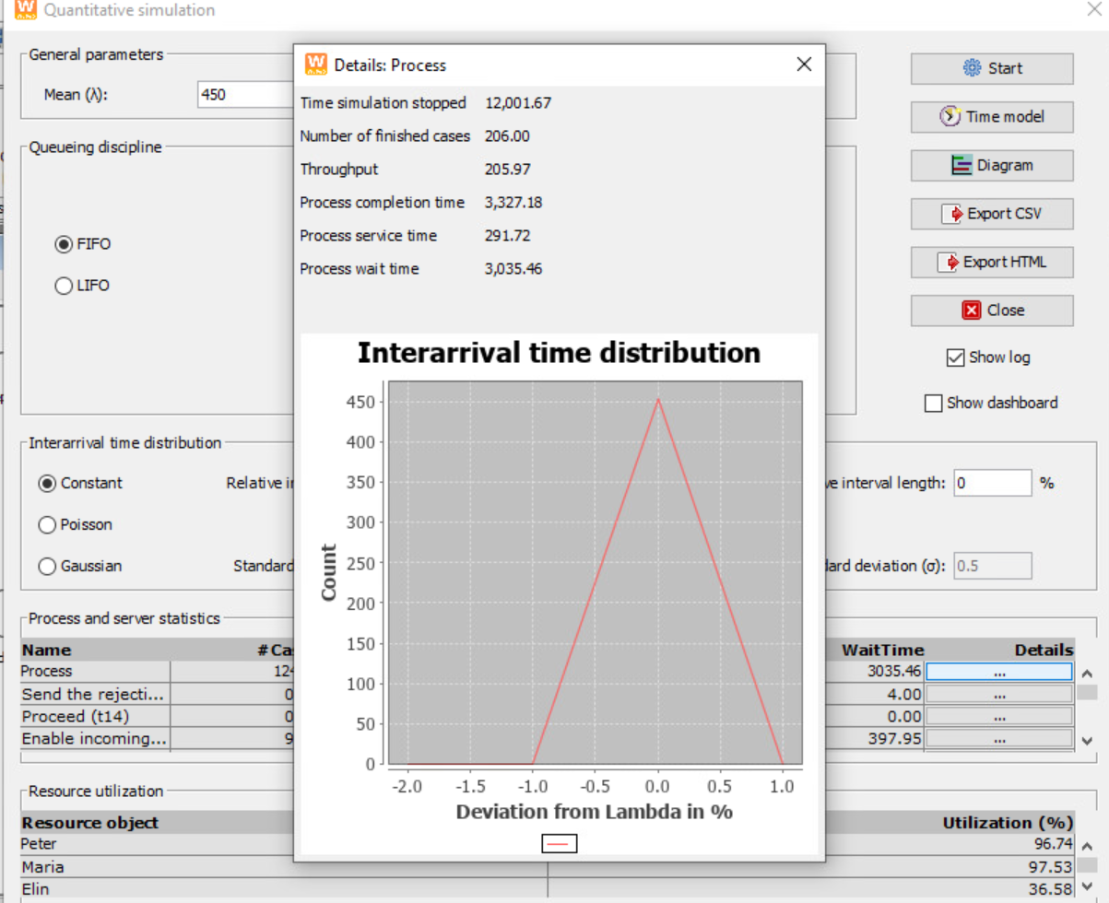
simulation 2:number of finished cases:206
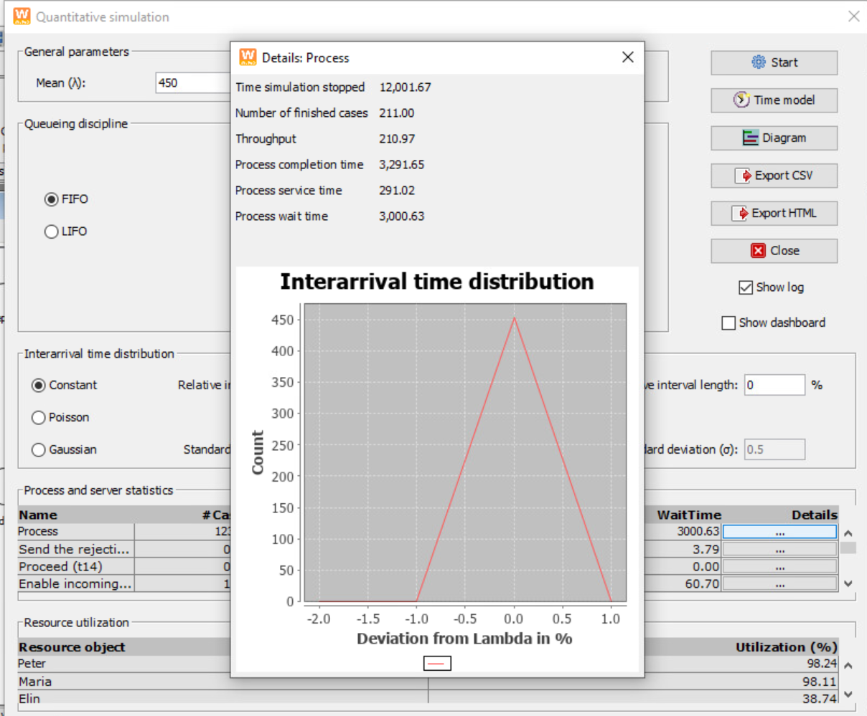
simulation 3:number of finished cases:211

