BIMP Report

Patterns support
Please summarized your findings for patterns support using BIMP for simulation in the table below. Each patten shall be documented in the following appropriate sections.
Pattern Name | Is supported? | Comment
sequence | yes
parallel | yes
XOR | yes | In BIMP, the XOR Gateway can only follow a random distribution (e.g., based on probabilities), and cannot be determined based on process data.
OR | yes
two tasks defer | no
two events defer | yes
two receive tasks defer | yes
one task and one event defer | no
loop | no

Supporting Patterns
Here is the list of details for patterns that are supported by BIMP:

Pattern Name
sequence

Screenshot of heatmap
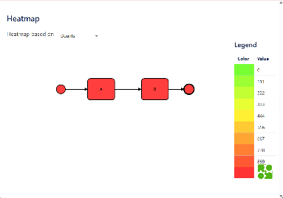

Pattern Name
parallel

Screenshot of Simulation
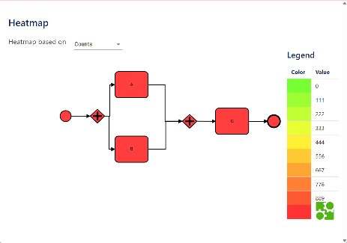

Pattern Name
XOR

Screenshot of Simulation
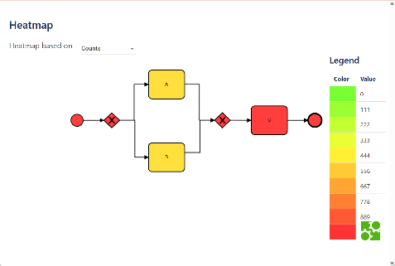

Pattern Name
OR

Screenshot of Simulation
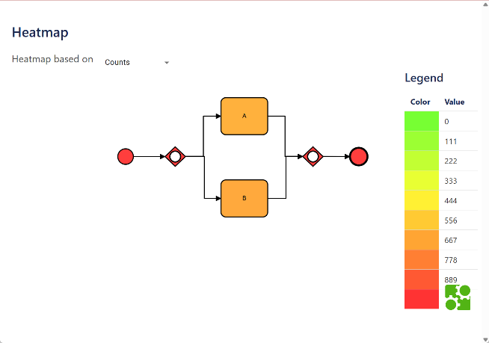

Pattern Name
two receive tasks defer

Screenshot of Simulation
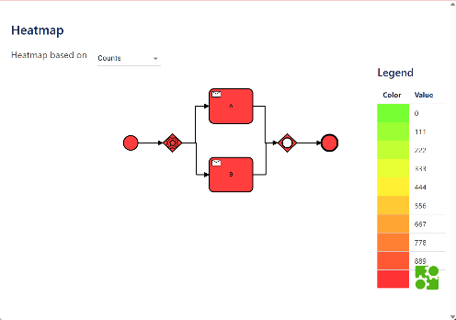

Pattern Name
two events defer

Screenshot of Simulation
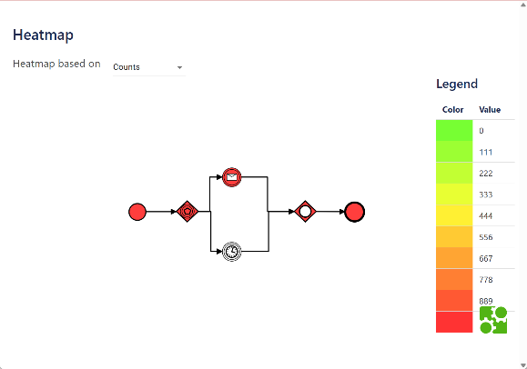

Unsupported Patterns
Here is the list of details for patterns that are not supported by BIMP:

Pattern Name
two tasks defer

Screenshot of Status result
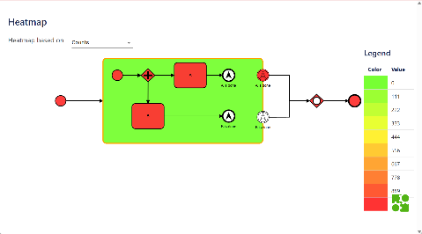

Pattern Name
one task and one event defer

Screenshot of Status result
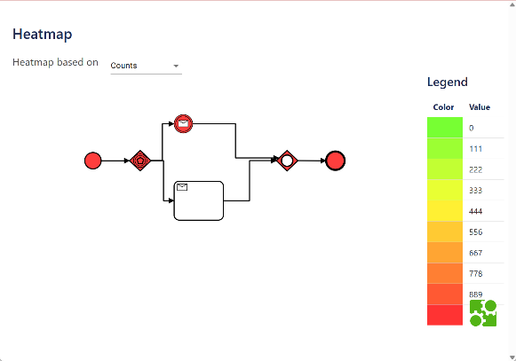

Pattern Name
loop

Screenshot of Status result
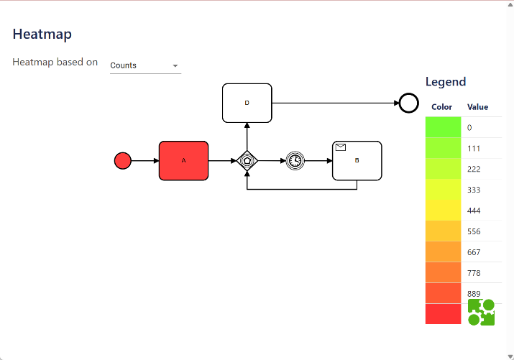

Basic Scenario
Here, you shall document the result of simulating the basic scenario in case description (to-be model) for the assignment.

Screenshot of heatmap
