Trisotech Report

Patterns support
Please summarize your findings for patterns support using Trisotech for interactive simulation in the table below. Each patten shall be documented in the following appropriate sections.
Pattern Name | Is supported? | Comment
sequence | yes
parallel | yes
XOR | yes
OR | yes
two tasks defer choice | yes
two events defer choice | yes
two receive tasks defer choice | yes
one task and one event defer choice | yes
loop | yes

Supporting Patterns
Here are the list of details for patterns that are supported by Trisotech:

Pattern Name
sequence

Screenshot of Simulation
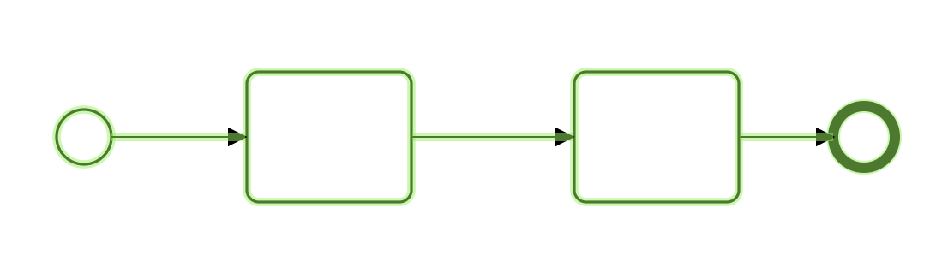

Pattern Name
parallel

Screenshot of Simulation
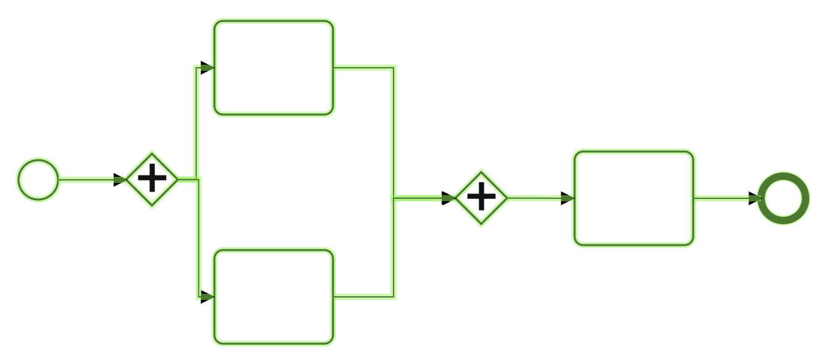

Pattern Name
XOR

Screenshot of Simulation
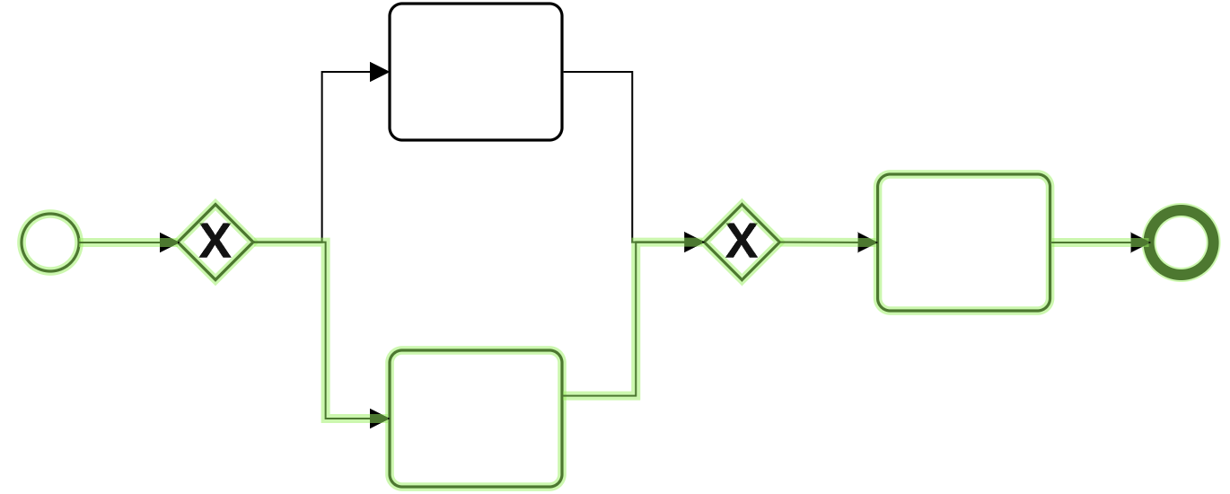

Pattern Name

OR

Screenshot of Simulation
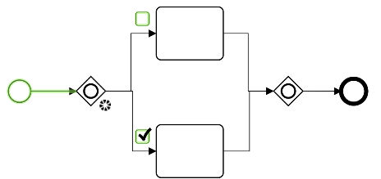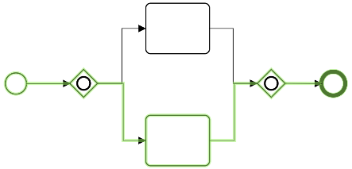
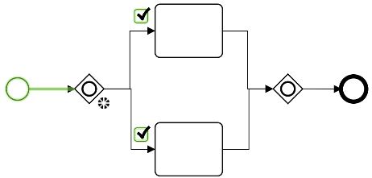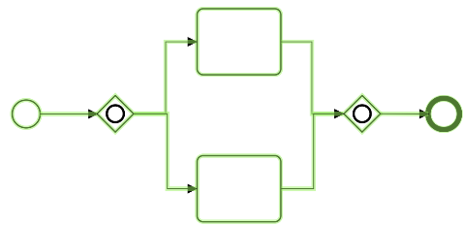

Pattern Name
two tasks defer

Screenshot of Simulation
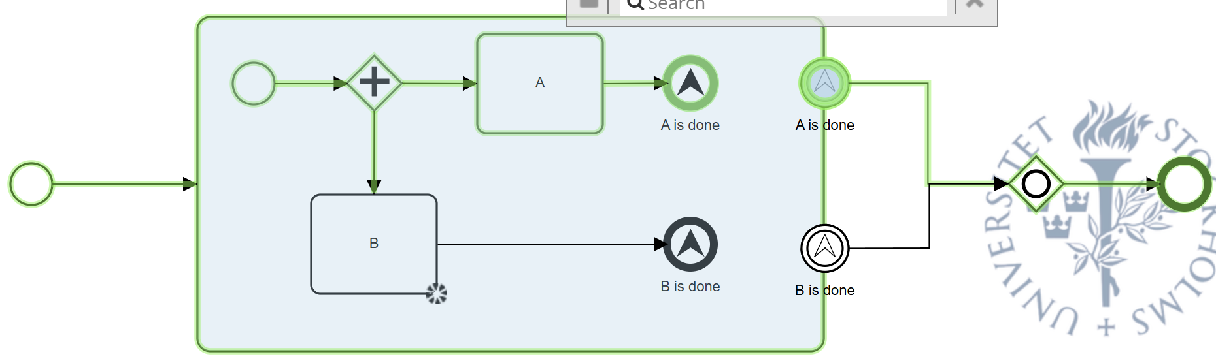

Pattern Name
two events defer

Screenshot of Simulation
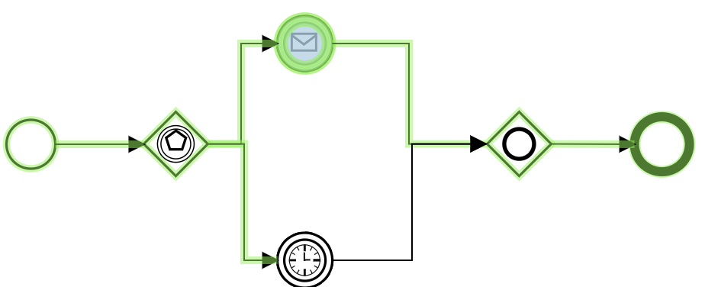

Pattern Name
two receive tasks defer

Screenshot of Simulation
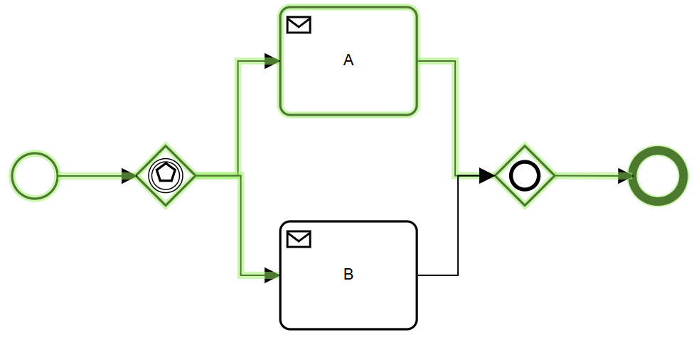

Pattern Name
one task and one event defer

Screenshot of Simulation
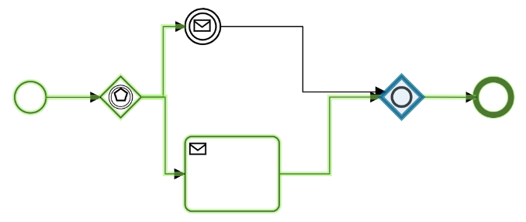

Pattern Name
loop

Screenshot of Simulation
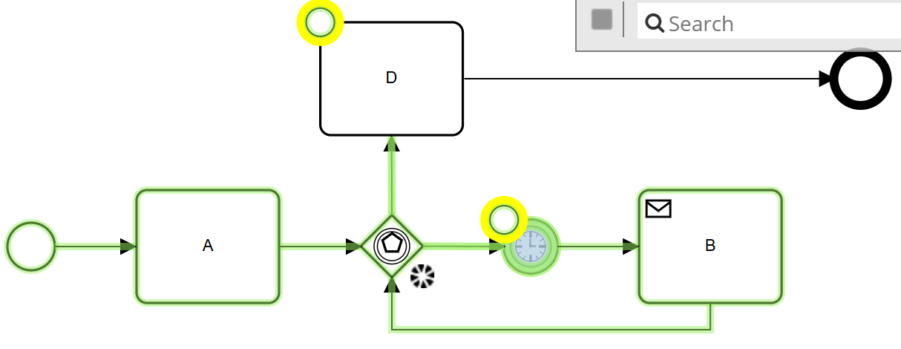

Basic Scenario
Here, you shall document the result of simulating the basic scenario in case description (to-be model) for the assignment.

Screenshot of Simulated model
