to-be-model-besic
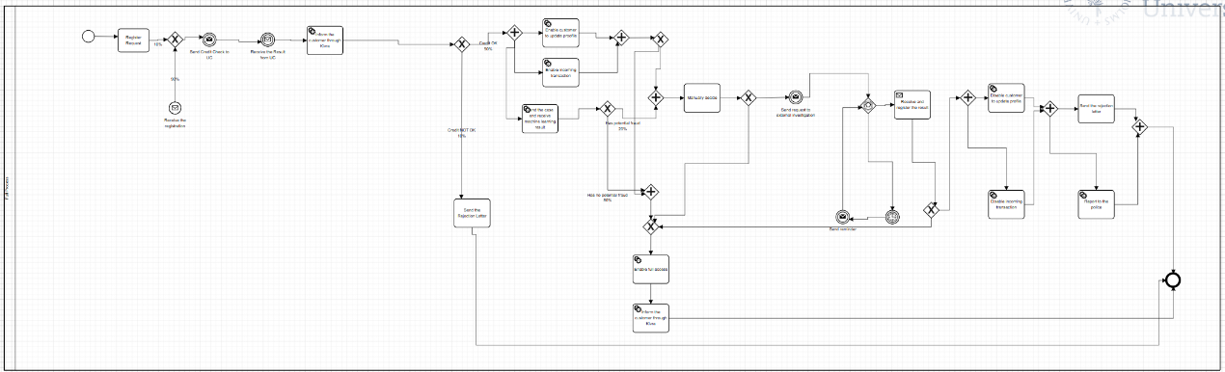

to-be-model-full
