Type: | [[TYPE]]
Heating System: | [[HEAT]]
Fuel Type: | [[FUEL]]
Floors: | [[FLOORS]]
Units: | [[UNITS]]
Square Feet: | [[SQFT]]
Installed: | [[INSTALLED]]
Year Built | [[YEARBUILT]]
 | F U E L U S A G E D A T A
 | YEARS | THERM USAGE | HEATING DEGREE DAYS | USAGE PER HDD
Pre [system]
With [system]
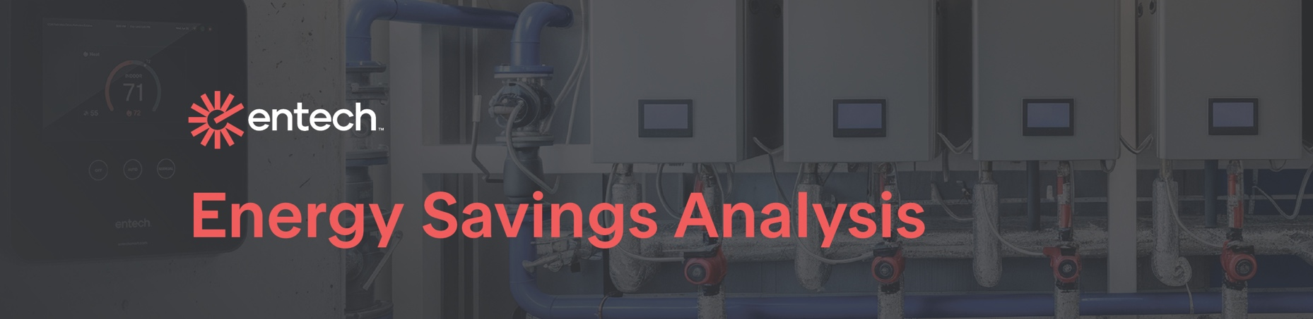
[[PCT]]
[[THERM]]
[[MONEY]]
[[MGMT]]
[[ADDR]]
[[CITYZIP]]
Therm Savings
Monetary Savings
Percentage Savings
*These numbers reflect [[FOOTNOTE]] savings.
[[DATE]]

